FITFORGE
Workout Tracker & Fitness Management App

Project Report

Submitted by
VIKAS
Roll No: 24BCA117
BCA – 4th Semester

Department of Bachelor of Computer Applications (BCA)
St. Claret College (Autonomous), Bengaluru
July 2026

CERTIFICATE
This is to certify that the mini project entitled
FITFORGE — WORKOUT TRACKER & FITNESS MANAGEMENT APP
has been successfully developed and submitted by VIKAS (Roll No. 24BCA117), a student of the 4th Semester, Bachelor of Computer Applications (BCA), St. Claret College (Autonomous), Bengaluru.
This mini project was developed independently as part of self-learning during the vacation period. The work is original and has not been submitted elsewhere for any academic examination or award.

St. Claret College (Autonomous), Bengaluru

DECLARATION
I, VIKAS, Roll No. 24BCA117, 4th Semester, BCA, St. Claret College (Autonomous), Bengaluru, declare that the mini project “FITFORGE” is a record of original work done by me during the vacation period.
I declare that:
- This project was carried out independently, without any formal institutional guidance.
- The work is genuine and has not been copied from any source without acknowledgement.
- This project has not been submitted for any degree or academic title elsewhere.
- All references have been duly cited.
- The conclusions drawn are based entirely on my own understanding and research.

Place: Bengaluru
Date: July 2026

Signature of the Student
VIKAS
Roll No: 24BCA117 | 4th Semester, BCA

ACKNOWLEDGEMENT
I thank all those who encouraged and supported me throughout the development of this project.
I am grateful to the open-source community and educational resources available through MDN Web Docs, Stack Overflow, and YouTube, which helped me understand React state management, localStorage persistence, Chart.js data visualisation, BMI calculation algorithms, and streak-based gamification systems in the browser.
I thank my family for their constant encouragement and for providing a focused environment for learning during the vacation period.
Building a complete fitness tracker that logs workouts, tracks daily progress, visualises analytics, and awards achievements — all in the browser without a backend — gave me a deep appreciation of how front-end technologies can solve real-world health and wellness problems.

VIKAS
Roll No: 24BCA117 | 4th Semester, BCA
St. Claret College (Autonomous), Bengaluru

ABSTRACT
Maintaining a consistent fitness routine is a challenge for millions of people worldwide. While gym-goers and home workout enthusiasts are motivated, they often lack a structured system to plan workouts, track daily completion, monitor caloric output, and celebrate milestones. Existing fitness apps are either locked behind subscription paywalls or require account creation and cloud sync, creating unnecessary barriers for casual users.
FitForge addresses this gap by offering a free, browser-based fitness tracking application that organises workouts by category, tracks daily and weekly completion, provides a visual analytics dashboard, calculates BMI, and awards achievements — all without requiring an account or server connection.
FitForge is structured around four core modules — Workouts, Tracker, Dashboard, and BMI Calculator — that together form a complete fitness management experience. The application persists all user data locally in the browser, ensuring privacy and offline capability.
Key Features:
- Workout Library: Seven pre-built workout categories (Chest, Abs, Legs, Arms, Full Body, Yoga, Cardio) with difficulty levels, duration, and calorie estimates.
- Workout Filters: Filter workouts by difficulty level (All, Beginner, Intermediate, Advanced) and search by keyword.
- Daily Tracker: Mark individual workouts as complete, track daily progress percentage, and view total calories burned.
- Weekly View: Switch between daily and weekly progress views in the Tracker module.
- Dashboard Analytics: 7-day activity bar chart, category breakdown with progress bars, and summary stats (total workouts, streak, calories, active days).
- Achievements System: Six unlockable badges — First Rep, 3-Day Fire, Week Warrior, Diamond, Challenger, and Kcal Crusher.
- BMI Calculator: Metric and imperial unit support, instant BMI result with category, and a persistent BMI history log.
- Day Streak Tracking: Consecutive active days counted automatically to motivate consistency.
- Fully client-side — no server, no account, no data transmission.

Technologies Used:
HTML5, CSS3, Vanilla JavaScript, Chart.js, localStorage API. Deployed on Netlify.

TABLE OF CONTENTS
Certificate | 2
Declaration | 3
Acknowledgement | 4
Abstract | 5
Table of Contents | 6
Chapter 1 – Introduction | 7
Chapter 2 – Objectives of the Project | 8
Chapter 3 – Existing System | 9
Chapter 4 – Proposed System | 10
Chapter 5 – Modules and Features | 11
Chapter 6 – Technologies Used | 16
Chapter 7 – Conclusion | 18

Chapter 1

INTRODUCTION

1.1 Background
Physical fitness and regular exercise are increasingly important in modern sedentary lifestyles. However, tracking workout consistency, monitoring caloric burn, and maintaining motivation over time remain significant challenges for individuals who exercise at home or in the gym without professional coaching.
Most dedicated fitness tracking apps — such as MyFitnessPal, Fitbod, or Nike Training Club — require account creation, monthly subscriptions, or are tightly coupled with wearable hardware. This creates an unnecessary barrier for students, casual exercisers, and individuals who simply want a straightforward way to organise their workout week and track whether they are improving.
A lighter, browser-based alternative that requires no installation and stores data privately on the user’s own device fills a real gap in the market.

1.2 About the Project
FitForge is a comprehensive, browser-based fitness tracking application built with vanilla web technologies. It provides a structured workout library, daily and weekly progress tracking, an analytics dashboard with streak counting, a BMI calculator, and a gamified achievement system — all without requiring a user account or internet connection beyond the initial page load.
Live at: https://fit-forge-v.netlify.app/ — deployed on Netlify.

1.3 Scope
- Pre-built workout library with seven categories, each with difficulty, duration, and calorie data.
- Daily and weekly workout completion tracking with persistent localStorage state.
- Analytics dashboard showing 7-day activity history and category-level breakdown.
- Streak tracking and achievement badge system for motivation.
- BMI calculator with metric/imperial support and history log.
- Fully client-side — no server, no account, no cloud data storage.

Chapter 2

OBJECTIVES OF THE PROJECT
The following objectives guided the design and development of FitForge:
- To build a structured workout library: Provide seven pre-configured workout categories with difficulty ratings (Beginner, Intermediate, Advanced), estimated duration in minutes, and approximate calorie burn per session.
- To implement a daily and weekly progress tracker: Allow users to mark individual workouts as complete, calculate daily progress as a percentage, accumulate total calories burned, and switch between daily and weekly views.
- To visualise fitness analytics on a dashboard: Render a 7-day activity bar chart, display category-level breakdown with horizontal progress bars, and show summary metrics including total workouts completed, current streak, total calories burned, and active days.
- To implement a streak and achievement system: Count consecutive active days as a streak, and unlock six achievement badges based on milestones — First Rep, 3-Day Fire, Week Warrior, Diamond, Challenger, and Kcal Crusher — to gamify the fitness experience.
- To provide a BMI calculator with history: Accept height and weight in both metric (cm/kg) and imperial (ft/lb) units, calculate BMI instantly, classify the result (Underweight, Normal, Overweight, Obese), and maintain a persistent BMI history log.
- To ensure persistent local storage: Use the browser’s localStorage API to persist all workout completion states, streak data, achievement status, and BMI history across sessions without any server or account.
- To maintain complete data privacy: Process all data locally in the browser — no personal fitness data is ever transmitted to any server, ensuring full confidentiality.

Chapter 3

EXISTING SYSTEM

3.1 Current Approaches to Fitness Tracking
Users currently rely on the following methods to manage their fitness routines, each with significant limitations:

a) Pen-and-Paper Logs
Many home gym enthusiasts track workouts in notebooks. This method is portable but difficult to analyse, produces no statistics or trend data, and provides no motivational feedback such as streak counts or achievement badges.

b) General-Purpose Spreadsheets
Some users maintain workout logs in Microsoft Excel or Google Sheets. While flexible, this requires manual formula construction for totals, provides no visual workout library, and cannot deliver streak tracking or real-time progress percentages without significant setup effort.

c) Enterprise Fitness Apps
Apps like MyFitnessPal, Fitbod, and Nike Training Club offer powerful features but require mandatory account creation, request access to personal health data, and often lock key features behind monthly or annual subscription fees. They are also primarily designed for mobile and are not suitable as browser-based tools.

d) Wearable-Dependent Platforms
Platforms such as Garmin Connect, Fitbit Dashboard, and Apple Fitness+ provide excellent analytics but require ownership of compatible hardware. Users without wearables cannot access these platforms’ core features.

3.2 Limitations Summary
- Manual logs are not analysable and provide no motivational feedback.
- Spreadsheet tools require significant manual configuration for fitness use cases.
- Consumer fitness apps mandate account creation and upload personal health data to third-party servers.
- Subscription paywalls block core features from free users.
- Wearable-dependent platforms exclude the majority of casual exercisers.
- No free, instant, browser-based tool combines a workout library, daily tracker, analytics dashboard, achievement system, and BMI calculator in a single interface.

Chapter 4

PROPOSED SYSTEM

4.1 Overview
FitForge proposes a zero-friction, browser-based fitness management platform that provides a complete workout planning and tracking experience without requiring an account, installation, or internet connection beyond the initial page load. All data is stored privately in the user’s browser.

4.2 Advantages
- Instant Access: Open the URL and start tracking immediately — no sign-up, no download, no subscription.
- Structured Workout Library: Seven pre-built categories remove the need for users to research exercises or build their own plans from scratch.
- Real-Time Progress Tracking: Daily completion percentage and calorie totals update instantly as workouts are marked done.
- Data Privacy: All fitness data is stored in localStorage on the user’s own device — nothing is transmitted to any server.
- Motivation through Gamification: Streak counting and achievement badges provide ongoing motivational feedback beyond simple logs.
- BMI Awareness: The built-in BMI calculator with persistent history encourages users to monitor their health metrics alongside workout progress.
- Analytics at a Glance: The dashboard’s 7-day chart and category breakdown provide immediate visual insight into fitness habits without manual data entry.

4.3 Architecture
FitForge is a single-page application structured around four navigable modules: Workouts, Tracker, Dashboard, and BMI Calculator. Navigation between modules is handled by a persistent top navigation bar. All application state — workout completion, streak data, achievements, and BMI history — is stored in the browser’s localStorage and loaded on page initialisation. Chart.js renders the 7-day activity bar chart on the Dashboard module. The application requires no build step and runs entirely as static HTML, CSS, and JavaScript.

Chapter 5

MODULES AND FEATURES
FitForge is structured around four primary modules accessible via a persistent navigation bar.

5.1 Workouts Module
The Workouts module is the entry point of the application and serves as the fitness library. It displays seven workout category cards arranged in a responsive grid layout:
- Chest — Intermediate · 25 min · 180 kcal: Push-up variations, dips and isometric holds for a powerful chest.
- Abs — Beginner · 20 min · 140 kcal: Crunches, planks, leg raises and mountain climbers for a steel core.
- Legs — Intermediate · 30 min · 250 kcal: Squats, lunges and glute bridges for powerful, sculpted legs.
- Arms — Beginner · 20 min · 120 kcal: Targeted bicep, tricep and forearm exercises using only bodyweight.
- Full Body — Advanced · 40 min · 350 kcal: Burpees, jump squats, push-up rows and core for a total-body blast.
- Yoga — Beginner · 30 min · 100 kcal: Sun salutations, warrior poses and deep stretches for mind and body.
- Cardio — Intermediate · 25 min · 280 kcal: HIIT circuits including jumping jacks, high knees and lateral shuffles.
Each card displays a representative emoji icon, the category name, a difficulty badge (colour-coded: green for Beginner, yellow for Intermediate, red for Advanced), duration in minutes, calorie estimate, and a brief description of the workout.
A search bar at the top of the module allows users to filter workouts by keyword. Difficulty filter buttons (All, Beginner, Intermediate, Advanced) allow users to narrow the library to their fitness level.
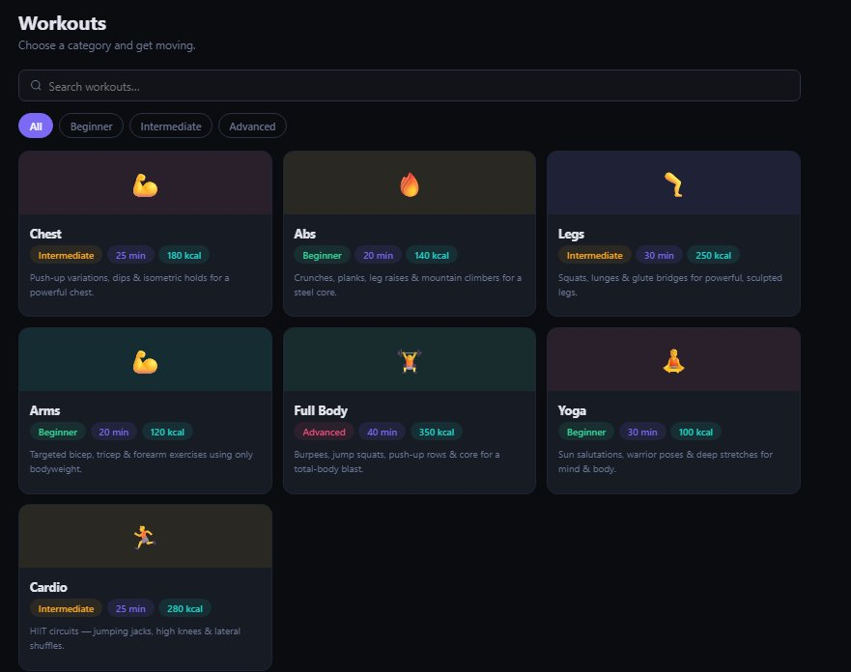
Figure 5.1 – Workouts Module showing all seven workout categories with difficulty filters

5.2 Tracker Module
The Tracker module is the core productivity interface of FitForge. It displays four summary metric cards at the top of the page:
- Done Today: Number of workouts completed on the current day.
- Total Plans: Total number of workouts available in the library (7).
- Calories: Total calories burned from completed workouts today.
- Day Streak: Number of consecutive days on which at least one workout was completed.
Below the metrics, a horizontal progress bar displays today’s completion percentage (workouts done / total plans, expressed as a percentage).
The main body of the Tracker lists all seven workouts as interactive rows. Each row shows the workout emoji, name, duration, calorie estimate, and difficulty level. A circular checkbox on the left allows the user to mark the workout as complete. Completed workouts are visually distinguished from pending ones. A Reset Day button in the top-right corner clears all completions for the current day.
Tab buttons allow the user to switch between Daily view (today’s individual workout checklist) and Weekly view (a broader view of progress across the current week).
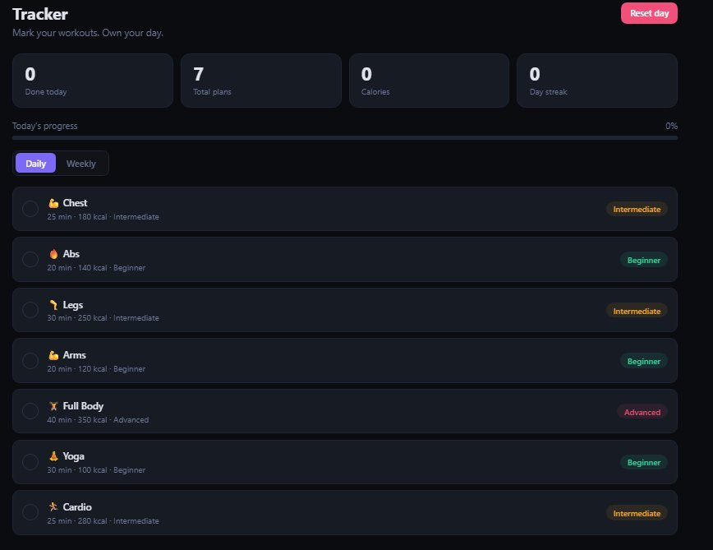
Figure 5.2 – Tracker Module showing daily workout checklist and progress metrics

5.3 Dashboard Module
The Dashboard module provides an analytics overview of the user’s fitness history. It displays four top-level summary statistics:
- Total Workouts: Cumulative number of individual workout sessions completed across all days.
- Current Streak: Number of consecutive active days, updated automatically each day.
- Calories Burned: Cumulative calories burned across all completed sessions.
- Active Days: Total number of distinct days on which at least one workout was completed.
A 7-Day Activity bar chart rendered using Chart.js plots daily workout counts for the current week (Monday through Sunday), giving users an at-a-glance view of their weekly consistency.
A Category Breakdown panel lists all seven workout categories with individual horizontal progress bars and session counts, allowing users to identify which areas of fitness they have focused on most and which they have neglected.
Below the charts, an Achievements section displays six badge cards:
- First Rep — Awarded on completing the first workout session.
- 3-Day Fire — Awarded on achieving a 3-day consecutive streak.
- Week Warrior — Awarded on completing workouts on 7 consecutive days.
- Diamond — A milestone achievement for sustained engagement.
- Challenger — Awarded for completing a high volume of workouts.
- Kcal Crusher — Awarded for burning a significant cumulative calorie total.
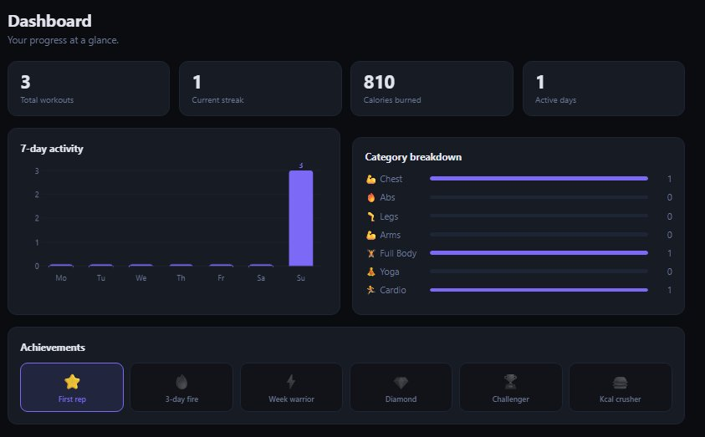
Figure 5.3 – Dashboard Module showing 7-day activity chart, category breakdown, and achievements
Earned badges are highlighted; unearned badges are displayed in a muted, greyed-out state, providing clear visual feedback on what remains to be achieved.

5.4 BMI Calculator Module
The BMI Calculator module provides a standalone health measurement tool integrated into the fitness app. The module includes:
- Unit Selection: A dropdown allows the user to choose between Metric (cm / kg) and Imperial (ft / lb) units.
- Input Fields: Height and Weight fields accept numerical input in the selected unit system.
- Calculate Button: Triggers instant BMI computation using the standard formula (weight in kg / height in metres squared for metric; a unit-converted equivalent for imperial).
- Result Panel: Displays the calculated BMI value and its classification category (Underweight, Normal, Overweight, or Obese).
- BMI History Table: A persistent log showing the date, BMI value, and category for all previous calculations, stored in localStorage. A Clear button removes all historical entries.
The BMI history log allows users to track changes in their body composition over time alongside their workout progress, providing a holistic view of their fitness journey.
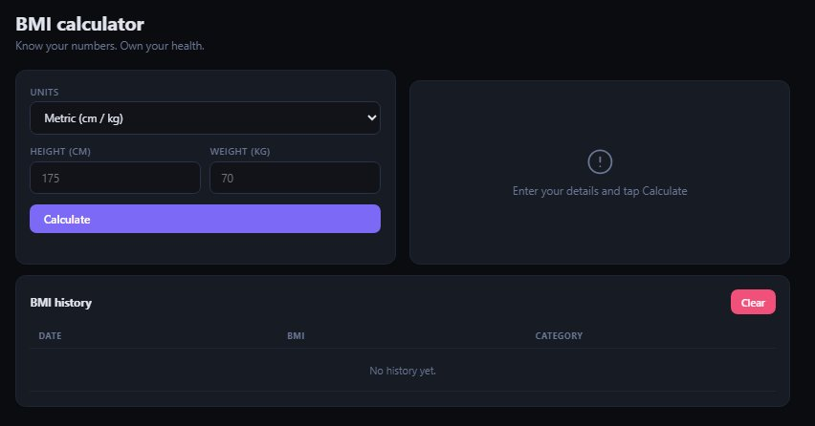
Figure 5.4 – BMI Calculator Module with metric/imperial support and history log

Chapter 6

TECHNOLOGIES USED
FitForge was developed using only native front-end web technologies. No back-end server or database is used.

6.1 HTML5
HTML5 provides the structural foundation of all four application modules. The semantic structure supports accessible navigation between Workouts, Tracker, Dashboard, and BMI Calculator sections. HTML5 drag events and input elements handle user interaction throughout the interface. The localStorage API — accessible via JavaScript — is the core persistence mechanism, storing all workout completion states and BMI history directly in the user’s browser.

6.2 CSS3
CSS3 delivers the application’s dark-themed interface with deep navy and charcoal card surfaces, purple accent colours for interactive elements and charts, and colour-coded difficulty badges. CSS Custom Properties manage the colour system consistently across all modules. CSS transitions animate card hover states, progress bar fills, and the achievement badge highlight states. Flexbox and CSS Grid handle the responsive layout of the workout card grid, the tracker checklist rows, and the dashboard metric cards.

6.3 JavaScript (ES6+, Vanilla)
All application logic is implemented in Vanilla JavaScript. Key algorithms include: a workout completion toggle that updates the done-today count and calorie total in real time; a streak calculation function that checks localStorage for consecutive active days; a BMI calculation function that handles both metric and imperial unit conversions; a chart data preparation function that aggregates daily workout counts for the 7-day activity chart; and an achievement evaluation function that checks current statistics against each badge’s unlock condition after every state change.

6.4 Chart.js
Chart.js renders the 7-day activity bar chart on the Dashboard module. The chart is initialised with daily workout count data aggregated from localStorage and updates dynamically as new workouts are completed during the session. The chart uses a purple colour palette consistent with the application’s dark design theme.

6.5 localStorage API
The browser’s localStorage API is the critical persistence mechanism that enables FitForge’s privacy-first architecture. It stores workout completion records, streak data, achievement unlock states, and BMI history as JSON-serialised objects, making them available across page reloads and browser sessions without any network request. All fitness data remains exclusively on the user’s device.

6.6 Netlify
The application is deployed as a static site on Netlify, providing HTTPS, a custom subdomain (fit-forge-v.netlify.app), and global CDN distribution with no server-side infrastructure.

# | Technology | Type | Purpose
1 | HTML5 | Markup | Structure, navigation, input handling
2 | CSS3 | Styling | Dark theme, card layout, progress bars
3 | JavaScript ES6+ | Programming | Tracking logic, streaks, BMI, achievements
4 | Chart.js | Library | 7-day activity bar chart
5 | localStorage API | Browser API | Client-side state and history persistence
6 | Netlify | Platform | Static hosting and CDN deployment

Chapter 7

CONCLUSION
FitForge successfully delivers a comprehensive fitness management experience in a lightweight, browser-based application that requires no account, no subscription, and no installation. By combining a structured workout library, daily tracking, analytics visualisation, achievement gamification, and a BMI calculator in a single cohesive interface, FitForge addresses the real needs of casual exercisers and home gym enthusiasts who want more than a notebook but less than a full enterprise fitness platform.
The technical architecture reflects a principled design philosophy: all processing is client-side, all data remains private in localStorage, and the tool is accessible to anyone with a modern browser. Implementing streak logic, achievement evaluation, BMI unit conversion, and dynamic chart rendering in Vanilla JavaScript demonstrated the expressive power of the core web platform without the overhead of a JavaScript framework.
The achievement badge system — with milestones like First Rep, 3-Day Fire, and Kcal Crusher — is particularly noteworthy as it introduces behavioural psychology principles (reinforcement, goal-setting, reward) into a fitness tracking context, distinguishing FitForge from simple workout logs and making it genuinely motivating to use over time.
The BMI Calculator module extends the application’s utility beyond workout logging into broader health awareness, and its persistent history log allows users to observe changes in their body composition alongside their fitness progress — a feature rarely found in free, client-side-only tools.
In conclusion, FitForge is a focused, well-designed, and publicly deployed fitness tracking application that fully achieves its stated objectives and demonstrates a clear understanding of both front-end development techniques and the real-world wellness problem it was built to solve.

Live Project: https://fit-forge-v.netlify.app/

