A PROJECT REPORT ON
SmartCompare AI
Product Comparison Platform

Submitted in partial fulfilment of the requirements
for the award of the degree of Bachelor of Computer Applications (BCA)
Submitted by
SYED ARAFATH
Roll No: 24BCA172

DEPARTMENT OF COMPUTER APPLICATIONS
Academic Year 2026

Certificate
This is to certify that the project report titled “SmartCompare AI – Product Comparison Platform” has been carried out and submitted by Syed Arafath, Roll No. 24BCA172, in partial fulfilment of the requirements for the award of the degree of Bachelor of Computer Applications.
The project work was carried out under supervision and represents the original work of the student. It has not been submitted elsewhere for the award of any other degree or diploma.

Project Guide Head of Department
Date: ____________
External Examiner

Declaration
I, Syed Arafath, Roll No. 24BCA172, hereby declare that the project report entitled “SmartCompare AI – Product Comparison Platform” is an original work carried out by me and has not been submitted, in part or in full, for the award of any other degree or diploma of this or any other institution.
All sources of information used in this report, including reference material and tools, have been duly acknowledged.
Syed Arafath
Roll No: 24BCA172

Acknowledgement
I would like to express my sincere gratitude to my project guide and faculty members of the Department of Computer Applications for their guidance, valuable feedback, and continuous support throughout the development of this project.
I am also thankful to my institution for providing the resources and environment necessary to complete this work, and to my peers for their encouragement and useful discussions during development and testing.
Finally, I extend my heartfelt thanks to my family for their constant support and motivation throughout the course of this project.
Syed Arafath
Roll No: 24BCA172

Abstract
SmartCompare AI is a frontend-only web application that allows users to compare two products side-by-side using raw, unstructured specification text. Instead of manually reading through lengthy spec sheets from different sources, users simply paste raw text for two products and the system automatically extracts structured fields such as price, RAM, storage, battery capacity, camera resolution, display size, rating, processor, operating system, and weight.
The application converts these extracted specifications into a normalized 0–100 scoring system across six key metrics: Performance, Battery, Camera, Storage, Value, and Rating. A unique feature of the system is mode-based weighting — users can select from five comparison modes (General, Student, Gamer, Professional, Photographer), each of which re-weights the scoring formula to reflect what matters most for that type of user. A gamer profile prioritizes performance and storage, while a photographer profile weighs camera quality heavily.
Results are presented through animated circular score rings, a radar chart, a grouped bar chart, and a price-versus-score bubble chart, all rendered using Chart.js. The system also generates AI-style textual analysis covering strengths, weaknesses, and best-use scenarios for each product based on threshold rules applied to the parsed specifications.
The platform supports exporting the full comparison — including charts — as a styled PDF report using jsPDF and html2canvas, and persists comparison history locally in the browser using localStorage so that users can revisit past comparisons without needing an account or backend server.
Built entirely with HTML, CSS, and vanilla JavaScript with no backend dependency, SmartCompare AI demonstrates how thoughtful client-side engineering — regex-based text parsing, weighted decision scoring, and dynamic data visualization — can deliver a genuinely useful decision-support tool without any server infrastructure.

Table of Contents
Certificate 2
Declaration 3
Acknowledgement 4
Abstract 5
Table of Contents 6
Chapter 1 – Introduction 7
Chapter 2 – Objectives of the Project 9
Chapter 3 – Existing System 10
Chapter 4 – Proposed System 11
Chapter 5 – Modules and Features 12
Chapter 6 – Technologies Used 17
Chapter 7 – Conclusion 19

Chapter 1 – Introduction
Choosing between two competing products — two laptops, two smartphones, two pieces of hardware — typically means juggling multiple spec sheets, each written in a different format and using different terminology. Buyers either build their own comparison spreadsheets manually or rely on third-party comparison websites that may carry advertising bias or lack the specific products being considered.
SmartCompare AI was built to solve this problem directly in the browser. The user is not asked to fill out a structured form for every spec — instead, they paste raw specification text exactly as copied from a retailer page, a manufacturer brochure, or any written source, and the system parses it automatically into a clean, structured product object.

1.1 Background
Most product comparison tools available online fall into one of two categories: large e-commerce comparison engines that only support products already in their own catalogue, or static spec-sheet tables that require manual data entry for every field. Neither approach handles the common real-world case of a user holding two pieces of raw text — copied from two different web pages — and wanting an instant, objective comparison.

1.2 Problem Statement
There is no lightweight, browser-only tool that can take arbitrary raw product specification text for two items, automatically extract comparable fields, score them according to a chosen use-case (student, gamer, professional, photographer, or general user), visualize the comparison, and export a shareable report — all without sending any data to a server.

1.3 Scope of the Project
The current scope covers two-product comparison only, with parsing tuned primarily for consumer electronics (smartphones, laptops, tablets). The system covers parsing, scoring, visualization, AI-style textual recommendations, PDF export, and local history — all executed entirely client-side with no backend or database.

Chapter 2 – Objectives of the Project
The project was guided by the following objectives:
- To design a text parser capable of automatically extracting structured product specification fields (name, price, RAM, storage, battery, camera, display, rating, processor, OS, weight) from unstructured, freely pasted text.
- To normalize extracted values into a standard schema so that two products from entirely different text formats can be compared on equal terms.
- To build a weighted scoring engine that converts raw specifications into comparable 0–100 scores across six metrics: Performance, Battery, Camera, Storage, Value, and Rating.
- To implement five distinct comparison modes (General, Student, Gamer, Professional, Photographer), each adjusting the scoring weights to reflect a different real-world priority.
- To visualize comparison results using radar charts, bar charts, and a price-versus-score chart for fast, intuitive interpretation.
- To generate AI-style natural language output describing each product's strengths, weaknesses, and best-fit use cases.
- To allow users to export the full comparison, including chart images, as a downloadable PDF report.
- To persist comparison history locally using the browser's localStorage, enabling users to revisit past comparisons without a backend.
- To deliver all of the above through a clean, responsive, minimal user interface that performs equally well on desktop, tablet, and mobile.

Chapter 3 – Existing System
Before building SmartCompare AI, the common alternatives available to a user wanting to compare two products were studied. They generally fall into the following categories:

3.1 Manufacturer and Retailer Comparison Tools
Most e-commerce sites and manufacturer websites provide a “compare” feature, but it only works for products already listed in their own catalogue. A user cannot compare a product from one retailer against a product from a different brand's website using these tools.

3.2 Manual Spreadsheet Comparison
Many buyers resort to manually creating a spreadsheet, copying specification values from multiple product pages by hand. This is time-consuming, error-prone, and offers no scoring, visualization, or recommendation support.

3.3 General Review and Comparison Websites
Some third-party websites offer side-by-side spec comparisons, but these are limited to a fixed, curated product database, often updated infrequently, and may be influenced by sponsorships or affiliate relationships.

3.4 Limitations of Existing Systems
- Cannot process arbitrary user-pasted text; products must already exist in a backend database.
- No support for adjusting comparison priorities based on intended use case (student vs gamer vs professional).
- Typically require an internet-connected backend or server-side database, raising privacy and dependency concerns.
- Little to no support for exporting a personalized report for offline reference.
- No transparent, adjustable scoring logic — rankings are often presented as fixed verdicts.

Chapter 4 – Proposed System
SmartCompare AI addresses the limitations of existing tools by allowing any two products to be compared from raw, freely pasted specification text, with no dependency on a backend database or server. The system performs parsing, normalization, scoring, visualization, and reporting entirely within the browser.

4.1 Key Improvements Over Existing Systems
- Works with any product, not just items pre-listed in a catalogue — the user simply pastes spec text from any source.
- Mode-based weighting lets the same two products score differently for a student versus a gamer versus a photographer, reflecting real decision-making priorities.
- Runs entirely client-side: no signup, no server, no data leaving the user's browser.
- Visual, chart-driven presentation (radar, bar, bubble) rather than a plain text table.
- One-click PDF export for offline sharing or record-keeping.
- Local comparison history so previous sessions can be revisited instantly.

4.2 System Architecture Overview
The application follows a simple, modular client-side architecture. Each concern — parsing, scoring, charting, recommendation text, and PDF export — is isolated into its own JavaScript module, coordinated by a central controller script. There is no server tier; all logic executes in the user's browser.
- Presentation Layer — index.html (landing page) and compare.html (dashboard), styled with a single CSS file.
- Parsing Layer — parser.js converts raw pasted text into a normalized product object using pattern-based extraction.
- Scoring Layer — compare.js normalizes each spec field to a 0–100 scale and applies mode-specific weights to compute a final score.
- Visualization Layer — charts.js renders radar, bar, and bubble charts via Chart.js.
- Recommendation Layer — recommendation.js generates strengths, weaknesses, and use-case text using rule-based thresholds.
- Export Layer — pdf.js captures the rendered charts and tables and compiles them into a downloadable PDF using jsPDF and html2canvas.
- Persistence Layer — browser localStorage stores up to the last 20 comparisons for later retrieval.

4.3 Deployment
The application is deployed as a static site and is publicly accessible at the following live link:
https://smart-compare-ai.netlify.app/
Being a static frontend-only application, it is hosted on Netlify with continuous deployment from the project source, requiring no server provisioning, database, or backend maintenance.

Chapter 5 – Modules and Features
The application is organized into five functional modules, each described below along with the corresponding screenshot from the live deployment.

5.1 Landing Page Module
The landing page introduces the application with a minimal hero section, a short description of its purpose, and quick-glance mode chips (Student, Gamer, Professional, Photographer, General). A live-style preview card on the right gives the user an immediate sense of what the comparison dashboard will look like before they click through. A single “Start Comparing” call-to-action leads into the main dashboard.
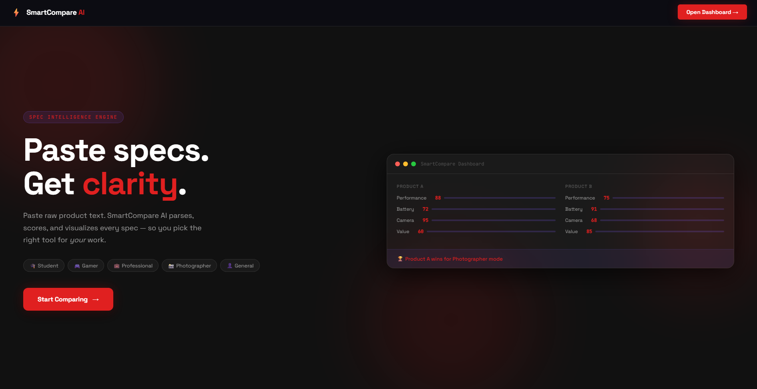
Figure 5.1 – Landing page of SmartCompare AI

5.2 Spec Input and Parsing Module
The dashboard presents two side-by-side input panels, Product A and Product B, each with a text area for pasting raw specification text and a “Parse Specs” button. The mode bar at the top lets the user pick one of five comparison modes (General, Student, Gamer, Professional, Photographer) before or after parsing. Once both products are parsed, the “Compare Products” button becomes active.
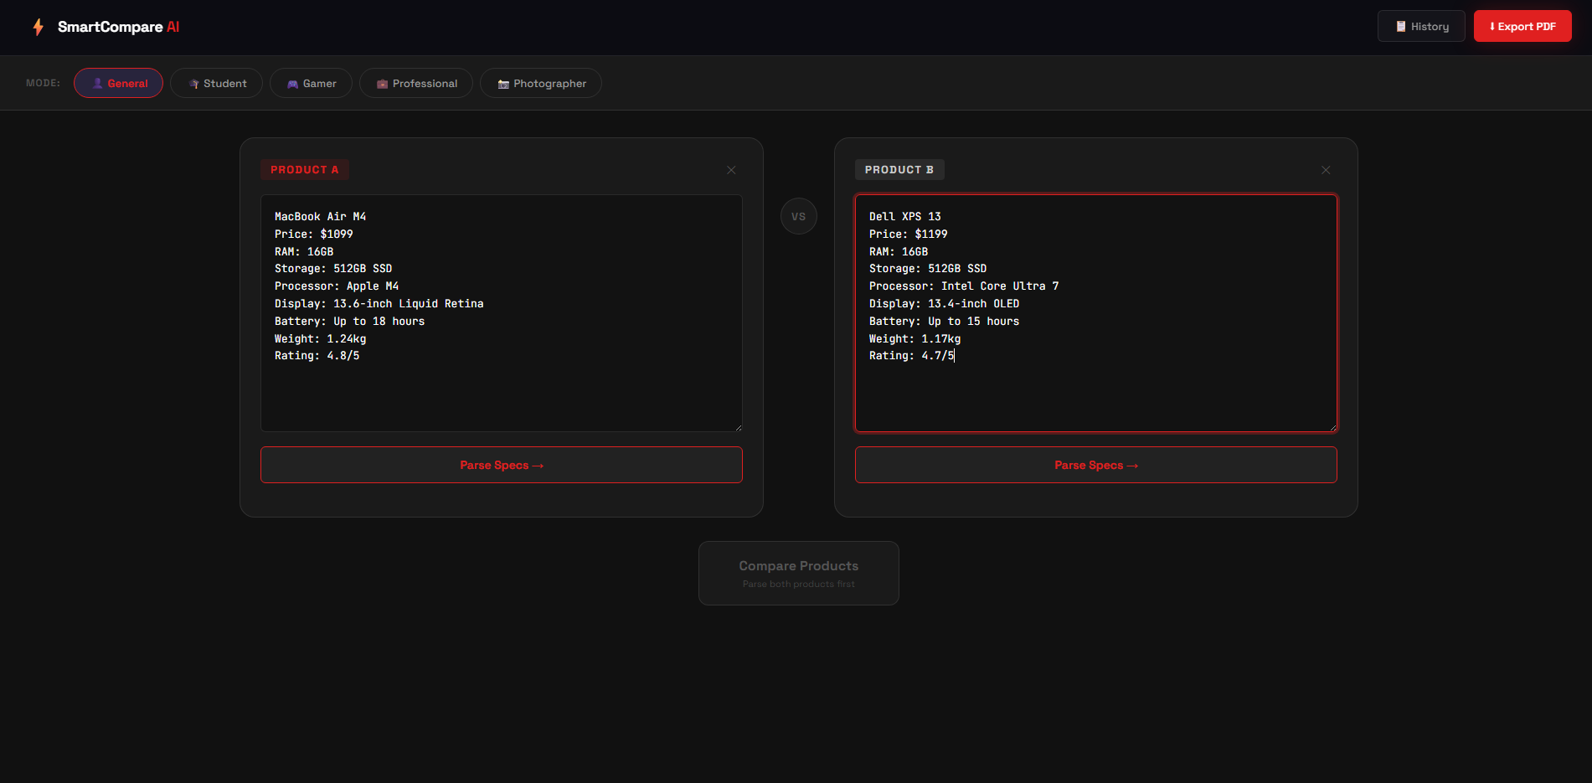
Figure 5.2 – Raw spec input panels for Product A and Product B
Internally, parser.js applies a sequence of regular expressions tuned to common spec-sheet phrasing (e.g. “RAM: 8GB”, “256GB SSD”, “4500 mAh”, “50MP main”) to extract each field, falling back to a generic key-value line sweep for anything not explicitly recognized.

5.3 Scoring and Visualization Module
Once both products are parsed and compared, the dashboard displays an animated score ring for each product, a metric-by-metric breakdown (Performance, Battery, Camera, Storage, Value, Rating), and three charts: a radar chart for overall shape comparison, a grouped bar chart for metric-by-metric values, and a price-versus-score bubble chart to visualize value for money.
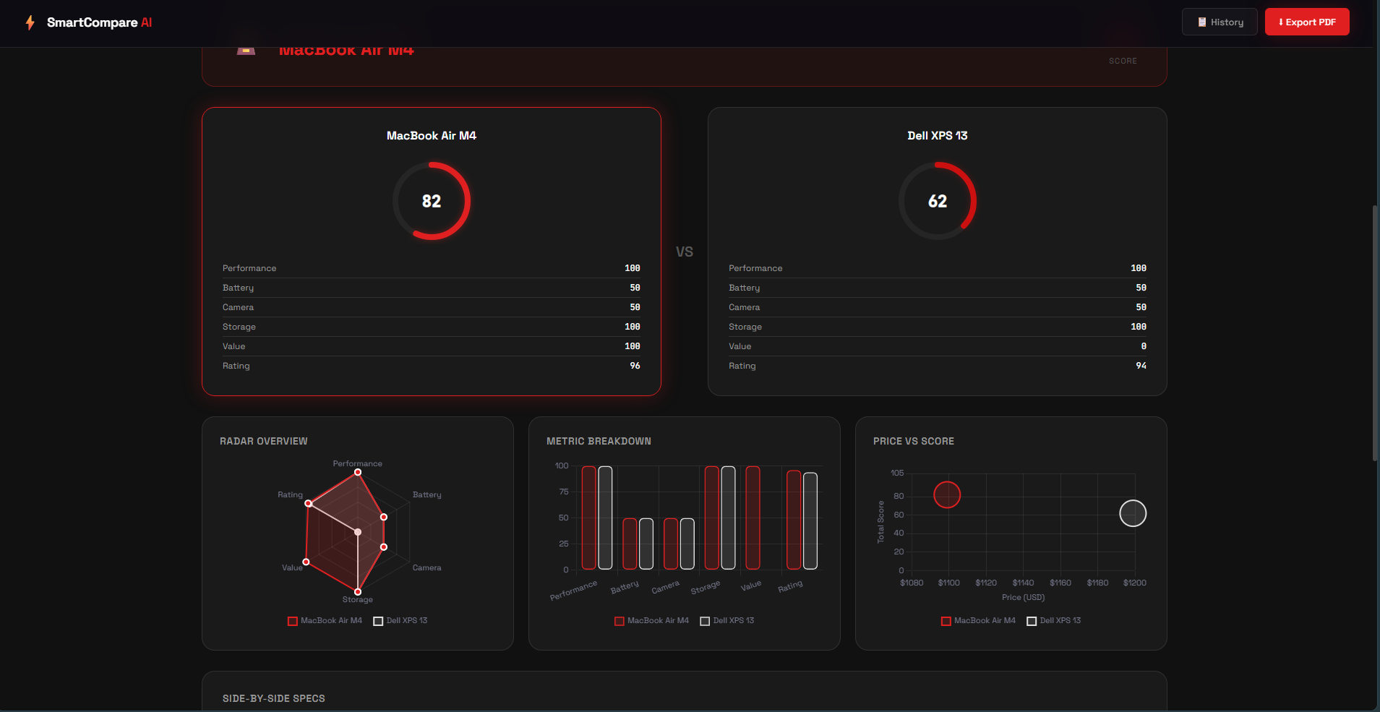
Figure 5.3 – Score rings, breakdown, and chart visualizations
Each product's total score is computed by normalizing its raw specification values to a 0–100 scale per metric, then combining those six metric scores using the weight profile of the currently selected mode.

5.4 AI-Style Recommendation Module
Below the charts, the AI Analysis section presents a structured breakdown per product: a list of strengths, a list of weaknesses, and a list of best-fit use-case scenarios. This text is generated using threshold-based rules applied to the parsed specification values rather than a hosted language model, keeping the entire experience client-side.
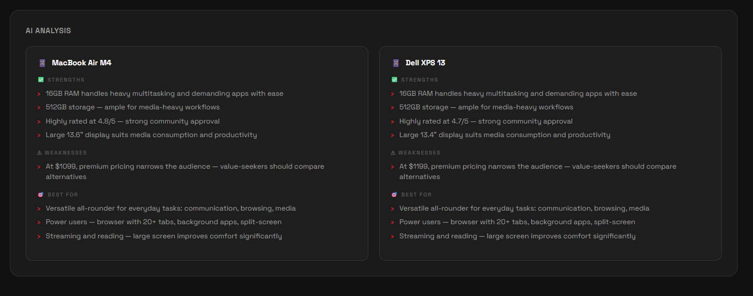
Figure 5.4 – AI-style strengths, weaknesses, and best-use analysis

5.5 PDF Export and History Module
The “Export PDF” button in the navigation bar compiles the current comparison — product specs, computed scores, and a snapshot of the rendered charts — into a styled, downloadable PDF report using jsPDF for layout and html2canvas for capturing the chart canvases as images.
The “History” button opens a modal listing past comparisons saved in the browser's localStorage (up to the most recent 20). Selecting an entry restores both product specs and the mode used, and immediately re-runs the comparison.

Chapter 6 – Technologies Used
SmartCompare AI is intentionally built without any backend server, database, or frontend framework. Every technology listed below runs directly in the user's browser, keeping the application lightweight, fast to load, and free of server infrastructure costs.

Technology | Purpose in the Project
HTML5 | Page structure for the landing page and the comparison dashboard.
CSS3 | Custom design system (dark theme, layout grid, responsive breakpoints, animated score rings) — no CSS framework used.
JavaScript (ES6+) | All application logic: parsing, scoring, DOM rendering, event handling, localStorage access — written without any frontend framework.
Chart.js | Renders the radar chart, grouped bar chart, and price-vs-score bubble chart.
jsPDF | Generates the downloadable PDF report layout, including styled tables and headers.
html2canvas | Captures the rendered chart canvases as images for embedding into the PDF export.
Browser localStorage | Client-side persistence of comparison history (up to 20 most recent entries) with no backend database.
Netlify | Static site hosting and continuous deployment for the live application.

6.1 Why No Framework?
Given the relatively contained scope — two input panels, a scoring engine, and a results dashboard — plain JavaScript with clearly separated modules (parser.js, compare.js, charts.js, recommendation.js, pdf.js) was sufficient to keep the codebase organized without the build-tooling overhead of a framework like React or Vue.

6.2 Why No Backend?
Because all comparison logic operates purely on text the user provides in the moment, there was no need for persistent server-side storage. Using the browser's localStorage for history keeps the application privacy-friendly — no spec data is ever transmitted off the user's device — and removes any server hosting cost beyond static file delivery.

Chapter 7 – Conclusion
SmartCompare AI demonstrates that a meaningful, decision-support web application can be built entirely on the client side, without a backend server or database. By combining pattern-based text parsing, a transparent weighted scoring model, and clear data visualization, the project turns raw, unstructured product specification text into an instant, mode-aware comparison.
The five comparison modes — General, Student, Gamer, Professional, and Photographer — show how the same underlying data can yield different, contextually relevant recommendations depending on what the end user actually values, which is something static comparison tables cannot offer.
The project also reinforced practical engineering lessons: the importance of designing a robust regex-based parser that gracefully falls back when expected patterns are not present, the value of separating concerns into independent JavaScript modules, and the considerations involved in generating a polished PDF report purely from in-browser HTML and canvas content.

7.1 Limitations
- Parsing accuracy depends on how closely the pasted text follows common labeling conventions (e.g. “RAM: 8GB”); unlabeled or highly irregular text may parse incompletely.
- The system currently supports comparing exactly two products at a time.
- Recommendation text is rule-based rather than generated by a trained language model, so it reflects fixed thresholds rather than deeper contextual reasoning.

7.2 Future Enhancements
- Support for comparing three or more products simultaneously.
- Auto-suggested scoring weights based on detected product category (e.g. laptop vs smartphone vs camera).
- Additional export templates and theming options for the PDF report.
- Expanded accessibility support, including full keyboard navigation and screen-reader friendly chart summaries.
- Optional integration with a language model for richer, more context-aware recommendation text.
Overall, the project successfully meets its stated objectives and delivers a functional, polished, and genuinely useful tool for comparing products quickly and intelligently, accessible at https://smart-compare-ai.netlify.app/.

