## 1. Introduction

In the modern era of smart cities, ensuring road safety and enforcing traffic rules efficiently has become a pressing concern. Traditional traffic management approaches depend heavily on manual monitoring and, where automated solutions exist, often require costly infrastructure that limits scalability. To address these challenges, we present a **Smart AI-Powered e-Challan Management System** that is both affordable and operationally effective. Unlike conventional setups, it does not demand expensive hardware installations and instead works seamlessly with **decent-quality traffic camera footage**, enabling rapid and low-cost deployment across diverse environments.

The system processes traffic violation data generated by ML-powered cameras, validates it against the RTO database, and automatically generates e-challans. It integrates a fraud detection module to flag mismatches in vehicle details, a wallet service for automatic fine deduction, and an email notification system to inform owners of pending or settled challans. Payments are facilitated securely through **Razorpay links**, ensuring convenience and transparency. For AI and ML, the solution is built on **Python**, employing advanced libraries such as **OpenCV, PyTorch, Supervision, Ultralytics, and YOLO** for vehicle detection, license plate recognition, and violation tracking. Higher-level reasoning leverages the **Gemini Advanced model (Gemini 2.5 Pro)**, ensuring accuracy and adaptability in real-world traffic conditions.

The architecture is modular and scalable, with a **Spring Boot (Java) backend** managing business logic, a **ReactJS frontend** providing a responsive user interface, and a data layer optimized for workload distribution—**MongoDB** for unstructured violation data and **PostgreSQL** for structured challan and owner records. This combination bridges **AI-driven traffic monitoring** with **real-time digital challan management**, delivering fairness, transparency, and efficiency while making adoption practical and financially viable for governments.

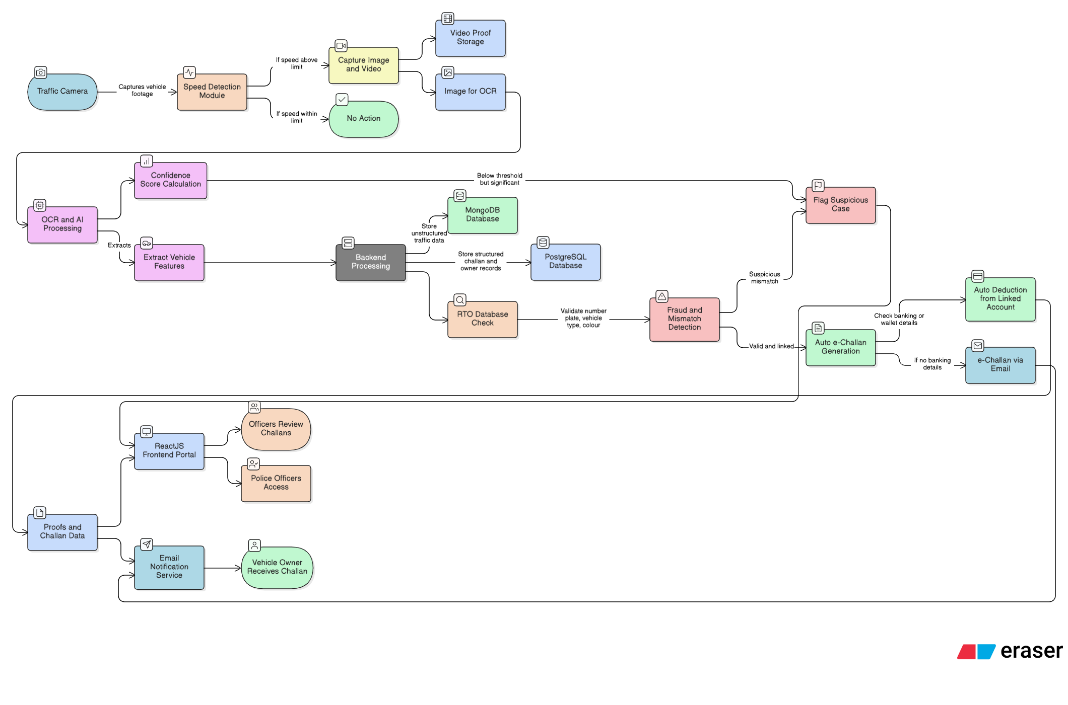

Fig No. 1 **Smart AI-Powered e-Challan Management System** Architecture

## 2. Objective of Project

The primary objective of this project is to develop a cost-effective, AI-powered e-Challan Management System that ensures fairness, transparency, and efficiency in traffic rule enforcement while minimizing reliance on expensive infrastructure.

1. **Automated Violation Detection & Challan Generation:**  
   To leverage AI and ML models for detecting traffic violations in real time using camera footage, automatically capturing proof, and generating digital challans without manual intervention.
2. **Accurate Vehicle Verification with RTO Integration:**  
   To cross-check number plates, vehicle type, and color with the official RTO database, ensuring accuracy, legitimacy, and prevention of errors in challan issuance.
3. **Fraud Detection & Case Management:**  
   To identify suspicious cases such as plate mismatches or low-confidence AI predictions and flag them for human review through a dedicated police officer portal.
4. **Automated and Flexible Payment Solutions:**  
   To provide seamless wallet-based auto-deductions where linked banking details exist, while offering secure and transparent online payment options (via Razorpay) for all users.
5. **Citizen Notification & Transparency:**  
   To ensure that vehicle owners are instantly notified of challan status, proofs, and payment details through emails, promoting transparency and accountability.
6. **AI-Driven Accuracy & Adaptability:**  
   To employ advanced AI/ML models (YOLO, OpenCV, PyTorch, Gemini 2.5 Pro) for reliable detection and reasoning, ensuring robustness under varying traffic and camera conditions.
7. **Scalable & Modular System Architecture:**  
   To design a flexible architecture using Spring Boot, ReactJS, PostgreSQL, and MongoDB that can scale across cities, remain maintainable, and adapt to future smart city needs.
8. **Enhanced Governance & Fair Enforcement:**  
   To reduce human bias and inefficiencies in traffic management by providing an AI-powered, evidence-backed, and fair challan system that is economically viable for governments.

## 3. Scope of Project

The project is designed with scalability and adaptability in mind, ensuring that it can evolve beyond its initial implementation. Its scope extends across technological, geographical, and governance dimensions to maximize impact and adoption.

1. **Integration with Live ML Camera Feeds:**  
   The system can be extended to connect directly with real-time traffic camera streams, enabling instant violation detection, evidence capture, and challan generation without manual intervention.
2. **Expansion Across Cities and States:**  
   By syncing with regional RTO databases, the solution can scale seamlessly to multiple cities and states while accommodating local traffic rules and compliance frameworks.
3. **Integration with Government Portals:**  
   The platform can be linked with national and state-level government portals to support large-scale adoption, centralized data sharing, and streamlined automation.
4. **Advanced AI-Powered Fraud Detection:**  
   Future iterations can leverage anomaly detection and predictive AI models to identify fraudulent activities, cloned plates, and suspicious violation patterns with higher accuracy.
5. **Analytics and Governance Dashboards:**  
   An interactive dashboard for traffic authorities can provide actionable insights on violation hotspots, fraud trends, payment compliance rates, and traffic behaviour to aid policy-making.

## 4. Tools and Technologies Used

To ensure scalability, security, and seamless user experience, our system leverages a modern and robust technology stack. The stack covers frontend, backend, database, services, AI/ML integration, and deployment to deliver a complete end-to-end solution.

* **Frontend**
* **ReactJS** for building a modular, component-based UI.
* **JavaScript, CSS, Bootstrap** for responsive and interactive design.
* **React Router** for seamless client-side navigation.
* **Backend**
* **Java (Spring Boot framework)** for business logic and service orchestration.
* **REST APIs** for efficient communication between frontend, backend, and external services.
* **Spring Security + JWT** for secure authentication and role-based access.
* **AI/ML Models**
* **Python-based AI/ML pipeline** for traffic violation detection and license plate recognition.
* Libraries include **OpenCV, PyTorch, Supervision, Ultralytics, YOLO**, and **Gemini 2.5 Pro** for higher-level reasoning and anomaly detection.
* Threading for parallel processing and load balancing (faster computation under high workload).
* **Database**
* **PostgreSQL** for structured challan, payment, and owner records.
* **MongoDB** for unstructured data such as violation images, video proofs, and detection logs.
* **Services**
* **Razorpay API** for secure online payments and wallet-based auto-deductions.
* **JavaMailSender** for automated challan notifications via email.
* **Design & Testing**
* **Figma** for designing intuitive and user-friendly UI/UX.
* **Postman** for API development, testing, and validation.
* **Deployment**
* **Vercel** for hosting the ReactJS frontend.
* **Render** for deploying and running backend services.
* **Azure Cloud** for scalable AI/ML model hosting and traffic data processing.
  1. **Time Frame Required for Various Stages of Project Implementation**

|  |  |  |
| --- | --- | --- |
| **Sr. No.** | **Phase** | **Time Duration** |
| 1 | Software Requirement Specification | 1 week |
| 2 | System Design | 2 weeks |
| 3 | Coding and Implementation | 5 weeks |
| 4 | Deployment and Testing | 2 weeks |

**Mrs. Shyna Babbar**