VGU – 25 Days In-campus Training
Subject – Data Science
Assignment 1: 6th March, 2026
Topic – Basic Python
- Take a sentence as input and print a new string where:
• characters at even index → uppercase
• characters at odd index → lowercase
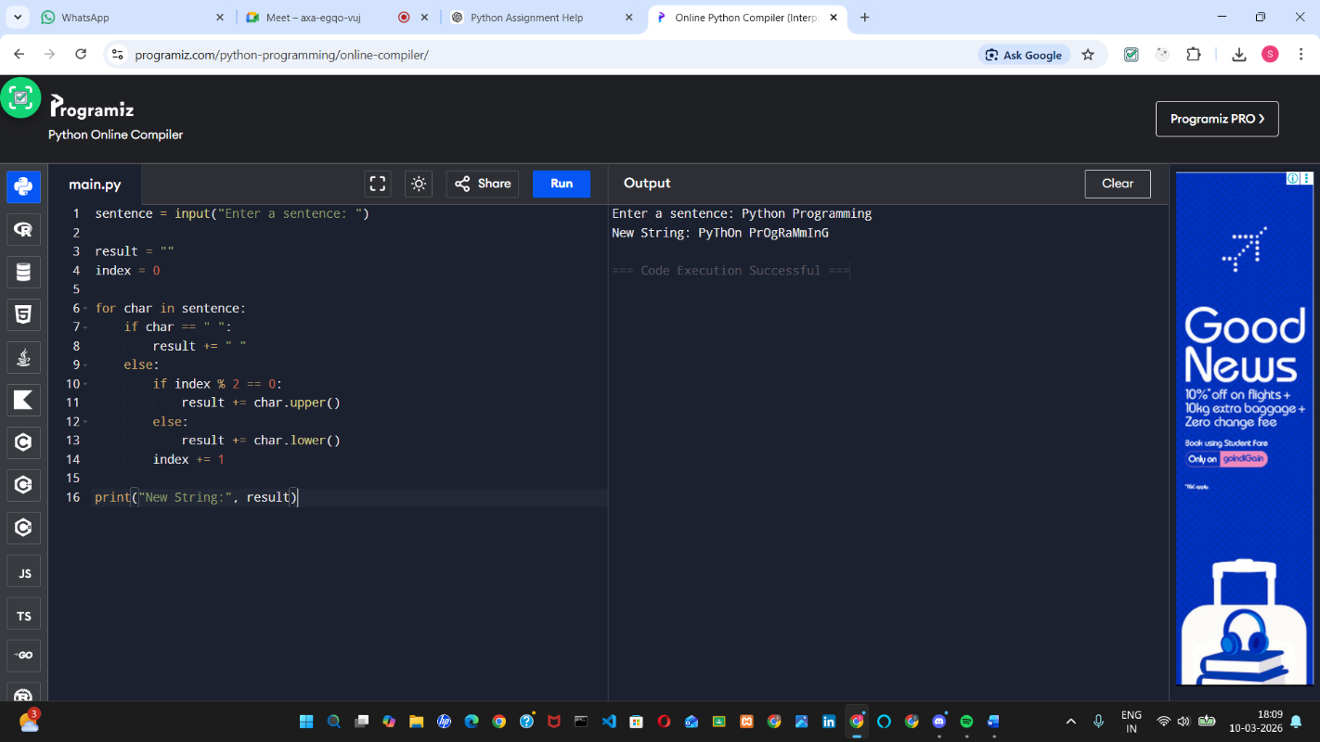
Ignore spaces while deciding the index.
Ans.

- Take a list of numbers from the user and create a new list containing only those numbers that:
• are greater than the average of the list, and
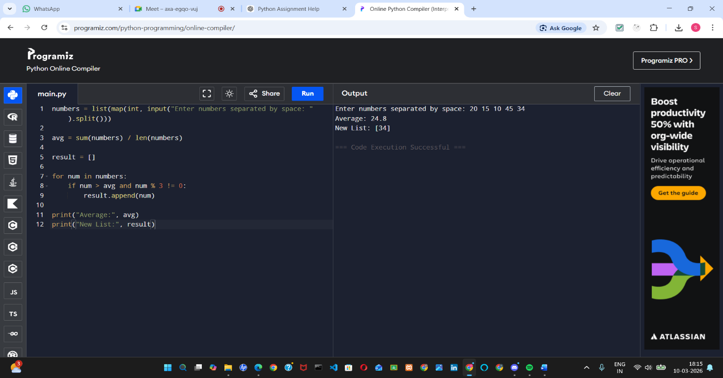
• not divisible by 3.
Ans .

- Take a sentence from the user and reverse only the words whose length is greater than 4, keeping the rest unchanged.
Example:
Input: data science is powerful
Output: atad ecneics is lufrewop
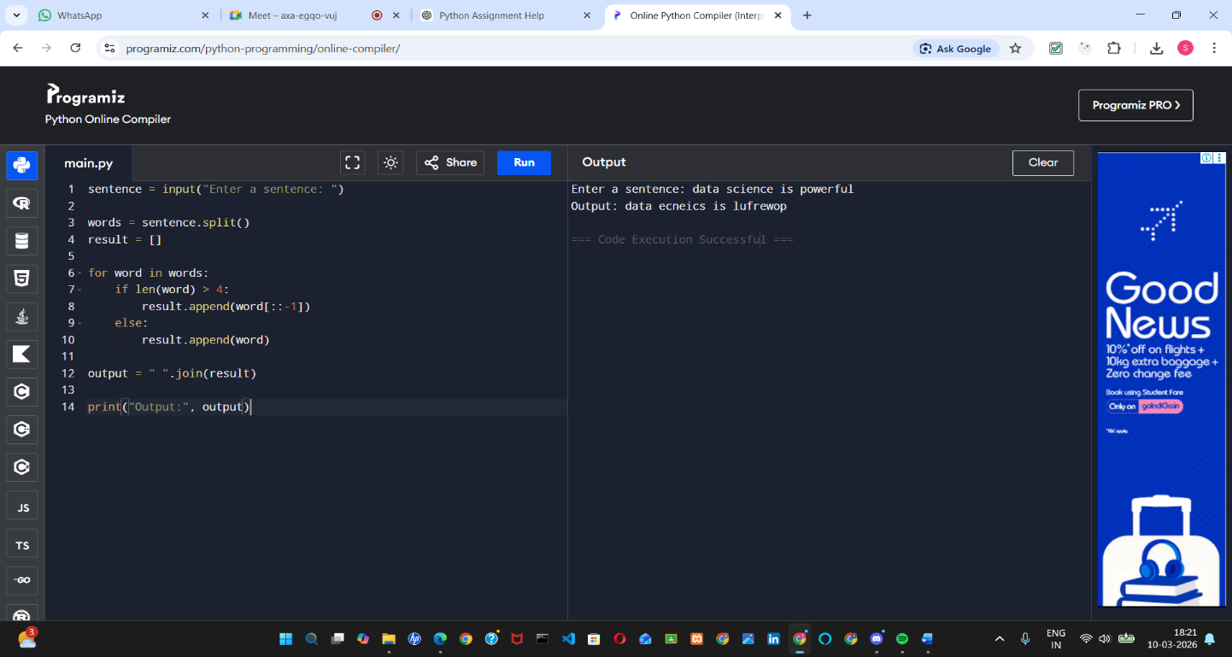
Ans.

- Create a list [1,2,3,4,5] and using loops generate a new list where:
• if the number is even → square it
• if the number is odd → cube it
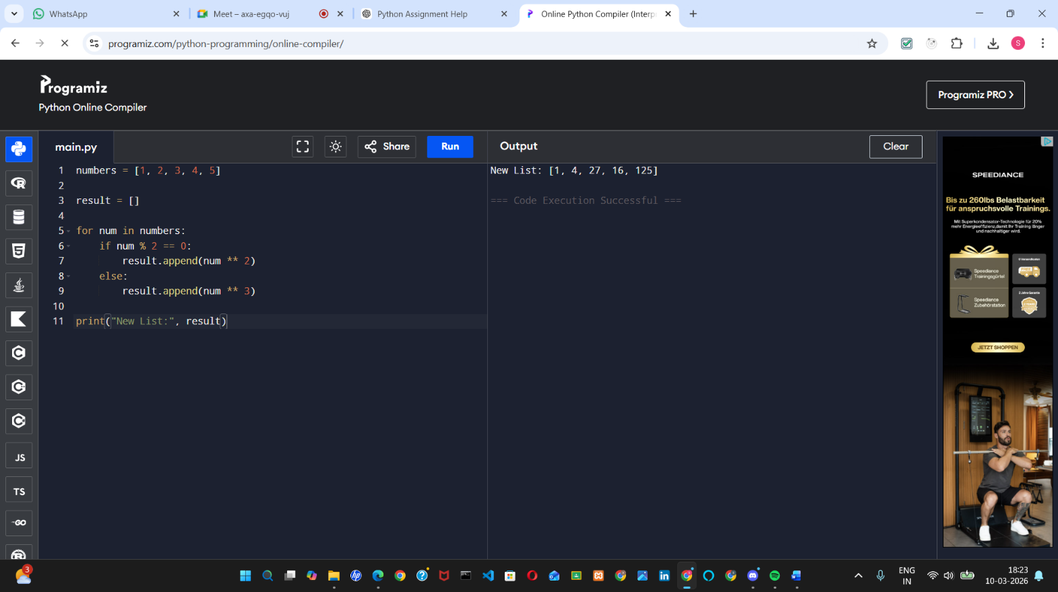
Ans.

- Take a password as input and check using conditions if it:
• has at least 8 characters
• contains at least one digit
• contains at least one uppercase letter
Print Valid Password or Invalid Password.
Ans. A. Valid Password Output
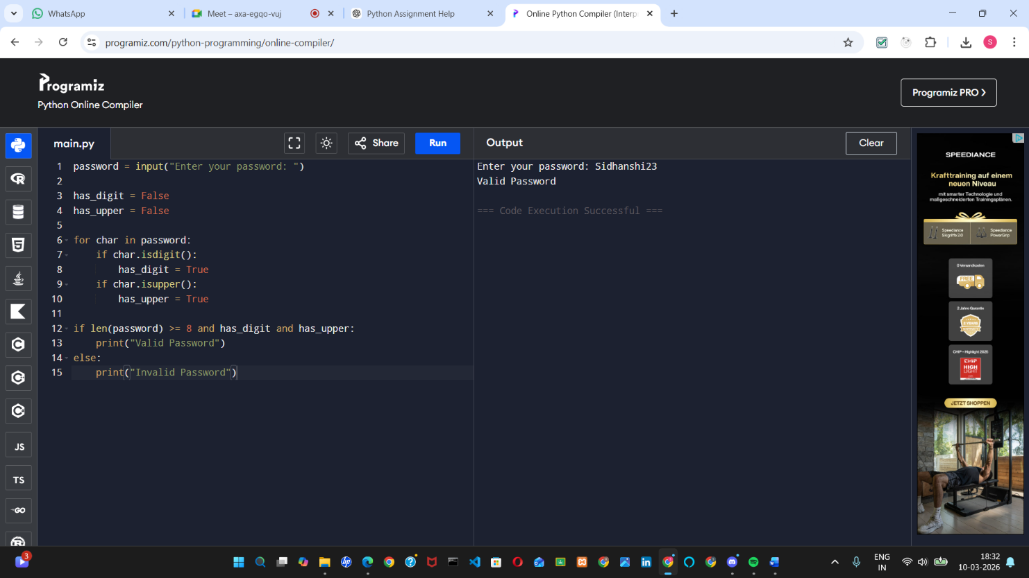

B. Invalid Password Output
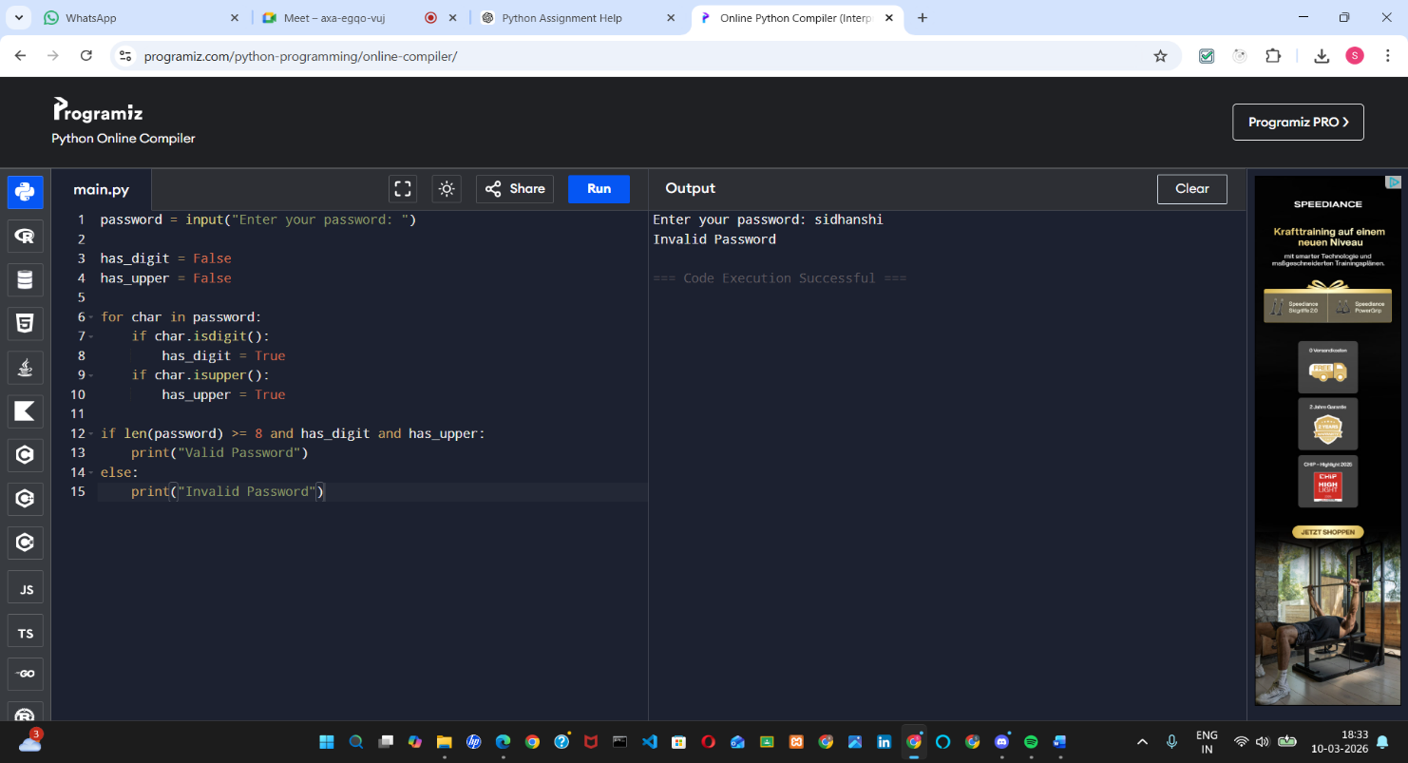

- Take a list and a number k from the user. Rotate the list to the right by k positions without using built-in rotation functions.
Example: [1,2,3,4,5], k=2 → [4,5,1,2,3]
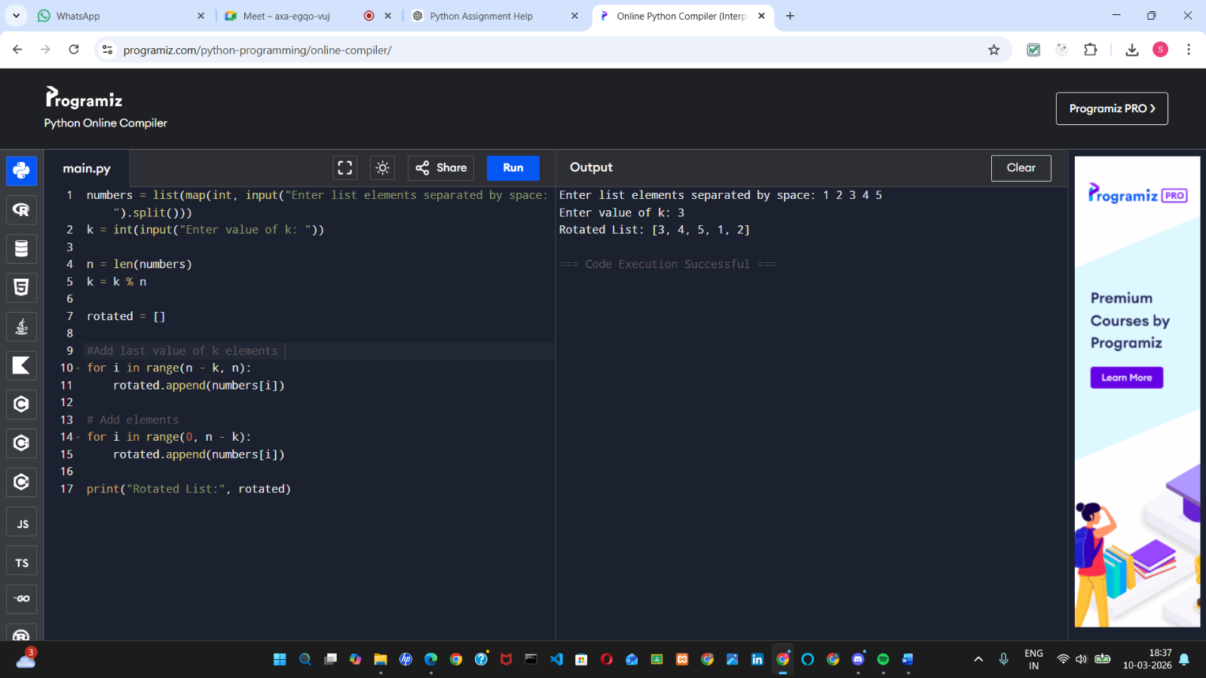
Ans.

Git_Url:

Thank you !

