

**Name : Sidhant Karbotkar**

**Roll No : 1917**

**Introduction**

Pixxel is a stock image website where you can get stock images for your website or graphic design or might be any project you working on. Stock images is existing photos –already created– made available download by paying the artist or free for personal use. Images can be stock photographs, graphic designs, vector art or illustrations. So basically In pixxel we can download stock images for free but the user has to acknowledge the creator’s right over the image by giving credit to the creator. Also you can buy the image by giving a tip to the creator using our pixxel wallet.

Creator can create his own collections to showcase his art and create a brand for himself.

**Requirements**

Front End : html, css, bootstrap

Back End : MySql Database

**Objective**

* To create a site where you can get Stock Images for free.
* The Images can be for commercial or personal user.
* Designers can get exposure by displaying their art.

**Design**

1. **ERD**

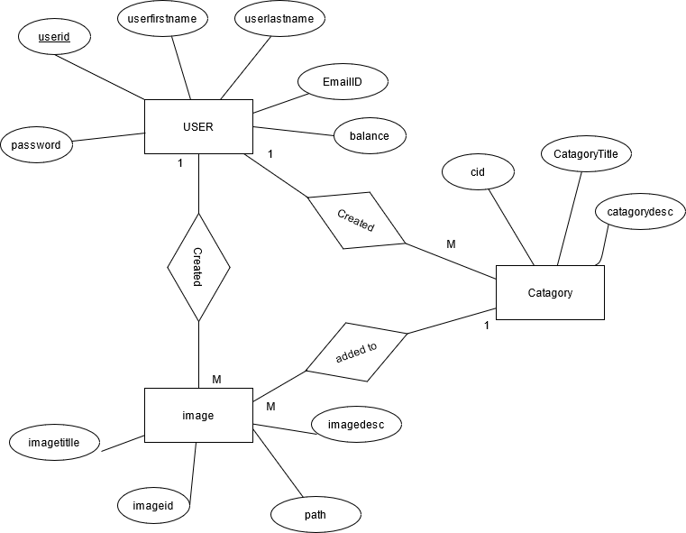

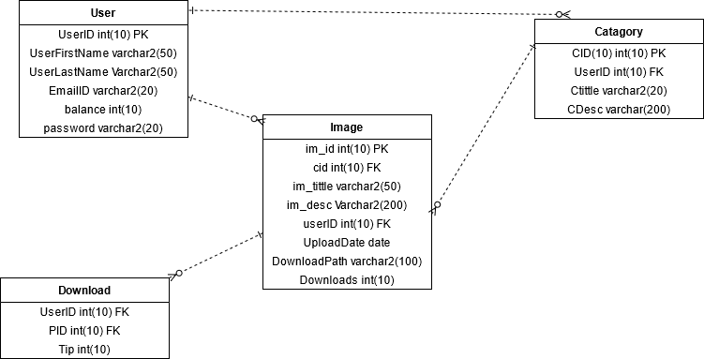

1. **Use Case Diagram**

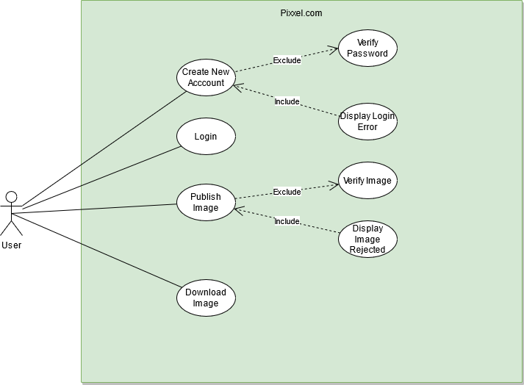

1. **Database Tables**

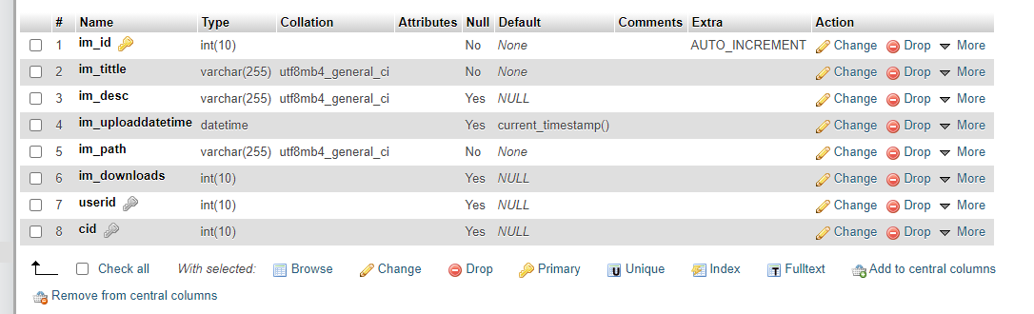

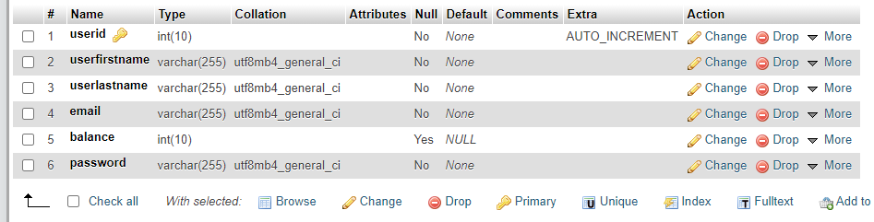

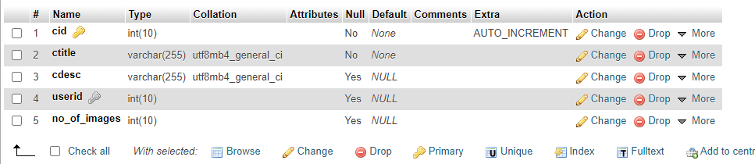

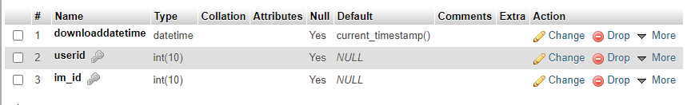

**REPORT**

**Displaying data**

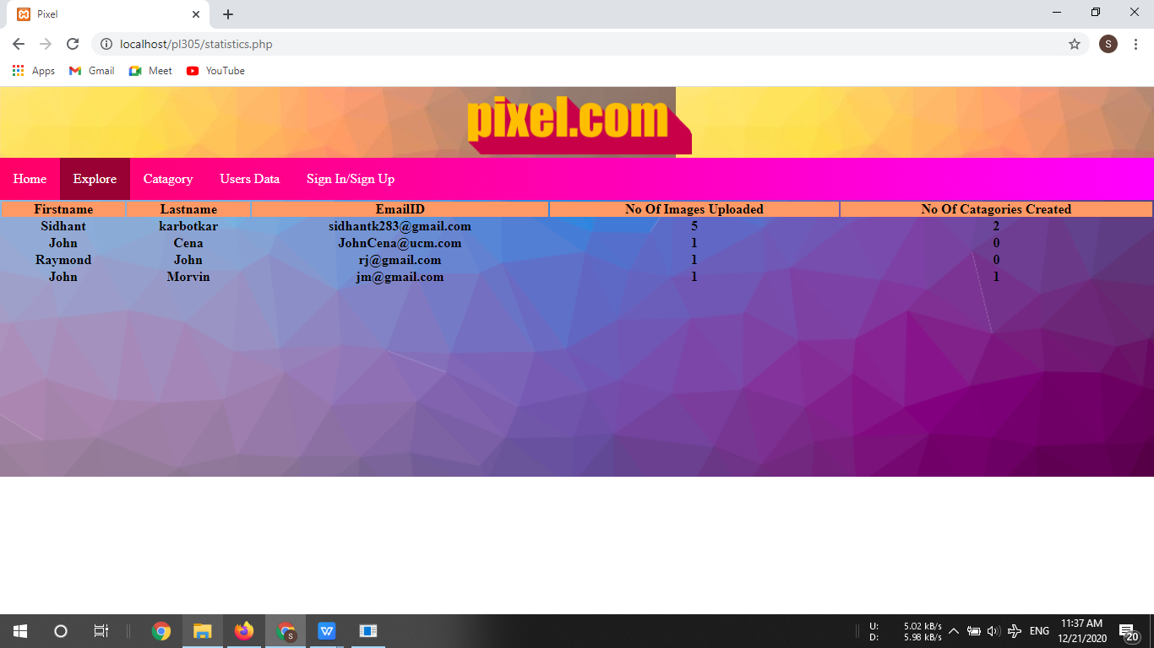

**PROFILE PAGE**

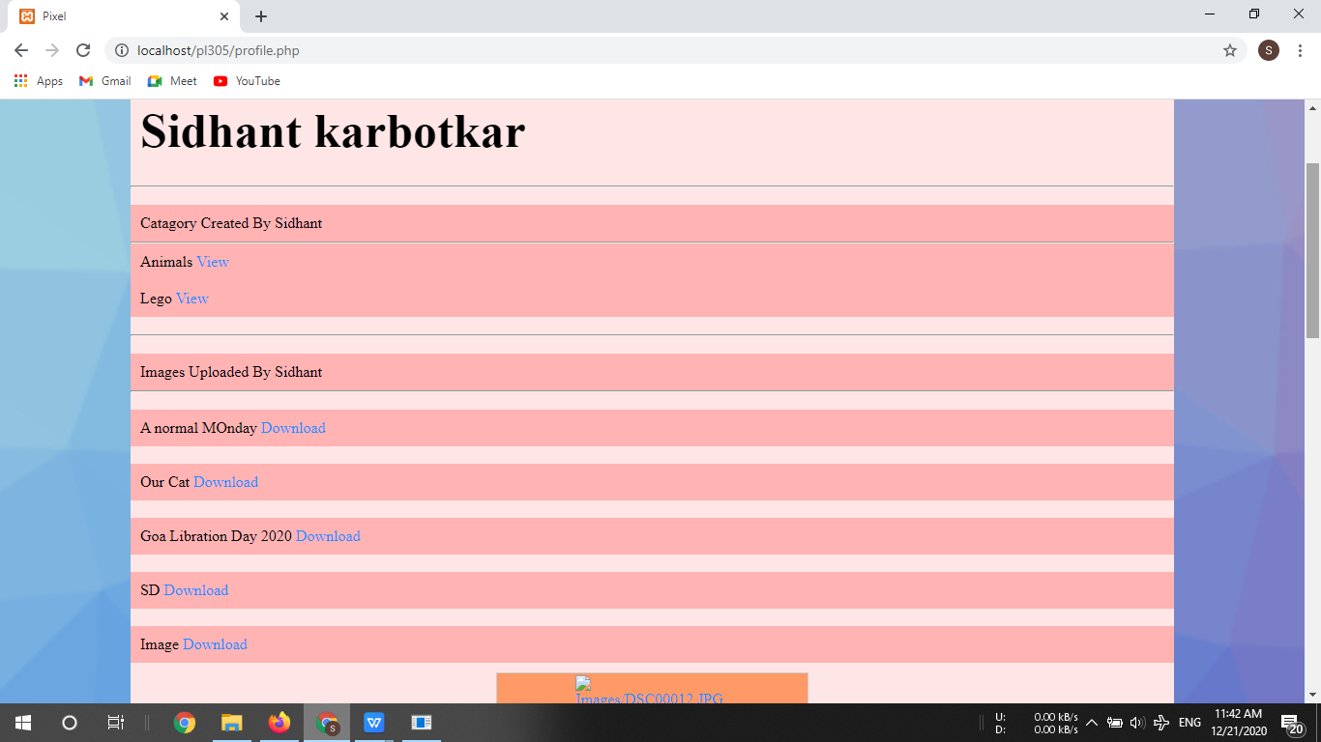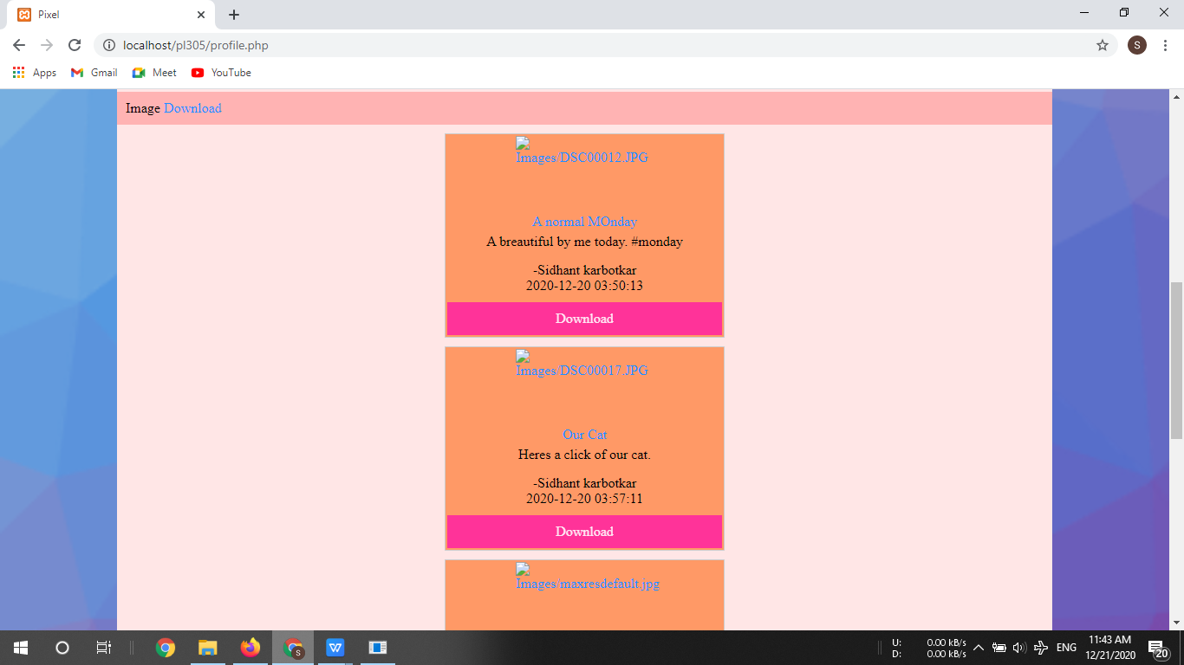

**LOGIN PAGE**

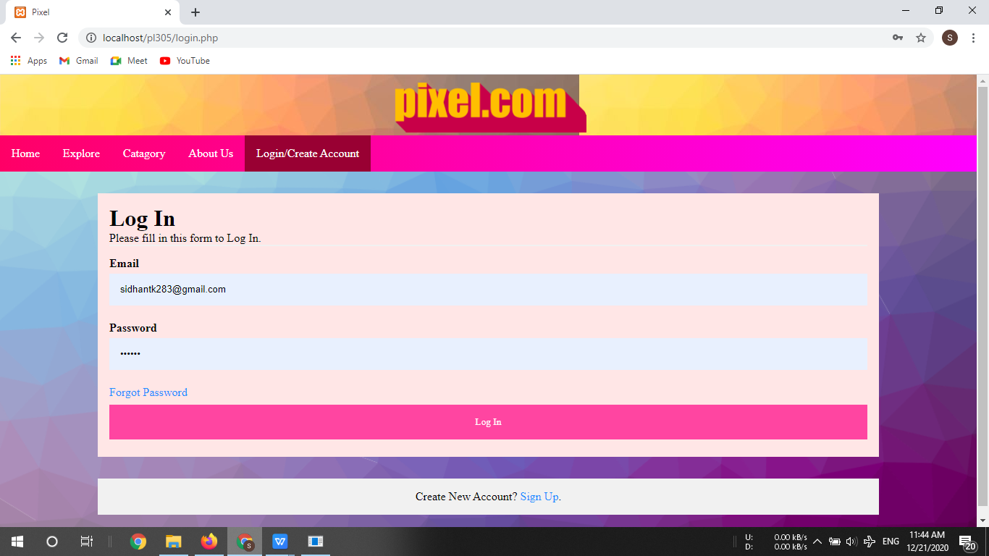

**NEW ACCOUNT PAGE**

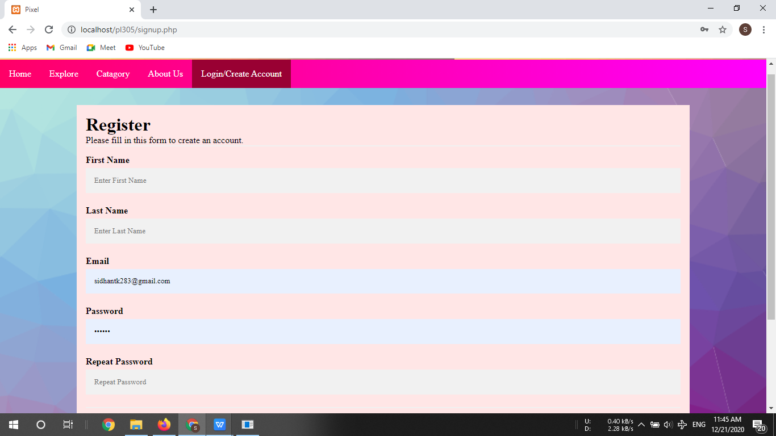

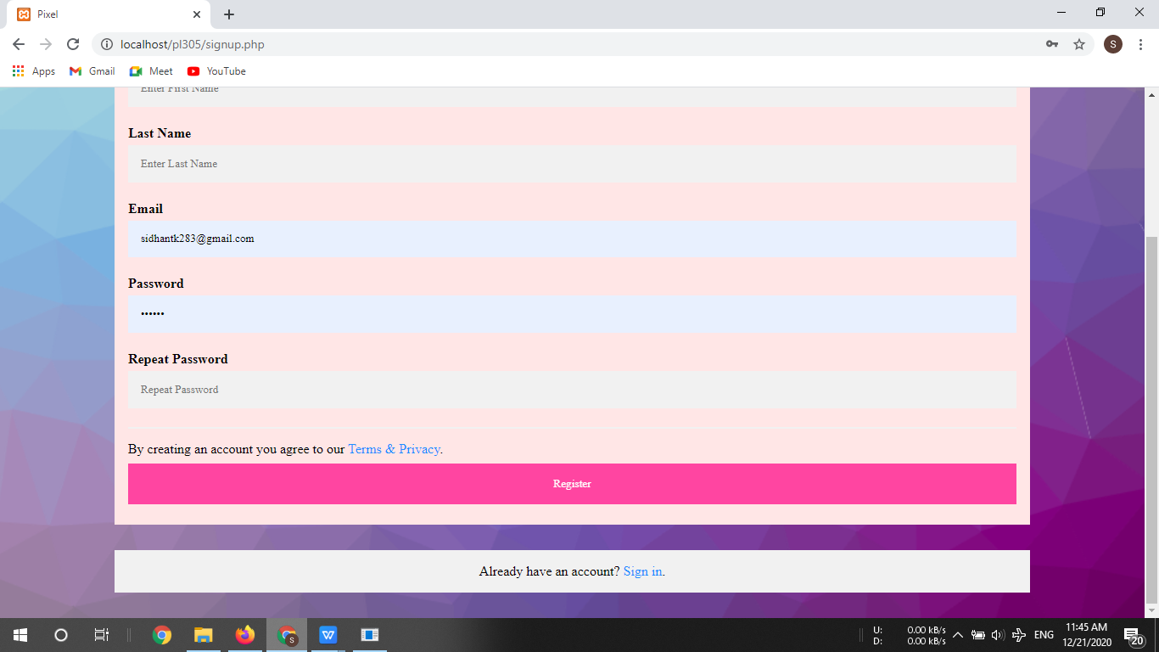

**UPLOAD IMAGE PAGE**

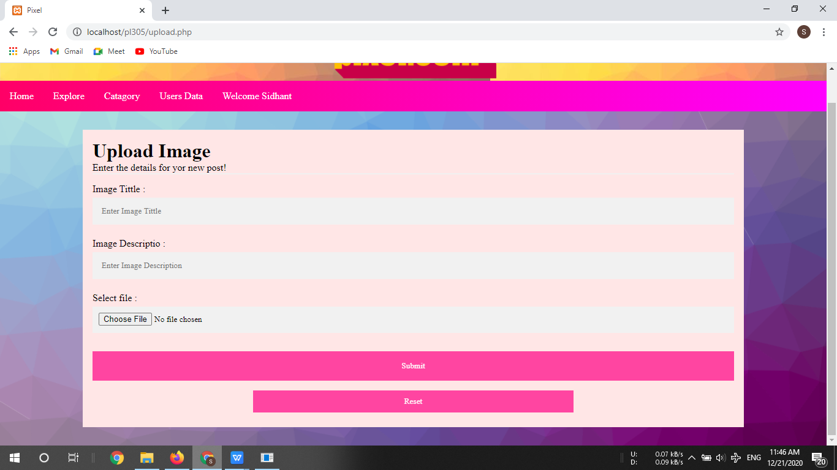

**SELECT OR CREATE NEW CATAGORY PAGE**

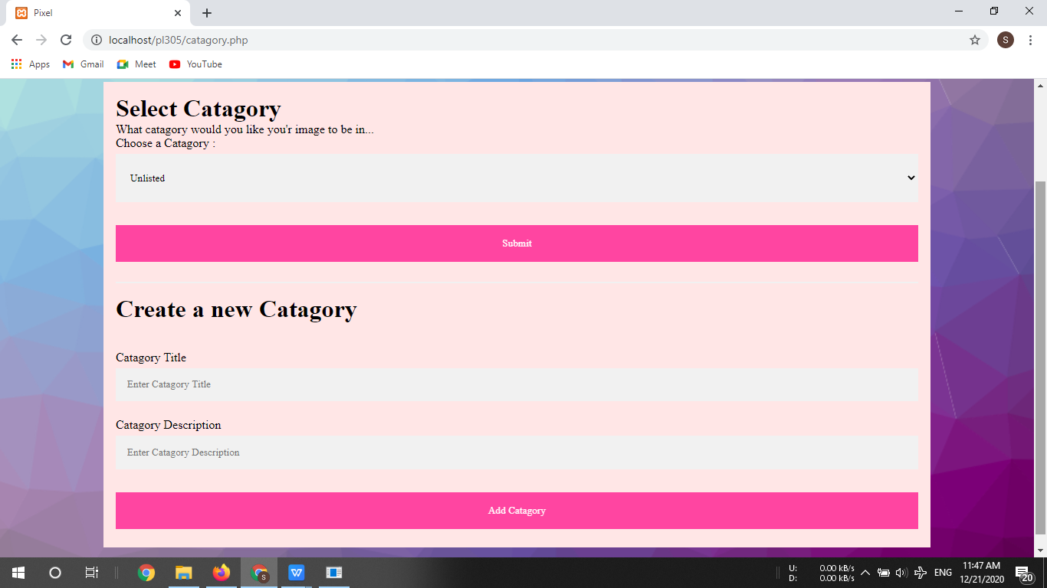

**HOMEPAGE**

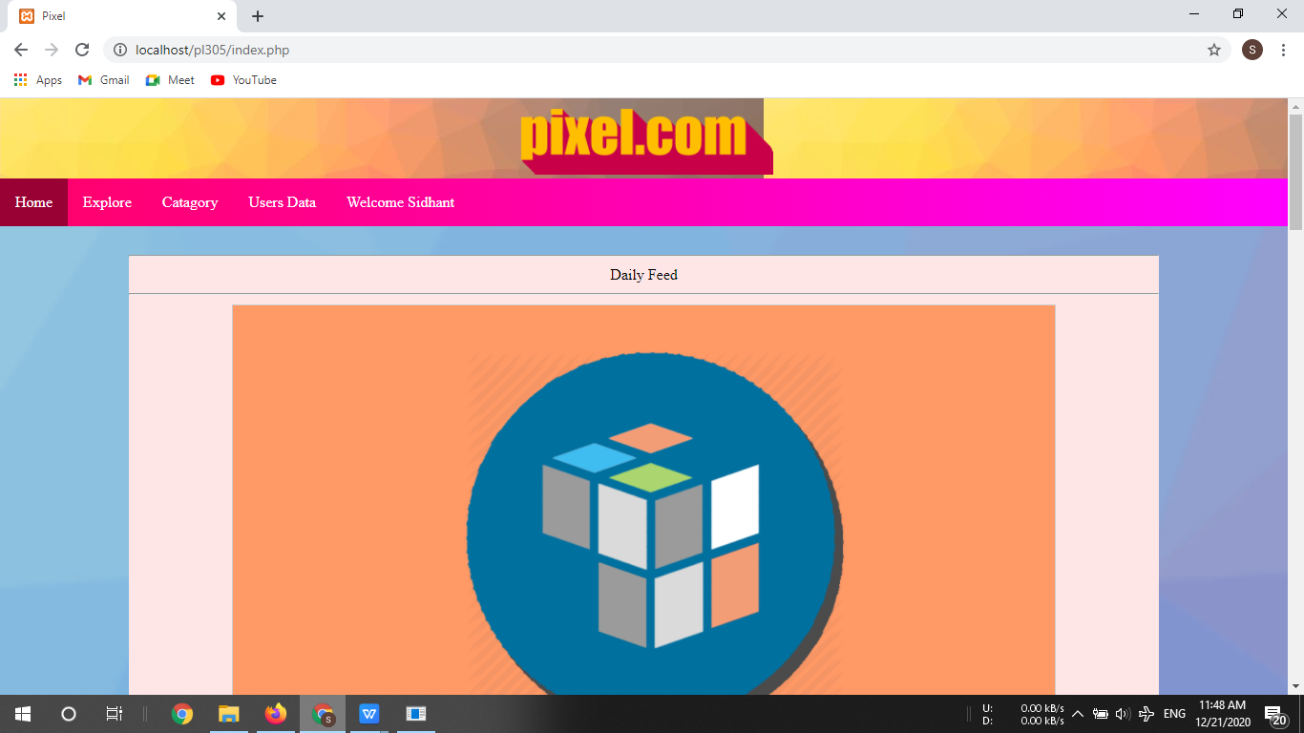

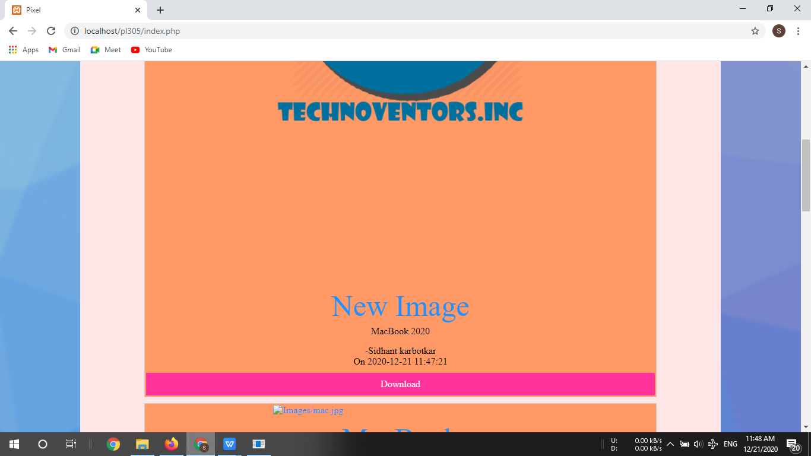

**PAGES SHOWING IMAGES CATAGORYWISE**

