End-to-End MLOps: Digit Image Classifier with DVC, GitHub Actions CI/CD, Docker and AWS
Project Report
Sidhant Nair
October 2026

1. Introduction
This project builds and deploys an image classification application, a handwritten-digit recognizer, using standard MLOps tooling:
Concern | Tool
Data and model versioning | DVC, with AWS S3 as remote storage
Pipeline definition | dvc.yaml (prepare → train → evaluate)
Continuous integration and delivery | GitHub Actions (.github/workflows/ci-cd.yaml)
Containerization | Docker (Dockerfile), image published to GitHub Container Registry
Hosting | AWS EC2, the container served on port 80
Model. A Support Vector Machine (RBF kernel, C = 10, gamma = 0.001) with calibrated probabilities, trained on 1,797 grayscale 8×8 digit images (scikit-learn digits dataset, exported as PNG files).
Result. 99.17 % accuracy and 0.9917 macro-F1 on 360 held-out test images.

1.1 Architecture
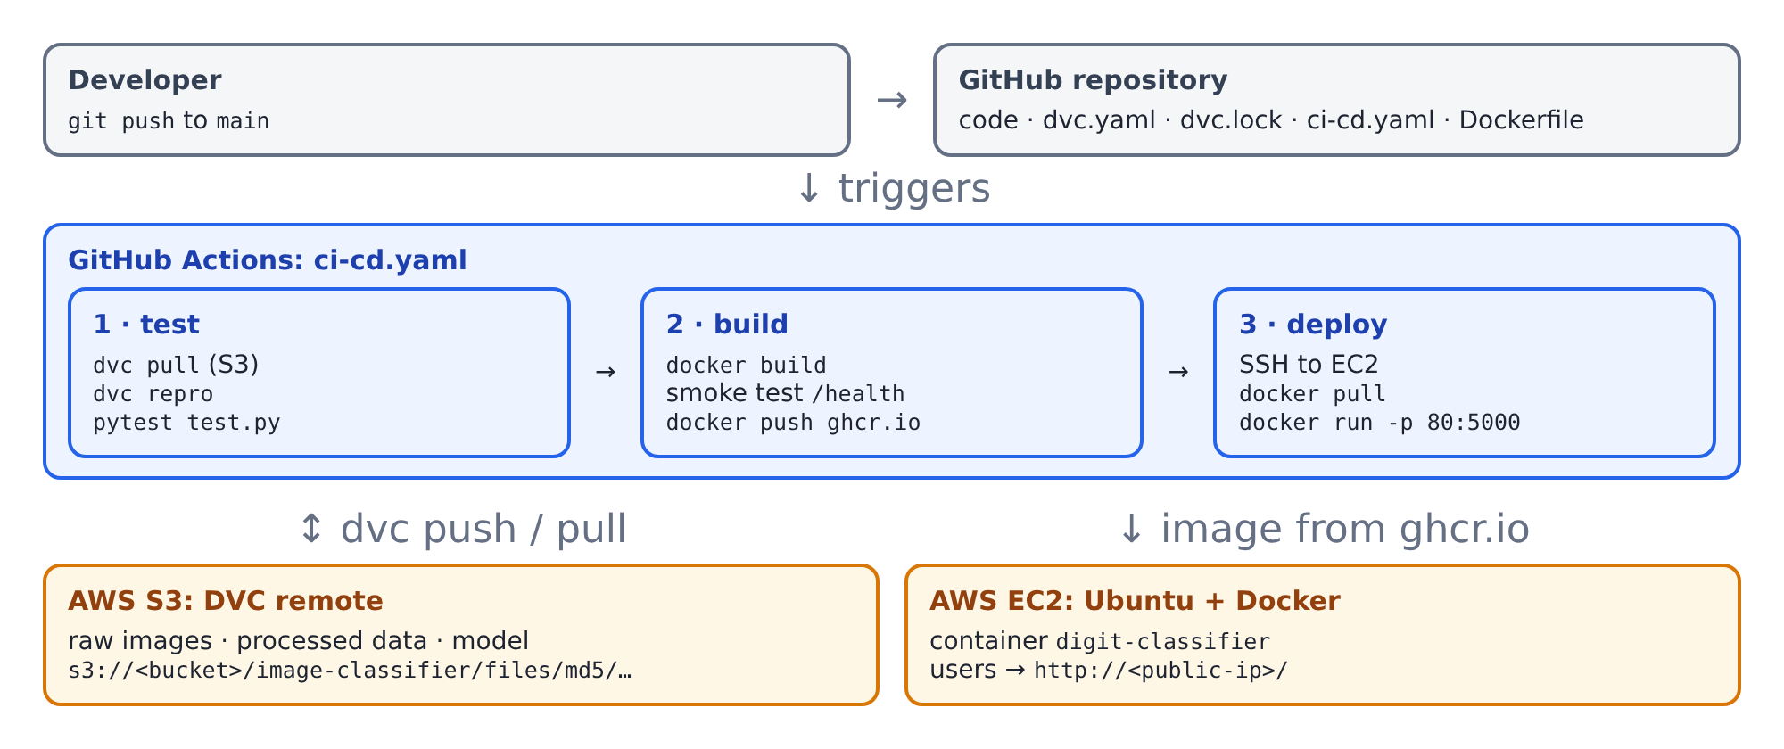
System architecture

1.2 Repository layout
File | Purpose
.github/workflows/ci-cd.yaml | CI/CD workflow
dvc.yaml, dvc.lock, params.yaml | DVC pipeline, lock file, hyper-parameters
data/raw.dvc | DVC pointer for the 1,797-image dataset
export_dataset.py | exports the dataset as PNGs to data/raw/<label>/
prepare.py, train.py, evaluate.py | pipeline stages
model.py | preprocessing, model definition, prediction
app.py, templates/index.html | Flask web application
test.py | 12 automated tests
Dockerfile, .dockerignore | container image
deploy/ec2-user-data.sh | EC2 bootstrap (installs Docker)
deploy/deploy-manual.sh | manual deployment script
requirements.txt, requirements-dev.txt | runtime and development dependencies

2. Step 1: Application
model.py holds the ML logic:
- preprocess(image) converts any uploaded image to the 64-value feature vector the model expects. It converts to grayscale, resizes to 8×8, inverts dark-on-light images (the training digits are light-on-dark) and scales the pixels to 0–16.
- build_model() creates the calibrated SVM. predict() returns {"label", "confidence"}.
app.py is a Flask application, served by gunicorn inside Docker:
Method | Route | Purpose
GET | / | Web page: draw a digit on a canvas, or upload an image
GET | /health | Health check, used by Docker HEALTHCHECK, CI smoke test and deploy verification
POST | /predict | Form field image → JSON prediction; returns 400 for a missing or invalid file

3. Step 2: DVC pipeline

3.1 Initialise DVC and version the raw images
dvc init
python export_dataset.py # 1,797 PNGs -> data/raw/0 ... data/raw/9
dvc add data/raw # creates data/raw.dvc; data/raw is git-ignored
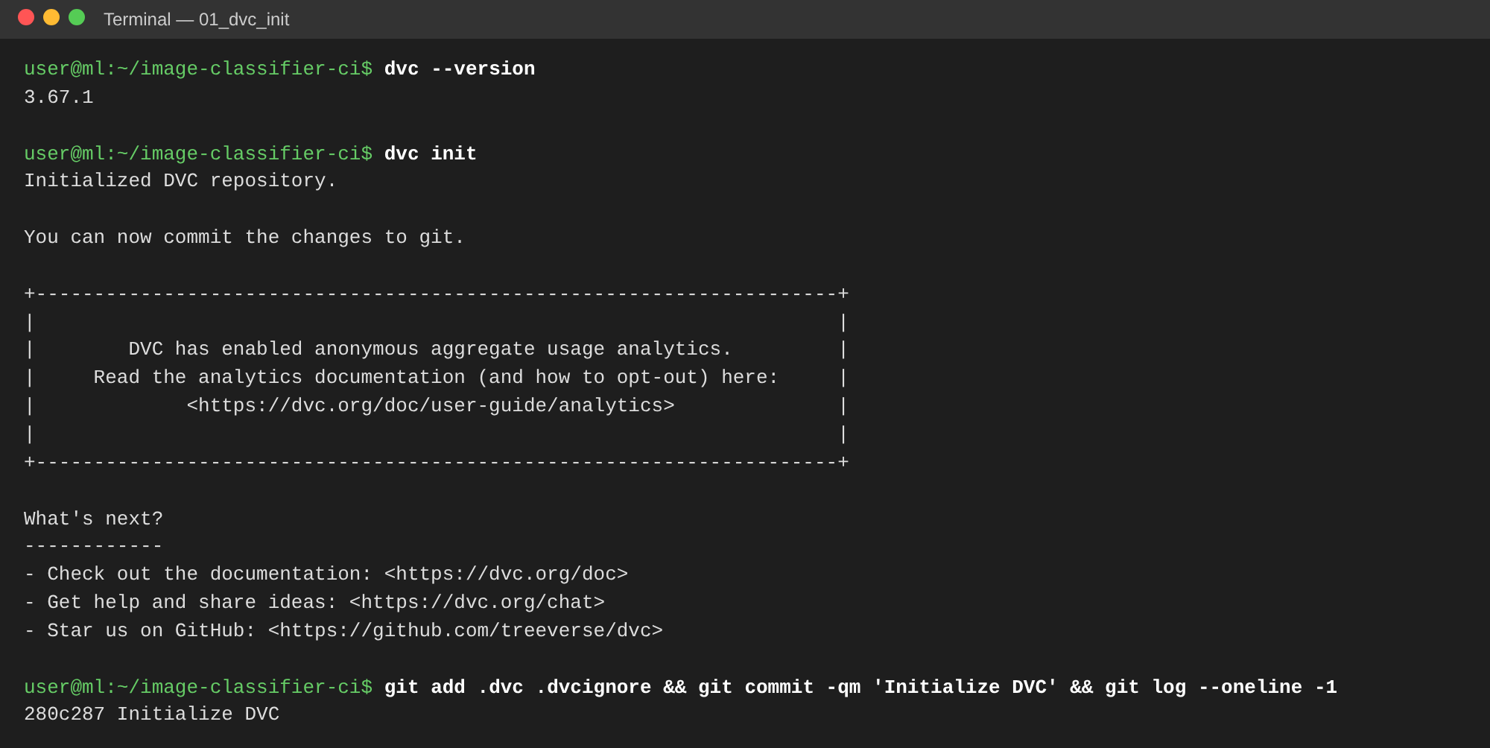
DVC initialised inside the Git repository
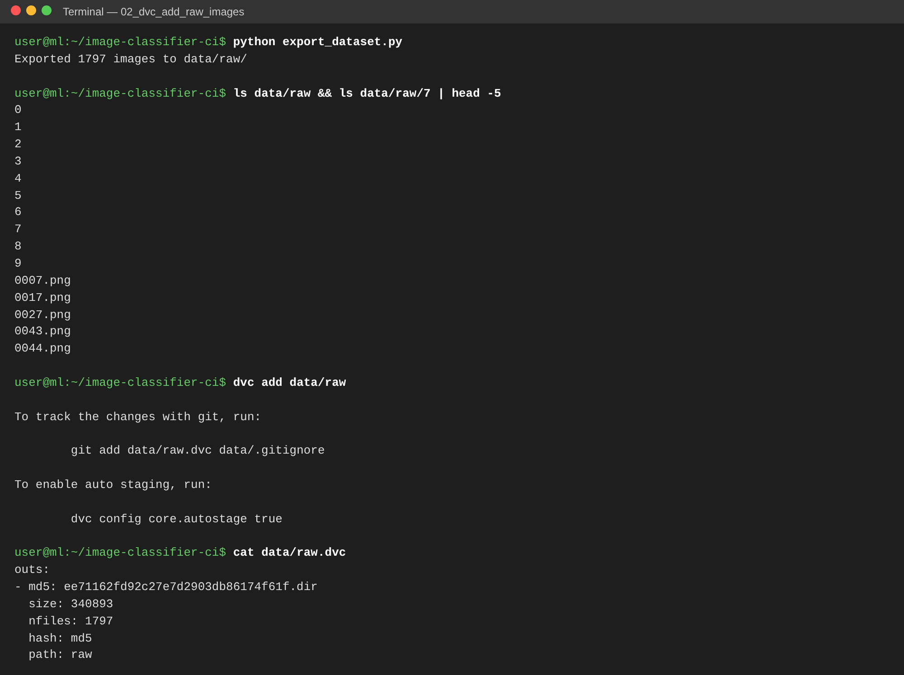
Raw image dataset exported and tracked with dvc add

3.2 Pipeline definition (dvc.yaml)
stages:
prepare:
cmd: python prepare.py
deps: [prepare.py, model.py, data/raw]
params: [prepare]
outs: [data/processed]
train:
cmd: python train.py
deps: [train.py, model.py, data/processed]
params: [train]
outs: [models/digit_classifier.joblib]
evaluate:
cmd: python evaluate.py
deps: [evaluate.py, models/digit_classifier.joblib, data/processed]
metrics:
- metrics.json: {cache: false}
Stage | Input | Output
prepare | data/raw/*/*.png, params.prepare | data/processed/{train,test}.npz (stratified 80/20 split)
train | training split, params.train | models/digit_classifier.joblib
evaluate | model and test split | metrics.json
dvc repro runs only the stages whose dependencies changed. dvc.lock records the MD5 hash of every input and output, so each Git commit pins an exact dataset and model version.
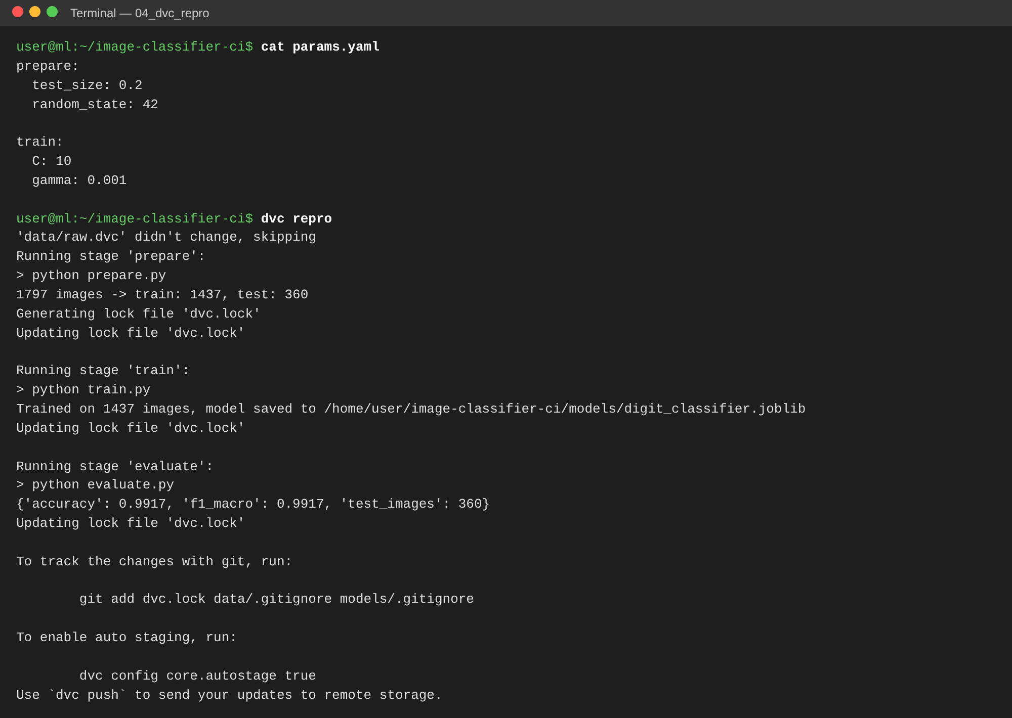
dvc repro running all three stages
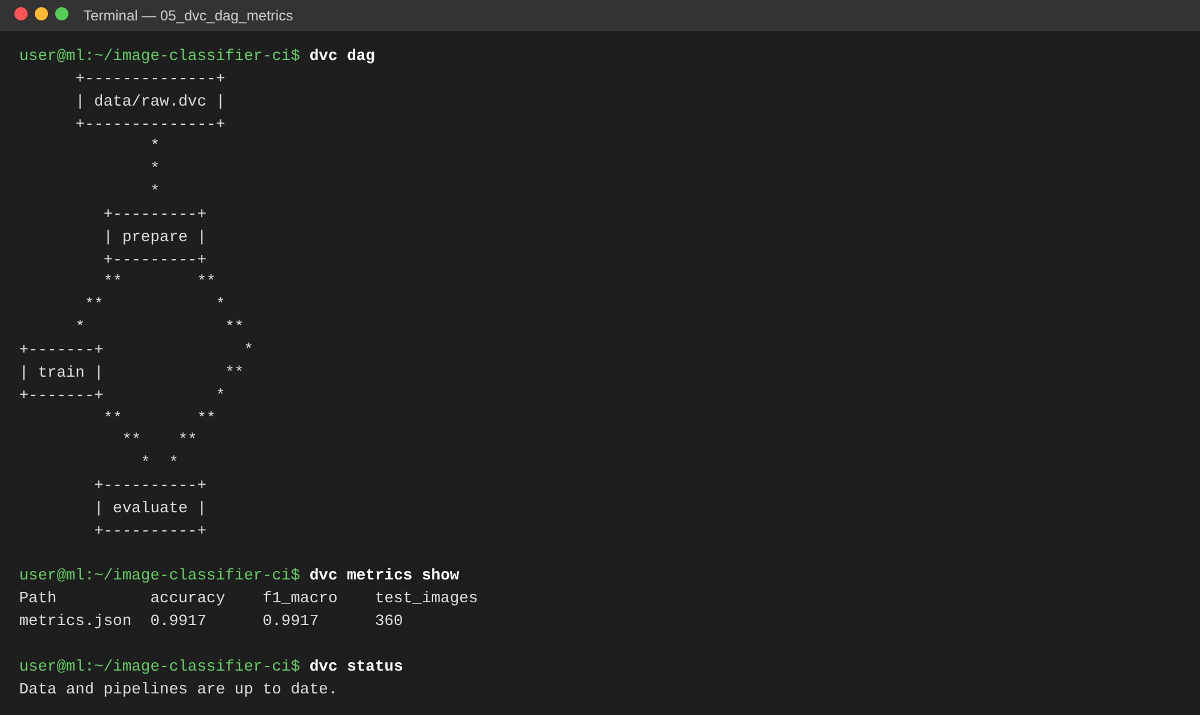
Pipeline DAG and metrics

4. Step 3: AWS S3 as DVC remote storage

4.1 IAM user and AWS CLI
- In IAM → Users → Create user, create dvc-ci-user with the policy AmazonS3FullAccess (in production, a policy limited to the single bucket).
- Under Security credentials → Create access key, choose the CLI use case.
- Run aws configure with that key and region us-east-1.
[INSERT SCREENSHOT] aws configure list and aws sts get-caller-identity

4.2 Bucket and DVC remote
aws s3 mb s3://<bucket-name> --region us-east-1
dvc remote add -d s3remote s3://<bucket-name>/image-classifier
dvc remote modify s3remote region us-east-1
dvc push
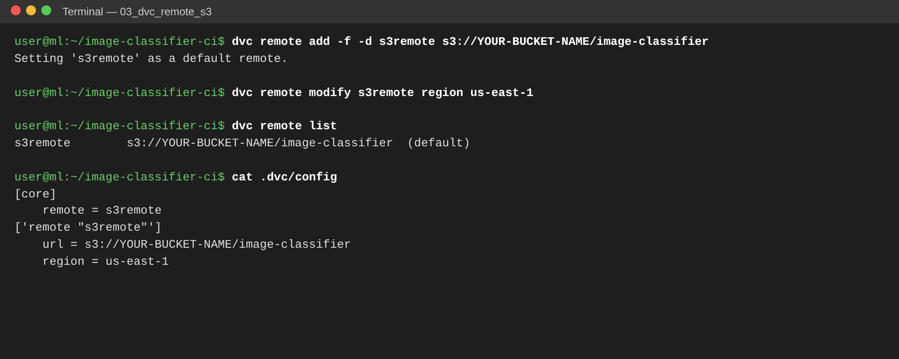
S3 configured as the default DVC remote
[INSERT SCREENSHOT] dvc push output, showing the files uploaded to S3
[INSERT SCREENSHOT] S3 console: bucket → image-classifier/files/md5/… objects
DVC stores objects under their MD5 hash, so the object keys in S3 match the hashes in dvc.lock and data/raw.dvc. On a new machine, or in CI, dvc pull restores the exact dataset and model for the checked-out commit.

5. Step 4: Automated tests (test.py)
test.py contains 12 pytest tests:
Area | What is verified
Data | split shapes, all 10 classes present
Model | test accuracy ≥ 0.95, model file is written
Preprocessing | any image → 1×64 vector in [0, 16]; light backgrounds are inverted
Prediction | ≥ 45 of 50 real digit images correct; output format
API | / renders, /health returns 200, /predict returns the correct label, 400 on missing or invalid upload
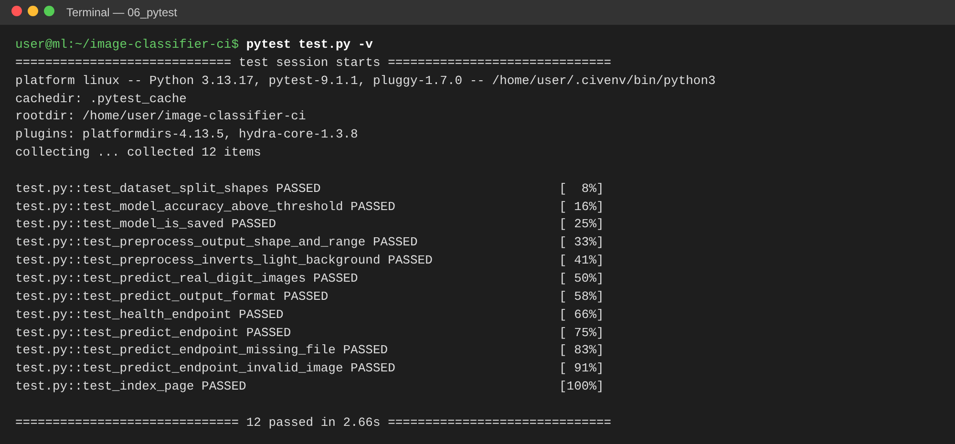
All 12 tests passing

6. Step 5: Docker
FROM python:3.12-slim
WORKDIR /app
COPY requirements.txt .
RUN pip install --no-cache-dir -r requirements.txt # (+ optional proxy-CA secret mount)
COPY model.py app.py ./
COPY templates/ templates/
COPY models/digit_classifier.joblib models/ # DVC-tracked model
ARG MODEL_VERSION=dev
ENV MODEL_VERSION=${MODEL_VERSION}
RUN useradd --create-home appuser
USER appuser
EXPOSE 5000
HEALTHCHECK CMD python -c "import urllib.request; urllib.request.urlopen('http://localhost:5000/health')"
CMD ["sh", "-c", "gunicorn --bind 0.0.0.0:${PORT} --workers 2 app:app"]
Design choices:
- A slim base image and only the runtime requirements. DVC and pytest stay out of the image.
- The container runs as a non-root user.
- The model is copied in at build time from the DVC output, so every image tag maps to exactly one model version. The Git SHA is passed in as MODEL_VERSION and shown in the UI footer.
- .dockerignore excludes the raw dataset, .git and the DVC cache.
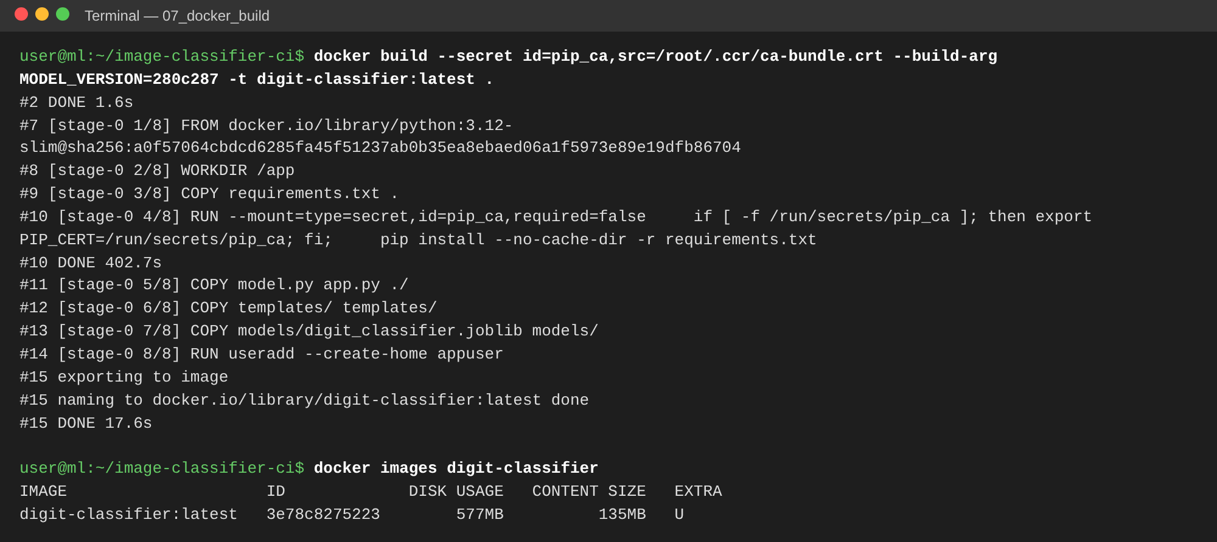
Docker image build
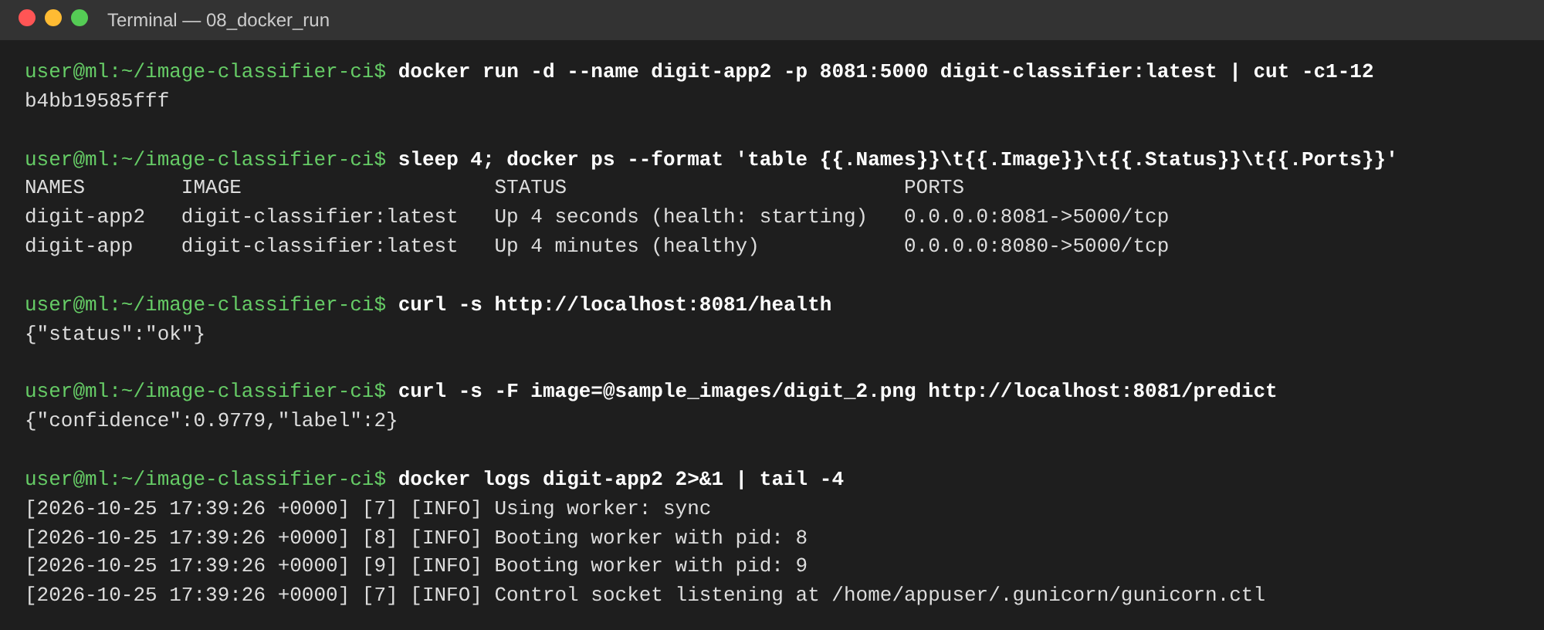
Running the container and calling the API

7. Step 6: GitHub Actions CI/CD (ci-cd.yaml)
The workflow runs on every push and pull request to main/master, and can also be started by hand (workflow_dispatch). It has three jobs:
1. test (CI)
- Checks out the code, sets up Python 3.12 and installs requirements-dev.txt.
- If AWS_ACCESS_KEY_ID is configured, it logs in to AWS and runs dvc pull from S3. Otherwise it regenerates the dataset.
- Runs dvc repro and dvc metrics show, then pytest test.py.
- Uploads the trained model and the test results (JUnit XML, metrics.json) as artifacts.
2. build (CD, not run for pull requests)
- Downloads the model artifact and builds the Docker image, tagged latest and with the commit SHA.
- Smoke-tests the image: starts the container, waits for /health, sends a real prediction.
- Pushes the image to GitHub Container Registry: ghcr.io/sidhantn12/image-classifier-ci.
3. deploy (CD, runs once the EC2_HOST variable is set)
- SSHes into EC2 (appleboy/ssh-action), logs in to GHCR with the job token, pulls the new image, replaces the running container (--restart unless-stopped -p 80:5000) and prunes old images.
- Verifies the deployment by polling http://<EC2_HOST>/health from the runner.
Required repository settings:
Type | Name | Purpose
Secret | AWS_ACCESS_KEY_ID, AWS_SECRET_ACCESS_KEY | dvc pull from S3
Secret | EC2_SSH_KEY | private key of the EC2 key pair
Variable | EC2_HOST | public IP of the instance (enables the deploy job)
Variable | EC2_USER | ubuntu
Run #1 of the workflow (commit 7a7988b) completed successfully. The test and build jobs passed and the image was pushed to GHCR. The deploy job was skipped because EC2_HOST was not yet configured.
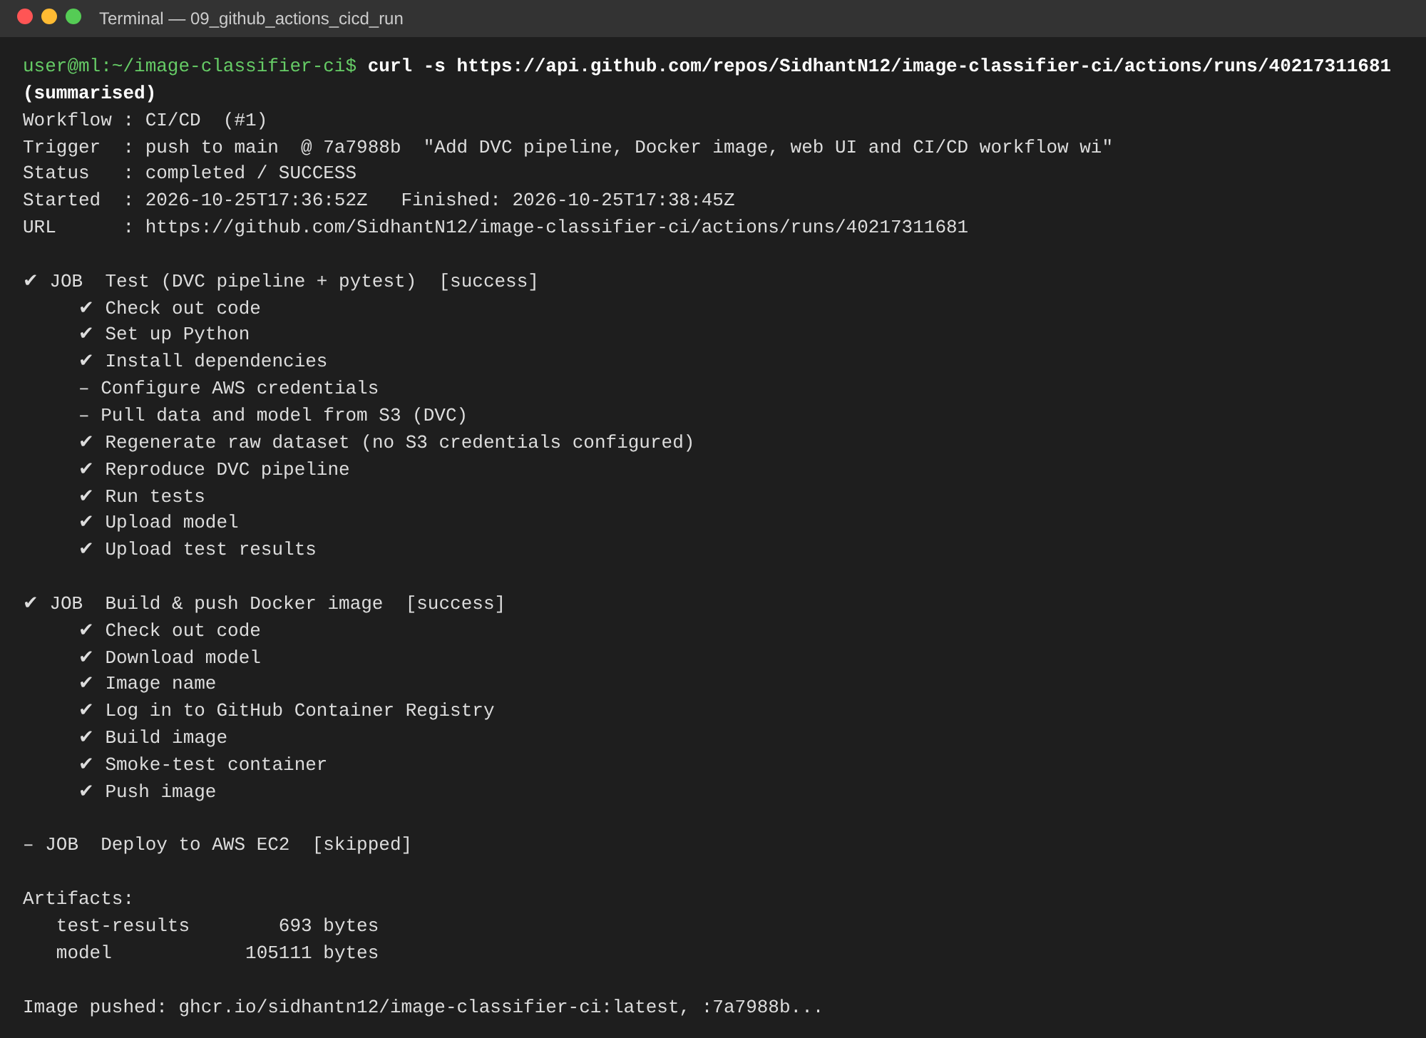
CI/CD run #1, from the GitHub API
[INSERT SCREENSHOT] GitHub → Actions → CI/CD run: workflow graph with all three jobs green
[INSERT SCREENSHOT] Expanded “Run tests” step showing 12 passed
[INSERT SCREENSHOT] “Deploy to AWS EC2” job log

8. Step 7: AWS EC2 deployment

8.1 Launch the instance
- EC2 → Launch instance: Ubuntu Server 24.04 LTS, t2.micro or t3.micro (free tier).
- Key pair: create image-classifier-key (.pem). Its content goes in the GitHub secret EC2_SSH_KEY.
- Security group inbound rules: SSH (22) from My IP; HTTP (80) from 0.0.0.0/0.
- Advanced details → User data: the contents of deploy/ec2-user-data.sh, which installs and enables Docker and adds ubuntu to the docker group.
- Launch the instance and copy its Public IPv4 address into the GitHub variable EC2_HOST.
[INSERT SCREENSHOT] EC2 instance list: instance Running, public IPv4 visible
[INSERT SCREENSHOT] Security group inbound rules (22, 80)

8.2 Deploy
Re-run the workflow (Actions → CI/CD → Run workflow) or push a commit. The deploy job then pulls the image on the instance and starts it. To deploy by hand instead:
ssh -i image-classifier-key.pem ubuntu@<EC2-IP>
./deploy-manual.sh ghcr.io/sidhantn12/image-classifier-ci:latest
docker ps
[INSERT SCREENSHOT] SSH session on EC2: docker ps showing digit-classifier on 0.0.0.0:80->5000/tcp

9. Step 8: Verification and application execution
From any machine, the application is reachable on the instance’s public IP:
curl http://<EC2-IP>/health # {"status":"ok"}
curl -F image=@sample_images/digit_2.png http://<EC2-IP>/predict # {"confidence":0.98,"label":2}
The screenshots below show the same Docker image running and classifying a hand-drawn digit and an uploaded image:
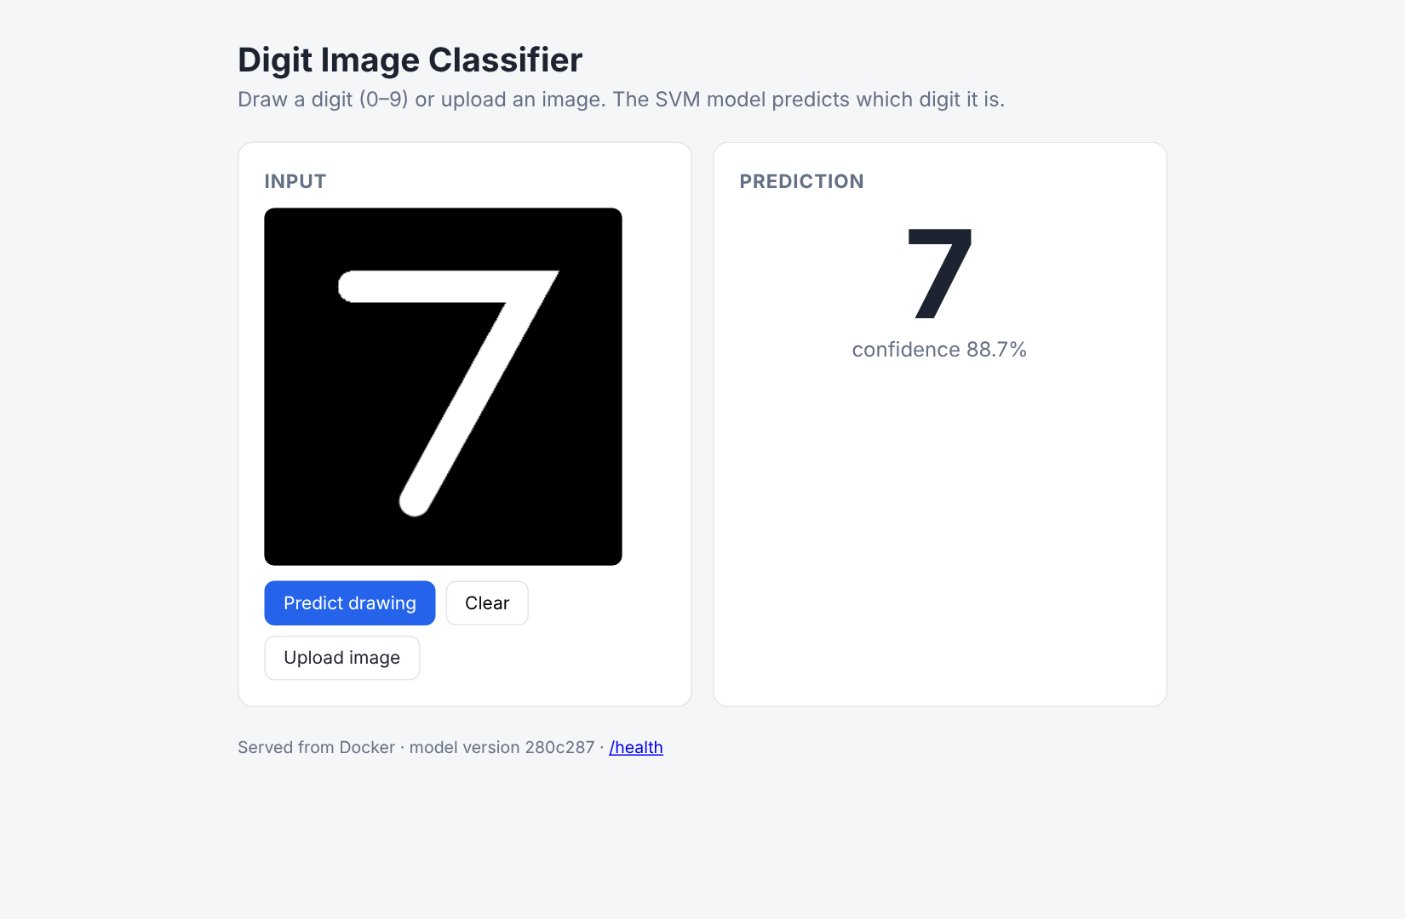
Web UI: hand-drawn “7” classified as 7
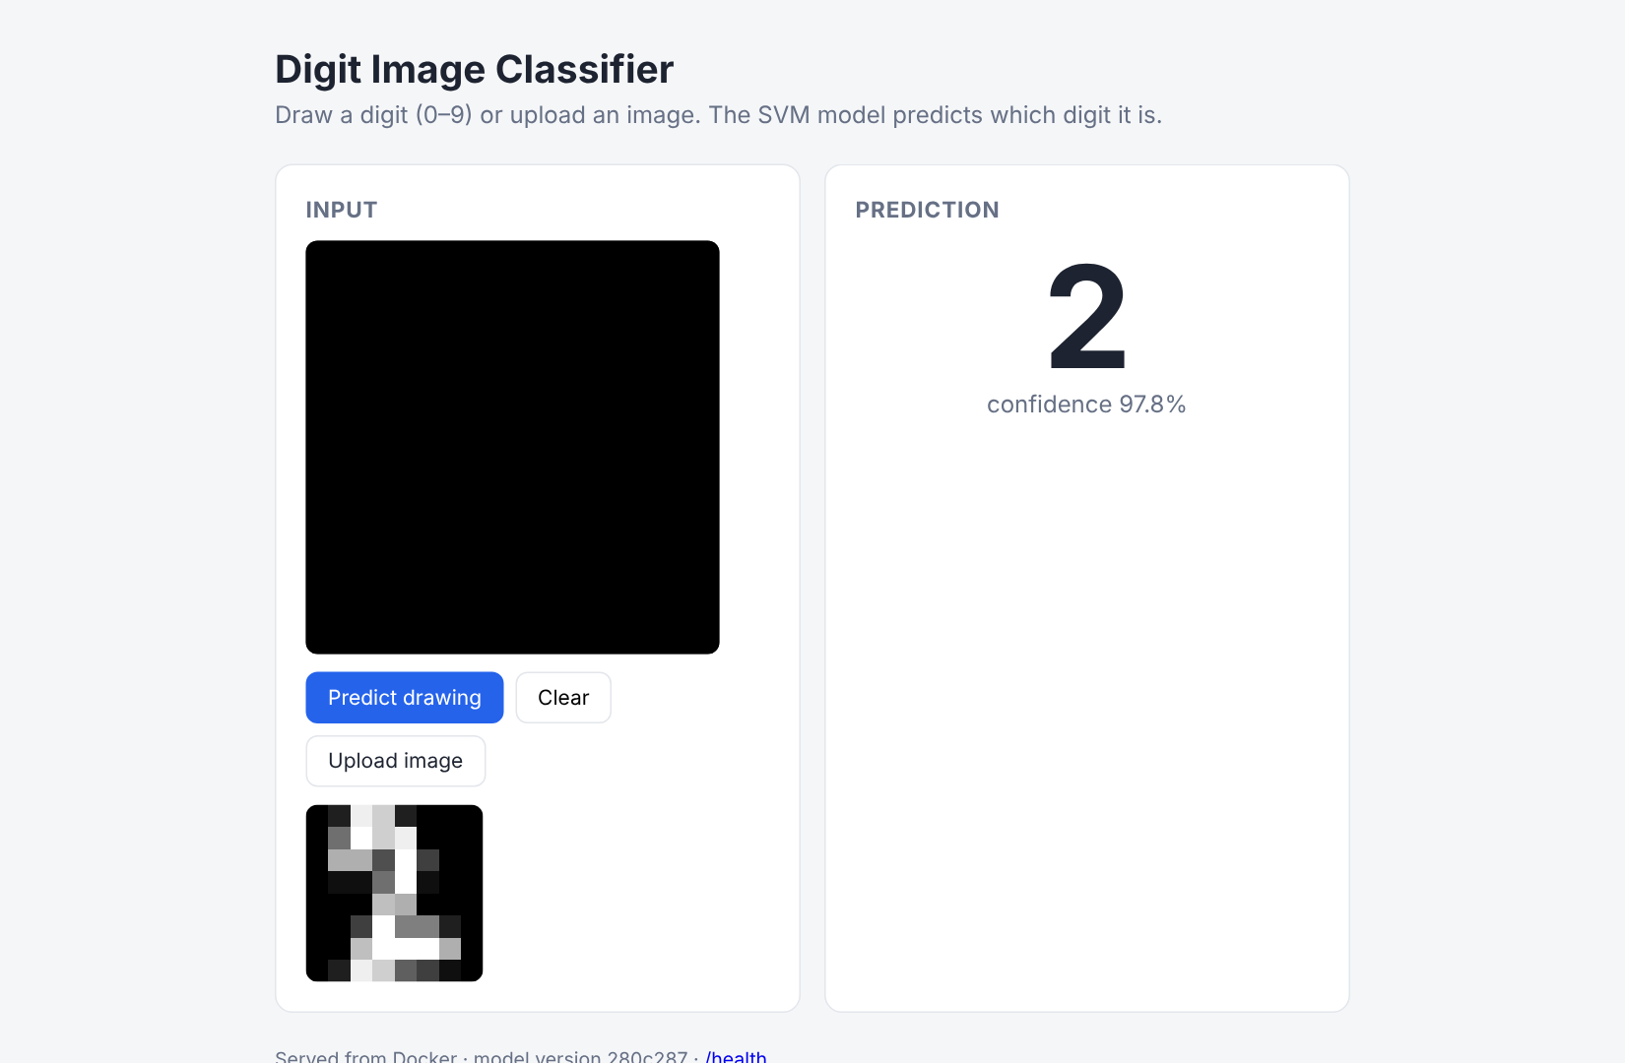
Web UI: uploaded image classified as 2
[INSERT SCREENSHOT] Browser at http://<EC2-public-IP>/ showing a prediction
[INSERT SCREENSHOT] curl http://<EC2-public-IP>/health from your machine
Public application URL: http://<EC2-public-IP>/

10. Challenges and solutions
Challenge | Solution
The trained model must reach the Docker image without committing binaries to Git. | The model is a DVC output. In CI it is produced by dvc repro (or pulled from S3), uploaded as an artifact by the test job and downloaded by the build job before docker build.
CI must not fail before AWS is set up. Without S3 credentials, dvc pull would fail. | The workflow checks secrets.AWS_ACCESS_KEY_ID. With no key, it regenerates the dataset and reproduces the pipeline. The deploy job runs only when vars.EC2_HOST is set.
GHCR rejects image names with upper-case letters, and the GitHub username is SidhantN12. | The image name is lower-cased in the workflow: ghcr.io/${GITHUB_REPOSITORY,,}.
The EC2 instance cannot pull a private GHCR image. | The deploy step pipes the job’s GITHUB_TOKEN into docker login ghcr.io on the instance, pulls, then logs out. No long-lived registry credential is stored on the server.
pip install failed inside docker build with CERTIFICATE_VERIFY_FAILED in the development environment, which sits behind a TLS-inspecting proxy. | An optional BuildKit secret (--secret id=pip_ca,...) supplies the proxy CA during the build only. It is not stored in the image, and normal builds (GitHub Actions, EC2) skip it.
The scikit-learn 1.9 deprecation of SVC(probability=True) (scheduled for removal in 1.11) would eventually break CI. | Switched to CalibratedClassifierCV(SVC(...), ensemble=False), the recommended replacement.
User drawings do not look like the training data: dark ink on a light background, any size. | preprocess() inverts light-background images and resizes to 8×8. Tests cover both cases.
Deployment must be verifiable automatically. | A Docker HEALTHCHECK, a CI smoke test that sends a real prediction, and a post-deploy curl /health against the public IP.

11. Conclusion
The project implements a reproducible path from data to deployment:
- DVC versions the 1,797-image dataset and the model and stores them in S3. Every commit pins exact data and model hashes.
- GitHub Actions reproduces the pipeline, runs 12 tests, then builds, smoke-tests and publishes a Docker image.
- The image runs on AWS EC2 and is reachable on the instance’s public IP.
A push to main carries a change through testing to production without manual steps.

12. Links
- GitHub repository: https://github.com/SidhantN12/image-classifier-ci
- CI/CD run #1: https://github.com/SidhantN12/image-classifier-ci/actions/runs/40217311681
- Docker image: ghcr.io/sidhantn12/image-classifier-ci:latest
- Deployed application: http://<EC2-public-IP>/

