SOLUTION PLAN
Dynamics 365 and social media
A controlled integration for insight, segmentation, and reporting
Prepared from the working session on 23 September 2026. The client is an organisation in Riyadh, Saudi Arabia, already using Microsoft Dynamics 365. Cloud Analogy remains the client-facing party. Delivery is a defined project, with this team providing the Dynamics 365 solution.
Channels in scope
Instagram and Facebook first, together with TikTok. LinkedIn next. YouTube only if discovery adds it.
Control that governs the design
Social insight comes into the CRM and sits with the segments and pipeline already there. Agencies stay on the advertising platforms. They do not receive a Dynamics 365 login or a copy of the customer database.

1. What this plan covers
Marketing and sales need one customer record. Today the social channels and the CRM are separate, so a comment, a lead form, or a campaign result is not visible next to the segment, account, and opportunity the business already holds. Agencies that buy media also must not be given open access to that CRM.
The integration has four outcomes.
• Bring social insight into Dynamics 365: named leads where a person can be identified, and campaign results where only a total is available.
• Join that insight to the segments, accounts, and pipeline already stored in the CRM.
• Give marketing and sales dashboards they can use for follow-up and for later targeted advertising.
• Leave third-party agencies on the advertising platforms, with a performance pack of totals and no path into the customer database.
Platforms, in the order named on the call.
Priority | Platform | Place in the solution
First | Instagram and Facebook | Main integration. Lead forms, permitted comments and messages, and campaign totals.
First | TikTok | Same weight as Meta for this client. Built as a dedicated path, because Microsoft has no native TikTok audience export.
Next | LinkedIn | Confirm in discovery whether the need is lead forms, advertising, or both.
Later | YouTube | Raised only as part of the monday.com example. Add it only if the client uses it.

The outcome to match is the one described for Campaign Bridge on monday.com: when someone engages, sales can see it inside the CRM and take the next step. Dynamics 365 reaches that outcome through the bridge and the app in the next section. It does not copy that product, and it does not create a contact for every anonymous view.
2. Recommended solution
The client owns two pieces that operate as one solution. A bridge outside the CRM collects social data. An app inside Dynamics 365 is where the client’s own people read it.
Bridge
An Azure integration service holds the social credentials in Key Vault, receives lead and message notifications, and pulls campaign totals on a schedule. It writes a narrow set of records into Dataverse. The only Dynamics identity it uses is an application user that can create leads and write the social tables. That user cannot browse the rest of the CRM. Agencies never see this service.
App inside Dynamics 365
A small model-driven app, plus Power BI, for the client’s marketing and sales users. Social leads appear on the normal lead form. Engagement appears on the timeline. Campaign performance sits next to the segments the client already maintains. Security roles decide who sees a named person and who sees a total.
Both pieces are required. The app cannot collect Meta, LinkedIn, or TikTok data on its own. The bridge on its own would leave sales looking at a store outside the CRM, which is the gap this work is meant to close.
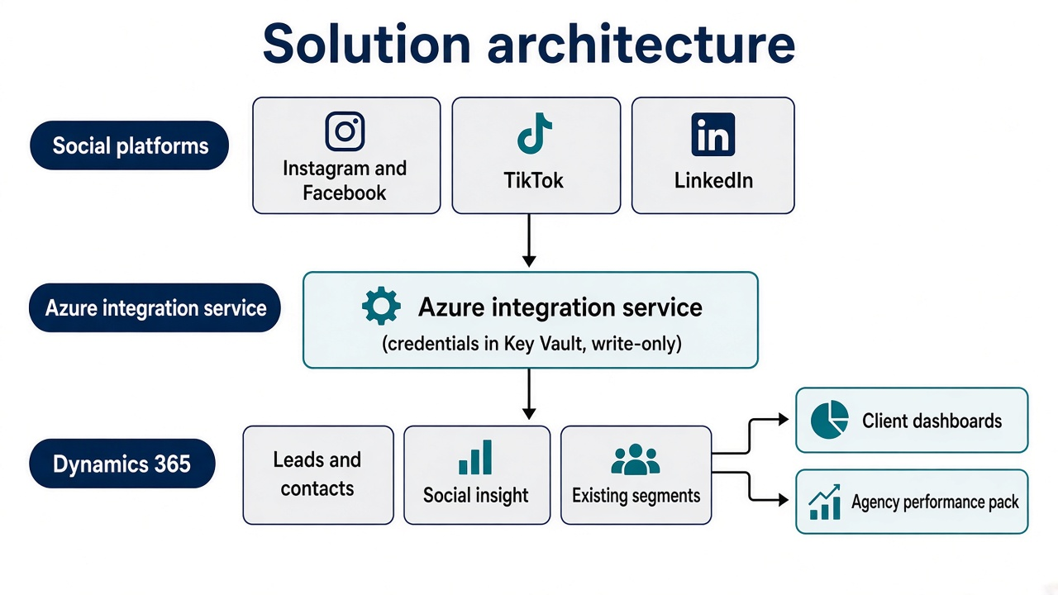
Figure 1. Social platforms feed the Azure bridge, which writes into Dynamics 365. Client users see the CRM. Agencies receive an aggregated pack only.
Use what Dynamics 365 already provides
• Lead, Contact, Account, and Opportunity carry the sales path. Social leads follow the lead process the client already runs.
• Social Profile stores a known person’s handle and links it to a contact.
• Customer Insights - Journeys, if the tenant already has it, covers LinkedIn lead forms and LinkedIn matched audiences.
• Customer Insights - Data, if the tenant already has it, can export a segment to Facebook and LinkedIn advertising. The same export path also reaches Snapchat and Google Ads if those appear later.
• Power BI on Dataverse is the cross-channel dashboard. Reporting stays inside the Dataverse boundary rather than copying the customer database out to a separate store.
Build the gap Microsoft does not cover
• Named leads from Meta lead forms, permitted comment authors, and messaging.
• Content totals for Instagram, Facebook, and TikTok: reach, views, clicks, reactions, and comments.
• The whole TikTok path, including any later audience return. Customer Insights does not export audiences to TikTok.
• The agency boundary: a report that can be shared without creating a CRM user.
A retired Microsoft Social Engagement add-on, or a packaged social suite installed into production, is the wrong start. Either widens access before the client has agreed the boundary. The first release uses the native sales tables and builds only the collection and reporting gap.
3. Who can see what
The integration is acceptable because the customer database stays with the client. Agencies continue to plan and buy media where they already work. The CRM publishes a performance pack outward. It does not invite the agency in.
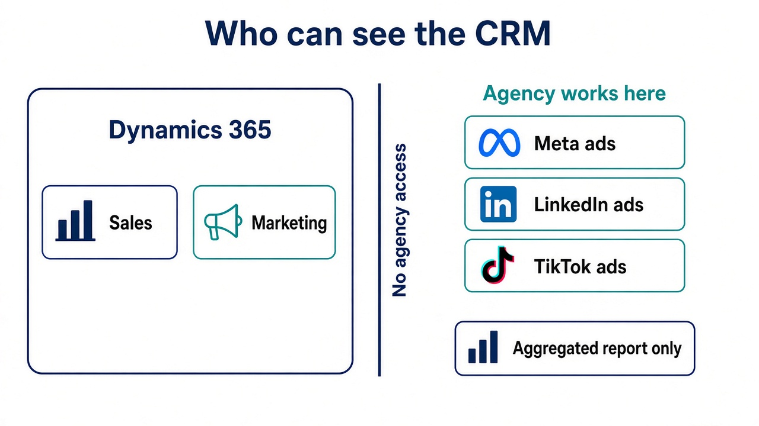
Figure 2. Sales and marketing work inside Dynamics 365. Agencies work in the ad accounts and receive aggregated results only.
Who | Where they work | What they can see
Sales | Dynamics 365 | Leads and contacts their role allows, and the social activity on those records.
Client marketing | Dynamics 365 and Power BI | Segments, campaign insight, lead quality, and the customer attributes their role allows.
Integration service | Azure, as an application user | Creates leads and social-insight rows. No browse of the customer database.
Agency media buyers | Meta, LinkedIn, and TikTok ad accounts | Their own ad accounts, plus the performance pack the client publishes.
Agency analysts | A separate report pack | Campaign and segment totals only. No names, phones, emails, opportunity values, or account financials.

A named agency user inside Dynamics 365 is a later decision, with its own security role, and only if the client asks for it. It is outside this design.
Credentials for Meta, LinkedIn, and TikTok stay in the client’s business-manager accounts and in Key Vault. The integration service is the only component that uses them. A CRM user cannot export an ad-account token, and an agency losing access to an ad account does not open the CRM.
Controls inside Dataverse
• The bridge’s application user has a custom role limited to creating and updating leads and the social tables.
• Field security covers national ID, financial fields, and any other sensitive columns already in the CRM, so a marketing role cannot read them from a shared form.
• Auditing is on for the application user and for lead creation.
• The agency report is built from a dataset that is already aggregated. The published dataset contains no person-level rows.
4. What data moves
Social platforms do not identify every viewer. A named lead is created only when the platform returns a person the client is allowed to store. Views and reach stay as campaign totals. The plan does not promise a contact record for every reel view.

Named people, written to a lead or a contact
• Lead-form submits from Meta Lead Ads, LinkedIn Lead Gen Forms, and TikTok lead generation.
• Comment authors, direct messages, and messaging contacts, where the platform returns a profile and the client’s consent position allows the store.
• Clicks that land on a client site or form and already carry an email, a mobile number, or an existing CRM id, together with the campaign.
Each of these creates or updates one lead, stamps the platform and the campaign, and links a Social Profile when a handle is present. Follow-up stays in the lead process the sales team already uses.
Campaign totals, written as insight
• Views, reach, impressions, clicks, reactions, comments, and spend, by post or ad and by day.
• Each row attaches to a campaign and, where the client already maps that campaign to a segment, to that segment.
• These rows do not create a contact.
A known person is matched to an existing record with the identifiers the CRM already trusts: email, mobile, and a customer number on the form. If none match, the person remains a new lead with a source campaign. They are not attached to an existing account by guesswork.
Anonymous performance still supports targeting. Marketing can see which campaign and which segment produced pipeline. When that picture is trusted, Customer Insights can push a segment out as a custom audience on Facebook and LinkedIn, and a separate step can do the same for TikTok. That return path waits until the inbound match rules are agreed. Turning it on earlier would send customer data into an agency-operated ad account.
5. Dashboards and reports
For sales, inside Dynamics 365
• Social leads waiting for first contact, by platform and campaign.
• Lead-to-opportunity conversion by platform, so the team can see which channel is worth calling.
• A timeline entry on the lead for the form, comment, or message that created it.
For marketing, in Power BI
• Reach, clicks, and leads by platform, campaign, and the segment the CRM already holds.
• Spend beside pipeline value, where the CRM already stores both.
• Content that produced leads, shown apart from content that produced reach only.
For the agency pack
• The same campaign totals. A segment name is included only if the client agrees the name itself is safe to share.
• No person-level page, and no link from the pack back into Dynamics 365.
6. Security, consent, and residency
• The client’s position under the Saudi Personal Data Protection Law is confirmed before any production write. Lead forms collect personal data of people in the Kingdom. Whether that data may be stored outside the Kingdom, or sent onward to an advertising platform, is the client’s legal decision. This plan does not make that decision.
• Microsoft has announced the Saudi Arabia East Azure region for November 2026. It is not a deployment target on the date of this plan. The bridge is placed as close as the tenant allows to the Dynamics 365 geography the client already uses, which for a Riyadh organisation is commonly the Middle East region. Discovery records the actual geography before anything is built.
• When Saudi Arabia East is available for the specific Dynamics and Azure services this design uses, the client can decide whether the bridge moves. No residency promise is made ahead of that.
• Consent text on the lead forms matches the fields that are stored and the teams that act on them. The bridge stores only the fields listed in discovery.
• Tokens, webhook secrets, and the application-user secret live in Key Vault. They are not written into the CRM, and they are not placed in any pack shared with an agency.
7. How delivery proceeds
The sequence agreed on the call is unchanged. Confirm the real requirement and the platforms, connect the interfaces, land the data in a sandbox, and open the live environment only after that behaviour is accepted.
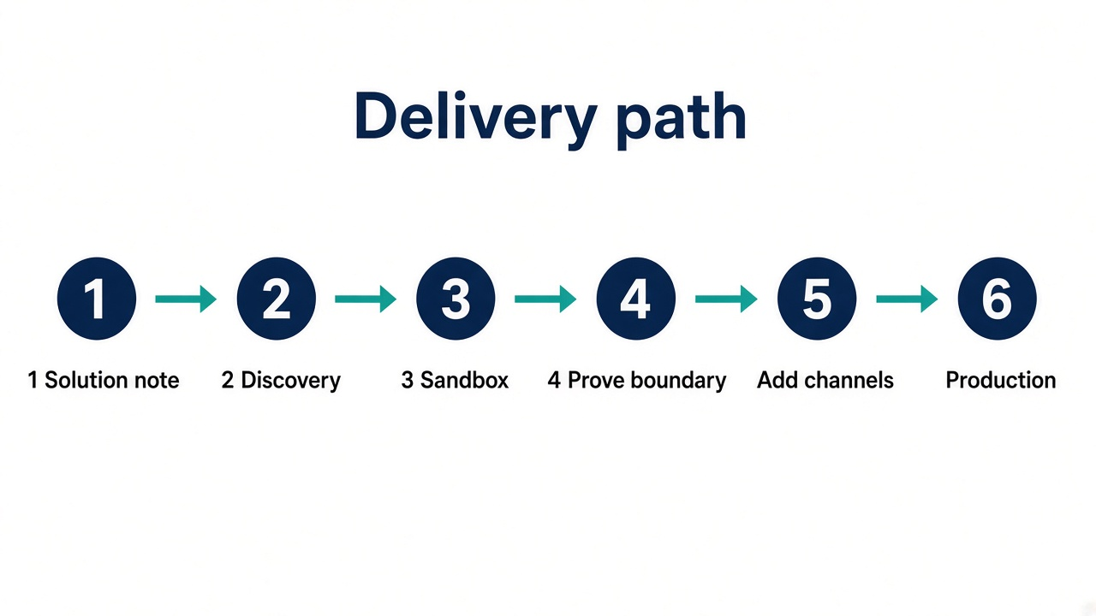
Figure 3. Discovery and a sandbox come before any production connection. The agency boundary is proved before the channel list is widened.
Step | What it produces
1. This plan | Describes the approach for discussion. No environment access is required to review it.
2. Discovery | The client shows the Dynamics environment, the licences, and the social accounts. This team joins as the Dynamics specialists. The questions are in the next section.
3. Sandbox | A minimal Dataverse sandbox. Meta first: lead forms and campaign totals, the application user, the lead form, and one internal dashboard. Production users are not connected.
4. Prove the boundary | Show that an agency identity cannot open the sandbox app, and that the performance pack contains no personal data.
5. Add channels | Still in the sandbox: TikTok, LinkedIn, matching to existing segments, and the internal Power BI report.
6. Production | Opened only after the sandbox behaviour is accepted. Sending segments back out to the ad platforms is a separate go-live from the inbound bridge.

Licences are confirmed in discovery rather than assumed. Dynamics 365 Sales and a model-driven app cover the lead path. Customer Insights - Journeys and Customer Insights - Data are used only if the tenant already has them, or if the client chooses to add them for LinkedIn forms and audience export. The first release of the bridge does not depend on Customer Insights.
8. What discovery needs to answer
• Which Dynamics 365 apps and licences are live, including Sales, Customer Insights - Journeys, and Customer Insights - Data, and which geography the environment is in.
• Whether a sandbox already exists, and who the system administrator is.
• Who owns the Meta, LinkedIn, and TikTok business-manager accounts, and whether lead forms are already running.
• Which events sales will act on (form, comment, message) and which events are campaign totals only.
• The segment model in use today: marketing lists, Customer Insights segments, or a custom structure. The bridge joins that model.
• Which agency works on which platform, and which numbers that agency is allowed to receive.
• PDPL and consent limits, including any field on today’s forms that must not be stored.
• One example of a good lead, and one campaign report the client already trusts, so the dashboard uses their definitions of a lead and of spend.
9. Experience that can be described
This team has delivered a Dynamics 365 CRM that runs an operational process from end to end: goods received, labelled, and shipped, together with leads, opportunities, and financial reporting. That work was done over the past year by the people who would deliver this integration.
That is Dynamics 365 CRM delivery experience. It is a different piece of work from a social-media bridge, and it should be described that way. The social pattern in this plan is the Campaign Bridge outcome, rebuilt on Dataverse with an explicit boundary for agencies. If a written example is needed, the operational CRM is the one that can be offered, and only with that client’s permission to be named.
10. Next working step
The next working step is the discovery conversation in section 8, with the Dynamics specialists in the room, once this approach is the one to take forward. The sandbox is opened only after those answers are known.

