# Title: Relating change complexity and system complexity

Name

# Abstract

Write this last.

# Introduction

Traditional complexity measures are normalised on or require a whole

file or system and were not designed to measure the complexity of code

fragments. The goal of this paper would be to evaluate which measures

are the best indicators of the complexity of an evolving system. One

point to note is that the complexity of a change can be very

different from the complexity of the files or system that contain a

change (e.g., a change to many simple files might be as complex as a

change to one difficult file). Change complexity is related to, for

example, "how hard is it to understand and review a change" vs system

complexity, which measures for example, "how hard is to understand and

potentially modify the system". ..

Furthermore, traditional complexity measures are not really

measuring the complexity of the system but simply the size of the files that make up the system. As a result, they do not add any additional information beyond how large a file is.

In contrast, all of the change complexity measures are based upon the notion that changes that are farther

from each other or involve multiple entities are more complex than those closer

together involving fewer entities. In total, we use seven measures of change

complexity: the churn (or size), the number of modified files in a diff, the

number of diffs per review, the number of and distance between contiguous

change blocks within a diff (\ie hunks), the directory distance between these

files, and depth of indentation of a change (Hindle2008ICPC).

In this work, we answer the following research questions:

1- Is there a relationship between traditional complexity measures and change complexity measures?

2- Does the change complexity measure at version (i) of a system relate to the difference between the traditional complexity measure at version (i+1) and version (i).

CCMv(i) ~ TCMv(i+1) – TCMv(i)

3- Does the traditional complexity measure at version (n) relate to the sum of all change complexity measures of the system?

TCMv6 ~ ∑0-6 CCMv(i)

The paper is organized as follows. In Section II, we describe … In Section III, we …

# Measures

# Background/Literature

Brief paragraphs on each traditional complexity measure

Source Lines of Code (SLOC):

To define SLOC we use the definition given by Conte [Conte 1986]:

A line of code is any line of program text that is not a comment or blank line, regardless of the

number of statements or fragments of statements on the line. This specifically includes all linescontaining program headers, declarations, and executable and non-executable statements.

* Lines of Code (LOC)

Lines of code refers to the total number of lines in each source code file including comments and blank lines. It is a straightforward measure and can be calculated using many available tools.

* McCabe’s Cyclomatic Complexity

McCabe’s Cyclomatic complexity is one of the earliest complexity measures developed by Thomas J. McCabe in 1976. It directly measures the number of linearly independent paths through a program’s source code. Any program can be represented as a graph with the simplest element being a flat series of statements with no conditions, loops or branches. [1] For a graph G with n vertices, e edges and p exit points, the complexity v is defined as follows:

v(G)=e-n+2p

It is worth mentioning that the minimum value for the cyclomatic complexity metric is 1, which corresponds to the flat series of statements with no bifurcations or loops. Every additional region in the flow graph would increase the Cyclomatic complexity by one unit.

* Halstead’s Metric

# Change Complexity Measures

Copy from my thesis and elaborate

# Methodology

Diagram showing sum of System and change complexity measures … (see email discussion)

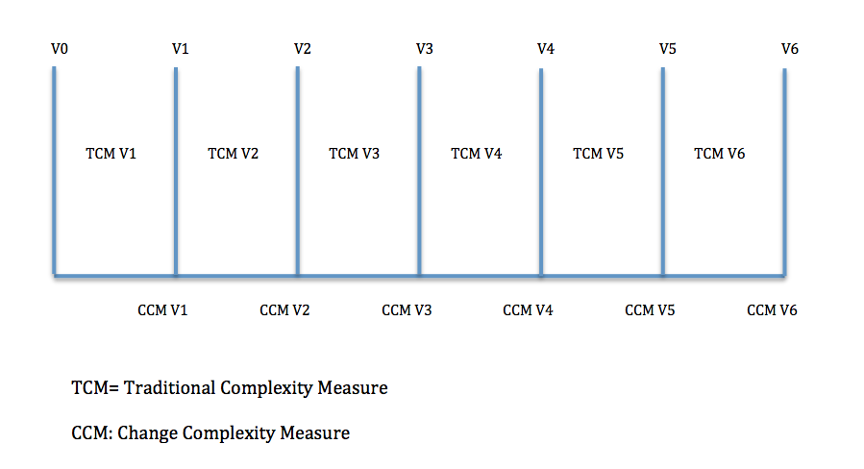

[Add mathematical equations here].

# Results

# Discussion

# Conclusion