Flynn’s Classification ( Multiprocessor System)
Computer architectures are classified based on how instructions and data streams are processed. One of the most widely used classifications was proposed by Michael J. Flynn in 1966.Flynn categorized computer systems into four types depending on the number of instruction streams and data streams handled simultaneously.
These classifications help in understanding parallel computing architectures and performance optimization techniques.
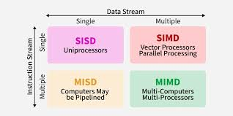

SISD (Single Instruction Single Data)
In SISD architecture, a single processor executes one instruction stream on one data stream at a time.
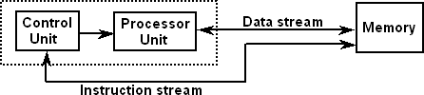

Characteristics
- Sequential execution
- Single control unit
- One processing unit
- No parallelism

Examples
- Traditional Von Neumann computers
- Early personal computers

Advantages
- Simple design
- Easy programming

Limitations
- Limited performance
- No parallel execution

SIMD (Single Instruction Multiple Data)

Definition
A single instruction controls multiple processing elements, which perform the same operation on different data elements simultaneously.
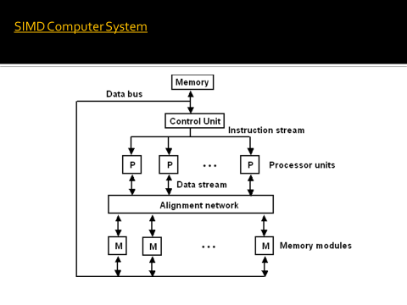

Characteristics
- Data-level parallelism
- Multiple ALUs
- Single control unit
- Used in vector processing

Examples
- Vector processors: Add A[i] + B[i] for i = 1 to 100 simultaneously
- Graphics Processing Units (GPU)

Advantages
- High throughput for data-parallel tasks
- Efficient for image processing, graphics, and scientific computing

Disadvantages
- Limited flexibility
- Not suitable for irregular computations

2.3 MISD (Multiple Instruction Single Data)

Definition
Multiple processors execute different instructions on the same data stream.
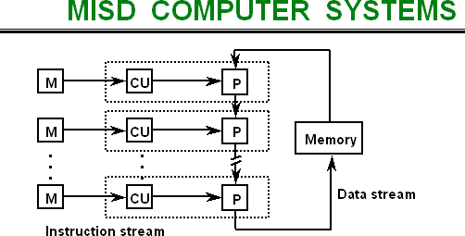

Characteristics
- Rare architecture
- Mainly theoretical

Example Applications
- Fault-tolerant systems
- Space and aerospace systems
Example:
Same sensor data processed by multiple algorithms to ensure reliability.

Advantages
- High reliability
- Fault tolerance

Disadvantages
- Complex design
- Rarely implemented

2.4 MIMD (Multiple Instruction Multiple Data)

Definition
Multiple processors execute different instructions on different data streams simultaneously.
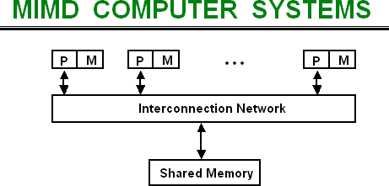

Characteristics
- True parallel computing
- Independent processors
- Shared or distributed memory

Examples
- Multicore processors
- Distributed systems
- Parallel supercomputers
Example:
Different processors performing different tasks in a parallel program.

Advantages
- Flexible
- High performance

Disadvantages
- Complex synchronization
- Communication overhead

Shared Memory Architectures
Shared memory architectures allow multiple processors to access a common memory space.
Two main types:
- UMA (Uniform Memory Access)
- NUMA (Non-Uniform Memory Access)

UMA (Uniform Memory Access) Architecture
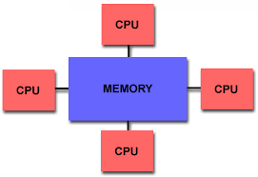
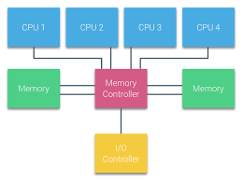

Definition
In UMA architecture, all processors access shared memory with equal access time.

Key Features
- Shared physical memory
- Uniform latency for memory access
- Processors connected via a bus or crossbar

Also Known As
Symmetric Multiprocessing (SMP)

Components
- Multiple CPUs
- Shared memory
- Interconnection network
- Cache memory

Advantages
- Simple programming model
- Easy resource sharing

Disadvantages
- Bus contention
- Limited scalability

Example Systems
- Early SMP servers
- Multicore CPUs with shared memory
NUMA (Non-Uniform Memory Access) Architecture

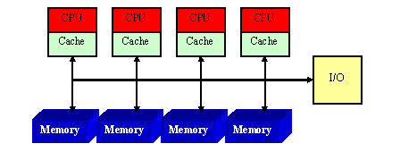

Definition
In NUMA architecture, memory is physically distributed among processors, and memory access time depends on memory location.

Key Concept
- Local memory access → Fast
- Remote memory access → Slow
Each processor has:
- Local memory
- High-speed interconnection network

Characteristics
- Scalable architecture
- Used in large servers and supercomputers

Advantages
- Better scalability
- Higher memory bandwidth

Disadvantages
- Complex programming
- Memory placement issues

Example Systems
- Modern high-performance servers
- Large-scale supercomputers
Difference Between UMA and NUMA
Feature | UMA | NUMA
Memory organization | Shared centralized memory | Distributed memory
Access time | Uniform | Non-uniform
Scalability | Limited | High
Complexity | Simple | Complex
Performance | Lower for large systems | Higher for large systems

