**To Install Script for Open SSL, OpenCV3.4.6**

OpenSSL - Installation under Windows

In some situations, it can be useful to generate a CSR using OpenSSL. This manual describes the installation of OpenSSL under Windows.

1. Download the [OpenSSL for Windows installation package](https://wiki.openssl.org/index.php/Binaries).
2. Double-click the installation file.
3. If the following error message appears, you should install Microsoft Visual C++ 2008 Redistributables. The installation file can be downloaded [here](http://www.microsoft.com/en-us/download/details.aspx?id=29). Graphical user interface, text, application

   Description automatically generated
4. Double-click the installation file and click on Next 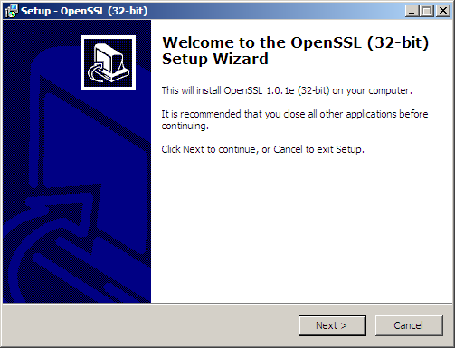
5. Click on I accept the agreement, followed by Next. 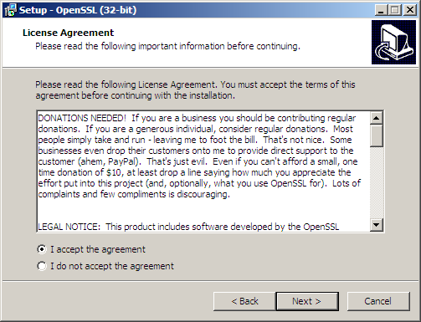
6. Leave the default installation path (C:\OpenSSL-Win32) and click on Next. 
7. Leave the default Startmenu folder(OpenSSL) and click on Next. 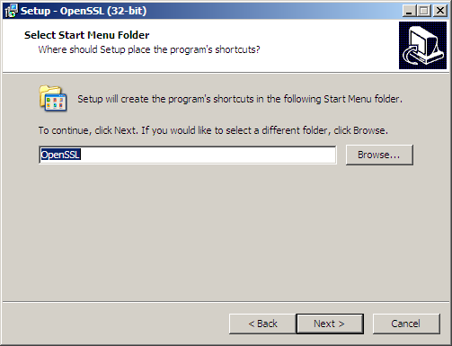
8. Leave the The Windows system directory and click on Next. 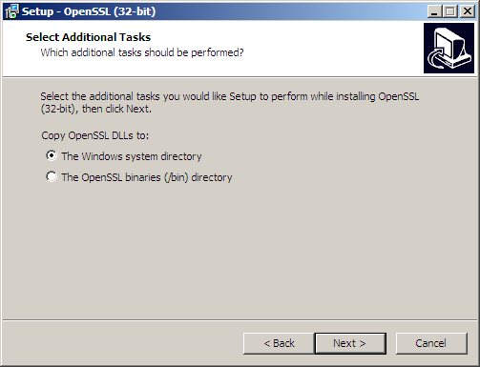
9. Click on Install. 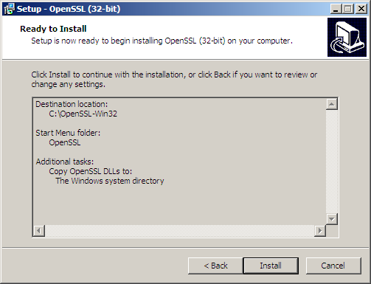
10. Click on Finish once the installation has been completed.

OpenSSL for Windows has now been installed and can be found as OpenSSL.exe in C:\OpenSSL-Win32\bin\. Always open the program as Administrator.  
Note: The following error message might appear when running OpenSSL:

WARNING: can't open config file: /usr/local/ssl/openssl.cnf

This can be solved as following:

1. Close OpenSSL.
2. Open a Command Prompt (CMD) as Administrator
3. Run the following command:SET OPENSSL_CONF=C:\OpenSSL-Win32\bin\openssl.cfg
4. Reboot the computer.

Reference : <https://www.xolphin.com/support/OpenSSL/OpenSSL_-_Installation_under_Windows>

Open CV 3.4.6

**Unofficial** pre-built OpenCV packages for Python.

### Installation and Usage

1. If you have previous/other manually installed (= not installed via pip) version of OpenCV installed (e.g. cv2 module in the root of Python's site-packages), remove it before installation to avoid conflicts.
2. Select the correct package for your environment:

There are four different packages and you should **select only one of them**. Do not install multiple different packages in the same environment. There is no plugin architecture: all the packages use the same namespace (cv2). If you installed multiple different packages in the same environment, uninstall them all with pip uninstall and reinstall only one package.

**a.** Packages for standard desktop environments (Windows, macOS, almost any GNU/Linux distribution)

* + run pip install opencv-python if you need only main modules
  + run pip install opencv-contrib-python if you need both main and contrib modules (check extra modules listing from [OpenCV documentation](https://docs.opencv.org/master/))

**b.** Packages for server (headless) environments

These packages do not contain any GUI functionality. They are smaller and suitable for more restricted environments.

* + run pip install opencv-python-headless if you need only main modules
  + run pip install opencv-contrib-python-headless if you need both main and contrib modules (check extra modules listing from [OpenCV documentation](https://docs.opencv.org/master/))

1. Import the package:

import cv2

All packages contain haarcascade files. cv2.data.haarcascades can be used as a shortcut to the data folder. For example:

cv2.CascadeClassifier(cv2.data.haarcascades + "haarcascade_frontalface_default.xml")

1. Read [OpenCV documentation](https://docs.opencv.org/master/)
2. Before opening a new issue, read the FAQ below and have a look at the other issues which are already open.

Reference : <https://pypi.org/project/opencv-python/3.4.6.27/>