**Project 2 Report**

**Sidharth Jahagirdar**

**ssj180009**

**1)ERD**

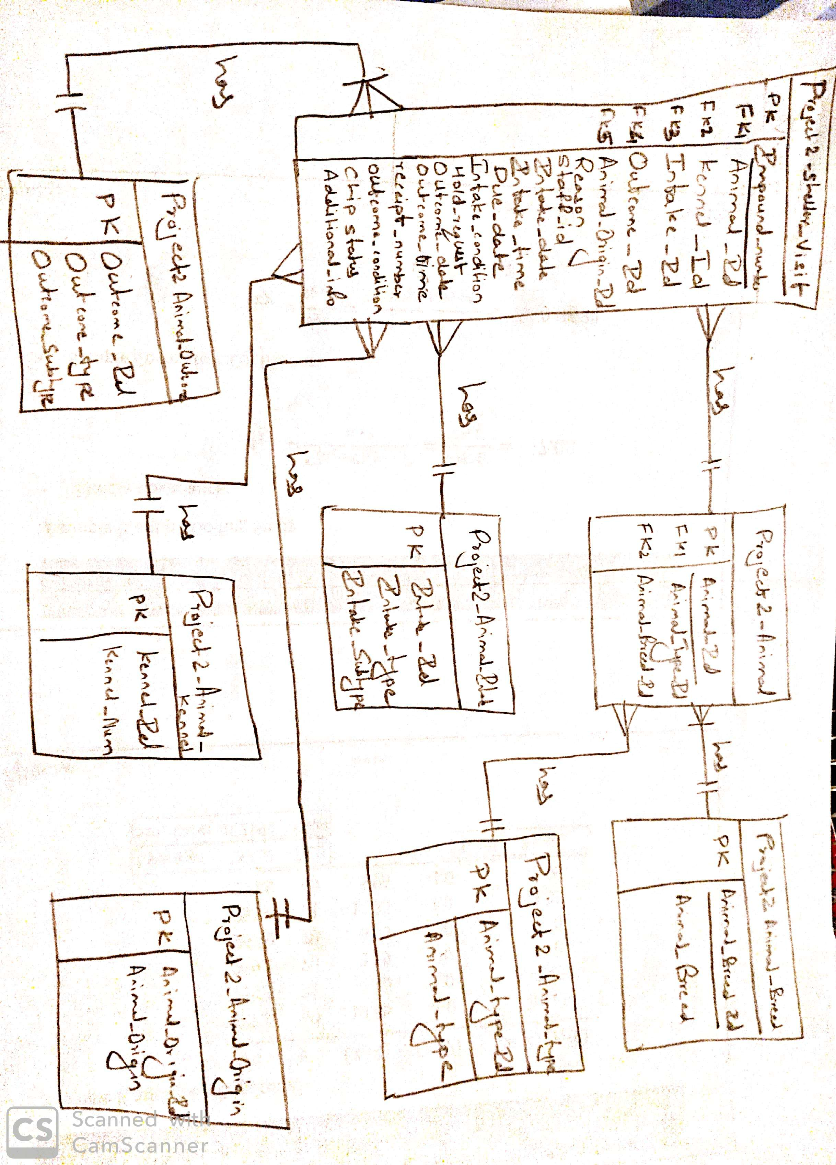

**2)Sql scripts to create and populate tables**

create table project2_animal_type as (select rownum as animal_type_id,animal_type from (select distinct animal_type from project2_data_load));

create table project2_animal_breed as (select rownum as animal_breed_id,animal_breed from (select distinct animal_breed from project2_data_load));

create table project2_animal_origin as (select rownum as animal_origin_id, animal_origin from (select distinct(animal_origin) from project2_data_load where animal_origin is not null) );

create table project2_animal_outcome as (select rownum as outcome_id, t1.* from(select outcome_type, outcome_subtype from project2_data_load group by outcome_type, outcome_subtype order by outcome_type, outcome_subtype)t1);

create table project2_animal_intake as (select rownum as intake_id, t1.* from(select intake_type, intake_subtype from project2_data_load group by intake_type, intake_subtype order by  intake_type, intake_subtype)t1);

create table project2_animal as (select  distinct pdl.animal_id, pat.animal_type_id,pab.animal_breed_id from project2_data_load pdl,project2_animal_type pat, project2_animal_breed pab where pdl.animal_type= pat.animal_type and pdl.animal_breed=pab.animal_breed);

create table project2_animal_kennel as (select rownum as kennel_id, kennel_number from (select distinct(kennel_number) from project2_data_load order by kennel_number));

create table  project2_shelter_visit as( select distinct pdl.impound_number, pdl.animal_id, pak.kennel_id,ai.intake_id,pdl.reason ,pdl.staff_id, pdl.intake_date, pdl.intake_time, pdl.due_out,pdl.intake_condition ,pdl.hold_request, ao.outcome_id, pdl.outcome_date,pdl.outcome_time,pdl.receipt_number, pdl.outcome_condition,pdl.chip_status, aor.animal_origin_id,pdl.additional_information from project2_data_load pdl, project2_animal an, project2_animal_intake ai, project2_animal_outcome ao, project2_animal_origin aor , project2_animal_kennel pak where pdl.animal_id=an.animal_id and (pdl.intake_type=ai.intake_type and pdl.intake_subtype=ai.intake_subtype) and (pdl.outcome_type=ao.outcome_type and pdl.outcome_subtype=ao.outcome_subtype) and (pdl.animal_origin=aor.animal_origin or nvl(pdl.animal_origin,'unknown')= aor.animal_origin) and pdl.kennel_number=pak.kennel_number);

alter table project2_animal_type add constraint proj2_animal_type_PK Primary key (Animal_type_id);

alter table project2_animal_source add constraint proj2_animal_source_PK Primary key (animal_source_id);

alter table project2_animal_breed add constraint proj2_animal_brerd_PK Primary key (Animal_breed_id);

alter table project2_animal_origin add constraint proj_animal_origin_PK Primary key (animal_origin_id);

alter table project2_animal_condition add constraint proj_animal_condition_PK Primary key (Condition_id);

alter table project2_animal_outcome add constraint proj2_animal_outcome_PK Primary key (outcome_id);

alter table project2_animal_intake add constraint proj2_animal_intake_PK Primary key (intake_id);

alter table PROJECT2_ANIMAL add constraint proj2_animal_id_PK Primary key (animal_id);

alter table PROJECT2_ANIMAL add constraint proj2_animal_type_FK foreign key (Animal_type_id) references project2_animal_type(Animal_type_id);

alter table PROJECT2_ANIMAL add constraint proj2_animal_breed_FK foreign key (Animal_breed_id) references project2_animal_breed(Animal_breed_id);

alter table project2_animal_kennel add constraint proj2_animal_kennel_id_PK Primary key (kennel_id);

alter table project2_shelter_visit add constraint proj2_shelter_visit_PK Primary key (impound_number);

alter table project2_shelter_visit add constraint proj2_shelter_animal_FK foreign key (animal_id) references project2_animal(animal_id);

alter table project2_shelter_visit add constraint proj2_shelter_kennel_FK foreign key (kennel_id) references project2_animal_kennel(kennel_id);

alter table project2_shelter_visit add constraint proj2_shelter_intake_FK foreign key (intake_id) references project2_animal_intake(intake_id);

alter table project2_shelter_visit add constraint proj2_shelter_outcome_FK foreign key (outcome_id) references project2_animal_outcome(outcome_id);

alter table project2_shelter_visit add constraint proj2_shelter_origin_FK foreign key (animal_origin_id) references project2_animal_origin(animal_origin_id);

**3)List of Normalized tables and count of records per table:**

Project2_Animal - 71823

project2_animal_type - 6

project2_animal_origin - 5

project2_animal_outcome - 80

project2_animal_breed -324

project2_animal_kennel - 1065

project2_shelter_visit – 87669

project2_animal_intake - 43

**4)Report Queries**

Report1)

select animal_type, animal_breed,percentage_of_animals_survived ,total_animals, year from

(select t1.animal_type, t1.animal_breed,round((t1.animals_survived/t2.total_animals)*100,2) as percentage_of_animals_survived, t1.animals_survived, t2.total_animals, t1.year from

(select project2_animal_type.animal_type, project2_animal_breed.animal_breed ,to_char(project2_shelter_visit.intake_date,'yyyy') as year, count(project2_animal_breed.animal_breed) as animals_survived

from project2_animal_type ,project2_animal_breed ,project2_shelter_visit , project2_animal ,project2_animal_outcome

where project2_shelter_visit.outcome_id=project2_animal_outcome.outcome_id

and project2_shelter_visit.outcome_id is not null

and project2_shelter_visit.animal_id=project2_animal.animal_id

and project2_animal_breed.animal_breed_id=project2_animal.animal_breed_id

and project2_animal.animal_type_id=project2_animal_type.animal_type_id

and project2_animal_outcome.outcome_type not in ('died','dead on arrival','euthanized')

and project2_animal_type.animal_type in ('cat','dog')

and to_char(project2_shelter_visit.intake_date,'yyyy')>='2016'

group by project2_animal_type.animal_type, project2_animal_breed.animal_breed,to_char(project2_shelter_visit.intake_date,'yyyy') having count(project2_animal_breed.animal_breed)>200 ) t1

inner join

(select project2_animal_type.animal_type, project2_animal_breed.animal_breed ,to_char(project2_shelter_visit.intake_date,'yyyy') as year, count(project2_animal_breed.animal_breed) as total_animals

from project2_animal_type ,project2_animal_breed ,project2_shelter_visit , project2_animal ,project2_animal_outcome

where project2_shelter_visit.outcome_id=project2_animal_outcome.outcome_id

and project2_shelter_visit.outcome_id is not null

and project2_shelter_visit.animal_id=project2_animal.animal_id

and project2_animal_breed.animal_breed_id=project2_animal.animal_breed_id

and project2_animal.animal_type_id=project2_animal_type.animal_type_id

and project2_animal_type.animal_type in ('cat','dog')

and to_char(project2_shelter_visit.intake_date,'yyyy')>='2016'

group by project2_animal_type.animal_type, project2_animal_breed.animal_breed,to_char(project2_shelter_visit.intake_date,'yyyy') having count(project2_animal_breed.animal_breed)>200 )t2

on t1.animal_breed=t2.animal_breed

and t1.animal_type=t2.animal_type

and t1.year=t2.year )

order by percentage_of_animals_survived desc ;

Report2)

select t1.intake_type, t1.outcome_type,t1.number_of_outcomes, round((t1.number_of_outcomes/t2.Total_intake_type)*100 ,2)as Percent_out_intake_typ,round((t3.Total_outcome_type/84630)*100,2) as Percent_total_outcomes,

round((t1.number_of_outcomes/t3.Total_outcome_type)*100,2) as Percent_out_outcome_typ

from (select project2_animal_intake.intake_type, project2_animal_outcome.outcome_type, count(project2_animal_outcome.outcome_type) as number_of_outcomes from project2_shelter_visit , project2_animal_intake , project2_animal_outcome , project2_animal_type, project2_animal

where project2_shelter_visit.intake_id=project2_animal_intake.intake_id

and project2_shelter_visit.outcome_id=project2_animal_outcome.outcome_id

and project2_shelter_visit.animal_id=project2_animal.animal_id

and project2_animal.animal_type_id=project2_animal_type.animal_type_id

and project2_animal_type.animal_type in ('CAT','DOG')

group by project2_animal_intake.intake_type, project2_animal_outcome.outcome_type order by project2_animal_intake.intake_type) t1,

(select project2_animal_intake.intake_type, count(project2_animal_intake.intake_type) as Total_intake_type from project2_shelter_visit , project2_animal_intake , project2_animal_outcome , project2_animal_type , project2_animal

where project2_shelter_visit.intake_id=project2_animal_intake.intake_id

and project2_shelter_visit.outcome_id=project2_animal_outcome.outcome_id

and project2_shelter_visit.animal_id=project2_animal.animal_id

and project2_animal.animal_type_id=project2_animal_type.animal_type_id

and project2_animal_type.animal_type in ('CAT','DOG')

group by project2_animal_intake.intake_type)t2,

(select project2_animal_outcome.outcome_type, count(project2_animal_outcome.outcome_type) as Total_outcome_type from project2_shelter_visit , project2_animal_intake , project2_animal_outcome , project2_animal_type , project2_animal

where project2_shelter_visit.intake_id=project2_animal_intake.intake_id

and project2_shelter_visit.outcome_id=project2_animal_outcome.outcome_id

and project2_shelter_visit.animal_id=project2_animal.animal_id

and project2_animal.animal_type_id=project2_animal_type.animal_type_id

and project2_animal_type.animal_type in ('CAT','DOG')

group by project2_animal_outcome.outcome_type)t3 where

t1.intake_type=t2.intake_type

and t1.outcome_type=t3.outcome_type;

**5) Report**

1)Report 1



2)Report 2

