OS-SENTINEL
AI-Powered Linux and Operating Systems Tutor
PROJECT REPORT
A Retrieval-Augmented Learning Platform with Command Risk Analysis
and Safe, Stateful Linux Simulation
Prepared by
Samarth Bhatnagar 24BCI0082
Sidharth Jain 24BKT0106
B.Tech — Computer Science and Engineering
Academic Year 2026–2027
Submitted to: ______________________________
Department: ________________________________
Institution: _________________________________

Abstract
OS-Sentinel is an AI-assisted educational application designed to help students understand Linux commands and foundational Operating Systems concepts through conversational tutoring, retrieval-augmented generation (RAG), command-impact analysis, and a stateful virtual environment. Conventional learning materials explain command syntax, but learners may not fully understand the resulting changes to files, directories, permissions, or processes. Executing unfamiliar commands on a personal machine can also cause unintended data loss or configuration changes.
The system combines a Streamlit-based interface with Python application logic, a semantic retrieval pipeline using Sentence Transformers and ChromaDB, a language-model tutoring layer, a deterministic command-risk layer, and a simulated Linux environment. The retrieval component uses the all-MiniLM-L6-v2 embedding model to identify relevant knowledge chunks. The risk layer classifies supported commands into SAFE, CAUTION, and HIGH IMPACT categories before the user inspects a simulated outcome. The virtual environment represents supported filesystem and process operations without invoking arbitrary shell commands on the host.
The educational workflow encourages learners to inspect a command, understand its components, consider its possible consequences, and observe the corresponding simulated state transition. The report describes the design, implementation approach, validation plan, limitations, and future development opportunities. Quantitative performance claims are intentionally not made because reproducible benchmark measurements and controlled learner-study data were not supplied for this report.
Keywords: Linux education, intelligent tutoring, large language models, retrieval-augmented generation, ChromaDB, Sentence Transformers, command-risk analysis, virtual filesystem, simulation-based learning.

Table of Contents
- 1. Introduction
- 2. Literature Review
- 3. Problem Statement
- 4. Project Objectives
- 5. Methodology and System Architecture
- 6. Results and Discussion
- 7. Limitations
- 8. Future Work
- 9. Conclusion
- 10. References
- Appendix A — Suggested Validation Checklist

1. Introduction

1.1 Background and Context
Linux and Unix-like operating systems are foundational to modern computing. They are widely used in servers, cloud infrastructure, software development environments, networking appliances, embedded platforms, and cybersecurity operations. Students entering computer science and information security therefore benefit from understanding the command-line interface, filesystem hierarchy, users and groups, permissions, process control, and system administration concepts.
The command line is powerful because short instructions can inspect or alter substantial portions of system state. Commands such as ls and pwd are generally observational, while mkdir, touch, cp, mv, and chmod modify state. Commands such as rm -rf, destructive redirections, disk-writing utilities, and privileged operations can have a much larger impact when used with incorrect paths or arguments. The same concise syntax that makes the shell efficient can make it difficult for a novice to predict consequences.
A beginner may memorize that chmod changes permissions without understanding the distinction between owner, group, and others, or the meaning of numeric permission notation. Similarly, knowing that kill sends a signal does not necessarily mean the learner understands process identifiers or the difference between graceful termination and SIGKILL. Effective instruction should connect syntax to system concepts and observable outcomes.

1.2 Motivation
The project is motivated by three educational gaps. First, static documentation is accurate and comprehensive but requires learners to translate descriptions into mental models. Second, a general-purpose conversational model can explain concepts naturally, but its answers may be incomplete, inconsistent with a course's preferred material, or insufficiently cautious about command effects. Third, practical experimentation on a real machine can be inappropriate when a student is learning destructive or privileged operations.
OS-Sentinel brings these activities into one learning workflow. It aims to make the command's potential impact visible, provide context from a curated knowledge base, and demonstrate supported operations in an application-managed virtual state rather than running arbitrary shell input on the host.

1.3 Scope of the Project
- Primary domain: introductory Linux command usage and selected Operating Systems concepts.
- Knowledge support: semantic retrieval over curated Linux and OS learning material.
- Command analysis: rule-based classification of recognized command patterns into SAFE, CAUTION, and HIGH IMPACT.
- Simulation: supported operations on virtual files, directories, permissions, and selected process records.
- Learning interaction: conversational explanation, command breakdown, prediction-oriented practice, and quiz or assessment interactions where enabled in the current build.
- Out of scope: replacing a real Linux shell, guaranteeing safe execution of arbitrary shell syntax, implementing a Linux kernel, or providing a production-grade security boundary.

1.4 Report Conventions and Evidence Boundary
This report uses the available OS-Sentinel project documentation and the supplied description of the current application as its implementation baseline. The report distinguishes implemented design elements from proposed extensions. Exact latency, retrieval precision, model accuracy, and educational learning gains are not asserted without repeatable measurements. Any feature whose exact availability depends on the latest source-code revision should be confirmed against the submitted build before final academic submission.

2. Literature Review

2.1 Traditional Operating Systems Laboratories and Documentation
Traditional OS laboratories provide direct experience with shells, filesystems, processes, permissions, and system utilities. Their main strength is authenticity: students can observe real operating-system behavior. Their limitations are that exercises are often fixed, explanations may be separated from the terminal, and mistakes can affect the lab environment. Man pages and official utility documentation provide precise reference material, but they are not inherently adaptive tutors and do not automatically model a student's misconceptions.

2.2 Intelligent Tutoring Systems
Intelligent Tutoring Systems (ITS) seek to provide individualized guidance by representing a subject domain, estimating aspects of learner understanding, and selecting suitable instructional responses. Survey literature describes recurring components such as domain knowledge, learner modelling, tutoring or pedagogical strategies, and an interaction interface [1], [2]. OS-Sentinel adopts a lightweight version of this pattern: curated Linux/OS content provides domain grounding; the student's questions and command choices provide interaction context; and the tutor layer generates explanations and concept checks.

2.3 Large Language Models in Education
Large language models can generate natural-language explanations, examples, hints, and follow-up responses. This makes them useful for conversational learning, particularly when a learner asks an unanticipated question. However, generated answers are probabilistic and may be inaccurate, overconfident, or insufficiently aligned with a particular syllabus. A language model should therefore not be the sole authority for command safety or system-state mutation. OS-Sentinel separates explanatory generation from deterministic command analysis and simulation logic.

2.4 Retrieval-Augmented Generation
Retrieval-Augmented Generation combines an information-retrieval component with a generative model. Rather than relying only on information encoded in model parameters, the system retrieves relevant external passages and supplies them as context to the generator. Lewis et al. describe RAG as a combination of parametric memory and non-parametric retrieved memory, improving the ability to ground generation in explicit knowledge sources [3].
In OS-Sentinel, Sentence Transformers produce semantic vector representations of knowledge chunks and user queries. The all-MiniLM-L6-v2 model is used as the embedding model in the documented design. ChromaDB stores embeddings alongside documents and metadata, enabling similarity-based retrieval. Sentence-BERT research provides the methodological basis for generating sentence embeddings that can be compared efficiently for semantic similarity [4].

2.5 Command Analysis and Static Checking
Static command analysis tools can identify classes of shell-script issues without executing the script. ShellCheck, for example, is designed to detect common shell scripting problems and provide diagnostic guidance [5]. Such tools are valuable for syntax and script-quality feedback, but they do not by themselves provide a complete interactive teaching environment or a stateful visual simulation of every command. OS-Sentinel's command-risk layer has a narrower educational purpose: it recognizes selected command patterns and communicates likely impact.

2.6 Containers, Sandboxes, and Simulation
Containers and virtual machines are widely used to isolate workloads and create repeatable laboratory environments. They offer stronger behavioral fidelity than a custom in-memory model, but they require configuration and resource management, and container isolation should not be described as an absolute security guarantee. A custom virtual filesystem takes a different approach: it implements a limited set of state transitions inside the application. This can reduce exposure to host-side changes, but it does not reproduce all semantics of a real Linux kernel or shell.

2.7 Comparative Analysis
Approach | Strengths | Limitations relative to OS-Sentinel's goal
Man pages / textbooks | Authoritative detail; broad coverage | Primarily reference-oriented; no persistent simulated state or adaptive dialogue
General LLM chatbot | Flexible natural-language conversation | May hallucinate; course grounding and command safety are not inherent
RAG-based tutor | Uses external domain knowledge to ground responses | Retrieval quality depends on corpus, chunking, metadata, and query design
Static shell checker | Can flag known script and syntax issues | Not a complete natural-language tutor or stateful OS simulator
Container / VM lab | High-fidelity real command behavior in isolation | Requires environment management; isolation still needs careful configuration
OS-Sentinel | Combines retrieval, tutoring, risk labels, and controlled simulation | Limited to implemented command coverage; not a real shell or formal security boundary

2.8 Research Gap
The reviewed approaches suggest a useful design opportunity: combine domain-grounded explanation, explicit command-impact reasoning, and observable state changes in a single beginner-oriented workflow. OS-Sentinel's contribution is an educational integration of these elements rather than a claim to have invented RAG, intelligent tutoring, command parsing, or filesystem simulation.

3. Problem Statement

3.1 Core Problem
Students learning Linux often encounter a gap between knowing a command's syntax and understanding its operational consequences. Documentation is usually passive, generic chatbots may not be grounded in course material, and direct experimentation with unfamiliar commands may modify or delete real data. There is a need for an interactive learning application that explains Linux commands using relevant knowledge sources, identifies potentially high-impact operations, and demonstrates supported outcomes in a controlled virtual environment.

3.2 Specific Challenges
- Insufficient consequence awareness: novice users may not anticipate recursive deletion, broad permission changes, or forced process termination.
- Fragmented learning workflow: command references, explanations, practical exercises, and assessment often exist in separate tools.
- Lack of course-specific grounding: generic model responses may not reflect the terminology or material expected in a particular course.
- Risk of host modification: unrestricted command execution is inappropriate for a teaching interface intended for beginners.
- Limited feedback: a learner may receive a correct command without understanding why it works or what state it changes.

3.3 Proposed Solution
OS-Sentinel addresses these challenges through a modular application. It accepts a command or conceptual question, analyzes recognized command patterns, retrieves relevant knowledge, generates a pedagogical response, and—where the command is supported—updates or displays a simulated state. The design deliberately avoids passing arbitrary user input to the host shell. The tutor explains; the risk engine classifies; the virtual environment simulates.

4. Project Objectives

4.1 Primary Objective
To develop an interactive, safety-aware Linux and Operating Systems learning platform that combines RAG-grounded tutoring, deterministic command-impact analysis, and controlled simulation so that learners can understand commands through explanation and observable outcomes.

4.2 Specific Objectives
- Build a curated knowledge collection covering common Linux commands and foundational OS concepts.
- Clean and segment learning material into meaningful chunks and attach useful source and topic metadata.
- Generate semantic embeddings using Sentence Transformers and store them in ChromaDB.
- Retrieve relevant knowledge for a student's command or natural-language question.
- Provide conversational explanations that break down command names, arguments, flags, and likely effects.
- Classify recognized commands into SAFE, CAUTION, and HIGH IMPACT categories using explicit analysis rules.
- Represent supported file, directory, permission, and process operations in an application-managed virtual environment.
- Encourage active learning through prediction, comparison, and concept-check interactions.
- Keep the architecture modular so that new commands, topics, and assessment activities can be added incrementally.

4.3 Functional Requirements
ID | Requirement
FR-01 | The interface shall accept Linux commands and natural-language OS questions.
FR-02 | The application shall provide a risk category and an explanatory reason for recognized command patterns.
FR-03 | The RAG component shall retrieve relevant knowledge chunks from the configured collection.
FR-04 | The tutor shall produce an understandable explanation and support follow-up questions.
FR-05 | Supported commands shall operate on virtual state rather than the host filesystem.
FR-06 | The interface shall display relevant virtual filesystem or process-state changes where supported.
FR-07 | Learning interactions shall provide feedback or concept checks where enabled.
FR-08 | Unsupported commands shall be identified as unsupported or outside the simulation scope rather than executed on the host.

4.4 Non-Functional Requirements
- Safety by design: no arbitrary command string should be passed to the host operating-system shell.
- Maintainability: retrieval, tutoring, risk analysis, and simulation should remain separable modules.
- Usability: explanations and risk labels should be understandable to a beginner.
- Traceability: knowledge records should retain source metadata where available.
- Reliability: unsupported syntax and simulation errors should be handled without corrupting virtual state.
- Privacy: minimize stored learner information and disclose when an external model API receives a prompt.

5. Methodology and System Architecture

5.1 Development Methodology
The project follows an iterative prototype-development approach. The application is divided into independently testable components. Initial development focuses on a small set of high-value Linux commands and concepts; command coverage and educational interactions can then be expanded based on testing. This approach reduces the risk of building a broad interface before validating the core learning workflow.
- Identify the syllabus concepts and commands to support.
- Collect and curate source material; retain provenance and topic labels.
- Clean, segment, and index documents in the vector database.
- Implement the user interface and conversational request flow.
- Implement command recognition and risk classification independently of model output.
- Implement virtual state objects and command handlers for supported operations.
- Connect retrieval context to the language-model tutoring prompt.
- Validate command classification, retrieval relevance, simulation state, and error handling.
- Conduct usability review and record measurable evaluation results.

5.2 High-Level Architecture
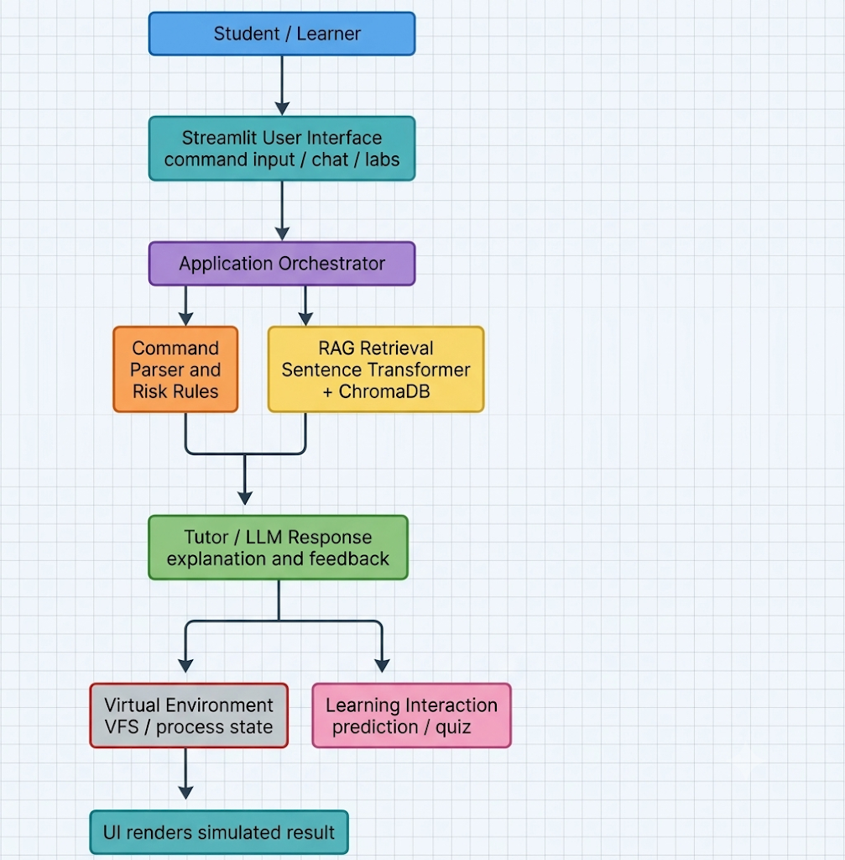
Figure 1. Logical architecture of OS-Sentinel. The diagram represents the documented design; exact call order may vary by feature and current application revision. The language model is not the authority for virtual state mutation or risk classification.

5.3 User Interface Layer
The application uses Streamlit to provide a browser-accessible interface implemented in Python. The interface is the learner's entry point for submitting commands, asking conceptual questions, inspecting risk information, and viewing supported simulated results. Streamlit is suitable for this prototype because it provides interactive data-app components without requiring a separate frontend framework [6].

5.4 Command Studio and Risk Analysis
The command-analysis component examines command text and identifies recognized utilities, options, privilege indicators, and potentially destructive patterns. The documented classification uses three educational categories:
Category | Interpretation | Illustrative examples
SAFE | Normally observational or low-impact in the supported context | pwd, ls -la, ps
CAUTION | Changes virtual state or may have meaningful side effects | mkdir project, touch file.txt, cp a.txt b.txt, chmod 644 file.txt
HIGH IMPACT | Can cause broad or difficult-to-reverse changes, especially with elevated privilege or dangerous targets | rm -rf target, chmod 777 file.txt, kill -9 PID, sudo or disk-writing operations

The category is a heuristic classification, not a formal proof of safety. Risk depends on context: target path, current directory, permissions, shell expansion, aliases, environment variables, command chaining, and privilege level can alter behavior. For this reason, a SAFE label must never be interpreted as a guarantee that arbitrary shell input is harmless. The classifier should prefer a conservative UNKNOWN/UNSUPPORTED outcome when syntax is not confidently recognized.

5.5 Retrieval-Augmented Generation Pipeline
The RAG subsystem is designed to provide the tutor with relevant domain context. Its main stages are:
- Source preparation: collect Linux manual-page material, command documentation, approved course notes, and project-authored explanations.
- Cleaning and chunking: normalize formatting while preserving command syntax, examples, warnings, and technical terms.
- Embedding: encode each chunk with all-MiniLM-L6-v2 using Sentence Transformers.
- Indexing: store vectors, text, and metadata in a ChromaDB collection.
- Query encoding: embed the learner's command or natural-language question using the same embedding model.
- Retrieval: perform similarity search and select relevant chunks.
- Prompt construction: combine the question, retrieved context, and tutoring instructions.
- Generation: produce a contextual explanation and invite follow-up learning.
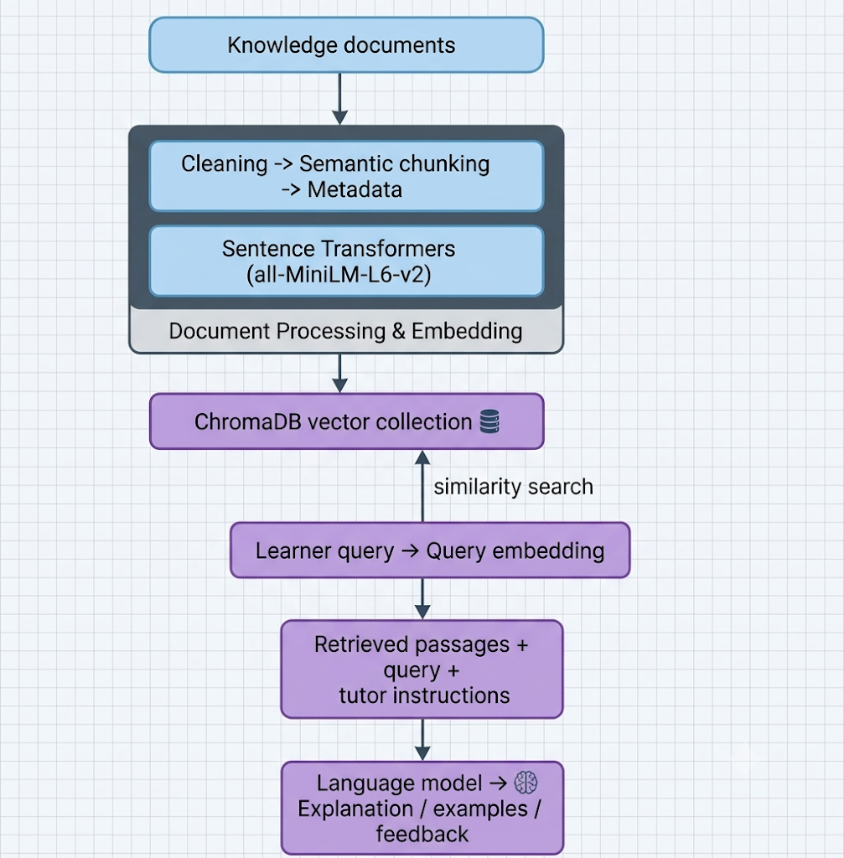
ChromaDB collections group embeddings, documents, and metadata for retrieval [7]. Sentence-BERT research describes sentence-level embeddings suitable for semantic similarity comparison [4]. Retrieval can improve grounding, but it does not guarantee factual correctness: poor source quality, irrelevant chunks, stale documentation, or an ambiguous query can still lead to a weak answer.

5.6 AI Tutor Chat
The tutor layer converts the learner's question and retrieved context into an accessible explanation. For command-focused questions, a useful response should identify the command, explain each argument or flag, describe the likely effect, relate the operation to an OS concept, and clarify any important caveat. The conversation should support follow-up questions rather than treating each input as an isolated syntax-validation task.
The LLM is a pedagogical component, not a safety enforcement mechanism. It should not be allowed to override the deterministic risk result or to issue direct host-execution instructions to the simulator. Where a configured hosted API is used, the application is not fully offline: prompt data is transmitted to that provider according to the provider's API terms and configuration. Local vector retrieval does not by itself make the entire application offline.

5.7 Virtual Sandbox and Virtual Filesystem
The virtual environment is an application-level simulation, not a Linux container or kernel sandbox. It maintains an internal representation of filesystem objects and selected process records. A virtual file or directory can contain attributes such as name, parent relationship, object type, permissions, and content. A process record can contain a simulated PID, command label, and state.
Virtual operation | Expected simulated effect
pwd | Display the virtual current working directory.
ls | List virtual entries in the current or specified virtual directory.
mkdir name | Create a directory object in virtual state.
touch name | Create an empty virtual file or update its simulated timestamp, according to handler behavior.
cat file | Display content stored in a virtual file.
cp source destination | Copy a supported virtual file or directory according to implemented semantics.
rm target | Remove supported virtual objects from the virtual tree; recursive behavior must be validated.
chmod mode target | Update the simulated permission representation.
ps | Display simulated process records.
kill PID | Update a matching simulated process state when supported.

The key safety property is architectural: user input should be parsed into a restricted set of known operations, and those operations should mutate only in-memory or application-managed virtual state. A secure implementation must not use Python subprocess, os.system, shell=True, or equivalent host-shell pathways for raw learner input. This property should be confirmed through code review and negative tests before the project is described as isolated.

5.8 Permission Representation
Linux permission notation is an important teaching example. In a three-digit octal mode, each digit represents the read, write, and execute bits for owner, group, and others. The values are computed as read = 4, write = 2, execute = 1. For example, 755 corresponds to rwx for the owner and r-x for group and others; 644 corresponds to rw- for the owner and r-- for group and others. The simulation should display the permission string and numeric representation consistently.
Mode | Owner | Group | Others | Typical interpretation
644 | rw- | r-- | r-- | Owner can read/write; group and others can read
755 | rwx | r-x | r-x | Owner can read/write/execute; others can read/execute
777 | rwx | rwx | rwx | All classes receive read/write/execute; often excessive for ordinary files

5.9 Adaptive Quiz and Active Learning
The project description includes quiz-oriented and prediction-oriented learning interactions. These activities can ask the learner to predict a command's risk or effect before revealing the explanation, then provide corrective feedback. This supports retrieval practice and reflection. If a persistent learner model is not implemented in the submitted build, the report should describe the quiz as interactive assessment rather than claiming fully adaptive personalization. True adaptivity requires recorded evidence of performance, a defined learner-state representation, and a rule for selecting subsequent question difficulty or topic.

5.10 Technology Stack
Layer | Technology / component | Role
Application UI | Python, Streamlit | Interactive web interface
Core logic | Python | Orchestration, command handling, simulation
Embeddings | Sentence Transformers | Semantic vector representations
Embedding model | all-MiniLM-L6-v2 | Encode documents and learner queries
Vector store | ChromaDB | Store and retrieve knowledge chunks
Tutor model | Configured LLM/API integration | Natural-language explanation and dialogue
Risk analysis | Python rules / command recognition | Deterministic risk categorization
Simulation | Custom virtual filesystem and process state | Safe, restricted command-effect demonstration

5.11 Security and Safety Design Principles
- Never execute arbitrary learner-provided strings on the host operating system.
- Use an allowlist of explicitly supported commands and parse arguments into structured operations.
- Treat unknown syntax, command substitution, pipelines, redirection, globbing, and chaining as unsupported unless correctly parsed.
- Keep the risk classifier separate from the LLM response and from the simulator's mutation logic.
- Validate virtual paths and enforce boundaries within the virtual tree.
- Keep test fixtures and virtual state isolated from real user files.
- Display simulation status clearly so that learners do not mistake a simulated result for a real Linux execution.
- Log errors and test outcomes without unnecessarily storing sensitive learner input.

6. Results and Discussion

6.1 Prototype Capabilities
The project documentation describes a prototype organized around a Streamlit interface, RAG knowledge retrieval, a command-risk layer, conversational tutoring, and a virtual environment for supported Linux operations. The central design benefit is that these components serve different responsibilities: retrieval supplies domain context, the LLM explains, the risk layer classifies known patterns, and the simulator represents a constrained set of effects.

6.2 Functional Validation Matrix
Test ID | Input / scenario | Expected result | Evidence to capture
T-01 | pwd | Displays virtual working directory | Screenshot and output log
T-02 | mkdir demo | Creates demo directory in virtual tree only | Before/after tree state
T-03 | touch notes.txt | Creates virtual file | Before/after tree state
T-04 | chmod 755 script.sh | Updates simulated permission bits and display | Mode value and symbolic display
T-05 | rm -rf demo | Classifies high impact and removes only supported virtual target after simulation flow | Risk explanation and before/after state
T-06 | chmod 777 file.txt | Flags broad permissions and explains owner/group/others | Risk result and permission panel
T-07 | kill -9 simulated_PID | Explains SIGKILL and changes only matching virtual process state | Process table before/after
T-08 | Unknown command or shell chaining | Rejects or marks unsupported; does not execute on host | Error response and code-path review
T-09 | Natural-language permissions question | Retrieves relevant permission knowledge and explains it | Retrieved source metadata and answer
T-10 | Follow-up question in tutor chat | Maintains relevant conversational context | Multi-turn transcript

6.3 Interpretation of Results
The validation matrix defines what should be demonstrated and recorded; it is not a claim that every test has already passed. A completed evaluation should attach screenshots, test logs, and source-code references for each implemented behavior. In particular, destructive-command tests should demonstrate both the risk warning and the absence of host-side mutation. The strongest evidence is a before-and-after comparison of the virtual tree together with a controlled check that no corresponding host file was created or deleted.

6.4 RAG Evaluation
RAG quality should be assessed independently from the fluency of the generated answer. A recommended test set should include exact command queries, paraphrased conceptual questions, ambiguous questions, and questions whose answers are absent from the corpus. For each query, record the expected source topic, the top-k retrieved chunks, their relevance, and whether the generated response accurately reflects them. Useful measures include Precision@k, Recall@k, Mean Reciprocal Rank, and a human relevance score. No numerical RAG accuracy or latency value is reported here because no measured evaluation dataset was provided.

6.5 Performance Evaluation
Performance should be measured separately for embedding, vector retrieval, model generation, and total end-to-end response time. Report the hardware, software versions, dataset size, number of repetitions, warm-up policy, and whether the model was local or remote. Hosted-model latency includes network and provider-side effects and should not be presented as local inference latency. A claim such as 'retrieval under 150 ms' should only be included after repeated measurements on the submitted configuration.

6.6 Pedagogical Discussion
The design encourages a sequence of prediction, explanation, simulation, and feedback. A learner can first reason about whether a command is observational or state-changing, then compare that prediction with the risk classification and simulated result. This structure may help connect command syntax to filesystem permissions and process concepts. However, a claim of improved learning outcomes requires a study involving learners, a defined assessment instrument, and a comparison or pre-test/post-test design. The current report therefore discusses pedagogical rationale rather than asserting measured learning gains.

6.7 Comparison with Baseline Approaches
Criterion | Static documentation | General chatbot | OS-Sentinel design
Command explanation | Reference text | Conversational | Conversational and domain-retrieval supported
Course grounding | Depends on chosen reference | Not inherent | Curated RAG corpus
Risk indication | Warnings in documentation | May be inconsistent | Separate rule-based category for recognized patterns
Stateful practice | External lab required | Usually not inherent | Restricted virtual state simulation
Host safety | Depends on learner environment | No execution boundary by default | Designed not to execute arbitrary commands on host
Learning feedback | Mostly self-directed | Dialogue possible | Command-focused dialogue plus prediction/quiz interactions

7. Limitations

7.1 Simulation Fidelity
The virtual filesystem is a simplified model. It does not implement the complete POSIX filesystem API, kernel permission checks, mount behavior, symbolic-link edge cases, file descriptors, race conditions, ACLs, extended attributes, filesystem journaling, or every GNU utility option. A simulated chmod or rm operation should therefore be described as an educational approximation.

7.2 Command Parsing and Coverage
Rule-based pattern recognition may fail on complex shell syntax, quoting, escaped characters, command substitutions, pipes, redirection, environment variables, aliases, wildcard expansion, and chained commands. A simple keyword match is not equivalent to parsing shell grammar. The classifier should state its coverage boundaries and treat uncertain input conservatively.

7.3 Risk Classification Is Contextual
A command's risk cannot always be inferred from its name alone. The target path, current directory, permissions, mounted volumes, privilege level, and surrounding shell expression can materially change impact. Risk labels are educational indicators, not formal guarantees or substitutes for operator judgment.

7.4 RAG Quality and Knowledge Freshness
Retrieval quality depends on the source corpus, document chunking, metadata, embedding model, similarity metric, and retrieval configuration. An outdated or incorrect source can be retrieved accurately but still produce an incorrect answer. The corpus requires maintenance, provenance tracking, and periodic technical review.

7.5 Model and Network Dependency
The tutoring experience depends on the configured language model. If a hosted API is used, connectivity, API availability, rate limits, cost, and provider-side model changes can affect operation. In that configuration, the system is not fully offline even if embeddings and vector search run locally. Local inference can reduce network dependence but introduces hardware and model-management requirements.

7.6 Evaluation Limitations
No controlled learner study, verified latency benchmark, retrieval benchmark, or formal safety audit is claimed in this report. The prototype's educational effectiveness and completeness of command handling remain subjects for systematic evaluation.

7.7 Scope of Operating Systems Concepts
The initial emphasis is Linux command learning, filesystem concepts, permissions, and selected process operations. It does not yet represent the full range of OS topics such as CPU scheduling, virtual memory, synchronization, deadlock handling, kernel internals, device drivers, or distributed operating systems.

8. Future Work

8.1 Shell-Aware Parsing
Replace basic pattern matching with a parser that can safely recognize command tokens, quoting, argument boundaries, pipelines, redirection, and chaining. Unsupported constructs should remain blocked from simulation until their semantics are implemented and tested.

8.2 Expanded Virtual Operating System
Extend the virtual model with symbolic links, ownership, groups, more complete permission semantics, environment variables, process hierarchies, signals, and a larger but explicitly allowlisted command set.

8.3 Better RAG Evaluation and Provenance
Add source citations in tutor responses, document versioning, retrieval-score inspection, curated benchmark questions, and automated relevance evaluation. Add a mechanism to flag missing or contradictory knowledge.

8.4 Local LLM Option
Provide a configurable local model backend for environments where offline operation or data locality is required. Benchmark memory use, token throughput, response quality, and hardware requirements before making performance claims.

8.5 Adaptive Learner Model
Represent learner progress by topic, question history, repeated misconceptions, and demonstrated mastery. Use transparent rules to select follow-up questions and adjust difficulty; provide controls for data retention and deletion.

8.6 Broader OS Simulators
Introduce separate visual modules for CPU scheduling, page replacement, memory allocation, deadlock detection, synchronization, and system-call tracing. Each simulator should expose its assumptions and state transitions.

8.7 Multi-User and Collaborative Labs
Support isolated sessions, persistent lab snapshots, reset/restore, and concurrent users. WebSocket-based interaction may be considered if real-time collaboration becomes a requirement.

8.8 Formal Safety Testing
Add adversarial tests for traversal attempts, shell metacharacters, malformed arguments, unexpected Unicode, command chaining, and state corruption. Conduct code review to confirm that learner input cannot reach host execution APIs.

8.9 eBPF and Host Telemetry — Optional Research Direction
A future research prototype could observe selected host events using eBPF in a carefully permissioned, opt-in environment. This must remain separate from the safe virtual sandbox and should not be presented as a prerequisite for the current educational product.

9. Conclusion
OS-Sentinel addresses a practical challenge in Linux and Operating Systems education: students need to understand not only what a command looks like, but also what it changes and why that change matters. The project brings together a conversational tutor, a domain-specific retrieval pipeline, a rule-based command-risk layer, and an application-managed virtual environment. This architecture connects explanation with controlled experimentation.
The use of Sentence Transformers and ChromaDB provides a mechanism for retrieving relevant course and command knowledge, while the language-model layer supports flexible, multi-turn explanation. The deterministic risk component provides a transparent first-pass indication of potential impact, and the virtual filesystem demonstrates selected state changes without requiring arbitrary command execution on the learner's host machine.
The project's value lies in this integration and its educational workflow, not in claiming that a language model alone guarantees correctness or safety. The simulator is intentionally limited, risk classification is contextual, and retrieval quality depends on the corpus. Future work should prioritize robust parsing, broader test coverage, measurable RAG evaluation, stronger provenance, and a controlled learner study. With these improvements, OS-Sentinel can develop into a more complete environment for learning Linux and foundational Operating Systems concepts.

10. References
[1] A. Alkhatlan and J. Kalita, “Intelligent Tutoring Systems: A Comprehensive Historical Survey with Recent Developments,” International Journal of Computer Applications, vol. 181, no. 43, pp. 1–20, 2019, doi: 10.5120/ijca2019918451.
[2] O.-A. Cuéllar-Rojas, M. Hincapié-Montoya, M. Contero, and D. Güemes-Castorena, “Bibliometric analysis and systematic literature review of the intelligent tutoring systems,” Frontiers in Education, vol. 7, 2022, doi: 10.3389/feduc.2022.1047853.
[3] P. Lewis et al., “Retrieval-Augmented Generation for Knowledge-Intensive NLP Tasks,” in Advances in Neural Information Processing Systems, vol. 33, 2020. [Online]. Available: https://arxiv.org/abs/2005.11401.
[4] N. Reimers and I. Gurevych, “Sentence-BERT: Sentence Embeddings using Siamese BERT-Networks,” in Proc. EMNLP-IJCNLP, 2019, pp. 3982–3992, doi: 10.18653/v1/D19-1410.
[5] ShellCheck, “ShellCheck: A shell script static analysis tool.” [Online]. Available: https://www.shellcheck.net/ (accessed Oct. 24, 2026).
[6] Streamlit, “Streamlit Documentation.” [Online]. Available: https://docs.streamlit.io/ (accessed Oct. 24, 2026).
[7] Chroma, “Chroma Documentation and Cookbook.” [Online]. Available: https://cookbook.chromadb.dev/ (accessed Oct. 24, 2026).
[8] Linux man-pages project, “Linux manual pages.” [Online]. Available: https://www.kernel.org/doc/man-pages/ (accessed Oct. 24, 2026).
[9] Python Software Foundation, “Python 3 Documentation.” [Online]. Available: https://docs.python.org/3/ (accessed Oct. 24, 2026).
[10] OpenAI, “API Documentation.” [Online]. Available: https://platform.openai.com/docs/ (accessed Oct. 24, 2026). Include this reference only if the submitted implementation uses the OpenAI API.

