Does Causal Decomposition Improve Residential Load Forecasting? A Leakage-Aware, Multi-Dataset Reproducibility Study of a Decomposition-Augmented Transformer
Sidharth Jain¹, Aditya Chhabra², Shubham Hazra³, Inba Senthil Kumar⁴, Sathya K⁵,*
¹ ² ³ ⁴ Student, School of Computer Science and Engineering, Vellore Institute of Technology (VIT), Vellore, India
⁵ Assistant Professor Senior Grade 2, School of Computer Science and Engineering, Vellore Institute of Technology (VIT), Vellore, India
* Corresponding author: Sathya K, sathya.k@vit.ac.in

Abstract
Short-term forecasting of household electricity demand is challenging because individual load series are non-stationary, intermittent, and sensitive to evaluation design. This study evaluates whether causal, window-level signal decomposition improves direct 24-hour residential load forecasting from historical load alone using a Decomposition-Augmented Transformer (DAT). Corrected, leakage-aware reconstructions are reported for the UCI Household Power Consumption and MORED Premises 6 datasets, using chronological evaluation, training-only scaling, and no interpolation of missing or invalid readings. On UCI, the Vanilla Transformer achieved the lowest RMSE (0.782735 ± 0.009840 kW), while DAT achieved 0.994470 ± 0.033898 kW. On MORED, a whole-recording-session split yielded 245 training, 119 validation, and 359 test windows, with the test windows spanning four original recording sessions. LSTM achieved the lowest mean RMSE (126.118 ± 0.207 W) and MAE (85.970 ± 0.107 W), narrowly ahead of the Vanilla Transformer (126.478 ± 0.185 W RMSE; 86.924 ± 0.075 W MAE); DAT achieved 128.751 ± 0.390 W RMSE and 89.323 ± 0.409 W MAE. MORED session-cluster inference remains underpowered: all exact two-sided sign-test p-values were 0.125 and all Holm-adjusted p-values were 1.000. All six MORED models had negative R² and forecast dispersion below target dispersion. London is reported separately as a controlled boundary end-effect mitigation (BES) case study on household MAC000147. BES-off DAT achieved RMSE 0.164207 ± 0.002561 and MAE 0.108367 ± 0.002577; BES-on achieved RMSE 0.164217 ± 0.002546 and MAE 0.108376 ± 0.002560. The findings do not demonstrate an accuracy benefit from decomposition or BES in these experiments and do not establish generalisation across households.
Keywords: residential load forecasting; signal decomposition; Transformer; reproducibility; multi-horizon forecasting; smart grids.

1 Introduction
Smart meters and advanced metering systems provide high-resolution records of household electricity consumption. Short-term load forecasting (STLF), which predicts demand from minutes ahead to approximately one day, supports demand response, dynamic pricing, economic dispatch, and distribution-grid operation (Hernandez et al., 2014; Hong and Fan, 2016; International Energy Agency, 2023).
Household load is harder to predict than aggregate or commercial demand. Occupancy, appliance use, lifestyle, and socioeconomic factors produce non-stationary consumption with abrupt appliance-driven peaks over a slowly varying baseline. Individual households also lack the smoothing effect of aggregation, leaving a lower signal-to-noise ratio and highly variable dynamics (Wang et al., 2016; Kong et al., 2019).
Classical methods such as ARIMA and exponential smoothing rely on assumptions that may not hold for residential load (Hippert et al., 2001; Box et al., 2015). Recurrent networks such as LSTM and GRU learn nonlinear dependencies (Hochreiter and Schmidhuber, 1997; Cho et al., 2014), while Transformer models use attention to model temporal structure in parallel (Vaswani et al., 2017; Zhou et al., 2021; Wu et al., 2021; Nie et al., 2023). Signal decomposition, including EMD-family methods and VMD, can expose components at different temporal scales (Huang et al., 1998; Wu and Huang, 2009; Torres et al., 2011; Dragomiretskiy and Zosso, 2014).
However, decomposition can introduce information leakage if performed on a full series before chronological splitting or if input representations incorporate observations beyond a forecast origin. Forecast-evaluation guidance identifies preprocessing leakage as a recurrent risk (Hewamalage et al., 2023), and research on EMD-family decomposition has documented leakage concerns and proposed window-wise alternatives (Yang et al., 2024). Residential forecasting studies also differ in their use of weather variables, forecasting architecture, and evaluation protocol, making broad conclusions from a single benchmark difficult.
Decomposition-augmented Transformers have already been explored, so the central question here is evaluative rather than a claim of architectural novelty (Ran et al., 2023; Ye et al., 2024; Liu et al., 2024a; Yang et al., 2024). This study separates two kinds of evidence: (i) corrected five-seed model comparisons on UCI and MORED, using an origin-block analysis for UCI and an original-recording-session clustered analysis for MORED; and (ii) a new controlled London Smart Meter experiment that isolates a boundary end-effect mitigation strategy on one household. The London experiment is not treated as a multi-household benchmark and is not compared numerically with unrecoverable historical London scores.
The revised contributions are as follows:
- A leakage-aware evaluation protocol that decomposes each observed look-back window using only information available by that window’s forecast origin.
- Corrected reproducibility reconstructions on UCI and MORED comparing DAT with recurrent, linear, attention-based, and zero-shot forecasting baselines, using five-seed summaries and dependence-aware statistical analyses at the forecast-origin-block (UCI) and original-recording-session (MORED) levels.
- A corrected five-seed London BES ablation, reported as a single-household case study with its dataset preparation and configuration stated explicitly.
- A transparent account of failure cases and limits: the paper does not claim that DAT is universally superior, that BES improves accuracy in the new London run, or that the experiments establish transfer across households.

2 Research Problem and Research Questions

2.1 Research Problem
The study addresses four related issues. First, full-series decomposition can incorporate future observations into representations used to forecast earlier points. Second, published experimental claims may be difficult to reproduce when configuration details, predictions, and seed-level outputs are missing. Third, decomposition-enhanced models require comparison against recurrent, linear, attention-based, and foundation-model baselines under a clearly stated input setting. Fourth, residential series vary by sampling frequency, variance, region, and dwelling behaviour, so an apparent gain on one dataset may not transfer to another. The research problem is therefore how to evaluate a causally constrained, decomposition-augmented Transformer for direct multi-horizon residential forecasting from load history alone, and under what conditions any benefit can be observed.

2.2 Central Research Question
Under what dataset conditions does causal decomposition improve direct multi-horizon residential load forecasting from historical load alone when evaluated using a leakage-aware, reproducibility-focused protocol?

2.3 Secondary Research Questions
- RQ1. What effect does causal VMD/CEEMDAN decomposition have on the accuracy and dispersion of Transformer forecasts?
- RQ2. Does relative model performance vary across the UCI and MORED reconstructions, and what can the separate London BES experiment establish?
- RQ3. Are differences between DAT and baselines distinguishable under dependence-aware analyses that respect the temporal and recording-session structure of the test data?
- RQ4. What is the empirical contribution of boundary end-effect mitigation in the controlled London household experiment?
- RQ5. What limitations remain when all models use load history only and no climate-informed baseline is evaluated?

3 Hypotheses
- H1 (dataset-dependent decomposition effect). Causal decomposition has no universal effect on Transformer forecasts; its effect depends on the dataset.
- H2 (ranking variability). Relative model performance varies across residential datasets with different sampling frequencies, spatial scales, and consumption patterns.
- H3 (statistical differentiation). Some forecast-error differences may be distinguishable where the evaluation provides sufficient independent forecast-origin blocks; inference will be limited where independent segment clusters are scarce.
- H4 (boundary mitigation). Boundary end-effect mitigation may affect DAT point-forecast accuracy in the controlled London setting, but the direction and magnitude must be determined empirically.
- H5 (load-only competitiveness). A load-only pipeline may be competitive with other load-only baselines in some settings, but no equivalence with climate-informed models can be asserted without direct comparison.

4 Related Work

4.1 Classical Statistical Forecasting
Early STLF research used ARIMA, seasonal ARIMA, Holt–Winters exponential smoothing, and multiple linear regression (Holt, 2004; Box et al., 2015; Hyndman and Athanasopoulos, 2021). These methods are interpretable and inexpensive, and semi-parametric approaches work well at system level (Fan and Hyndman, 2012). At household level, however, occupancy, appliance use, and seasonality produce nonlinear and non-stationary patterns that can limit classical assumptions.

4.2 Machine Learning and Recurrent Networks
Machine learning methods such as support vector regression (Vapnik, 1995), random forests (Breiman, 2001), gradient boosting, and neural networks provide flexible approximators for nonlinear load series (Hippert et al., 2001; Goodfellow et al., 2016; Runge and Zmeureanu, 2019). LSTM and GRU networks model temporal dependencies and have been applied to building and household demand (Hochreiter and Schmidhuber, 1997; Cho et al., 2014; Chung et al., 2014; Marino et al., 2016; Kong et al., 2019). CNN–RNN hybrids combine local pattern extraction with sequential modelling, though recurrent processing can constrain parallelism and recursive forecasts can accumulate error.

4.3 Transformer-Based Forecasting
The Transformer uses attention to model long-range relationships in parallel (Vaswani et al., 2017). Variants include Informer (Zhou et al., 2021), Autoformer (Wu et al., 2021), Pyraformer (Liu et al., 2022), Temporal Fusion Transformer (Lim et al., 2021), PatchTST (Nie et al., 2023), and iTransformer (Liu et al., 2024b). DLinear has also matched or outperformed complex models on several long-horizon tasks, highlighting the importance of strong simple baselines (Zeng et al., 2023). These architectures should be evaluated on the same dataset and forecasting protocol before their results are ranked.

4.4 Signal Decomposition for Forecasting
EMD decomposes a series into intrinsic mode functions without a predefined basis (Huang et al., 1998). Ensemble EMD adds noise-assisted averaging (Wu and Huang, 2009), while CEEMDAN injects adaptive noise at each stage (Torres et al., 2011). VMD instead estimates a set of band-limited modes around centre frequencies (Dragomiretskiy and Zosso, 2014). These methods provide a multi-scale representation, but decomposition must be fitted only to information available at the forecast origin to avoid leakage.

4.5 Hybrid Decomposition and Deep Learning
Decomposition-assisted forecasting has been explored for non-stationary electricity demand and other temporal applications. Ran et al. (2023) combined CEEMDAN, sample entropy, and a Transformer; Ye et al. (2024) studied VMD with a Temporal Fusion Transformer; Liu et al. (2024a) used adaptive signal decomposition with iTransformer. The combination itself is not new. A key concern is that full-series or otherwise non-causal decomposition can allow future information to influence inputs (Hewamalage et al., 2023; Yang et al., 2024).

4.6 Research Gaps
Four gaps motivate the present evaluation: decomposition causality is not always explicit; seed-level outputs and configurations are often insufficient for reproduction; comparisons and statistical validation can be narrow; and benefits observed on one favourable series may not generalise. The present study therefore treats reproducibility and cautious interpretation as central objectives rather than presuming DAT superiority.

5 Methodology

5.1 Overall Framework
DAT comprises four stages: (1) chronological preprocessing and sliding-window construction; (2) sample-wise VMD or CEEMDAN decomposition using only the look-back window; (3) mode-aware embeddings, including frequency, calendar, and positional information, followed by Transformer encoding; and (4) a direct head that predicts the complete future horizon in one pass. The workflow is load-only and does not use weather or other exogenous covariates.
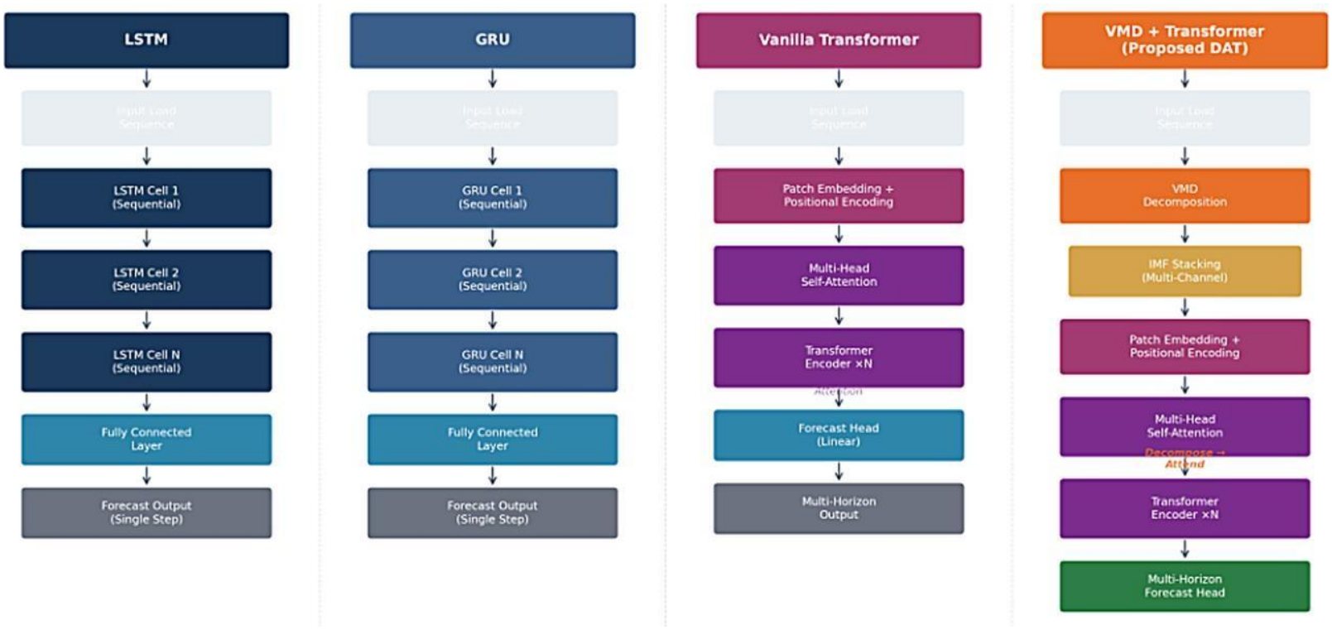
Figure 1. Schematic comparison of recurrent, attention-based, and decomposition-augmented forecasting architectures. The GRU is illustrative and is not part of the reported primary benchmark.

5.2 Datasets and Experimental Scope
Three public sources are discussed, but they do not form a uniform three-dataset model-ranking benchmark in the revised analysis. UCI and MORED support the main reconstruction comparisons. London Smart Meter is used only for the controlled BES experiment on household MAC000147. Although the public London source contains records from thousands of households, the new experiment does not train or evaluate across all households.
Table 1. Dataset coverage and role in the revised experiments.
Dataset | Public source / coverage | Resolution and period | Corrected data used in this study | Role
UCI Household Power Consumption | Single French household; 2,075,259 raw minute records, including 25,979 missing active-power readings (1.25%). | 1-minute; 16 Dec 2006–26 Nov 2010 | No interpolation; training-only scaling; complete 48-hour windows: 903 train, 189 validation, 192 test. | Main baseline comparison (corrected reconstruction)
London Smart Meter | Low Carbon London; source archive covers thousands of households. | 30-minute readings; 2011–2014 source period | Household MAC000147 only; 336-step input, 48-step output; 117 test windows. | Separate controlled BES case study; not a multi-household benchmark
MORED Premises 6 | Whole-premises measurement from one dwelling in Salé, Morocco; 1,346,393 raw 5-second samples. | 5-second raw data aggregated to 1-minute means; 5 May–26 July 2020 source period. | 1,036 negative readings invalidated; 112,260 retained minute bins; no interpolation; whole raw sessions 0–4 / 5 / 6–9 assigned to train / validation / test; 245 / 119 / 359 complete 48-hour windows, respectively. | Main baseline comparison (corrected whole-session reconstruction)

The London split files contain 27,807 training, 5,959 validation, and 5,959 test half-hourly records. Sliding windows are formed separately inside each split so that a window does not cross a split boundary. This produces 572 training, 117 validation, and 117 test windows for look-back P = 336, forecast horizon F = 48, and stride s = 48. The unit of analysis for this experiment is one household, not the London population.

5.3 Data Preprocessing and Leakage Prevention
All series are ordered chronologically and scaled using parameters fitted on the training partition only. No model receives climate or context covariates. For UCI, the original active-power missing-value mask is retained: 25,979 of 2,075,259 raw readings (1.25%) are missing. No interpolation is applied. A candidate 48-hour window is retained only when every input and target minute is observed and finite; this yields 903 training, 189 validation, and 192 test windows after the chronological 70/15/15 split. For MORED Premises 6, 1,036 negative raw real-power readings are invalidated. Valid 5-second measurements are aggregated to minute means only when at least 10 valid raw samples are present in that minute; no interpolation is used. The 112,260 retained minute bins belong to ten original raw recording sessions. Entire sessions are assigned chronologically to training (IDs 0–4), validation (ID 5), and testing (IDs 6–9), rather than splitting individual rows across sessions. Complete 48-hour input-target windows are constructed only within uninterrupted within-session continuity runs, using a 60-minute stride. This produces 245 training, 119 validation, and 359 test windows; the test windows span four original recording-session clusters and seven within-session continuity runs. No window crosses a recording-session boundary or a within-session data gap. The London split and its separate 30-minute BES protocol are described in Sections 5.2 and 5.7.
For a univariate series x_t, a forecast origin t_b defines an input window x^(b) and a future target y^(b):
x^(b) = [x_(t_b-P+1), …, x_t_b] ∈ R^P → y^(b) = [x_(t_b+1), …, x_(t_b+F)] ∈ R^F (1)
The end of the b-th input window is t_b = P + (b − 1)s. The full series is not decomposed once globally. Instead, the decomposition operator is applied separately to each input window, producing a mode tensor U^(b) ∈ R^(K×P) and centre-frequency vector Ω^(b) ∈ R^K from values at or before that window’s forecast origin. No observation after t_b is supplied to the decomposition for that forecast origin.
U^(b) = [u^(1,b), …, u^(K,b)]^T; Ω^(b) = [ω_1^(b), …, ω_K^(b)]^T; x^(b) ≈ Σ_k u^(k,b) (2)

5.4 Signal Decomposition

5.4.1 Variational Mode Decomposition
VMD decomposes an input signal f(t) into K modes u_k(t), each associated with a centre frequency ω_k. It estimates modes by minimising their summed bandwidth subject to reconstruction of the input. In compact form, the constrained objective is:
min_{u_k, ω_k} Σ_k || ∂_t[(δ(t) + j/(πt)) * u_k(t)] e^(−jω_k t) ||²₂, subject to Σ_k u_k(t) = f(t). (3)
The constrained optimisation is commonly solved by the alternating direction method of multipliers (ADMM), which alternates updates of mode spectra and centre frequencies. The London controlled experiment uses VMD with K = 5 and penalty α = 2000.

5.4.2 CEEMDAN
CEEMDAN extends EMD and EEMD by injecting adaptive noise into successive residuals. At each stage, an intrinsic mode function is estimated as an ensemble average over noise-perturbed residuals, and that component is removed to form the next residual. The process continues until the residual has no more than two extrema. CEEMDAN is described as part of the general DAT framework, while the new London BES ablation uses VMD.

5.4.3 Adaptive IMF Filtering with Fuzzy Entropy
Fuzzy entropy (FE) is used to characterise the complexity of decomposed components. Using embedding dimension m, tolerance r, and gradient parameter n, the entropy is expressed as FE(m,r,n) = ln φ^m(r) − ln φ^(m+1)(r) (4). Components above an adaptive threshold are treated as complex/high-frequency components and receive secondary VMD refinement; lower-entropy components are retained in the representation. In the corrected London code, the median of primary-mode entropy values defines the refinement threshold and each of the five primary modes contributes two fixed channels to the input tensor.
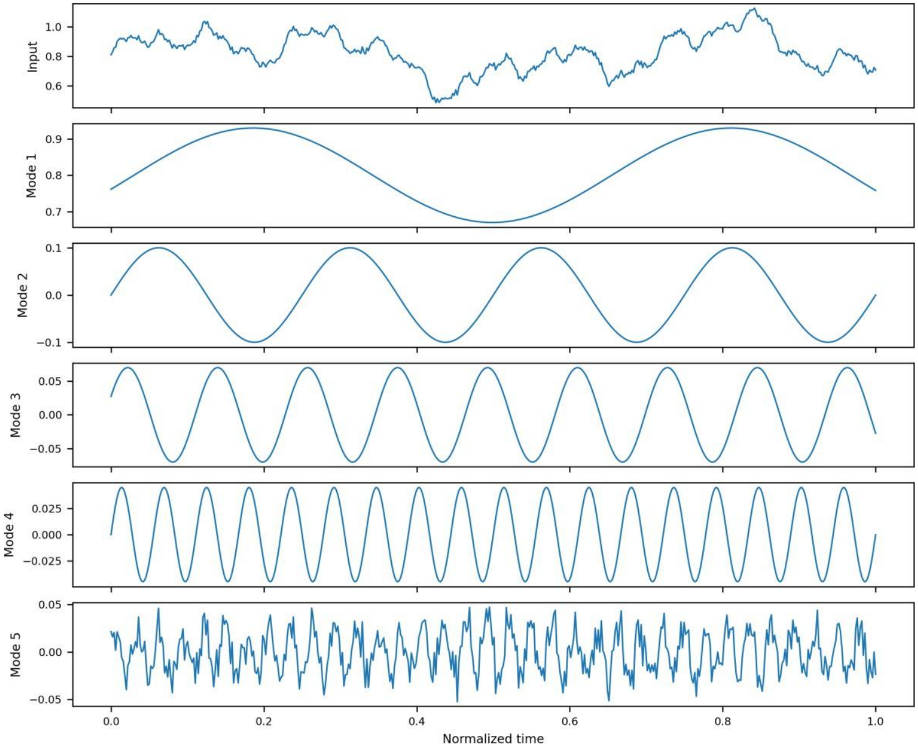
Figure 2. Illustrative synthetic decomposition of a residential-like signal into progressively finer temporal components. The plot is illustrative, not an empirical London, UCI, or MORED result.

5.5 DAT Architecture
The K decomposed modes are projected into a shared latent space by mode-specific one-dimensional convolutions. Each token receives a learnable embedding of the corresponding VMD centre frequency, shared calendar embeddings (hour and weekday), and sinusoidal positional encoding. The resulting tensor is processed by Transformer encoder layers with multi-head self-attention. The final representation is passed to a feed-forward prediction head that emits all F target steps simultaneously. The attention operation is:
Attention(Q,K,V) = softmax(QKᵀ / √d_k) V (5)
In the corrected London experiment, the model uses five primary VMD modes, a ten-channel entropy-refined input representation, 64-dimensional model embeddings, four attention heads, two encoder layers, and a direct 48-step output head. The architecture includes frequency, calendar, and positional information; the BES comparison changes the boundary-processing package while keeping the downstream predictor and evaluation splits fixed.
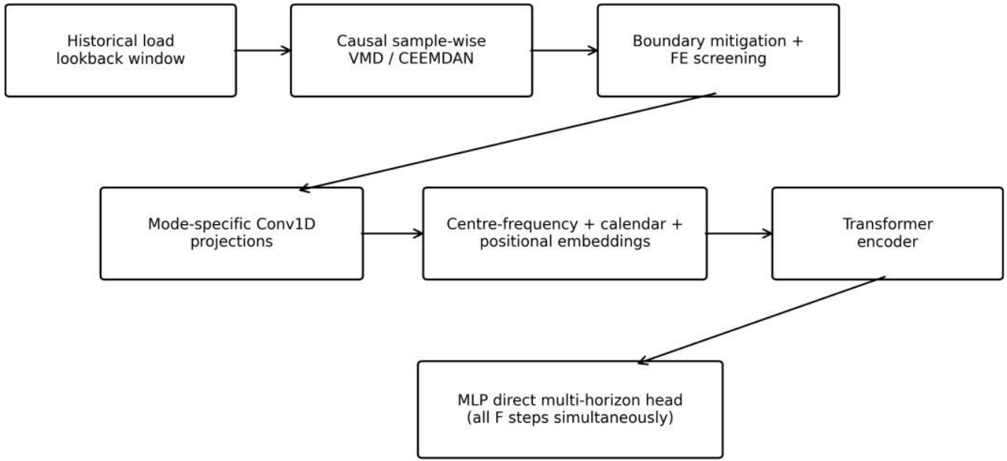
Figure 3. DAT processing pipeline: historical input window, causal sample-wise decomposition, boundary handling and fuzzy-entropy screening, mode-specific projections, frequency/calendar/positional embeddings, Transformer encoder, and direct multi-horizon prediction head.

5.6 Baseline Models
The corrected UCI and MORED comparisons include LSTM, Vanilla Transformer, DLinear, PatchTST-style, and DAT models. TimesFM 2.5 is evaluated once in zero-shot mode, without fine-tuning, and therefore has no seed-to-seed standard deviation. The PatchTST-style results come from a custom univariate PyTorch implementation and should not be interpreted as results from an official library benchmark. An exploratory univariate iTransformer run is excluded from the main tables because a single variate token does not provide a meaningful cross-variate attention comparison. The corrected London experiment is not a baseline comparison: only the controlled BES-off and BES-on DAT configurations are reported there.

5.7 Experimental Protocol and Training
The UCI and MORED results are corrected reproducibility reconstructions rather than exact reproductions of previously reported runs, because the original unpublished configurations were not fully recoverable. Both use a 1,440-minute (24-hour) look-back and a direct 1,440-minute forecast. UCI uses chronological 70/15/15 partitions and non-overlapping 1,440-minute strides; only fully observed windows are retained, yielding 903 training, 189 validation, and 192 test windows. MORED uses a whole-recording-session split: original raw session IDs 0–4 are assigned to training, ID 5 to validation, and IDs 6–9 to testing. Complete 48-hour windows are created only within gap-free continuity runs, with a 60-minute stride, yielding 245 training, 119 validation, and 359 test windows. Thus the MORED test contains four original raw recording-session clusters; accepted windows are nested within seven within-session continuity runs. Trainable models use seeds 0–4, Adam with learning rate 0.001, and 300 optimizer steps. The corrected MORED neural runs use a physical batch size of four with gradient accumulation of eight (effective batch size 32) where required for Apple MPS memory. Checkpoints are selected using validation loss; the corrected UCI Transformer validation selection uses sample-weighted validation MSE. All final metrics are computed after inverse scaling and use the same canonical test targets within each dataset. TimesFM 2.5 is a single zero-shot evaluation and is not seed-averaged.
The London run is a separate controlled experiment. It uses a 7-day look-back (336 half-hourly steps), a 24-hour forecast horizon (48 steps), and stride 48. The chronological split is identical for BES-off and BES-on, and both configurations use the same five seeds. The model uses VMD K = 5, α = 2000, a boundary extension length M = 48, d_model = 64, four attention heads, two Transformer layers, and batch size 64. Early stopping selects the checkpoint with the lowest validation loss. Predictions are inverse-scaled before test metrics are calculated. The London experiment is not merged with UCI/MORED results for statistical ranking because it has a different protocol and no matched multi-model London reruns.

5.8 Evaluation Metrics
Forecast accuracy is reported using root mean squared error (RMSE), mean absolute error (MAE), MAPE, and coefficient of determination R². MAPE is shown for UCI and MORED for completeness, but it is not a primary criterion because values near zero make percentage errors unstable. The standard-deviation ratio is defined as StdR = σ_pred / σ_actual (6). A value near one means that the forecast spread matches the target spread; values below one indicate under-dispersion. StdR is a dispersion diagnostic, not an accuracy metric.

5.9 Statistical Analysis and Clustered Inference
The corrected UCI analysis uses paired forecast-origin losses and a hierarchical moving-block bootstrap with 5,000 resamples. The primary comparison uses seven-day blocks over the chronological candidate-origin sequence; three-day and fourteen-day block lengths are used as sensitivity checks. Trainable-model uncertainty is represented by resampling the five seed-level predictions, while TimesFM 2.5 remains a single fixed zero-shot run. Pairwise comparisons are made against the Vanilla Transformer and adjusted for multiple comparisons using the Holm procedure. Positive differences indicate higher error for the alternative model. The UCI test partition contains 215 candidate origins, of which 192 pass the complete-observation window filter.
For MORED, the 359 accepted test windows each contain a 1,440-minute horizon and are spaced by 60 minutes, so adjacent forecast windows overlap substantially. They are not treated as independent observations. Errors are pooled within each of the four original raw test recording sessions (IDs 6–9); the five seed-level metrics for each trained model are averaged within session, while TimesFM 2.5 remains a single zero-shot run. Pairwise differences against the Vanilla Transformer are assessed using exact two-sided sign tests across the four recording-session clusters, with Holm correction across ten RMSE/MAE comparisons. A 20,000-replicate percentile bootstrap resampling whole recording sessions supplies descriptive intervals only. With four independent clusters, the smallest attainable two-sided exact sign-test p-value is 0.125; all observed pairwise p-values are 0.125 and all Holm-adjusted p-values are 1.000. The bootstrap intervals are exploratory and are not treated as confirmatory population intervals. Accordingly, MORED differences are reported as descriptive effects and directional consistency, not as statistically significant superiority or equivalence. No multi-model statistical comparison is reported for London because the available London experiment is a single-household BES ablation.

5.10 Boundary End-Effect Mitigation
Finite-window decomposition can distort modes near window boundaries. The BES package used in the corrected London ablation combines three components: (1) left-boundary reflection padding; (2) a historical right extension selected by matching a recent segment against earlier history and appending only observations that were already available by the current forecast origin; and (3) linear weighted fusion across the overlap in adjacent look-back windows. The overlap fusion smooths the representation in the currently evaluated window and does not revise an already issued earlier forecast. BES-off performs VMD on the unpadded look-back window and disables overlap fusion. The remainder of the model and the data splits remain fixed between conditions.

6 Results and Discussion

6.1 Quantitative Performance on UCI and MORED
The corrected quantitative benchmark is reported for UCI and MORED only. Both datasets use training-only scaling and retain complete observed windows without interpolation. Tables 2 and 3 report mean ± sample standard deviation over five seeds for trainable models; TimesFM 2.5 is a single zero-shot run and is shown without a standard deviation. iTransformer is excluded from the main ranking for the univariate-token reason stated in Section 5.6. The former DM/Wilcoxon/MCS tables based on superseded data and split definitions have been replaced by the corrected UCI hierarchical block-bootstrap and MORED original-recording-session cluster summaries in Section 6.7.
Table 2. Corrected UCI Household 24-hour reconstruction (mean ± sample SD over five seeds for trainable models; TimesFM 2.5 is a single zero-shot run). RMSE and MAE are in kW.
Model | RMSE (kW) | MAE (kW) | MAPE (%) | R² | StdR
Vanilla Transformer | 0.782735 ± 0.009840 | 0.567287 ± 0.022962 | 107.809627 ± 14.785082 | 0.173908 ± 0.020779 | 0.541370 ± 0.036280
LSTM | 0.820548 ± 0.004493 | 0.632089 ± 0.006222 | 135.306918 ± 3.781718 | 0.092260 ± 0.009930 | 0.425470 ± 0.052066
DLinear | 0.849813 ± 0.011597 | 0.610658 ± 0.012286 | 105.389372 ± 4.979169 | 0.026233 ± 0.026542 | 0.681856 ± 0.025599
PatchTST-style | 0.859433 ± 0.004283 | 0.615488 ± 0.001901 | 105.965146 ± 1.050743 | 0.004192 ± 0.009906 | 0.471566 ± 0.006315
TimesFM 2.5 (zero-shot) | 0.890434 | 0.587980 | 79.179894 | −0.068923 | 0.514655
DAT | 0.994470 ± 0.033898 | 0.761134 ± 0.028644 | 158.953 ± 8.718 | −0.334534 ± 0.091419 | 0.819308 ± 0.063380

Table 3. Corrected MORED Premises 6 24-hour reconstruction (mean ± sample SD over five seeds for trainable models; TimesFM 2.5 is a single zero-shot run). RMSE and MAE are in W.
Model | RMSE (W) | MAE (W) | MAPE (%) | R² | StdR
Vanilla Transformer | 126.478 ± 0.185 | 86.924 ± 0.075 | 139.805 ± 1.764 | −0.0192 ± 0.0030 | 0.0978 ± 0.0076
LSTM | 126.118 ± 0.207 | 85.970 ± 0.107 | 137.440 ± 1.205 | −0.0134 ± 0.0033 | 0.0178 ± 0.0180
DAT | 128.751 ± 0.390 | 89.323 ± 0.409 | 134.209 ± 0.700 | −0.0561 ± 0.0064 | 0.1778 ± 0.0180
TimesFM 2.5 (zero-shot) | 130.868 | 90.388 | 145.327 | −0.0911 | 0.3873
DLinear | 146.011 ± 0.328 | 103.382 ± 0.289 | 149.267 ± 1.853 | −0.3583 ± 0.0061 | 0.6202 ± 0.0052
PatchTST-style | 146.976 ± 1.417 | 105.164 ± 1.261 | 113.900 ± 0.706 | −0.3764 ± 0.0264 | 0.3531 ± 0.0136

On UCI, the Vanilla Transformer has the lowest RMSE and MAE among the six reported models, while zero-shot TimesFM 2.5 has the lowest MAPE. DAT has the highest RMSE and MAE and a negative R², so this corrected reconstruction does not support an accuracy advantage from decomposition. On MORED, LSTM has the lowest mean RMSE (126.118 W) and MAE (85.970 W), narrowly ahead of the Vanilla Transformer (126.478 W RMSE; 86.924 W MAE). DAT is worse than the Vanilla Transformer on both RMSE and MAE (128.751 W and 89.323 W). TimesFM 2.5 is intermediate on RMSE and MAE, while DLinear and PatchTST-style have the largest RMSE and MAE. PatchTST-style has the lowest MAPE (113.900%), but percentage error is not the primary ranking criterion because low loads can make MAPE unstable. All six MORED models have negative R² and StdR below one; the LSTM StdR (0.0178) indicates especially severe under-dispersion. The results do not support a consistent accuracy benefit from decomposition.
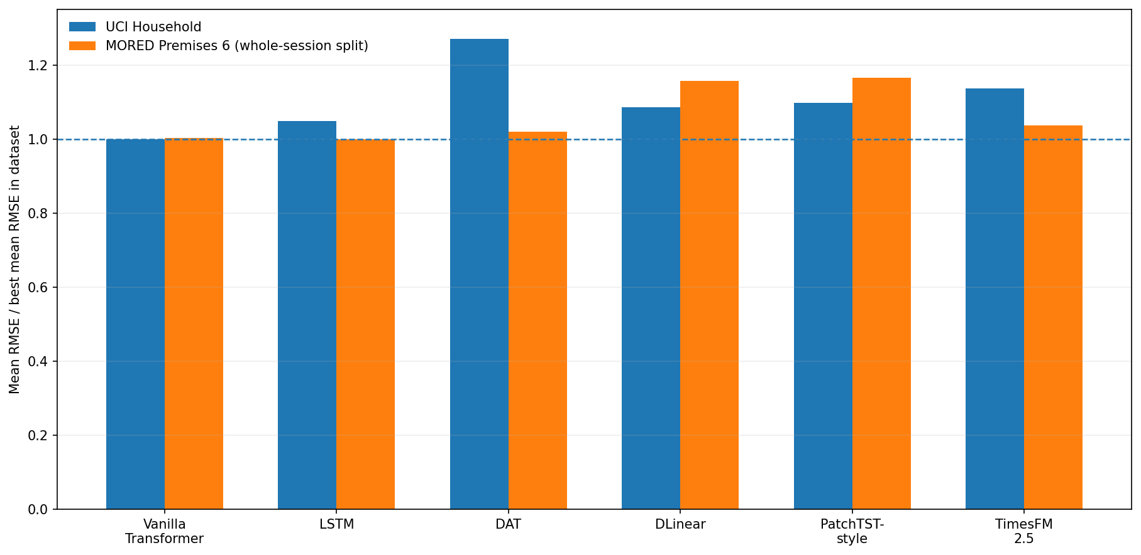
Figure 4. Within-dataset-normalised RMSE for the six models common to the corrected UCI and MORED reconstructions. Each model’s mean RMSE is divided by the lowest mean RMSE on that dataset; lower is better. The two datasets are normalised separately, so ratios are not absolute cross-dataset errors.

6.2 Dataset-Wise Interpretation
UCI Household. The Vanilla Transformer provides the lowest RMSE (0.782735 ± 0.009840 kW) and MAE (0.567287 ± 0.022962 kW). DAT has higher RMSE (0.994470 ± 0.033898 kW), higher MAE, and negative mean R² (−0.335). In the primary seven-day block-bootstrap analysis, every alternative model has significantly higher RMSE than the Vanilla Transformer after Holm correction. DAT, LSTM, DLinear, and PatchTST-style also have significantly higher MAE; the TimesFM MAE difference is not significant. The UCI results do not support a point-accuracy benefit from DAT.
MORED Premises 6. The whole-session split provides 359 test windows across four original raw recording sessions. LSTM has the lowest mean RMSE (126.118 W) and MAE (85.970 W), with the Vanilla Transformer close behind (126.478 W and 86.924 W). DAT, DLinear, PatchTST-style, and TimesFM have higher mean RMSE and MAE than the Vanilla Transformer. The observed directions are consistent across the four sessions: LSTM is better on both RMSE and MAE in all four, while each of the other four alternatives is worse on both metrics in all four. However, the exact two-sided sign-test p-value is 0.125 for every comparison and the Holm-adjusted p-value is 1.000 throughout. The 95% cluster-bootstrap intervals are exploratory with only four clusters and are not interpreted as confirmatory evidence. All six models have negative R² and are under-dispersed; LSTM has particularly severe under-dispersion (StdR = 0.0178). No statistically significant superiority or equivalence claim is made.
London Smart Meter. London is not ranked against the UCI or MORED models. The corrected London experiment is a controlled BES-off/BES-on DAT ablation on household MAC000147 only. It does not compare London models and cannot support metropolitan or multi-household generalisation.

6.3 Controlled London BES Ablation
BES was evaluated on and off using the corrected DAT architecture and identical data splits, preprocessing, and five random seeds. The test set contains 117 complete forecast windows, each predicting 48 half-hourly steps. Metrics were computed after inverse scaling and are reported in the original consumption units (kWh per half-hour reading). Only the boundary-processing package differs: BES-on includes reflection, historical right extension, and weighted overlap fusion; BES-off uses unpadded VMD and no overlap fusion.
Table 4. Corrected five-seed London BES ablation on household MAC000147 (24-hour horizon; RMSE and MAE in kWh per half-hour reading).
Configuration | RMSE | MAE | R² | StdR
DAT, BES off | 0.164207 ± 0.002561 | 0.108367 ± 0.002577 | −0.539934 ± 0.047940 | 0.559785 ± 0.027437
DAT, BES on | 0.164217 ± 0.002546 | 0.108376 ± 0.002560 | −0.540119 ± 0.047667 | 0.559913 ± 0.027340

BES-on RMSE is 0.000010 higher than BES-off (approximately a 0.006% increase); MAE is 0.000009 higher (approximately a 0.008% increase). These changes are negligible and slightly favour BES-off, not BES-on. The R² means are both negative (approximately −0.54), indicating poor predictive performance relative to a mean-prediction reference on this test split. The experiment therefore does not support the earlier 0.27% BES improvement claim; that value came from a different setup and is not retained in this revision. With five seeds and no pre-specified significance test for this paired ablation, we make no claim that the tiny numerical difference is statistically significant.
These results are not directly comparable with the older London values because the earlier configuration and raw predictions are not available for verification. Rather than treating that gap as a reason to preserve the earlier scores, this revision reports only the experiment that can be tied to a documented script and saved per-seed predictions.

6.4 Direct versus Recursive Forecasting
DAT predicts the full forecast window directly, avoiding feedback from its own earlier predictions by construction. The present experiments do not isolate forecasting strategy from model architecture and training: the compared baselines differ in architecture and optimisation. Consequently, these results do not demonstrate that direct forecasting is more accurate than recursive forecasting.

6.5 Transformer versus Recurrent Architectures
The results do not support a universal claim that attention-based models outperform recurrent networks. On UCI, the Vanilla Transformer achieves lower RMSE than LSTM (0.783 versus 0.821 kW). On MORED, LSTM has slightly lower RMSE than the Vanilla Transformer (126.118 versus 126.478 W) and lower MAE (85.970 versus 86.924 W), although its prediction spread is severely under-dispersed. The difference is small in point-error terms, and four recording-session clusters are insufficient for confirmatory inference. The separate London experiment contains no matched baseline models and does not alter this interpretation.

6.6 Cross-Dataset Robustness
The common-model benchmark across UCI and MORED demonstrates variability in relative rankings, not cross-dataset transfer. Every model is trained and tested within its own dataset; no model is transferred between households, regions, or countries. London contributes a separate one-household ablation rather than a third dataset on the same benchmark table. The revised paper therefore avoids claims that DAT is the best model across three datasets or that the experiment establishes generalisation across London households.

6.7 Dependence-Aware Statistical Analysis on UCI and MORED
Table 5 reports the primary seven-day hierarchical moving-block bootstrap comparisons on UCI against the Vanilla Transformer. Positive differences indicate higher error for the alternative model. Table 6 reports MORED mean original-recording-session differences against the Vanilla Transformer, the direction across four raw recording sessions, exact sign-test p-values, and Holm adjustment. With only four independent recording-session clusters, all two-sided exact p-values are 0.125 and all Holm-adjusted p-values are 1.000; this low power must not be interpreted as evidence of equivalence.
Table 5. Corrected UCI pairwise hierarchical moving-block bootstrap results versus the Vanilla Transformer (24-hour horizon; primary block length 7 days; 5,000 resamples; Holm-adjusted p-values).
Model vs. Vanilla Transformer | ΔRMSE (kW) | 95% CI | Holm p | ΔMAE (kW) | 95% CI | Holm p
DAT | +0.212 | [0.168, 0.264] | 0.001 | +0.194 | [0.154, 0.242] | 0.001
LSTM | +0.038 | [0.018, 0.052] | 0.001 | +0.065 | [0.041, 0.086] | 0.001
DLinear | +0.067 | [0.047, 0.084] | 0.001 | +0.043 | [0.012, 0.069] | 0.013
PatchTST-style | +0.077 | [0.057, 0.099] | 0.001 | +0.048 | [0.025, 0.076] | 0.002
TimesFM 2.5 | +0.108 | [0.070, 0.128] | 0.001 | +0.021 | [−0.027, 0.050] | 0.298

For UCI, all five alternatives have higher RMSE than the Vanilla Transformer, with Holm-adjusted p = 0.001 in the seven-day analysis. The same RMSE conclusion holds for three-day and fourteen-day sensitivity blocks. For MAE, DAT, LSTM, DLinear, and PatchTST-style are significantly worse at all three block lengths; TimesFM is not significantly different in MAE at any of the tested block lengths. These results are conditional on the corrected UCI test period and the block-bootstrap design; they do not establish population-wide performance.
Table 6. Corrected MORED original-recording-session-cluster pairwise differences versus the Vanilla Transformer (24-hour horizon; 359 test windows; four independent raw recording sessions).
Model vs. Vanilla Transformer | ΔRMSE (W; 95% CI) | Sessions with higher RMSE | ΔMAE (W; 95% CI) | Sessions with higher MAE
DAT | +2.605 [1.677, 3.659] | 4/4 | +2.741 [1.969, 3.446] | 4/4
LSTM | −0.299 [−0.660, −0.053] | 0/4 | −0.846 [−1.133, −0.589] | 0/4
DLinear | +24.285 [14.052, 41.182] | 4/4 | +21.667 [13.082, 36.932] | 4/4
PatchTST-style | +20.673 [18.660, 22.686] | 4/4 | +18.791 [16.388, 20.839] | 4/4
TimesFM 2.5 zero-shot | +4.003 [1.712, 6.192] | 4/4 | +3.788 [1.353, 6.681] | 4/4

On MORED, the mean differences and their directions are descriptive. DAT, DLinear, PatchTST-style, and TimesFM have higher average session-level RMSE and MAE than the Vanilla Transformer in all four sessions; LSTM has lower RMSE and MAE in all four sessions. Nevertheless, each exact two-sided sign test has p = 0.125, and Holm-adjusted p = 1.000 for all ten RMSE/MAE comparisons. The 95% percentile cluster-bootstrap intervals are also shown in Table 6 as exploratory summaries of observed effect magnitudes; with only four clusters, they should not be treated as reliable confirmatory population intervals. The analysis therefore indicates consistent directions in this test sample but does not establish statistical superiority or equivalence.

6.8 Computational Cost, Load-Only Operation, and Deployment
Causal decomposition and fuzzy-entropy refinement add computation relative to forecasting the raw series. This study does not quantify latency, memory, or deployment cost, so it does not make a real-time suitability claim. Load-only operation avoids the need to source weather covariates, but because no climate-informed baseline was evaluated, equivalence with or superiority over weather-based models cannot be established.

7 Limitations and Future Work

7.1 Limitations
1. Load-only inputs. The models use consumption history only and omit weather, occupancy, appliance-level, and socioeconomic variables.
2. Reconstruction uncertainty. UCI and MORED experiments are reproducibility reconstructions; the original settings were not fully recoverable, so the numbers should not be described as exact reproductions of prior unpublished runs.
3. London scope. The new London experiment uses one household, MAC000147, rather than the full multi-household source dataset. It supports a controlled BES ablation but not London-wide performance claims.
4. Historical London benchmark omitted. Earlier London scores and pairwise tests are not retained in the revised quantitative tables because their raw predictions and complete configuration records could not be verified. The new controlled experiment is reported independently.
5. No controlled direct-versus-recursive test. Forecasting strategy is not separated from architecture and training, so direct forecasting is not claimed to be more accurate.
6. No transfer experiment. Models are trained and evaluated within each dataset; cross-household or cross-region transfer is not assessed.
7. Under-dispersion and negative R². MORED R² is negative for every model, and forecast dispersion is substantially below target dispersion for all models. UCI DAT and both London BES settings also have negative R². These findings show that point error alone does not capture the weaknesses of the forecasts.
8. MAPE instability. Loads near zero can cause percentage errors to become uninformative.
9. Computational cost and statistical coverage. Runtime, memory, probabilistic forecast quality, and broad BES sensitivity were not measured. Although the revised MORED session-based split increases the test set to 359 overlapping windows across four original raw recording sessions, four clusters still provide low inferential power: the minimum attainable two-sided exact sign-test p-value is 0.125. The London BES result is limited to one household and five seeds.

7.2 Future Work
Future work should evaluate additional independent MORED recording sessions or longer independent recording periods so that session-clustered inference has adequate power, and should rerun common baselines under identical splits, horizons, preprocessing, and metric definitions. The controlled London experiment should be extended to multiple households with matched baseline models. Further work should compare direct and recursive strategies on a common backbone, evaluate climate-informed baselines, report probabilistic forecasts and calibration, measure computational cost, and test transfer across households and regions.

8 Conclusion
This study examined whether causal window-level decomposition improves direct multi-horizon residential load forecasting from historical consumption alone. In the corrected UCI reconstruction, the Vanilla Transformer achieved the lowest RMSE (0.782735 ± 0.009840 kW), while DAT reached 0.994470 ± 0.033898 kW. The corrected UCI block-bootstrap analysis found higher RMSE for all five alternatives relative to the Vanilla Transformer under the tested block lengths; DAT was also worse in MAE. In the revised MORED whole-session evaluation, LSTM achieved the lowest mean RMSE (126.118 ± 0.207 W) and MAE (85.970 ± 0.107 W), narrowly ahead of the Vanilla Transformer (126.478 ± 0.185 W RMSE; 86.924 ± 0.075 W MAE). DAT reached 128.751 ± 0.390 W RMSE and 89.323 ± 0.409 W MAE. The MORED test contains 359 overlapping windows across four original raw recording-session clusters. The direction of the pairwise differences is consistent across these four sessions, but exact sign-test p-values are 0.125 and Holm-adjusted values are 1.000; statistical superiority cannot be established. All six MORED models have negative R² and under-dispersed predictions. Across UCI and MORED, decomposition did not produce a consistent accuracy advantage.
The new London experiment offers a narrower result: on household MAC000147, the corrected DAT configuration performed almost identically with BES on and off, with BES-on RMSE slightly higher by approximately 0.006%. Both settings had negative R². This single-household ablation therefore does not support a BES accuracy benefit or demonstrate strong London household forecasting performance. Earlier London multi-model values remain excluded because their raw predictions and complete configurations could not be independently verified.
The broader conclusion is that decomposition, boundary handling, and forecasting architecture must be tested under transparent, causality-aware protocols with preserved predictions and dataset-appropriate uncertainty analysis. The current evidence supports a reproducibility-focused conclusion, not general DAT superiority, statistical equivalence, or cross-household transfer. Additional independent MORED recording sessions and multi-household London experiments are required before broader claims can be made.

Data availability
The datasets used in this study are publicly available. UCI Household Power Consumption is available from the UCI Machine Learning Repository (doi: 10.24432/C58K54); London Smart Meter data are available through the Low Carbon London dataset collection (UK Power Networks, 2014); and MORED is described by Ahajjam et al. (2020; doi: 10.3390/en13246737). The corrected UCI and MORED preprocessing outputs, split manifests, training configurations, five-seed predictions, metric summaries, integrity-audit reports, and statistical-analysis outputs have been retained in the project working archive, together with the corrected London BES scripts, split definitions, per-seed metrics, predictions, and cache files. The corresponding author should confirm the public archive/repository location before submission; no repository URL is supplied here because one has not been confirmed.

CRediT authorship contribution statement
Sidharth Jain: Conceptualization, Methodology, Software, Investigation, Writing – original draft. Aditya Chhabra: Conceptualization, Methodology, Software, Investigation, Writing – original draft. Shubham Hazra: Conceptualization, Methodology, Software, Investigation, Writing – original draft. Inba Senthil Kumar: Conceptualization, Methodology, Software, Investigation, Writing – original draft. Sathya K: Supervision, Validation, Writing – review & editing. All authors reviewed and approved the submitted manuscript.

Funding
This research received no external funding.

Declaration of competing interest
The authors declare that they have no known competing financial interests or personal relationships that could have appeared to influence the work reported in this paper.

Declaration of generative AI and AI-assisted technologies in manuscript preparation
During manuscript preparation, the authors used OpenAI ChatGPT and Anthropic Claude for language editing, restructuring, consistency checking, and code troubleshooting. The authors reviewed and edited the AI-assisted content and take responsibility for the publication. No experimental data were generated or altered by these tools.

References
Ahajjam, M. A., Bonilla Licea, D., Essayeh, C., Ghogho, M., and Kobbane, A. (2020). MORED: A Moroccan Buildings’ Electricity Consumption Dataset. Energies 13, 6737. doi: 10.3390/en13246737.
Box, G. E. P., Jenkins, G. M., Reinsel, G. C., and Ljung, G. M. (2015). Time Series Analysis: Forecasting and Control, 5th Edn. Hoboken, NJ: Wiley.
Breiman, L. (2001). Random forests. Mach. Learn. 45, 5–32.
Chen, W., Wang, Z., Xie, H., and Yu, W. (2007). Characterization of surface EMG signal based on fuzzy entropy. IEEE Trans. Neural Syst. Rehabil. Eng. 15, 266–272.
Cho, K., van Merriënboer, B., Gulcehre, C., Bahdanau, D., Bougares, F., Schwenk, H., et al. (2014). Learning phrase representations using RNN encoder–decoder for statistical machine translation. In Proc. EMNLP, 1724– 1734.
Chung, J., Gulcehre, C., Cho, K., and Bengio, Y. (2014). Empirical evaluation of gated recurrent neural networks on sequence modeling. arXiv preprint arXiv:1412.3555.
Clark, T. E., and West, K. D. (2007). Approximately normal tests for equal predictive accuracy in nested models. J. Econom. 138, 291–311.
Das, A., Kong, W., Sen, R., and Zhou, Y. (2024). A decoder-only foundation model for time-series forecasting. In Proc. ICML.
Diebold, F. X., and Mariano, R. S. (1995). Comparing predictive accuracy. J. Bus. Econ. Stat. 13, 253–263.
Dragomiretskiy, K., and Zosso, D. (2014). Variational mode decomposition. IEEE Trans. Signal Process. 62, 531–544.
Fan, S., and Hyndman, R. J. (2012). Short-term load forecasting based on a semi-parametric additive model. IEEE Trans. Power Syst. 27, 134–141.
Goodfellow, I., Bengio, Y., and Courville, A. (2016). Deep Learning. Cambridge, MA: MIT Press.
Hansen, P. R., Lunde, A., and Nason, J. M. (2011). The model confidence set. Econometrica 79, 453–497.
Harvey, D., Leybourne, S., and Newbold, P. (1997). Testing the equality of prediction mean squared errors. Int. J. Forecast. 13, 281–291.
Hebrail, G., and Berard, A. (2012). Individual household electric power consumption dataset. UCI Machine Learn- ing Repository. doi: 10.24432/C58K54.
Hernandez, L., Baladrón, C., Aguiar, J. M., Carro, B., Sanchez-Esguevillas, A., and Lloret, J. (2014). A survey on electric power demand forecasting: future trends in smart grids, microgrids and smart buildings. IEEE Commun. Surv. Tutor. 16, 1460–1495.
Hewamalage, H., Ackermann, K., and Bergmeir, C. (2023). Forecast evaluation for data scientists: common pitfalls and best practices. Data Min. Knowl. Discov. 37, 788–832. doi: 10.1007/s10618-022-00894-5.
Hippert, H. S., Pedreira, C. E., and Souza, R. C. (2001). Neural networks for short-term load forecasting: a review and evaluation. IEEE Trans. Power Syst. 16, 44–55.
Hochreiter, S., and Schmidhuber, J. (1997). Long short-term memory. Neural Comput. 9, 1735–1780.
Holt, C. C. (2004). Forecasting seasonals and trends by exponentially weighted moving averages. Int. J. Forecast. 20, 5–10.
Hong, T., and Fan, S. (2016). Probabilistic electric load forecasting: a tutorial review. Int. J. Forecast. 32, 914– 938.
Huang, N. E., Shen, Z., Long, S. R., Wu, M. C., Shih, H. H., Zheng, Q., et al. (1998). The empirical mode decomposition and the Hilbert spectrum for nonlinear and non-stationary time series analysis. Proc. R. Soc. Lond. A 454, 903–995.
Hyndman, R. J., and Athanasopoulos, G. (2021). Forecasting: Principles and Practice, 3rd Edn. Melbourne: OTexts.
Hyndman, R. J., and Koehler, A. B. (2006). Another look at measures of forecast accuracy. Int. J. Forecast. 22, 679–688.
International Energy Agency (2023). World Energy Outlook 2023. Paris: IEA.
Kong, W., Dong, Z. Y., Jia, Y., Hill, D. J., Xu, Y., and Zhang, Y. (2019). Short-term residential load forecasting based on LSTM recurrent neural network. IEEE Trans. Smart Grid 10, 841–851.
Lim, B., Arik, S. O., Loeff, N., and Pfister, T. (2021). Temporal fusion transformers for interpretable multi-horizon time series forecasting. Int. J. Forecast. 37, 1748–1764.
Liu, J., Yang, F., Yan, K., and Jiang, L. (2024a). Household energy consumption forecasting based on adaptive signal decomposition enhanced iTransformer network. Energy Build. 324, 114894. doi: 10.1016/j.enbuild.2024.114894.
Liu, S., Yu, H., Liao, C., Li, J., Lin, W., Liu, A. X., et al. (2022). Pyraformer: low-complexity pyramidal attention for long-range time series modeling and forecasting. In Proc. ICLR.
Liu, Y., Hu, T., Zhang, H., Wu, H., Wang, S., Ma, L., et al. (2024b). iTransformer: inverted Transformers are effective for time series forecasting. In Proc. ICLR.
Mallat, S. (1999). A Wavelet Tour of Signal Processing. San Diego, CA: Academic Press.
Marino, D. L., Amarasinghe, K., and Manic, M. (2016). Building energy load forecasting using deep neural net- works. In Proc. IECON, 7046–7051.
Newey, W. K., and West, K. D. (1987). A simple, positive semi-definite, heteroskedasticity and autocorrelation consistent covariance matrix. Econometrica 55, 703–708.
Nie, Y., Nguyen, N. H., Sinthong, P., and Kalagnanam, J. (2023). A time series is worth 64 words: long-term forecasting with Transformers. In Proc. ICLR.
Ran, P., Dong, K., Liu, X., and Wang, J. (2023). Short-term load forecasting based on CEEMDAN and Transformer. Electr. Power Syst. Res. 214, 108885. doi: 10.1016/j.epsr.2022.108885.
Runge, J., and Zmeureanu, R. (2019). Forecasting energy use in buildings using artificial neural networks: a review. Energies 12, 3254.
Torres, M. E., Colominas, M. A., Schlotthauer, G., and Flandrin, P. (2011). A complete ensemble empirical mode decomposition with adaptive noise. In Proc. ICASSP, 4144–4147.
UK Power Networks (2014). Low Carbon London project: smart meter data. UK Data Service, SN 7857.
Vapnik, V. (1995). The Nature of Statistical Learning Theory. New York, NY: Springer.
Vaswani, A., Shazeer, N., Parmar, N., Uszkoreit, J., Jones, L., Gomez, A. N., et al. (2017). Attention is all you need. In Proc. NeurIPS, 5998–6008.
Wang, Y., Chen, Q., Kang, C., and Xia, Q. (2016). Clustering of electricity consumption behavior dynamics toward big data applications in smart grids. IEEE Trans. Smart Grid 7, 2437–2447.
Wilcoxon, F. (1945). Individual comparisons by ranking methods. Biometrics Bull. 1, 80–83.
Wu, H., Xu, J., Wang, J., and Long, M. (2021). Autoformer: decomposition Transformers with auto-correlation for long-term series forecasting. In Proc. NeurIPS, 22419–22430.
Wu, Z., and Huang, N. E. (2009). Ensemble empirical mode decomposition: a noise-assisted data analysis method. Adv. Adapt. Data Anal. 1, 1–41.
Yang, X., Li, J., and Jiang, X. (2024). Research on information leakage in time series prediction based on empirical mode decomposition. Sci. Rep. 14, 28362. doi: 10.1038/s41598-024-80018-9.
Ye, H., Zhu, Q., Zhang, X., et al. (2024). Short-term load forecasting for residential buildings based on multivariate variational mode decomposition and temporal fusion transformer. Energies 17, 3061. doi: 10.3390/en17133061.
Zeng, A., Chen, M., Zhang, L., and Xu, Q. (2023). Are Transformers effective for time series forecasting? In Proc. AAAI, 11121–11128.
Zhou, H., Zhang, S., Peng, J., Zhang, S., Li, J., Xiong, H., et al. (2021). Informer: beyond efficient Transformer for long sequence time-series forecasting. In Proc. AAAI, 11106–11115.

