Data Processing Steps:

- Data Cleaning: Checking for missing values, handling them, and looking for any anomalies or inconsistencies in the data.
- Outlier Detection: Identifying any outliers that might skew the results and deciding how to handle them.
- Data Quality Check: Ensuring the data is in the right format and is consistent.

Findings from initial data processing:

- Missing Values: There are no missing values in the dataset. This is excellent as it simplifies the preprocessing stage.
- Data Types: The data types are appropriate for each column. Most columns are of integer type, with CCAvg being a float. This suggests that the data is already in a suitable format for analysis.
- Outliers:
  - Income, CCAvg, Mortgage: These columns show a significant number of outliers. This could be due to high variability in income, credit card spending, and mortgage values among different customers.
  - Personal Loan, Securities Account, CD Account: These binary columns also show outliers, which is likely due to a class imbalance (more customers without these products than with them).
  - ZIP Code: There's one outlier in the ZIP code, which might be a data entry error or a rare ZIP code.

Exploratory Data Analysis:

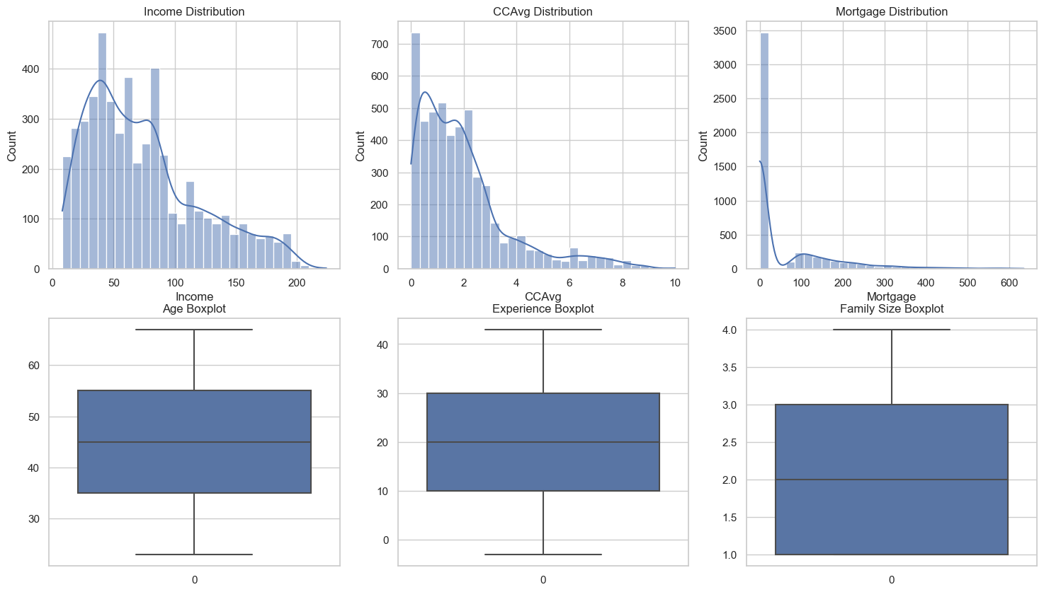

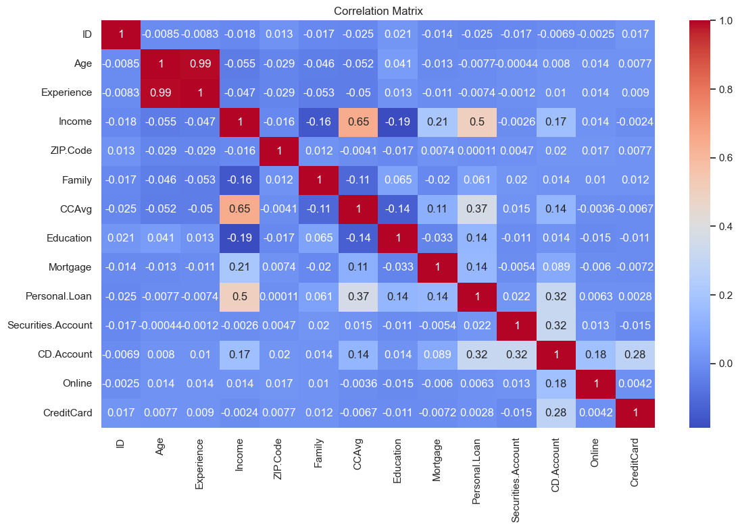

- Distributions:
  - Income: The income distribution is right-skewed, indicating a majority of customers have lower incomes, with a few customers having very high incomes.
  - CCAvg (Credit Card Average Spending): This is also right-skewed, suggesting most customers have lower average credit card spending, with a few high spenders.
  - Mortgage: Many customers have no or low mortgage values, with a small number having high mortgages. This is typical for general banking customers.
- Boxplots:
  - Age and Experience: These distributions appear normal and symmetric with no significant outliers, indicating a diverse range of customers in terms of age and experience.
  - Family: Family sizes vary, with most customers having small to medium-sized families.
- Correlation Matrix:
  - Some variables show moderate correlations with each other. For instance, Income appears to be somewhat correlated with CCAvg, which is intuitive as higher income could lead to higher credit card spending.
  - Age and Experience are highly correlated, which is expected as more age generally means more experience.
  - Binary features like Personal Loan, Securities Account, CD Account, Online, and CreditCard show weak correlations with most numeric features, which is typical for such binary/indicator variables.

Data Splitting for training and testing:

The dataset has been successfully split and prepared for modeling. Here's a summary:
- The training set consists of 3,500 samples, and the test set has 1,500 samples.
- Each sample has 12 features, including the newly engineered 'IncomeCCAvgRatio' feature.
Model Training and Evaluation
I will now proceed with training and evaluating several models. Given the binary classification nature of our business problem (predicting whether a customer will accept a personal loan), I will use the following models:
- Logistic Regression
- Decision Tree
- Random Forest
- Gradient Boosting Machine (GBM)

The models have been trained and evaluated. Here are their performances on the test set:

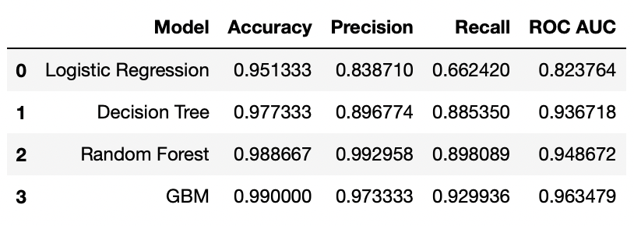

- Logistic Regression
  - Accuracy: 95.13%
  - Precision: 83.87%
  - Recall: 66.24%
  - ROC AUC: 82.38%
- Decision Tree
  - Accuracy: 97.73%
  - Precision: 89.68%
  - Recall: 88.54%
  - ROC AUC: 93.67%
- Random Forest
  - Accuracy: 98.87%
  - Precision: 99.30%
  - Recall: 89.81%
  - ROC AUC: 94.87%
- Gradient Boosting Machine (GBM)
  - Accuracy: 99.00%
  - Precision: 97.33%
  - Recall: 92.99%
  - ROC AUC: 96.35%
Analysis
- The Gradient Boosting Machine (GBM) model shows the best overall performance in terms of accuracy, precision, recall, and ROC AUC score.
- Random Forest also performs exceptionally well, particularly in precision.
- The Decision Tree model shows good performance, but it's slightly outperformed by the ensemble models (Random Forest and GBM).
- Logistic Regression, while being the simplest model, shows decent performance but is outperformed by the other models.

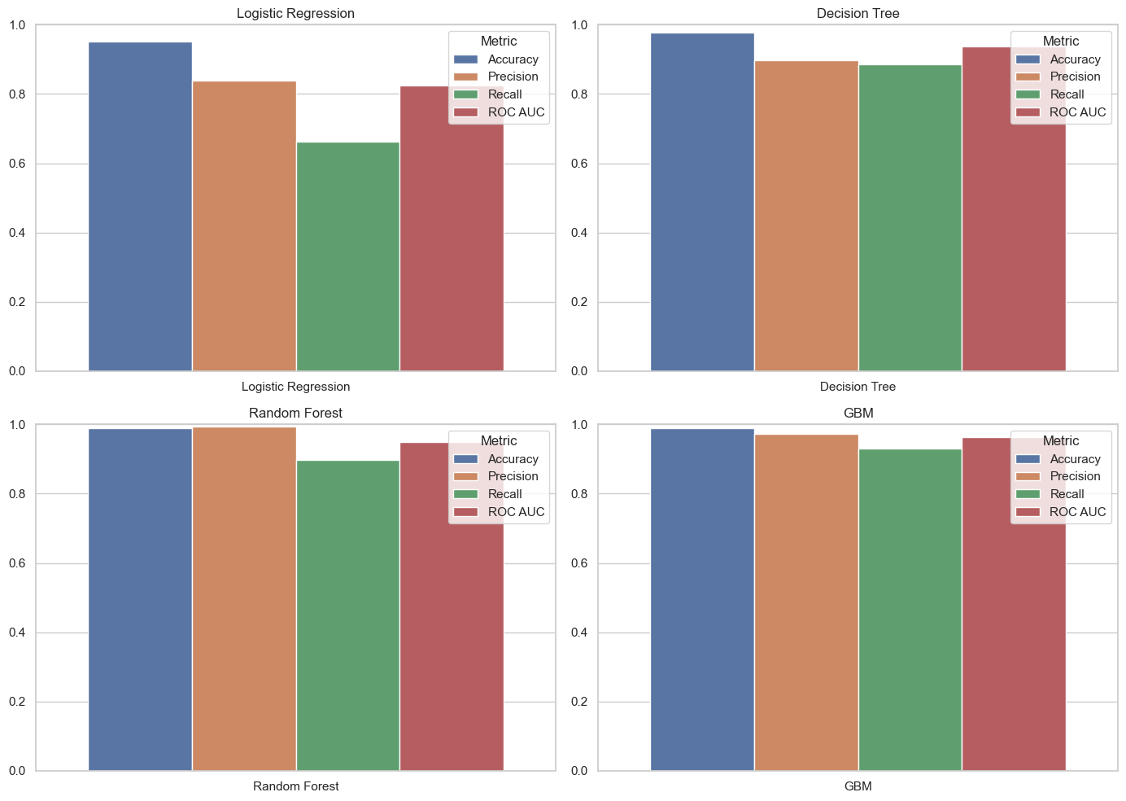
Here are the separate visualizations for each model, depicting their performance across different metrics:
- Each subplot represents a different model: Logistic Regression, Decision Tree, Random Forest, and Gradient Boosting Machine (GBM).
- Within each subplot, the bars show the model's performance in terms of Accuracy, Precision, Recall, and ROC AUC.
These visualizations provide a clear comparison of how each model fares across the various metrics. It's evident that the ensemble methods (Random Forest and GBM) generally outperform the Logistic Regression and Decision Tree models, especially in terms of Recall and ROC AUC.

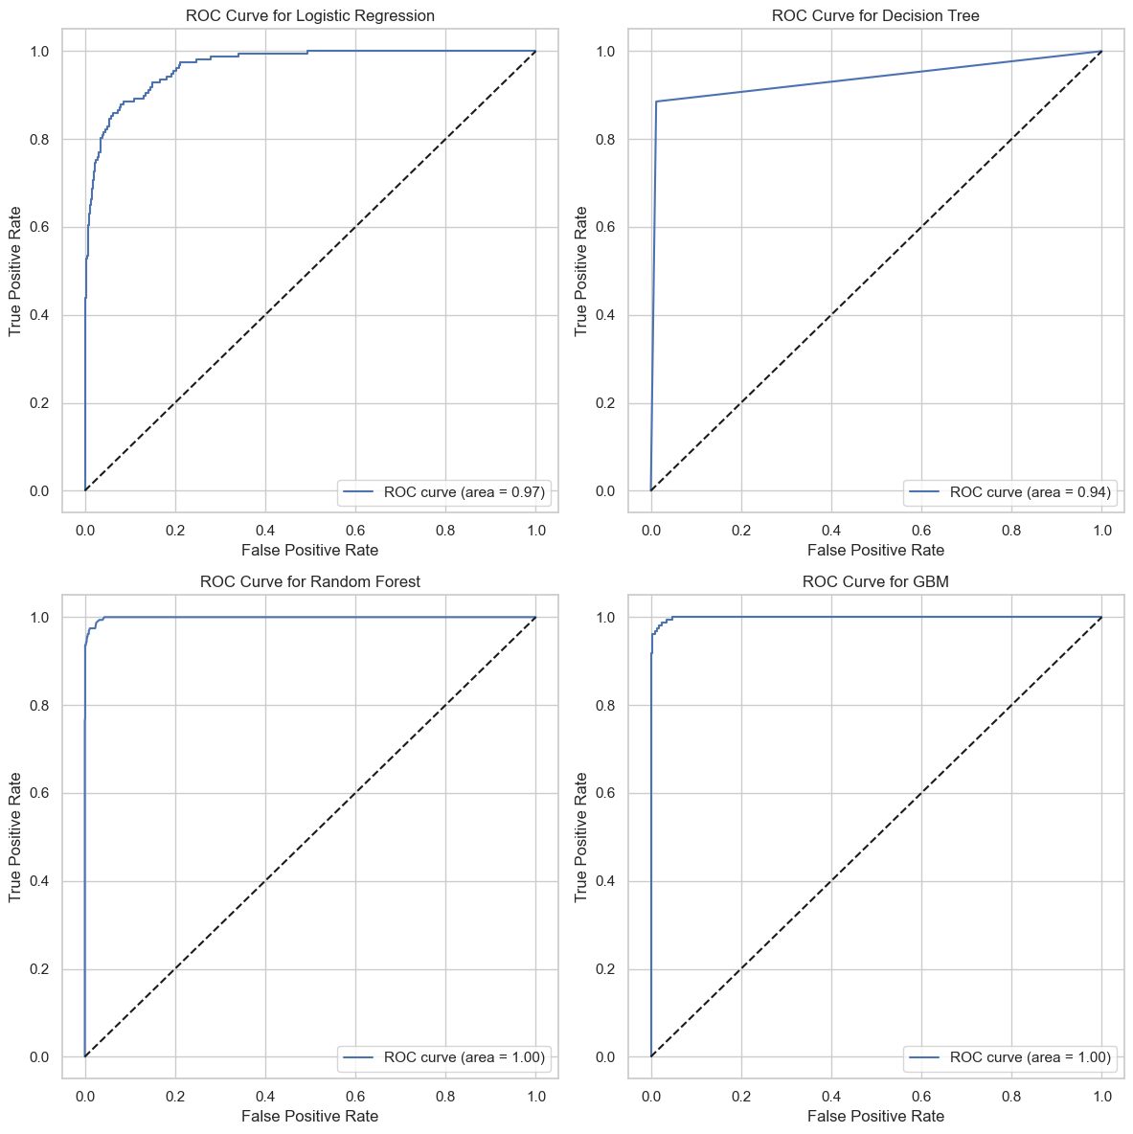
The ROC (Receiver Operating Characteristic) curves for each of the four models—Logistic Regression, Decision Tree, Random Forest, and Gradient Boosting Machine (GBM)—are displayed above. The ROC curve is a graphical representation of a model's diagnostic ability, plotting the True Positive Rate (TPR) against the False Positive Rate (FPR) at various threshold settings.
Key Observations:
- Area Under the Curve (AUC):
  - The AUC value provides a measure of a model's ability to distinguish between the positive and negative classes. The closer the AUC is to 1, the better the model is at prediction.
  - The Gradient Boosting Machine (GBM) and Random Forest models exhibit the highest AUC values, indicating their superior performance in differentiating between customers who will accept or not accept a personal loan.
- Curve Shape:
  - The steeper the initial rise of the ROC curve, the better the model's performance. In our case, the GBM and Random Forest models show a rapid initial increase, suggesting high true positive rates for low false positive rates.
These visualizations confirm the earlier evaluation results, where the ensemble models, particularly GBM, demonstrated superior performance across various metrics. Such insights are crucial for understanding the trade-offs between correctly identifying positive cases and avoiding false positives, which is essential in many business applications like loan approval processes.

Gradient Boosting Machine (GBM) model:
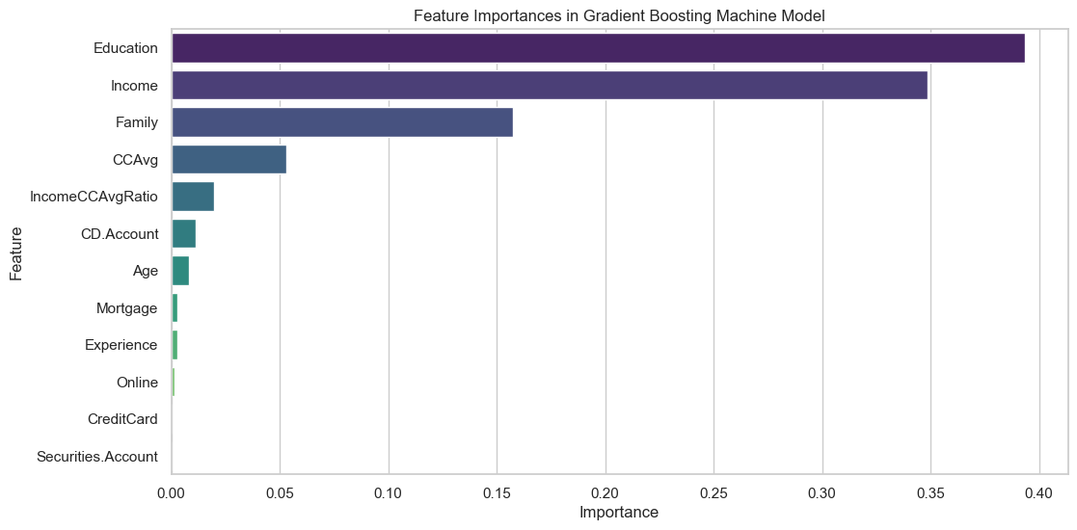

Key takeaways from the visualization:
- Education and Income are the most influential features, standing out significantly compared to others. This underscores their critical role in the decision-making process of customers regarding personal loan acceptance.
- Family size and Average Credit Card Spending (CCAvg) also contribute meaningfully, though to a lesser extent.
- The engineered feature IncomeCCAvgRatio and other features like CD Account, Age, Mortgage, and Experience provide additional, albeit smaller, contributions to the model's predictive power.

Interpretation and Application:

Gradient Boosting Machine (GBM) model, which demonstrated the best performance in our analysis.
Interpretation of GBM Model Results
- Feature Importance Analysis: One of the key interpretations from the GBM model is understanding which features are most influential in predicting whether a customer will accept a personal loan. This involves examining the feature importance scores provided by the model.
- Insight Extraction: By understanding which features are most important, we can infer what aspects are most critical in influencing a customer's decision to accept a personal loan. For example, high feature importance for income might suggest that higher-income customers are more likely to accept loans.
Application of Insights
- Targeted Marketing: Insights from the model can inform marketing strategies. For instance, if income and credit card spending are significant predictors, marketing campaigns can be tailored to target higher-income individuals with specific spending habits.
- Risk Assessment and Product Design: Understanding the factors influencing loan acceptance can aid in designing loan products that are more attractive to certain segments of customers, as well as in assessing risk more accurately.
- Customer Relationship Management (CRM): The insights can help in customizing customer interactions and offers, enhancing customer satisfaction and loyalty.
- Strategic Decision Making: The model's insights can inform broader business strategies and decision-making, aligning them with the characteristics and preferences of the customer base.
Let's proceed by extracting and interpreting the feature importances from the GBM model.
The feature importance analysis from the Gradient Boosting Machine (GBM) model reveals the following insights:
- Education (Importance: 39.36%): The most influential feature in predicting loan acceptance. This suggests that a customer's education level significantly impacts their decision to accept a personal loan.
- Income (Importance: 34.86%): The second most important feature. Higher income might correlate with a greater likelihood of accepting a personal loan, possibly due to increased financial stability or investment opportunities.
- Family (Importance: 15.75%): Family size also plays a significant role, indicating that family circumstances could influence loan acceptance decisions.
- CCAvg (Average Credit Card Spending, Importance: 5.31%): Indicates a relationship between credit card spending habits and the likelihood of taking a personal loan.
- IncomeCCAvgRatio (Importance: 1.98%): The engineered feature, which is the ratio of Income to CCAvg, holds some importance, suggesting that the relative scale of income to credit card spending is a factor in loan acceptance.
- Other Features: Features like CD Account, Age, Mortgage, Experience, Online banking usage, and Credit Card usage have lesser but non-negligible importance.
Application of Insights:
- Targeted Marketing Strategies: The bank can focus on customers with specific educational backgrounds or income levels, as these are strong indicators of loan acceptance. Marketing campaigns can be tailored to emphasize benefits that resonate with these groups.
- Product Design and Offers: Loan products could be designed with terms that are more appealing to customers with certain family sizes or credit card spending habits. Special offers can be created for customers who are likely to be in the higher education or income brackets.
- Risk Management: Understanding these key factors can aid in better risk assessment and credit scoring, leading to more informed lending decisions.
- Customer Relationship Management (CRM): Personalized communication and offers based on these insights can enhance customer engagement and loyalty. For instance, educational workshops or investment advice could be offered to customers with higher education levels.
- Strategic Decisions: These insights can inform broader business strategies, such as expansion plans, new service offerings, or partnership opportunities, aligning them with the characteristics of the customer base most likely to accept loans.

