PA Model – Experiment Progress Report
Nov 12, 2026 · @Sid

Summary
Over three iterations we corrected the training data and improved the model. Judged fairly (same test set, same labels, same review workload), the new model misses 840–1,150 fewer PA services per quarter (−9 to −12%), on both seeds.
- Headline, view 5 (same review workload): missed PA 9,461 → 8,310 (seed 42) and 9,479 → 8,642 (seed 7); catch rate 80% → 81.8–82.5%. To catch 90% of PA it needs ~25k (14%) fewer flags.
- Mirror, view 4 (same catch rate): at 80% recall, false positives ~45.6k → ~36.8k (−19%) and precision 44–47% → 51% (score cut-off ~0.61); at 75% recall, precision 53% → 57% (cut-off ~0.75–0.76).
- Ranking quality, view 3: AUC-PR 0.657 → 0.676, the same gain on both seeds.
- As reported, view 1: FN 18,070 → 12,799 at the 0.8 cut-off; ~4,600 of that drop is the labels being corrected (those were never real PA), ~660 is the model.
- Experiments: 4 experiments, 12 registered runs, one frozen test set (May–Jul 2026, 1.50M services).
- Decision proposed: adopt quality codes excluded + passenger relabel (LABEL_V6_PAX) as the new base; drop the Acuity denial-code labels.
All figures are service level (CSN + CPT, the prediction unit) on the corrected labels unless marked; seed 42 / seed 7 where both exist.

Data
The 27.5M raw rows (claims std v4, 2022–2026) become 9.4M clean claim lines; the model trains on 7.7M of them and is tested on 1.7M.
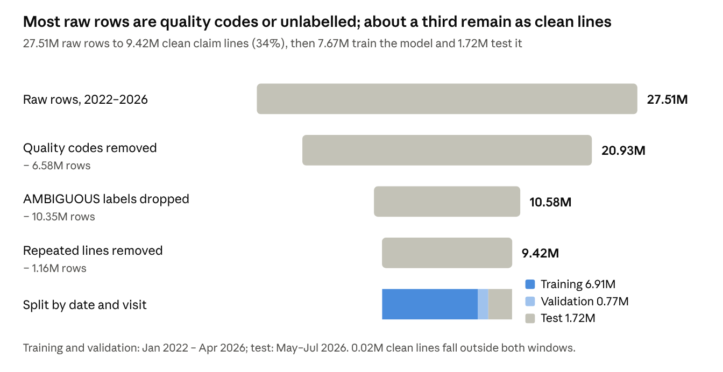
removal_funnel.csv and split_counts.json of run exp_v8d_l6pax_s42 · claims std v4, 2022–2026
The largest losses are quality-code rows (6.58M) and lines whose PA status cannot be determined (10.35M AMBIGUOUS); removing repeats takes another 1.16M.
PA labels (raw lines, all years)
Label version | PA lines | Change
Original (GROUP_LABEL) | 547,317 | –
Quality codes set to not-PA (LABEL_V6) | 526,292 | −21,025 quality-code lines
+ Passenger relabel (LABEL_V6_PAX) | 502,761 | −23,531 passenger lines
Train / validation / test (current best run, LABEL_V6_PAX, seed 42)
Split | Period | Lines | Visits | PA rate (lines)
Training | Jan 2022 – Apr 2026 | 6,908,273 | 3,560,941 | 5.7%
Validation (random 10% of visits) | Jan 2022 – Apr 2026 | 766,707 | 395,661 | 5.8%
Test | May – Jul 2026 | 1,717,478 | 819,665 | 3.1%
Training + validation hold 439,145 PA lines. The frozen official test set, used to score every run, is 1,501,135 services (CSN + CPT) in 819,033 visits: 49,751 PA services on the original labels, 47,411 on the corrected labels (2,340 passenger services differ). A visit is in the test set when its first service date falls in May–Jul 2026.

How the experiments were run
Every change is judged on the same services, the same labels and the same catch rate, and must hold on two seeds before it is adopted.
- Model (fixed): LightGBM, 5 features – CPT, modifier, place of service, payer, plan. Trained on all years (Jan 2022 – Apr 2026), secondary claims included, early stopping on a random 10% of visits.
- Frozen test set: May–Jul 2026, stored with a checksum. Every run is scored on exactly these services.
- Run registry: every run gets an ID that encodes its data, labels, quality-code handling, validation, seed and dates (e.g. pa-lgb5-v8d-l6pax-qcexcl-rv10-s42-y22-26-t2605-2607), plus its settings, code fingerprint and results.
- Two seeds (42 and 7): the seed sets which 10% of visits are used for validation and the random sampling inside LightGBM. A gain counts only if it shows on both. Seed-to-seed noise is about 0.001 AUC-PR and up to ~5k false positives at 80% recall for the benchmark model.
- Same answer key for all models: when labels change, every model is re-scored on both keys – the original labels and the corrected labels – so progress is never a side effect of a changed definition.
- Same catch rate: models are compared at a fixed recall (75%, 80%), where TP and FN are equal by design and only false positives differ.

Two sources of label noise
Analysing the base model's missed PA cases showed that many "PA" labels were not real PA: they were inherited from the claim, not earned by the service.
1. Quality codes (CPT Category II, e.g. 3074F, 1159F)
- $0 reporting codes for quality measures; they never need prior authorization.
- 6.58M of the 27.5M raw rows (24%), rising to 37% of 2025 rows and 31% of 2026 rows. 21,025 of them carried a PA label copied from the claim.
- Fix: removed from training and test (PA_QUALITY_MODE=exclude); in production a quality code is answered "no PA" by rule.
2. Passenger services
- Routine services (office visits such as 99214, G2211, labs, ECG) marked PA only because the claim's auth number is copied onto every line. On 91.7% of multi-CPT visits, every line carries the same auth number.
- Rule: a PA line is a passenger when its auth number is shared with another CPT on the same claim, its CPT is rarely PA on its own (< 2% of lines when alone on a claim), the payer is not a known exception, and another real PA line on the claim owns the auth.
- Fix: 23,531 passenger lines relabelled not-PA (LABEL_V6_PAX). 7,120 lines whose claim has no owning PA line (likely referrals or visit-level auths) were kept PA pending a decision.

Five ways to read the results
The same runs can be read five ways. Only views 4 and 5 isolate the model's own gain, so view 5 is the headline; views 1 and 2 can show fewer misses simply because what counts as PA, or where the cut-off lands, changed.
View | Held fixed | Can FN fall without a better model? | Role in the story
1. As reported per iteration | Nothing | Yes: label and test-set changes remove misses that were never PA | Progress story
2. Score cut-off 0.8 (best F1) | The score threshold | Yes: 0.8 lands at a different catch rate for each model, and it was picked on the test data | Continuity with the old sheet
3. AUC-PR | Labels | No | Technical one-number summary
4. Fixed catch rate (80% / 75% recall) | Labels + missed PA (FN) | No | Mirror of the headline
5. Missed PA at equal workload | Labels + services flagged, or PA caught | No | Headline

View 1 – Progress as reported per iteration
The story. Each iteration was scored the way the team reported it at the time. Missed PA fell from 18,070 to 12,799, but most of that fall is the dataset being corrected, not the model getting better. This view tells the progress story; it cannot on its own say how much better the model is.
Why the test set changes between iterations. Fixing the labels changes what counts as PA. Iteration 1 counted quality codes as PA; iteration 2 removed them; iteration 3 also stopped counting passenger services. Each fix removes "misses" that were never real PA, so FN drops even if the model did not change. Row 4 re-scores the benchmark on today's corrected test set to separate the two effects.
# | Iteration | Test set · labels | AUC-PR | Precision | Recall | F1 | TP | FP | FN | TN
1 | Benchmark (NoFilter_2022_2026) | Old set incl. quality codes · original (52,278 PA) | 0.6203 | 0.5783 | 0.6543 | 0.6140 | 34,208 | 24,946 | 18,070 | 1,872,432
2 | + Quality codes excluded | Frozen set · original (49,751 PA) | 0.6527 | 0.5749 | 0.7064 | 0.6339 | 35,144 | 25,983 | 14,607 | 1,425,401
3 | + Passenger relabel | Frozen set · corrected (47,411 PA) | 0.6751 | 0.5900 | 0.7300 | 0.6526 | 34,612 | 24,054 | 12,799 | 1,429,670
4 | Benchmark re-scored (check) | Frozen set · corrected (47,411 PA) | 0.6575 | 0.5742 | 0.7161 | 0.6373 | 33,953 | 25,181 | 13,458 | 1,428,543
All at the score cut-off 0.8, service level, seed 42. TN falls from 1.87M to 1.43M because quality-code services left the test set, not because of the model. TP is lower in row 3 than row 2 because there are fewer real PA services to catch (47,411 vs 49,751); recall still rises.
Where the 5,271 fewer misses come from
Step | FN at cut-off 0.8 | Change | Type of change
Benchmark as originally reported | 18,070 | – | –
Same model, quality-code services no longer counted as PA | 15,547 | −2,523 | Data correction
Same model, passenger services no longer counted as PA | 13,458 | −2,089 | Data correction
New model (quality codes excluded + passenger relabel) | 12,799 | −659 | Model improvement
What to say: "Each iteration corrected the data and improved the model. Of the 5,271 fewer misses, about 4,600 came from fixing the labels, which were never real PA, and about 660 from the model itself, which also raises ~1,100 fewer false alarms. Seed 7 shows the same: 13,576 → 13,104 for the model step."

View 2 – Fixed score cut-off 0.8 (best F1)
The story. The benchmark sheet reports every model at the cut-off with the best F1, which is 0.8 for all service-level runs here. It keeps continuity with how results were reported before, but at a fixed cut-off FN and FP move together, so this view can show fewer misses without a better model.
Why it can mislead. Each model's scores sit on a slightly different scale. Excluding quality codes raised the PA rate in training (≈4.0% → 5.5% of lines), so all scores shifted up and 0.8 now lands at a higher catch rate. The quality-excluded model is the example: at 0.8 it misses 924 fewer PA than the benchmark but raises 1,069 more false alarms, so this view alone cannot say whether it is better. The cut-off was also picked on the test data, so it is slightly optimistic.
Same frozen set, corrected labels (seed 42 / seed 7) | Recall | Precision | F1 | FN | FP
Benchmark | 71.6% / 71.4% | 57.4% / 57.0% | 0.637 / 0.634 | 13,458 / 13,576 | 25,181 / 25,481
+ Quality codes excluded | 73.6% / 72.8% | 57.1% / 57.4% | 0.643 / 0.642 | 12,534 / 12,897 | 26,250 / 25,622
+ Passenger relabel | 73.0% / 72.4% | 59.0% / 59.1% | 0.653 / 0.651 | 12,799 / 13,104 | 24,054 / 23,739
What to say: "At the reporting cut-off of 0.8 the final model has fewer misses and fewer false alarms than the benchmark on the same data, and the best F1. We don't use this view to judge models, because the same cut-off lands at a different catch rate for each model. The production cut-off will be set from a catch-rate target agreed with the business."

View 3 – AUC-PR (ranking quality)
The story. AUC-PR does not depend on any cut-off: it asks how well the model puts real PA services at the top of its list. Scored on the same labels, it can only rise if the ranking genuinely improves, and it rose at each step, by the same amount on both seeds.
How to read it. Sort all test services from highest score to lowest and walk down the list. Each time another real PA service is found, note the share of services checked so far that were real PA. AUC-PR is the average of those shares: 1.0 means every PA service is at the top; a random order scores the PA rate, about 0.03 here. Our 0.68 means that, on average, about two in three of the services checked on the way to each PA service were real PA.
Same frozen set (seed 42 / seed 7) | Corrected labels | Original labels | Visit level (seed 42)
Benchmark | 0.6575 / 0.6572 | 0.6447 / 0.6445 | 0.672
+ Quality codes excluded | 0.6658 / 0.6659 | 0.6527 / 0.6527 | 0.677
+ Passenger relabel | 0.6751 / 0.6763 | 0.6516 / 0.6527 | 0.680
The quality-code gain was also bootstrapped on the test set: +0.0081 (95% interval +0.0071 to +0.0093), better in 200 of 200 resamples. On the original labels the passenger model does not gain, because those labels still count the passenger services it deliberately ranks low.
What to say: "On the same corrected labels, ranking quality rose from 0.657 to 0.676, identically on both seeds. It is the one-number technical summary; views 4 and 5 turn it into workload and missed PA."

View 4 – Fixed catch rate (80% and 75% recall)
The story. Each model's cut-off is set so that it catches exactly the same share of PA services. Missed PA is then equal by design (at 80%: ~37,940 caught, ~9,470 missed out of 47,411), so the only thing that can differ is how many false alarms each model raises to get there. Fewer false alarms at the same catch rate can only come from better ranking.
What to say: "To catch 80% of PA services, the final model raises about 8,900 fewer false alarms than the benchmark, a 19% cut in review work. At a 75% catch rate the cut is 16%."
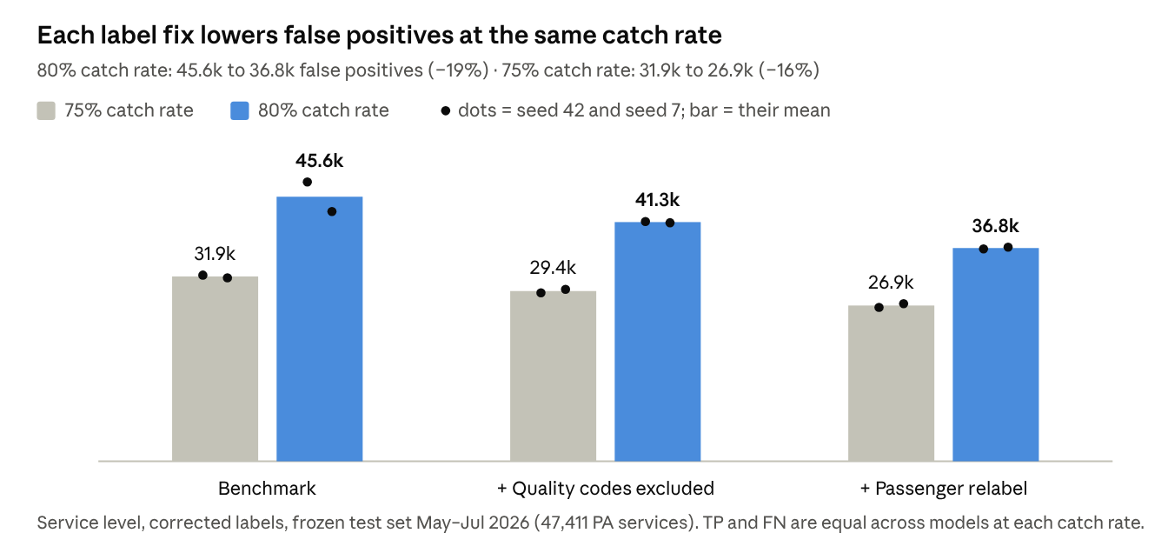
progress_report.py run · frozen test set May–Jul 2026, service level, corrected labels, seeds 42 and 7
Same frozen set, corrected labels (seed 42 / seed 7) | Precision at 80% | Cut-off for 80% | Precision at 75% | Cut-off for 75%
Benchmark | 44.1% / 46.8% | 0.59 / 0.62 | 52.5% / 52.9% | 0.73 / 0.75
+ Quality codes excluded | 47.8% / 48.0% | 0.64 / 0.64 | 55.0% / 54.5% | 0.77 / 0.77
+ Passenger relabel | 50.9% / 50.7% | 0.61 / 0.61 | 57.3% / 56.7% | 0.76 / 0.75
The cut-off that gives a set catch rate differs from model to model, which is why views 4 and 5 fix the catch rate or the false alarms, not the cut-off. Moving from 75% to 80% catch rate means lowering the final model's cut-off from ~0.76 to ~0.61, adding ~10k false alarms for ~2.4k more PA caught.

View 5 – Missed PA at equal workload (headline)
The story. The business priority is to miss as few PA services as possible: a missed PA is a likely denial, and the patient may end up paying. This view answers that directly in two fair ways, each holding one side equal: (a) give both models the same review workload and count the PA each catches; (b) set the same catch target and count the work each needs. Same test set and same corrected labels throughout, so any difference comes from the model.
(a) Same review workload: fewer missed PA. Both models flag exactly the same number of services (the number the benchmark flags at an 80% catch rate).
How the workload is set: step 1, the benchmark is run to an 80% catch rate and its number of flagged services is noted; step 2, the latest model is given exactly that many flags and its catch is counted. The number comes from each seed's own benchmark, so it is 86,144 for seed 42 and 81,035 for seed 7 (the seed-7 benchmark happens to reach 80% with fewer flags). Within each seed both models flag the same number.
Same number of services flagged | Seed 42: benchmark | Seed 42: latest | Seed 7: benchmark | Seed 7: latest
Services flagged | 86,144 | 86,144 | 81,035 | 81,035
PA caught | 37,950 | 39,101 | 37,932 | 38,769
PA missed | 9,461 | 8,310 (−12%) | 9,479 | 8,642 (−9%)
Catch rate | 80.0% | 82.5% | 80.0% | 81.8%
Which runs: benchmark = the original model (quality codes kept, original labels), trained twice: seed 42 (exp_nofilter_2022) and seed 7 (exp_keep_s7). Latest = the passenger-relabel model (quality codes excluded + LABEL_V6_PAX), not the quality-codes-only model: seed 42 (exp_v8d_l6pax_s42) and seed 7 (exp_v8d_l6pax_s7). Each seed's latest model is compared with the benchmark trained on the same seed. The same runs are used in table (b).
(b) Same catch target: less review work. How many services each model must flag to catch a given share of the 47,411 PA services (seed 42).
To catch | Benchmark flags | Latest flags | Fewer flags | Precision: benchmark → latest
80% of PA | 86,144 | 74,574 | −11,570 (−13%) | 44.1% → 50.9%
85% of PA | 120,456 | 102,311 | −18,145 (−15%) | 33.5% → 39.4%
90% of PA | 182,825 | 157,923 | −24,902 (−14%) | 23.3% → 27.0%
Seed 7 gives the same picture: 13–18% fewer flags at each target (−6,138 at 80%, −14,324 at 85%, −24,000 at 90%). Raising the catch rate is expensive for any model: going from 80% to 90% roughly doubles the flags and halves precision. That trade-off is the business decision; whichever target is chosen, the latest model reaches it with 13–15% less work.
Why this is the headline and not views 1 or 2. In view 1, FN fell partly because services that were never PA stopped being counted. In view 2, FN can fall just because the same cut-off lands at a higher catch rate with more flags. Here neither can happen: same services, same answer key, and either the same workload or the same catch, so the gain is the model's own. (In view 4 at exactly 80% the benchmark shows 17 more PA caught; that is rounding at the 80% point, 80.04% vs 80.01%, not a real difference.)
What to say: "Reviewing the same number of services, the new model catches about 1,150 more PA cases over three months, roughly 380 a month, that the benchmark would have missed. If the business wants to catch 90% of PA, the new model gets there with about 25,000 fewer flags."
Not yet computed: the same two comparisons between the quality-codes model and the latest model. On the fair views already run (same catch rate, AUC-PR) the latest model is ahead of it.

Checks: original labels, visit level, seeds
Original labels. Someone may ask what happens if passengers are still counted as PA. On the original labels the final model is penalised for the 2,340 passenger services it deliberately does not flag, yet it still has the fewest false alarms at a 75% catch rate:
Same frozen set, original labels (seed 42 / seed 7) | AUC-PR | FP at 75% recall | FP at 80% recall | FN at cut-off 0.8
Benchmark | 0.6447 / 0.6445 | 37,256 / 36,549 | 60,737 / 55,243 | 15,547 / 15,665
+ Quality codes excluded | 0.6527 / 0.6527 | 34,723 / 34,711 | 52,306 / 51,920 | 14,607 / 15,000
+ Passenger relabel | 0.6516 / 0.6527 | 32,398 / 31,734 | 55,868 / 51,703 | 15,113 / 15,421
Visit level. A visit is PA if any of its services is PA, so the passenger fix leaves visit labels unchanged (23,404 PA visits) and no label change can flatter this view. At an 80% catch rate, false-alarm visits fall 21.8k → 20.2k → 18.9k (−13.5%) and visit AUC-PR rises 0.672 → 0.677 → 0.680 (seed 42; the benchmark visit figures come from an earlier comparison with a very slightly different scope).
Seeds. On the corrected labels, every gain above points the same way on seeds 42 and 7. The final model is also more stable: its false alarms at 80% recall differ by ~300 between seeds, against ~5,100 for the benchmark.

Experiment register
Four experiments, twelve registered runs; two adopted, two dropped.
# | Question | Runs | Result vs previous base | Decision
E1 | How to treat quality codes: keep, label not-PA, or exclude | 5 (keep ×2 seeds, not-PA ×1, exclude ×2) | Exclude: AUC-PR +0.008 on both seeds; bootstrap 200/200 in favour; labelling them not-PA was slightly worse than keeping | Adopted
E2 | Relabel passenger services as not-PA | 3 (v8 sanity run + 2 seeds) | Sanity run reproduced E1 exactly (AUC-PR 0.6527). AUC-PR +0.009 / +0.010 on corrected labels; FP at 80% recall −11% / −10% | Adopt
E3 | Add Acuity auth-only denial codes (10 codes) on top of E2 | 2 | Worse than E2 alone, even scored on its own labels (0.6691 vs 0.6738) | Drop
E4 | Add the full Acuity denial list (17 codes) on top of E2 | 2 | Changes the target to ~2.5× more PA lines, mostly codes 59/16/96 that are not auth codes in X12; own-label AUC-PR only 0.61 | Drop
Earlier exploratory runs (training start year, primary-only vs all claims, time-based vs random validation, diagnosis features, update-on-recent-data, lookup baselines, a payer-rules feature) set up the current configuration but were not scored on the frozen test set, so their figures are not compared here.

How the cut-off is chosen
The model gives each service a score from 0 to 1, and services at or above the cut-off are flagged as needing PA. Lowering the cut-off catches more PA (higher recall) and raises more false positives (lower precision).
- Recall (catch rate) = TP / (TP + FN): the share of real PA services flagged. Precision (hit rate) = TP / (TP + FP): the share of flags that are real PA.
- For comparing models: fixed recall. Each model's scores sit on a slightly different scale, so the same cut-off lands at a different recall. For 80% recall the cut-off is 0.59–0.64 depending on the model; for 75% it is 0.73–0.77. We set each model's cut-off to the same recall and compare false positives.
- Cut-off 0.8 (reference only). It is the cut-off with the best balance of precision and recall (maximum F1, searched in steps of 0.05). It was picked on the test data, so it is slightly optimistic and is not a production setting. At 0.8 the current model catches 73% of PA services with 59% precision.
- For production. The business agrees a target catch rate (for example 75% or 80%); the cut-off that meets it is set on recent validation data and re-set at every retrain, because scores shift when the training data changes.
Answer to "can we reach 75% recall?" Yes. At 75% recall the current model flags ~62k services over the 3-month test period, of which ~35.6k are real PA (57% precision) and ~26.9k are false positives. At 80% recall precision is 51%.

Caveats, open questions and next steps
The label fixes are done; the next gains have to come from features available at prediction time.
Caveats
- The passenger rule is a draft (dataset folder std_data_v8_draft); it needs team sign-off before it becomes the official label.
- The 7,120 visit-level auth lines are still labelled PA, but the new model ranks them low (12.5% above the 80%-recall cut-off vs 28% before). If referrals count as PA, the model under-flags them.
- The PA rate in the test months (3.1% of lines) is about half the training rate (5.7%). Not yet explained; recent claims may not be fully adjudicated. Another reason to set the production cut-off on recent data.
- Two seeds and one test window (May–Jul 2026); gains are consistent but their size is a range, not a point.
Open questions
- ☐ Do referrals (visit-level auths, denial codes 165/243) count as PA? (Raghu, business)
- ☐ What catch rate and precision does the business need? (sets the production cut-off)
- ☐ Does a prediction request carry one service or the whole order/visit? (API team)
- ☐ Which fields are available at prediction time: diagnosis, provider NPI, specialty, product, age, units? (API team)
Next steps
- Sign off quality codes excluded + LABEL_V6_PAX as the new benchmark and register it.
- Rank the candidate pre-visit features by the information they add beyond the current five (existing entropy analysis, add provider NPI, leave out sex and other protected attributes).
- Feature experiments one at a time on the new base: frozen test set, two seeds, registered.
- Push the run registry and the frozen test set to the agreed S3 location.

