Statistical Inference Course Project, Part 1: Simulation Exercises

The exponential distribution can be simulated in R with *rexp(n, lambda)* where lambda λ is the rate parameter. The mean of exponential distribution is 1/λ and the standard deviation is also 1/λ. For this simulation, we set λ = 0.2. In this simulation, we investigate the distribution of averages of 40 numbers sampled from exponential distribution with λ = 0.2.

Let’s do a thousand simulated averages of 40 exponentials.

set.seed(3)

lambda <- 0.2

num_sim <- 1000

sample_size <- 40

sim <- matrix(rexp(num_sim*sample_size, rate=lambda), num_sim, sample_size)

row_means <- rowMeans(sim)

The distribution of sample means is as follows

## Plot the histogram of averages

hist(row_means, breaks=50, prob=TRUE, main="Distribution of averages of samples, drawn from exponential distribution with lambda=0.2", xlab="")

#density of the averages of samples

lines(density(row_means))

#theoretical center of distribution

abline(v=1/lambda, col="red")

#theoretical density of the averages of samples

xfit <- seq(min(row_means), max(row_means), length=100)

yfit <- dnorm(xfit, mean=1/lambda, sd=(1/lambda/sqrt(sample_size)))

lines(xfit, yfit, pch=22, col="red", lty=2)

#add legend

legend('topright', c("simulation", "theoretical"), lty=c(1,2), col=c("black", "red"))

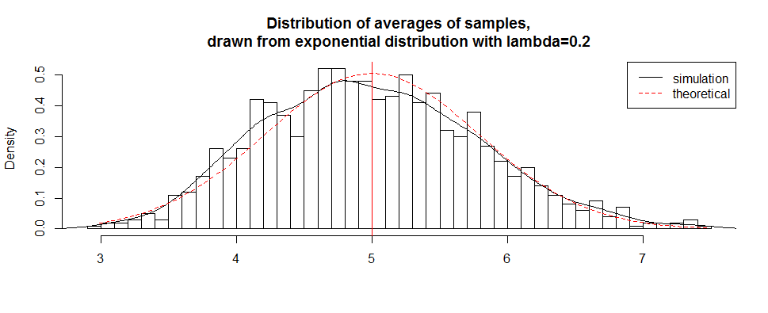

The distribution of sample means is centered at 4.9866 and the theoretical center of the distribution is

λ−1 = 5. The variance of sample means is 0.6258 where the theoretical variance of the distribution is

σ2/n = 1/(λ2n) = 1/(0.04 × 40) = 0.625.

Due to the central limit theorem, the averages of samples follow normal distribution. The figure above also shows the density computed using the histogram and the normal density plotted with theoretical mean and variance values. Also, the q-q plot below suggests the normality

qqnorm(row_means); qqline(row_means)

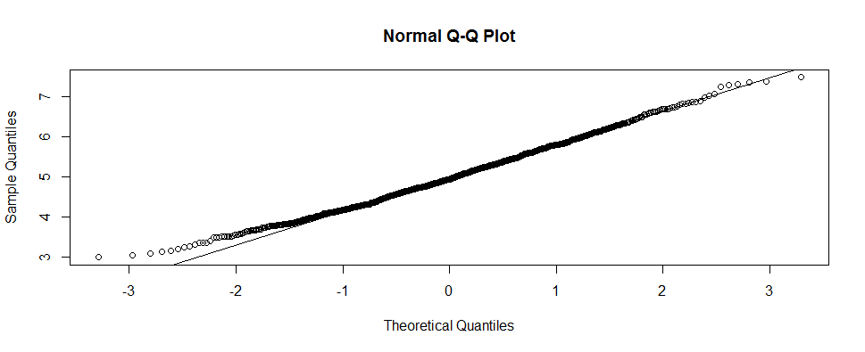

Finally, let’s evaluate the coverage of the confidence interval for 1/λ =± 1.96 

lambda_vals <- seq(4, 6, by=0.01)

coverage <- sapply(lambda_vals, function(lamb) {

mu_hats <- rowMeans(matrix(rexp(sample_size*num_sim, rate=0.2),

num_sim, sample_size))

ll <- mu_hats - qnorm(0.975) * sqrt(1/lambda**2/sample_size)

ul <- mu_hats + qnorm(0.975) * sqrt(1/lambda**2/sample_size)

mean(ll < lamb & ul > lamb)

})

library(ggplot2)

qplot(lambda_vals, coverage) + geom_hline(yintercept=0.95)

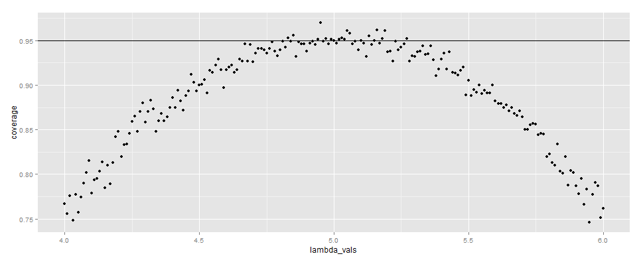

The 95% confidence intervals for the rate parameter (λ) to be estimated  are

 and  As can be seen from the plot above, for selection of  around 5, the average of the sample mean falls within the confidence interval at least 95% of the time. Note that the true rate, λ is 5.