CR MANAGEMENT SYSTEM
User Guide
A step-by-step walkthrough of raising, approving and closing a Change Request

Contents
Contents 2
What is CRMS, and why does it exist? 4
The 12 phases 5
Who does what 5
Step-by-step walkthrough 6
1 · Sign in & the dashboard 6
Sign in 6
Your dashboard 6
2 · Raise a CR (RD Phase) 7
The RD form 7
The business case 8
CR created 9
Find it later 10
3 · RD approval 11
Submit for Approval 11
Awaiting approval 12
The approver’s queue 12
Approve or reject 13
4 · FSD Phase & the CR Owner 13
Set the CR Owner 14
Locked in 14
The sub-task gate 15
5 · Sub-tasks: creation to closure 16
Add a sub-task 16
Describe the work 17
It’s on the board 18
Set the schedule 19
Upload & get ready to close 20
Close it 21
Gate cleared 22
6 · CR-level attachments 22
Attach and submit 22
7 · Development through Deployment 23
Same screen, new phase 23
8 · Observation & closing the CR 24
Observation Phase 24
Close CR 25
Closed — full history 26
Field reference 27
New Release — RD Phase 27
Add Sub-Task 27
Good to know 28

What is CRMS
The CR Management System replaces email threads and spreadsheets for tracking a change request — from the moment someone asks for it, through design, build, approval and deployment, to the day it’s confirmed working in production.
Every Change Request (CR) moves through one predictable pipeline: it’s raised with a business case, designed, approved at up to three checkpoints, built as one or more sub-tasks, tested, deployed, and observed before it’s closed for good. The system enforces the order — you can’t skip the sub-task gate on FSD, you can’t close a CR that isn’t in Observation, and only the CR Owner can send the final sign-off.
Along the way it keeps a full audit trail (History tab), a place to attach documents (per-CR and per-sub-task), and role-based visibility so people only see what’s theirs to act on.

Vision
Login authentication is envisioned to connect directly to Oracle, so the user signs in with their own Oracle username and password — removing the need to create and maintain a second, separate set of credentials just for this tool.
Ownership and hand-offs across all phases, from RD to Closed, are envisioned to work as follows:
1. RD Phase
Raised by Business User (Ankur C.)
↓
2. RD Approval
Approved by Module Head / Divisional Head (Amit Garg)
↓
On approval → auto-assigned to IT Module Process Owner
↓
3. FSD Phase
Held by Process Owner (IT Team) (Bhupesh Nischal)
Process Owner sets the CR Owner (locked for the CR’s life)
Process Owner creates the Sub-Task and assigns it to an IT resource
Resource Create the MD50 Provide the Dates on sub task and close the Task
↓
After Task Clouser
↓
4. FSD Approval
Reviewed by IT Functional Module Owner (Bhupesh Nischal)
↓
5. Development
Held by IT Development Team (Yashwant Mishra)
Creates the Dev Sub-Task and assigns it to a developer
and developer close the task
↓
6. Testing
Held by Assigned CR Owner
Creates the Test Sub-Task and Close the task
↓
7. UAT
Sub-Task assigned directly to Business User (Ankur C.)
Business user creates the subtask and close it
↓
On close → auto-reassigned to CR Owner
↓
9. Deployment
Held by IT Development Team
Creates a sub task provide the dates and close it
↓
8. Deployment Approval
Approved by IT Head (Ajay Chandel)
↓
10. DBA Deployment
Held by DBA Team — mandatory Sub-Task
DBA Team create a sub task provide the dates and close the Task
↓
11. Observation
Auto-assigned to CR Owner
↓
12. Closed
Only the CR Owner can close the CR

Current Use
Today, the Oracle username and password are separate and independently maintained from this tool’s own login — Oracle authentication has not yet been integrated.
Today, all phases — from RD creation through Closed — are maintained by IT; ownership has not yet been split out to Business users or to Module / Divisional Heads as described in the Vision above.
From the Business point of view, this is what actually happens today — one hand-off, then IT owns it end to end:
● All 12 phases handled end-to-end by the same team

1. RD Phase
Raised by Business User (Sidharth)
↓
2. RD Approval
Approved by Module Head / Divisional Head (Bhupesh Nischal)
↓
On approval → auto-assigned to IT Module Process Owner
↓
3. FSD Phase
Held by Process Owner (IT Team) (Sidharth / Bhupesh Nischal)
Process Owner sets the CR Owner (locked for the CR’s life)
Process Owner creates the Sub-Task and assigns it to an IT resource
Resource Create the MD50 Provide the Dates on sub task and close the Task
↓
After Task Clouser
↓
4. FSD Approval
Reviewed by IT Functional Module Owner (Bhupesh Nischal)
↓
5. Development
Held by IT Development Team (Sidharth)
Creates the Dev Sub-Task and assigns it or close it
↓
6. Testing
Held by Assigned CR Owner
Creates the Test Sub-Task and Close the task
↓
7. UAT
Sub-Task assigned directly to Requester (Sidharth)
Requester creates the subtask and close it
↓
On close → auto-reassigned to CR Owner
↓
9. Deployment
Held by IT Development Team (Sidharth)
Creates a sub task provide the dates and close it
↓
8. Deployment Approval
Approved by IT Head (Ajay Chandel)
↓
10. DBA Deployment
Held by DBA Team (Sidharth)— mandatory Sub-Task
DBA Team create a sub task provide the dates and close the Task
↓
11. Observation
Auto-assigned to CR Owner
↓
12. Closed
Only the CR Owner can close the CR

The 12 phases
This is the exact order shown on every CR’s phase bar. Three phases — RD, FSD, Deployment — additionally gate on an approval step before the CR can move on.
Phase | What happens here
RD Phase | The CR is raised: title, summary, priority, the business case (Reason of Change, Business Benefits, Cost & Manpower Saving), and who it’s assigned to. No sub-task is required to submit RD for approval.
RD Approval | Up to however many levels the module is configured with (the requester only picks the Level 1 approver — each approver picks the next level when they approve). State shows as RD Awaiting Approval L1/L2/L3.
FSD Phase | Functional design. The CR Owner must be set here before the phase can be submitted for approval, and at least one sub-task must be created and closed first.
FSD Approval | Same mechanics as RD Approval, shown as FSD Awaiting Approval L1/L2/L3.
Development | Build work, tracked as one or more sub-tasks assigned to developers. Advancing without a closed sub-task shows a warning, but isn’t hard-blocked.
Testing | QA / test-cycle sub-tasks. Same soft gate as Development.
UAT | User acceptance testing. Closing a UAT sub-task automatically re-assigns the CR to the CR Owner.
Deployment Approval | Pre-deployment sign-off, shown as Deployment Approval L1/L2/L3 — note this one doesn’t say “Awaiting” the way RD/FSD do.
Deployment | The change goes live.
DBA Deployment | Database-side deployment. Unlike every other phase, this sub-task is mandatory — the CR cannot advance to Observation without one being created and closed.
Observation | A settling period after go-live. The CR is auto-assigned to the CR Owner on arrival. Only the CR Owner can act — either Close CR or send it back to Development.
Closed | Terminal state. Reachable only from Observation, only by the CR Owner, only through the dedicated Close CR action.

Who does what
Five roles show up throughout the workflow. None of them are exclusive — the same person is often the Requester on one CR and an Approver on someone else’s.
Role | What they do
Requester | Raises the CR in RD Phase. Shown as "Requested By" everywhere.
CR Owner | Set once, from FSD Phase onward, then permanently locked. Gates FSD approval, gets auto-assigned the CR at UAT-closure and at Observation, and is the only person who can close the CR or send it back from Observation.
Approver | Configured per Module + Phase + Level in Admin → Mappings. Approves/rejects RD, FSD and Deployment submissions; each approver picks who approves the next level.
Assignee | The person a sub-task is assigned to. Only the assignee (or an admin) can close their sub-task.
Process Owner | One person per Module + Phase, set by an admin. When a phase is approved, the CR auto-assigns to this person if no sub-task assignee is already set — no manual hand-off needed.

Step-by-step walkthrough
Every screen below is captured from the live application.

1 · Sign in & the dashboard
CRMS authenticates against your Oracle EBS username. Once in, the dashboard is your home base — your own numbers, your own releases, and anything waiting on your approval.
STEP 1

Sign in
Enter your Oracle EBS username and password. A first-time login auto-creates your CRMS account with a default password you’re prompted to change.
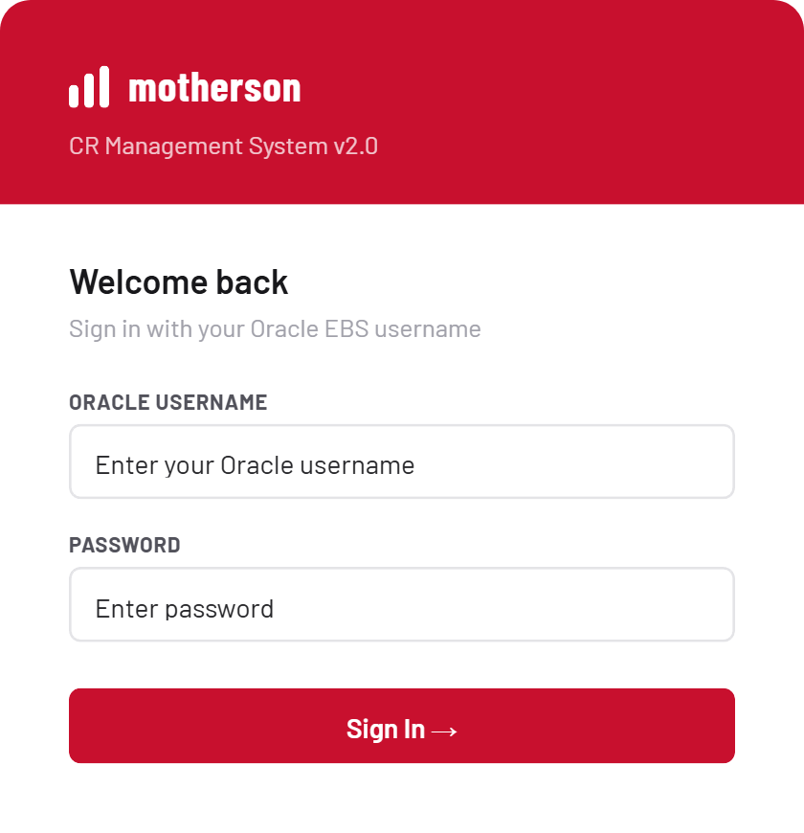
Sign in
STEP 2

Your dashboard
Five tiles summarize your world: total releases, open, critical, closed, and tasks assigned to you. Below that, your recent releases, tasks assigned to you, and anything pending your approval — with one-click Approve / Reject right from the list.
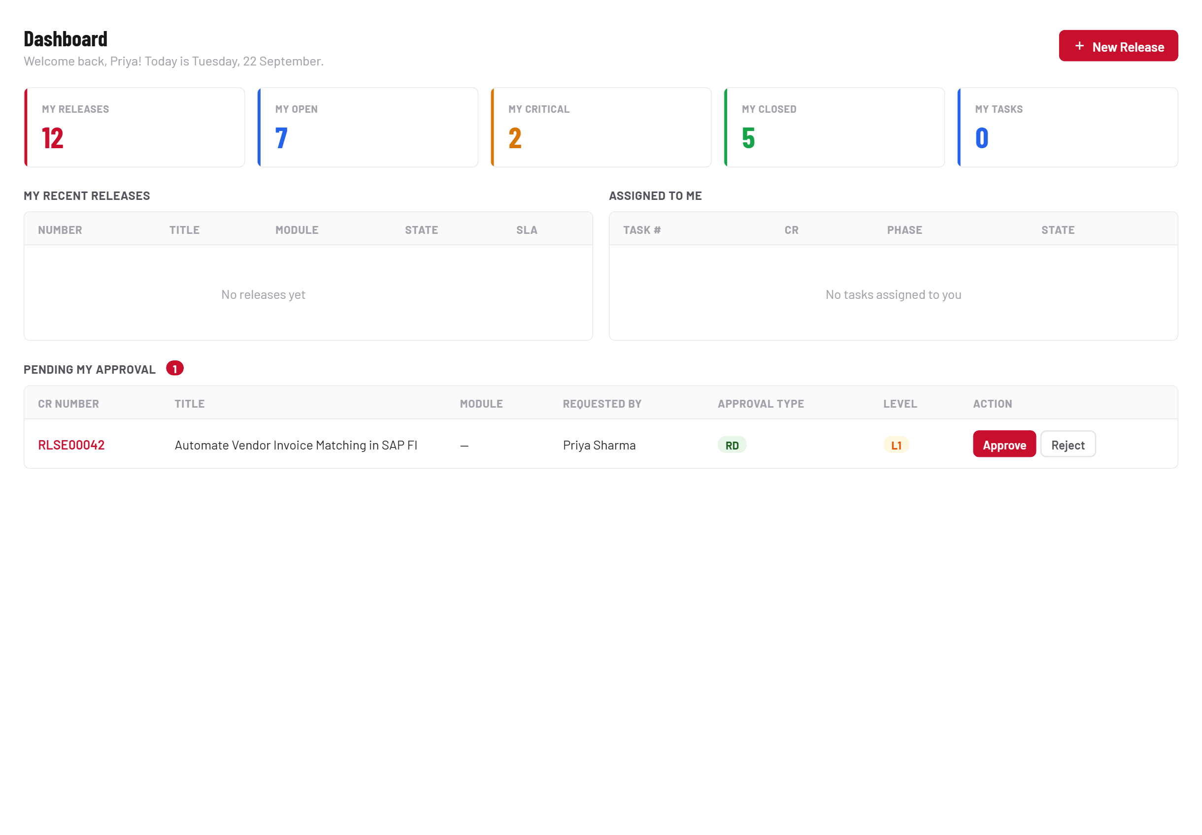
Your dashboard

2 · Raise a CR (RD Phase)
Click + New Release from the dashboard or My Releases. Every CR starts in RD Phase — this is where the business case gets made.
STEP 3

The RD form
Number and Requested By are filled in for you. Everything else — Priority, Company, Service, Title, Summary, Module, Assignment Group, Assigned To, plus the RD Phase Details block — is required.
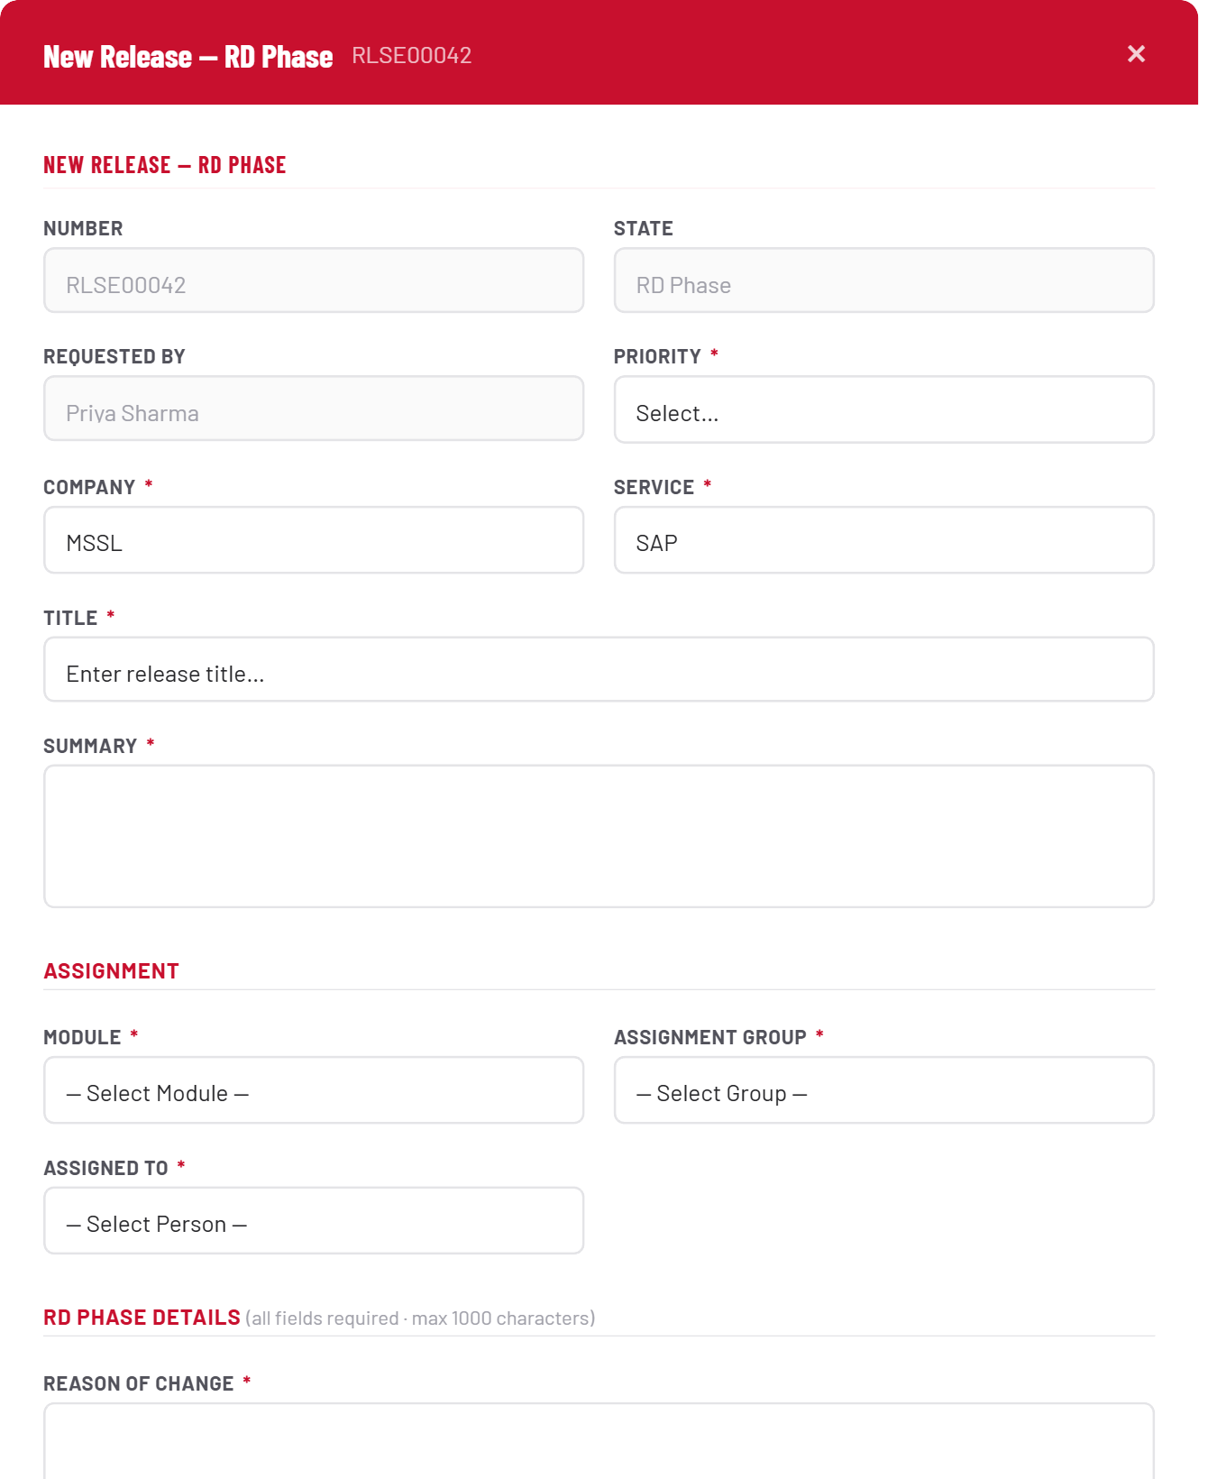
The RD form
STEP 4

The business case
Reason of Change, Business Benefits (Process), Business Benefits (Qualitative), Cost Saving and Manpower Saving are all mandatory, max 1000 characters each — this is what an approver sees when they’re deciding whether to sign off.
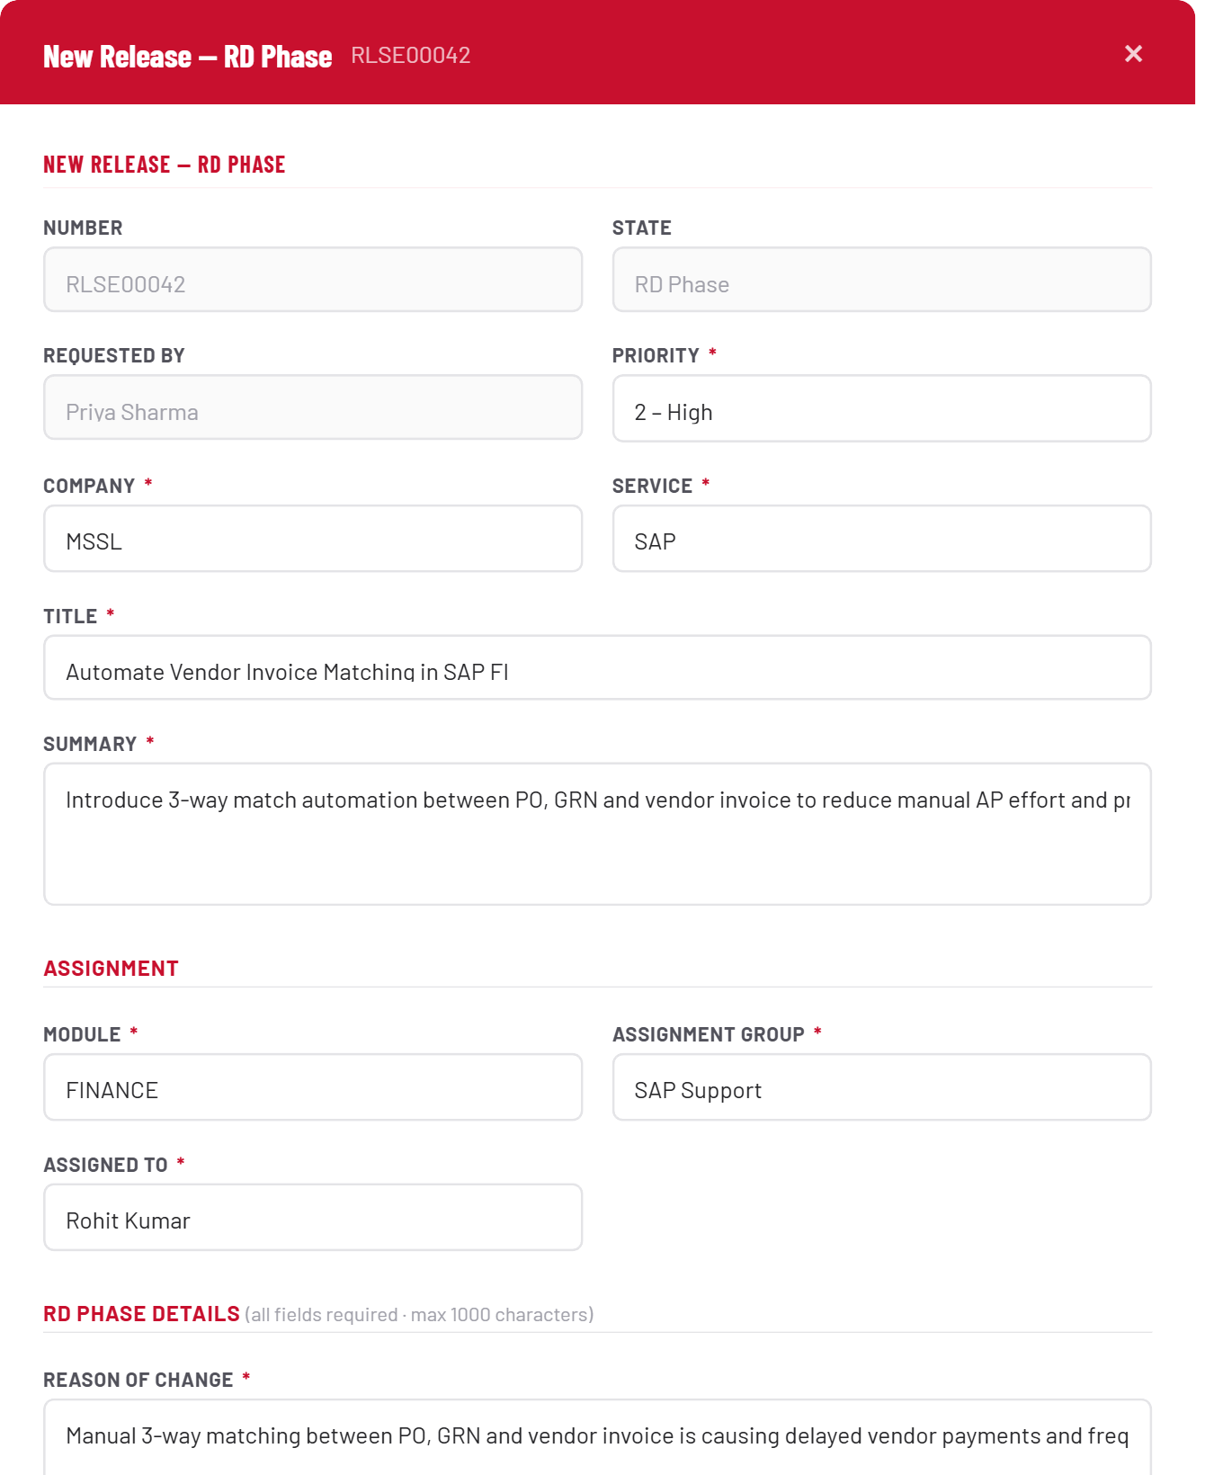
The business case
STEP 5

CR created
The CR opens in RD Phase. The phase bar across the top tracks every stage the CR will pass through; the current one is highlighted. From here you can Put On Hold, Cancel, or Submit for Approval.
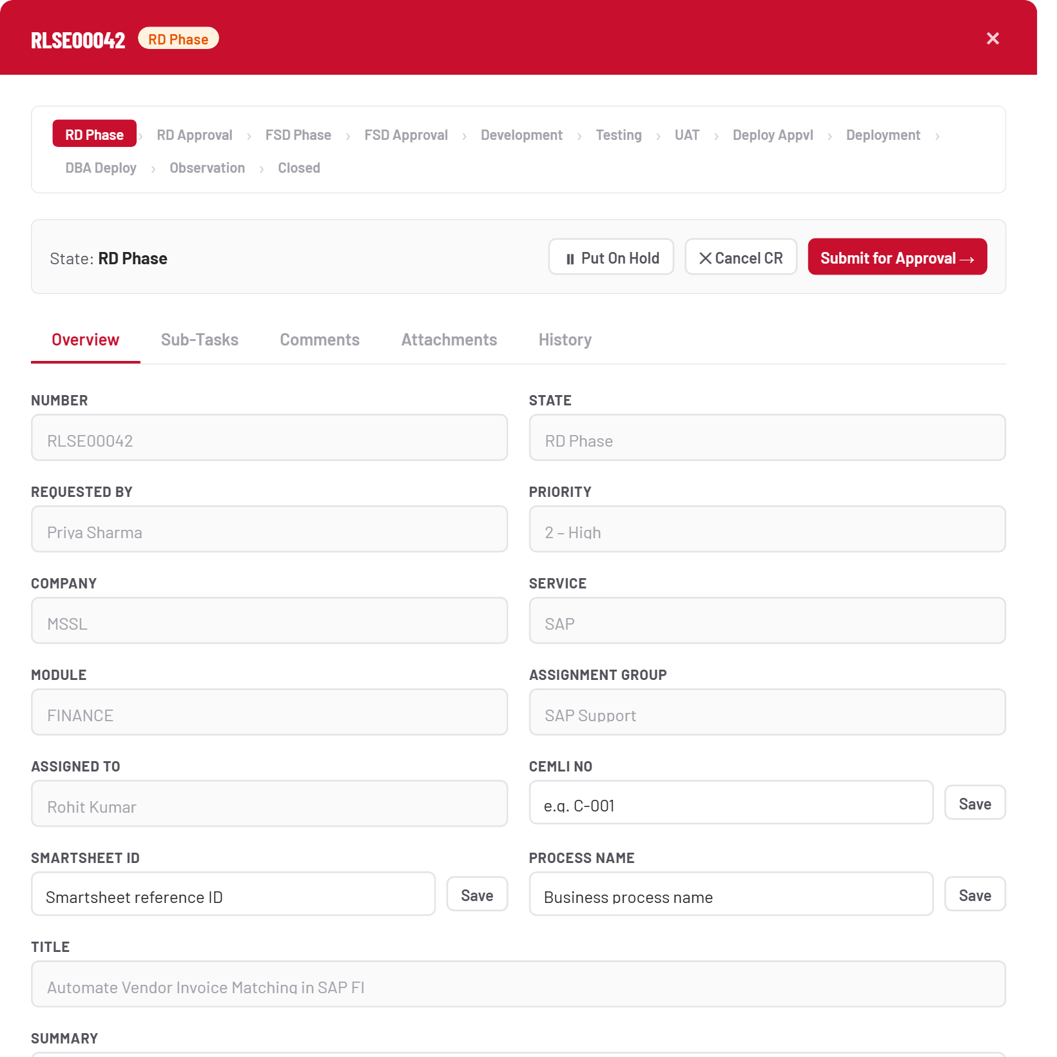
CR created
STEP 6

Find it later
Every CR you’ve raised shows up in My Releases, with its current phase, who it’s pending with, and an SLA indicator for how long it’s been sitting in that phase.
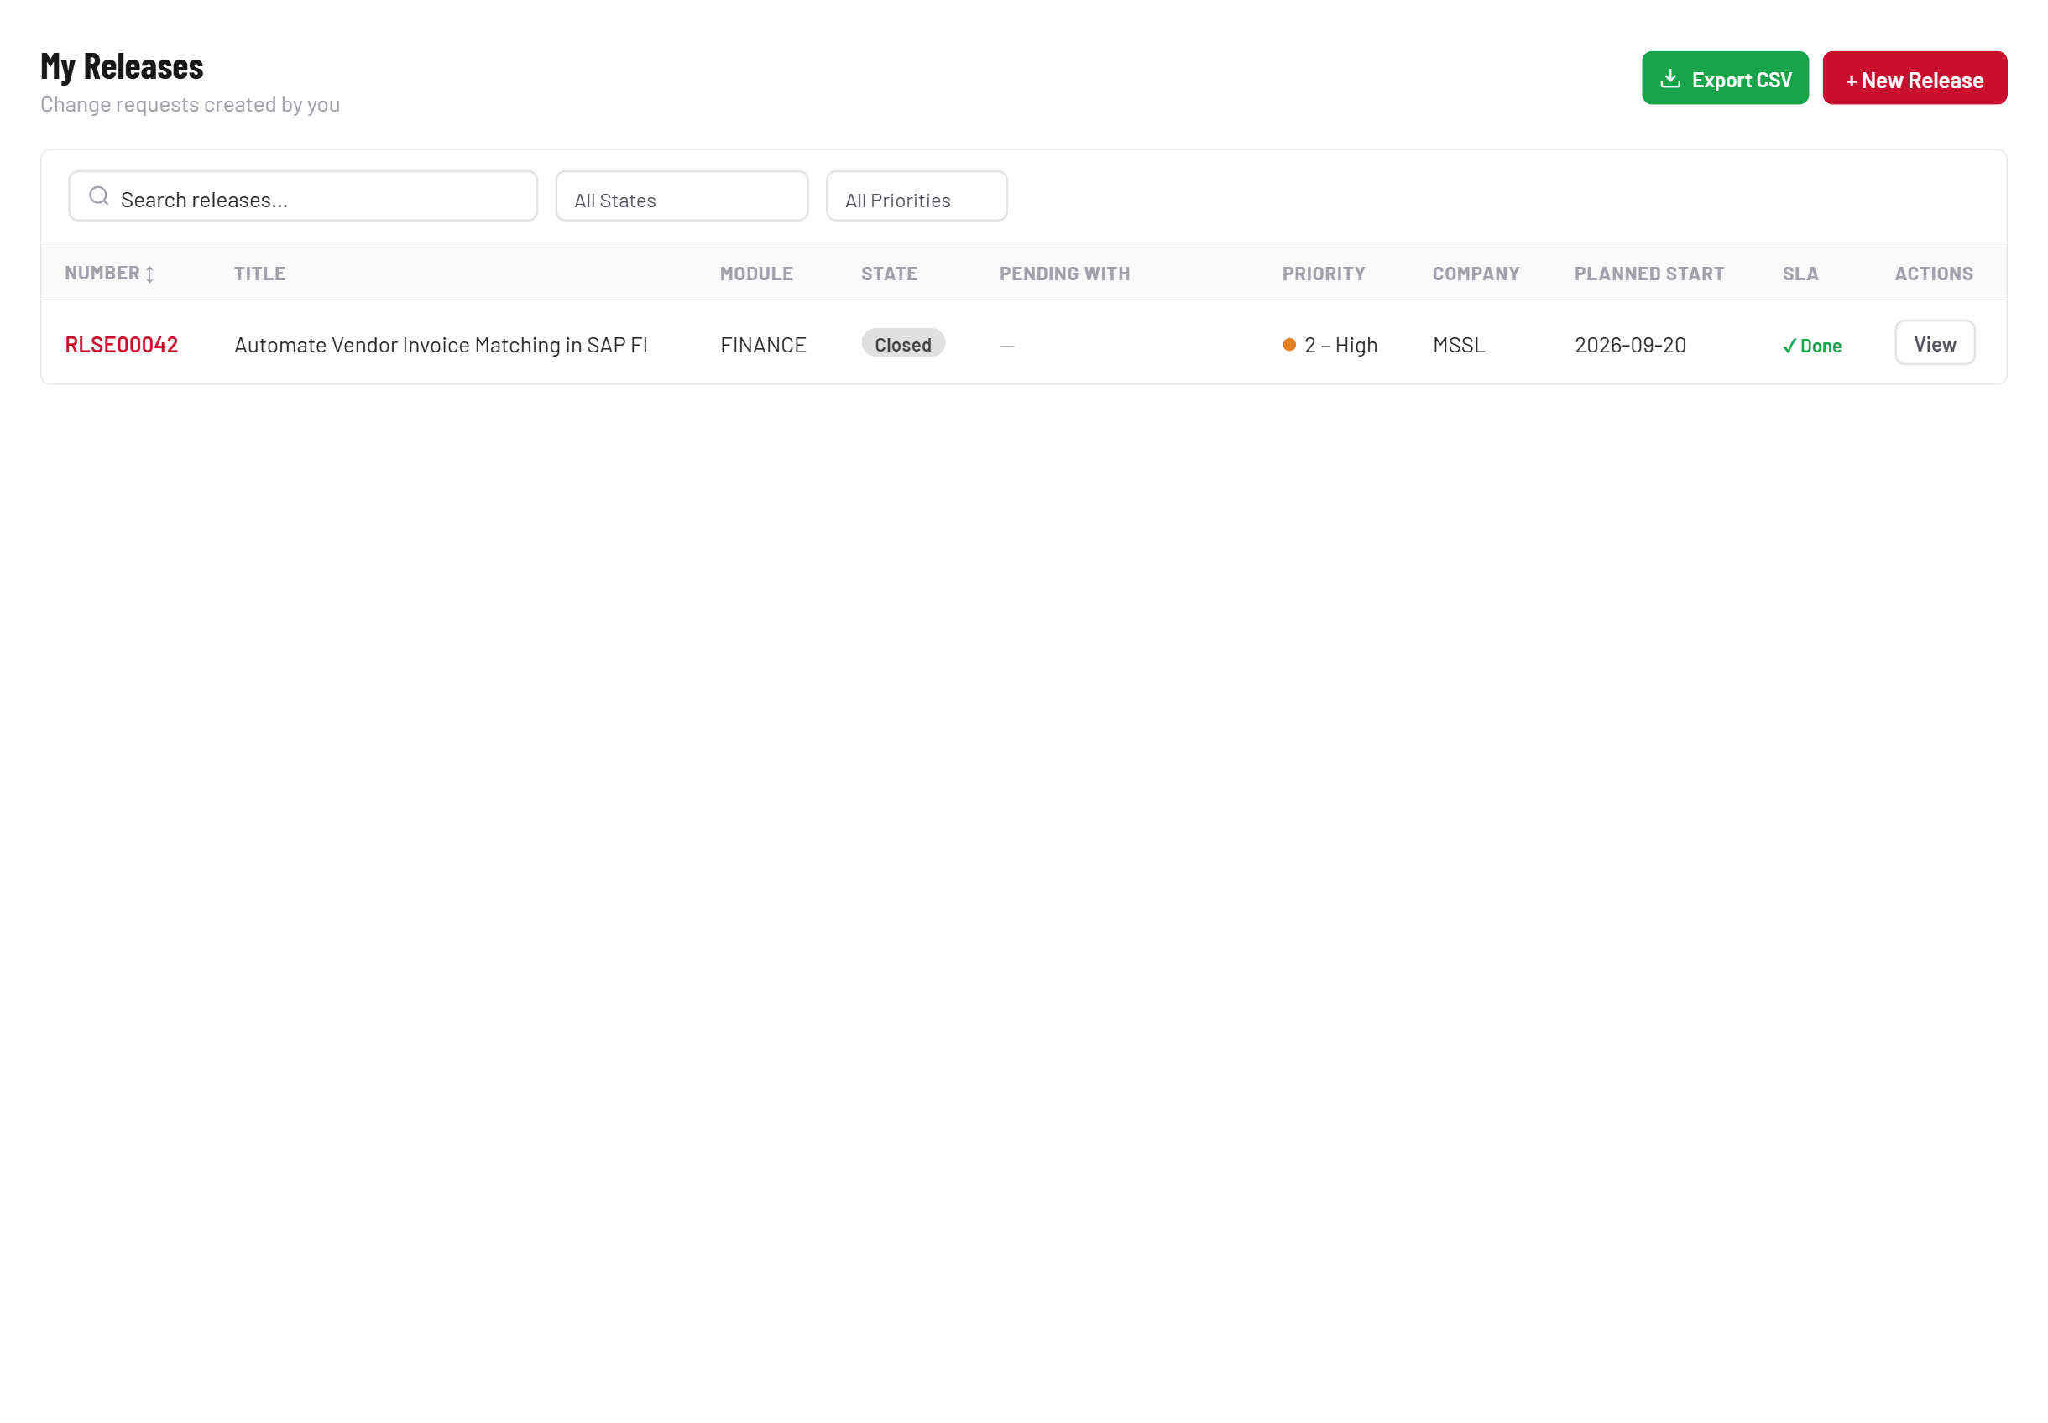
Find it later

3 · RD approval
RD, FSD and Deployment all use the same approval mechanic — this is the only place in the guide it’s shown in full.
STEP 7

Submit for Approval
Click Submit for Approval. You only choose the Level 1 approver — if the module’s flow has more levels, each approver nominates the next one when they approve.
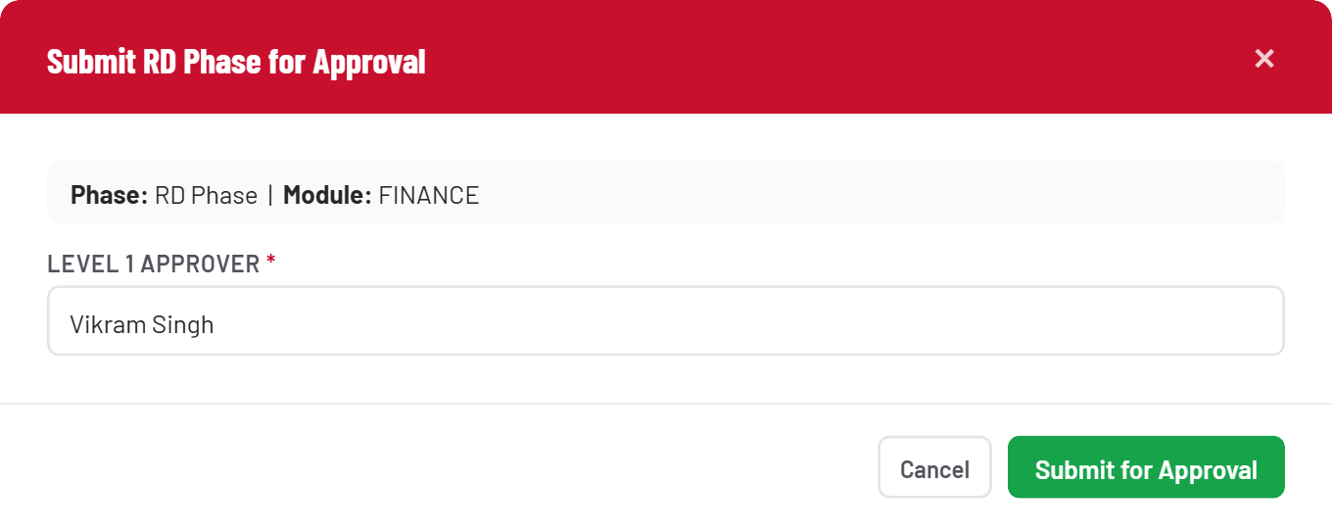
Submit for Approval
STEP 8

Awaiting approval
The CR moves to RD Awaiting Approval L1. While a CR is awaiting approval, Put On Hold is disabled — only Cancel CR remains available to the requester.
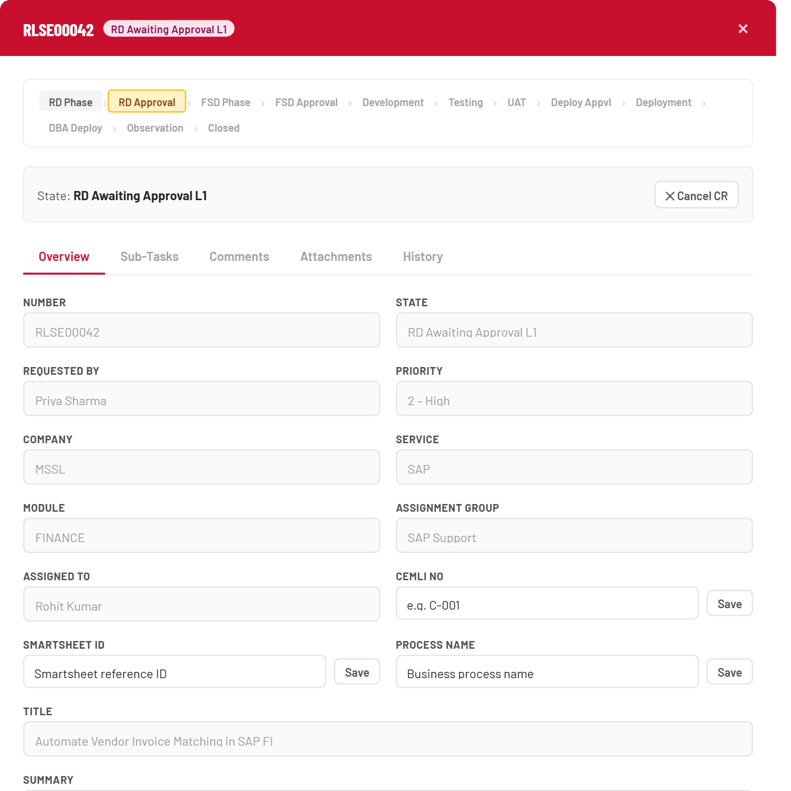
Awaiting approval
STEP 9

The approver’s queue
The approver sees it in their own Approvals view — phase, level, priority, requester, and one-click Approve / Reject.
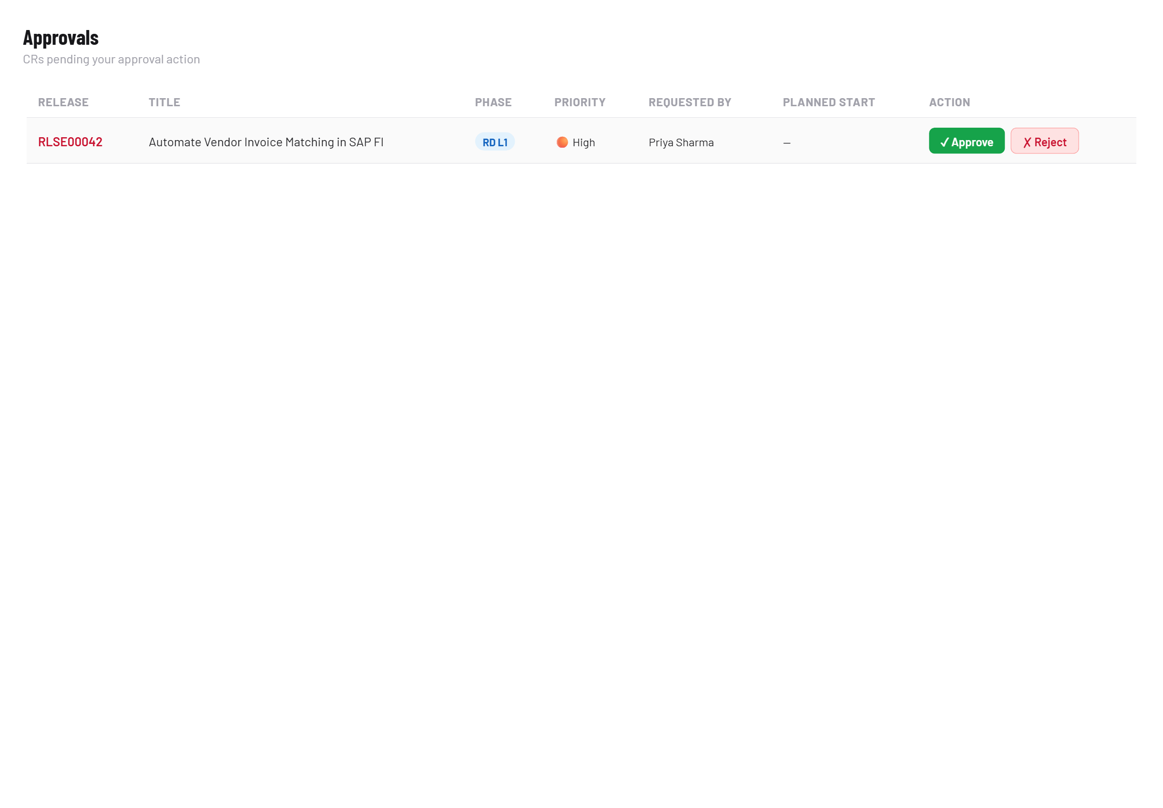
The approver’s queue
STEP 10

Approve or reject
Approve accepts optional comments; Reject requires a reason. On the last configured level’s approval, the CR automatically advances to the next phase — here, RD → FSD.
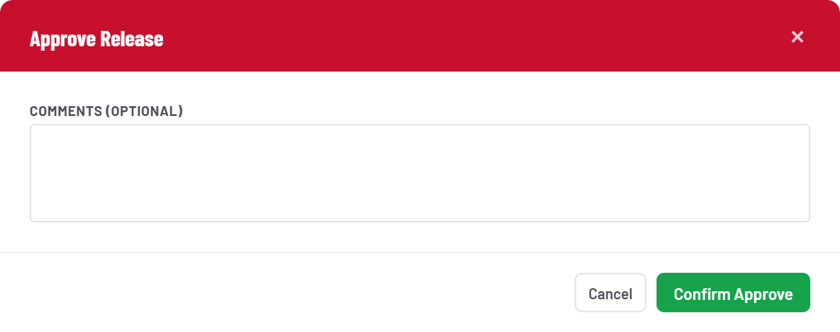
Approve or reject

4 · FSD Phase & the CR Owner
FSD Phase introduces two things nothing before it has: a CR Owner requirement, and a hard sub-task gate.
STEP 11

Set the CR Owner
A CR Owner dropdown appears in Overview for the first time. It must be set before FSD can be submitted for approval — and once set, it can never be changed.
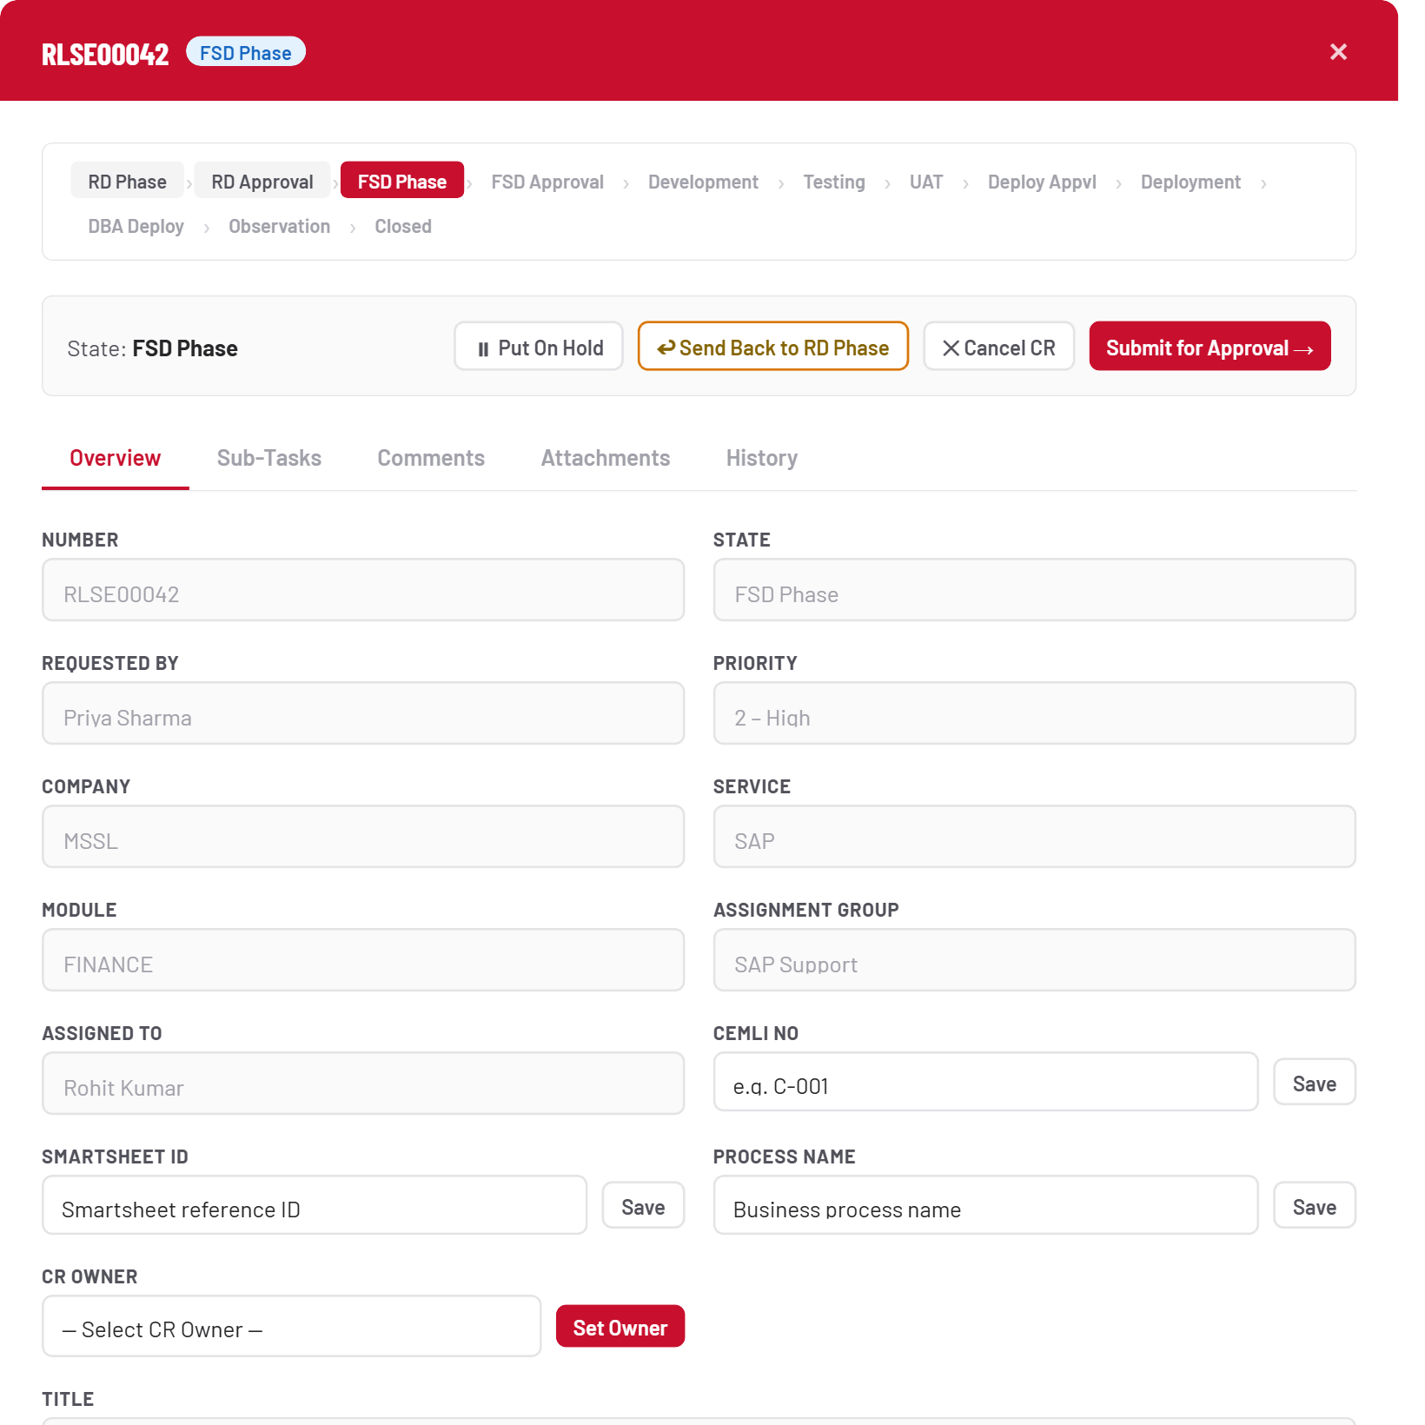
Set the CR Owner
STEP 12

Locked in
Once saved, the field shows a green Locked badge. From here on, this person is auto-assigned the CR when UAT closes and when it reaches Observation — and they’re the only one who can close it at the end.
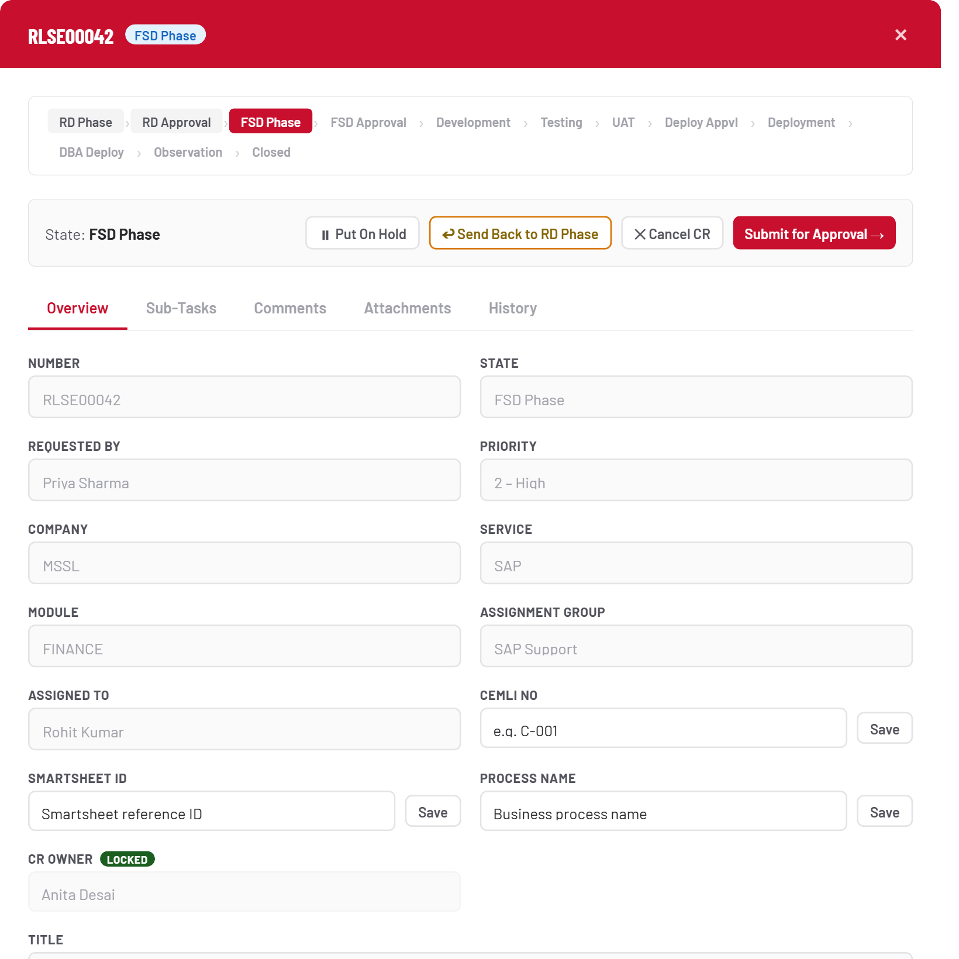
Locked in
STEP 13

The sub-task gate
Try to submit FSD for approval with no closed sub-task, and the Sub-Tasks tab tells you exactly what’s blocking you. This is a hard stop, not a warning — go create one.
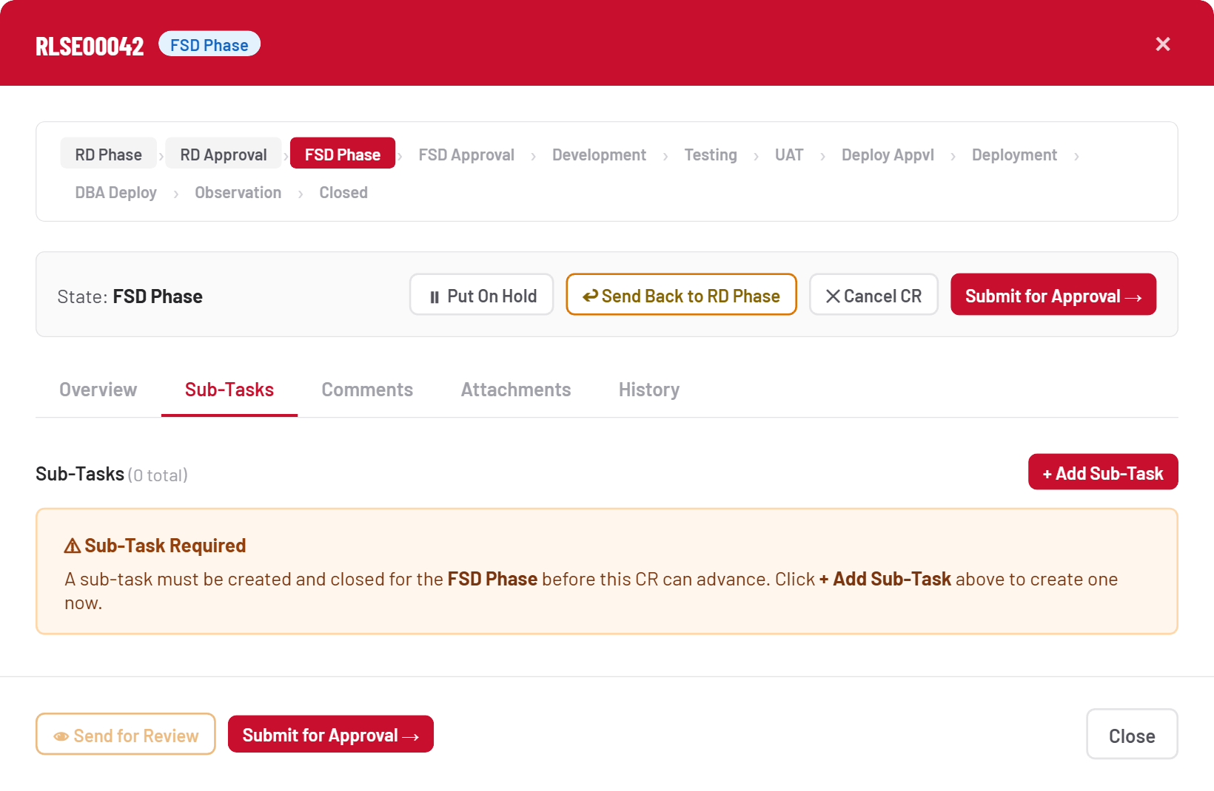
The sub-task gate

5 · Sub-tasks: creation to closure
Sub-tasks are the actual units of work — one CR can have many, in any phase it currently sits in. This is the only place work gets assigned to a specific person with a schedule.
STEP 14

Add a sub-task
From the Sub-Tasks tab, + Add Sub-Task. The phase is detected automatically from the CR’s current state — you don’t pick it.
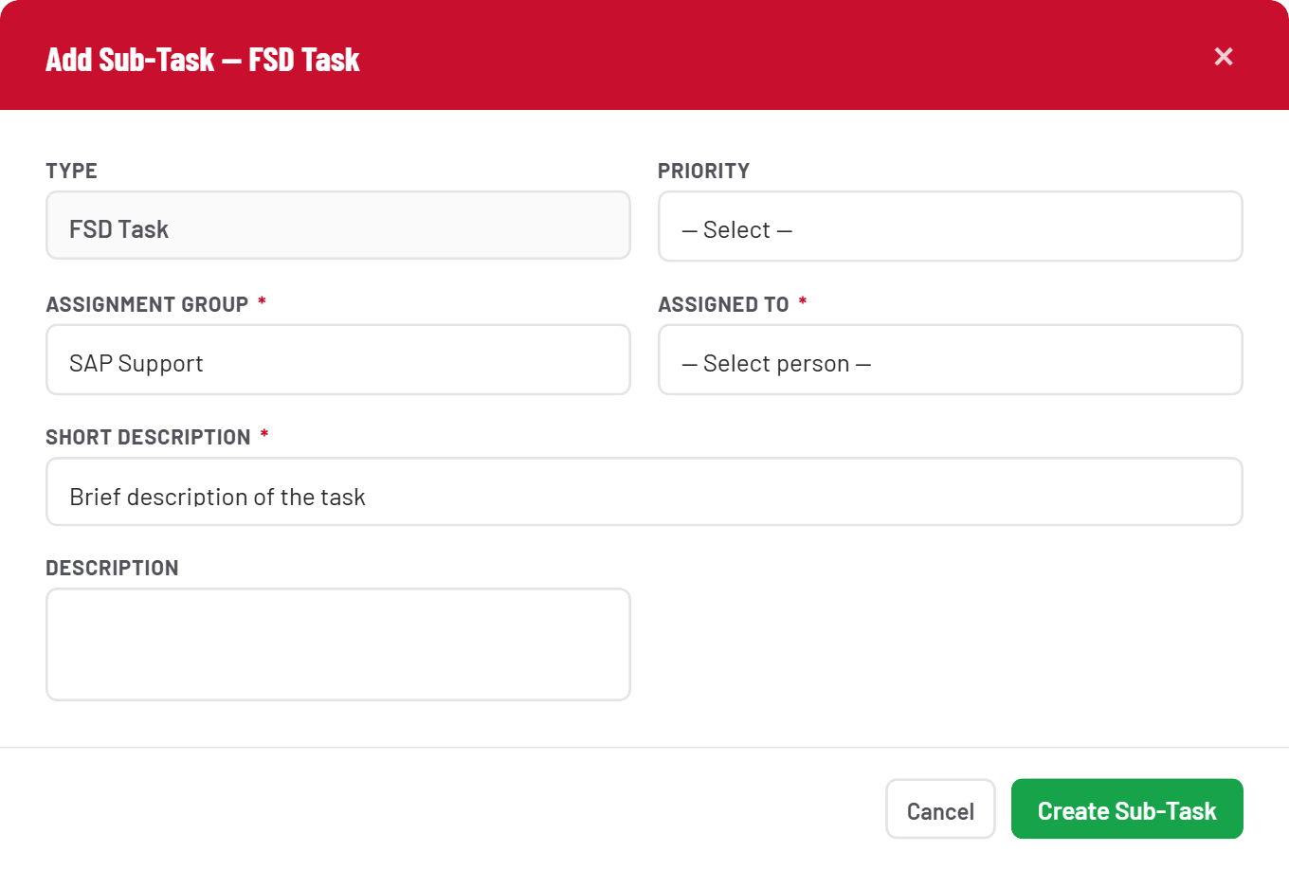
Add a sub-task
STEP 15

Describe the work
Assignment Group defaults from the CR; pick who’s actually doing the work and describe it. Planned dates aren’t collected here — they’re added afterward by the assignee.
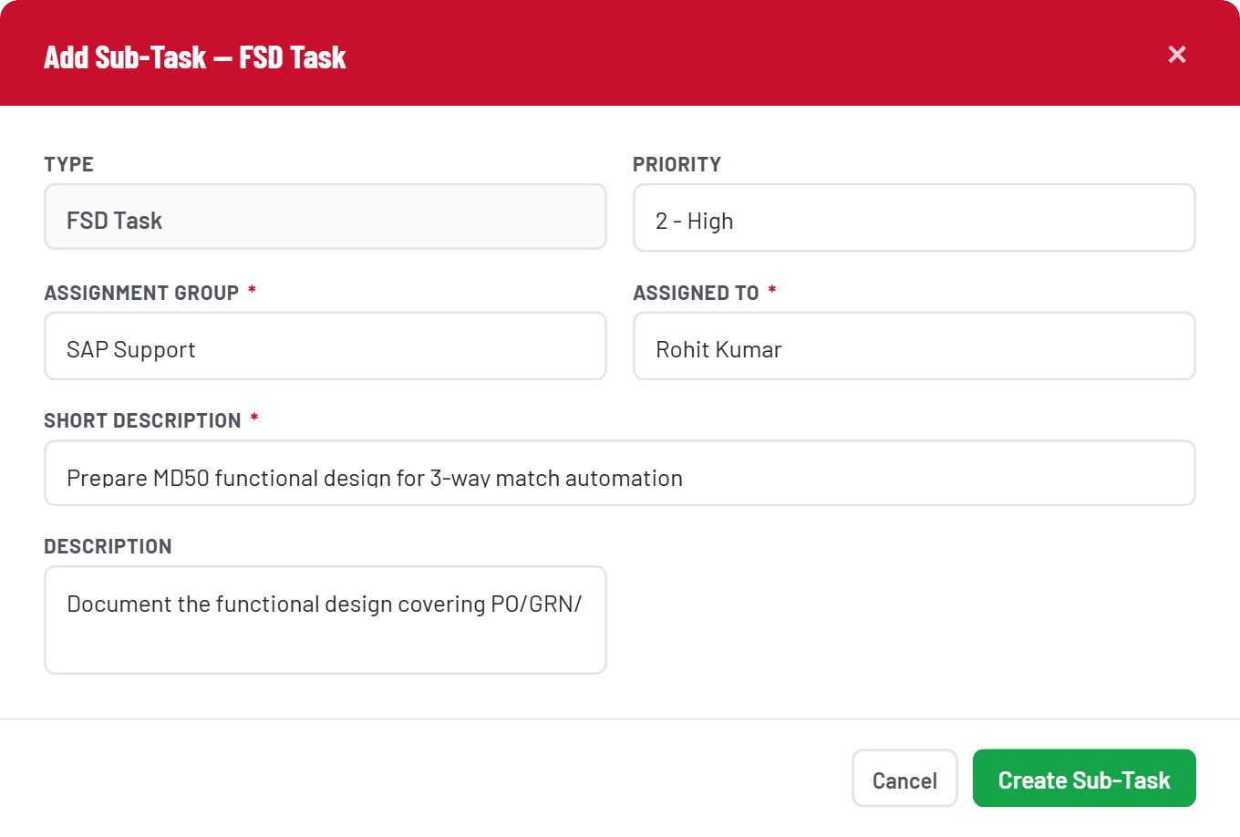
Describe the work
STEP 16

It’s on the board
The sub-task appears in the list with its own number, type, state and assignee — click into any row to open its detail panel.
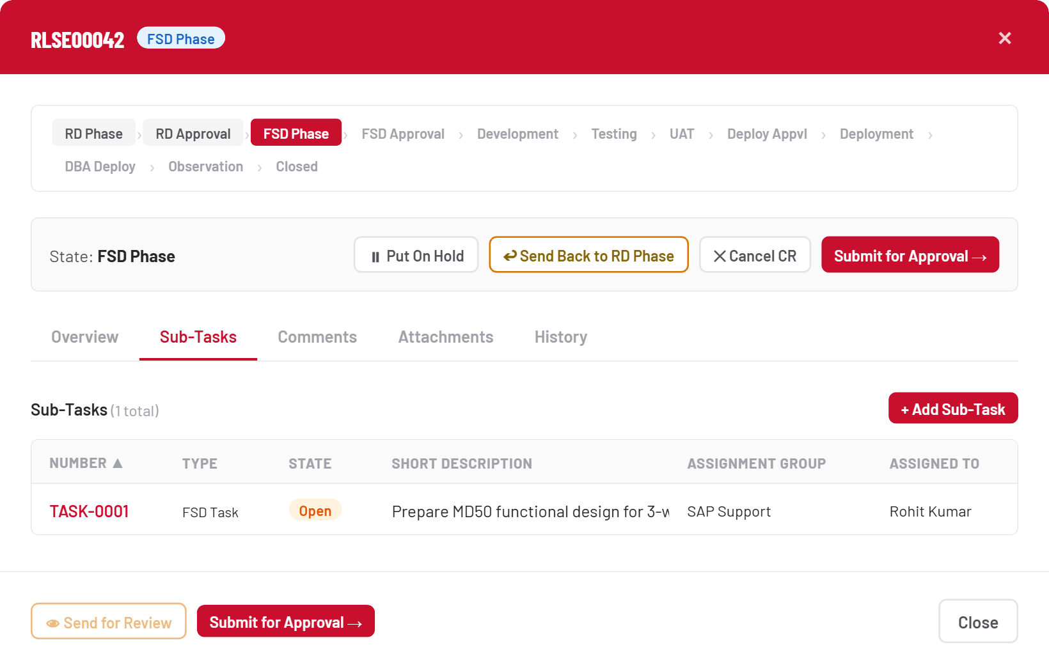
It’s on the board
STEP 17

Set the schedule
Planned Start Date and Planned End Date are both required before the task can close. Note the note on Actual Completion Date — it’s not something you fill in ahead of time.
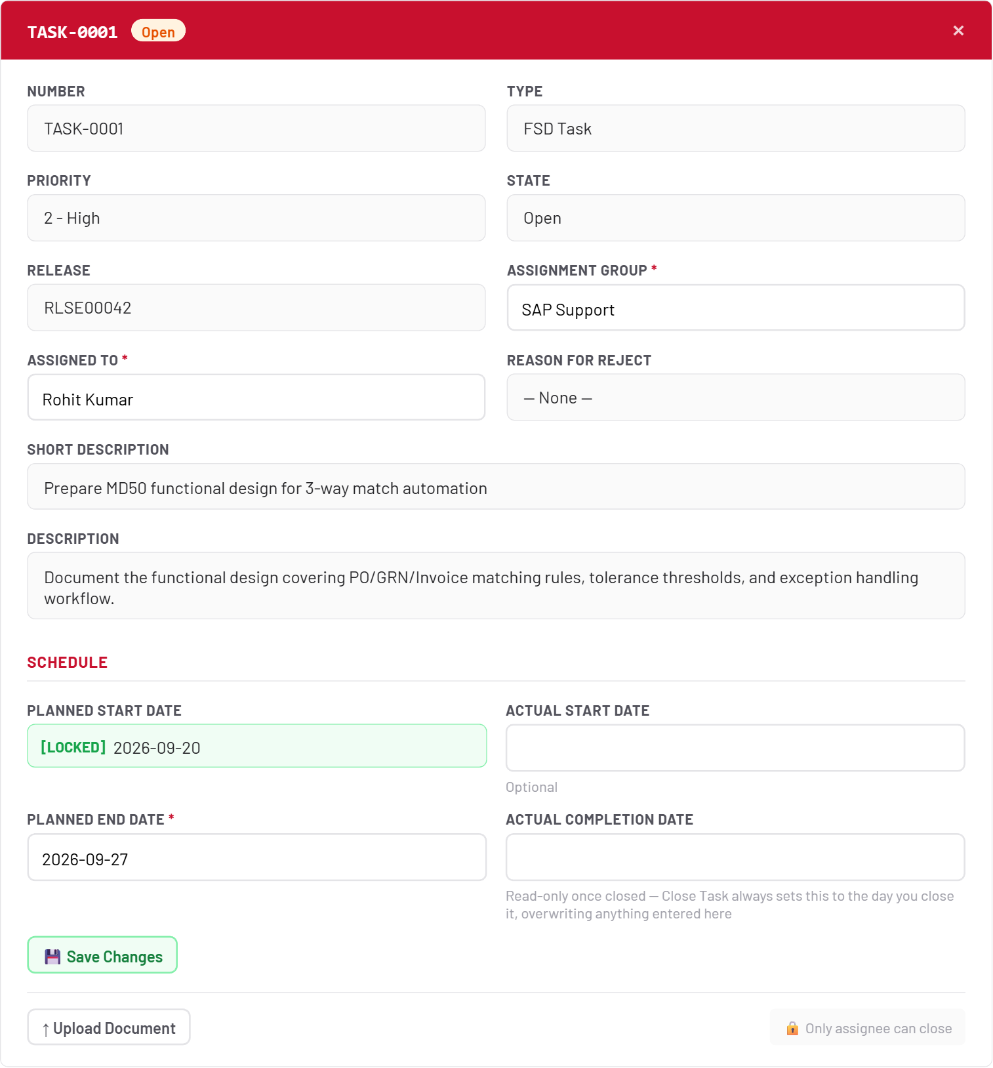
Set the schedule
STEP 18

Upload & get ready to close
Upload is optional but common practice — attach the design doc, test evidence, or deployment script here. Once you’re the assignee, Close Task appears.
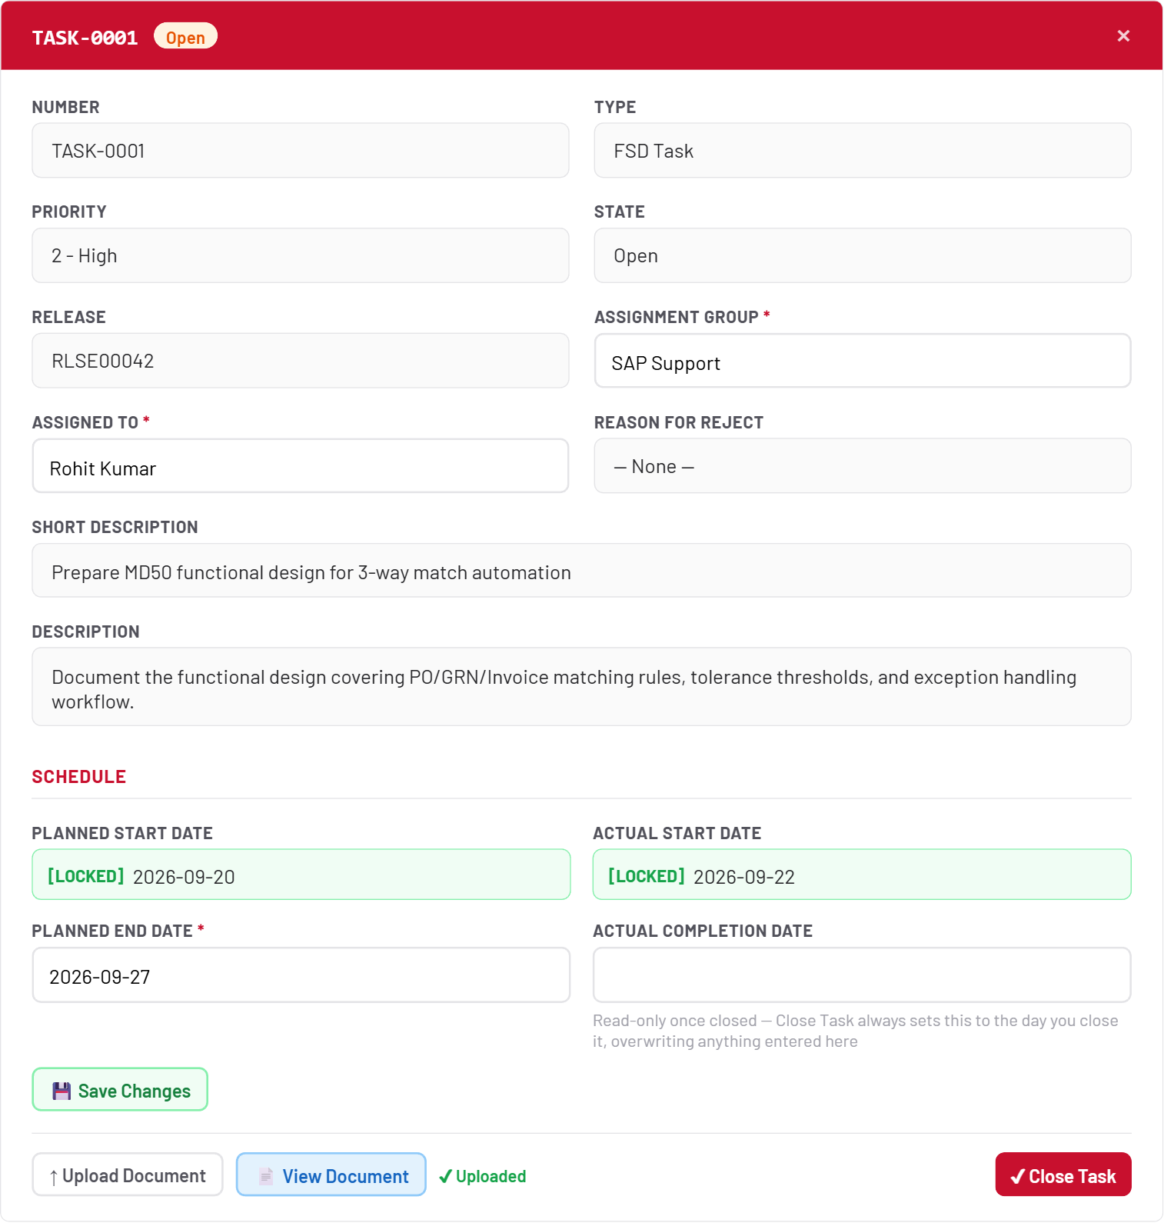
Upload & get ready to close
STEP 19

Close it
Closing is final — no undo. Actual Completion Date is always set to today, the moment you click Close Task, regardless of anything you typed into that field earlier.
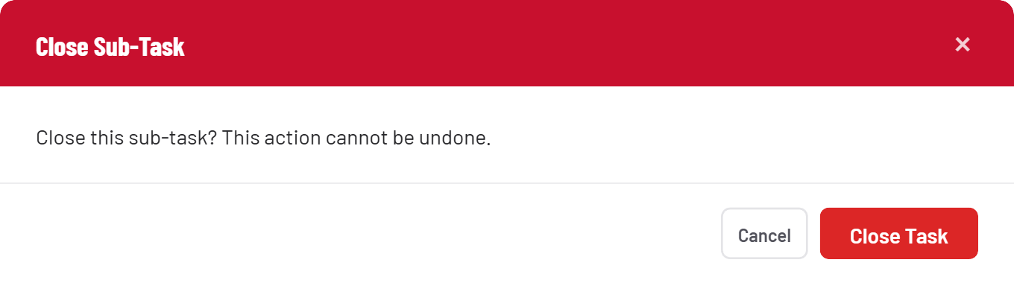
Close it
STEP 20

Gate cleared
With the sub-task Closed, the FSD gate is satisfied and Submit for Approval is unblocked again.
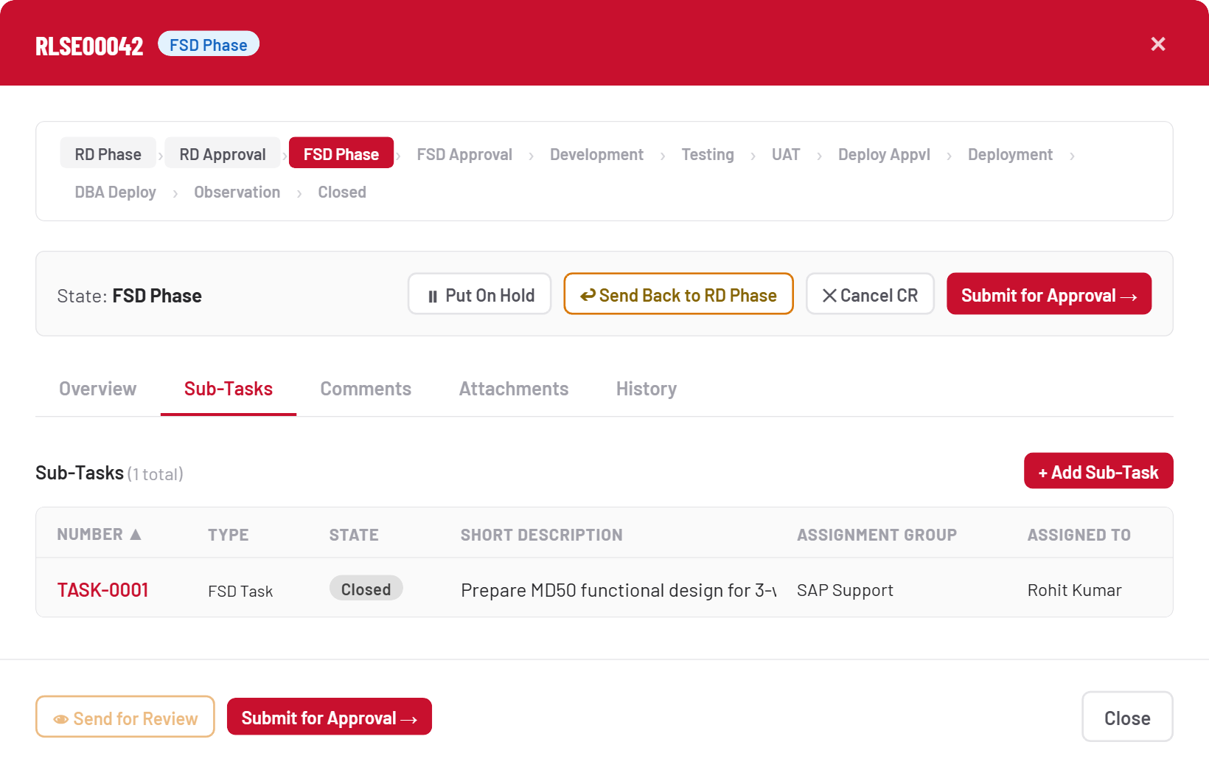
Gate cleared

6 · CR-level attachments
Separate from per-task uploads, the Attachments tab holds documents against the CR itself — and in FSD Phase specifically, it doubles as the submission point.
STEP 21

Attach and submit
PDF, Word, Excel, PowerPoint or images, up to 5MB. In FSD Phase, once a document is attached, a banner offers a direct Submit to FSD Approval shortcut.
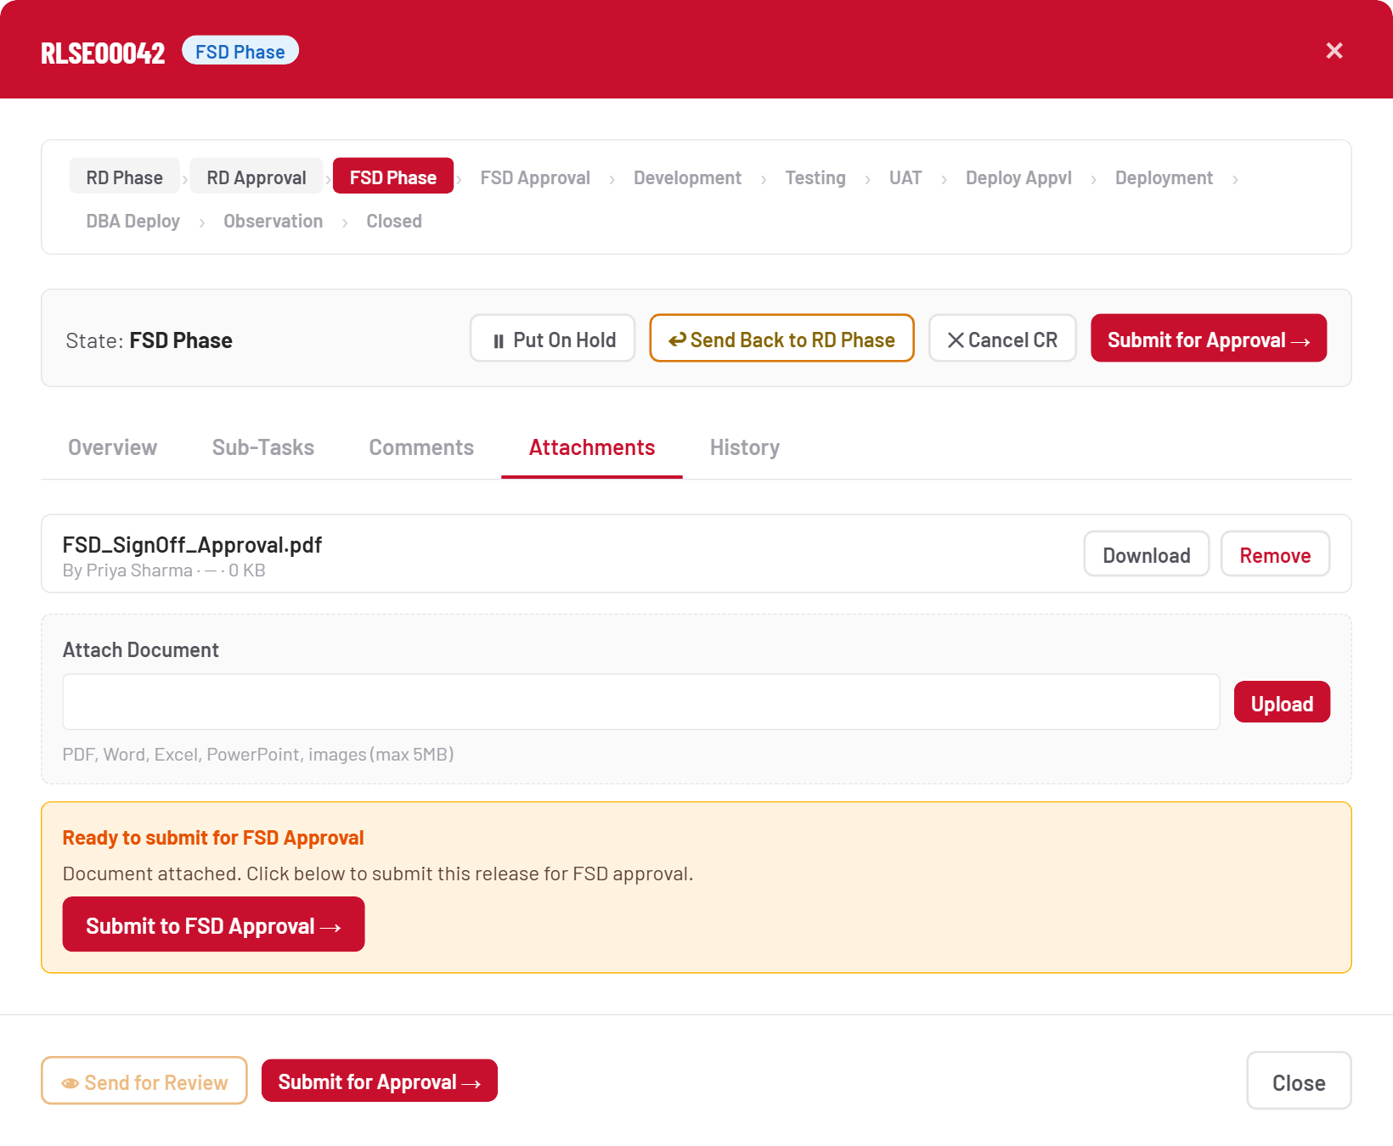
Attach and submit

7 · Development through Deployment
Once FSD is approved, five phases run back-to-back with no approval gate — only sub-tasks. Development, Testing and UAT will let you advance without a closed sub-task (after a warning); DBA Deployment will not.
STEP 22

Same screen, new phase
Every phase reuses the identical CR detail view — only the phase bar, the state label, and the Advance button’s destination text change. Here: Development Phase, next stop Testing.
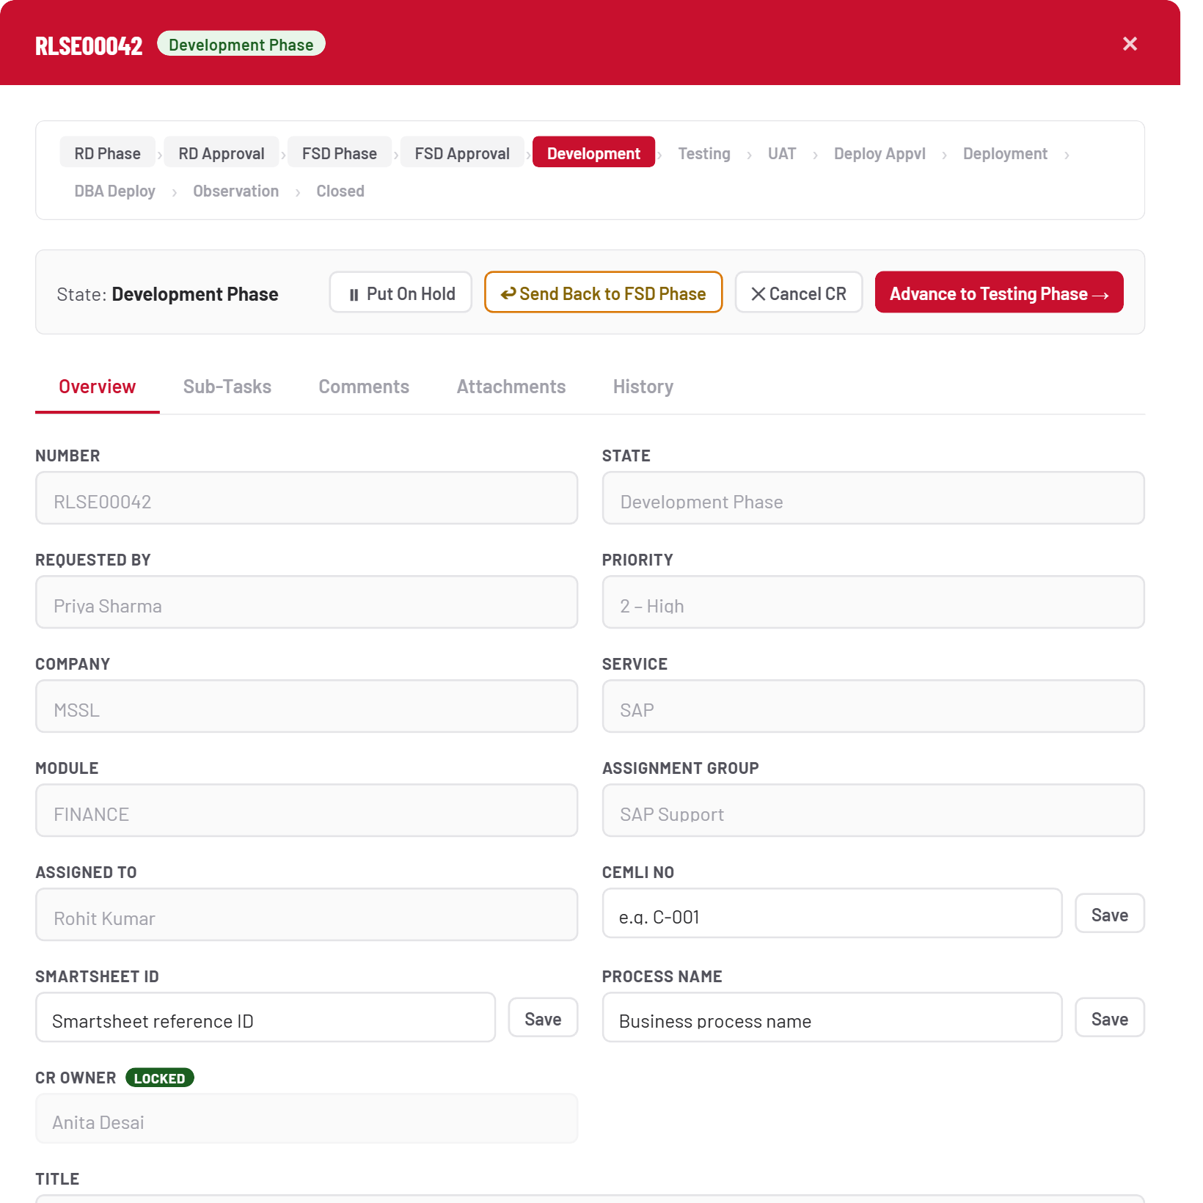
Same screen, new phase
DBA Deployment is a hard gate
Every other phase in this stretch lets you advance without a sub-task, after a confirmation warning. DBA Deployment doesn’t — a DBA Deployment sub-task must exist and be Closed before the CR can move to Observation.

8 · Observation & closing the CR
The last leg belongs entirely to the CR Owner.
STEP 23

Observation Phase
The CR is auto-assigned to the CR Owner on arrival. Only they see Close CR and Send Back to Development Phase — everyone else sees a read-only view.
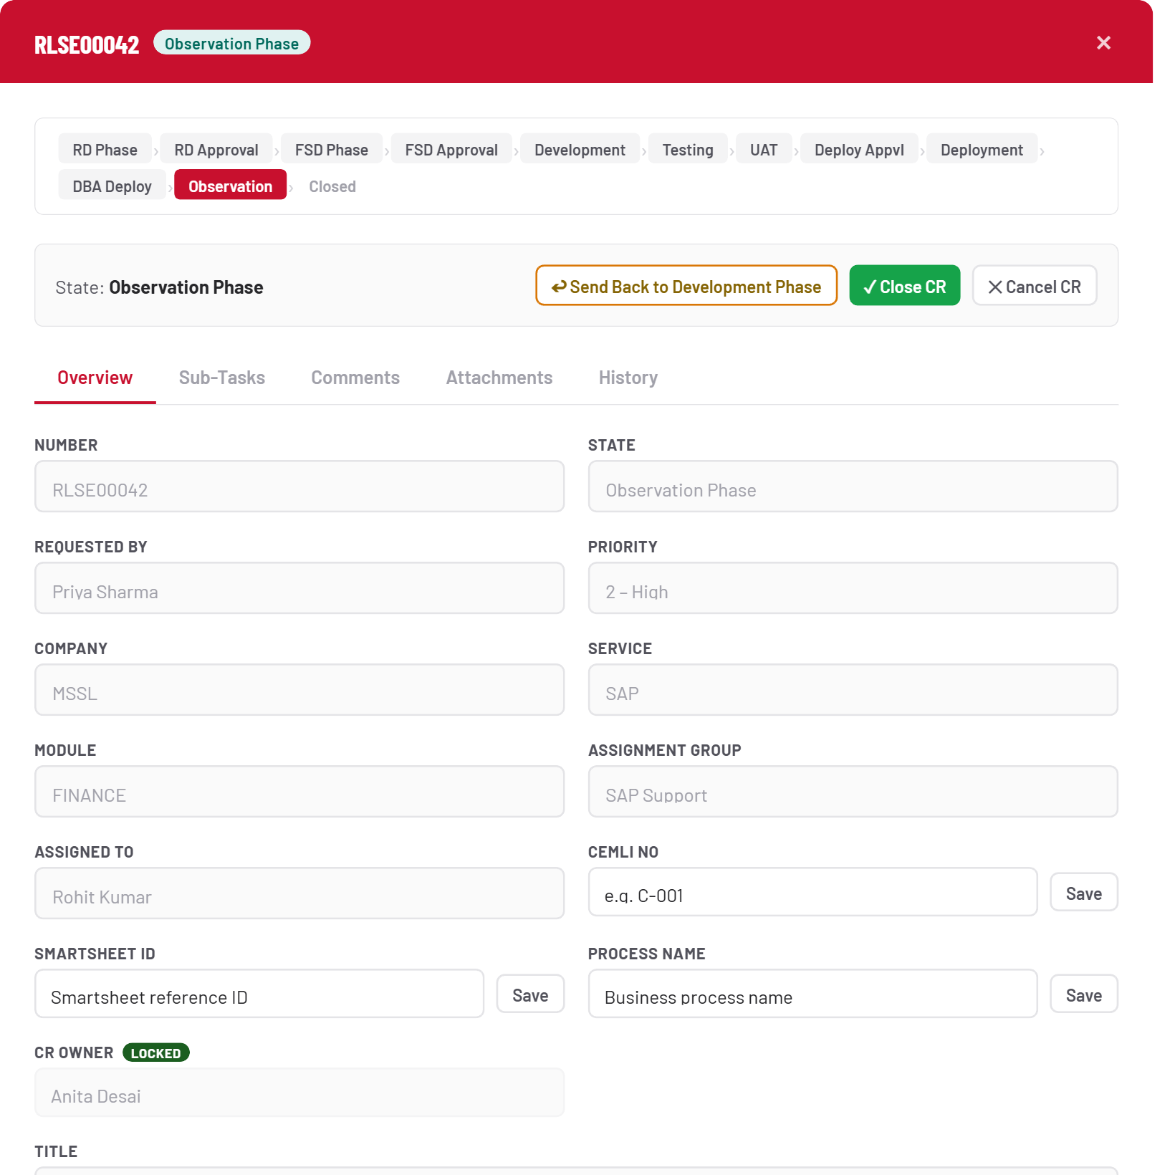
Observation Phase
STEP 24

Close CR
One confirmation, no going back through this route: Observation → Closed. This is the only path to Closed — the generic Advance action explicitly refuses to do it.
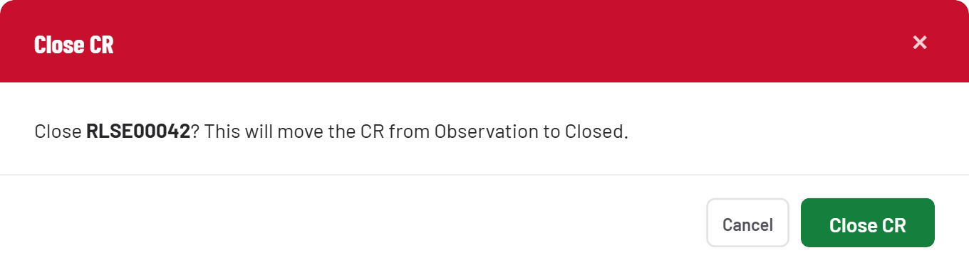
Close CR
STEP 25

Closed — full history
The complete audit trail is one tab away — every state change, who made it, and when. This is the record a CR carries for good.
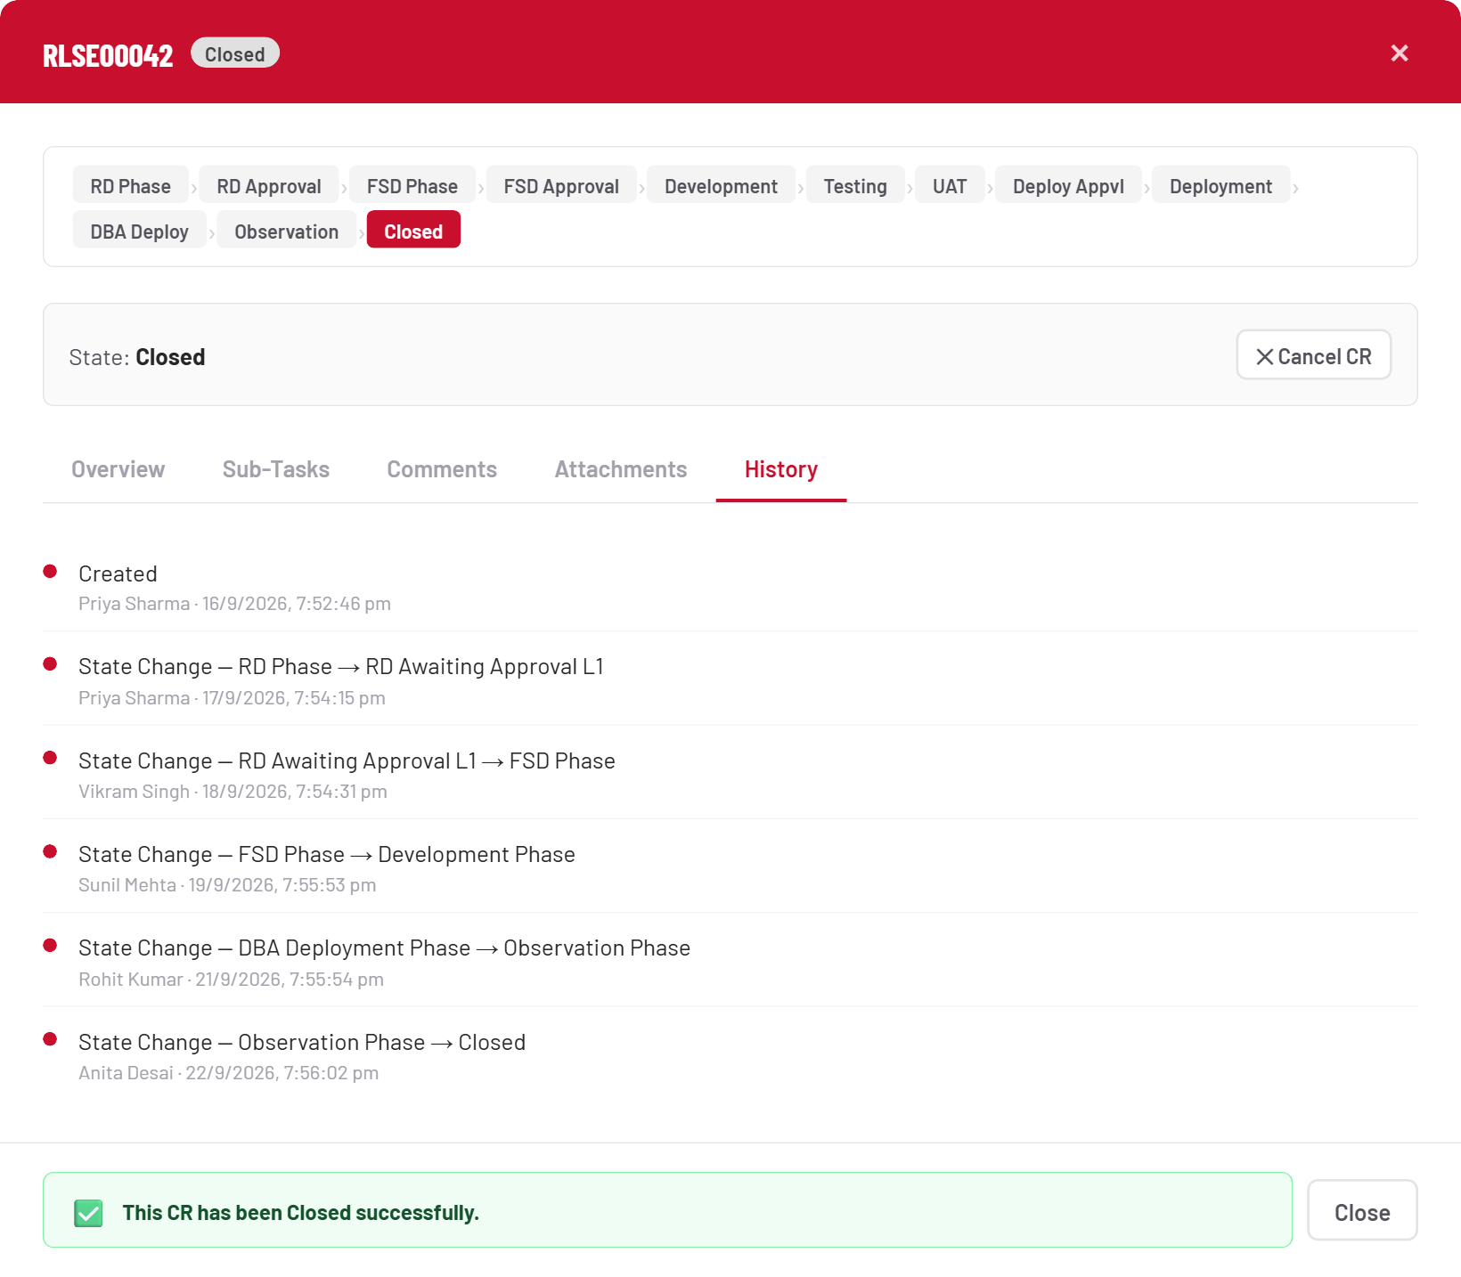
Closed — full history

Field reference
The two forms you’ll fill in most often.

New Release — RD Phase
Field | Required | Notes
Priority | Yes | 1 – Critical → 4 – Low
Company / Service | Yes | Filters the Module and Assignment Group choices below
Title / Summary | Yes | Plain text
Module / Assignment Group | Yes | Assignment Group is filtered by Module
Assigned To | Optional in practice | Marked required on screen, but can be left blank and assigned later
Reason of Change | Yes | Max 1000 characters
Business Benefits (Process / Qualitative) | Yes | Two separate fields, max 1000 characters each
Cost Saving (₹) / Manpower Saving (person-days) | Yes | Numeric

Add Sub-Task
Field | Required | Notes
Assignment Group | Yes | Defaults from the CR
Assigned To | Optional | Falls back to whoever creates the task
Short Description | Yes | One line
Priority / Description | Optional
Planned Start Date / Planned End Date | Yes, before closing | Not on the creation form — added afterward via the task detail panel

Good to know
A handful of behaviors that aren’t obvious from the screen alone.
Topic | Behavior
Actual Completion Date | Always set to the moment Close Task is clicked — never to whatever was typed into that field beforehand.
CR Owner | Settable exactly once, only from FSD Phase, then permanently locked.
Approval levels | Configurable per module in Admin → Mappings — not fixed at three, though a few internal lookups currently assume no more than L1–L3.
Attachments | 5MB cap, enforced in the browser. PDF, Word, Excel, PowerPoint, images — both at CR level and per sub-task.
Pending With | Always reflects who holds the current open sub-task for the CR’s active phase — not a phase or approval-status label.
Hold / Resume | Put On Hold works from most phases; unavailable while a CR is awaiting approval or in Observation.
CRMS User Guide — compiled from the live application. Screens shown use illustrative sample data.

