Feature Engineering Mini Project - IBM HR Dataset
Date: 2025-11-05 06:57 UTC

Dataset Overview
File: WA_Fn-UseC_-HR-Employee-Attrition.csv | Records: 1470 | Features: 35

Data Cleaning & Preprocessing
Duplicate removal, missing-value imputation using median/mode, outlier capping for MonthlyIncome.

Feature Engineering
Target encoding, one-hot encoding, log transform, and identifier removal.

Visualizations
Age Hist Original
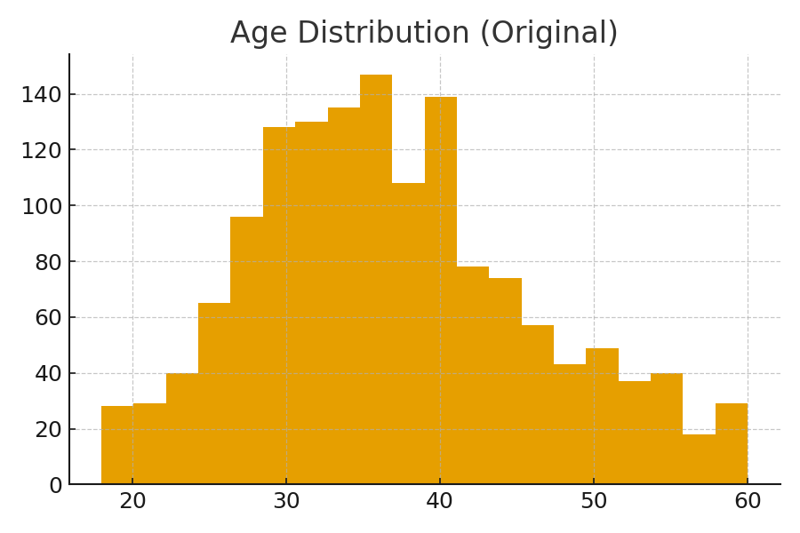
Attrition By Department
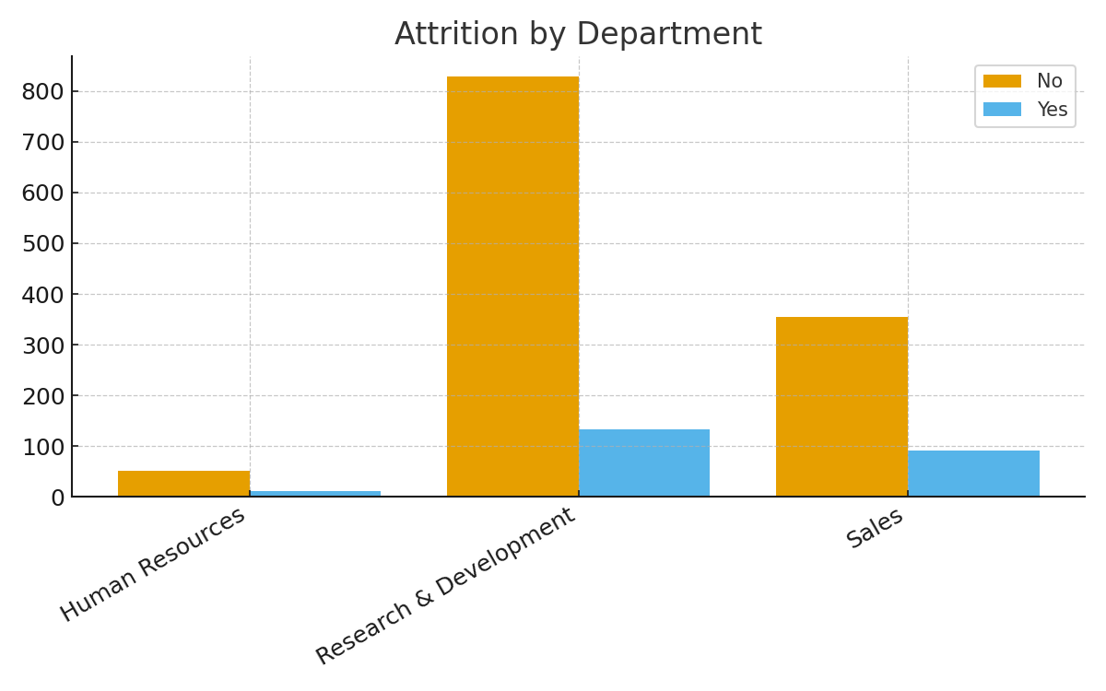
Attrition Count
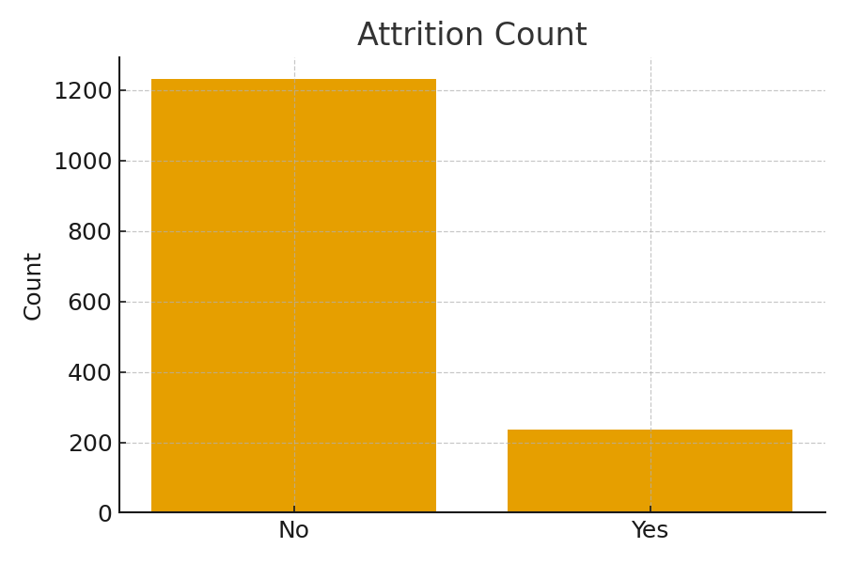
Correlation Matrix
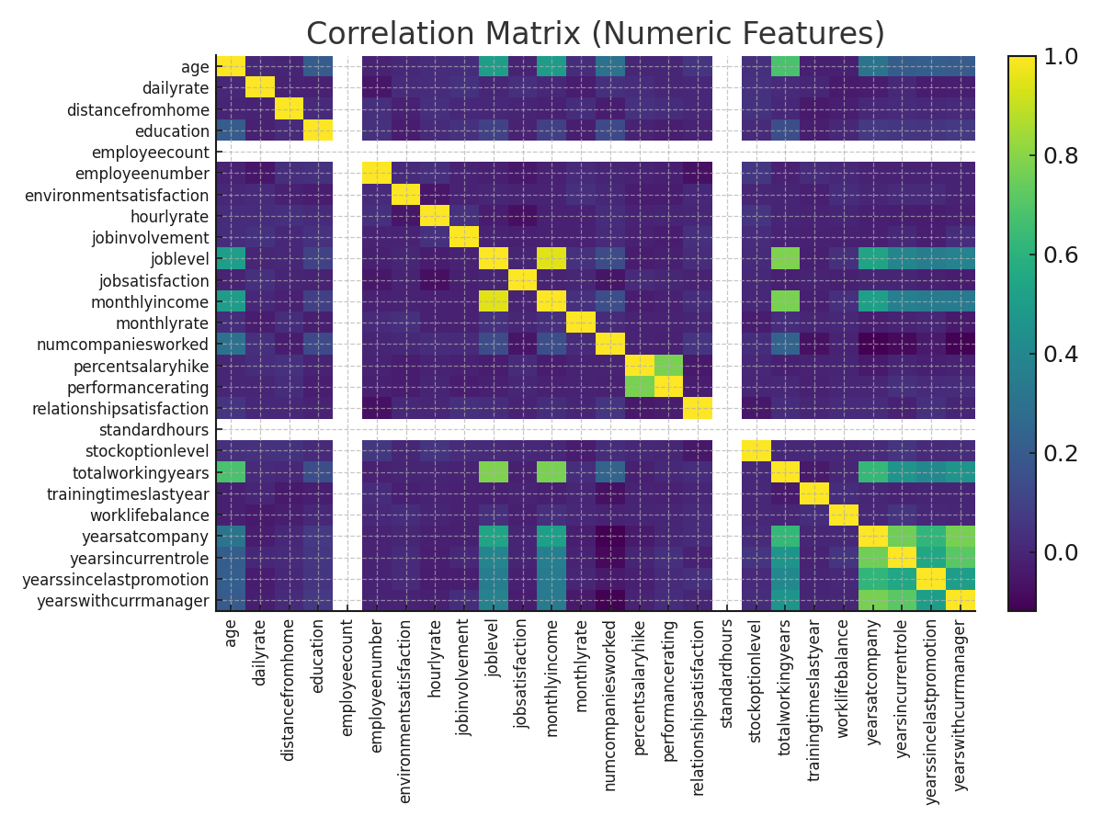
Monthlyincome Box Original
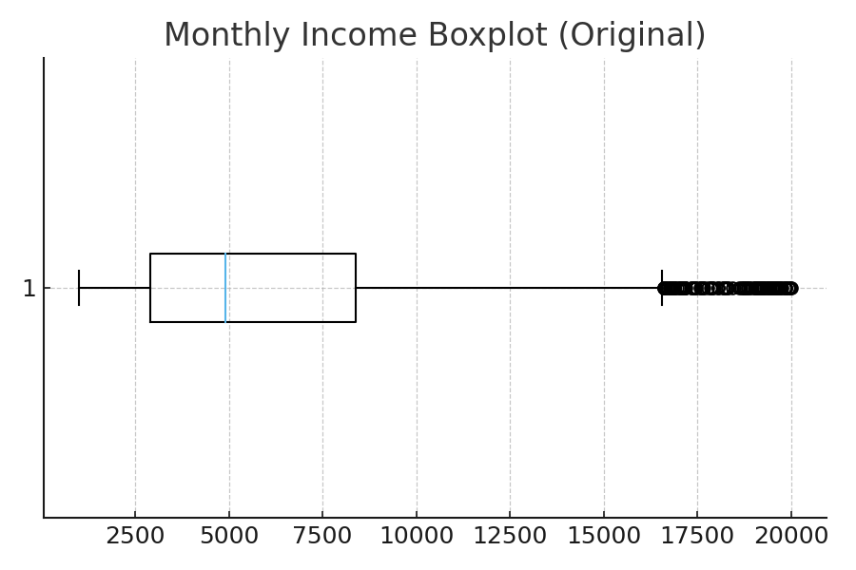
Monthlyincome Hist Processed
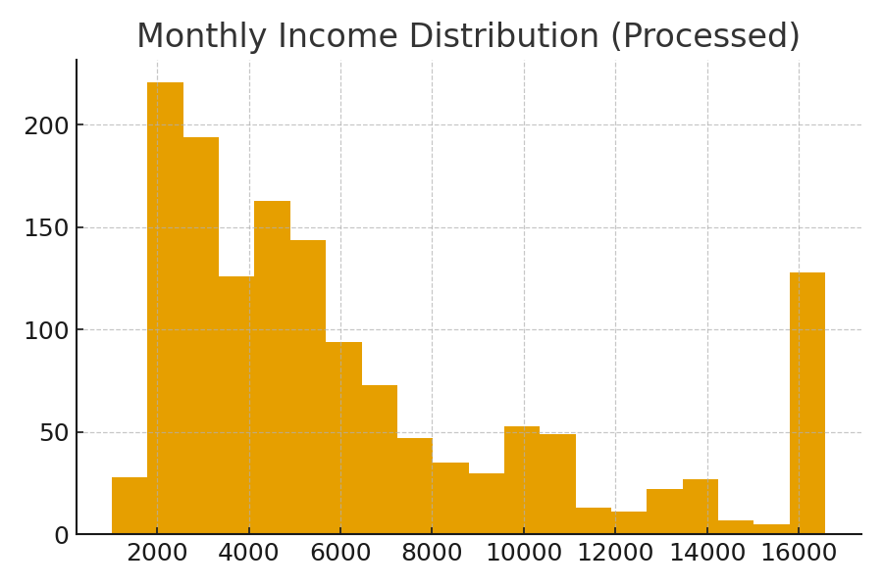

Conclusion
Processed CSV saved as data/feature_engineered_ibm_hr.csv inside the archive.

