**Individual Project Report (Due 3/02 noon)**

Last name: Sidhu

Fist name: Manbir Singh

ID: 300200328

First, rename this file by adding your last name and first name initial (e.g., **Project01Winter23_LeeKJ**).

In addition to writing a report, your presentation is required; Your presentation (around 5 minutes) must include (a) a demo-run of your program and (b) an explanation of your Java program design including function definition.

**Your report sections.**

1. **Summary**: Write a summary of your program design.

This is a Java program that simulates a trip in a car, considering various factors that affect the car's fuel efficiency. The program prompts the user to choose a car from a menu of three options (Mercedes AMG One, Lamborghini Urus, and Honda Civic), and then calculates and displays various statistics about the chosen car's fuel efficiency, including the amount of fuel consumed during the trip and the car's miles per gallon (mpg).

The program includes two helper class methods: "carinfo" and "foreignFactor". The "carinfo" method prompts the user to choose a car and creates a new instance of the "CarInitiate" class with the required parameters. The "foreignFactor" method calculates and returns a "foreign" object, which represents the impact of various external factors on the car's fuel efficiency, such as weather, road conditions, traffic, and wind.

The main method of the program repeatedly prompts the user for input until the user enters "-1", allowing the user to run the program multiple times if desired. Each time through the loop, the program calls the "carinfo" and "foreignFactor" methods to create a new car object and calculate the external factors affecting fuel efficiency. It then calculates and displays various statistics about the car's fuel efficiency and prompts the user to stop the program or continue.

1. **Output**: Attach screenshot images of your entire Java program running output (not the source code) with a short description.

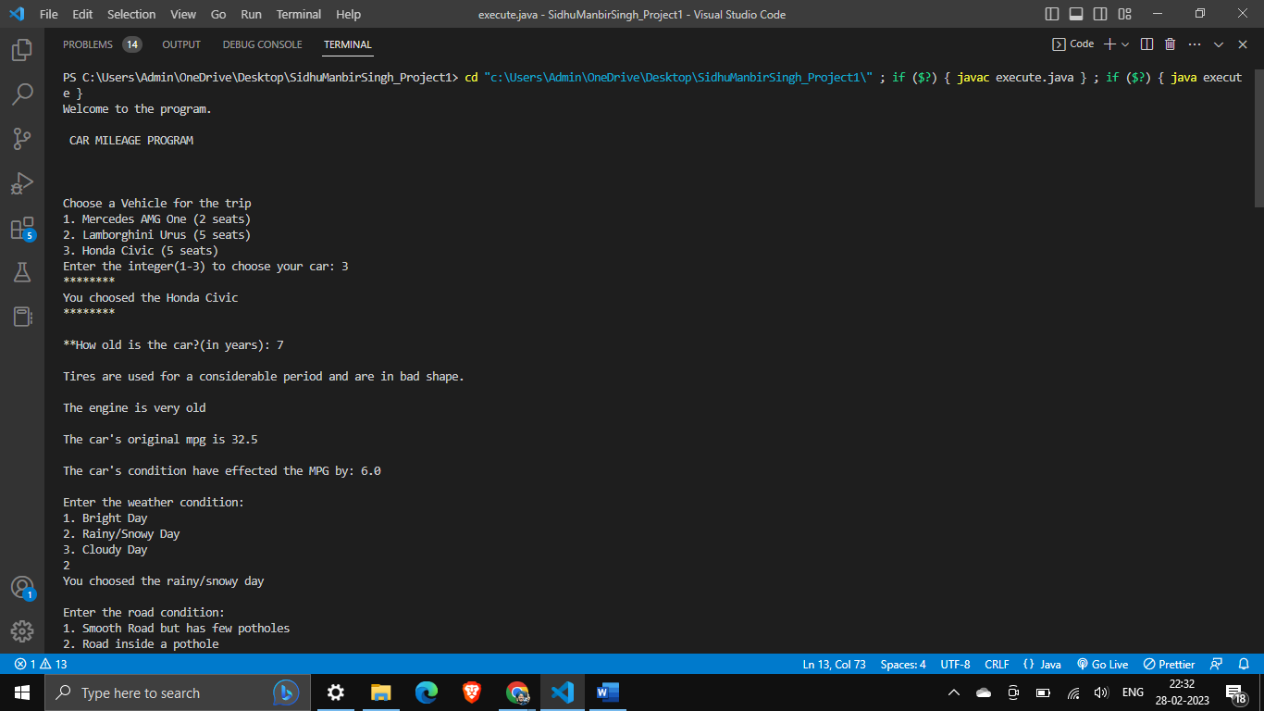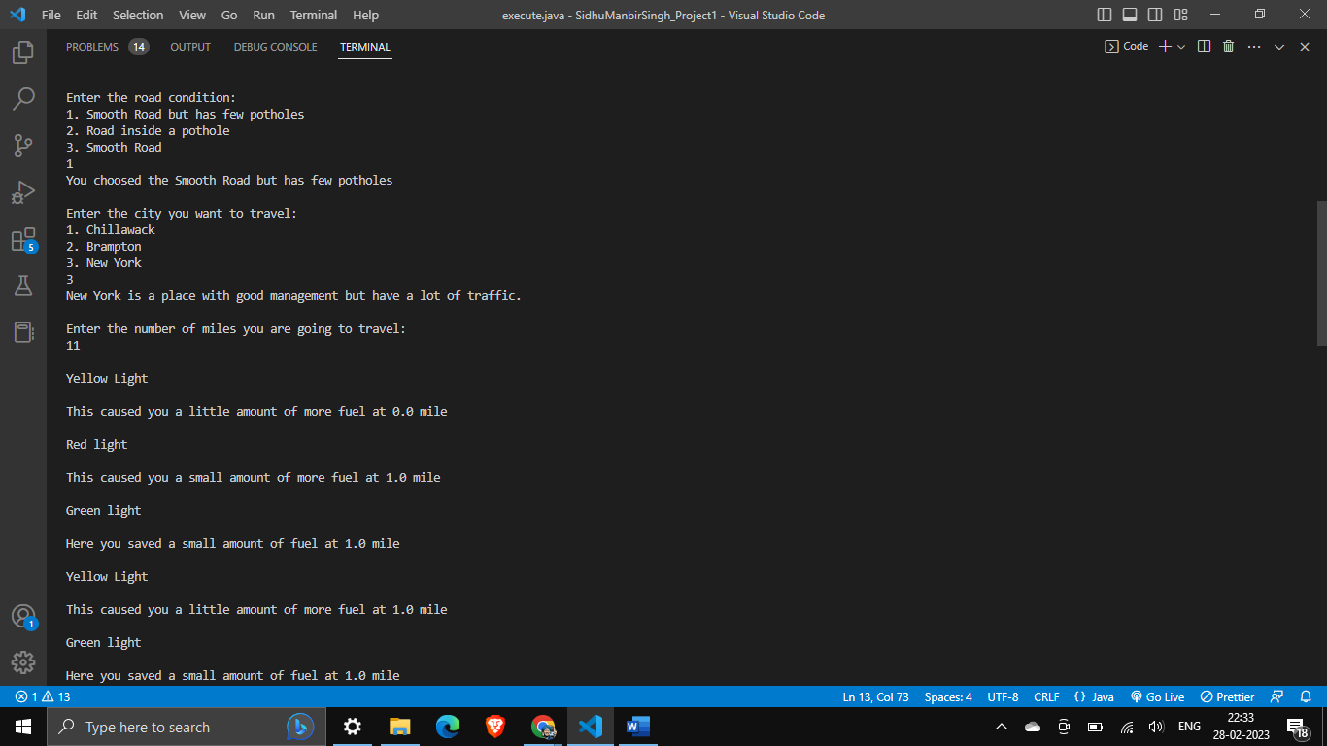

1. **Code**: Explain a few highlights of your algorithm design in detail; including separate Java class design, conditional statements (e.g., *if, else),* loop *(while or/and for),* randomization*, and* function definition. You must add images of screen capture or actual code block along with your design approach.

Conditional Statement:

If the user enters 1, the condition in the first if statement will be true, and the message "You choosed the Smooth Road but has few potholes" will be printed to the console. The value of the "road" variable will be updated to 0.5.

If the user enters 2, the condition in the second if statement will be true, and the message "You choosed the road inside a potholes" will be printed to the console. The value of the "road" variable will be updated to 1.5.

If the user enters 3, the condition in the third if statement will be true, and the message "You choosed the smooth road" will be printed to the console. The value of the "road" variable will be updated to 0.1.

If the user enters any value other than 1, 2, or 3, the condition in the else block will be true, and the message "Invalid" will be printed to the console. The value of the "road" variable will remain 0.

While Loop:

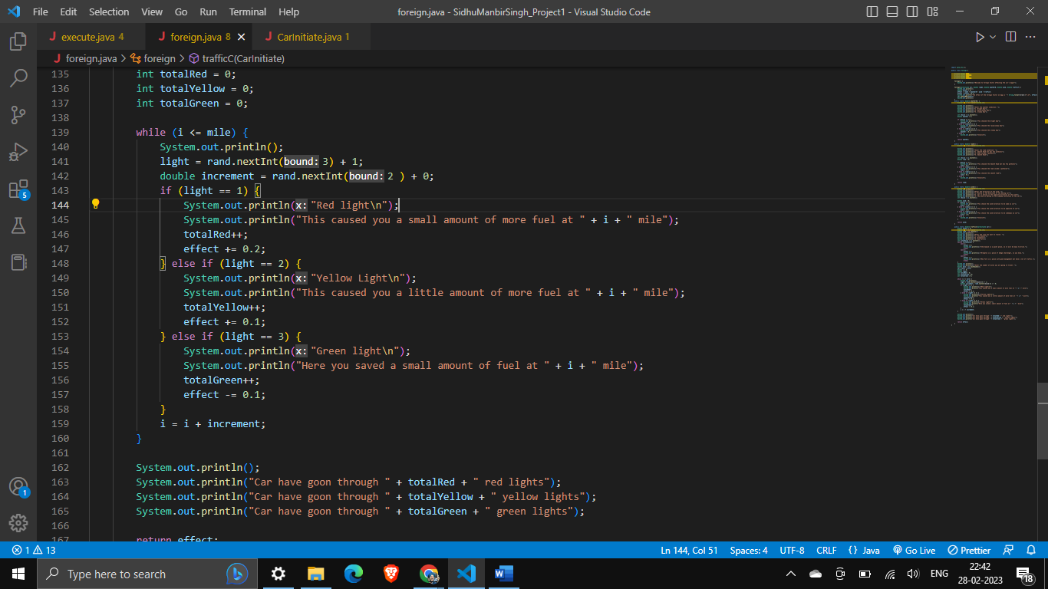

The while loop in the given code snippet is used to simulate driving along a certain distance, represented by the value of the "mile" variable.

The condition of the while loop is "i <= mile", which means that the loop will continue to execute if the value of the "i" variable is less than or equal to the value of the "mile" variable. The "i" variable is initialized to 0 before the loop starts, and it is updated at the end of each iteration based on the value of the "increment" variable.

1. Add a reference relate to any information about your project (e.g., reference product or image). Please follow [APA citation guide.](https://www.ufv.ca/media/assets/academic-success-centre/handouts/APA-Quick-Bits-7th-Ed.-rev-June-2021.pdf) None