**Individual Project 2 Report**

**Last name: Sidhu**

**Fist name: Manbir Singh**

**ID: 300200328**

If not presenting in class, attach YouTube video link of your presentation explaining your code/output.

1. Attach both a reference image of your project idea and a screenshot of your actual Python graphics output.

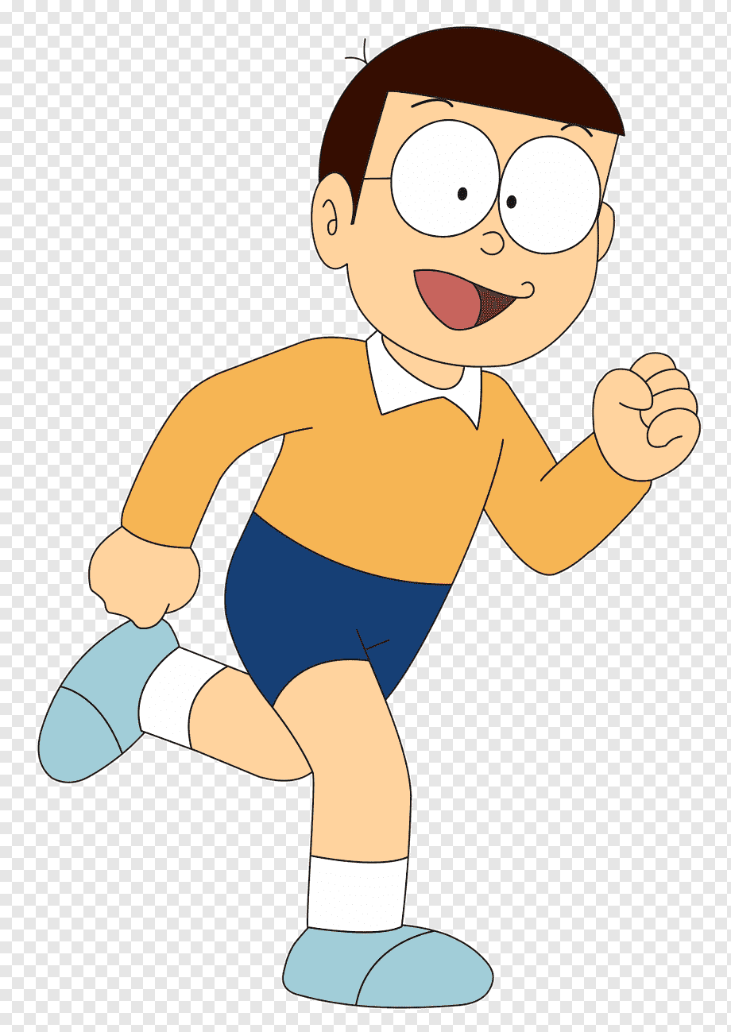This is my reference image. I have taken the inspiration of the color from the image. I tried to create a standing version of this cartoon.

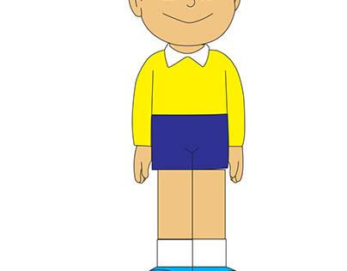

So, I tried to create the similar image in the picture.

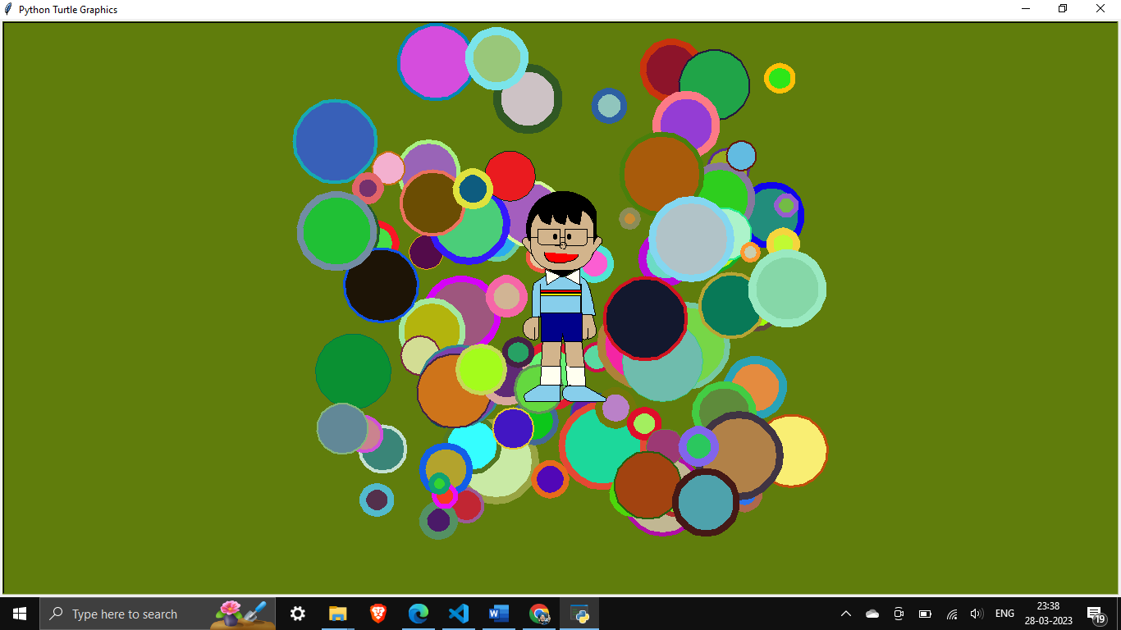

So, I achieved this output where I have randomized the background. We can see the created character. It has been made in the middle of the screen. It also seems that our character is playing holi.

1. Briefly explain your algorithm design to draw certain shapes (e.g., use of ***random( ),*** ***for****,* ***while****,* ***if****,* ***elif*** and/or ***def*** function statements)

In this program we have used number of algorithms in the projects.

Random()

We can see in the background the random color and the circle in specific area.

The code that define this is background()

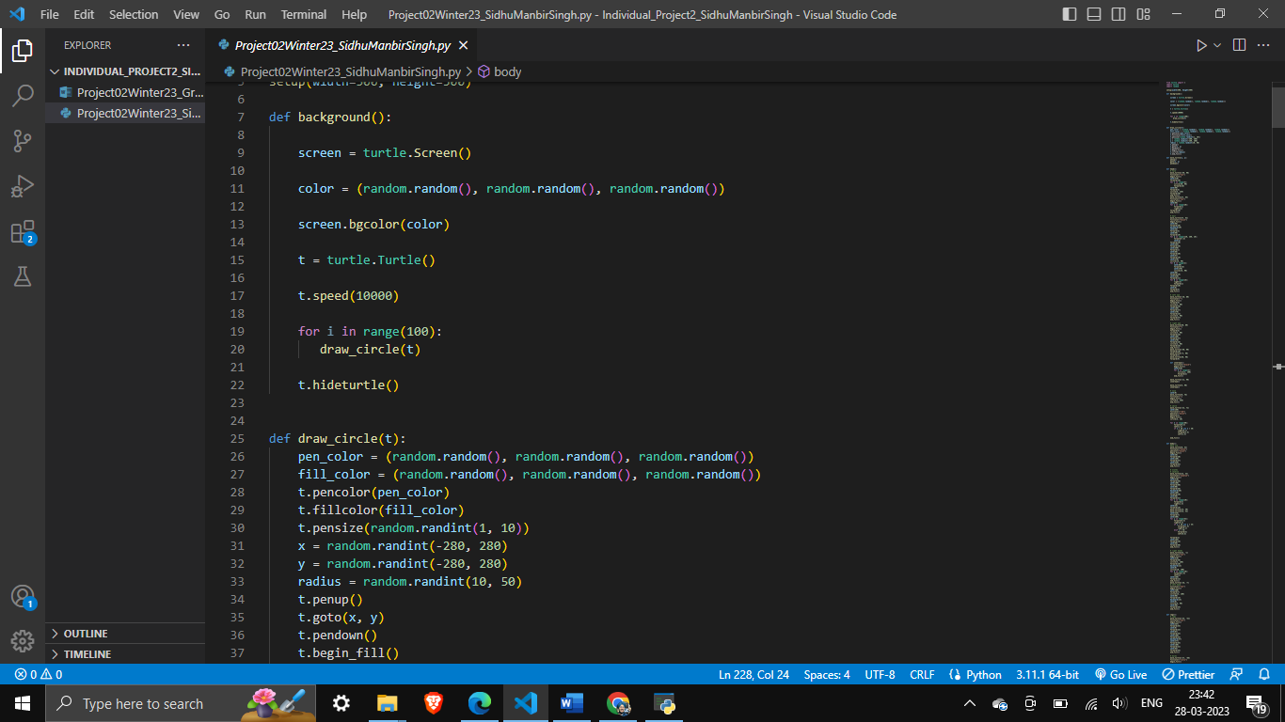

We can clearly see that the background screen’s color is being defined by the color variable. In this random number is being assigned to RGB of the background.

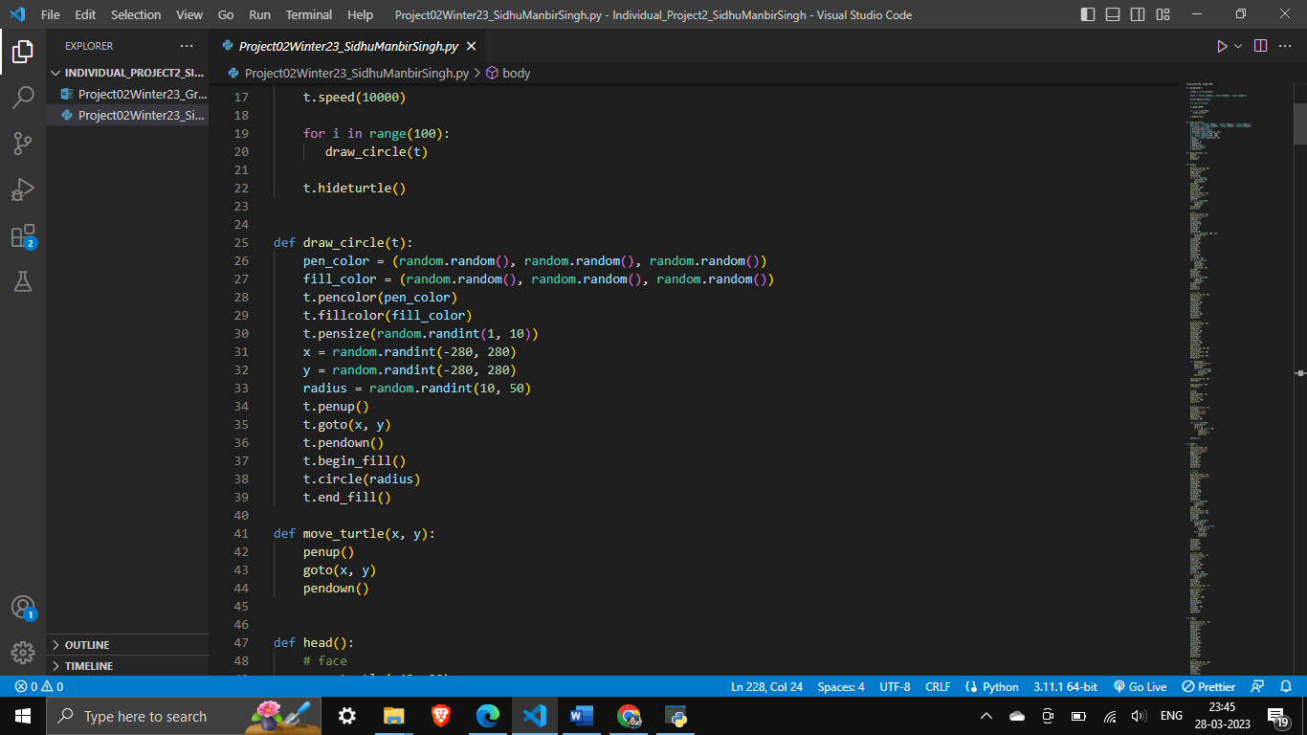

In this function random is beginning used to set x and y co-ordinates of the center of the circle. Another randint is used to randomize the size of the circle. Again the fill color and pen color is also randomized by the using random RGB values.

Loop

In this program we can see the for loop has been used at many instance. For example:

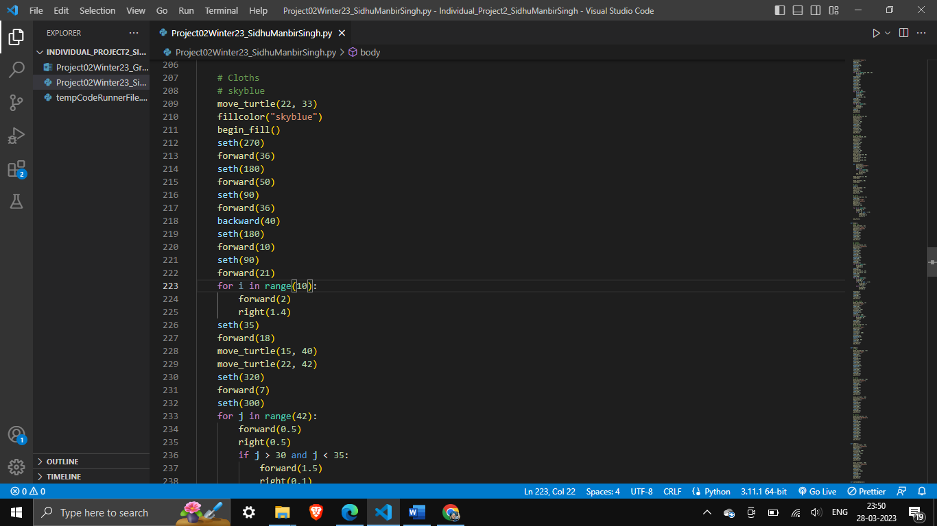

In this code we can see that a for loop is being runned for times. This is set specifically because the it has to curve the shoulder. The value has been achieved by hit and trail. Again this for loop is used to create arches where ever need.

If else

According to SimpliLearn, The if-else statement is used to execute both the true part and the false part of a given condition. If the condition is true, the if block code is executed and if the condition is false, the else block code is executed.

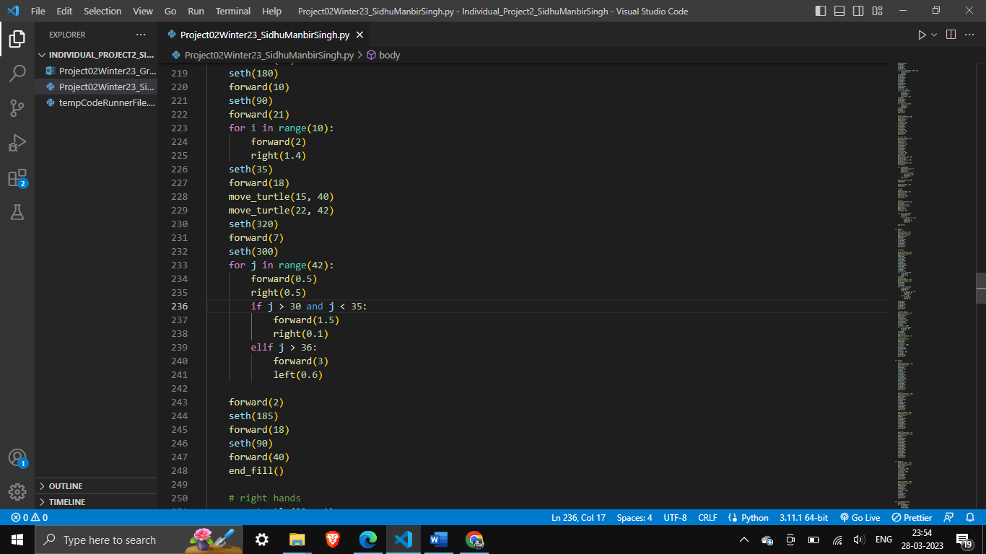

In this block code we have used if else statement to make a sharp turn after a certain point. Here the if else is being governed to create arms. That is why for loop is incorporated with if else statement to create a arch with a long straight line with changes where ever required.