**Assignment 4**

**Navigation in Visualization**

**Description**: In this representation, I consider my music collection of 100 songs. I am using a tree structure to categorize my collection into four main categories according to language like(English, Punjabi, Hindi, and Tamil). Sub categories are divided according to singers. All the songs are arranged alphabetically so that user can easily navigate to the song whatever song they want to listen according to the singer, song name, and type.

**Motive:** The main motive of this visualization is that it not only provides the option to play the audio version of the song but the user can also watch the video of the selected song.

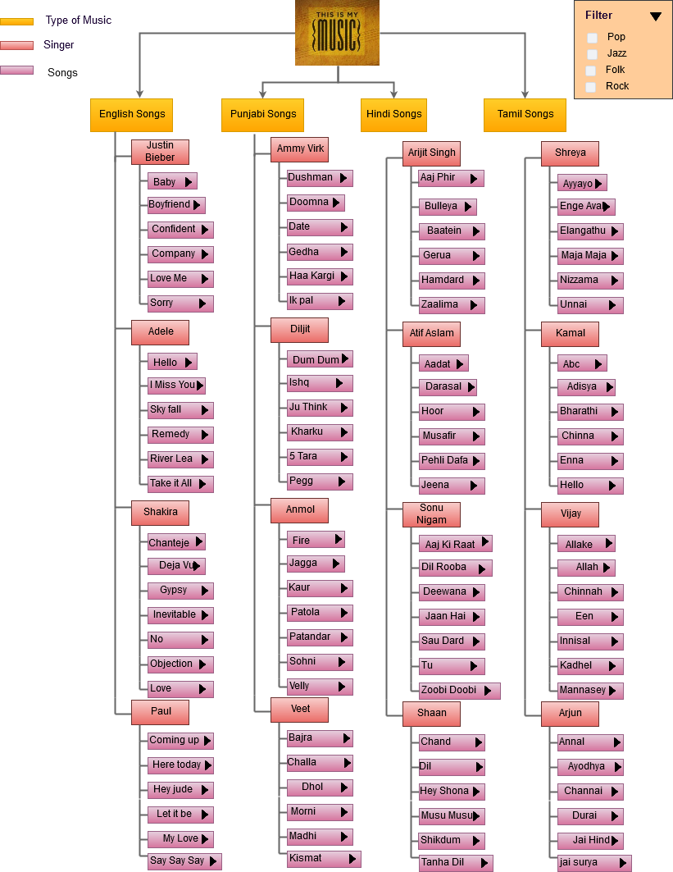

In the above hierarchy, all the songs in a collection are displayed. At a first glance, the user can see 100 songs of a different category. Colour Combination is used to differentiate between type of music, singers and songs. Secondly, whenever the user clicks on any song, the other songs in the collection related to the type of that selected song will also highlight to increase the visualization effect as shown in below figure. It will also strengthen the navigation feature because if the user just wants to check all the jazz songs in the collection, they can easily see or play the song. But if their mind converts to listen to another type of songs then they can select any other excepting the highlighted ones.

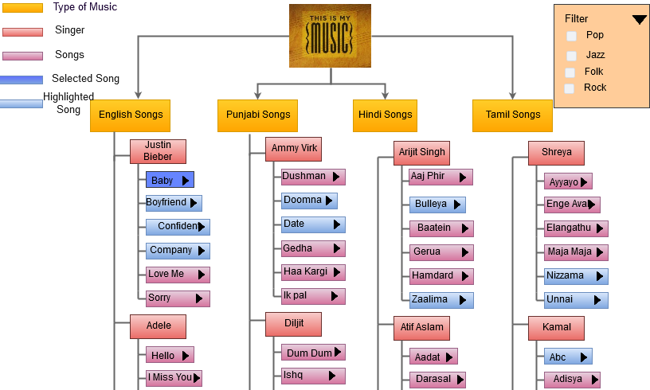

Thirdly, this device also provides an option for the users who just want to listen to a specific type of music. For example (jazz, pop, rock, and folk). This feature is provided using **Filter** function. Through this user can click on any type of music. Whichever box or boxes are selected, the tree structure according to that selected criteria will pop up. As represented in below figure, the user has clicked on pop music, then all the pop music in different categories will come out. This feature will also give the Dj effects as the user just have to click on the type of music, and then all the songs of that selected type will play one by one.The user does not have to click on a song every time.

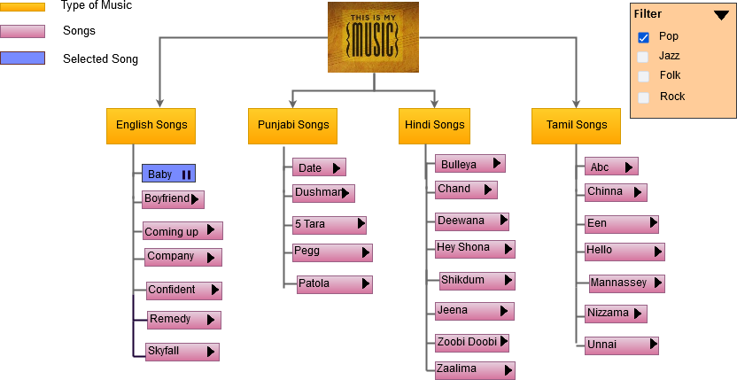

The next and the main thing of this collection is to provide the mp4 version of the song as well as mp3. If the user wants to listen only the audio, they can simply click on the play button display at the side of the song name. It will convert into the playing bars to show that audio is playing as visualized in above figure. But, if the user wants to see the video of the particular song then they have to click on that song. It will get the user into the next screen where the video will play as shown in below diagram.

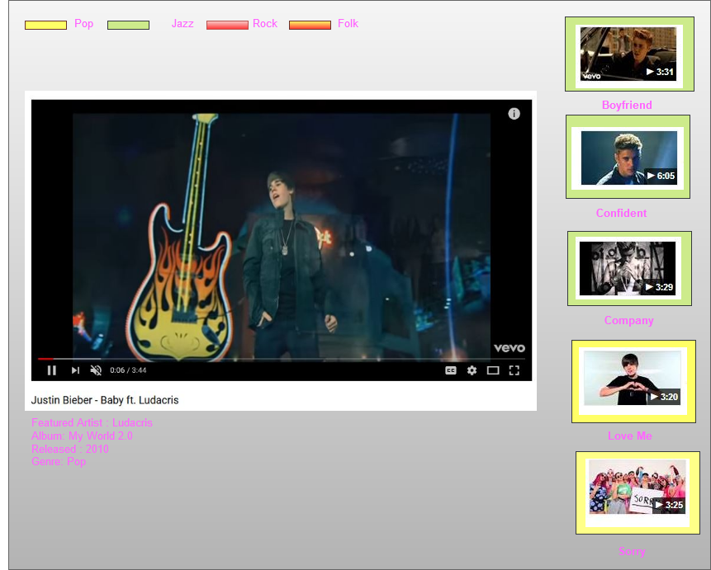

The main feature of this device is that it will not only play the video of the selected song but also display the other links of the songs of that particular singer whose song has been selected to play. So that viewer can also watch other videos if they want.

Moreover, below the video, information related to the song, like the album, released date, type of music will display. The video which is displaying at the side is differentiated with the rectangle color box. It makes easy for the viewer to navigate as all the pop songs are displaying in the green box and the jazz ones are displaying in the yellow box. Pink and orange box are used to display Rock and Folk music respectively.

Another thing is that, If in future, the user wants to add more songs to the collection, they can easily add, by adding the new singer name or the new song of the singers already in the collection. If collection will become large then at the end of the list of each singer’s song in hierarchy “**see more**” option can be added. So that user can click on that option and get the whole list of songs of the selected group.

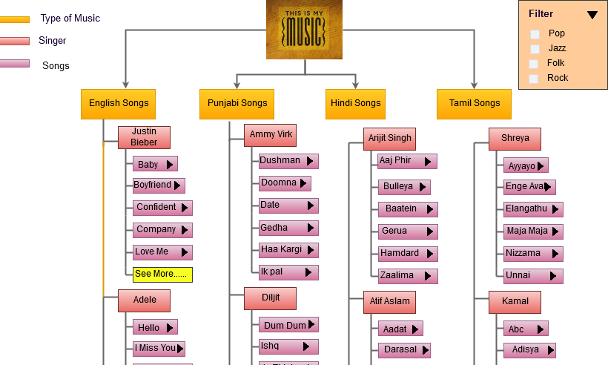

As shown above, when the user clicks on to see more option, it will display all the songs of Justin Bieber. So in this way tree structure can be managed and also a vast information or list of songs can be displayed

All in All, this representation is well organized for a user to manage his/her music collection firstly in a tree structure which does not need more clicks to get the songs. All the songs are displaying at once in an organized form. Further, for going in more details and to get selected features, easy, simple and effective ways have been used.