

**ELEC-E8126 - Robotic manipulation**

**Exercise 6 Report**

**Student Name: - ABHIJIT. K. KAMATH**

**Student Number: - 802664**

**Date: - 05/04/2020**

**1) P matrix**

0 0 0 0 0 0

0 1 0 0 0 0

0 0 1 0 0 0

0 0 0 1 0 0

0 0 0 0 1 0

0 0 0 0 0 1

The first diagonal element is 0 because the x co-ordinate is not controlled by the controller.

**2) Mathematical equations used to compute position error**

Error is calculated using the following code

const Eigen::Isometry3d desired_pose = Eigen::Translation3d(0.0,y,z)* starting_pose;

err = desired_pose.linear() * (desired_pose.inverse() * current_pose).translation();

The desired pose is formed using the translation of the starting pose by the y and z co-ordinate.

The co-ordinates are obtained by updating the co-ordinates as shown in the graph.

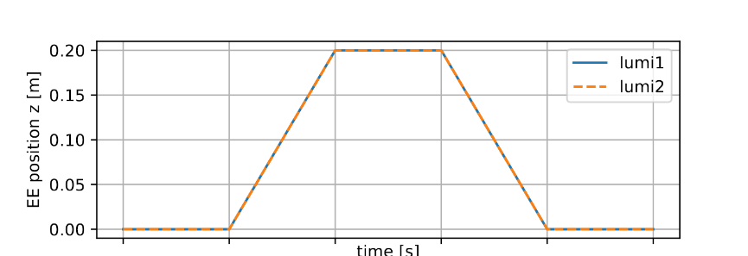**3) Plots of the desired and applied force**

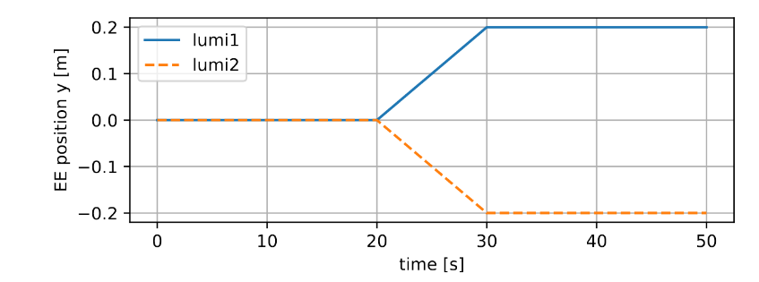**Figure 1:- Expected Graph in the z direction**

**Figure 2:- Expected Graph in the y direction**

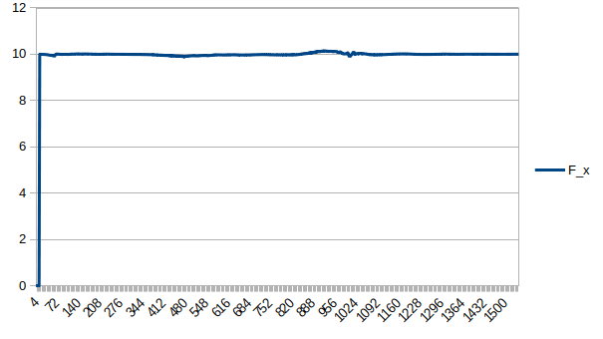**Robot 1 Plots**

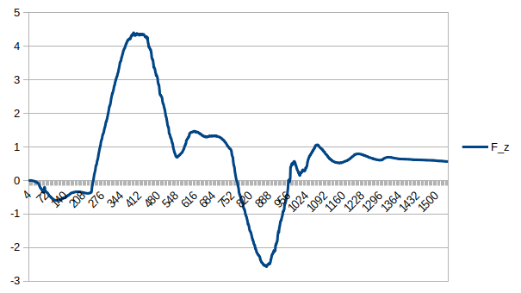

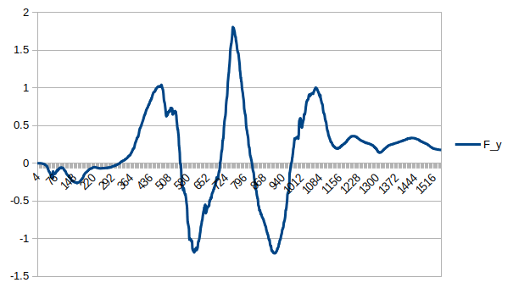

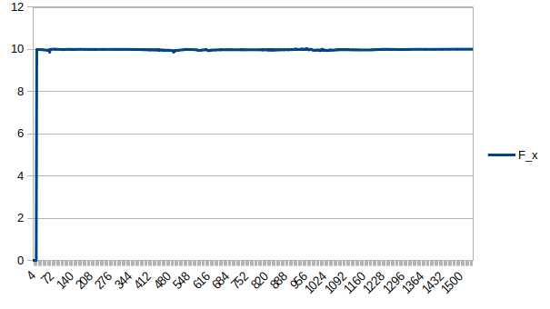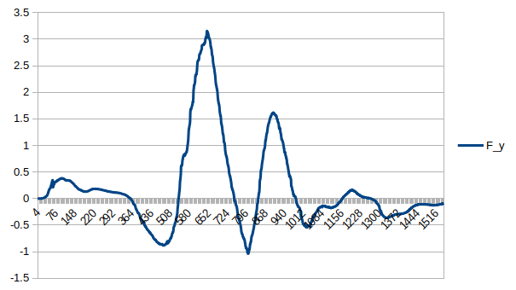**Robot 2 Plots**



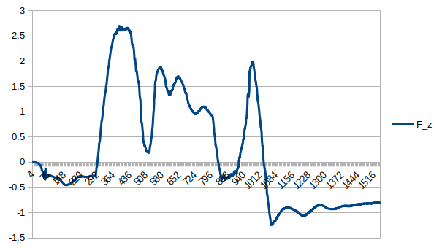

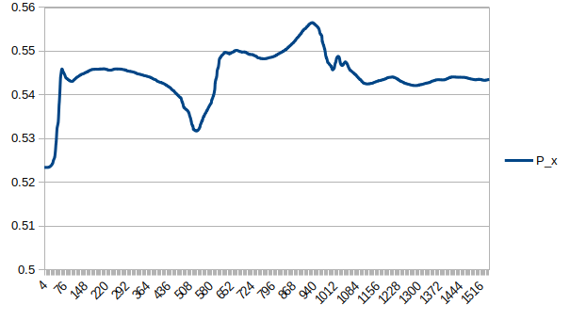**4) Plots of the followed paths**

**Robot 1**

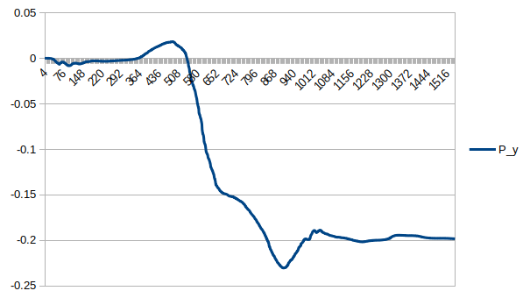

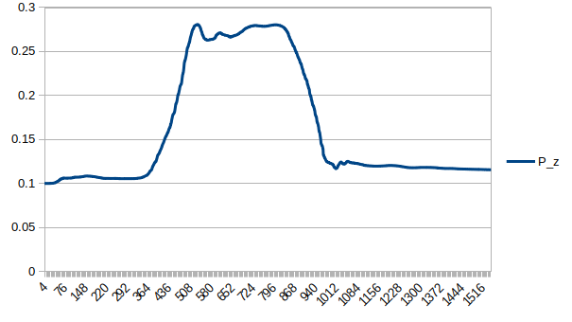

**Robot 2**



Is the contact force equal to the desired force?

Yes the contact force is equal to the desired force as shown in the Force in x direction graph.

– Does the followed trajectory correspond to the desired one?

As seen in the graphs the trajectory is more or less following the expected trajectory but has a few spikes.

– Are all Cartesian degrees of freedom followed equally accurately? If not, explain why.

Well even though we control the x co-ordinate with force and y and z co-ordinates with the controller we see that x co-ordinates are also changing. Hence not all Cartesian degrees of freedom are followed equally.

Estimate of time spent: - 18 hours