*Venice, Italy*

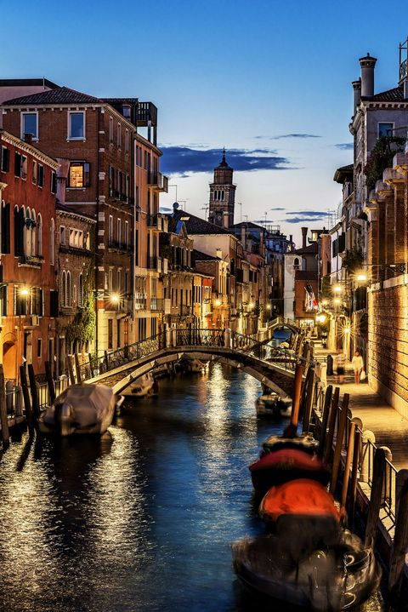

GETTY IMAGES

If traversing the canals with a be-striped gondolier sounds unbearably touristy, stick to the sidewalks and spectacular arched bridges to get your fill of this truly unique, wildly romantic floating city.

*Cape Town, South Africa*

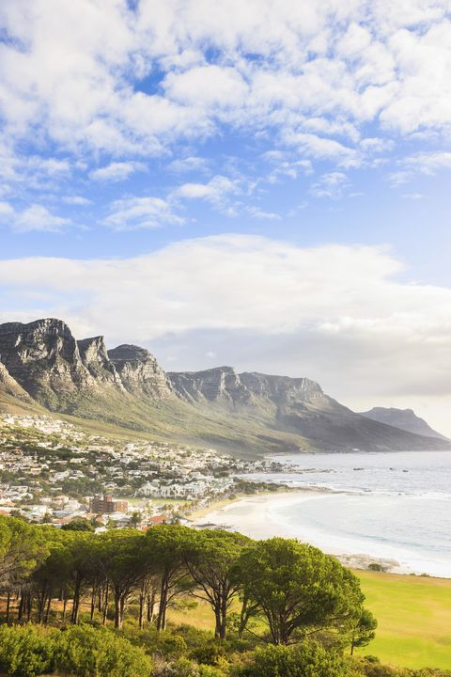

GETTY IMAGES

It might take nearly a full day of travel to reach Cape Town, but the city's sweeping vistas from Table Mountain and miles of beaches are totally worth the long haul.

*Lofoten Islands, Norway*

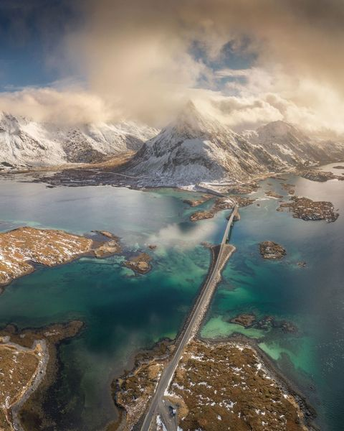

BEERPIXSGETTY IMAGES

If you’re looking for the perfect mix of winter and spring then you need to check out the Logoten Islands. Technically located in the Arctic, it contains some of the warmest temperatures due to an elevation anomaly. It’s also a great place to watch the Northern Lights in the winter season.

*Iguazú Falls, Argentina*

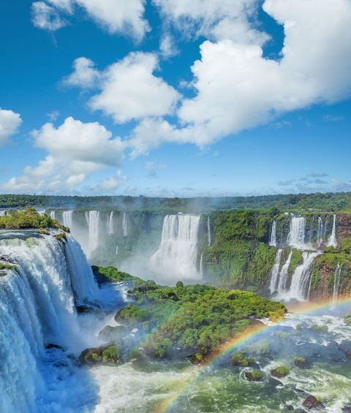

GRAFISSIMOGETTY IMAGES

The Iguazú Falls are the largest waterfall systems in the world. Located on the borders of Argentina and Brazil, legend has it that a powerful deity was rejected by his mortal lover and in a rage sliced the rivers thus creating the waterfalls.

*Caño Cristales, Colombia*

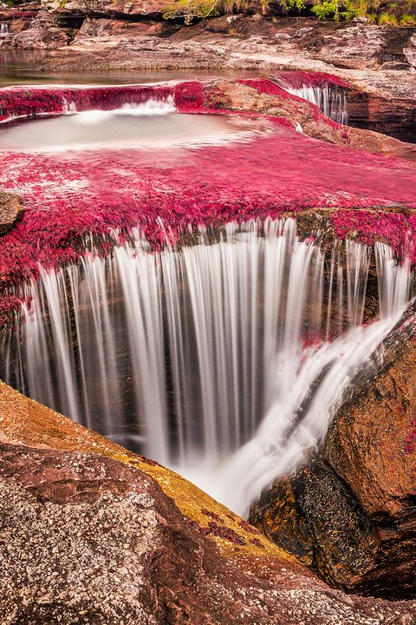

GETTY IMAGES

When its endemic vegetation is in full bloom, this Colombian river appears to be painted. Yellows, greens, reds and blues mix dramatically to create a living rainbow that flows from the Andes, through the Eastern Llanos grasslands, to the Amazon rainforest.