Part A
- Computing a single expected profit by plugging in mean inputs hides the full distribution of outcomes. The distribution of outcomes is the answer, not the average. Monte Carlo reveals what a single number cannot, for example, the spread of outcomes, the probability of loss, and the asymmetry in upside vs. downside, which is critical for a business decision under uncertainty.

- Monte Carlo - It allows for the modeling of uncertainty and risk in cost variables by simulating thousands of possible project scenarios to generate a probability distribution of total costs

Discrete-Event Simulation - checkout wait times depend on the dynamic arrival and service of individual customers over time, which requires modeling queues and resource capacity as events unfold sequentially.
Agent-Based Modeling - driver and passenger decisions emerge from individual behavioral responses to price signals, and the system-level outcome arises from the interactions of many autonomous agents acting independently.

- She is not right to worry because this is expected behavior, not a bug. In stochastic simulations like TrendWave, the Seed determines the sequence of random numbers used to generate scenarios. Using seed 42 and seed 99 creates two entirely different sets of potential market outcomes. Each seed initializes a different sequence of pseudo-random numbers, so two runs will produce slightly different samples and therefore slightly different summary statistics.
- You should not worry in practice. With a mean of 1,200 and a standard deviation of 250, a negative value occurs when the result is more than 1200/250 = 4.8 standard deviations below the mean, which is a probability of roughly 0.0001%, which is negligibly rare across 10,000 iterations. This means the probability of a negative value is extremely low (less than 1 in 10,000), meaning it likely won't affect the overall results of a simulation.

Part B
BASELINE MONTE CARLO SIMULATION
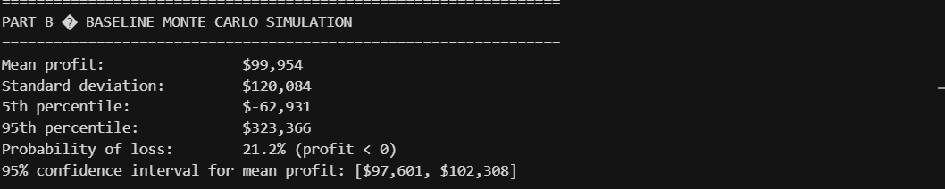
Histogram
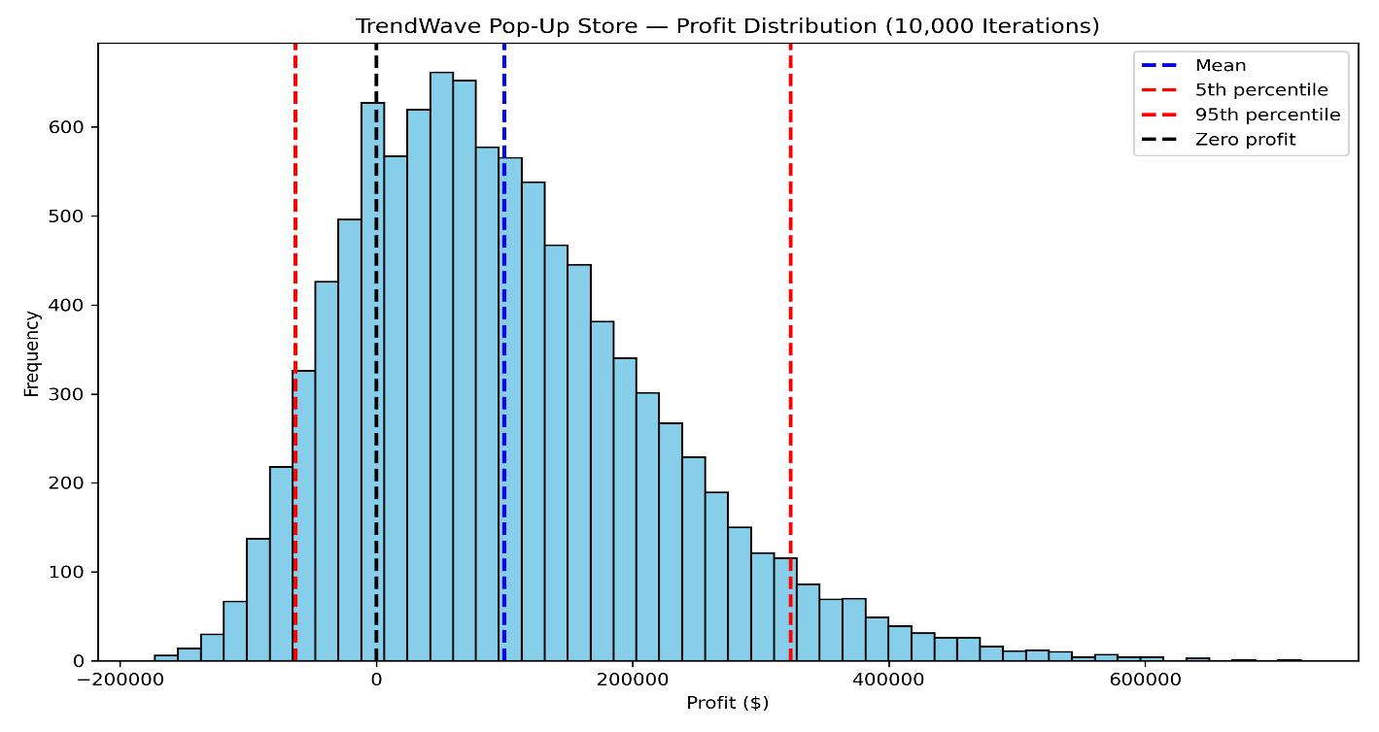
Confidence Interval (CI) = 95% confidence interval for mean profit: [$97,601, $102,308]
Comment
The simulation suggests the pop-up is modestly profitable on average at ~$100 000, but with enormous uncertainty, the standard deviation of $120 000 is larger than the mean itself, which signals high risk. The 90% confidence interval spans from a $63 000 loss to a $323 000 gain, meaning outcomes are widely dispersed. The 21.2% probability of loss means roughly 1 in 5 scenarios results in TrendWave losing money. The histogram shape is likely right-skewed, reflecting the upside potential from strong foot traffic and conversion rate combinations.

PART C 1
Sensitivity Analysis:
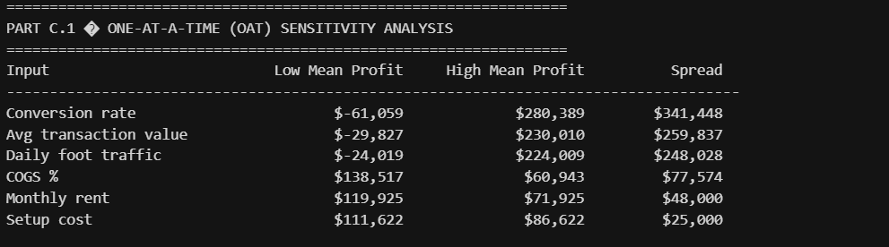

Tornado diagram
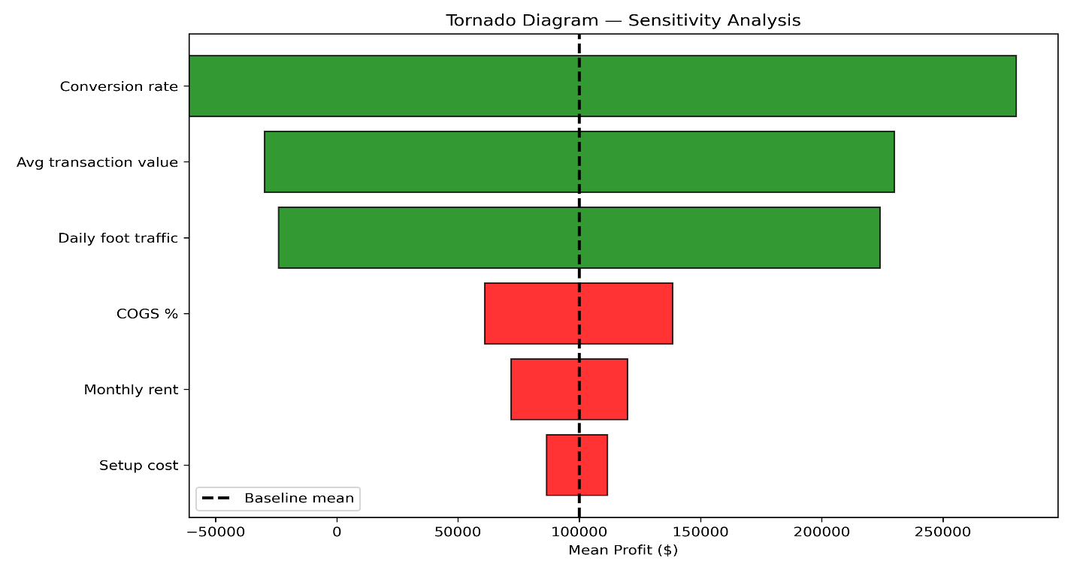

Comment
The tornado diagram tells that the conversion rate is by far the dominant risk driver, with a spread of $341 000 between its low and high scenarios, nearly $100 000 more impact than the next input. Average transaction value and daily foot traffic are close behind and roughly equal in influence. On the cost side, COGS has the most impact ($78 000 spread) but is still less than half the influence of the top revenue drivers. Rent and setup costs are relatively minor concerns. The takeaway for TrendWave is to invest pre-launch effort into things that drive conversion store placement within the mall, product display, and marketing, rather than focusing on cost negotiations.
PART C.2
Comparison table
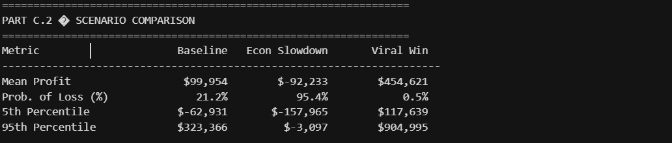

Overlay histogram
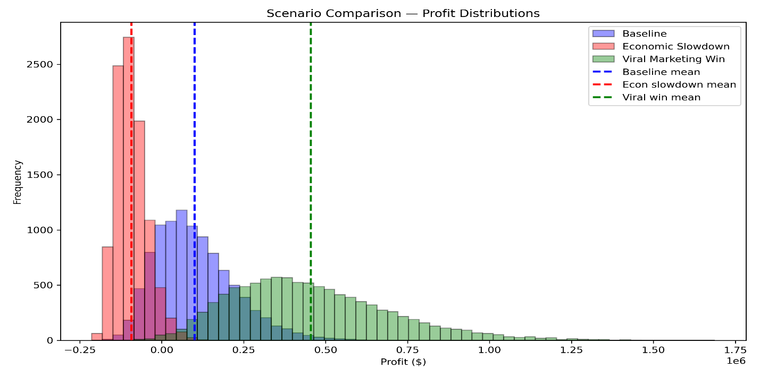
Comments
The scenario results are stark. Under the Viral Marketing Win, the business is nearly a sure thing, with only 0.5% chance of loss and a median outcome well into six figures, with upside reaching $905 000. The Economic Slowdown scenario, however, is devastating, with a 95.4% probability of loss and a mean profit of -$92 000, with even the 95th percentile barely breaking even at -$3 000. TrendWave should pay close attention to leading economic indicators and local mall traffic trends before committing to the lease, since a deteriorating consumer environment could make the pop-up a near-certain money-losing business.

MEMORANDUM

TO: VP of Retail Expansion, TrendWave Retail
FROM: Business Analytics Team
DATE: February 24, 2026
RE: Riverside Mall Pop-Up Store - Simulation Findings & Recommendation

Our team ran a Monte Carlo simulation with 10,000 scenarios to model the full range of possible outcomes for the proposed 180-day Riverside Mall pop-up. Here is what we found.
Expected Profitability and Range of Outcomes
On average, the store is expected to generate a profit of approximately $100,000 over the six-month lease. However, outcomes vary widely; in the best cases, the store could earn over $320,000, while in weaker scenarios it could lose more than $60,000. This level of variability is significant and means a single expected profit figure should not be used alone to make this decision.
Probability of Losing Money
Across all simulated scenarios, the store loses money in roughly 1 out of every 5 outcomes, which is 21.2%. While the odds favor profitability, the chance of a loss is meaningful enough to warrant careful consideration before committing to the lease.
Biggest Risk Driver
The single biggest factor determining whether this store succeeds or fails is the conversion rate the percentage of passersby who actually stop and make a purchase. When conversion is weak, the store loses money on average; when it is strong, profits are substantial. This gap is larger than any cost factor. The clearest action TrendWave can take is to invest in store placement within the mall, visual merchandising, and a pre-launch social media push to maximize foot traffic conversion from day one.
Economic Slowdown Scenario
If consumer spending deteriorates, lower mall traffic, weaker purchase intent, and smaller basket sizes, the picture changes dramatically. Under this scenario, the probability of loss rises to 95%, and the store is expected to lose roughly $92,000. This scenario materially changes the risk calculus and should be treated as a serious downside case, not an unlikely one.
Recommendation: Conditional Go
We recommend proceeding with the pop-up, but only with two conditions in place. First, TrendWave should secure aggressive conversion-boosting tactics before opening; this is the lever that most determines the outcome. Second, the team should monitor leading indicators of consumer spending in the months ahead. If the economic outlook deteriorates significantly, the decision should be revisited before lease signing. The expected return justifies the investment, but success is far from guaranteed without active management of the key risk driver.

