1. Unit Test

https://github.com/SidneyLann/spring-biz-member-repo/blob/master/spring-biz-member/src/test/java/com/blockchain/member/controller/MemberControllerUT.java

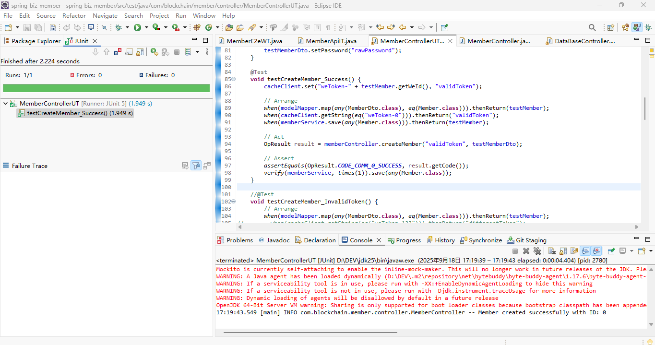

1. Integrated Test

https://github.com/SidneyLann/spring-biz-member-repo/blob/master/spring-biz-member/src/test/java/com/blockchain/member/api/MemberApiIT.java

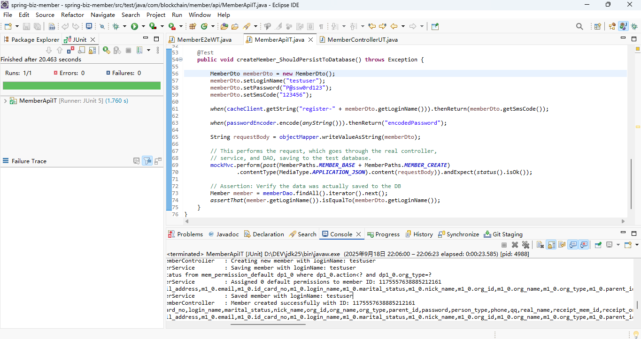

1. End-To-End Test

https://github.com/SidneyLann/spring-biz-member-repo/blob/master/spring-biz-member/src/test/java/com/blockchain/member/e2e/MemberE2eWT.java

