Conservation Planning with R

**First Author:** Sidney Gerst, **Second Author**: Robert Saldivar

**Summary**:

R is an open source program that can be very useful for conservation planners. Practitioners can create transparent, fully reproducible analyses allowing others to observe and contribute to a project. In this report we analyzed three climate threats (ocean acidification, sea temperature change, and UV change) along the Eastern Pacific Ocean to the top 20% of species that live there. While using R and ArcGIS, we can see the hotspots where climate threats intersect with the species.

**Problem**:

R can replace many conservation planning tools. It can be difficult to remember the pathway workflow in tools like ArcGIS or MaxEnt. With R, we can write a script that can be reproducible or even change the code to further tweak to more specific outputs.

**Approach**:

The approach for this lab was to assess hotspots between climate threats and the top 20% of species richness. We used the spatial packages that allow for raster analysis in R ("raster", "rgdal", "rasterVis", "maps", "rgeos", and “dplyr“,”RColorBrewer"). Once the .tif files of the three threats (sea surface temperature change, UV change, and ocean acidification) were added, visualization tools were applied. Because the threats were in the same extent, they could be overlaid into one climate threat layer. Next, we looked at the all-species raster. The resolution is much lower than the threats layer, so the extent of the threats was sampled to the extent of the species. Next, the species layer was reclassified to the top 20% present. Finally the two layers were overlaid to show species and threat hotspots. Once the final hotspot layer was created, it was exported as a .tif to ArcGIS. In Arc, the National Marine Sanctuary’s shapefile was added and a final map was produced.

**Results**:

There are two major areas along the Eastern Pacific Ocean where climate threats and the top 20% of species overlap: The Pacific Northwest, and the tip of Baja California (Figure 1). Species are seen all along the coast and The National Marine Sanctuaries are just along the California coast. There is no overlap between the threats and species layer and the Sanctuary layer.

**Conclusions**:

Conservation planners use R to create fully transparent, reproducible analyses. We have used R to convey hotspots between species present and climate change threats. It is interesting that climate threats are not seen in the same area as the National Marine Sanctuaries. Someone else can recreate the analysis if they are so inclined.

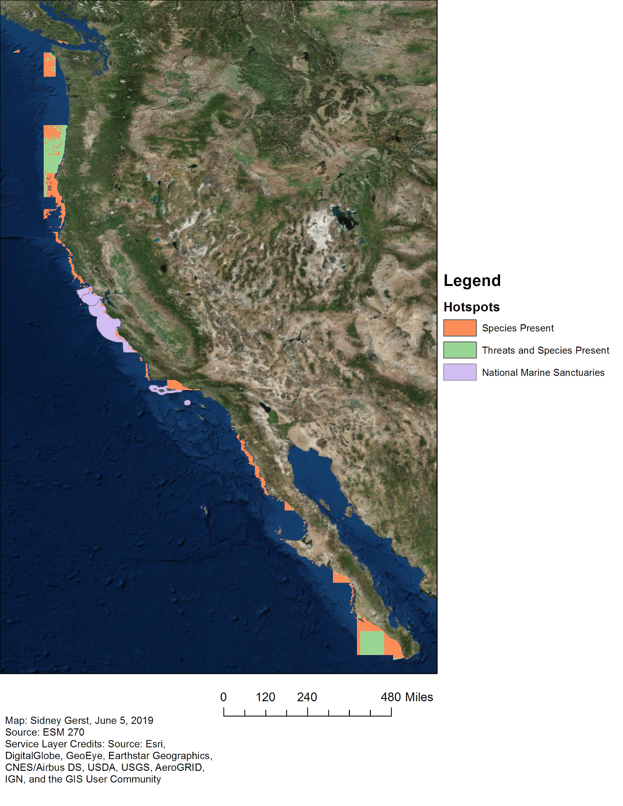

**Figure 1. Hotspots where top 20% of species and climate threats intersect.** The top 20% of all species found on the Eastern Pacific are seen in orange. Three climate change threats - ocean acidification, sea temperature change, and UV change - were overlaid together into one layer and cross examined over the species, seen in green. National Marine Sanctuaries are seen in purple.