Homework 2

Sidney Gerst

January 27, 2020

#### 1. Analyze the Model

#create the model  
r <- 0.05  
K <- 2000  
P <- 4  
a <- 0.05  
h <- 0.2  
function1 <- function(N) (r*N)*(1-(N/K))-((P*a*N)/(1+(a*h*N)))  
  
#plot it  
function1_plot <- ggplot(data.frame(N = 0:2000), aes(x = N)) +  
 stat_function(fun = function1, color = "red") +  
 geom_hline(yintercept = 0) +  
 theme_bw()+  
 ylab("dN/dt")  
  
function1_plot

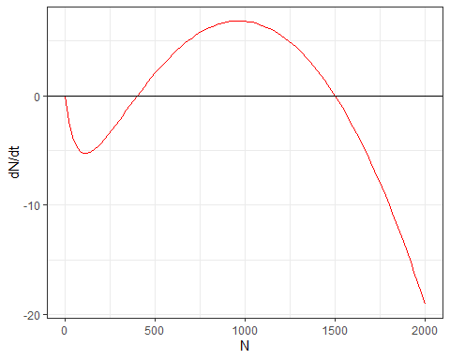

#### 2. How many equilibria?

There are three equilibira in this model (0,0), (375,0), and (1500,0). The points (0,0) and (1500,0) are stable and the point (375,0) is unstable.

#### 3. Equilibrium at N = 0

When N = 0, the intrinsic population growth rate $\frac{dN}{dt}$ = 0, and is a equililbium.

To evaluate N at equilibium, the derivative should be calculated:

$\frac{df(N)}{dN}=r(1−\frac{2N}{K})−P(\frac{a}{(1+ahN)^{2}})$

When N = 0, the equation becomes: $\frac{df(N)}{dN}=r−P*a$

Then we solve for P: $P=\frac{r}{a}$. Hunters = the growth rate per prey attack rate. P needs to be greather than this number.

When P is larger than $\frac{r}{a}$, the equilibrium is locally stable.

The number of hunters needs to be larger than the intrinsic growth rate over per prey attack rate (or the rate hunters are able to kill the species) in order to eliminate the invasive species. Or the hunters and their attack rate needs to be greater than the intrinsic growth rate.

#### 4. Non-zero equilibria

$0=r*N*(1−\frac{N}{k})−P*(\frac{aN}{1+ahN})$

#### 5. Graph model

r <- 0.05  
K <- 2000  
P <- 4  
a <- 0.05  
h <- 0.2  
  
function2 <- function(N) (r*N)*(1-(N/K))  
function3 <- function(N) ((P*a*N)/(1+(a*h*N)))  
  
function2_plot <- ggplot(data.frame(N = 0:2000), aes(x = N)) +  
 stat_function(fun = function2, color = "red") +  
 stat_function(fun = function3, color = "blue") +  
 geom_hline(yintercept = 0) +  
 theme_bw()+  
 ylab("dN/dt")  
  
function2_plot

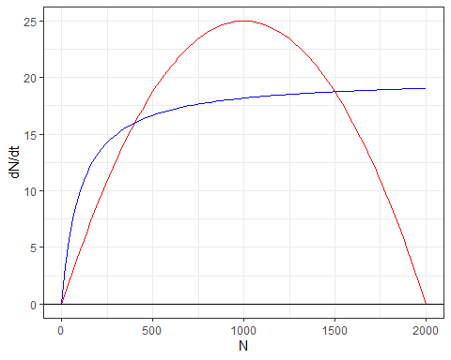

When the intrinsic growth rate is greater than the hunting rate, the population will continue to grow. When the hunting rate is greater than the intrinsic growth rate, the population will go down to 0. When they are equal, the population will be at equilibrium.

All three equilibrium points are at the same N values as in Problem 1.

#### 6. Graphs of different hunting rates

########## P = 1  
r <- 0.05  
K <- 2000  
P <- 1  
a <- 0.05  
h <- 0.2  
  
function4 <- function(N) (r*N)*(1-(N/K))  
function5 <- function(N) ((P*a*N)/(1+(a*h*N)))  
  
function3_plot <- ggplot(data.frame(N = 0:2000), aes(x = N)) +  
 stat_function(fun = function4, color = "red") +  
 stat_function(fun = function5, color = "blue") +  
 geom_hline(yintercept = 0) +  
 theme_bw()+  
 ylab("dN/dt")  
  
function3_plot

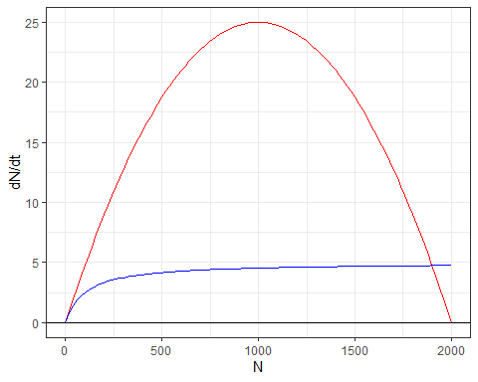

There are two equilibria. An unstable equilibrium at N = 0, and a stable at N ~ 1900.

############ P = 6  
  
r <- 0.05  
K <- 2000  
P <- 6  
a <- 0.05  
h <- 0.2  
  
function6 <- function(N) (r*N)*(1-(N/K))  
function7 <- function(N) ((P*a*N)/(1+(a*h*N)))  
  
function4_plot <- ggplot(data.frame(N = 0:2000), aes(x = N)) +  
 stat_function(fun = function6, color = "red") +  
 stat_function(fun = function7, color = "blue") +  
 geom_hline(yintercept = 0) +  
 theme_bw()+  
 ylab("dN/dt")  
  
function4_plot

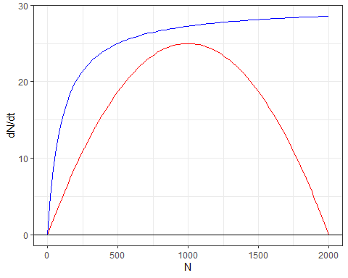

There is only one equilibrium at N = 0 and it is stable.

#### 7. Bistability

The domain of attraction for the zero equilibrium goes from 0 - 400. The domain of attraction for the largest equlibrium is any number greater than 400.

The hunting rate is greater than the intrinsic growth rate, so you would be able to extirpate the invasive species.

When the population is at the carrying capacity and the harvest rate is greater, the population will come back to about 1500 individuals.

#### 8. Derivatives

r <- 0.05  
K <- 2000  
a <- 0.05  
h <- 0.2  
d <- 1/(a*h)  
  
function8 <- function(P) (1/2) * ((K - d) - sqrt((K-d)^2 + ((4*K*d)/(r)) * (r - a * P)))  
  
function9 <- function(P) (1/2) * ((K - d) + sqrt((K-d)^2 + ((4*K*d)/(r)) * (r - a * P)))   
  
function_8_9_plot <-ggplot(data.frame(P = 0:7) , aes(x = P)) +  
stat_function(fun = function8, color = "red", n = 10000) +   
 stat_function(fun = function9, color = "blue", n = 10000) +  
 geom_hline(yintercept = 0) +  
 geom_vline(xintercept = 1, linetype = "dotted", color = "purple", size = 2) +  
 theme_bw() +  
 ylab("Equilibrium")  
  
function_8_9_plot

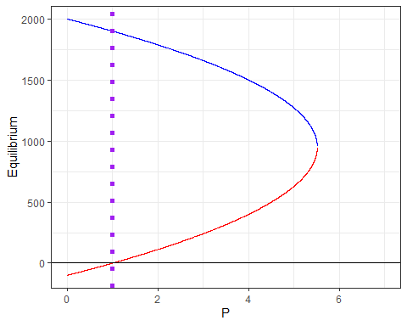

The equilibium changes from locally stable to locally unstable at P = 1. When there is less than one hunter the equilibrium is negative.

With this graph we can learn what the equilibrium of a population is given the number of hunters. When the number of hunters is greater than 1 there is always a positive equilibrium till about P = 5.5. We saw in question number 6 when P = 6, there is no equilibrium between hunters and the population; the species will be completely taken out. I am still a bit confused about what happens when P = 1 at the negative equilibrium at the top of this chart.