Homework 1

Sidney Gerst

1/21/2020

####1. Mean Density of Adults

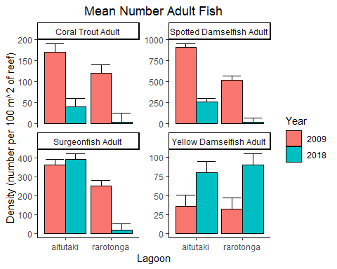

For the Coral Trout and Spotted Damselfish, there is a significant decrease from 2009 to 2018 in both Aitutaki and Rarotonga. There is no significant difference in Surgeonfish from Aitutaki from 2009 to 2018, but there is in Rarotonga. The only instance where 2018 was significantly greater than 2009 in both Aitutaki and Rarotonga is with Yellow Dameslfish.

####2. Young Fish Density

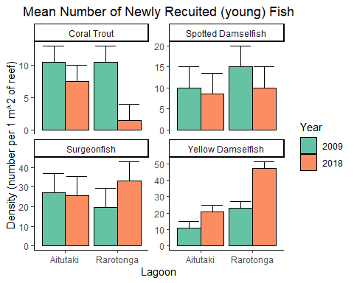

Coral Trout recruits were the only young fish with a significant decrease from 2009 to 2018 in both Aitutaki and Rarotonga. The Spotted Damselfish did not show significant change in Aitutaki but did in Rarotonga. Surgeonfish did not show significant change in Aitutaki, but did in Rarotonga from 2009 to 2018. The Yellow Damselfish was the only fish to significantly increase from 2009 to 2018 in both Aitutaki and Rarotonga.

####3. Microhabitat

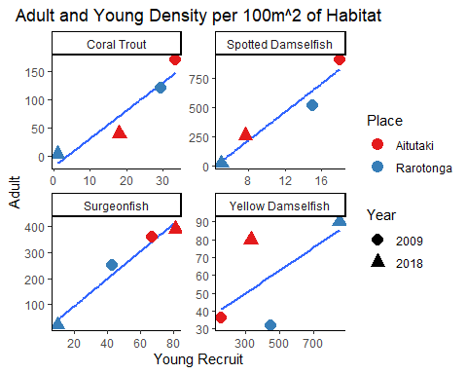

The Spotted Damselfish is the second most correlated between young and adults of the four fish types (R^2= 0.94), and the Surgeonfish is the most (R^2= 0.9675). Coral Trout is also very correlated (R^2= 0.8958), and Yellow Dameselfish is least (R^2= 0.4017).

#### 4. Adults and Microhabitat

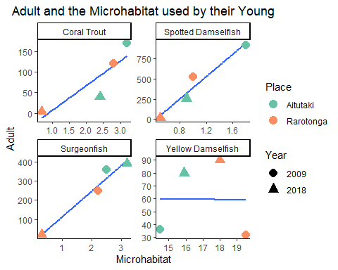

The Yellow Dameslfish is the least correlated (R^2= 1e-04). Coral Trout is second to least correlated (R^2= 0.7761). Spotted Dameselfish and Surgeonfish are very correlated (R^2= 0.9482, R^2= 0.9646)

#### 5. Adults and Microhabitat Density

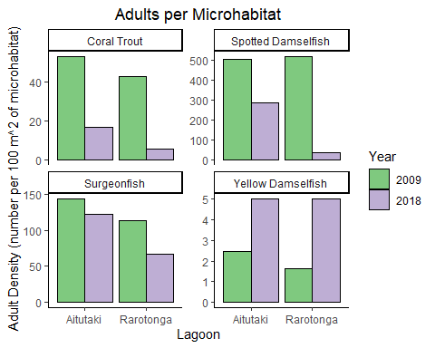

Yellow Damselfish is the only fish that increased in both lagoons from 2009 to 2018 per Mounding Coral. Every other fish per their respective microhabitat (Coral Trout per Course-Branching Coral, Spotten Dameselfish per Sea Anenomoes, and Surgeonfish per Fine-branching Coral) decreased from 2009 to 2018.

#### 6. Compare each fish

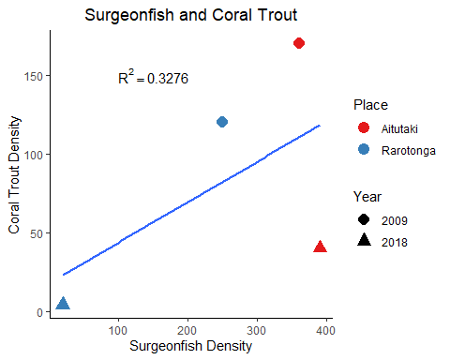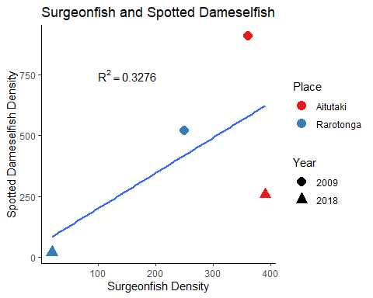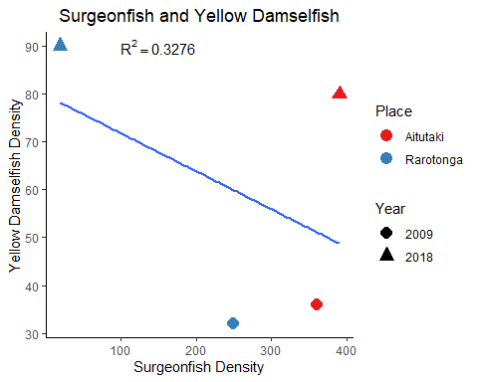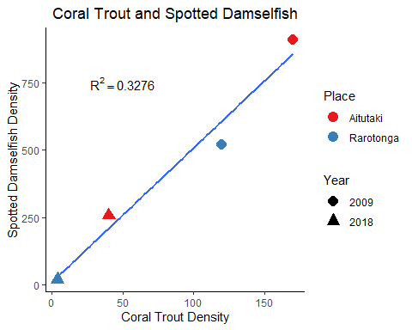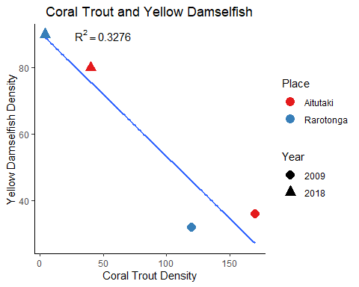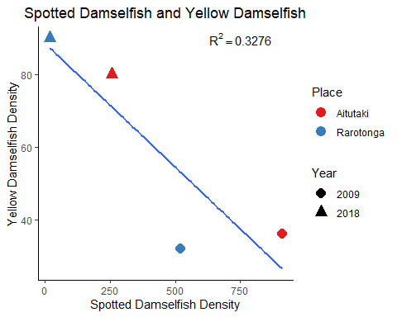

As Surgeonfish decrease in Rarotonga, Coral Trout decrease. As Surgeonfish increase in Aitutaki, Coral Trout decrease. The overal trend is postive, but isn’t very strongly correlated.

As Surgeonfish decrease in Rarotonga, Spotted Damselfish decrease. As Surgeonfish increase in Aitutaki, Spotted Damselfish decrease. The overal trend is postive, but isn’t very strongly correlated.

As Surgeonfish increased in Rarotonga, Yellow Damselfish decreased. As Surgeonfish increased, Yellow Damselfish increased in Aitutaki. Overall the trend is negative, but it isn’t strongly correlated.

As Coral Trout decreased, Spotted Damselfish decreased in both Rarotonga and Aitutaki from 2009 to 2018.

From 2009 to 2018, Coral Trout decreased as Yellow Damselfish increased in Rarotonga and Aitutaki.

In both Rarotonga and Aitutaki, as Spotted Damselfish decreased, Yellow Damselfish increased from 2009 to 2018.