Homework 4

Sidney Gerst

3/4/2020

### 1. Climate Change

**Geographic Range**

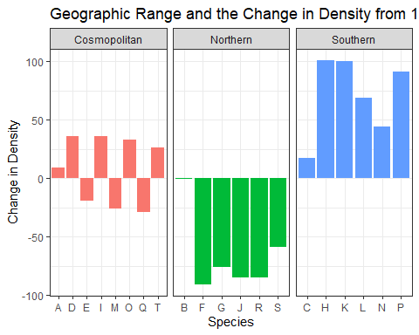

There is a pattern for each of the different geographic ranges. The Cosmopolitan species are split between positive and negative density change. The Northern species all had a negative change in density from the year 1955. The Southern species all had a positive change in density from the year 1955. This shows that climate change has a positive effect on Southern species and a negative effect on Northern species.

**Trophic Level**

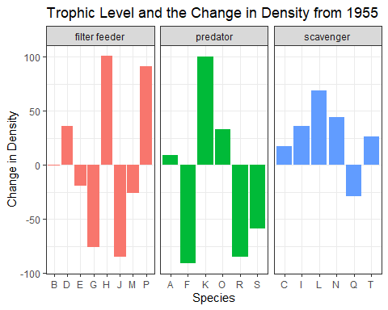

Scavengers had the most positive effect from climate change where five out of six species showed a positive change in density.

### 2. Nuclear Power

**Species A**

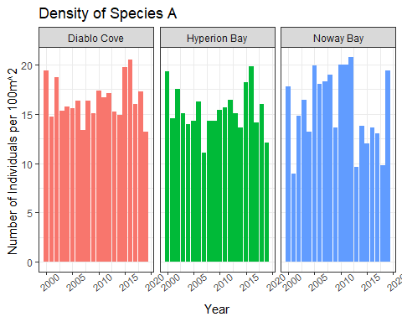

**Species B**

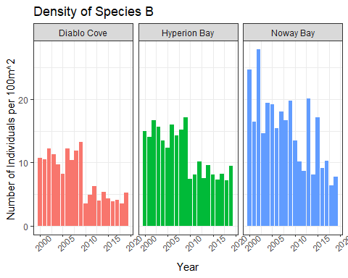

**Species C**

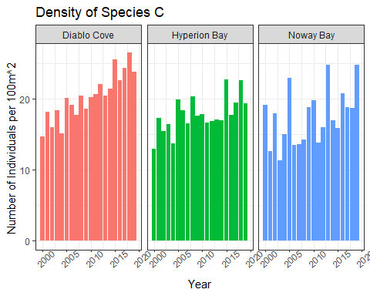

Hyperion Bay should be used as the control because it tracks closely to Diablo before the plant became operational. There doesn’t seem to be any detectable impacts on species A from any of the areas sampled. There were detecable impacts on species B with a distinct drop at Diablo and Hyperion and a steady decline with a few peaks at Noway Bay. For species C there seemed to be a positive impact at all of the sites, with the most stable increase at Diablo Cove. Overall, the plant had the biggest impact species B.

### 3. Fisheries and Invasive Species

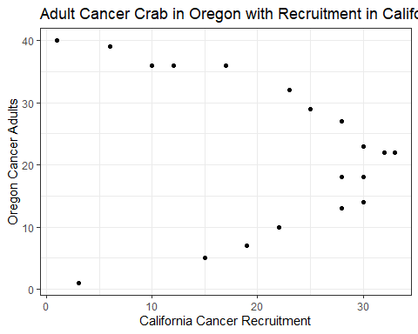

Cancer adults from Oregon affect the number of recruits in California because the current flows from north to south. When there are too many or too little adults, there is a small number of recruits. When there is median number of adults in Oregon, there is a high number of recruits in California.

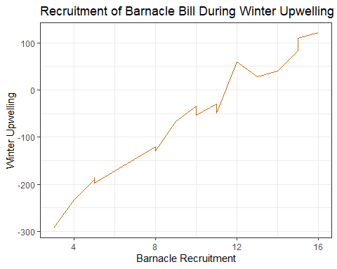

Recruitment of Barnacles in California depends heavily on Winter upwelling. As there is more upwelling during the winter in California, there is higher recruitment of Barnacles.