Sidney Gerst

ESM 260: Homework 5

3/18/2020

Cancer Crab Management Plan

Cancer crabs in California depend on the well being of crabs in Oregon due to the southern flowing California Current. According to the data, the maximum number of California recruits occurs when there is about 23 adults in Oregon (Figure 1). The recruitment also happens one year after the adults are seen in Oregon. This means that if the adults survive in Oregon, the following year in California will show positive recruitment. This means a fishery should focus on the adults in Oregon. Cancer crabs should be harvested in Oregon for the optimum number of recruits to arrive in California. According to Figure 1, Oregon fishers can harvest about 18 crabs before the peak recruitment is met. Fishers should also harvest after the peak spawning season in the spring. This allows for maximum availability of recruitment in California.

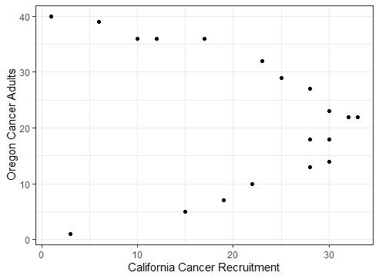

**Figure 1. Adult Cancer Crab in Oregon with Recruitment in California.** Number of annual adults (2000-2018) and recruits (2001-2019). The year is off by one to account for the time it takes for recruits to make it to California from Oregon.