206 Assignment 4

Sidney Gerst

November 13, 2018

Load Packages and read in files

library(tidyverse)

## -- Attaching packages ----------------------------------------------------------------------------------------------- tidyverse 1.2.1 --

## v ggplot2 3.0.0 v purrr 0.2.5  
## v tibble 1.4.2 v dplyr 0.7.6  
## v tidyr 0.8.1 v stringr 1.3.1  
## v readr 1.1.1 v forcats 0.3.0

## -- Conflicts -------------------------------------------------------------------------------------------------- tidyverse_conflicts() --  
## x dplyr::filter() masks stats::filter()  
## x dplyr::lag() masks stats::lag()

library(pwr)  
library(knitr)  
library(kableExtra)  
library(plotly)

##   
## Attaching package: 'plotly'

## The following object is masked from 'package:ggplot2':  
##   
## last_plot

## The following object is masked from 'package:stats':  
##   
## filter

## The following object is masked from 'package:graphics':  
##   
## layout

library(ggrepel)  
library(effsize)  
library(vcdExtra)

## Loading required package: vcd

## Loading required package: grid

## Loading required package: gnm

##   
## Attaching package: 'vcdExtra'

## The following object is masked from 'package:plotly':  
##   
## summarise

## The following object is masked from 'package:dplyr':  
##   
## summarise

library(dplyr)  
  
lobster_pressure <- read_csv("lobster_traps.csv")

## Parsed with column specification:  
## cols(  
## YEAR = col_integer(),  
## MONTH = col_integer(),  
## DATE = col_character(),  
## FISHING_SEASON = col_character(),  
## SITE = col_character(),  
## SWATH_START = col_character(),  
## SWATH_END = col_character(),  
## TRAPS = col_integer(),  
## OBSERVER = col_integer(),  
## NOTES = col_character()  
## )

lobster_size <- read_csv("lobster_size_abundance.csv")

## Parsed with column specification:  
## cols(  
## YEAR = col_integer(),  
## MONTH = col_integer(),  
## DATE = col_character(),  
## SITE = col_character(),  
## SBC_LTER_TRANSECT = col_integer(),  
## LOBSTER_TRANSECT = col_character(),  
## SIZE = col_integer(),  
## COUNT = col_integer()  
## )

Clean up Data before converting to tidy

size_clean <- lobster_size %>%  
 select(YEAR, SITE, SIZE, COUNT) %>%  
 filter(COUNT != "0")  
  
size_clean

## # A tibble: 2,878 x 4  
## YEAR SITE SIZE COUNT  
## <int> <chr> <int> <int>  
## 1 2012 IVEE 70 1  
## 2 2012 IVEE 60 1  
## 3 2012 IVEE 65 1  
## 4 2012 IVEE 70 1  
## 5 2012 IVEE 85 1  
## 6 2012 IVEE 60 1  
## 7 2012 IVEE 65 1  
## 8 2012 IVEE 67 1  
## 9 2012 IVEE 70 1  
## 10 2012 IVEE 85 1  
## # ... with 2,868 more rows

pressure_clean <- lobster_pressure %>%  
 select(YEAR, SITE, TRAPS)   
   
pressure_clean

## # A tibble: 5,741 x 3  
## YEAR SITE TRAPS  
## <int> <chr> <int>  
## 1 2012 CARP 4  
## 2 2012 CARP 14  
## 3 2012 CARP 10  
## 4 2012 CARP 7  
## 5 2012 CARP 11  
## 6 2012 CARP 12  
## 7 2012 CARP 12  
## 8 2012 CARP 2  
## 9 2012 CARP 13  
## 10 2012 CARP 5  
## # ... with 5,731 more rows

Part 1: Lobster abundance and fishing pressure - Exploratory data analysis - Data frame and scatter plots with 5 locations with counts and fishing pressure (traps) for 2012-2017 (separately) - Finalized data summary table for counts/traps at each of the locations by year *** Need to do this - Finalized Histogram for each location with count/fishing pressure *** Need to do this - Finalized QQ-Plots for each location *** Need to do this

abundance <- size_clean %>%   
 select(YEAR, SITE, COUNT) %>%   
 group_by(SITE, YEAR) %>%   
 summarize (  
 total_count = round(sum(COUNT), digits = 1)  
 ) %>%   
 ggplot(aes(x=YEAR, y = total_count))+  
 geom_point() +  
 facet_wrap(~SITE, scale = "free") +  
 xlab("Year") +  
 ylab("Total Count")  
   
  
abundance

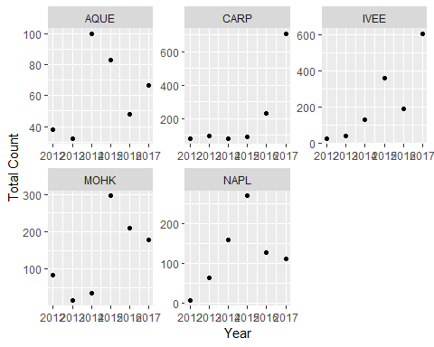

abundance_col <- ggplot(size_clean, aes(x = YEAR, y = COUNT))+  
 geom_col()+  
 facet_wrap(~SITE, scale = "free")  
  
abundance_col

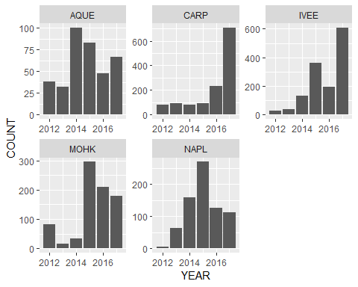

pressure <- pressure_clean %>%   
 select(YEAR, SITE, TRAPS) %>%  
 filter(SITE == "AQUE"| SITE == "NAPL" | SITE == "MOHK"| SITE == "IVEE"| SITE == "CARP") %>%   
 group_by(SITE, YEAR) %>%   
 summarize (  
 total_traps = round(sum(TRAPS), digits = 1)  
 ) %>%   
 ggplot(aes(x=YEAR, y = total_traps))+  
 geom_point() +  
 facet_wrap(~SITE, scale = "free") +  
 xlab("Year") +  
 ylab("Total Traps")  
  
pressure

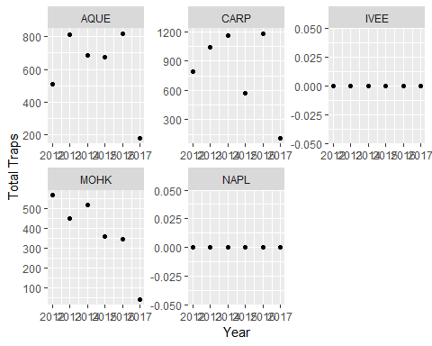

pressure_col <- ggplot(pressure_clean, aes(x = YEAR, y = TRAPS))+  
 geom_col()+  
 facet_wrap(~SITE, scale = "free")  
  
pressure_col

