Add custom cover here

Certificate
This is to certify that “<student name>”, student of class - <class> <stream> ‘<section>’ has successfully completed his Chemistry Project on “Tensile Strength of Different Fibers” under the guidance of “<teacher name>”.

_____________ _____________
Teacher’s sign Student’s sign



Index
S. No. |  | Topic | Page No.
1. |  | Certificate | I
2. |  | Acknowledgment | II
3. |  | Introduction | 1
 | 1. | Cotton | 1
 | 2. | Wool | 2
 | 3. | Silk | 3
 | 4. | Nylon | 4
4. |  | Objective | 6
5. |  | Scope and Limitation | 7
6. |  | Theory | 8
7. |  | Experiment | 11
8. |  | Observation | 12
9. |  | Result and Conclusion | 13
10. |  | Bibliography | 15

Introduction
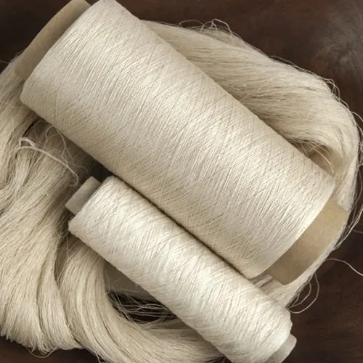
In the ever-evolving landscape of materials science, understanding the mechanical properties of fibers is a pivotal pursuit with far-reaching implications for diverse industries. Tensile strength, a fundamental parameter gauging a material's capacity to withstand axial forces, stands as a critical facet in assessing the viability of fibers for applications ranging from textiles to biomedical engineering. This research initiative undertakes a thorough exploration into the intriguing dynamics of fiber behavior, honing in on the tensile strength variations exhibited by four distinctive fibers—cotton, silk, wool, and nylon—following exposure to both acidic and basic solutions. As we embark on this journey, the intricacies of each fiber's composition and structural nuances shall unravel, shedding light on their unique mechanical responses and paving the way for nuanced insights into the interplay between chemical environments and tensile strength. The study's implications extend beyond the confines of individual fiber characteristics, contributing to a broader understanding of how varying chemical exposures influence the mechanical resilience of fibrous materials in a spectrum of real-world scenarios.

Cotton: A Natural Marvel with Deep Roots
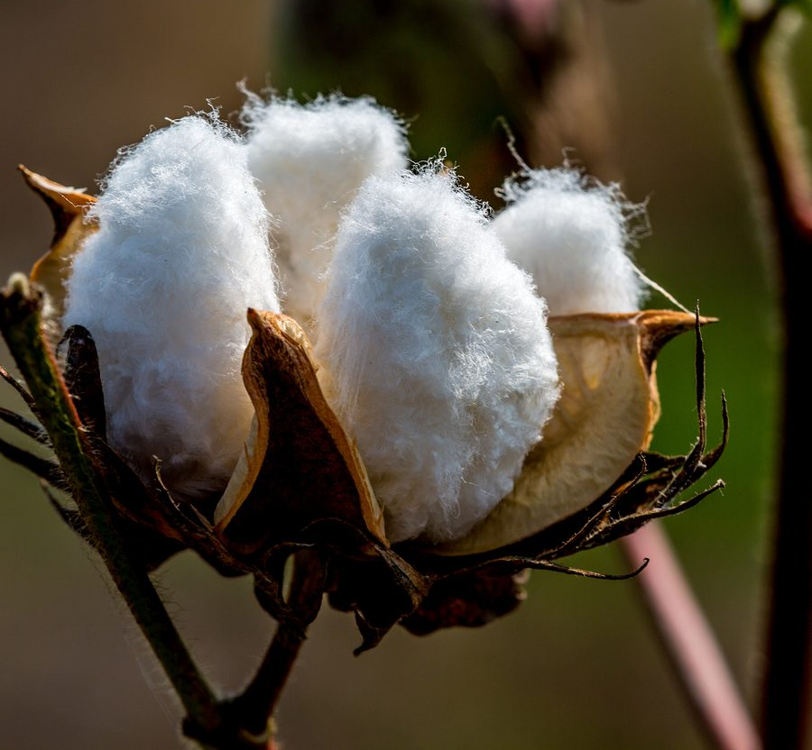
Cotton, originating from the fibers of the Gossypium plant, boasts a rich heritage intertwined with human civilization. The cotton plant yields delicate white fibers known as lint, enveloping its seeds, and this bounty has been cultivated and cherished for millennia. Grown globally, cotton has become synonymous with textile production due to its innate qualities. Its breathability, softness, and absorbent nature make cotton a sought-after fabric, adaptable to diverse climates and styles.

1

Fabrication of Comfort: From Harvest to Weave
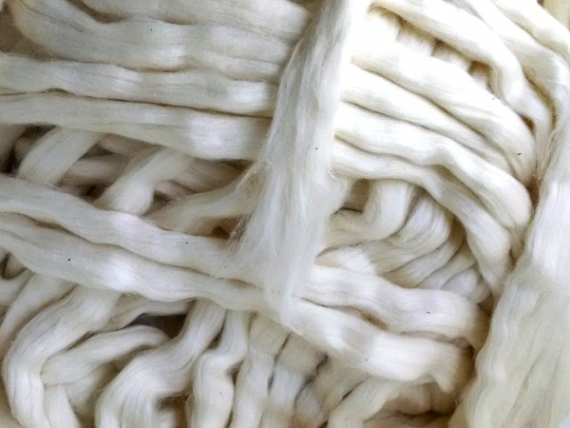
The journey of cotton from plant to fabric involves a meticulous manufacturing process. After harvesting, the cotton fibers undergo ginning, separating seeds from lint. Subsequent carding and combing align fibers for strength and smoothness. Spinning transforms them into yarn, ready for weaving or knitting. Final stages include bleaching, dyeing, and optional treatments for added properties. This intricate process ensures that the end product retains cotton's desirable characteristics, resulting in garments cherished for their comfort and wearability.

Cotton: Symbolizing Nature’s Bounty and Human Innovation
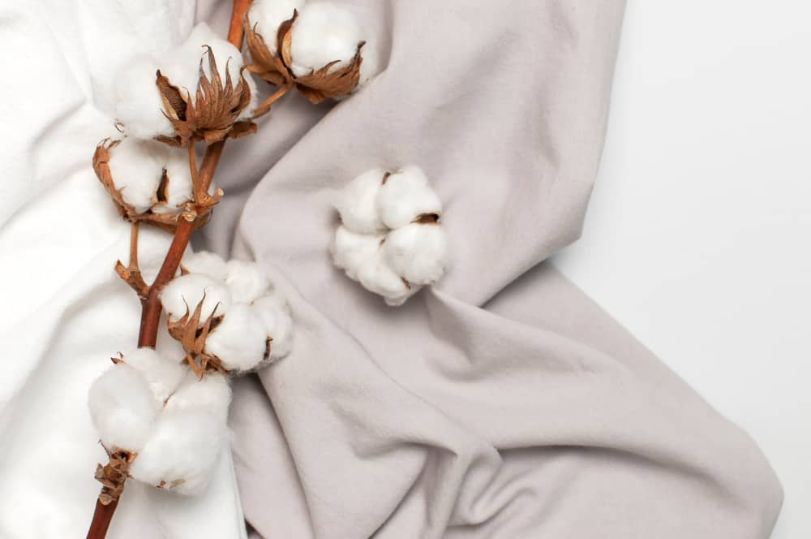
Beyond its tactile allure, cotton represents a harmonious intersection of nature's bounty and human ingenuity. The economic significance of cotton, coupled with its adaptability and comfort, positions it as a timeless symbol in textiles. From the delicate origins of the cotton plant to the complex manufacturing stages, the narrative of cotton is one that weaves together tradition and innovation, creating a fabric that stands the test of time and continues to be an integral part of our global sartorial story.

Wool: A Heritage of Warmth and Resilience
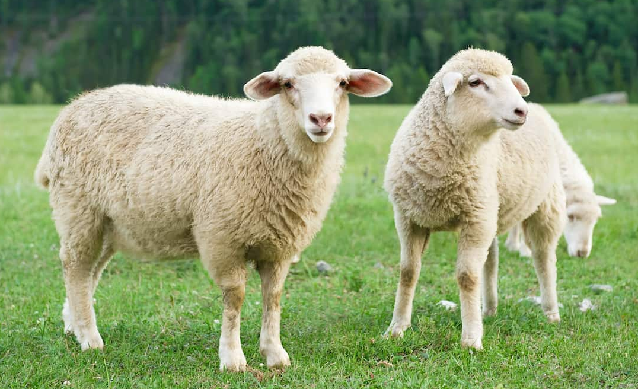
Wool, derived from the fleece of sheep and other animals, is a testament to nature's ingenuity and the enduring relationship between humans and their woolly companions. With origins deeply embedded in pastoral traditions, wool has served as a source of warmth and protection for centuries. The intricate structure of wool fibers, primarily composed of keratin proteins, contributes to its natural crimp and insulating properties, making it a fabric of choice in colder climates.

2

Wool: Crafting Comfort from Fleece to Fiber
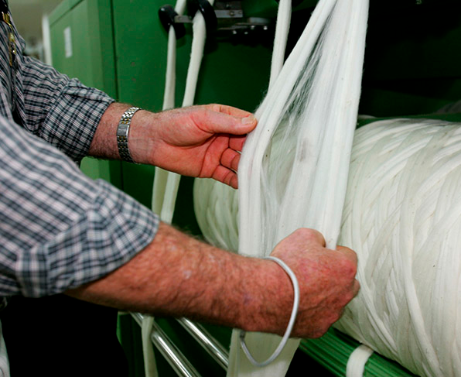
The manufacturing journey of wool involves a series of carefully orchestrated steps to transform raw fleece into a versatile textile. After shearing, the wool undergoes cleaning processes to remove impurities. Next, the fibers are carded and combed to align them in a parallel fashion, enhancing the yarn's strength and smoothness. Spinning then transforms the prepared fibers into yarn, ready to be woven or knitted into the fabric that captures the essence of warmth and luxury associated with wool.

Wool: Bridging Tradition and Modernity
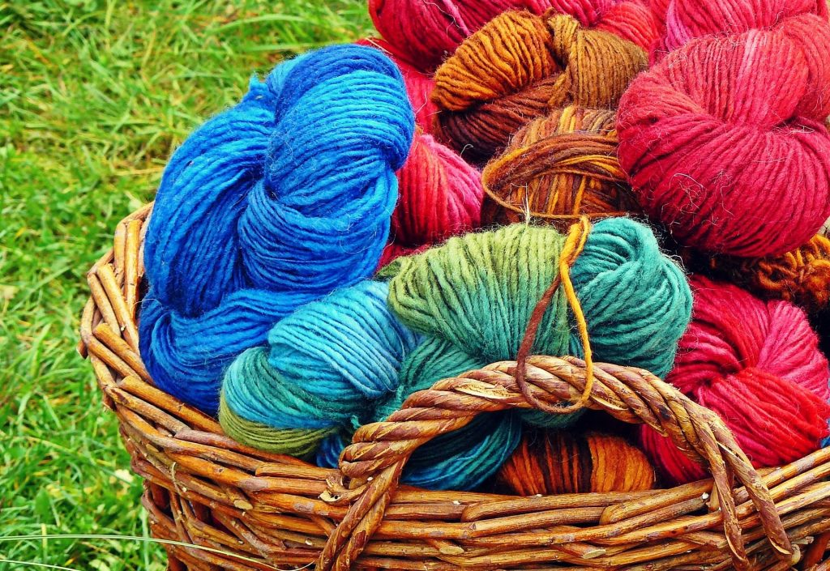
Beyond its physical attributes, wool symbolizes a connection between tradition and modernity. This natural fiber, steeped in history, continues to find relevance in contemporary fashion and lifestyle. Whether in the form of cozy sweaters or sophisticated suiting, wool's versatility and timeless appeal bridge the gap between the past and the present, making it a fiber that not only withstands the test of time but also evolves with the changing tides of fashion and functionality.

Silk: Threads of Elegance and Silkmoth Alchemy
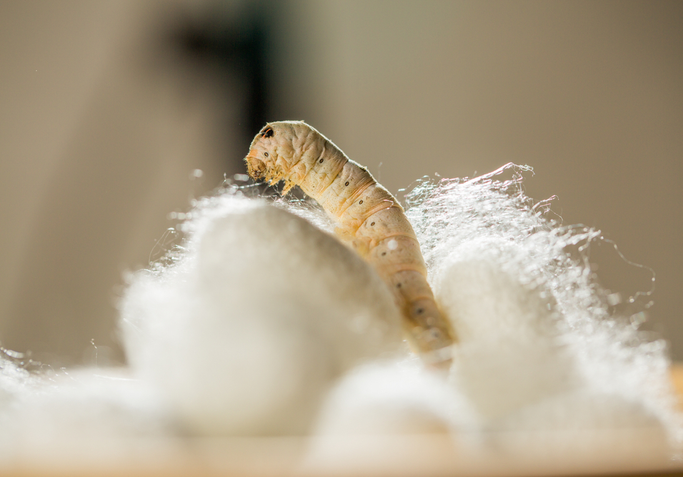
Silk, a luxurious and prized natural fiber, unfolds its origins through a fascinating process intertwined with the life cycle of silkworms. Produced during the pupal stage of silkmoths, silk fibers are meticulously spun as a protective cocoon. This intricate natural process, often referred to as sericulture, results in the creation of delicate silk threads that have been revered for centuries for their unparalleled sheen, softness, and regal allure.

3

Artistry in Weaving: From Silkworm to Silk Fabric
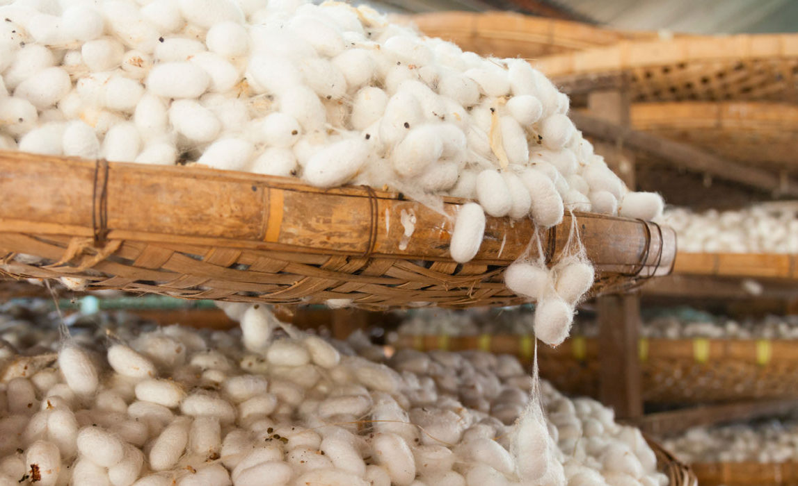
The journey from silkworm to silk fabric involves a meticulous transformation process. After harvesting the silk cocoons, the fibers are carefully unraveled through a process known as reeling. These fine silk threads are then twisted into yarn, ready to be woven into the luxurious fabric that epitomizes sophistication. The inherent properties of silk, including its smooth texture and natural luster, make it a coveted material for a wide range of applications, from exquisite clothing to opulent home furnishings.

Silk: A timeless Tapestry of Tradition and Modern Glamour
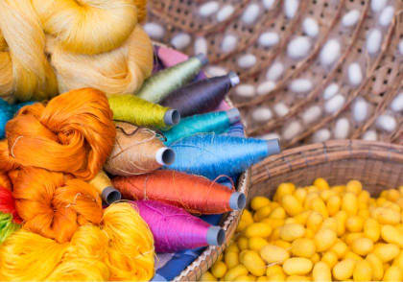
Silk, with its enduring allure, weaves a timeless tapestry that connects tradition with modern glamour. Its association with royalty and luxury spans cultures and epochs, making silk a symbol of refinement. From traditional silk saris to contemporary high-fashion garments, this exquisite fiber continues to captivate with its unparalleled beauty and versatility. Silk, with its rich history and contemporary relevance, stands as a testament to the seamless fusion of nature's artistry and human craftsmanship.

Nylon: The Synthetic Marvel of Modern Engineering
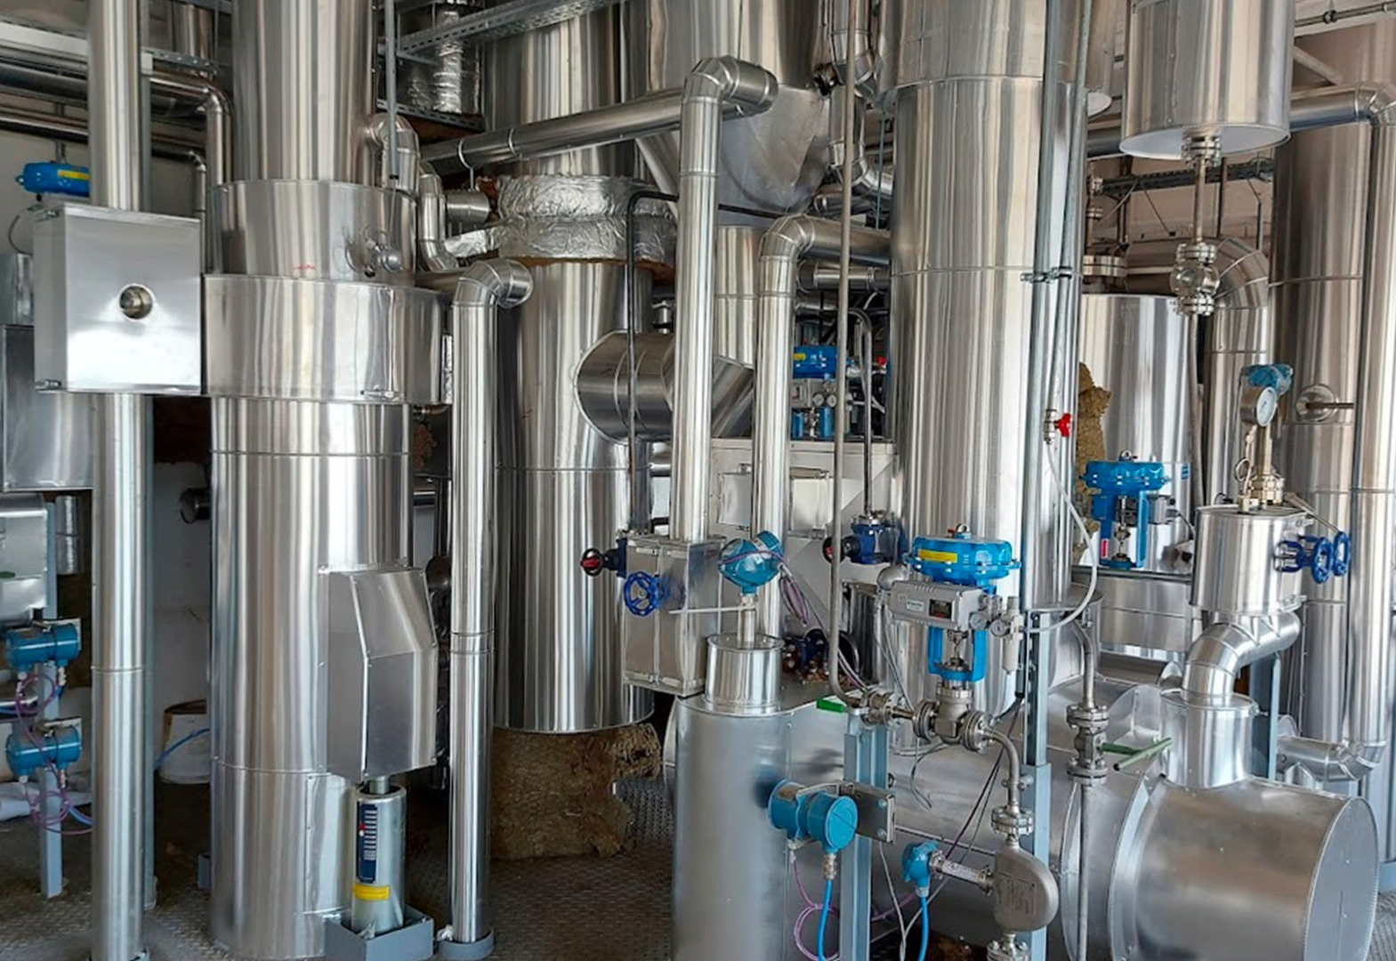
Nylon, a synthetic polymer, stands as a testament to the ingenuity of modern engineering. Developed in the early 20th century, nylon revolutionized the textile industry by offering a versatile alternative to natural fibers. Composed of repeating amide groups, nylon exhibits exceptional strength, durability, and elasticity. Its creation marked a significant milestone in material science, opening new possibilities for applications ranging from apparel to industrial uses.
4

Precision in Production: Crafting Strength from Polymer Chains
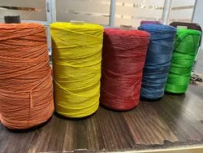
The manufacturing process of nylon involves the polymerization of specific monomers, resulting in long chains of polyamide. These chains are then spun into fibers, showcasing remarkable tensile strength and resilience. The versatility of nylon extends beyond its physical properties; it can be easily modified to meet various specifications, making it an ideal choice for a wide array of products, including clothing, carpets, and industrial components.

Nylon: Where Innovation meets Practicality
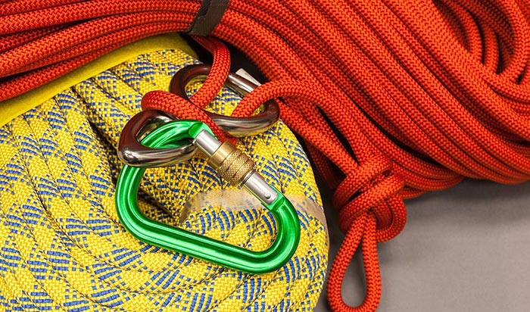
Nylon epitomizes the marriage of innovation and practicality. Its synthetic nature allows for precise control over its properties, ensuring it meets the demands of diverse industries. From the runways of high fashion to the gears of machinery, nylon's adaptability has earned it a ubiquitous presence in our daily lives. As a product of modern engineering, nylon serves as a reminder of humanity's ability to harness science and technology to create materials that not only meet but often surpass our expectations.

In the intricate tapestry of fibers, cotton's versatile legacy, wool's warmth, silk's regal allure, and nylon's synthetic marvel converge and diverge, each contributing a unique thread to our material landscape. Cotton, with its time-honored legacy, emerges as a breathable fabric, intricately woven into cultures worldwide. Wool, sourced from animals, bridges tradition and modernity, symbolizing enduring elegance.
Silk's timeless appeal connects tradition with modern glamour, while nylon, a modern engineering marvel, reshapes textiles with its strength and versatility. From cotton's natural elegance to nylon's engineered precision, these fibers showcase the diverse ways human creativity intertwines with science to shape our fabric landscape, weaving a distinct narrative in the materials that surround us.
5

Objective
This project's core objective is to evaluate the tensile strength of diverse fibers and scrutinize how alkali and acid impact this crucial parameter. Through systematic experiments, we aim to gain insights into the nuanced behavior of different fibers, facilitating informed choices for specific applications. Visual assessments alone prove inadequate; hence, our focus on the comprehensive exploration of tensile strength under various chemical conditions.
In essence, this multifaceted project contributes to understanding fiber characteristics and aids decision-making for optimal fiber choices in diverse contexts. The findings empower stakeholders to make discerning choices, ensuring fibers are matched with the most appropriate applications based on their performance in response to challenges posed by alkali and acid environments.
6

Scope and Limitation
The aim of this experiment is to determine whether plant fibers under tension are stronger or weaker by calculating their tensile strength. The theoretical expectation is that the plant might show different tensile strength after submerging them in different solutions due to the affect on the molecules. However, there are limitations to consider. Fiber strands taken from the stem may vary in maturity, introducing potential strength variations, especially if sourced from different parts or plants of the same species. Within a single fiber, the diameter may differ along its length, with the end potentially having a thicker diameter than the middle. Additionally, the drying process may lead to over-drying, increasing brittleness and causing fibers to snap prematurely under minimal loads, potentially providing misleading indications of their actual tensile strength.

The project aims to investigate the dependencies influencing the tensile strength of stone wool fibers and understand their fracture characteristics. These characters are:
1. Production-related factors
1. Hyper quenching
2. Melting atmosphere
3. Fiber diameter variations
4. Applied axial tension during forming
2. Fiber surfaces characteristics
1. Surface homogeneity
2. Surface roughness
3. Surface reactivity
Certainly, these factors display a notable correlation, a relationship that will be explored in the thesis overview and across the four associated articles. The mechanical performances of both continuous and discontinuous fibers will be examined, focusing on measuring their tensile strength in relation to varying production parameters. This investigation aims to provide valuable insights into the interconnected influences on fiber strength.
7

Theory
Depending upon the source, various fibers can be categorized as:
1. Plant fiber (e.g. cotton and jute)
2. Animal fiber (e.g. silk and wool)
3. Synthetic fiber (e.g. nylon and polyester)
Natural fibers can be grouped based on where they come from. The plant-based category, like cotton, flax, and jute, comes from vegetables or cellulose. The animal-based group includes fibers from animals like wool, mohair, and silk. Another category is minerals, and a key example is asbestos. These fibers are derived from different sources and have various uses.
Vegetable fibers, like cotton, kapok, and coir, can be grouped based on where they come from in plants. For example, some fibers, such as cotton, grow as hairs on seeds or inner fruit walls, with each fiber being a long, narrow cell. Others, like flax and hemp, are called bast fibers and come from the inner tissue of certain plant stems, made up of overlapping cells. Fibers such as abaca and sisal come from the fibrovascular system of leaves.
Chemically, all these vegetable fibers are mostly made of cellulose, but they also have other substances like hemicellulose, lignin, pectins, and waxes that need to be removed or reduced during processing. Animal fibers, on the other hand, are made entirely of proteins. Except for silk, which is spun by moth larvae to make cocoons, animal fibers are essentially fur or hair that acts as a protective covering for animals.
Except for mineral fibers, all natural fibers really like water, whether it's in liquid or vapor form. This strong liking for water makes the fibers swell when they soak up water. This swelling is helpful when dyeing the fibers in watery solutions.
Unlike many man-made fibers, all-natural fibers don't change when heat is applied; they are what we call "nonthermoplastic." They don't get soft when heated, and at temperatures below the point where they break down, they don't really react much to dry heat. There's no shrinking or stretching when you heat them, and they don't become brittle if you cool them below freezing. However, natural fibers have a tendency to turn yellow when exposed to sunlight and moisture, and if they're exposed for a long time, they can lose some of their strength.
Natural fibers, like those from plants or animals, are prone to being broken down by tiny living things, such as bacteria and fungi. For plant-based fibers, this happens especially when it's humid and warm, and there's not much light. Even animal fibers like wool and silk can be broken down by bacteria and molds. Bugs like moths and carpet beetles can also harm animal fibers, while cellulose fibers can be attacked by termites and silverfish. However, this damage can be resisted by using certain chemicals.
8

Structure of Polysaccharide
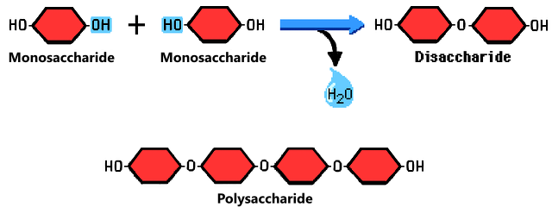
Structure of Polyamide
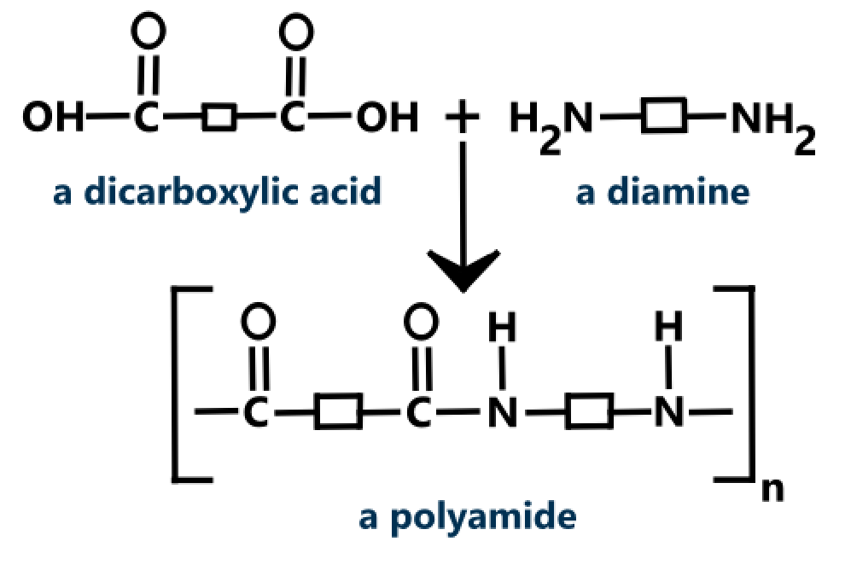
9

Structure of Nylon 6,6
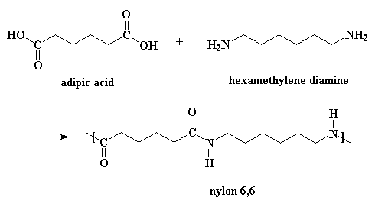
C₁₂H₂₂N₂O₂
10

Experiment
Aim: To compare tensile strength of cotton, wool, silk and nylon fibers.
Apparatus Required: Cotton, wool, silk, nylon, hook, weight hangers, slotted weights, acid, base, clamp, clamp stand, tweezers.
Procedure
1. Take five different samples of fibers in equal length.
2. Take a ring fixer and tie one end of the fiber on an iron stand and the other end with a hanger which carries the weights to keep the fiber gets straighten.
3. Now, start adding weight onto the weight hanger and observe the stretching of the thread.
4. Repeat step 2 and 3 with other threads made up of different material and compare their tensile strength.
5. To study the effect of acid and base on the tensile strength of fibers, dip each type of fabric in dilute HCl or dilute NaOH solution of equal quantity for equal interval of time.
6. After a fixed interval of time, the fibers are removed from the solution, washed with water and dried.
7. Determine again the tensile strength of the dried fibers by repeating steps 2, 3 and 4.
11

Observation
S.no. | Type of Fiber | Original Tensile Strength | Tensile strength after HCl | Tensile strength after NaOH
1. | Cotton | 250 g | 350 g | 200 g
2. | Wool | 1300 g | 1300 g | 1250 g
3. | Silk | 50 g | 100 g | 100 g
4. | Nylon | 1700 g | 1600 g | 1750 g
12

Result and Conclusion
Conclusions drawn from the experiment are:
1. When woolen fibers come into contact with bases, their tensile strength tends to decrease, showing a reduction in overall strength.
2. Fibers don't undergo significant changes when exposed to acids, as acids have minimal impact on their properties.
3. The tensile strength of cotton thread experiences a decrease in the presence of acids, while exposure to bases has comparatively less effect, leaving the strength relatively unaffected.
4. Nylon fiber exhibits remarkable stability, showing little to no change in its properties when exposed to both acids and bases.

In a comprehensive study of fiber tensile strength, cotton, wool, silk, and nylon were examined. Cotton exhibited a tensile strength of 250 g, increasing to 350 g in HCl and decreasing to 200 g in NaOH. Wool maintained a consistent strength of 1300 g despite exposure to acids and bases. Silk, with an original strength of 50 g, showed increased tensile strength (100 g) in acid but remained stable in a basic environment. Nylon, starting at 1700 g, demonstrated stability under both acidic and basic conditions.

Cotton's Response:
Cotton's versatile nature was evident as it displayed varying tensile strengths under different chemical exposures. The increase in strength in HCl suggests a complex interaction, while the decrease in NaOH highlights the material's responsiveness to different environments.

Wool's Resilience:
Wool, known for its warmth and resilience, exhibited a consistent tensile strength of 1300 g throughout the experiment. This stability underscores wool's durability, showcasing its resistance to changes induced by acidic or basic solutions.

Silk's Sensitivity:
Silk, celebrated for elegance, presented a delicate original strength of 50 g. Its sensitivity to acidic environments, as seen in the increased tensile strength in acid, provides insights
13

into how chemical exposures can influence the mechanical properties of this natural fiber.

Nylon's Stability:
Nylon, a synthetic marvel engineered for strength and versatility, demonstrated an impressive original tensile strength of 1700 g. Surprisingly, both acids and bases had minimal impact on nylon's tensile strength, highlighting its stability and consistency.

This multifaceted experiment revealed nuanced responses of cotton, wool, silk, and nylon fibers to acidic and basic environments. These findings emphasize the importance of considering chemical exposures when assessing fiber suitability for various applications, contributing to more informed material selection in practical scenarios.
14

Bibliography
1. <education board> Chemistry Lab Manual
2. Wikipedia
3. Polymer Science Learning Center
4. American Chemistry Learning Center
5. Science Photo Lab
6. Britannica

