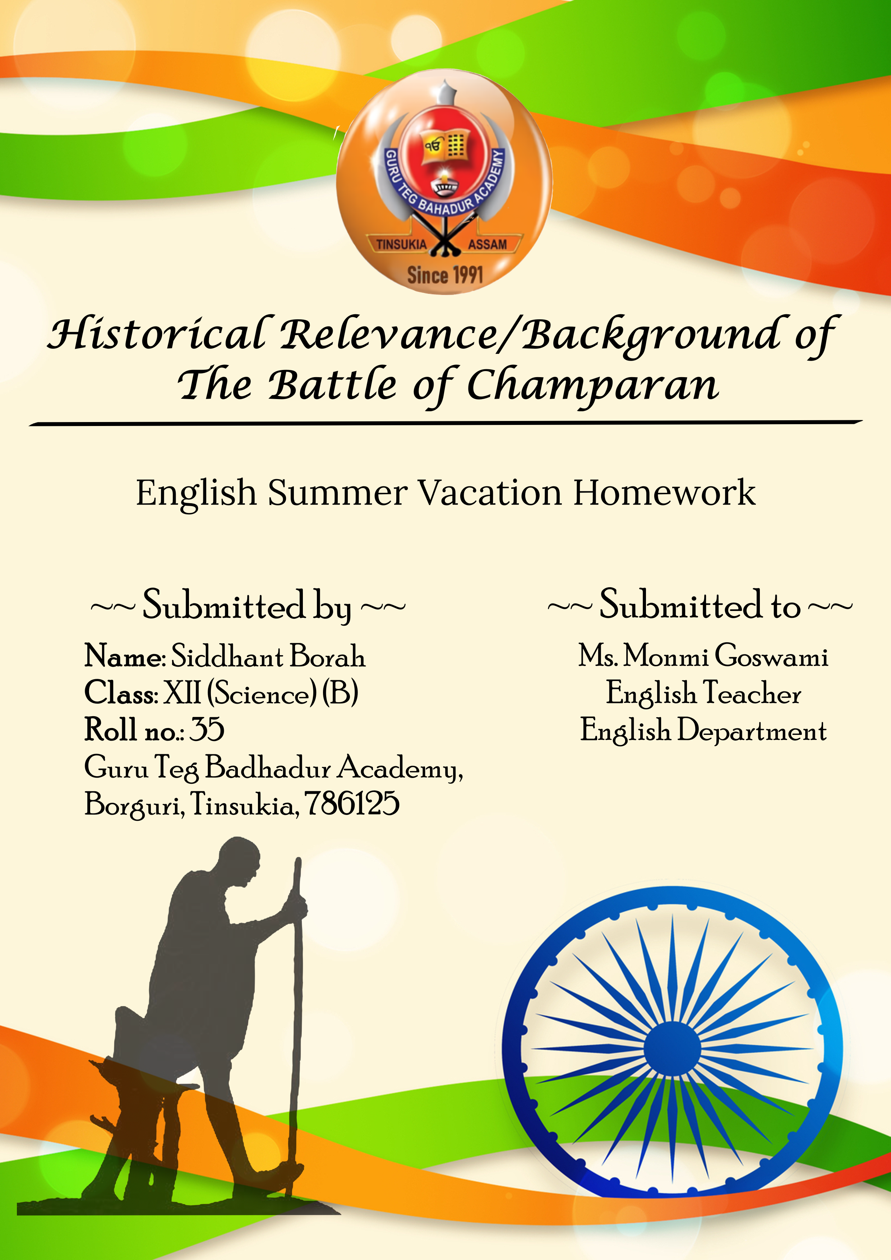

Acknowledgment
I would like to express my sincere gratitude to Ms. Monmi Goswami, my English teacher, for her continuous support and guidance throughout this summer vacation assignment. Her insights and feedback were invaluable in shaping this project.
I am also thankful to my parents for their encouragement and for providing the necessary resources and environment to complete this assignment successfully. Their support was instrumental in helping me stay focused and motivated.
Additionally, I would like to acknowledge the developers of the tools and software that made it possible to analyze the data for this project. Their innovative solutions and dedication have greatly enriched my understanding of the subject matter and facilitated my research.
Finally, I am grateful to Guru Teg Bahadur Academy, Tinsukia for providing the opportunity and platform to undertake this assignment, which has significantly enhanced my learning experience and knowledge during the summer vacation.
Thank you all for your support and contributions.

