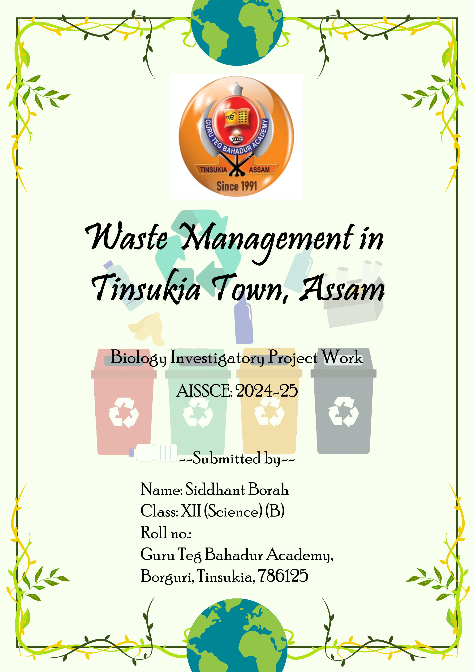

Certificate

This is to certify that the project work entitled "Waste Management in Tinsukia Town, Assam" is the original and genuine investigative work carried out by Siddhant Borah, student of Class XII (Science) (B) of Guru Teg Bahadur Academy, Tinsukia.
This investigatory project work has been completed as a partial fulfillment of the course curriculum of AISSCE, 2024-25, under the guidance of Mr. Sailendra Mohan Das and Mr. Arup Roy, PGTs Biology, GTBA, Tinsukia.

--------------------- ---------------------
Internal Examiner External Examiner

i

Acknowledgment
I would like to express my sincere gratitude to Mr. Sailendra Mohan Das and Mr. Arup Roy for their invaluable guidance, support, and encouragement throughout this project. Their expertise and insights have been instrumental in the successful completion of this study.

I am also thankful to Guru Teg Bahadur Academy for providing the necessary resources and facilities to conduct this research. I would like to express my special thanks to Mr. Pratap Ch. Padhiary, Principal of Guru Teg Bahadur Academy, Tinsukia, for giving me the golden opportunity to undertake this wonderful project work entitled "Waste Management in Tinsukia Town, Assam."

I would like to acknowledge the contributions of my fellow classmate and friend, Kissan Sah, who offered his time and help during various stages of the project. His collaboration and support were greatly appreciated.

Finally, I extend my deepest gratitude to my family for their unwavering support and encouragement throughout this endeavor. Their belief in my abilities and continuous motivation have been the foundation of my success.

Thank you all for making this project a rewarding and enlightening experience.

ii

Content

1. Certificate ………………………………………………………………………. i
2. Acknowledgment ……………………………………………………………. ii
3. Abstract ………………………………………………………………………….. 1
4. Introduction ……………………………………………………………………. 2
5. Aim of the Experiment …………………………………………………….. 3
6. Need Statement ………………………………………………………………. 3
7. Methodology …………………………………………………………………… 4
7.1 Literature Review …………………………………………………… 4
7.2 Biodegradability and Hazards …………………………………. 7
7.3 Documentation ………………………………………………………. 8
8. Observation …………………………………………………………………….. 10
8.1 Waste Management Challenges in Tinsukia ……………. 10
8.2 Common Indian Waste Management Problems ………. 11
9. Conclusion ……………………………………………………………………….. 13
10. Bibliography …………………………………………………………………… 15
11. Photo Gallery …………………………………………………………………. 16

Abstract
This project, titled "Waste Management in Tinsukia Town, Assam," examines the various aspects of waste management, focusing on practices, challenges, and potential solutions relevant to the region. The study emphasizes the importance of effective waste management for public health, environmental protection, and sustainable development.
Key areas explored include:
- Current Practices: Analysis of existing waste collection, transportation, and disposal systems in Tinsukia.
- Segregation and Recycling: Importance of waste segregation at the source and recycling programs in reducing waste and conserving resources.
- Organic Waste Management: Benefits of composting organic waste into nutrient-rich compost for agriculture.
- Waste-to-Energy: Technologies converting non-recyclable waste into renewable energy, reducing waste volume.
- Hazardous Waste Management: Treatment and disposal methods to prevent environmental and health risks.
- Regulatory Framework: Role of regulations and public participation in effective waste management.
- Challenges and Recommendations: Addressing rapid urbanization, inadequate infrastructure, and limited public awareness with strengthened infrastructure, segregation, recycling, and waste-to-energy solutions.
The study underscores the need for collaboration between the government, private sector, and citizens to achieve effective waste management and ensure a sustainable future for Tinsukia.

1

Introduction
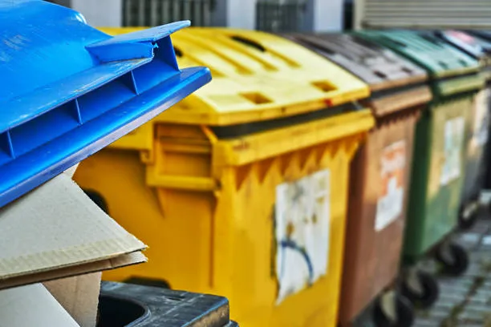
Waste management is a critical issue due to the increasing waste volumes and their environmental and health impacts. Effective waste management mitigates pollution, conserves resources, and protects ecosystems. This project explores composting and anaerobic digestion, which decompose organic waste into valuable end products.
Traditional waste disposal methods like landfilling and incineration pose environmental challenges, including greenhouse gas emissions and contamination. Biological waste management offers an eco-friendly alternative using natural decomposition by microorganisms. Composting transforms organic waste into nutrient-rich compost, while anaerobic digestion produces biogas and digestate.
This project examines the efficiency, environmental impact, and economic viability of composting and anaerobic digestion. The methodology involves setting up compost bins and biogas plants, monitoring decomposition, identifying key microorganisms, and analyzing the products. These processes aim to transform waste into valuable resources, reduce pollution, and promote a circular economy.
Dumpsters used to collect garbage efficiently
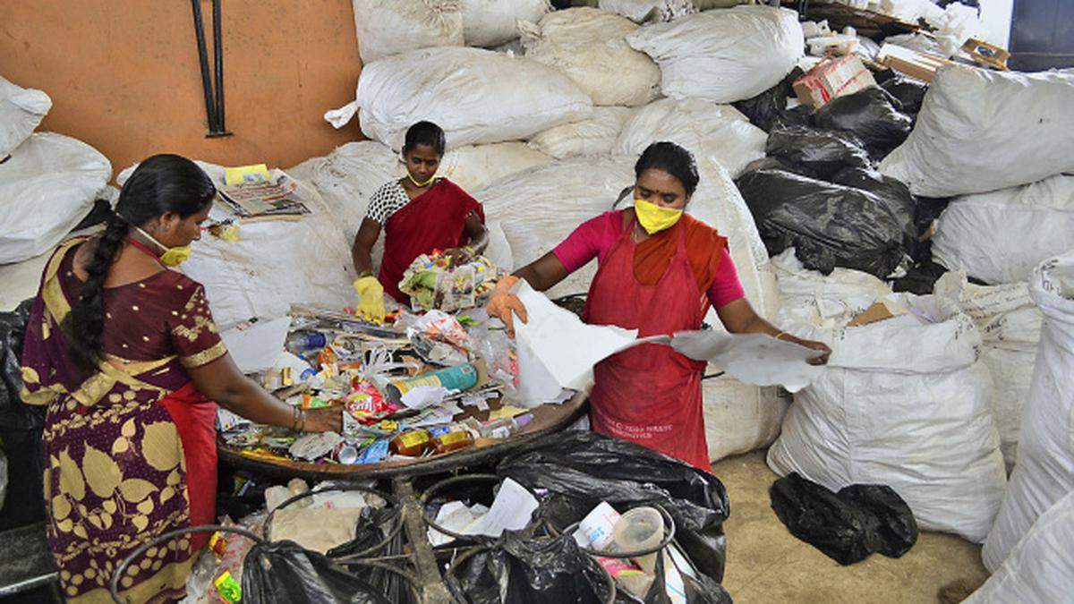

Waste segregation in process at Saahas Foundation in Ejipura, Bangalore; Photo: Karan Ananth

2

Aim of the Experiment

The aim of this project is to investigate and analyze the current waste management practices in Tinsukia, Assam, to identify the key challenges and propose effective solutions for improving waste management. This includes examining the processes of waste collection, segregation, recycling, composting, and waste-to-energy technologies, with the ultimate goal of promoting sustainable waste management practices and enhancing public health and environmental protection.

Need Statement

The management of waste is crucial due to its significant environmental, health, and economic impacts. Improper waste disposal leads to pollution, habitat destruction, and adverse health effects, necessitating efficient waste management practices to minimize these negative impacts.
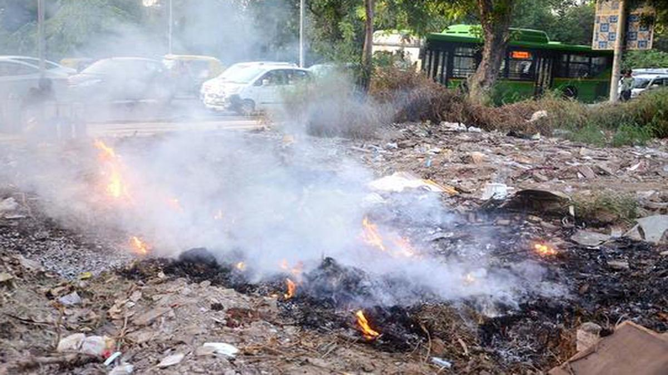
Efficient waste management helps conserve resources and promotes sustainability. Traditional methods like landfilling and incineration have numerous drawbacks, including greenhouse gas emissions and soil contamination. Therefore, exploring alternative methods is vital for a sustainable future.
Burning of Wastes leading to production of harmful gases
This project focuses on biological methods of waste management, specifically the roles of decomposition processes, recycling, and microorganisms. By examining these biological processes, we aim to develop sustainable waste management practices that reduce environmental impact and promote resource conservation.

3

Methodology
The methodology section outlines the approach and methods used to conduct our research on waste management. Given the inaccuracies and improper practices in our locality, all data was collected online to ensure accuracy and reliability. In the sections below, we provided background
information on waste management and its importance. This includes defining waste management and explaining why it is crucial for maintaining environmental health and sustainability.
Here, we discuss the current issues and challenges in waste management. We explain the need for improved waste management practices due to the negative impacts of improper waste handling on the environment and human health.

Literature Review
We conducted a comprehensive review of existing research and studies on waste management. This involved summarizing key findings from academic papers, government reports, and publications from non-governmental organizations. The literature review helped us identify the gaps in current knowledge and the areas that need further investigation.

Types of Waste
This section categorizes different types of waste, including municipal, industrial, hazardous, biomedical, and electronic waste. We describe the characteristics and examples of each type, highlighting how they are generated and managed.

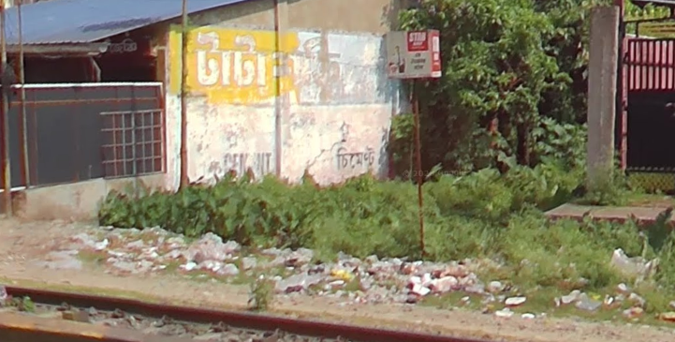
1. Municipal Solid Waste (MSW)
- Definition: Commonly known as trash or garbage, MSW includes everyday items discarded by the public.
- Examples: Household waste, food scraps, packaging materials, paper, plastics, glass, metals.
Uncollected Municipal Waste in Makum, nearby town of Tinsukia.
Also a route for GTBA School Bus no. 1
- Management Practices: Collection by local authorities, recycling, composting, and landfilling.

4

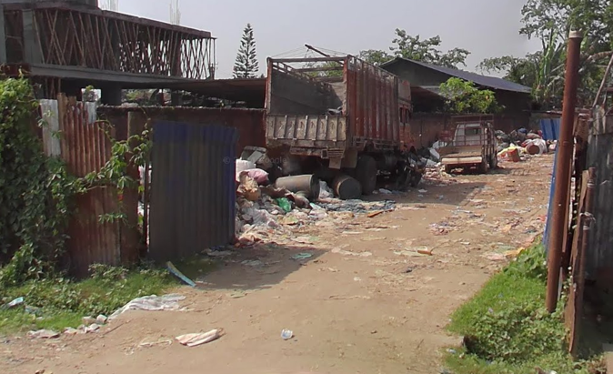
2. Industrial Waste
- Definition: Waste produced by industrial activities and manufacturing processes.
- Examples: Scrap metal, chemicals, plastics, packaging materials, and by-products from factories.
Industrial Waste near Harsh Agencies, Tinsukia
- Management Practices: Recycling, treatment of hazardous components, landfilling, and incineration.

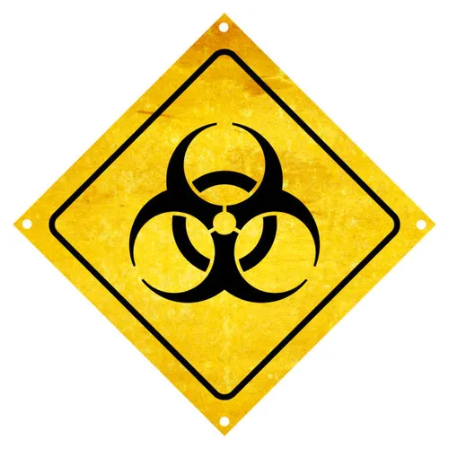
3. Hazardous Waste
- Definition: Waste that poses substantial or potential threats to public health or the environment.
- Examples: Batteries, paints, chemicals, pesticides, medical waste, electronic waste (e-waste).
Symbol to represent Bio-hazard Waste
- Management Practices: Specialized treatment and disposal processes, secure landfills, incineration, and recycling.
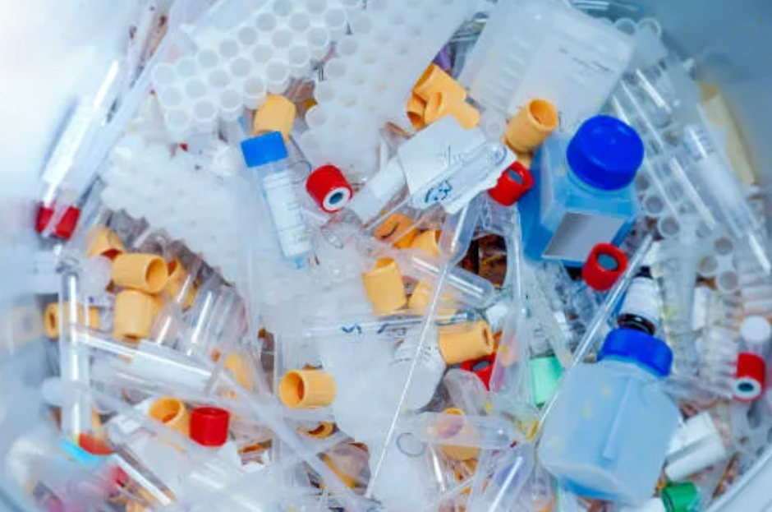
4. Biomedical Waste
- Definition: Waste generated from medical facilities, such as hospitals, clinics, and laboratories.
- Examples: Used needles and syringes, bandages, surgical gloves, discarded medicines, and body fluids.
Disposed medical supplies
- Management Practices: Incineration, autoclaving, chemical disinfection, and secure landfilling.

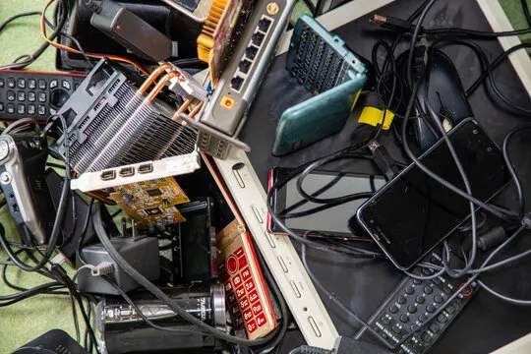
5. Electronic Waste (E-waste)
- Definition: Discarded electronic devices and components.
- Examples: Computers, mobile phones, televisions, printers, and other electronic gadgets.
Thrown-away electronics
- Management Practices: Recycling, refurbishing, and safe disposal to recover valuable materials and reduce environmental impact.

5

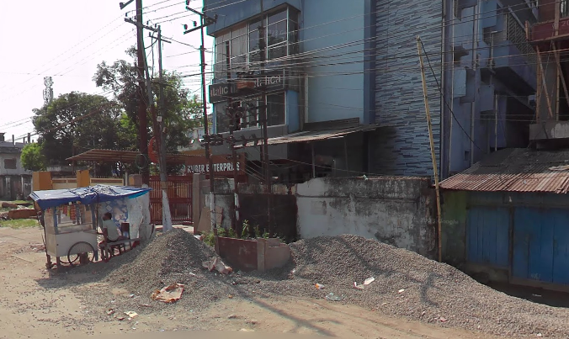
6. Construction and Demolition Waste (C&D Waste)
- Definition: Waste materials produced during construction, renovation, and demolition activities.
- Examples: Concrete, wood, metals, bricks, glass, and plastics.
C&D Waste Near Dhekiajuri Bongali Gaon, Tinsukia
- Management Practices: Recycling and reusing materials, landfilling, and specialized treatment for hazardous components.

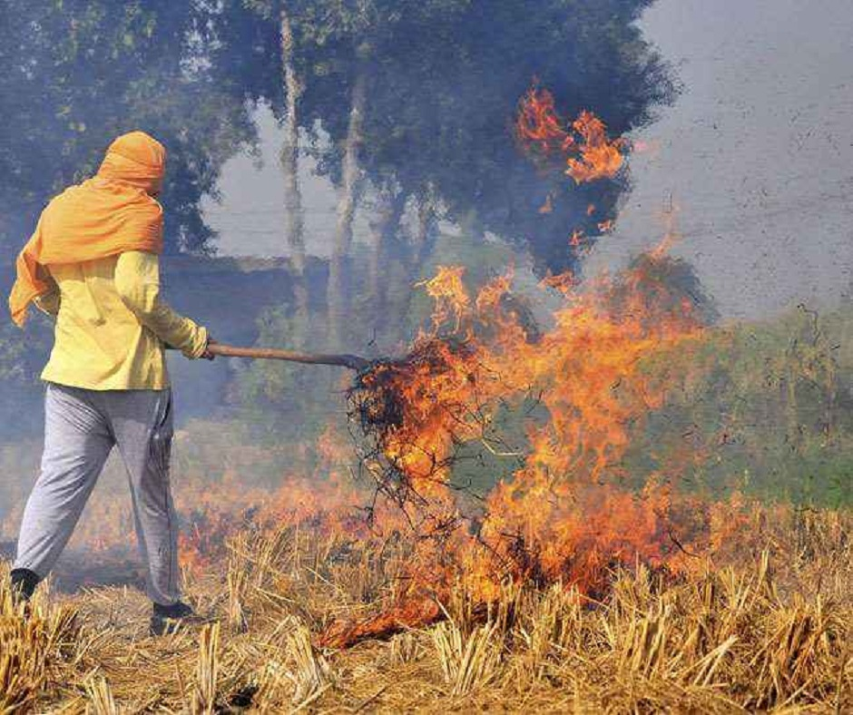
7. Agricultural Waste
Burning of Stubble (Parali) is a common practice in certain parts of India creating massive air pollution.
- Definition: Waste produced from farming activities.
- Examples: Crop residues, manure, pesticide containers, and unused fertilizers.
- Management Practices: Composting, recycling, and proper disposal of hazardous materials.

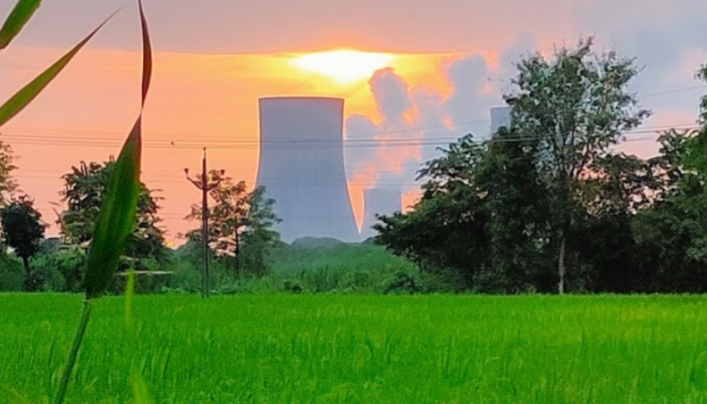
8. Radioactive Waste
- Definition: Waste containing radioactive substances.
- Examples: Spent nuclear fuel, radioactive isotopes from medical and industrial processes, and contaminated materials.
Kakrapar Atomic Power Station, Hyderabad
- Management Practices: Containment, deep geological storage, and specialized treatment to reduce radioactivity over time.

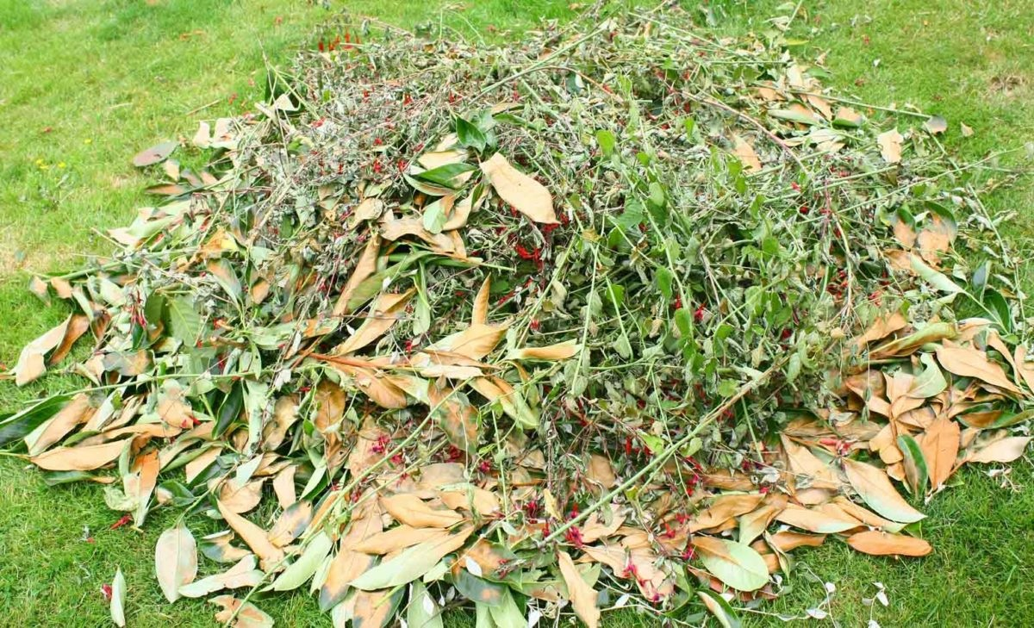
9. Green Waste
- Definition: Biodegradable waste composed of garden or park waste.
- Examples: Grass clippings, leaves, branches, and organic garden debris.

6
Green waste collected after cleaning a park
- Management Practices: Composting, mulching, and anaerobic digestion to produce biogas.

Biodegradability and Hazards
Effective waste management in Tinsukia necessitates a comprehensive understanding of the biodegradability of waste materials and the associated hazards. This subsection outlines the methodology for assessing the biodegradability of various waste types and identifying potential environmental and health hazards.

Waste Segregation and Collection
- Sampling: Collect samples of waste from different sources within Tinsukia, including residential, commercial, and industrial areas.
- Segregation: Separate the waste samples into biodegradable and non-biodegradable categories. Biodegradable waste includes organic matter such as food scraps, garden waste, and paper, while non-biodegradable waste encompasses plastics, metals, and glass.

Assessment of Biodegradability
- Laboratory Analysis: Conduct laboratory tests to determine the biodegradability of organic waste. This involves measuring the rate of decomposition and the breakdown products.
- Field Studies: Implement pilot composting projects to observe the natural decomposition process of biodegradable waste. Monitor parameters such as temperature, moisture, and microbial activity to evaluate the efficiency of biodegradation.

Identification of Hazards
- Chemical Analysis: Analyze the chemical composition of non-biodegradable waste to identify hazardous substances. This includes testing for heavy metals, toxic chemicals and persistent organic pollutants.
- Risk Assessment: Evaluate the potential health and environmental risks associated with the identified hazardous substances. Consider factors such as toxicity, exposure pathways, and the persistence of pollutants in the environment.

7
The results of this methodology will provide valuable insights into the biodegradability of waste in Tinsukia and the associated hazards. Based on the findings, recommendations can be made to improve waste management practices, enhance public awareness, and mitigate environmental and health risks. These recommendations may include promoting waste segregation at the source, implementing safe disposal methods for hazardous waste, and encouraging the use of biodegradable materials.

Documentation

Data Collection Methods

1. Surveying Localities via. Google Street View
- This helps with in the effective and fast environment surveying with online tools such as Google Street View to get a glance of the area without actually traveling to it.
A powerful tool to view the world from home
- Using Google Street View ensures efficient data collection from reliable sources. It reduces the costs associated with transport and safety issues.
- This method ensured efficient data collection from trusted sources.
2. Online Observations and Case Studies
- Utilized online resources such as videos, webinars, and vlogs to observe waste management practices.
- Reviewed case studies and reports from other regions to understand effective waste management systems.

Data Analysis Procedures
1. Quantitative Analysis
- Analyzed survey responses using basic statistical methods (averages and percentages).
- Summarized data to identify common trends in waste generation and segregation practices.

8
2. Qualitative Analysis
- Reviewed transcripts from virtual interviews and notes from online observations.
- Identified common themes and insights using coding techniques.

Tools and Techniques
1. Data Collection Tools
- Google Street View for images and records.
- Observed waste collection points and public spaces.
2. Data Analysis Tools
- LibreOffice Calc for organizing and analyzing data.
- LibreOffice Writer for making the document.
- VSCodium for recording plain text and keeping an updated online copy.
- Git as a safety measure and keeping file records.

Ethical Considerations
1. Digital Privacy and Confidentiality
- Every data used in this Project is under Public domain and can be accessed freely by everyone due to the digital nature of data collection and the use of online tools such as Google Street View and YouTube.
- Participants were assured that their personal information would be handled securely and in accordance with ethical guidelines, minimizing risks associated with online data collection and storage.
2. Data Protection
- All data collected, including survey responses, interview transcripts, and observational notes, were stored securely using encrypted digital storage systems.
- Anonymization techniques were employed to protect the privacy of participants. Personal identifiers were removed and faces are blurred.

9

Observation

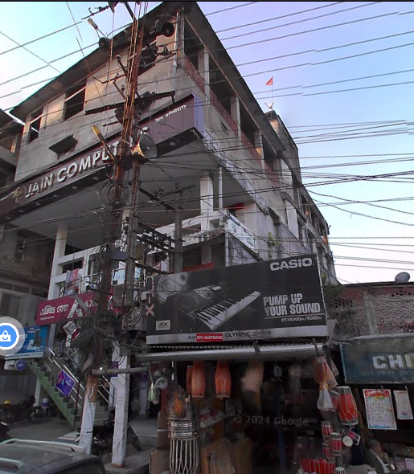
Waste Management Challenges in Tinsukia
Tinsukia, a town in Assam, faces significant waste management issues that reflect common problems seen throughout India. These challenges include inadequate infrastructure, lack of public awareness, insufficient recycling practices, and improper waste disposal methods. This section highlights the specific problems observed in Tinsukia, with examples from common Indian waste management issues.
Overlapping power lines shows unorganized construction in Tinsukia

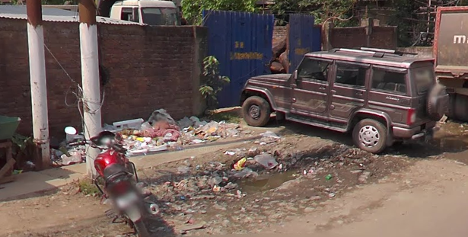
Inadequate Infrastructure
The town's waste management infrastructure is insufficient to handle the growing volume of waste generated by its residents. Collection and transportation systems are often overwhelmed, leading to uncollected waste accumulating in public areas. This not only creates unsightly conditions but also poses health risks due to the proliferation of disease vectors like rodents and insects.
Lacking infrastructure for waste management in Dhekiajuri Bongali Gaon, Tinsukia

Lack of Public Awareness
There is a notable lack of public awareness and participation in proper waste management practices. Many residents are unaware of the importance of waste segregation, leading to mixed waste being disposed of inappropriately. This hampers recycling efforts and complicates waste processing.

10

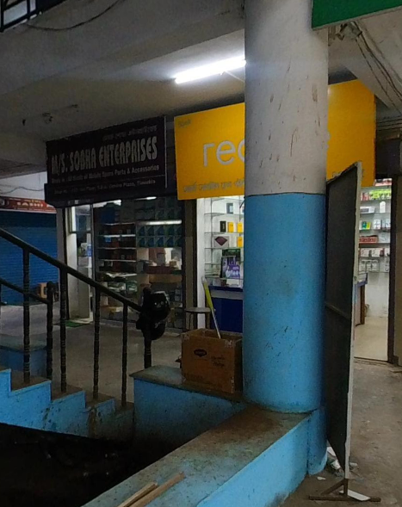
Gutka Spits
A unique and pervasive problem in Tinsukia is the widespread spitting of gutka (a chewing tobacco product). This habit results in red stains on walls, sidewalks, and other public surfaces, creating an unsightly environment and posing hygiene concerns. The prevalence of gutka spits highlights the need for targeted public awareness campaigns and stricter enforcement of cleanliness regulations.

Improper Waste Disposal
Gutka spits all over TDA Complex’s walls and corners
Improper disposal of waste, including hazardous materials, is a significant issue. Industries and households often dispose of waste in open areas or water bodies, leading to soil and water contamination. For example, leachate (water containing dissolved pollutants) from unregulated dumps can seep into groundwater, affecting drinking water quality.

Insufficient Recycling Practices
Recycling practices in Tinsukia are underdeveloped. There are limited facilities for recycling different types of waste, and public participation in recycling programs is low. This results in recyclable materials ending up in landfills, contributing to environmental pollution and resource wastage.

Common Indian Waste Management Problems
The challenges faced by Tinsukia are reflective of broader issues in India’s waste management system:

- Rapid Urbanization: Like many towns and cities in India, Tinsukia is experiencing rapid urbanization, leading to increased waste generation and pressure on existing waste management infrastructure.

11

- Inadequate Funding: There is often a lack of adequate funding for waste management projects, resulting in poorly maintained equipment and insufficient resources to implement effective waste management strategies.
- Limited Policy Implementation: Despite having policies and regulations in place, the implementation at the local level is often weak. Corruption and lack of accountability further exacerbate the problem.
Urbanized Tinsukia at night; Photo: Rajeev Sharma

Addressing these challenges requires a multi-faceted approach involving the municipal corporation, residents, and other stakeholders. By improving infrastructure, enhancing public awareness, promoting recycling, and enforcing proper waste disposal methods, Tinsukia can move towards a cleaner and healthier environment. Special attention to unique issues like gutka spits can significantly improve the town's public spaces, fostering a more pleasant and hygienic community for all.

12

Conclusion
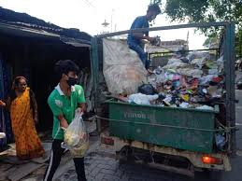
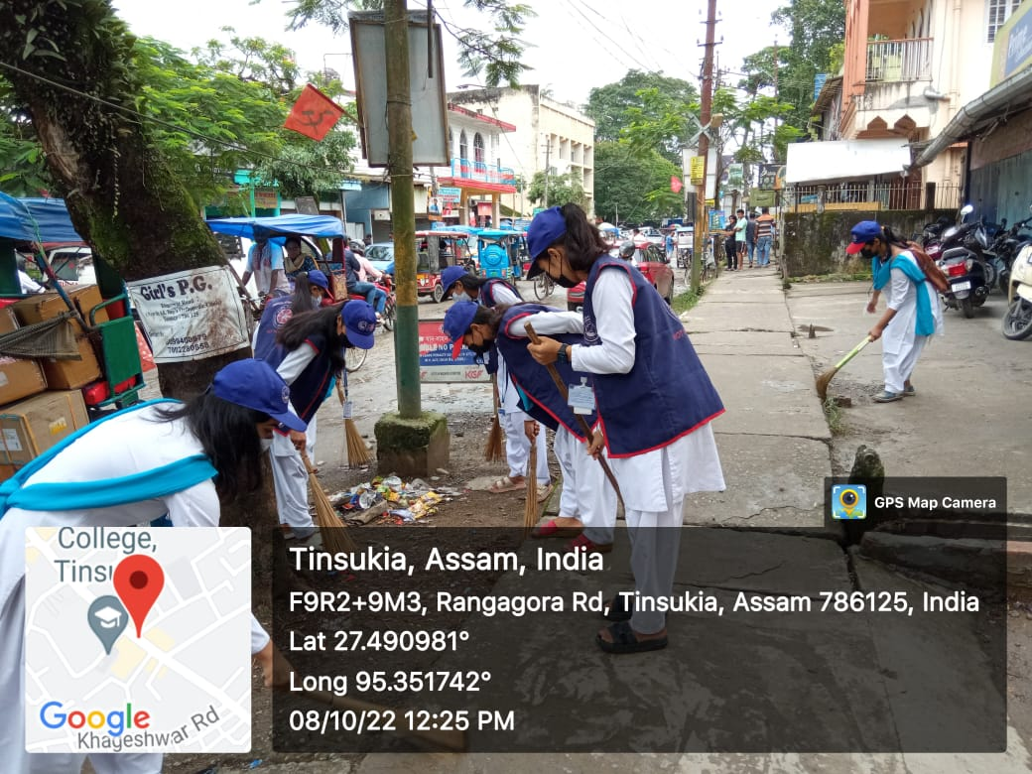
Effective waste management in Tinsukia requires a collaborative effort between the municipal corporation and the residents. By improving infrastructure, educating the community, and ensuring transparency in funding, Tinsukia can achieve a cleaner and healthier environment. It is essential for residents to actively participate and take responsibility for their waste to support the municipal efforts in maintaining a clean town.
In conclusion, effective waste management in India is crucial for promoting public health, protecting the environment, and ensuring sustainable development. The country faces significant challenges, including rapid urbanization, inadequate infrastructure, insufficient public awareness, and limited recycling practices. However, by adopting a comprehensive and multi-pronged approach, these challenges can be addressed effectively.
Strengthening waste management infrastructure, promoting waste segregation at the source, enhancing recycling and reuse practices, and integrating waste-to-energy technologies are key steps toward improving the waste management system. Developing comprehensive policies and regulations, encouraging public-private partnerships, and supporting research and innovation are essential for driving sustainable waste management practices.
Efforts to dispose waste properly in Tinsukia
Clean India Campaign by Women’s College, Tinsukia; Source: www.wcttsk.ac.in
Raising public awareness and engagement, enhancing capacity building and training, and implementing incentive-based programs can further motivate individuals and businesses to adopt sustainable practices. By focusing on the basic principles of refuse, reduce, reuse, and recycle, India can significantly reduce the volume of waste generated and promote resource conservation.
Ultimately, addressing the challenges and implementing these suggestions will lead to a cleaner, healthier, and more sustainable future for Tinsukia and the entire country. It is a collective responsibility of the government, private sector, and citizens to work together to achieve effective waste management and protect the environment for future generations.

13
Swachh Bharat Mission in progress; Source: indianrailways.gov.in
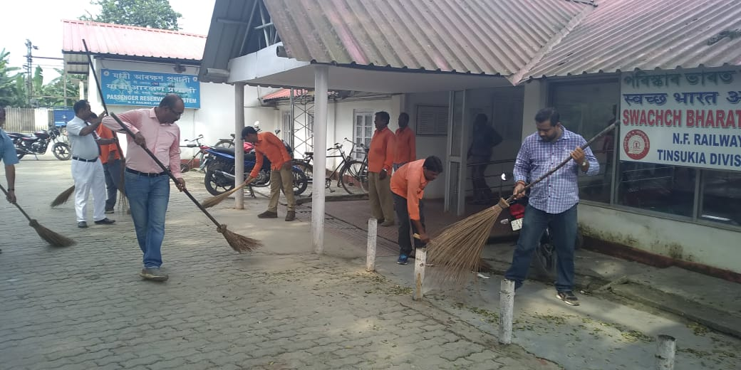

14

Bibliography

1. https://borgenproject.org/indias-waste-management/
2. https://cpcb.nic.in/
3. https://home.iitk.ac.in/~anubha/H16.pdf
4. https://www.niti.gov.in/sites/default/files/2021-12/Waste-Wise-Cities.pdf
5. https://www.eastmojo.com/assam/2022/05/16/gone-to-waste-tinsukia-municipal-board-an-ngo-their-disastrous-mou/
6. https://en.wikipedia.org/wiki/Waste_management_in_India
7. https://www.thehindu.com/news/national/karnataka/high-court-notice-to-government-on-segregation-of-waste-at-source/article3708796.ece
8. https://www.istockphoto.com
9. https://indianrailways.gov.in
10. https://wcttsk.ac.in/

15

Photo Gallery

16

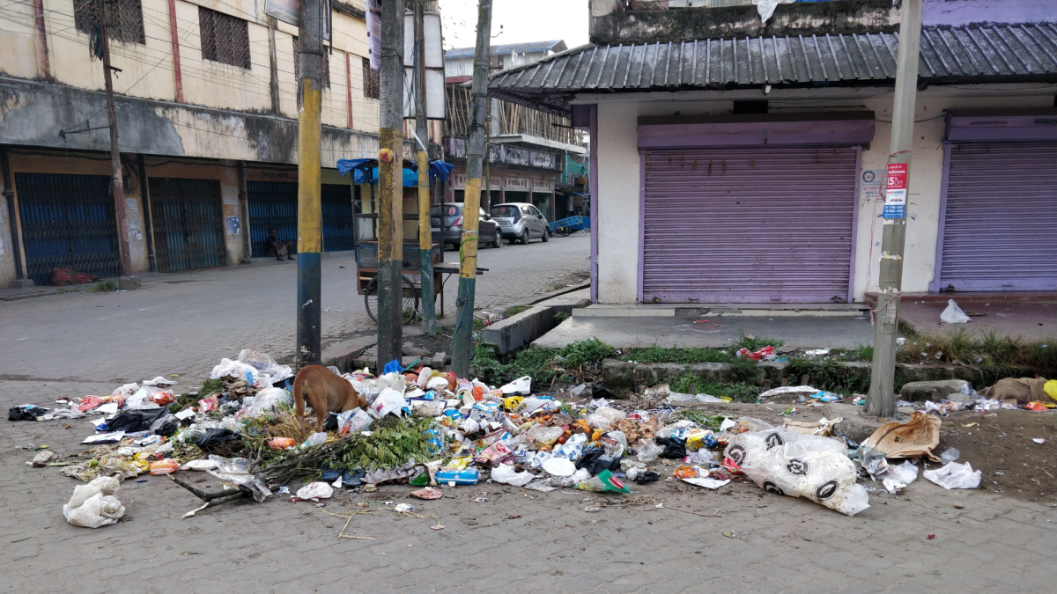Waste Dumps in Tinsukia; Source: EastMojo
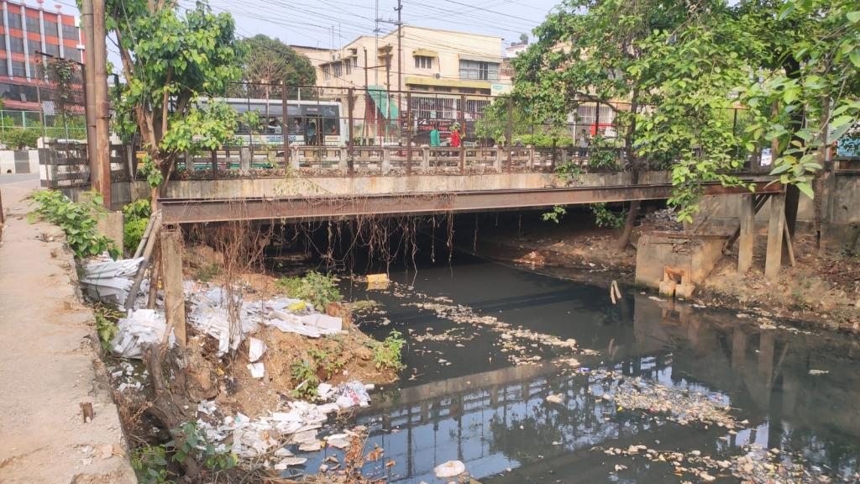Poor domestic wastewater management in Tinsukia; Source: downtoearth.org.in
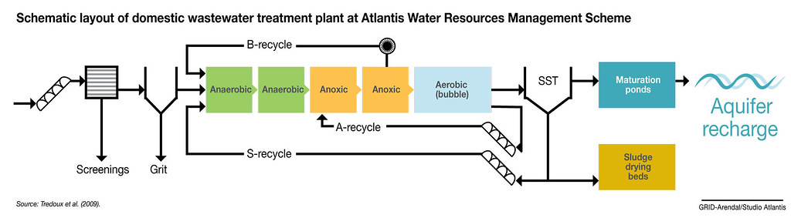Source: www.grida.no

