CPU5005-20 SOFTWARE ENGINEERING
ASSESSMENT 2: VIRTUAL PROJECT
PASSWORD MANAGER PROJECT

Item | Value
Group | CTRL +8
Campus | Manchester Campus
Submission deadline | 8 October 2026
Project type | Software engineering virtual project

Executive Summary
This report integrates the project-management, requirements, architecture, security, QA, DevOps, UI/UX, accessibility and business/compliance contributions produced by Group CTRL +8 for the CPU5005-20 Software Engineering Virtual Project. The product is a lightweight local password manager intended for an individual user. Its core purpose is to allow the user to establish a master password, authenticate, store credential records locally, view them during an authenticated session, delete or edit records, and lock the vault. The project deliberately avoids cloud synchronisation, external databases, browser extensions, mobile builds and biometric hardware so that the implementation remains small, locally controlled and traceable.
The verified implementation supplied to the group is a Node.js command-line application. It creates settings.json and an encrypted user_vault.enc file, performs SHA-256 master-password verification, derives a 256-bit key using PBKDF2 with SHA-256 and 100,000 iterations, encrypts the vault with AES-256-CBC and creates a .bak backup before writes. The supplied QA evidence also identifies defects and gaps, including acceptance of an empty master password, acceptance of blank credential fields, unsafe handling of a corrupted vault and the mismatch between the conceptual Electron/UI target and the verified CLI implementation.
Accordingly, this integrated report distinguishes three states rather than overstating completion: (1) verified current implementation, (2) corrected implementation baseline supplied with this report, and (3) conceptual/target desktop UI architecture. The revised class diagram removes the multi-user User relationship, removes the unsupported PlatformAdapter and Configuration classes, places cryptographic responsibilities in EncryptionService, makes Vault depend on EncryptionService, and requires LocalStorage to provide backup().

Table of Contents
The document follows the assessment structure and is organised as Sections 1–8, followed by appendices. In Microsoft Word, use References → Table of Contents → Update Table after opening if a dynamic TOC is required.
- 1. Project Initiation & Governance
- 2. Requirements Engineering
- 3. System Design & Architecture Specification
- 4. Project Lifecycle & Schedule Management
- 5. Risk Management & Quality Assurance
- 6. Team Collaboration & Version Control
- 7. Individual Contributions and Reflective Analyses
- 8. References
- Appendix

1. Project Initiation & Governance

1.1 Business Case & Project Background
Credential management is a practical security problem because users commonly need to retain many service usernames and passwords while avoiding insecure storage such as unprotected notes or spreadsheets. The business case for CTRL +8 is therefore based on privacy, simplicity and local control. The proposed product keeps the encrypted vault on the user's device and does not introduce a cloud service, remote API or external database.
The project is intentionally an educational prototype rather than a commercial password-management product. The group therefore prioritized a demonstrable core journey over feature breadth: create a master password, authenticate, access the vault, add/view/edit/delete credential records, persist the encrypted vault locally, and lock the session. The project-management material explicitly recommends accurately distinguishing implemented features from proposed features.
The business analysis contribution strengthened this rationale by considering the user and stakeholder perspective. The team identified privacy, simplicity and local control as the main value of a local password manager and compared the project concept with alternatives such as doing nothing, using a commercial cloud manager or using an existing open-source tool. Building the prototype was considered appropriate for the assessment because it provides local control and transparency without license cost, while the main cost is team time. The analysis also highlighted that the tutor/client, university assessment process, project team and end user have different expectations: the tutor needs demonstrable evidence, the team needs clear ownership and integration, the university requires academic integrity, and the end user needs simple private storage.

1.2 Project Objectives and Success Criteria
- Deliver a demonstrable local password-manager prototype with master-password authentication.
- Protect credential data at rest using AES-256 with PBKDF2-derived keys.
- Maintain local persistence using settings.json and an encrypted user_vault.enc file.
- Create an automatic backup before modifying the vault file.
- Provide traceable requirements, architecture decisions, risks, QA evidence and release snapshots.
- Keep cloud synchronisation, browser extensions, mobile applications, external databases and biometric login outside the baseline scope.
- Document the difference between verified implementation and conceptual Electron/UI designs.

1.3 Scope and Boundary Management
The scope decision was also informed by the business and compliance review. The team considered local control against alternatives such as doing nothing, using a commercial cloud password manager or using an existing open-source solution. The local prototype was selected because it demonstrates authentication, encryption and persistence without introducing third-party services, licensing dependencies or unnecessary network attack surfaces. This keeps the educational project boundary clear and testable.
Feature / boundary | Status | Evidence / rationale
Master-password authentication | In scope / verified | SHA-256 hash comparison; PBKDF2 key derivation
Local encrypted vault | In scope / verified | user_vault.enc; AES-256-CBC
Create credential | In scope / verified | Service/URL, username, password
Read credential | In scope / verified | View during authenticated session
Delete credential | In scope / verified | Confirmed delete in corrected baseline
Edit credential | Target / added in corrected baseline | Included because architecture/UI requirements specify CRUD
Automatic backup | In scope / verified | user_vault.enc.bak before write
Electron graphical UI | Target / not verified in supplied code | Conceptual UI evidence only
Cloud sync / external API | Out of scope | No network service
Browser extensions | Out of scope | Not required by the project
Mobile application | Out of scope | Not required
Biometric hardware | Out of scope | Not required
Multi-user accounts | Out of scope | Single local master-password vault
PlatformAdapter / Configuration classes | Removed | Not supported by verified scope

1.4 Team Structure and Responsibilities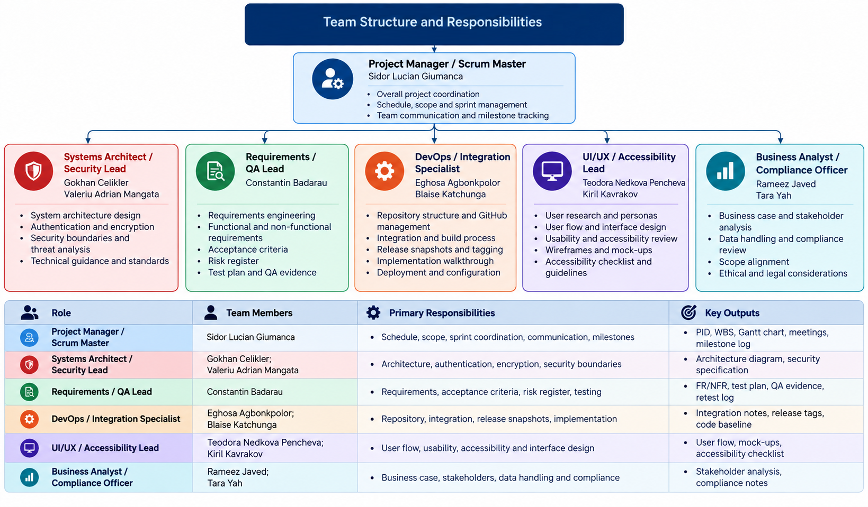

1.5 Governance and Communication
Governance was supported by role-specific handoffs. Architecture and Security defined technical boundaries; Requirements and QA translated them into acceptance criteria and tests; DevOps connected implementation to repository and release evidence; UI/UX translated requirements into interaction and accessibility considerations; and Business Analysis/Compliance reviewed stakeholders, data handling and responsible claims. This structure helped the project operate as one integrated workstream rather than separate documents.
The project uses an Agile/Scrum-style governance model. Microsoft Teams is the primary collaboration space additionally using Whatsapp to increase communication, weekly stand-ups are used for progress and technical decisions, and GitHub is used for version control and release evidence. The Project Manager coordinates workstream dependencies and milestone readiness. Technical decisions are recorded rather than assumed, and the final report is intended to use verified evidence.
Technical governance also depended on communication between specialist roles. The architecture contribution required security decisions such as process separation, secure handling of sensitive data and cryptographic boundaries to be understood by the wider team. The Requirements and QA workstream then translated those decisions into acceptance criteria and verification activities, while UI/UX and business/compliance workstreams checked that the proposed design remained understandable and within scope. This cross-role coordination was important because the project contained a difference between the conceptual Electron desktop target and the verified Node.js CLI implementation.

1.6 Stakeholder Register
Stakeholder | Interest / need | Influence | Engagement
Module tutor / client | Assessment compliance, evidence, demonstrable prototype | High | Tutor-approved communication; review scope and evidence
CTRL +8 team | Clear ownership, timely decisions and integration | High | Weekly stand-ups, shared documents and GitHub
End user | Simple and private credential storage | Medium | Validate core journey against requirements and QA
University / assessment process | Academic integrity, data protection awareness, on-time submission | High | Accurate claims, references and evidence
Project Manager | One controlled final report and accurate status | High | Collect contributions and baseline evidence

2. Requirements Engineering

2.1 Requirements Elicitation and Baseline
The requirements baseline was treated as a living project artefact. Proposed functionality from the design contributions was not automatically treated as implemented functionality. In particular, Edit/Update and the graphical Electron interface required confirmation against the final build. This distinction improved traceability because each requirement could be classified as implemented, proposed, defective or requiring final verification.
Requirements were developed from the assessment brief, tutor-facing constraints, role contributions, architecture analysis and QA review of the supplied implementation. The QA handoff is particularly important because it identifies what is actually present in the current build and what still requires confirmation or correction.
The Requirements and QA review provided a practical baseline rather than relying only on the original design documents. The review asked the team to confirm whether the terminal interface satisfied the tutor's desktop-application expectation and whether editing, password rules and recovery behaviour should be treated as required features or proposals. This helped separate requirements that were already demonstrated from requirements that still needed a decision or final-build evidence. The QA lead also linked requirements to testable acceptance criteria, making it possible to trace authentication, credential management, logout, encrypted storage and safe failure handling into later verification.

2.2 Functional Requirements
The functional baseline centers on the authenticated vault journey: the user establishes or enters the master password, gains access only after successful authentication, performs permitted credential operations and logs out to return to a protected state. Acceptance conditions were used to make these functions testable. Where Edit/Update was described in the UI/UX design, it remained a proposed capability until demonstrated in the final implementation.

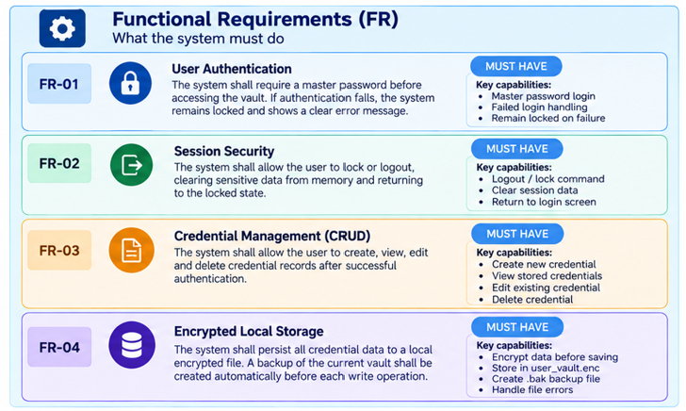

2.3 Non-Functional Requirements
The non-functional requirements were treated as design constraints as well as test considerations. Security covers protection of data at rest and authentication boundaries; usability covers understandable interaction and accessibility; and portability concerns reliable operation across the intended desktop environments. These requirements help evaluate whether a technically working feature is also acceptable from a user and deployment perspective.

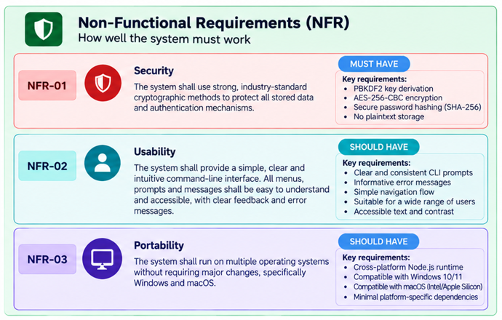

2.4 MoSCoW Prioritisation and Traceability
The traceability approach was also informed by the architecture and security work. Authentication, session locking, encrypted persistence and the specified cryptographic controls were treated as essential requirements, while edit functionality was retained as a lower-priority item until its implementation status was confirmed. Verification methods included functional tests, file inspection, security review and cross-platform verification. This created a link between business intent, requirements, architectural components and evidence rather than treating the requirements list as a standalone document.
User stories from the UI/UX work provide an additional requirements perspective. The proposed stories cover login, viewing credentials, adding, editing and deleting credentials, and logout. Their acceptance criteria focus on visible controls, understandable feedback, validation and safe completion. This gives traceability from business need to system function and then to user interaction.

Requirement | Business/security intent | Architecture mapping | Verification | Priority
FR-01 | Master password | Settings + login | Authentication test | Must
FR-02 | Credential CRUD | Vault / Credential | Add + view tests | Must
FR-03 | Delete | Vault | Delete test | Must
FR-04 | Encrypted persistence | Vault + LocalStorage + EncryptionService | File inspection | Must
FR-05 | Lock/logout | SessionManager | Logout test | Must
FR-06 | Edit | Credential / MainController | Edit test | Should
FR-07 | Backup | LocalStorage | Backup inspection | Must
NFR-01 | AES-256/PBKDF2 | EncryptionService | Security review | Must
NFR-05 | Safe failure | Vault.load / save | Corrupt-vault test | Must

3. System Design & Architecture Specification

3.1 Architectural Style and Technology
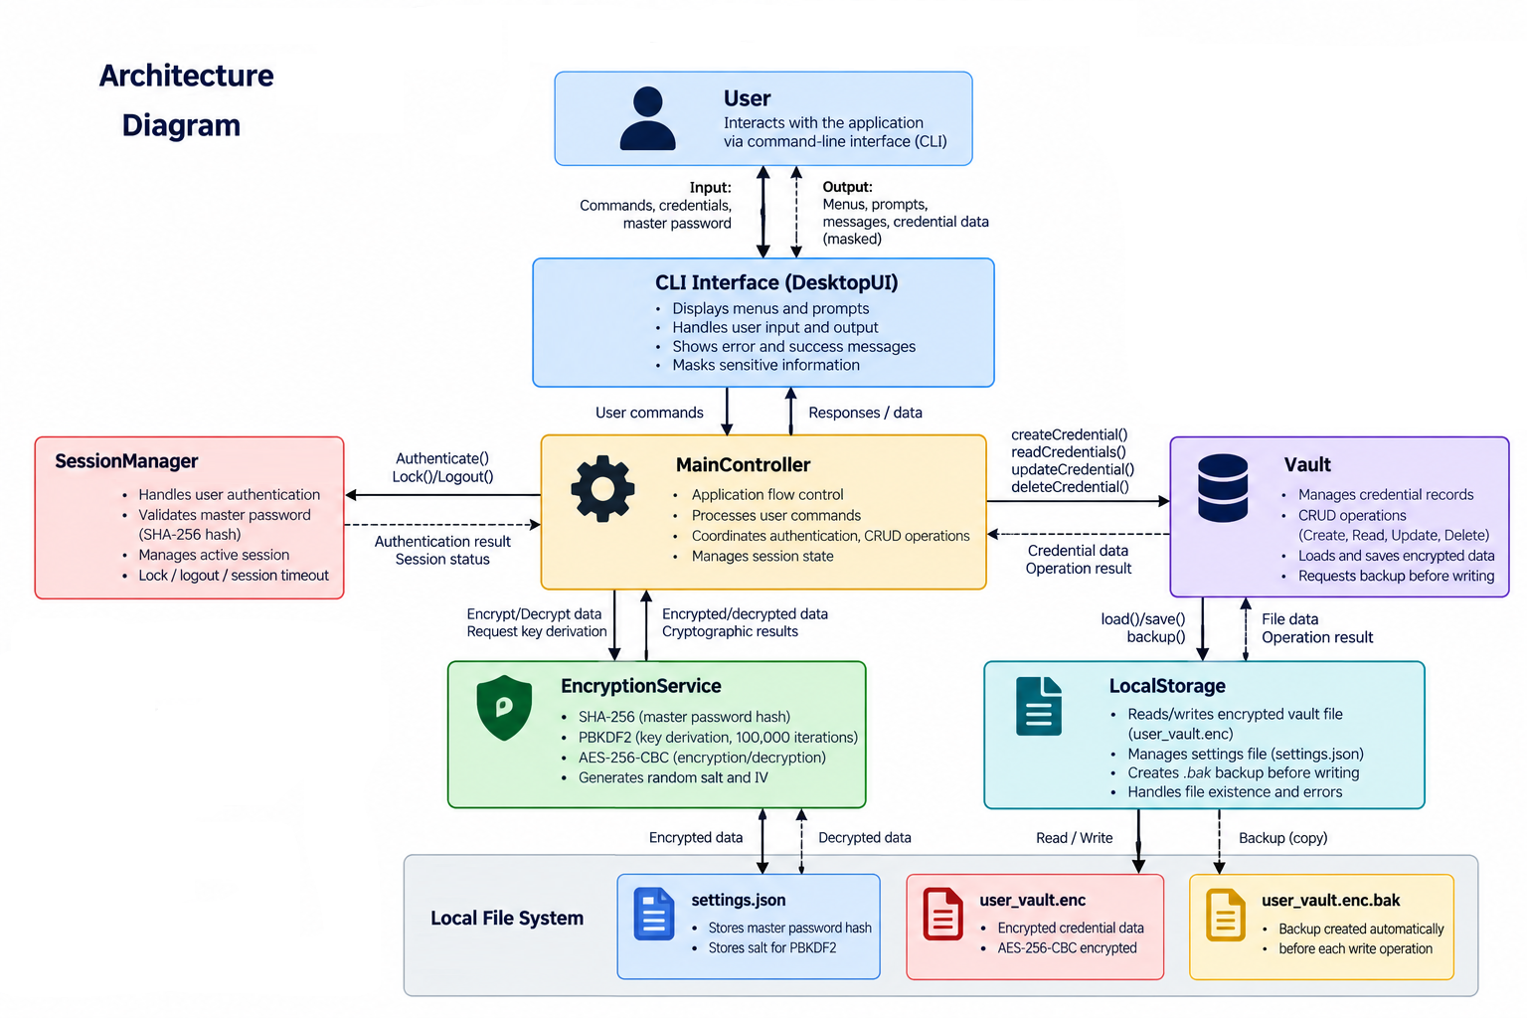
The supplied individual architecture contributions describe a three-tier Electron/Node.js target: an Electron presentation layer, a Node.js application layer containing IPC and cryptographic processing, and a local data tier containing user_vault.enc. The verified implementation supplied for this integrated report is a Node.js command-line baseline. Therefore, the report does not claim that Electron is already implemented. The conceptual Electron design remains a valid target architecture if the group completes and tests that interface.

3.2 Single-User Vault Model
The original class diagram modelled a User class with an id and a userID on Vault. This implies multiple accounts, which is inconsistent with the stated product model. The corrected design treats the application as a single local master-password vault. There is no User entity and no userID foreign key. The master password is an application-level credential protecting the local vault rather than an account-management system.

3.3 Class Responsibilities

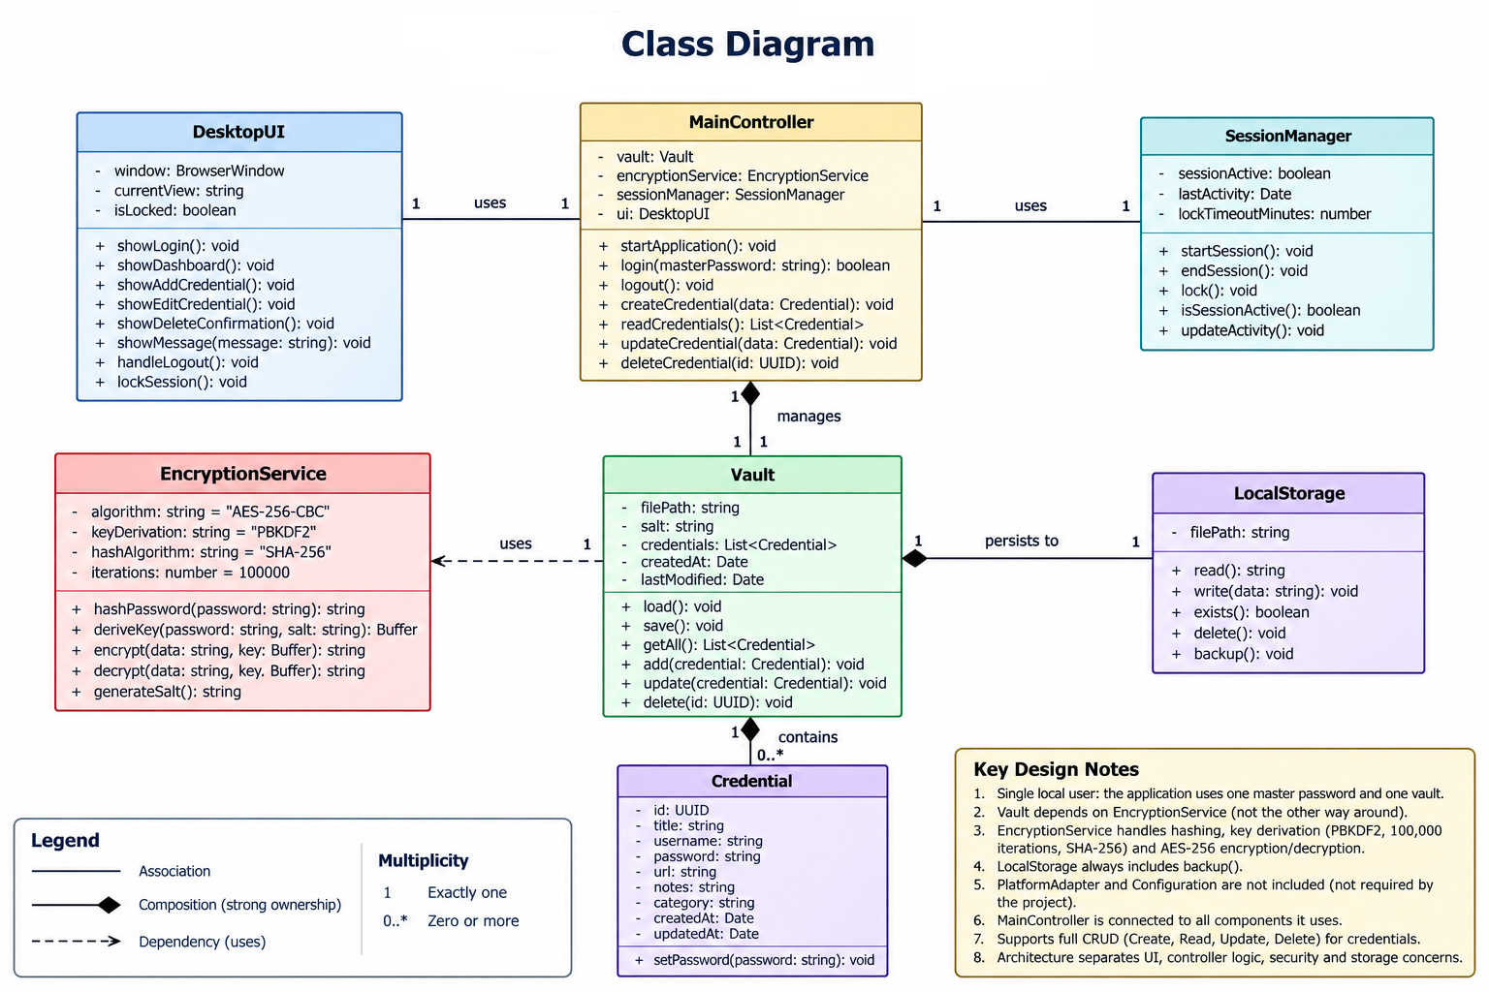
Figure 3.1 – Revised class diagram incorporating the teacher's corrections.

3.4 Client Feedback Resolution Matrix
Teacher issue | Original | Correction | Reason
1. Dependency arrow | EncryptionService → Vault | Vault → EncryptionService | Vault uses the service for cryptographic operations.
2. Duplicated security responsibilities | Vault had encrypt/decrypt/salt/iterations | Moved to EncryptionService | Separation of security and storage concerns.
3. Unsupported PlatformAdapter | PlatformAdapter + Configuration | Removed from baseline | No requirement or verified implementation requires these classes.
4. MainController connections | Mentions dependencies without full relationships | Explicit relationships to Vault, UI, EncryptionService and SessionManager | Controller now has visible architectural dependencies.
5. SHA-256 / 100,000 iterations | Not clearly represented | EncryptionService includes PBKDF2-SHA256 and 100,000 iterations | Matches supplied code and security contributions.
6. LocalStorage backup | Missing | backup() added | Matches the implementation's pre-write backup.
7. Multiple users | User + userID relationship | Single local vault; no User class | Matches master-password model and supplied code.

3.5 Security and Cryptographic Model
The supplied code uses SHA-256 to produce a hexadecimal master-password hash for local verification. PBKDF2 then derives a 32-byte key from the entered password and the stored salt, using SHA-256 as the PRF and 100,000 iterations. The derived key is used with AES-256-CBC to encrypt and decrypt the JSON vault payload. Each encryption operation generates a fresh 16-byte IV. The encrypted object stored on disk therefore contains the IV and ciphertext rather than the plaintext credential list.
The architecture contributions also considered session security as part of the cryptographic boundary. The intended design is that the derived key is available only during an authenticated session and that logout removes active references to sensitive session material. Temporary staging and atomic replacement were proposed to reduce the chance of exposing plaintext or leaving a partially written vault after an interruption. The DevOps walkthrough confirms the practical lifecycle of initialise, authenticate, derive a session key, load and decrypt the vault, perform an operation, create a backup, encrypt and write the vault, and finally log out.
- Master-password verification: SHA-256 hash comparison.
- Key derivation: PBKDF2-SHA256, 100,000 iterations, 32-byte output.
- Salt: generated during initial setup and stored with settings.
- Vault encryption: AES-256-CBC with a fresh 16-byte IV per write.
- Persistence: encrypted JSON payload in user_vault.enc.
- Backup: user_vault.enc.bak is created before a write.
- Session: the derived key is held only while the authenticated session is active.
Security limitation: AES-256-CBC provides confidentiality but does not itself provide authenticated integrity. The supplied DevOps/security material therefore treats authenticated encryption or a separate MAC as future hardening, rather than claiming the academic prototype is production-ready. Similarly, the supplied compliance review notes that fast SHA-256 password hashing is not an ideal modern password-storage construction; this report retains SHA-256 because it is part of the agreed assignment architecture, while recording stronger password-hardening as future work.

3.6 Storage and Failure Handling
The corrected implementation changes a critical QA behaviour: a failed vault load is no longer converted into an empty list. If the encrypted file is missing, malformed or cannot be decrypted, the session refuses to continue with write operations. This prevents a damaged vault from being overwritten by a newly created empty or partial vault. Before any successful write, the existing encrypted vault is copied to a .bak file, and the corrected code writes a temporary encrypted file before replacing the active vault.

3.7 UI/UX, User Personas and Accessibility Design
The UI/UX contribution translated the functional requirements into a user-centred interaction model. Two personas were defined to represent different needs. Sarah, aged 34 with average technical ability, needs a simple login, clear dashboard, readable text, familiar terminology and obvious credential controls. David, aged 48 with intermediate technical ability, relies more heavily on keyboard navigation and therefore needs logical focus order, visible focus indicators, descriptive labels and predictable structure. These personas helped the team consider usability as a design requirement rather than treating the interface as decoration.
The proposed workflow begins with a clearly labelled master-password login and understandable failure feedback. After successful authentication, the credential dashboard provides View, Add, Edit, Delete and Logout actions. The design emphasizes persistent form labels, readable typography, sufficient contrast, logical keyboard navigation, visible focus states and error messages that avoid unnecessary technical terminology. Delete actions should include confirmation to reduce accidental data loss. The UI/UX work also included conceptual mock-ups, user stories and acceptance criteria; these remain design evidence and must be labelled as conceptual unless the corresponding graphical implementation is built and tested.
The personas provide a practical rationale for these choices. Sarah represents an average technical user who prioritizes simplicity and familiar terminology, while David represents an intermediate user who relies more heavily on keyboard navigation. These personas support minimal interface clutter, persistent labels, predictable navigation and visible focus. The UI/UX contribution also specifies confirmation for destructive actions and clear, non-technical error feedback. The graphical mock-ups remain conceptual unless the corresponding interface is verified in the final implementation.

4. Project Lifecycle & Schedule Management

4.1 Agile Scrum Framework
The project follows an Agile Scrum-style lifecycle with short development cycles, weekly stand-ups and milestone reviews. The architecture and security baseline is established before integration, QA evidence is reviewed before final documentation, and baseline snapshots are retained in version control.
The lifecycle also benefited from role-specific handoffs. Architecture and security decisions informed the implementation baseline; QA then checked the actual runtime rather than assuming the design had been implemented; DevOps connected the working source and repository evidence; and UI/UX and business/compliance contributions were integrated into the documentation. This made milestone readiness dependent on evidence from several workstreams instead of a single status update.

4.2 Work Breakdown Structure
WBS | Package | Outputs | Owner
1.0 | Initiation & Governance | PID, business case, scope, roles, communication plan | Project Manager
2.0 | Requirements & QA | FR/NFR, acceptance criteria, risk register, test evidence | Requirements/QA
3.0 | Architecture & Security | Class diagram, security model, encryption/storage design | Architecture/Security
4.0 | Implementation & Integration | Working code, integration notes, release baseline | DevOps + technical leads
5.0 | UX, Accessibility & Compliance | User flow, accessibility review, stakeholder/data handling | UI/UX + Business
6.0 | Final Verification | Retest, evidence checklist, report integration | All leads + PM
The WBS provides a dependency structure rather than only a task list. Initiation establishes governance and scope; requirements and QA define what must be demonstrated; architecture and implementation establish the technical baseline; UX, compliance and documentation provide supporting evidence; and final verification confirms that the integrated report and software claims are supported. This sequencing makes dependencies visible when one workstream is delayed.

4.3 Milestones
ID | Target | Phase | Primary output
MS-01 | 11 Sep 2026 | Initiation | PID, role allocation and communication baseline
MS-02 | 18 Sep 2026 | Architecture baseline | Requirements and architecture/security sign-off
MS-03 | 27 Sep 2026 | Beta / integration | Integrated application, QA evidence and repository snapshot
MS-04 | 8 Oct 2026 | Final review | Verified documentation and evidence
MS-05 | 8 Oct 2026 | Submission | Final report and submission evidence

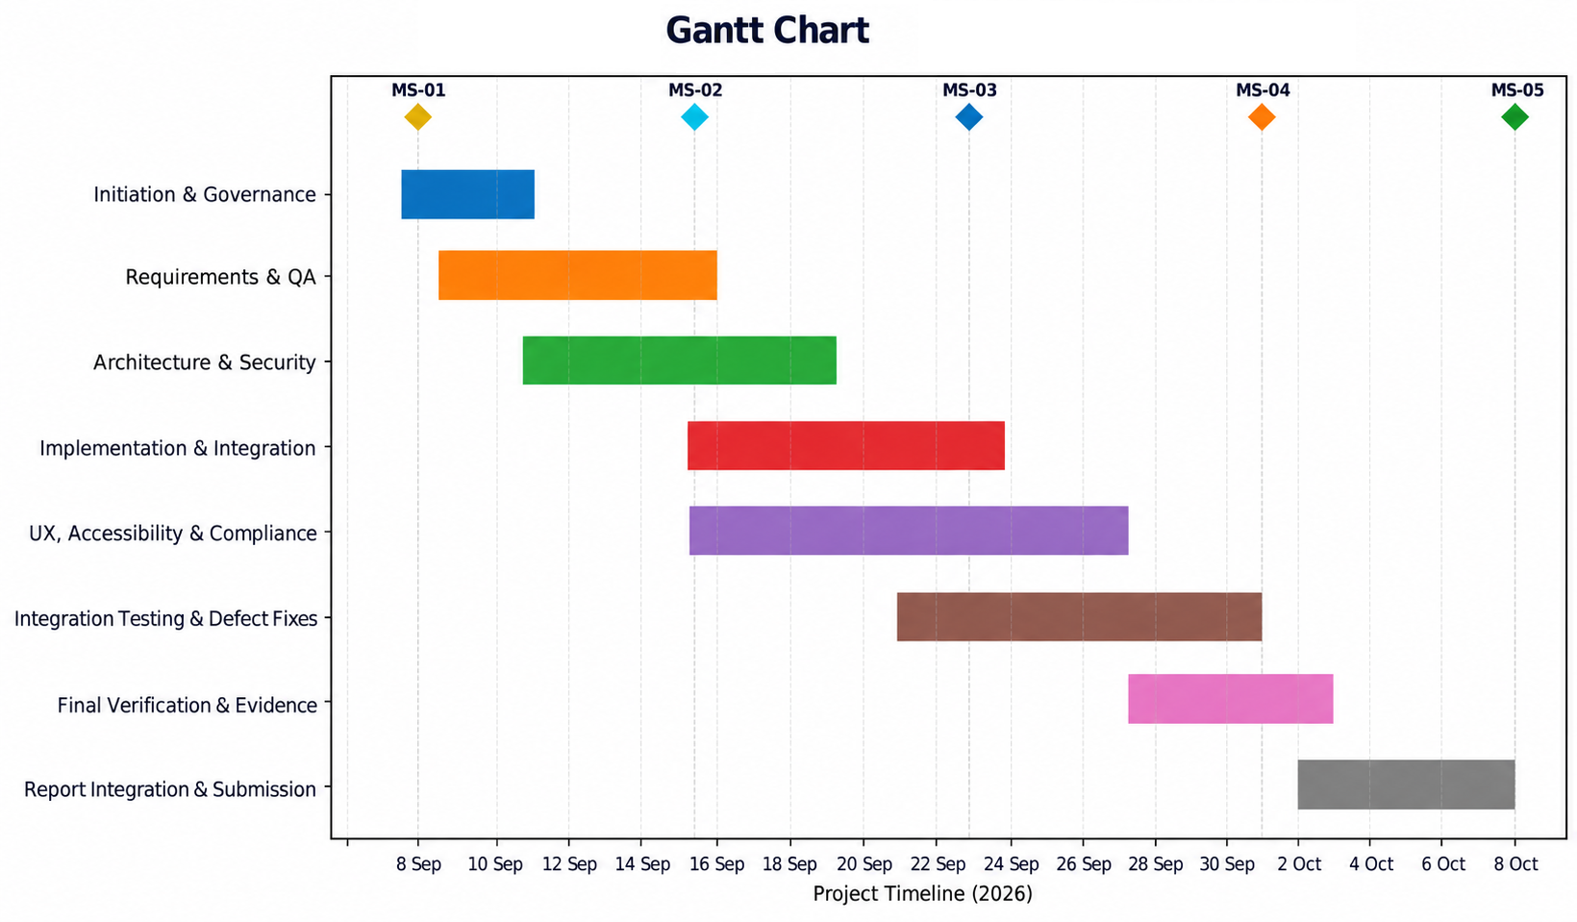

Schedule basis: the chart visualises the project work packages and milestone dates in the supplied project materials. Task windows are presented as planning windows for the corresponding work packages; the milestone dates are the stated MS-01 to MS-05 targets.
The schedule was also used as a readiness mechanism. MS-01 established the project baseline, MS-02 represented the architecture and security baseline, MS-03 represented beta/integration readiness, MS-04 focused on final review and evidence, and MS-05 represented submission. The later 8 October meeting is retained in the collaboration log as a final closure/follow-up point rather than an original milestone in the earlier baseline.

4.4 Baseline and Change Control
The group uses version-control snapshots such as v0.1-initiation, v0.2-alpha and v1.0-final as baseline references. Changes that affect security, scope or requirements should be discussed by the relevant lead and recorded before the final report claims the feature is complete. This is particularly important for the Electron interface and Update/Edit feature, which were present in design documents but were not present in the originally supplied CLI.

5. Risk Management & Quality Assurance

5.1 Risk Management Strategy
The risk process was strengthened by the QA and DevOps reviews. High-priority technical risks included replacing a damaged vault after a load failure, accepting an empty master password, accepting blank credential fields and claiming a graphical Electron implementation without evidence. DevOps also identified the absence of authenticated encryption, limited backup retention, lack of automated tests for critical sequencing and terminal password-visibility concerns as hardening items. These risks were treated as issues requiring evidence and decisions rather than being presented as already resolved.
The risk review combined technical, process and assessment risks. Technical risks included vault corruption, weak or empty passwords, invalid credential fields and limitations in encryption integrity. Process risks included missing evidence, delayed document contributions and mismatch between proposed design and verified implementation. Responses therefore included code changes as well as escalation, evidence checkpoints, backups, release snapshots, retesting and explicit reporting of unresolved limitations.

ID | Risk | Probability / impact | Mitigation | Owner
R-01 | Vault data loss after load failure | Low / High | Block writes after load/decrypt/parse failure; retain backup; retest | Architecture + DevOps + QA
R-02 | Blank/weak master password | Medium / High | Validate setup input; enforce minimum acceptance rule | Security + QA
R-03 | Blank credential fields | Medium / Medium | Reject empty required fields and test whitespace input | Development + QA
R-04 | Encryption lacks authenticated integrity | Medium / Medium | Document limitation; consider AEAD/MAC as future hardening | Security + DevOps
R-05 | Electron/UI mismatch | High / High | Do not claim graphical implementation until built and tested; agree scope | PM + Architecture + QA
R-06 | Missing final evidence | Medium / Medium | Release checklist, dated tests, screenshots and GitHub evidence | PM + DevOps + QA
R-07 | Scope creep | Medium / High | Use PID boundaries and sprint review decisions | PM + all leads

5.2 QA Verification
Test | Area | Expected / observed | Status
T01 | First-launch files | settings.json and user_vault.enc created | Pass / evidence supplied
T02 | Authentication | Correct password opens menu; wrong password denied | Pass
T03 | Add / view / encryption | Credential can be added/viewed; plaintext not found in encrypted vault | Pass in isolated test
T04 | Backup | .bak file created before write | Pass
T05 | Empty master password | Empty password accepted during setup | Fail – corrected baseline adds validation
T06 | Blank credential fields | Blank service/username/password accepted | Fail – corrected baseline adds validation
T07 | Corrupt vault | Load error followed by possible Add/write | Fail – corrected baseline blocks writes
T08 | Delete | Delete flow | Requires final-build evidence
T09 | Cross-session persistence | Saved entries survive relaunch | Requires final-build evidence

5.3 QA Acceptance Criteria
- A blank master password is rejected at setup.
- Blank or whitespace-only credential fields are rejected.
- A wrong master password never opens the vault.
- A corrupted or undecryptable vault cannot be replaced through a normal add operation.
- A backup is produced before every vault write.
- Credential passwords are not displayed in plaintext in list output.
- Create, read, update and delete operations are demonstrated if Update is included in the final baseline.
- The final build is retested from the final commit, with dated evidence and fictional credentials only.
The QA handoff specified that final verification should be repeated against the team's final commit, with dated screenshots or logs, expected-versus-actual results and retesting after fixes. Delete and cross-session persistence also require evidence from the final build. This approach supports reproducibility and prevents isolated test results from being presented as proof of the final release state.

6. Team Collaboration & Version Control

6.1 Collaboration
The team used Microsoft Teams/Whataspp for asynchronous communication and weekly Agile stand-ups for progress discussions. The paired workstreams were expected to coordinate their internal division of labour while keeping the Project Manager informed of dependencies, risks and milestone readiness.
In practice, collaboration also included smaller discussions between individual members when a task required clarification or support. The Project Manager worked directly with members including Rameez, Constantin and Eghosa and helped Rameez progress his assigned work. When document contributions became difficult to obtain and communication began affecting the schedule, the issue was escalated to the teacher so that the project would not fall behind. Communication improved after the issue was raised. The Project Manager also supported the improvement of the report diagrams, including the architecture, class, requirements, user-flow and Gantt presentations, so that the visual evidence was consistent with the written report.

6.2 Integration Baseline
The supplied DevOps walkthrough describes a self-contained Node.js CLI with no network API, database or external service. The corrected code included with this report extends that baseline with Update, input validation, safe vault-load failure handling, masked password display in the credential list, backup-before-write and temporary-file replacement. It remains a local academic prototype and should be tested before being described as a release.
The DevOps contribution also defined the evidence expected around the repository and integration boundary: source and configuration, code walkthroughs, dependency/runtime notes, test logs linked to a commit or tag, release snapshots when actually created, and versioned documentation. The runtime lifecycle was documented from initialisation through authentication, key derivation, vault loading, credential operations, backup and encrypted persistence to logout. This helped connect the implementation to the wider QA and release process.

7. Individual Contributions

8. References
- National Cyber Security Centre NCSC,2024) Password manager buyers guide,NCSC Password Manager Buyers Guide .
- Baskar, K., Muthumanickam, K., Vijayalakshmi, P. and Kumarganesh, S. (2025) ‘A strong password manager using multiple encryption techniques’, Journal of The Institution of Engineers (India): Series B, 106(4), pp.1207-1214.Electronjs (2026) Context Isolation, Context Isolation | Electron
- OWASP (2025) Password Storage Cheat Sheet. OWASP Cheat Sheet Series. OWASP Password Storage Cheat Sheet
- OWASP (2025) Cryptographic Storage Cheat Sheet. OWASP Cheat Sheet Series. Available at: OWASP Cryptographic Storage Cheat Sheet
- National Institute of Standards and Technology,2023, Advanced Encryption Standard (AES). FIPS 197-upd1, NIST FIPS 197 – Advanced Encryption Standard
- National Institute of Standards and Technology ,2025, Digital Identity Guidelines: Authentication and Authenticator Management,NIST SP 800-63B-4
- Node.js (2026) Crypto documentation. Node.js Documentation,Node.js Crypto Documentation
- World Wide Web Consortium, 2023, Web Content Accessibility Guidelines (WCAG), W3C WCAG 2.2
- Schwaber, K. and Sutherland, J.,2020, The Scrum Guide: The Definitive Guide to Scrum: The Rules of the Game, The Scrum Guide
- International Organization for Standardization,2023, Systems and software Quality Requirements and Evaluation (SQuaRE) — Product quality model, ISO/IEC 25010:2023
- National Cyber Security Centre,2024, Securing your users’ accounts, NCSC – Securing your users' accounts

Appendix

User Flow and Accessibility
Ta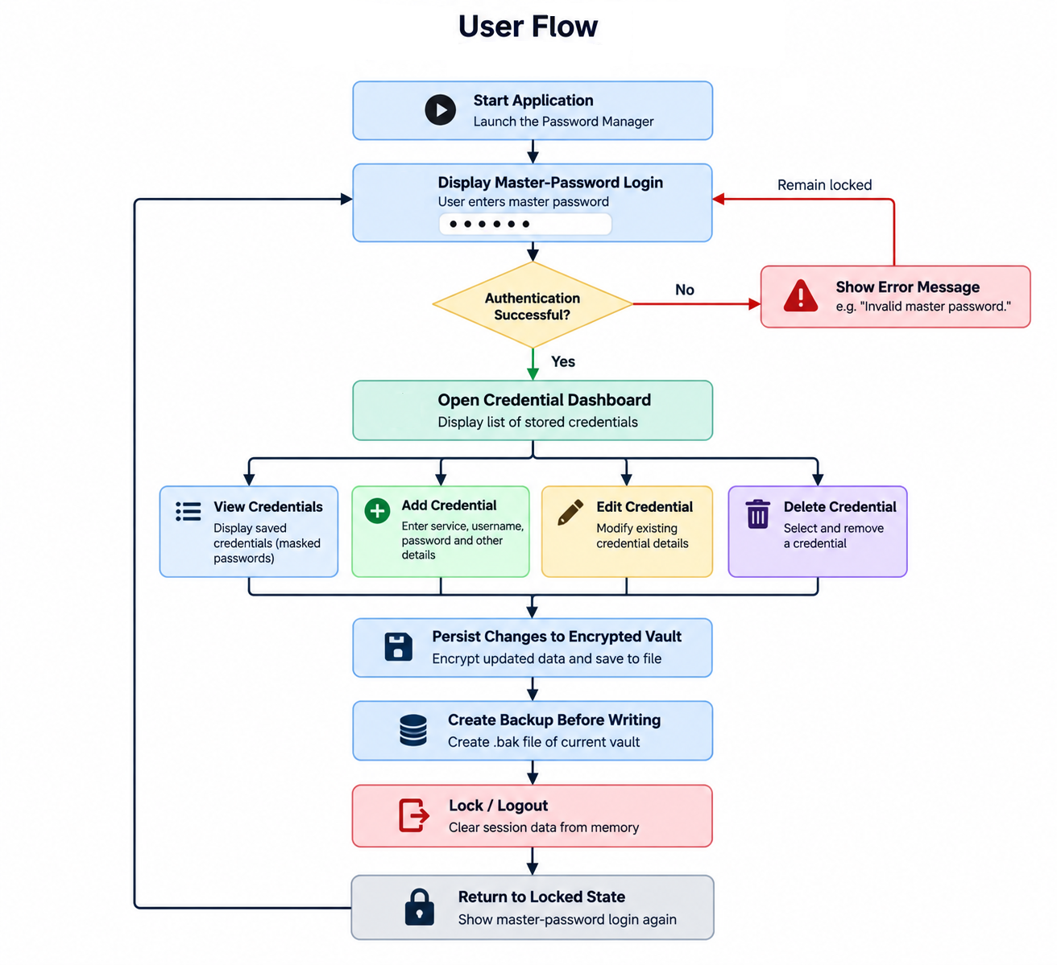

Weekly Meetings/ Discussions:
6 September 2026: Project initiation and scope – Discussed the password-manager concept, assessment requirements, project objectives and initial division of responsibilities. Agreed on the local password-manager concept and began allocating team roles.
10 September 2026: Project scope and boundaries – Discussed the main features, local encrypted storage, authentication, security requirements and features outside the project scope. Agreed on the initial project boundaries and priorities.
13 September 2026: Project planning and baseline – Reviewed the PID, WBS, team responsibilities, communication approach and project milestones. Confirmed the initial project plan and allocation of responsibilities.
17 September 2026: Requirements engineering – Discussed functional and non-functional requirements, acceptance criteria and the main user needs. Agreed on the core requirements to be taken forward into design and development.
17 September 2026: Architecture and security – Discussed the system architecture, authentication, password hashing, PBKDF2 key derivation, AES-256 encryption and local vault storage. Reviewed and agreed the main architecture and security approach.
20 September 2026: Implementation progress – Reviewed development progress, vault functionality, credential management, authentication and session handling. Identified implementation issues and agreed actions for continued development.
24 September 2026: Beta and integration review – Reviewed the integrated application, repository progress, encrypted storage and initial QA evidence. Discussed remaining integration issues and preparation for further testing.
27 September 2026: Testing and defect review – Discussed QA results, identified defects, validation issues, accessibility considerations and the user flow. Prioritised fixes and agreed the remaining testing activities.
1 October 2026: Final review – Reviewed the application baseline, requirements, architecture and class diagrams, QA evidence, risk register and report progress. Identified final corrections and missing evidence.
4 October 2026: Submission preparation – Reviewed the final report, appendices, diagrams, individual contributions, references and supporting evidence. Agreed final proofreading and submission-preparation actions.
7 October 2026: Submission preparation – Reviewed and updating diagrams, references and supporting evidence.
8 October 2026: Final project closure – Reviewed the final project artefacts, supporting evidence, report version and outstanding actions. Confirmed final project completion and submission arrangements.

