Peer Tutoring Sheet

COURSE NAME: Database Systems
TUTOR NAME: Sidra Babar
TUTOR STUDENT ID: S2023105007
DATE OF CLASS: 24/04/2025, 15/05/2025,29/05/2025, 5/06/2025, 26/05/2025
LECTURE #: 3,4, 5,6,7,8

Name of Tutee | Student ID of Tutee
Fatima Zaman | S2023065109@umt.edu.pk
Noor ul Huda | S2023105078@umt.edu.pk

Note: No one attends the remaining lectures.
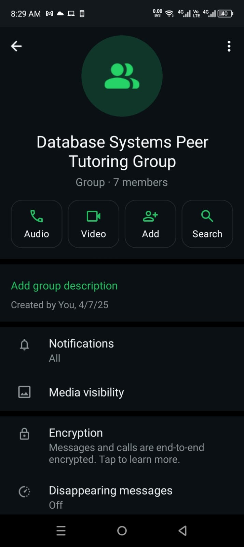
Emails:
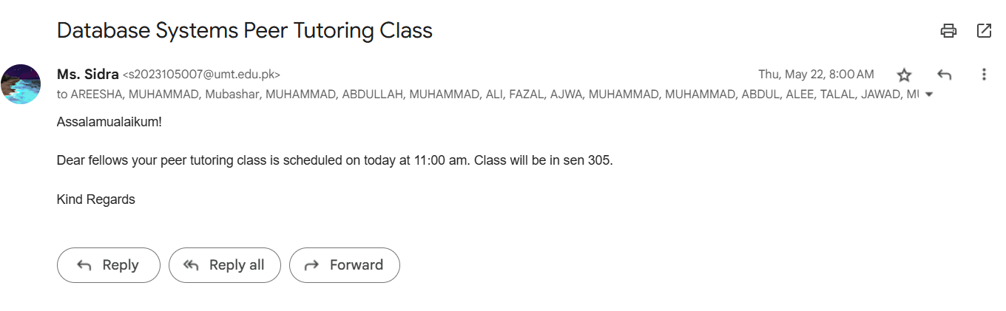
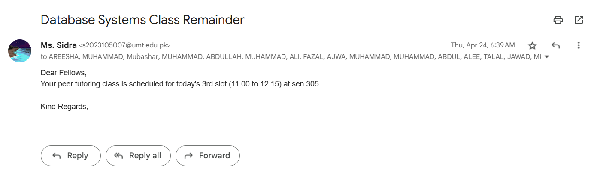
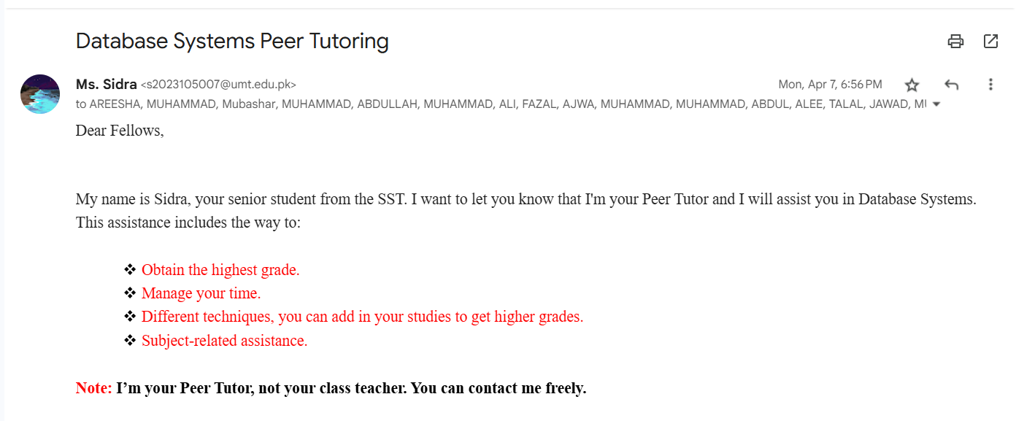

Note: All classes were held on the same fixed day and time, so students attended without needing an email reminder.

