RiyalPay Activation & KYC Experiment
Recommendation for Product Leadership
Prepared for: VP of Product | Prepared by: Product Analytics
RECOMMENDATION: Conditional go.
Ship the streamlined KYC flow to iOS now. Hold Android until the assignment bug is fixed and re-tested. In parallel, prioritize the signup→KYC-start step — it is the single biggest leak in the funnel, larger than anything the KYC experiment touches.

The Situation
Signups are healthy, but too few of those signups turn into real usage. Of every 100 people who finish creating an account, only 48 ever complete a transaction. We were also asked to validate the streamlined KYC experiment before it rolls out further, since the early dashboard numbers looked like an unambiguous win.

Where Activation Is Actually Leaking
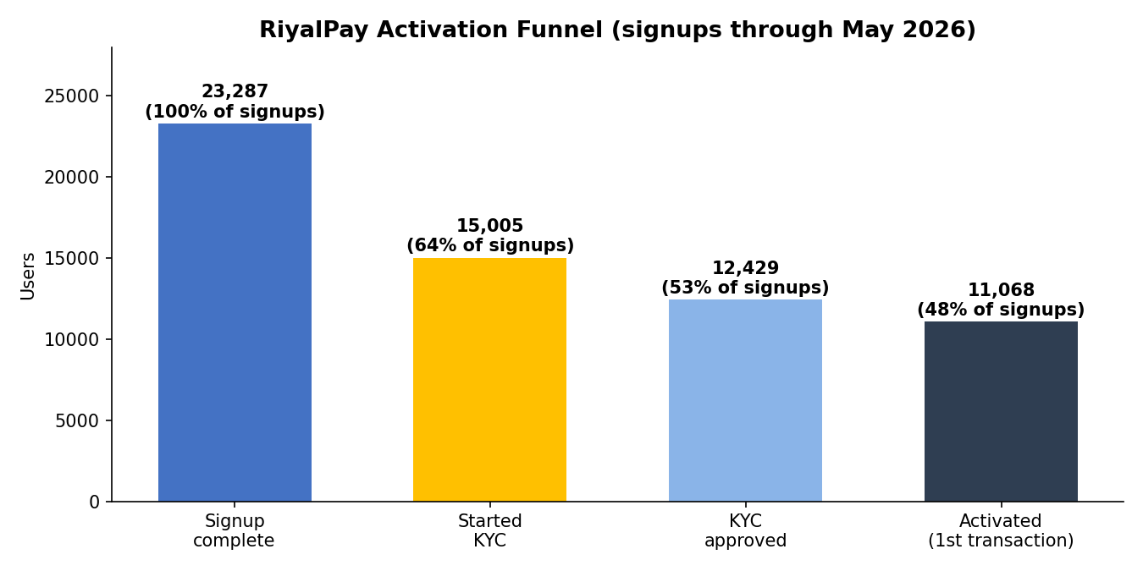
The single biggest drop is not KYC — it's earlier. 36% of users who finish signup never even start KYC. That is a bigger loss than KYC rejections, and bigger than anything the current experiment touches. Once someone starts KYC, the process itself works reasonably well: 83% get approved, and 89% of approved users go on to transact.
- Biggest lever: get more signed-up users to start KYC at all. This deserves its own investigation — is it a UI/motivation problem, a timing problem, or users not understanding why KYC is required?
- Smaller, real lever: the KYC completion step itself, which the current experiment addresses (below).
- Not a major lever: acquisition channel — activation rate is roughly flat across channels (47–49%), so channel mix isn't where the leak is.
Scope: figures cover users who signed up through May 2026, so every user had at least six weeks to transact (June signups are too recent to judge). About 1.4% of users have KYC and transaction activity but no recorded signup events, a tracking gap; they are counted as signed up.

The KYC Experiment: What We Can and Can't Trust
The streamlined KYC flow was tested on both iOS and Android. The Android results cannot be trusted — the assignment system had a bug that skewed who got the new flow vs. the old one on Android (roughly 62% control / 38% treatment instead of the intended 50/50). This isn't a subtle statistical nuance; it means the two Android groups weren't comparable to begin with, so any difference between them could be caused by the imbalance itself rather than the new flow. The iOS assignment passed our balance check, narrowly (p = 0.011), and iOS is what this recommendation is based on.
Metric (iOS only) | Control | Treatment | Lift
KYC approval rate | 54.6% | 63.7% | +9.1 pts
Activation rate | 53.3% | 61.8% | +8.5 pts

Both results are statistically significant (not due to chance) and hold up under a formal power check — we had enough iOS users in the test to trust a lift this size. We also checked whether the improvement faded over the 6-week test. Treatment stayed ahead of control in every week. The gap was narrower in the last two weeks (about 5.5 points versus about 13 in weeks 2–4), but with roughly 200 users per arm per week that difference could be noise (p ≈ 0.08), so we recommend monitoring after rollout.

Recommendation
- Ship the streamlined KYC flow to 100% of iOS users now. The result is real and meaningful; confirm that it holds after rollout.
- Do not extend it to Android yet. Fix the assignment bug first, then re-run a short confirmation test on Android before rolling out there.
- Open a separate workstream on the signup→KYC-start drop-off. It's the largest single leak in the funnel and isn't addressed by this experiment at all — likely the highest-ROI next investigation for the activation goal overall.

What We'd Want Before Going Further
- Engineering fix + re-test for the Android assignment bug (est. 1 sprint + a 2-week confirmation test).
- An engineering check on why about 1.4% of users have no signup events recorded, so the top of the funnel can be measured directly.
- A qualitative/UX look at why 36% of users stop right at the KYC entry point — this analysis can tell you it's the biggest gap, but not why.
- An extended monitoring window on iOS post-rollout, to confirm the lift holds beyond the 6-week test window.
Full methodology, data-quality checks, and the underlying SQL/Python analysis are available on request for anyone who wants to audit the numbers.

