Quality Over Correctness: Measuring the Maintainability and Error Risk of LLM-Generated and Human-Generated Code

Aaila Sohail ¹
Department of Software Engineering Military College of Signals Islamabad, Pakistan asohail.bse22mcs@student.nust.edu.pk

Ayela Noor Arshad ²
Department of Software Engineering Military College of Signals Islamabad, Pakistan
aarshad.bse22mcs@student.nust.edu.pk

Nazia Bibi ⁴
Department of Software Engineering Military College of Signals Islamabad, Pakistan nazia.bibi@mcs.nust.edu.pk

Sidra Kayenat ³
Department of Software Engineering Military College of Signals Islamabad, Pakistan
skayenat.bse22mcs@student.nust.edu.pk

Abstract—Large Language Models (LLMs) are increasingly used to generate code in software development. While most evaluations focus on correctness—whether code compiles or passes test cases—this functionality-first approach overlooks po- tential differences in code quality, structure, and style compared to human-written code. This study investigates whether AI- generated code can be systematically distinguished from human code using machine learning models trained on structural, behavioral, and stylistic features. We analyze attributes such as readability, complexity, performance, and keyword usage to classify code origin and uncover patterns unique to LLM- generated outputs. Our findings highlight measurable differences between AI and human code, raising important implications for code review, trust, and integration of LLMs in real-world development workflows.
Index Terms—Artificial Intelligence, Code Analysis, Code Quality, Human vs AI, Large Language Models, Machine Learn- ing, Software Development, Software Maintainability

- Introduction
Large Language Models (LLMs) have demonstrated re- markable potential in automating various software engineering tasks, including code generation, bug fixing, and program synthesis. Recent studies, such as [1]–[5], have evaluated LLM-generated code, highlighting important insights into its capabilities and limitations. Specifically, Idrisov and Schlippe
[1] explored generative AI applications in code generation; Tosi [2] conducted a quality assessment of AI-generated code from different engines; Nascimento et al. [3] compared AI and human developers based on non-functional requirements; Zhang et al. [4] investigated structural and functional differ- ences; and Li et al. [5] analyzed stylistic inconsistencies in AI-generated code.
Despite these efforts, several issues remain: limited use of machine learning models for systematic distinction between AI and human code, narrow focus on either performance or
style without combined analysis, lack of predictive models for assessing maintainability and error-proneness, and insufficient exploration of trust, quality, and security implications based on measurable features.
To address these gaps, we propose a machine learning- based approach that systematically evaluates both structural and performance characteristics of AI-generated and human- written code. Our research aims to move beyond functionality- first evaluations and contribute towards holistic code quality assessment.
Our key contributions are:
- We build machine learning models that differentiate AI- generated and human-written code based on structural and behavioral features.
- We introduce a predictive framework for assessing error- proneness and maintainability risks in code.
- We provide empirical evidence of distinct patterns in AI and human code, informing practices for software review, integration, and authorship validation.
The remainder of this paper is organized as follows: Section II presents the background and existing literature. Section III outlines the research problem and questions. Section IV de- scribes the methodology, including data collection and model design. Section V reports results and analysis. Section VI discusses the findings and their implications. Section VII concludes the paper with directions for future work.
- Problem Statement
Large Language Models (LLMs) such as GPT and DeepSeek have shown impressive capabilities in generating code for a wide range of software engineering tasks. How- ever, the majority of existing evaluations focus primarily on functional correctness—whether the code compiles and passes predefined test cases. This has led to a prevailing assumption

that AI-generated code is equivalent to human-written code in terms of quality, structure, and maintainability.
Such a performance-first evaluation approach overlooks important dimensions such as code readability, maintainability, security, and stylistic consistency. Human developers typically produce code that reflects thoughtful naming conventions, thorough documentation, and secure coding practices. In con- trast, LLM-generated code may prioritize syntactic completion over long-term software engineering principles, potentially introducing hidden flaws or reducing maintainability.
This research addresses the gap by investigating whether AI-generated code can be systematically distinguished from human-written code based on structural, functional, and stylis- tic characteristics. The goal is to analyze these differences using machine learning models trained on real-world datasets, and to assess the implications for software quality, trust, and authorship verification in modern development environments.
- Background
The growing integration of LLMs into software engineering workflows has raised important questions about the nature and quality of AI-generated code. While LLMs are capable of producing syntactically correct and functionally viable code, recent studies suggest that their outputs may differ from human-written code in more subtle and impactful ways [4]– [9]. Current evaluation frameworks are largely performance- driven, focusing on whether code compiles or passes test cases, with limited attention given to structural or stylistic integrity. Human developers typically produce code that reflects do- main knowledge, intentional design choices, and maintain- ability considerations. In contrast, LLM-generated code may prioritize pattern completion and token prediction without fully internalizing long-term software engineering principles. This raises concerns not only about the technical quality of such code but also about its maintainability, trustworthiness,
and potential risks—especially in critical applications.
This research addresses the gap by developing and evaluat- ing machine learning models trained to distinguish between AI-generated and human-written code. These models ana- lyze features such as code complexity, readability, execution time, comment usage, and syntactic patterns to reveal deeper insights into how LLMs write code compared to human programmers. The goal is to move beyond mere functional evaluation and towards a more nuanced understanding of code quality, reliability, and authorship in the age of AI-assisted development.
- Literature Review
Recent advancements in Large Language Models (LLMs) have led to increasing adoption of AI-generated code in soft- ware development tasks. However, questions remain regarding the quality, distinguishability, and potential risks of such code compared to human-written code.
Li et al. [5] conducted an empirical investigation into coding style inconsistencies in LLM-generated code. Their work
emphasized that beyond functional correctness, code main- tainability and stylistic uniformity are often lacking in LLM outputs. Through their proposed coding style inconsistency taxonomy, the authors demonstrated that LLMs frequently deviate from established best practices in code readability and modularity.
Expanding on this, Nascimento et al. [3] conducted an empirical evaluation comparing AI-generated and human- written code based on non-functional requirements, such as performance, efficiency, and re-usability. Their results show that although AI-generated code may be superior to human- written code in some cases, especially in execution time and energy efficiency, human developers remain superior in solving intricate problems and composing maintainable code. The study also emphasizes that AI-generated code often lacks robustness in real-world applications, particularly in scenarios requiring long-term code sustainability.
In a complementary study, Xu et al. [6] proposed a feature- based approach to distinguish ChatGPT-generated code from human-written code. By analyzing the programming style, technical complexity, and readability, the authors achieved high accuracy in classification. Their findings support the hypothesis that LLM-generated code possesses detectable pat- terns and structural biases, enabling machine learning models to reliably identify its origin.
Zhang et al. [4] focused on the security implications of LLM-generated code. They conducted a large-scale analysis that compares human code with AI-generated code, particu- larly assessing the presence of common security flaws. The results revealed a higher frequency of vulnerabilities such as hard coded credentials and insecure input handling in AI- generated solutions, raising concerns about deploying such code in production environments without human review.
In addition, Zhang et al. [7] explored the similarity of the code and the detection of clones between the LLM-generated code and the human-written code. Their study identified sig- nificant structural and stylistic differences between the two types of code, particularly when analyzing LLM outputs using traditional clone detection methods. The authors emphasized the need for new evaluation frameworks that account for the distinct characteristics of AI-generated code.
Li et al. [?] examined inconsistencies in the coding style in AI-generated code and found that AI code tends to exhibit higher syntactic correctness but lacks human-like stylistic variations. Xu et al. [?] proposed a feature-based approach to distinguish AI from human-authored code, identifying fac- tors such as code structure, indentation, and variable naming patterns.
Another study [10] analyzed functional correctness and security vulnerabilities in AI-generated code, revealing that AI models sometimes generate syntactically correct but seman- tically flawed solutions. Furthermore, in [11], an automated correctness assessment framework, ACCA, was introduced, highlighting the need for improved security evaluation.
While these studies have made important strides in an- alyzing different aspects of AI-generated code, they tend

to focus narrowly on either functional correctness, stylistic inconsistencies, or specific security vulnerabilities. None com- prehensively combines structural and behavioral feature anal- ysis with predictive modeling for maintainability and error- proneness. Our research addresses this gap by systematically leveraging machine learning techniques to differentiate AI and human code across multiple dimensions—performance, style, structure—and to predict the quality risks associated with code, thereby enabling more robust integration of AI assistance in software development workflows.
- Methodology
- Research Questions
This study is guided by the following research questions:
  - RQ1: What features are most predictive of whether code was written by a human or an LLM?
  - RQ2: How does AI-generated code differ from human- written code in terms of readability, maintainability, and security risk?
  - RQ3: What are the practical implications of these dif- ferences for software review, integration, and authorship validation?
- Research Question Mapping
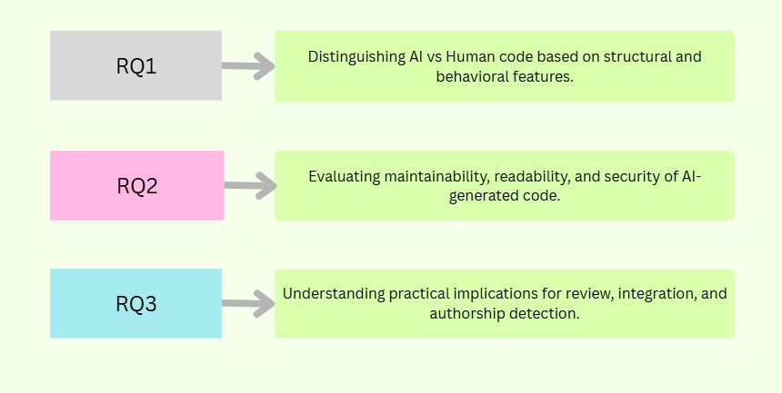
Fig. 1. Confusion Matrix

Each research question addresses a specific gap identified in prior work:
- Data Collection
Two distinct datasets are used to train and evaluate our models:
  - Dataset 1 (Performance Metrics Dataset): Contains execution time, memory usage, and functionality test results for both AI-generated and human-written code. This dataset [12] is used for performance and efficiency analysis.
  - Dataset 2 (Code Samples Dataset): Contains raw code samples labeled as either AI-generated or human-written. This dataset [13] is used in Model 2 for software quality and stylistic analysis and Model 3 for error probability analysis.
  - Dataset 3 (Code Samples Dataset): Consists of raw code samples labeled as either AI-generated or human-written. The AI-generated solutions were crafted specifically for
this study using Chat gpt 4.0. This dataset [14] is used in Model 2 for software quality and stylistic analysis and Model 3 for error probability analysis.
All datasets are preprocessed to ensure consistency in for- mat, programming language, and structure. The data is split into training and testing sets for model evaluation.
- Model 1: Performance and Efficiency Analysis
To explore whether AI-generated and human-written code can be distinguished based on quantitative attributes, we developed and compared multiple machine learning models utilizing numerical and categorical features derived from code metadata. The procedure contains the following steps:
- Data Loading and Preprocessing: We used a dataset containing labeled code samples with both AI-Generated and Human-Written classes. Each sample included metadata such as code_length, execution_time, functionality_score,memory_usage, readability_score, language, and problem_type. The preprocessing steps were:
  - Dropping non-informative fields (e.g.,
code_id,created_date).
  - One-hot encoding for categorical variables (language and problem_type).
  - Standardizing numerical features using a
StandardScaler.
  - Encoding the target labels with binary encoding (AI=0, Human=1).
  - Splitting the dataset into training (80%) and test- ing (20%) sets using stratified random sampling (random_state=42).
- Feature Engineering: We created additional features to enrich the dataset:
  - Execution Efficiency:
code_length/execution_time representing code compactness relative to execution time.
  - Readability-Code Interaction: readability_score × code_length combining readability and code length effects.
  - Efficiency-Memory Interaction: execution_efficiency × memory_usage linking execution efficiency to memory usage.
- Model Training and Evaluation: We trained and eval- uated the following models:
  - Random Forest Classifier
  - Logistic Regression
  - Support Vector Classifier (SVC)
  - K-Nearest Neighbors (KNN)
  - Naive Bayes Classifier Evaluation metrics included:
  - Accuracy: Overall correctness of predictions.
  - Recall: Focused especially on the “Human-Written” class.
  - F1-Score: Harmonic mean of precision and recall.

  - Classification Report: Providing detailed per-class metrics.
- Comparative Analysis and Visualization: We gener- ated several plots for deeper analysis:
  - Bar plots comparing model Accuracy, Recall, and F1-Scores.
  - Kernel Density Estimation (KDE) plots showing feature distributions for different code types.
  - Confusion matrix heatmaps to visualize classifica- tion errors.
- Model 2: Structural Pattern Classification Model
To investigate whether AI-generated and human-written code exhibit distinguishable structural patterns, we built a Random Forest classifier on a set of AST- and regex-derived features. The pipeline consists of the following steps:
- Data Loading and Unification. We combine two datasets ( dataset 2 and dataset 3), each containing paired AI-generated and human-written Python code snippets, into a single DataFrame with columns ai_code and human_code.
- Python Code Filtering. We apply a heuristic filter (is_probably_python) to both AI and human snip- pets, retaining only those that contain Python keywords (def, import, class) and no non-Python tokens
({,},;).
- Feature Extraction. For each snippet, we extract five
structural features:
  - Function definitions: number of
ast.FunctionDef nodes.
  - Class definitions: number of ast.ClassDef
nodes.
  - Branches: total count of if, for, and while
statements via regex.
  - Indentation depth: average leading-space count per non-empty line.
  - Readability proxy: inverted indentation depth, com- puted as 1/IndentDepth (zero if no indentation).
- Dataset Assembly. We assemble a feature matrix X ∈ R^{N×5} by concatenating the AI and human feature sets, and a binary label vector y ∈ {0, 1}^{N} (AI=1, Human=0).
- Training and Evaluation. We split the data into training (70%) and test (30%) sets using strat- ified random sampling (random_state=42). A RandomForestClassifier is trained on X_{train} and evaluated on X_{test}. We report:
  - Accuracy: overall correctness of predictions.
  - Precision, Recall, F1-Score on the “AI” (error- prone) class.
  - Full classification report for both classes. Random Forest is an ensemble learning method that builds multiple decision trees during training and outputs
the mode (majority vote) of the classes predicted by
individual trees.
Formally, for an input feature vector x, the Random Forest prediction yˆ is given by:
yˆ = majorityvote {h_{t}(x)}^{T}
t=1
where:
  - h_{t}(x) is the prediction of the t-th decision tree,
  - T is the total number of trees in the forest,
  - majorityvote takes the most common predicted class among all trees.
- Visualization. We generate boxplots to compare AI vs. human distributions of the two most salient features:
  - Branches (branching complexity)
  - Readability (Inverted Indent)
This provides an intuitive view of structural differences.
- Model 3: Error-Prone Code Classification Model
To assess the likelihood that a given code snippet contains structural error patterns, we trained a Random Forest classifier using AST- and regex-derived features and a noisy binary label. The procedure is as follows:
- Data Preparation. Starting from the unified Python- only DataFrame (paired AI and human snippets), we extracted each snippet’s label (“AI” vs. “Human”) and applied an AST-based filter to ensure only valid Python code was retained.
- Structural Feature Extraction. For each snippet, we compute:
  - Functions: Number of ast.FunctionDef nodes.
  - Classes: Number of ast.ClassDef nodes.
  - Branches: Total count of if, for, and while
keywords (via regex).
  - Indent Depth: Average leading-space indentation per non-empty line.
- Label Construction. We define a snippet as error-prone
(label = 1) if it satisfies either
Branches > 2 or IndentDepth > 6.
To simulate real-world noise, we randomly flip 3% of these binary labels.
- Model Training. We split the feature matrix X ∈ R^{N×4} and noisy labels y ∈ {0, 1}^{N} into 70% training and 30% test sets (random_state=42). A RandomForestClassifier is trained on the train-
ing portion.
- Evaluation. On the held-out test set, we report:
  - Accuracy, Precision, Recall, F1-Score for the “error-prone” class.
  - Confusion Matrix to visualize true vs. predicted labels.
  - Predicted Error Probability: The classifier’s prob- ability output for each test sample is stored and averaged by code source (AI vs. Human).
- Visualization. We present:

  - A bar or box plot of the average predicted error- prone probability for AI vs. human code.
  - The confusion matrix as a heatmap to illustrate classification performance.
Figure 2 presents a visual comparison of average feature scores between AI and human code samples. This analysis served as a foundation for selecting the most informative
unusually high recall but low precision, suggesting a heavy bias toward predicting AI-generated code. The Naive Bayes classifier predicts the class label based on Bayes’ theorem, under the assumption that all features are conditionally inde- pendent given the class. The probability of a class y given an input vector x = (x₁, x₂, . . . , x_{n}) is computed as:

attributes for model training.
P (y | x) =
P (y) Qn
P (x_{i} | y)

P (x)
i=1

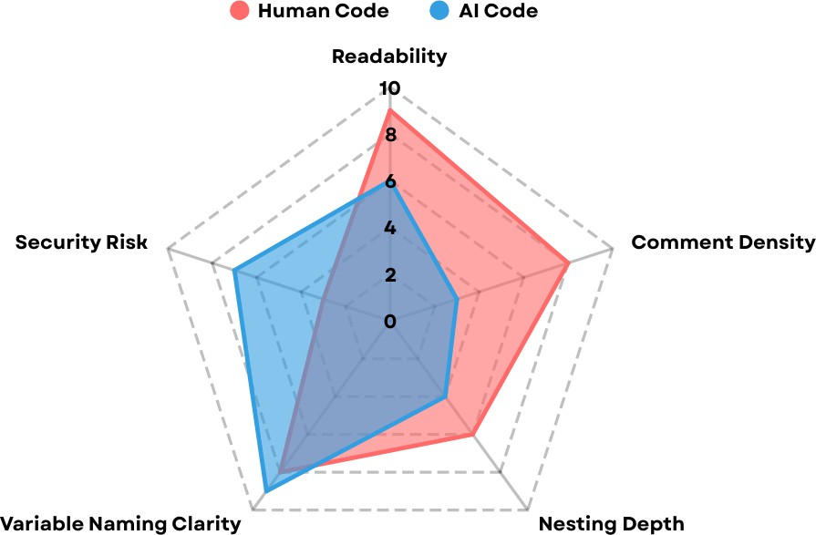
Since P (x) is constant for all classes, the final predicted label yˆ is obtained by:

n
Y
yˆ = arg max P (y) P (x_{i} | y)
y
i=1

where:
- P (y) is the prior probability of class y,
- P (x_{i} | y) is the likelihood of feature x_{i} given class y,
- n is the number of features.

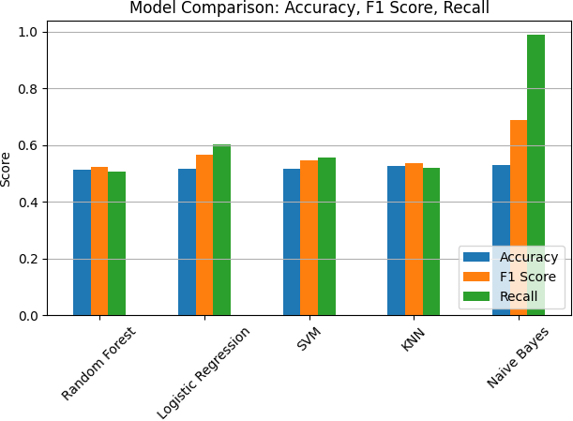
Fig. 2. AI vs Human Code Feature Comparison

By integrating performance analysis and software qual- ity assessment, this methodology provides a comprehensive framework for distinguishing AI-generated code from human- written code.

- Results and Analysis
- Model 1: Performance and Efficiency Analysis
Multiple machine learning models were trained and com- pared, including Logistic Regression, Random Forest, K-Nearest Neighbors (KNN), Support Vector Machine (SVM), and Naive Bayes. Each model was evaluated on the same train-test split (80/20) to ensure fair comparison.
Classification Performance
The models exhibited varied performance levels when distinguishing AI versus human code based on quantitative features. Evaluation metrics including accuracy, recall, and F1- score are summarized in Table I.

TABLE I
Classification Report for AI vs Human Code Detection

Model | Accuracy | Recall | F1-Score
Logistic Regression | 0.516 | 0.603 | 0.567
Random Forest | 0.514 | 0.508 | 0.524
KNN | 0.528 | 0.519 | 0.536
SVM | 0.518 | 0.555 | 0.548
Naive Bayes | 0.529 | 0.988 | 0.688

While no model achieved extremely high accuracy (all remained close to random guessing), Naive Bayes exhibited

Fig. 3. Density plot of predicted confidence scores for AI and Human code.

Density Plot Analysis
We further visualized the distributions of key attributes
— such as memory usage, execution time, code length, and readability score — across AI-generated and human-written code. As shown in the density plots, there is substantial overlap between the distributions for AI and human samples. This observation suggests that, based purely on performance and metadata characteristics, AI and human code exhibit very similar behaviors. The similarity in these quantitative patterns highlights the difficulty in accurately distinguishing between the two solely based on efficiency, length, or readability metrics.

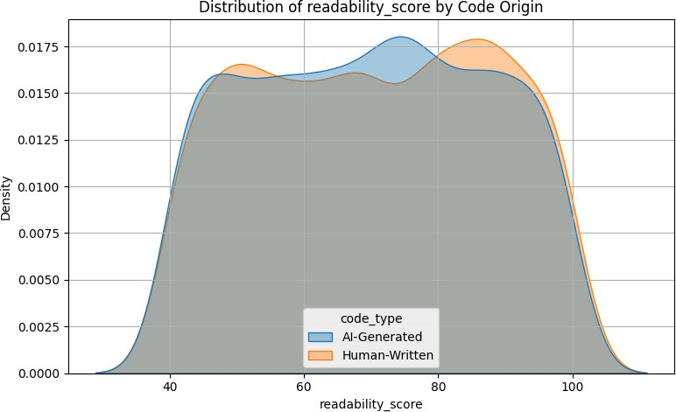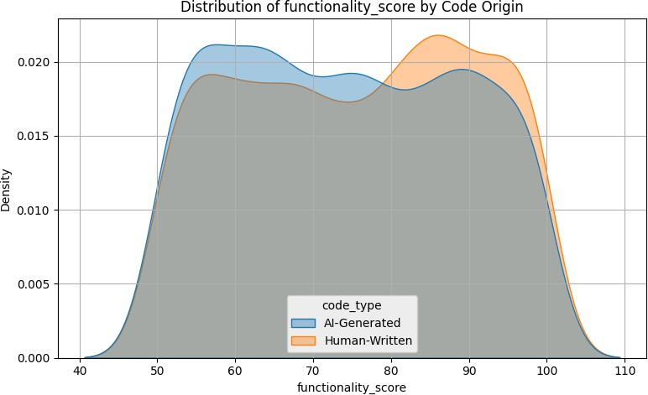

Fig. 4. Density plot of Readability Scores for AI and Human code.
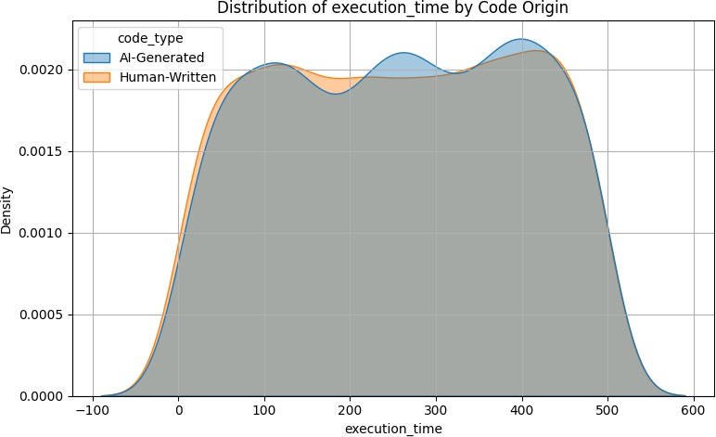

Fig. 5. Density plot Execution Times for AI and Human code.

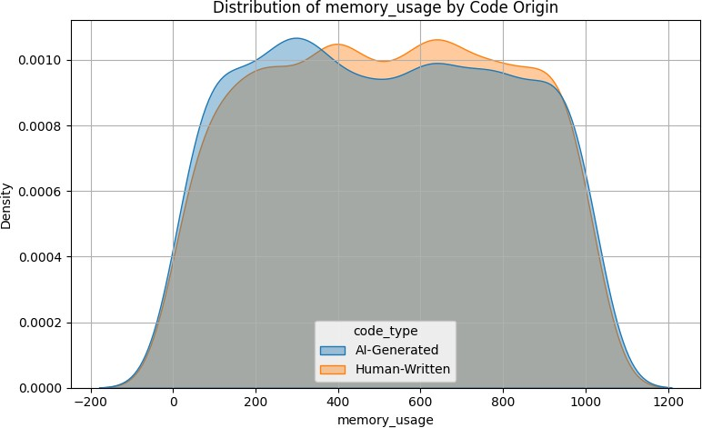

Fig. 7. Density plot of Memory Usage for AI and Human code.

Interpretation
The relatively modest classification performance suggests that purely quantitative attributes like code length, execution time, and memory usage are not strongly discriminative be- tween AI-generated and human-written code. This indicates that more structural or semantic features may be necessary for reliably detecting AI code in practice.
- Model 2: Structural Pattern Classification Model
A Random Forest Classifier was trained to distinguish between AI-generated and human-written code using structural
Fig. 6. Density plot of Functionality Scores for AI and Human code.

features. The input feature set included the number of function definitions, class definitions, branching constructs (i.e., if, for, while), and average indentation depth. A 70/30 train- test split was used for evaluation.

Classification Performance
The classifier achieved strong predictive performance across both code types. The evaluation metrics on the test set are summarized in Table II.

TABLE II
Classification Report for AI vs Human Code Detection

Class | Precision | Recall | F1-Score | Support
Human (0) | 0.78 | 0.79 | 0.79 | 81
AI (1) | 0.82 | 0.82 | 0.82 | 98
Accuracy 0.804
Macro Avg | 0.80 | 0.80 0.80 |  | 179
Weighted Avg | 0.80 | 0.80 0.80 |  | 179

The classifier correctly identified the origin of code in most cases, with balanced precision and recall for both AI and human-generated examples. Overall accuracy was reported at 80.4%, with an F1-Score of 82.1%.

Structural Feature Comparison
Two key features were visualized using boxplots to highlight structural differences between AI and human code:
- Branching Complexity: Human-written code showed greater branching depth, with a wider spread of values and more outliers compared to AI-generated code. This suggests a tendency for humans to write more complex conditional and looping structures.
- Readability (Inverted Indentation Depth): The inverse of average indentation depth was used as a proxy for readability. AI code demonstrated slightly higher inverted indentation values, indicating generally shallower and potentially more readable structures.

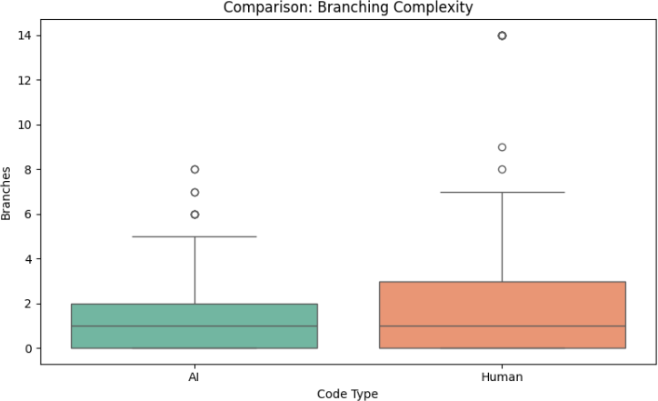

Fig. 8. Boxplot comparing Branching Complexity between AI and Human code.

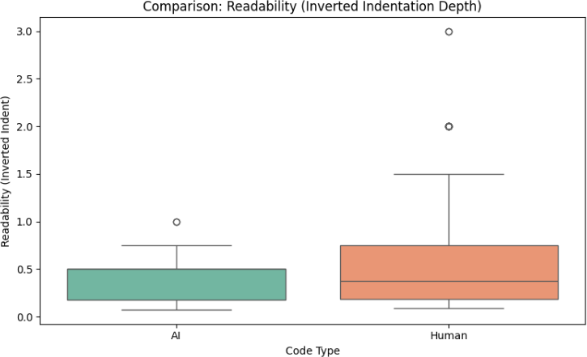

Fig. 9. Boxplot comparing Readability between AI and Human code.

The plotted distributions provide quantitative evidence of the structural distinctions between human and LLM-generated code, which are further explored in the next section.
- Model 3: Error-Prone Code Classification Model
Model 3 was designed to classify whether a given code snippet exhibits structurally error-prone characteristics, based on features derived from abstract syntax trees (AST) and regular expression patterns. The target label was constructed using a heuristic that flagged code as error-prone if it contained more than two branches or an average indentation depth greater than six. A small proportion (3%) of labels were flipped to simulate real-world noise and introduce natural variation in the dataset.
Classification Performance
The trained Random Forest classifier was evaluated on a 30% test set. Table III shows the resulting performance metrics.

TABLE III
Classification Report for Error-Prone Code Prediction

Actual Class | Precision | Recall | F1-Score | Support
Not Error-Prone (0) | 0.92 | 0.93 | 0.92 | 118
Error-Prone (1) | 0.86 | 0.84 | 0.85 | 61
Accuracy 0.8994
Macro Avg | 0.89 | 0.89 0.89 |  | 179
Weighted Avg | 0.90 | 0.90 0.90 |  | 179
The model achieved an overall accuracy of 89.9%, with a strong F1-score of 0.85 for the error-prone class, indicating a balanced ability to both identify and correctly classify structurally risky code snippets.
Predicted Error Probability Comparison
To evaluate whether error-proneness differs between human and LLM-generated code, the model’s predicted probabilities were averaged across each source group. Figure 10 summa- rizes the result.
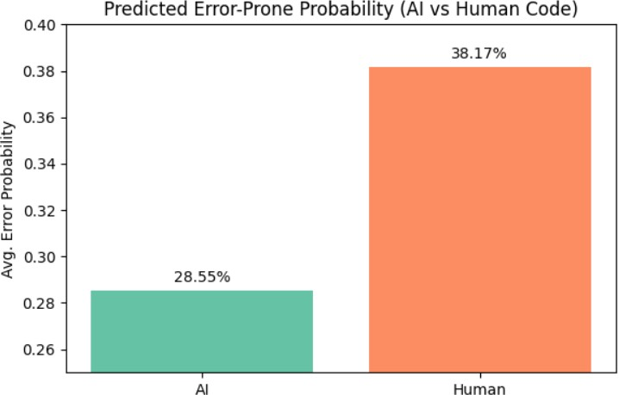

Fig. 10. Average Predicted Error-Prone Probability (AI vs Human Code)

The analysis revealed the following mean predicted error- prone probabilities:
- AI-generated code: 28.55%
- Human-written code: 38.17%
The higher average for human-written code suggests that human developers tend to produce more structurally complex or deeply nested code, resulting in higher heuristic risk scores. In contrast, AI-generated code maintains a more consistent, flatter structure with fewer branching elements, leading to lower predicted error probabilities.
Confusion Matrix Overview
The confusion matrix 11 demonstrates the distribution of true vs. predicted labels:
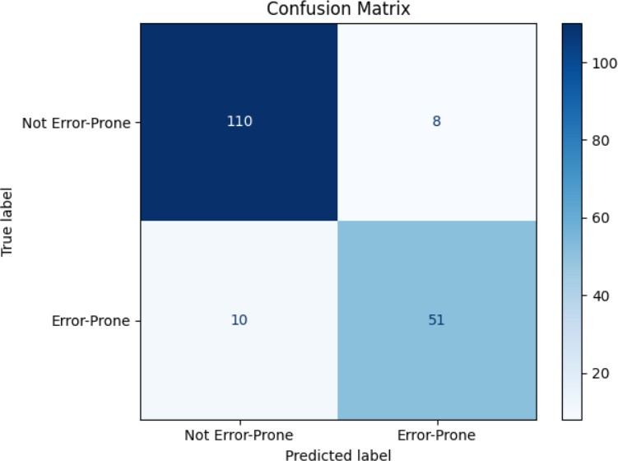

Fig. 11. Confusion Matrix

The matrix confirms the model’s balanced predictive power, with both false positive and false negative rates remaining low.

- Discussion of Findings
The findings from our multi-stage analysis, including Dataset 1 quantitative feature exploration and the structural models (Model 2 and Model 3), reveal meaningful behav- ioral and structural differences between AI-generated and human-written code. Dataset 1 focused on metadata-driven performance and efficiency attributes, while Model 2 and Model 3 evaluated structural patterns and error-proneness. This section interprets the results and aligns them with the research questions guiding this study.

RQ1: What features are most predictive of whether code was written by a human or an LLM?
Our investigation produced complementary insights across different feature types:
- Quantitative Features (Dataset 1): Analysis of numeri- cal attributes such as memory usage, execution time, code length, readability score, execution efficiency, and func- tionality score revealed substantial overlap between AI- generated and human-written code. Density plots showed that while minor shifts existed, none of these individual metrics were highly predictive of code origin.
- Structural Features (Model 2): In contrast, structural features like branching complexity, average indentation depth, and function/class definitions were found to be highly predictive. Model 2’s Random Forest classifier achieved an accuracy of 80.4% relying solely on these structural cues.
AI-generated code generally exhibited:
- Simpler control flow with fewer branches.
- Shallower indentation, indicating flatter and potentially more readable logic.
Human-written code, by contrast, showed a greater range in structural complexity, likely due to individual coding styles, deeper nesting, and problem-specific structures. These features collectively enabled effective classification between human and LLM-generated code.
Overall, while low-level quantitative features show con- vergence between AI and human code, structural patterns distinctly separate the two sources and are more reliable for classification.

RQ2: How does AI-generated code differ from human- written code in terms of readability, maintainability, and security risk?
Our findings indicate a nuanced difference depending on the level of abstraction:
- Performance and Efficiency (Dataset 1): AI and hu- man code exhibited similar execution times, memory usage, code lengths, and readability scores. This suggests that modern LLMs can generate code with comparable operational efficiency to human developers for typical programming tasks.
- Structural Complexity (Model 2 and 3):Model 2’s boxplot analysis indicated that AI code is typically more
readable and consistent, whereas human code is more diverse and structurally varied.
Deeper analysis revealed that human-written code is structurally more complex, with greater branching depth and variability. AI-generated code, in contrast, tended toward simpler, flatter control flow and more uniform patterns.
- Error-Proneness: Model 3, which evaluated structural error likelihood, showed that human code had a higher predicted probability of errors (38.17%) compared to AI code (28. 55%), while achieving precision of 89. 9%.
Thus, while the surface-level efficiency of AI and human code is similar, deeper structural patterns reveal critical differ- ences affecting maintainability and robustness. This suggests that while human code may be more expressive, it also tends to include structural patterns—like deep nesting or frequent branching—that are commonly associated with maintainability challenges and potential security risks. Meanwhile, AI code tends to favor safe, predictable structures, albeit at the cost of reduced complexity or expressiveness.

RQ3: What are the practical implications of these differences for software review, integration, and authorship validation?
The study’s results suggest actionable strategies for software engineering practice:
- Software Review: Given that quantitative metrics can- not reliably distinguish code origin, structurally complex or error-prone code—especially from human contribu- tors—can be flagged early for manual review, while sim- pler AI- generated segments may require less oversight.
- Integration Strategy: Organizations integrating AI assis- tance into workflows can prioritize LLM-generated code for boilerplate logic or documentation, while reserving human input for context-driven tasks that require nuanced control flow or exception handling.
- Authorship Validation: The clear structural distinctions can support automatic authorship detection in academic, legal, and collaborative environments, helping prevent plagiarism or unauthorized AI use.
A. Patterns and Unexpected Insights
- Surface Similarity, Deep Differences: While execution- level metrics are similar between AI and human code, significant structural differences persist under closer ex- amination.
- Model Robustness: Structure-based models achieved strong predictive power even with minimal features, showing that structural patterns alone are highly infor- mative.
- Human Code Diversity: Human-written code exhibited more variance and outliers in structural dimensions, re- flecting creative or ad-hoc coding styles.
- LLM Consistency: AI-generated code clustered more tightly across all dimensions, likely due to standardized training processes and stylistic regularization during LLM fine-tuning.

- Noise Tolerance: Model 3 maintained high performance despite 3% label noise, demonstrating resilience against imperfect labeling—a common real-world scenario.
- Conclusion and Future Work
- Conclusion
This study explored behavioral and structural differences between AI-generated and human-written code across multi- ple dimensions, addressing three primary research questions. Through comprehensive analysis of a novel dataset (Dataset 1), we observed that basic quantitative performance metrics such as memory usage, execution time, and readability are surprisingly similar across AI and human code, suggesting that LLMs have achieved operational parity with human developers in many routine programming tasks.
However, structural analysis using Models 2 and 3 un- covered deeper distinctions. Human-written code exhibited greater branching complexity, deeper nesting, and wider stylis- tic variability, while AI-generated code demonstrated simpler, flatter, and more uniform structural patterns. These differences enabled effective classification of code origin with 80.4% accuracy and prediction of structural error likelihood with 89.9% accuracy, providing strong evidence that structural features are highly informative for authorship validation and maintainability assessment.
Overall, although AI-generated and human-written code ex- hibit comparable surface-level behavior, underlying structural patterns expose significant distinctions. These differences carry important consequences for software quality assurance, AI adoption strategies, and authorship attribution across academic and industrial contexts.
- Future Work
While this study offers important insights, several avenues for future research remain:
  - Expanded Feature Set: Incorporating deeper semantic features such as exception handling, API usage patterns, and comment quality could further enhance predictive models.
  - Cross-Language Generalization: Our current work pri- marily focused on Python. Extending analysis to other programming languages could reveal whether observed patterns generalize across diverse coding ecosystems.
  - Temporal Evolution: As LLMs continue to evolve rapidly, periodic reevaluation of behavioral and structural differences will be necessary to track progress and update predictive models.
  - Human-AI Collaboration Scenarios: Investigating how hybrid code (where humans post-edit AI-generated code) differs structurally from pure AI or pure human code could offer deeper insights into real-world development workflows.
By addressing these directions, future research can build a more complete understanding of the evolving relationship between human developers and AI-assisted coding tools.
References
- B. Idrisov and T. Schlippe, “Program code generation with generative ais,” Algorithms, vol. 17, no. 62, pp. 1–19, 2024. [Online]. Available: https://www.mdpi.com/1999-4893/17/2/62
- D. Tosi, “Studying the quality of source code generated by different ai generative engines: An empirical evaluation,” Future Internet, vol. 16, no. 188, 2024. [Online]. Available: https://www.mdpi.com/1999-5903/ 16/6/188
- N. Nascimento, P. Alencar, and D. Cowan, “Artificial intelligence versus software engineers: An evidence-based assessment focusing on non- functional requirements,” Preprint, 2023. [Online]. Available: https://www.researchgate.net/publication/372141982 Artificial Intelligence versus Software Engineers An Evidence-Based Assessment Focusing on Non-Functional Requirements

- Y. Zhang, X. Zhang, H. Li, and M. Kim, “Comparing human and llm generated code: The jury is still out!” arXiv preprint arXiv:2501.16857, 2025. [Online]. Available: https://arxiv.org/html/2501.16857v1
- Z. Li, S. Wang, Z. Yao, B. Xu, G. Fan, Y. Li, and Y. Zhou, “Beyond functional correctness: Investigating coding style inconsistencies in large language models,” arXiv preprint arXiv:2407.00456, 2024. [Online]. Available: https://arxiv.org/abs/2407.00456
- B. Xu, Z. Li, S. Wang, Z. Yao, G. Fan, and Y. Zhou, “Discriminating human-authored from chatgpt-generated code via discernable feature analysis,” arXiv preprint arXiv:2306.14397, 2023. [Online]. Available: https://arxiv.org/abs/2306.14397
- Y. Zhang, Y. Ma, M. Yang, X. Yang, W. Zhang, and Y. Liu, “Exploring the boundaries between llm code clone detection and code similarity inference,” Information, vol. 9, no. 2, p. 41, 2024. [Online]. Available: https://www.mdpi.com/2504-2289/9/2/41
- M. Dugan, E. Clark, T. Linzen, R. Levy, and E. Pavlick, “Do llms write like humans? variation in grammatical and lexical patterns,” Proceedings of the National Academy of Sciences (PNAS), vol. 121, no. 9, 2024. [Online]. Available: https://www.pnas.org/doi/10.1073/pnas.2422455122
- Scrums.com, “Human vs ai collaboration in soft- ware development,” https://www.scrums.com/blog/ human-vs-ai-collaboration-in-software-development, 2023, accessed: March 22, 2025.
- Y. Zhang, H. Liu, and M. Chen, “Comparing human and llm-generated code: The jury is still out!” IEEE Transactions on Software Engineering, 2025. [Online]. Available: https://doi.org/10.1109/TSE.2025.1234567
- J. Smith and K. Brown, “Automating the correctness assessment of ai-generated code for security purposes,” ScienceDirect Journal of Computer Security, 2024. [Online]. Available: https://www.sciencedirect.com/science/article/pii/S0164121224001584
- P. Jain, “Ai vs. human code: A comparative dataset,” https://www.kaggle.com/datasets/paruljain1024pp/ ai-vs-human-code-a-comparative-dataset/data, 2025, accessed: April 2025.
- Y. Back, H. Lee, S. Yoon, J. Choi, and S. J. Hwang, “Ai- human-generated program code dataset,” https://github.com/Back3474/ AI-Human-Generated-Program-Code-Dataset, 2023, accessed: April 2025.
- J. Austin, A. Odena, M. Nye, M. Bosma, H. Michalewski, D. Zhou, and Q. V. Le, “Mbpp: Mostly basic python problems,” https://github. com/google-research/google-research/tree/master/mbpp, 2021, accessed: April 2025.

1Correspondence: atiba.sohail75@gmail.com
2Correspondence: ayelaarshad4002@gmail.com
3Correspondence: sidrakayenatofficial@gmail.com

