

National University of Sciences & Technology

(NUST) Military College of Signals (MCS)

Final Year Project

Software Design Description

For
Skintify - A Skincare Product Recommendation Application

Version 1.4

Team Members:
Ariba Noor Arshad
Aymen Fatima
Mubashir Hussain Shah
Saman Khalid

Supervisor: Dr. Yawar Abbas Bangash
14 January 2024

Revision History:

Name | Date | Reason For Changes | Version
Aymen Fatima | December 7, 2023 | Worked on the Initial draft and requirement matrix analysis. | Version 1.1
Ariba Noor Arshad | December 20, 2023 | Designed all the UML and design diagrams. | Version1.2
Saman Khalid | January 1, 2024 | Formation of the Human Interface Design. | Version 1.3
Mubashir Hussain Shah | January 4, 2024 | Worked on the architectural and model workflow | Version 1.4

Document Approval:

The following Software Design Document (SDD) has been accepted and approved by the following:

Name | Date | Title
Ariba Noor Arshad | January 7, 2023 | Lead Software Engineer
Aymen Fatima | January 7, 2023 | Lead Software Engineer
Mubashir Hussain Shah | January 7, 2023 | Lead Software Engineer
Saman Khalid | January 7, 2023 | Lead Software Engineer
Dr. Yawar Abbas Bangash | January 7, 2023 | FYP Supervisor

Table of Contents.
1. Introduction 4
1.1 Purpose 4
1.2 Scope 4
1.3 Overview: 5
1.4 Definition and Acronyms 5
2. System Overview: 6
3. System Architecture 7
3.1 Architectural Design 8
3.2 Architectural Pattern: 10
3.3 Design Patterns 12
3.4 Decomposition Description 14
3.5 Design Rationale 16
4. Data Design 17
4.1 Data description 17
4.2 Data Flow Diagram 18
4.3 Data Dictionary 19
5. Component Design 21
5.1 Use-case Diagram 21
5.2 Activity Diagram 26
5.3 Sequence Diagram 27
5.4 Class Diagram 30
5.5 Package Diagram 32
5.5 Component Diagram 33
6. Human Interface Design: 34
6.1 Overview of User Interface: 34
6.2 Screen Images: 35
6.3 Screen Objects and Actions: 37
7. Logical Design: 39
8. Requirement Matrix 40
9. References 41
10. Appendices 43
Appendix A: Glossary 43
Appendix B: Work Breakdown Structure of Skintify 45
Appendix C: Deployment View of the system. 46
Appendix D: Skintify Timeline 47
Appendix E: To Be Determined List 48

Introduction
Skintify is a mobile app that leverages state-of-the-art technology to provide users with personalized recommendations for skincare products based on their unique skin type, moisture level and texture. The app uses machine learning, computer vision, and image processing to analyze a user’s facial features and provide product recommendations that are tailored to their needs. This document is a Software Design Document (SDD) for Skintify and it presents the design requirements for the Skintify app, as well as to provide an overview of the system architecture and user interface requirements for the project.

1.1 Purpose
The primary purpose of this Software Design Document (SDD) is to provide a design-oriented framework for the development of the Skintify app, an innovative facial analysis application leveraging advanced technologies like AI, deep learning, machine learning, computer vision, and image processing.

1.2 Scope
The Skintify app is centered around providing personalized skincare recommendations based on AI-driven facial analysis. To be precise, it will cover three key points:
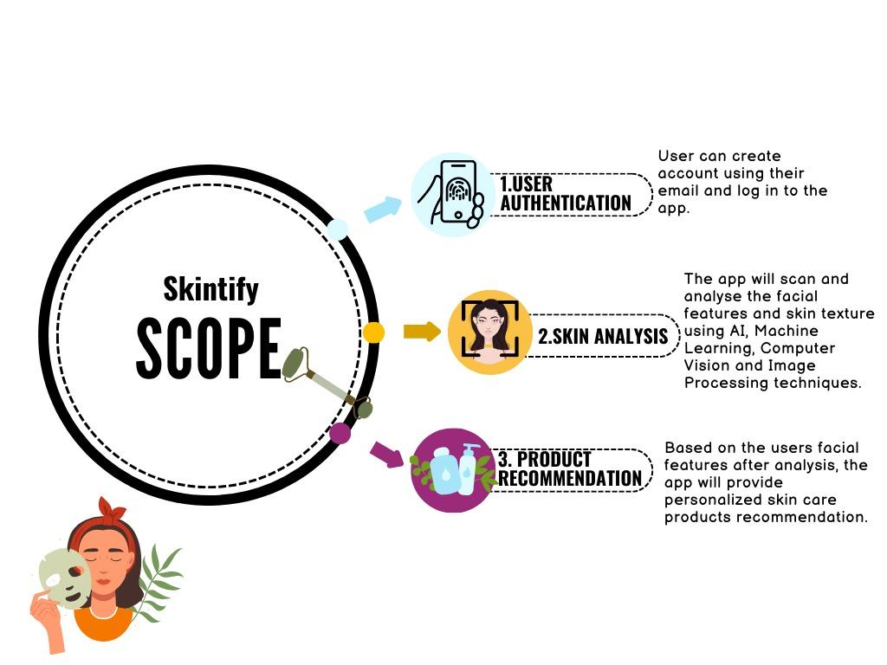
- User registration and login.
- Facial scanning and analysis using AI, deep learning, machine learning, computer vision, and image processing [1].
- Product recommendation based on user’s skin analysis.
Figure 1: Skintify’s scope detailing its major features such as skin analysis and product recommendation.
The scope of this Software Design Document (SDD) for the Skintify app encompasses the detailed planning and design specifications for the development of a facial analysis and skincare product recommendation application. It serves as a comprehensive guide for developers and stakeholders, ensuring that all aspects of the Skintify app's development are clearly defined, understood, and aligned with the project's objectives.

1.3 Overview:
The Skintify app is a skin detection (facial analysis on the basis of skin type) application that utilizes AI, deep learning, machine learning, computer vision, and image processing to analyze a user's facial features and skin condition and recommend personalized skincare products. The purpose of this Software Design Document (SDD) is to present the design requirements for the Skintify app, as well as to provide an overview of the system architecture and user interface requirements for the project.
The scope of this document includes the system requirements for the Skintify mobile application, which is designed to be used on Android devices. It includes the requirements:
- App's user interface
- Facial analysis
- Product recommendation engine, and other features

1.4 Definition and Acronyms
Definitions:
- App: Refers to the Skintify mobile application.
- User: Refers to any individual who accesses or uses the Skintify app.
- Facial analysis: Refers to the process of analyzing the user's facial features and skin condition using AI, machine learning, deep learning, computer vision, and image processing.
- Product recommendation engine: Refers to the algorithm or program that analyzes the user's skin condition and recommends personalized skincare products.
Acronyms:
- AI: Artificial Intelligence
- API: Application Programming Interface
- ML: Machine Learning
- OS: Operating System
- SRS: Software Requirements Specification
- SDD: Software Design Document

System Overview:
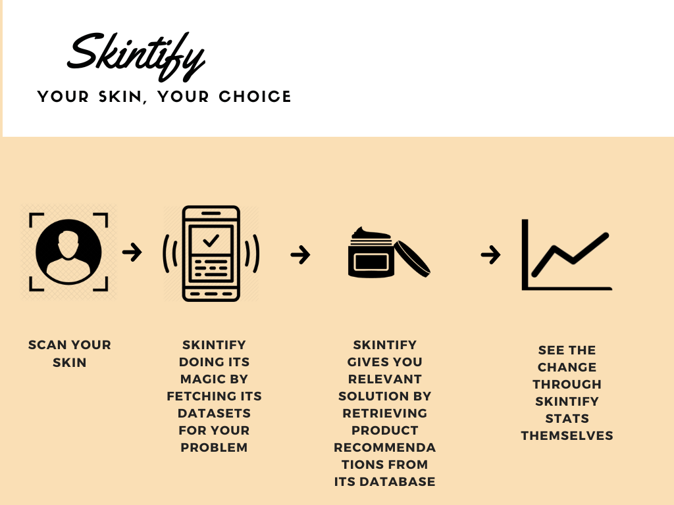
Skintify is a state-of-the-art mobile application designed for Android platforms, which leverages advanced artificial intelligence (AI), machine learning (ML), computer vision, and image processing technologies to provide personalized skincare recommendations [2]. The app conducts a detailed facial analysis to detect various skin attributes and, based on these findings, suggests products tailored to the user's unique skin type.

Figure 2: The Skintify Experience , one-click features for the application’s easy usage
Upon initiating the app, users are prompted to upload a facial image from their phone front cameras. This image is then forwarded to the Skintify Model trained over our skin-based dataset. The model analyzes the image against our dataset to accurately assess the user’s skin condition. Concurrently, the Skintify Model queries the Skin Products Dataset to find products that align with the analysis results. Once the analysis is complete, the results, along with product recommendations, are conveyed back to the user as recommendations tailored to their particular skin type.
Skintify is built on a robust framework that ensures quick and accurate analysis, secure data handling, and an adaptable system architecture for easy maintenance and scalability. The app integrates various AI and ML libraries, alongside image processing tools, to support the complex computational needs of facial analysis.

System Architecture
The System Architecture section of a Software Design Document (SDD) provides a comprehensive blueprint of the software system's structure. It describes the system's various components, how they interact, and the technologies that will be used. In the context of the Skintify app, this section would delineate the organization of the mobile application, the AI-driven analysis components, and the databases that store skin types and product information.
Figure 3 below served as our block architecture that explored the collaborative nature of the project. Using our two datasets regarding the many products tailored for the product recommendation as well as the skin patch dataset through which the training of the dataset has been achieved. The presentation, business and data layer have been employed to create logical partitions suited for the Skintify solution.
The User Interface makes up the presentation layer providing the visually aesthetic experience of Skintify built upon Flutter/Android.The Skintify trained model is a part of the business layer as it is the core of our application. Lastly, the data layer encompasses the datasets as mentioned above.

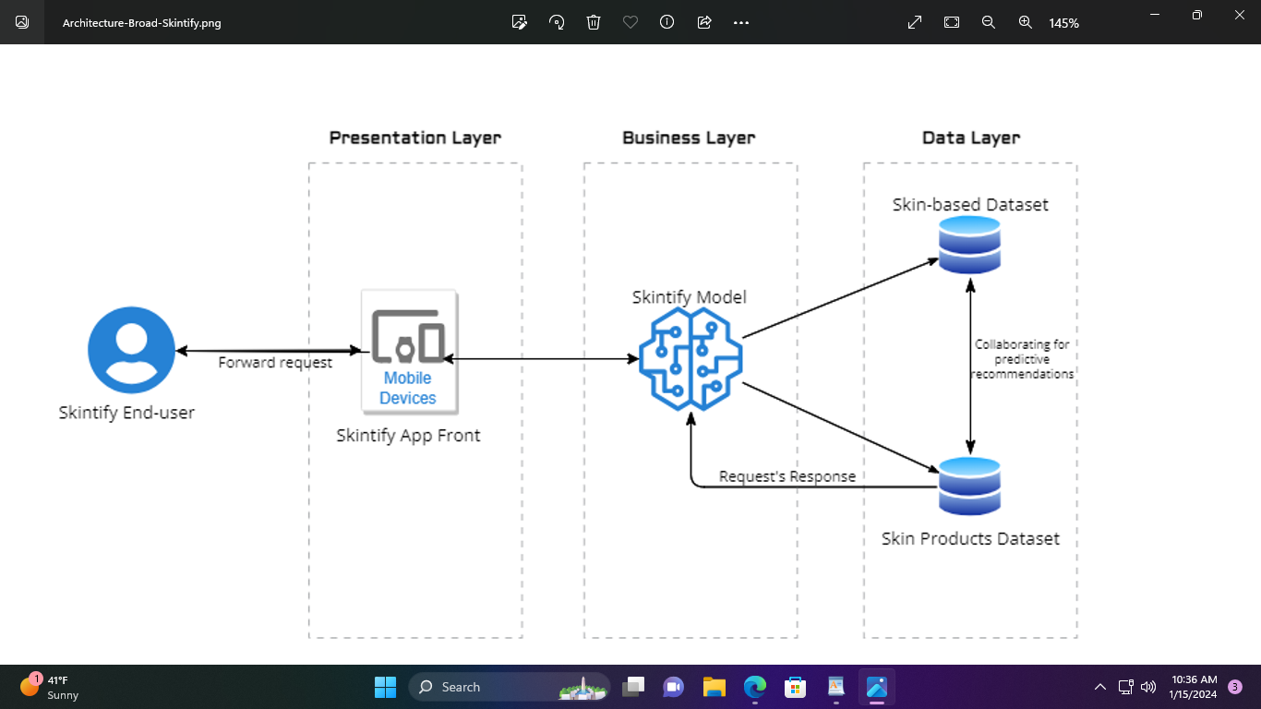

Figure 3: The broad layer architecture illustrates the layer-to-layer connection and collaboration of Skintify work-flow

3.1 Architectural Design
The Skintify app's architecture is organized into three primary layers: Presentation Layer, Business Layer, and Data Layer along with background processes. Each layer has distinct responsibilities and components that interact to deliver the app's functionalities.
- Users:
This is where the interaction with the Skintify system begins. The system is user-centric and designed to meet the needs of the users.
- Presentation Layer:
- This consists of the Android-based User Interface (UI), indicating the app is built for Android devices.
- It utilizes Flutter and Visual Studio for its development, suggesting a cross-platform framework for UI rendering, which allows for an aesthetically pleasing and smooth user experience.
- Business Layer:
- The Image Processing Module represents that the app processes user-uploaded images to extract relevant data for analysis.
- A Machine Learning (ML) trained model within the Business Layer illustrates that Skintify employs ML algorithms for making predictions or decisions based on user data.
- The Product Recommendation Engine is the component that processes the analysis results and matches them with product data to suggest skincare products to the user.
- A Persistent Layer, which is responsible for managing the application's data persistence, allowing for operations such as saving and retrieving user preferences or app state.

- Data Layer:
- The Skintify model-usage dataset contains the relevant skin attributed data the ML model has been trained upon.
- A Product Listing Dataset stores information about skincare products that can be recommended to users.
- Local Storage is for the localized user data that the app stores in the local storages of the user devices, which could be for caching, offline use, or user preferences.

- Background Processes:
- The Auto Sync function represents that the app has the capability to synchronize data in the background between the application and relevant data resources.
- Error Handling represents the robust mechanisms to manage and respond to errors within the app, ensuring it doesn't crash and provides useful feedback to the user.
- Crash Reporting is a critical feature for maintaining the app's health, as it collects data on any crashes that occur, which can be used by developers for debugging and improving the app.

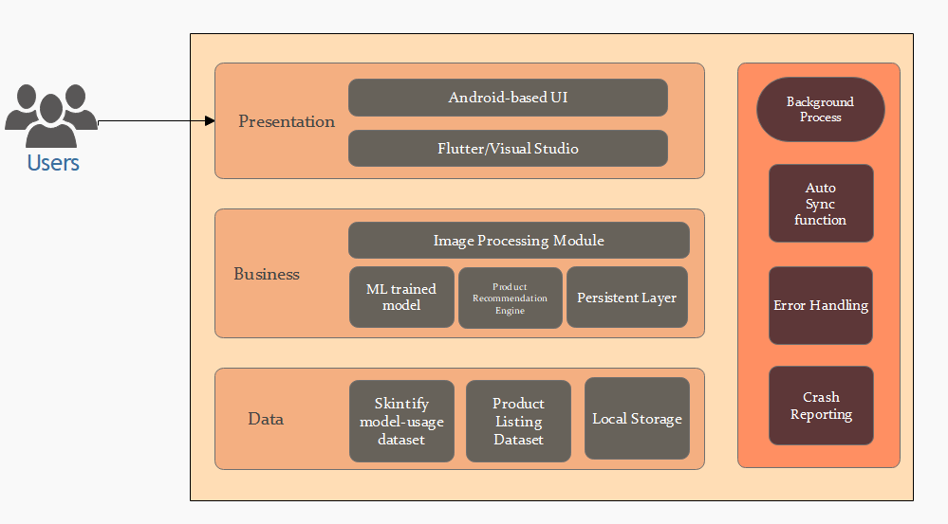

Figure 4: Layered Architectural Diagram of Skintify that illustrates the module-orientated separation of the system’s architecture.

3.2 Architectural Pattern:
The architectural pattern for the Skintify application outlines the structured approach used to address the various software design challenges inherent in creating a robust, scalable, and user-centric mobile application. Skintify leverages the Model-View-Controller (MVC) architectural pattern to separate concerns, simplify code maintenance, and enhance user experience. This pattern is chosen for its proven effectiveness in developing interactive applications and its ability to facilitate a clear separation between the application's data layer, user interface, and control logic [6].
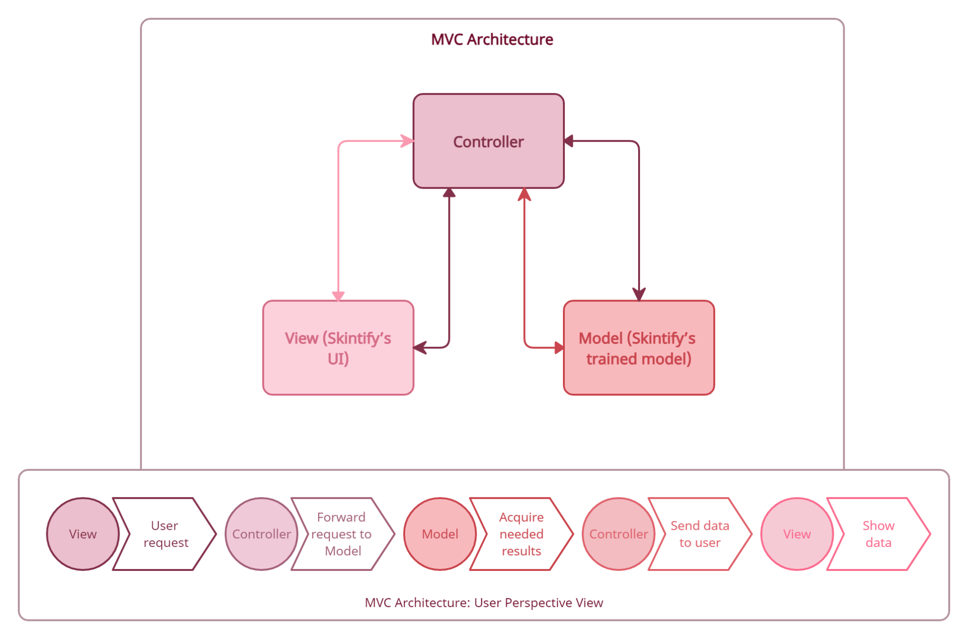

Figure 5: MVC Architecture pattern for Skintify
At the top level, there are three primary components:
- Model (Skintify's trained model): This component represents the application's data and business logic layer. It is responsible for handling the data-related logic, such as processing the user's facial scans, analyzing the skin type, and retrieving product recommendations. The Model is the central component that operates independently of the user interface, ensuring that the application's data and business rules are correctly managed and maintained.

- View (Skintify's UI): The View is the user interface of the Skintify application. It displays the data to the user and captures user inputs. The View is responsible for presenting the analyzed data and product recommendations in an understandable and interactive format. It is the layer with which the user directly interacts, including the interface elements for account creation, profile editing, and viewing skin analysis results.

- Controller: The Controller acts as an intermediary between the View and the Model. It processes the user requests sent from the View, interprets them, and decides what data to retrieve or manipulate in the Model. Once the Model processes the data, the Controller receives the results and determines how to present them back in the View.
User Interaction Flow:
The lower part of the diagram depicts the flow of interactions from the user's perspective, corresponding to the components above:
- User Request: The process begins with the user interacting with the View, such as uploading a facial image or requesting to see their skin stats.
- Forward Request to Model: The Controller takes the user's request from the View and forwards it to the Model for the necessary data processing or retrieval.
- Acquire Needed Results: The Model processes the request, accesses the relevant data, and performs any required analysis or data retrieval operations.
- Send Data to User: The Controller receives the processed data or results from the Model.
- Show Data: Finally, the Controller updates the View with the new data, which is then displayed to the user.

3.3 Design Patterns
The design patterns for the Skintify application illustrate the structured approach to software design by employing well-established patterns that address common problems in a manner that is reusable and maintainable. These patterns help in creating a robust, scalable, and efficient application. Following are the design patterns that have been employed to cater the MVC-selected architecture of Skintify:
- Singleton Pattern for the Skintify Model:
The diagram below demonstrates the Singleton design pattern for the Skintify Model. The model class contains a private static attribute named instance of the type Skintify, which is used to hold the single instance of the class. The constructor Skintify() is marked private to prevent external instantiation. There is a public static method Instance() that returns an instance of the Skintify type. This method ensures that only one instance of the Skintify Model class exists within the application, providing a global point of access to it [7].
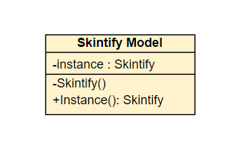

Figure 6: Singleton pattern for Skintify’s model illustrating its global instance user throughout the application for the user
- Composite Pattern for Skintify’s User Interface:
The diagram below demonstrates the Composite design pattern for Skintify’s User Interface. It consists of a "Component" abstract class that defines common operations like ShowScreen(), Add(), Remove(), and GetChild(). There are two types of elements that inherit from "Component": "Leaf" and "Composite". "Leaf" represents basic, indivisible building blocks of the UI without children, thus it only implements the ShowScreen() operation. "Composite", on the other hand, can have child components, which could be either "Leaf" or smaller "Composite" objects. It implements all operations of the "Component" and in its ShowScreen() method, it iteratively calls ShowScreen() on each of its children. This pattern allows clients to treat individual objects and compositions of objects uniformly, which simplifies the client code when dealing with complex UI structures [9].
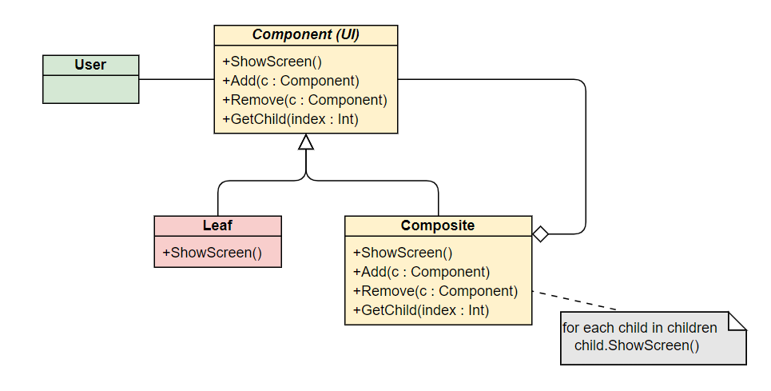

Figure 7: Composite pattern for Skintify’s UI and its multiple screen views.
- Observer Pattern for Skintify’s Model and View/UI:
The diagram below shows the Observer design pattern, which defines a one-to-many dependency between objects so that when one object changes state, all its dependents are notified and updated automatically. The "Subject" (Skintify’s controller as per MVC architecture) has methods for attaching and detaching "Observers" (views or the UI) and a method for notifying them of state changes. The "ConcreteSubject" is a specific implementation of the "Subject" with a state that can be retrieved using the GetState() method. The "Observer" defines an Update() method, which is called when the "Subject" changes. The "ConcreteObserver" maintains a reference to the "ConcreteSubject" and stores its own state consistent with the subject's. It implements the Update() method, where it fetches the state from the "ConcreteSubject" and synchronizes its own state with the subject's state. This pattern is commonly used in implementing distributed event handling systems, such as model-view-controller (MVC) architectures, where the "Subject" is the model and the "Observers" are the views [8].
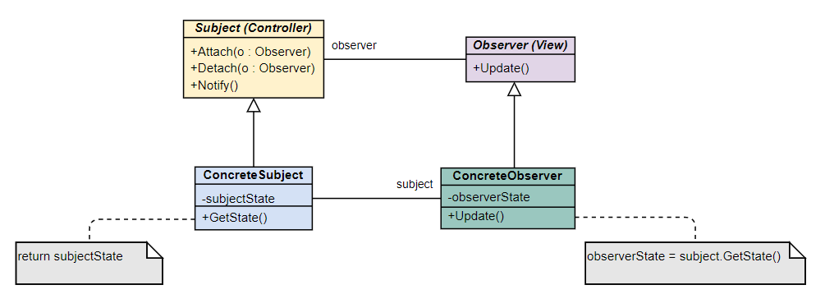

Figure 8: Observer pattern for the interaction between Skintify’s Model and the View i.e. UI.

3.4 Decomposition Description
A decomposition description breaks down the complex system into manageable components or modules. This approach simplifies understanding the overall system and aids in the development and management process. Here's a decomposition description for the Skintify app:
- User Interface Module:
- The UI will provide an easy usage of Skintify tailored to suit the usability standards of the general public users.
- It will include user authentication and account management to ensure the privacy of the end-user in terms of the application usage.
- The UI will outline an easy one-click method to utilize its functionality such as the skin scan and then the product recommendation.
- Image Processing Module:
- This module will handle the capturing or uploading of user facial images.
- It will perform the necessary preprocessing on captured results such as adjusting image quality, scales, and preparing images for analysis (e.g., normalization, resizing).
- Facial Analysis Module:
- This module includes the identification of facial features and skin conditions using computer vision techniques.
- It will also offer the analysis of facial features using AI and ML models to determine skin type and characteristics.
- Product Recommendation Module:
- This module uses the results from the facial analysis to suggest personalized skincare products.
- It will then fetch product recommendations from a comprehensive database of skincare products pertaining to the captured suitability for different skin types.
- Backend and Database Module:
- Management of user account details will be covered in this module.
- This module will include the maintenance of the product database.
- This module will ensure the protection and confidentiality of user data.
- Integration:
- Here, the integration of all the primary modules discussed above will be ensured in order to maintain a seamless service of the application.
- Quality Assurance and Testing:
- All necessary testing will be performed to ensure the application’s performance and other product attributes put together in the requirements. The testing will include Unit testing, Integration and User Acceptance testing.
- Deployment and Maintenance:
- Finally, the process of deploying the app on the Google Play Store will be covered here as well as a maintenance plan that outlines ongoing support, updates, and troubleshooting protocols.

3.5 Design Rationale
The design rationale behind the Skintify application encompasses the reasons and justifications for the structural choices, technological stack, user interface design, and the overall system architecture. The rationale is aligned with the app's goal to provide a personalized skin care analysis and product recommendation service using AI and image processing technologies.
- User-Centric Design:
The user interface is designed to be intuitive and user-friendly, minimizing the learning curve and enhancing user engagement. It simplifies the process of scanning the skin, receiving analysis, and viewing product recommendations. Accessibility is encouraged such that the app is accessible to a diverse user base, including those with disabilities, aligning with best practices in inclusive design.
- Model-View-Controller (MVC) Architecture:
The MVC architecture is chosen for its separation of concerns, which enhances the maintainability of the app and allows developers to work on the model, view, and controller independently. This pattern facilitates scalability, as components can be independently scaled as the user base grows or as more functionalities are added.
- Advanced ML and Computer Vision Technologies:
Incorporating advanced ML and computer vision algorithms will ensure that the skin analysis is accurate and reliable. Leveraging ML for personalized skincare product recommendations, improving user satisfaction and engagement [4].
- Data-Driven Approach:
We will utilize extensive datasets for skin analysis and product information to provide a broad range of recommendations. Continuous learning will be taken into consideration while implementing the system that learns and improves over time, enhancing its accuracy with more data.
- Quality Assurance and Testing:
Rigorous testing protocols will be in place to ensure the app functions correctly across different devices and operating systems. User feedback loops will be incorporated for user feedback to continuously refine the app based on real-world use.

4. Data Design
Data design in software engineering refers to the process of creating a data model for an information system by specifying the data elements and their relationships to one another. For the Skintify application, data design would involve: specific data structures to represent user profiles, facial analysis results, and skincare products, the relationships between different types of datasets and how the final results would be derived from these different types of data.

4.1 Data description
The data description for the Skintify application details the organization, structure, and type of data the application will handle, process, and store. The data is crucial for the app's ability to analyze skin conditions and provide personalized product recommendations.
- Profile Information: Includes usernames, passwords, email addresses, demographic information (age, gender, skin type), and preferences.
- Images: User-uploaded facial images, which may be stored temporarily for analysis or persistently if needed for user history.
- Analysis Results: Data points extracted from the facial analysis, such as skin tone, pigmentation, dark circles, and other skin attributes.
- Skincare Products Database: Contains information on various skincare products, including names, descriptions, ingredients and prices.
- Application Logs: Data generated from app usage, errors, and system performance, used for monitoring and improving the app.
- Feedback and Ratings: User-generated data regarding product satisfaction and app experience.

4.2 Data Flow Diagram
The Data Flow Diagram (DFD) statement for the Skintify application encapsulates the flow of information within the system, detailing how user input is processed and transformed into actionable output, such as skin analysis results and product recommendations [10].
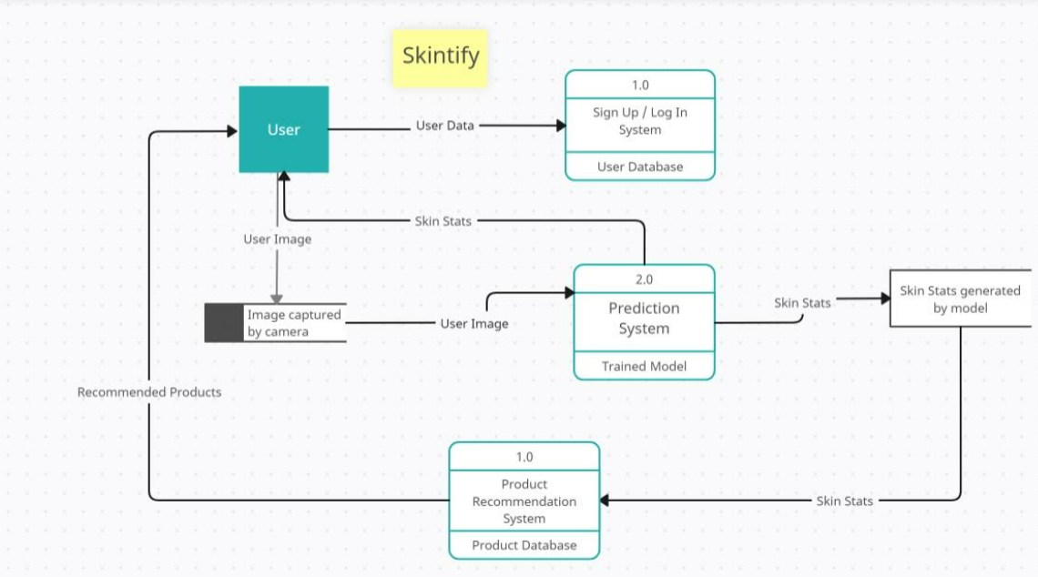

Figure 9: Data Flow Diagram showing the systematic flow of data between the different modules.
The flow begins with the User, the primary actor who provides User Data to the Sign Up / Log In System. This system interacts with the User Database, where user credentials and related data are stored and managed. This step is crucial for authenticating users and personalizing their experience.
The user then provides a User Image, which is captured by the camera. This image flows into the Prediction System, where a Trained Model processes the image to generate Skin Stats. These statistics likely include information about skin type and other relevant metrics that the model can infer from the image.
The Skin Stats are then utilized by the Product Recommendation System, which accesses a Product Database. This system uses the skin statistics to select appropriate products tailored to the user's specific skin analysis results. Finally, Recommended Products are presented back to the user, completing the cycle of interaction.

4.3 Data Dictionary
A data dictionary is a centralized repository of information about data, such as meaning, relationships to other data, origin, usage, and format. It is a reference tool that provides detailed information about the attributes and elements of the database.
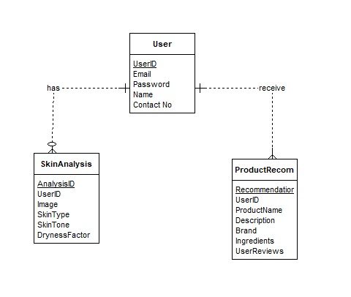

Figure 10: ERD for Skintify showing the entity relationships and how their data dictionary has been formed.
Based on the Entity-Relationship Diagram (ERD) provided in Figure 9, here's the data dictionary for the Skintify application:
- User Entity:
- UserID: (Integer) A unique identifier for each user of the Skintify app.
- Email: (String) The user's email address, used for account identification and communication.
- Password: (String) The user's password for accessing the Skintify app, stored securely.
- Name: (String) The full name of the user.
- Contact No: (String) The user's contact number for additional communication or account recovery purposes.
- SkinAnalysis Entity:
- AnalysisID: (Integer) A unique identifier for each skin analysis conducted within the Skintify app.
- UserID: (Integer) The identifier for the user who has undergone the skin analysis. This creates a link between the User and the SkinAnalysis.
- Image: (Binary) The digital representation of the user's skin image that is analyzed.
- SkinType: (String) The categorized type of the user's skin as determined by the analysis (e.g., oily, dry, combination).
- SkinTone: (String) The detected tone of the user's skin.
- DrynessFactor: (Decimal) A quantified measure of the user's skin dryness.

- ProductRecom Entity (Product Recommendation):
- RecommendationID: (Integer) A unique identifier for each product recommendation provided to the user.
- UserID: (Integer) The identifier of the user for whom the recommendation is intended, linking to the User entity.
- ProductID: (Integer) An identifier that uniquely represents a skincare product.
- Description: (Text) A textual description of the product, detailing its use and benefits.
- Brand: (String) The brand or manufacturer of the product.
- Ingredients: (Text) A list or description of the active and inactive ingredients in the product.
- UserReviews: (Text) Aggregated reviews or ratings from users regarding the product.

- Relationships:
- has: A one-to-many relationship from User to SkinAnalysis, indicating that a user can have multiple skin analyses.
- receive: A one-to-many relationship from User to ProductRecom, indicating that a user can receive multiple product recommendations.

5. Component Design
The component design for the Skintify application outlines the structure and characteristics of the individual components that make up the application, each serving a specific function within the system. These components work together to realize the application's capabilities in providing personalized skincare recommendations.

5.1 Use-case Diagram
The use-case diagram for the Skintify application illustrates the interactions between the users and the system, detailing the primary operations that users can perform within the application. The use-case diagram is a visual representation of the system’s functionalities as perceived by the user and the system’s data interactions.
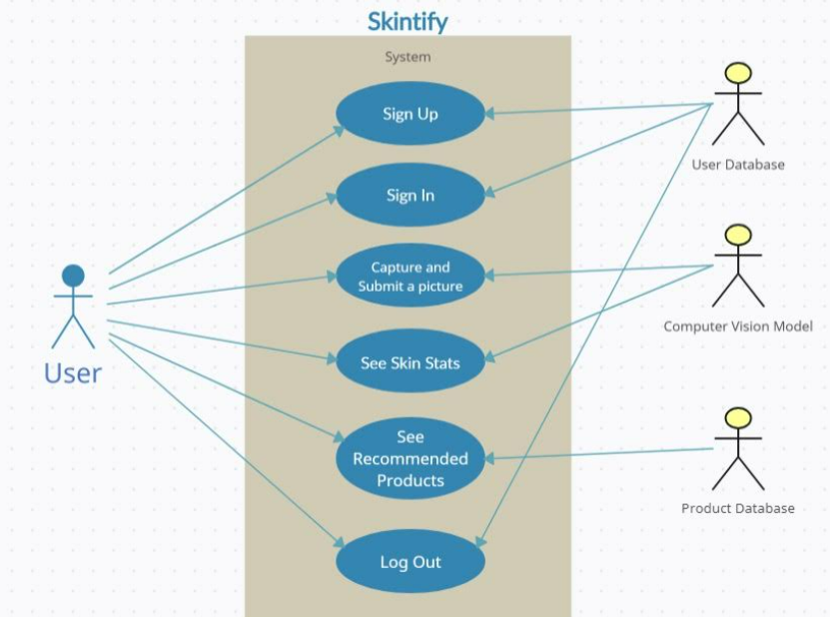

Figure 11: Use-case Diagram of Skintify detailing the system’s user functionalities.
At the center of the diagram is the Skintify System, which includes several use cases directly involving the User:
- Sign Up: The user can create a new account within the system.
- Sign In: The user can log into their existing account.
- Capture and Submit a Picture: Once logged in, the user can capture a picture of their skin and submit it for analysis.
- See Skin Stats: After the picture is analyzed, the user can view their skin statistics.
- See Recommended Products: Based on the analysis, the user can view products that are recommended for their skin type.
- Log Out: The user can sign out of the system.
The diagram also illustrates how the Skintify system interacts with three external actors/components:
- User Database: This is where user account information is stored. The system interacts with this database when the user signs up or signs in.
- Computer Vision Model: This represents the machine learning model used by the system to analyze the user's skin from the captured picture. It is involved in generating skin stats.
- Product Database: This database stores information about skincare products. The system uses this database to fetch recommended products for the user based on their skin analysis.
Use-case Descriptions:
Use Case ID: | 1
Use Case Name: | Sign up
Actors: | User (primary), User Database(Secondary).
Created By: | Ariba Noor Arshad | Last Updated By: | Mubashir Hussain Shah
Date Created: | 25/12/2023 | Date Last Updated: | 30/12/2023
Description: | Creation of user account for the application usage.
Preconditions: | The application requests the user to fill in necessary details regarding account creation
Post conditions: | The user enters the relevant information and an account is created.
Normal Flow (primary scenario): | After entering the correct information required, the user will have an account to log into the application and to use its features accordingly.
Alternative Flows: | Empty fields or wrongly-entered information generates an error message.
Exception flows: | When an invalid option is entered, display an error message.

Use Case ID: | 2
Use Case Name: | Sign in
Actors: | User (primary), User Database(Secondary).
Created By: | Ariba Noor Arshad | Last Updated By: | Mubashir Hussain Shah
Date Created: | 25/12/2023 | Date Last Updated: | 30/12/2023
Description: | The user will try to log into their account registered on Skintify.
Preconditions: | The application requests the user to fill in necessary details regarding account login.
Post conditions: | The user enters the relevant information and login is successful.
Normal Flow (primary scenario): | After entering the correct information required, the user will be logged into their account and the main menu page will be displayed.
Alternative Flows: | Empty fields or wrongly-entered information generates an error message.
Exception flows: | When an invalid option is entered, display an error message.

Use Case ID: | 3
Use Case Name: | Capture and submit a picture
Actors: | User (primary), Computer Vision Model(Secondary).
Created By: | Ariba Noor Arshad | Last Updated By: | Mubashir Hussain Shah
Date Created: | 25/12/2023 | Date Last Updated: | 30/12/2023
Description: | The user will select the skin scan option to get a skin analysis.
Preconditions: | The user has accessed the main screen.
Post conditions: | The user receives a detailed skin analysis.
Normal Flow (primary scenario): | The user selects the "Scan skin" option. The system captures an image of the user's face. The system analyzes the image to determine skin characteristics. The analysis includes parameters like skin type and skin tone. The results are displayed to the user.
Alternative Flows: | If the image quality is insufficient, the user is prompted to capture a better image.
Exception flows: | The user can choose to abandon the operation at any time.

Use Case ID: | 4
Use Case Name: | See skin stats
Actors: | User (primary), Computer Vision Model(Secondary).
Created By: | Ariba Noor Arshad | Last Updated By: | Mubashir Hussain Shah
Date Created: | 25/12/2023 | Date Last Updated: | 30/12/2023
Description: | The user will be shown their detailed skin analysis.
Preconditions: | The user has taken a facial scan.
Post conditions: | The user receives a detailed skin analysis.
Normal Flow (primary scenario): | After capturing a well-defined and a good quality image from the front camera, it is analyzed under the skintify model to present the skin stat report or the skin analysis the user wants.
Alternative Flows: | If the image quality is insufficient, the user is prompted to capture a better image.
Exception flows: | The user can choose to abandon the operation at any time.

Use Case ID: | 5
Use Case Name: | See Recommend Products
Actors: | User (primary), Product database(Secondary).
Created By: | Ariba Noor Arshad | Last Updated By: | Mubashir Hussain Shah
Date Created: | 25/12/2023 | Date Last Updated: | 30/12/2023
Description: | The user will select the ‘recommend product’ option to get product recommendations tailored to their skin analysis.
Preconditions: | The user skin has been analyzed.
Post conditions: | The user receives personalized product recommendations based on their skin analysis.
Normal Flow (primary scenario): | The user selects the ‘recommend product’ option. The system reviews the user's skin analysis results. Based on the analysis, the system recommends skincare products suitable for the user's skin type. The recommendations include product names and descriptions.
Alternative Flows: | If the user hasn't performed a skin analysis, they are prompted to do so before receiving recommendations.
Exception flows: | The user can choose to abandon the operation at any time.

Use Case ID: | 6
Use Case Name: | Logout
Actors: | User (primary), User Database(Secondary).
Created By: | Ariba Noor Arshad | Last Updated By: | Mubashir Hussain Shah
Date Created: | 25/12/2023 | Date Last Updated: | 30/12/2023
Description: | The user can opt to log out of their account from Skintify.
Preconditions: | The user has an account registered on Skintify.
Post conditions: | The user successfully logged out of their account.
Normal Flow (primary scenario): | The user will select the ‘Logout’ option which will generate a confirmation message and after receiving the confirmation, the account will be logged out, taking the user back to the User Authentication page.
Alternative Flows: | The confirmation is not approved or provided causing the application to persist for the confirmation before continuing towards account logout.
Exception flows: | The user can choose to abandon the operation at any time.

5.2 Activity Diagram
An activity diagram is a type of UML (Unified Modeling Language) diagram that visually represents the flow of activities and actions within a system or a business process. It is particularly useful for modeling dynamic aspects of a system, showcasing how different activities are performed and how they interact with each other. Activity diagrams provide a high-level view of the workflow in a system, emphasizing the sequence of activities, decision points, and parallel processes.
The activity diagram for the Skintify application describes the dynamic aspects of the system by detailing the workflow of activities and actions taken by the user, as well as the system's responses. It captures the sequence of operations that occur from the initiation of a task to its completion, including decisions and parallel processes.
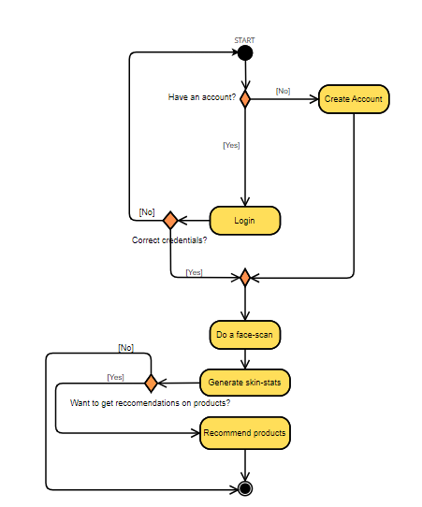

Figure 12: Activity Diagram of Skintify illustrating the process flow of the application use
- Start of the Process:
The diagram begins at the ‘Start’ point, where the user initiates the application.
- Account Check:
The first decision point asks whether the user has an existing account. If the user does not have an account, the flow leads to the ‘Create Account’ activity, where the user can register. If the user has an account, the flow proceeds to the ‘Login’ activity.
- Login Process:
At the ‘Login’ activity, the user enters their credentials. The system checks if the credentials are correct. If not, the flow loops back to the ‘Login’ activity for the user to try again. If the credentials are correct, the flow moves on to the next activity.
- Face Scan:
The next activity is ‘Do a face-scan’, where the user is expected to scan their face using the app’s interface. After the scan, the system generates skin statistics.
- Product Recommendation Decision:
A decision point follows, asking if the user wants to get product recommendations. If the user chooses not to receive recommendations, the process ends. If the user wants recommendations, the flow leads to the ‘Recommend products’ activity.
- End of the Process:
The final activity is the system presenting the recommended products to the user, after which the process reaches its end point.

5.3 Sequence Diagram
The sequence diagram for Skintify illustrates processes such as user registration, login, face scanning, skin analysis, and receiving product recommendations and how they interact with each other to carry out the system functionality.

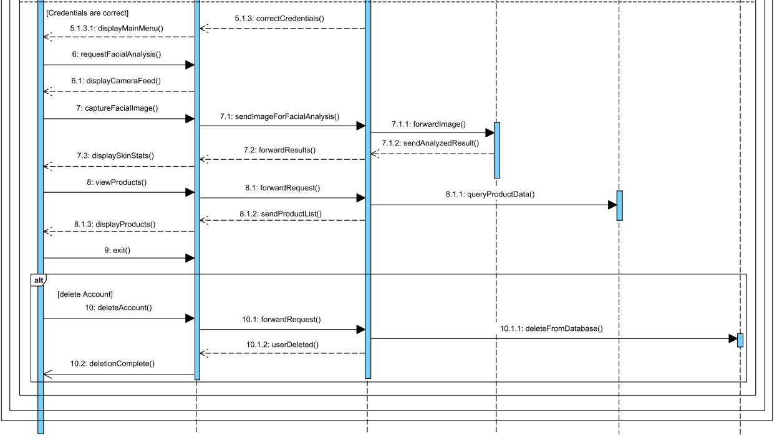
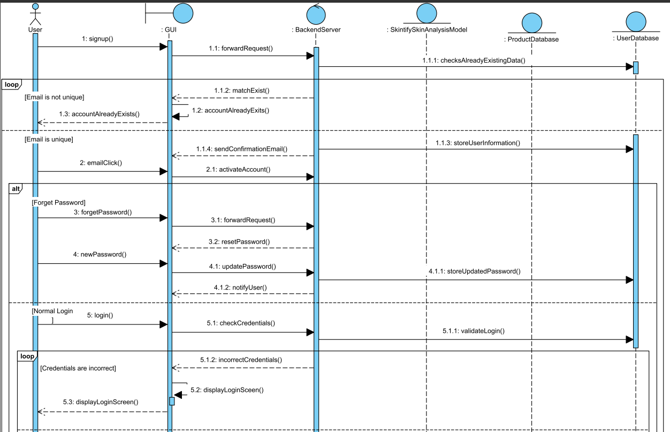
Figure 13: Sequence Diagram of Skintify showing the detailed logical flow of application.

Here's an overview of the interactions depicted in the diagram:
- User Registration:
The user interacts with the GUI to sign up. The GUI forwards this request to the backend server. The server creates an entry in the user database and sends a confirmation email to the user.
- Password Recovery:
If the user forgets their password, the GUI provides an option to recover it. The server manages the password recovery process, including sending an email to reset the password.
- User Login:
For logging in, the user provides credentials that the GUI sends to the server for verification. If credentials are correct, the server responds positively, allowing access to the system.
- Skin Analysis:
Upon successful login, the user can request a skin analysis. The GUI sends a request to the backend server, which in turn uses the SkintifySkinAnalysisModel to process the request. The results are then sent back to the GUI for display to the user.
- Product Recommendations:
Based on the analysis, the backend server fetches relevant product recommendations from the product database. These recommendations are then presented to the user through the GUI.
- Account Deletion:
If the user chooses to delete their account, the GUI sends this request to the backend server. The server removes the user's information from the user database and confirms the deletion to the GUI.

5.4 Class Diagram
A class diagram is a type of static structure diagram within the Unified Modeling Language (UML) that describes the structure of a system by showing the system's classes, their attributes, operations (or methods), and the relationships among the classes. It serves as a blueprint for the actual coding process in object-oriented programming and is widely used in software engineering.
The class diagram for the Skintify application provides a structured overview of the system's architecture in terms of classes, their attributes, methods, and the relationships between these classes.

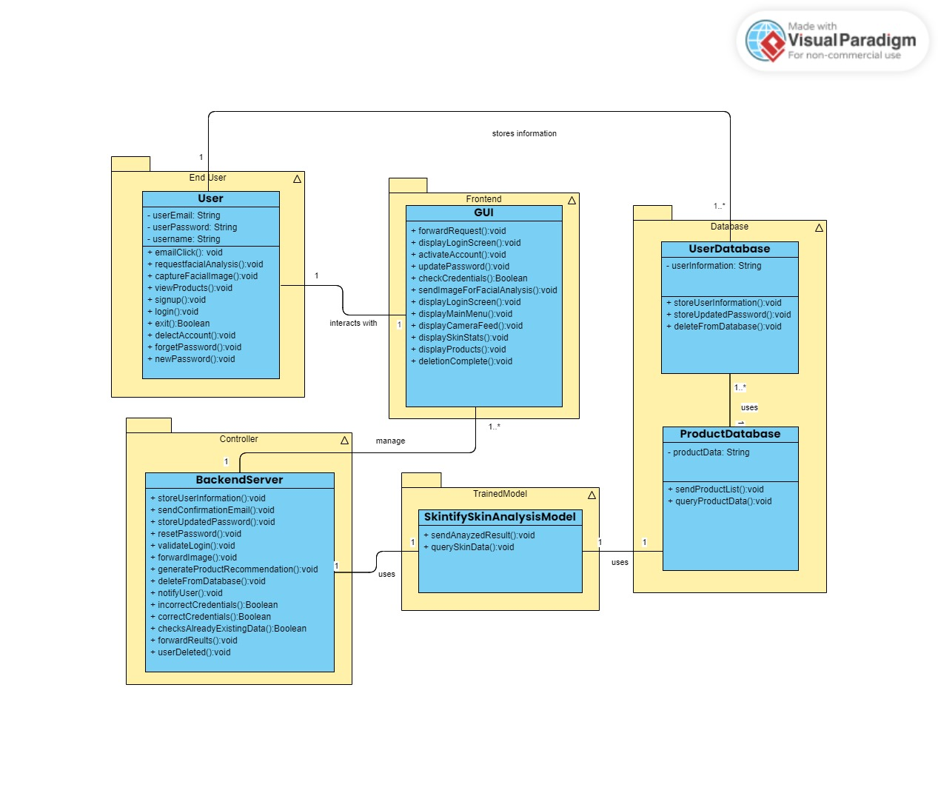

Figure 14: Class Diagram for Skintify - illustrating the key classes and their relationships for effective product recommendations based on skin analysis.

Starting with the End User, which represents the people who will be using the Skintify application, they interact primarily with the Frontend GUI. This GUI is essentially the interface of the application, which includes a variety of methods for user interaction such as displaying different screens (login, main menu, camera feed), forwarding requests, and handling account activation and password updates.
The User class has attributes to store email, password, and username, and includes methods for account management tasks such as email checking, login, logout, account deletion, and password management.
This GUI interacts with the BackendServer, which serves as the controller in this architecture. The BackendServer class has methods to manage user information and authentication, send confirmation emails, reset passwords, forward messages, and generate product recommendations. It interacts with two databases: the UserDatabase and the ProductDatabase.
The UserDatabase stores user information and has methods to manipulate this data, such as storing, updating, and deleting user information. Similarly, the ProductDatabase contains product data and methods to send product lists to the frontend and query product data.
Additionally, the BackendServer uses a SkintifySkinAnalysisModel, which represents the trained machine learning model used by the application. This model has methods to send analysis results and query skin data, which are essential for the skin analysis functionality of the application.
The SkintifySkinAnalysisModel is shown as a trained model, indicating that it's a component developed through machine learning methods to analyze and interpret skin data. It's used by the BackendServer to perform the core analysis that underpins the service provided by the Skintify app.
The relationship lines indicate how these classes interact. For instance, the Frontend GUI stores information in the UserDatabase and ProductDatabase, and it manages these interactions through the BackendServer. There's a one-to-many relationship from the BackendServer to the User and Product databases, as one instance of the server will handle multiple instances of data retrieval or storage actions.

5.5 Package Diagram
Skintify’s package diagram provides a visual representation of the organization and dependencies between different packages in a system. In software engineering, a package is a grouping mechanism for organizing elements, such as classes, interfaces, and other packages, into a cohesive unit. With this diagram, we have visually represented the dependencies between different packages.Moreover, it represents how we have organized the elements of a system into cohesive and manageable units called packages. Each package acts as a modular container for related classes, interfaces, or other packages.
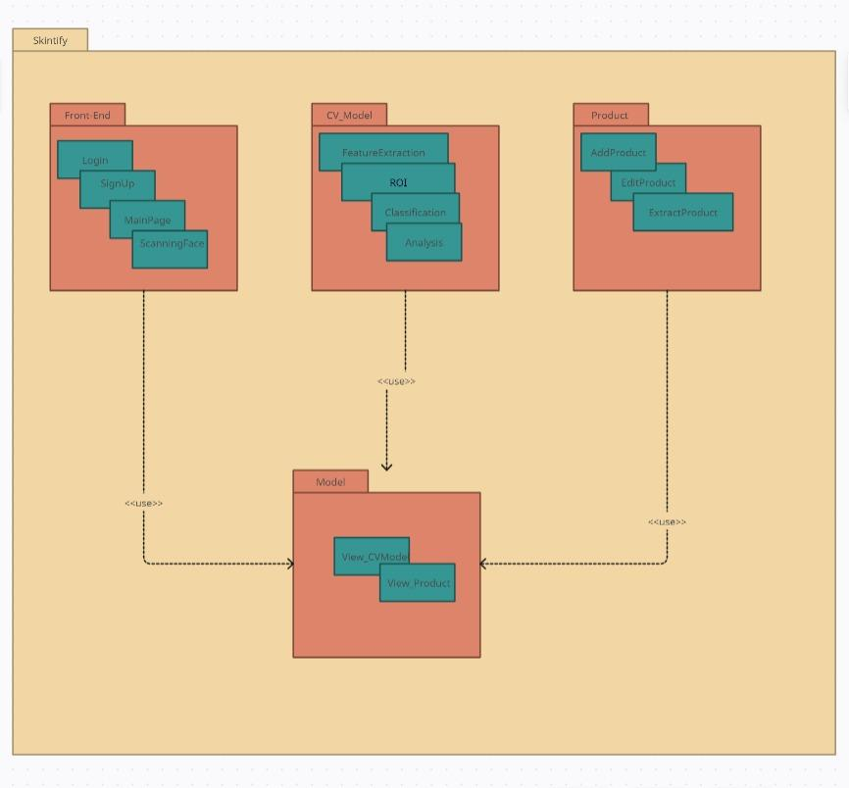
Figure 15: Package Diagram of Skintify indicating the package dependencies throughout the system.

5.5 Component Diagram
A component diagram is a type of UML (Unified Modeling Language) diagram that depicts the organization and relationships between components in a system. In software engineering, a system can be broken down into smaller, modular units known as components. These components represent the building blocks of a system, and they can be implemented as software modules, classes, or even physical entities.
The main purpose of a component diagram is to illustrate the high-level structure of a system and how its components interact with each other. It helps in understanding the architecture of a system and aids in communication among stakeholders, including developers, architects, and other members of a project team.
Skintify’s component diagram illustrates how the diagram captures the process flow through each component. The process starts when the user logs in to the app and scans their skin using the device's camera. The scanned image is then sent to the Skintify trained model, which analyzes the image and determines the unique skin statistics such as whether a certain person has oily skin or dry skin; whether a person’s skin has black heads or dark circles. These statistical results of the analysis are then sent back to the app and displayed to the user as per a skin stat report.
After the analysis of skin, the app offers the option of providing personalized product recommendations tailored to the skin analysis of the user.

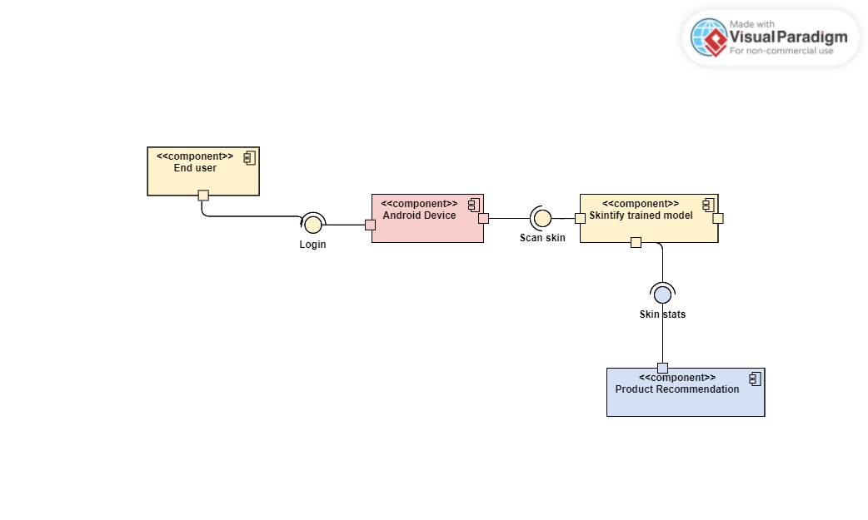
Figure 16: Component Diagram for Skintify - illustrating the process flow between the different components of the system.

6. Human Interface Design:
Human Interface Design, often referred to as User Interface (UI) Design, is a subset of User Experience (UX) design that focuses on the design of user interfaces for software, such as mobile apps, websites, and other electronic devices, with the goal of maximizing usability and the user experience. It is concerned with ensuring that the interface elements are laid out in an understandable, accessible, and efficient manner.

6.1 Overview of User Interface:
At Skintify, the focus of our Human Interface Design is to deliver an experience that feels intuitive, efficient, and engaging for our diverse user base. We prioritize ease of use, clarity, and aesthetic integrity to foster an environment where users can navigate and utilize our skin analysis and product recommendation features with confidence and ease.
The interface design is built around the premise that users should be able to navigate the application with minimal instruction. It prioritizes ease of use and clarity, offering a straightforward journey from skin analysis to product recommendation.

6.2 Screen Images:
The screen images have been included showing the Human User Interface showing the individual screens tailored to the application. The Interface is being worked upon with the help of Flutter and Visual Studio.
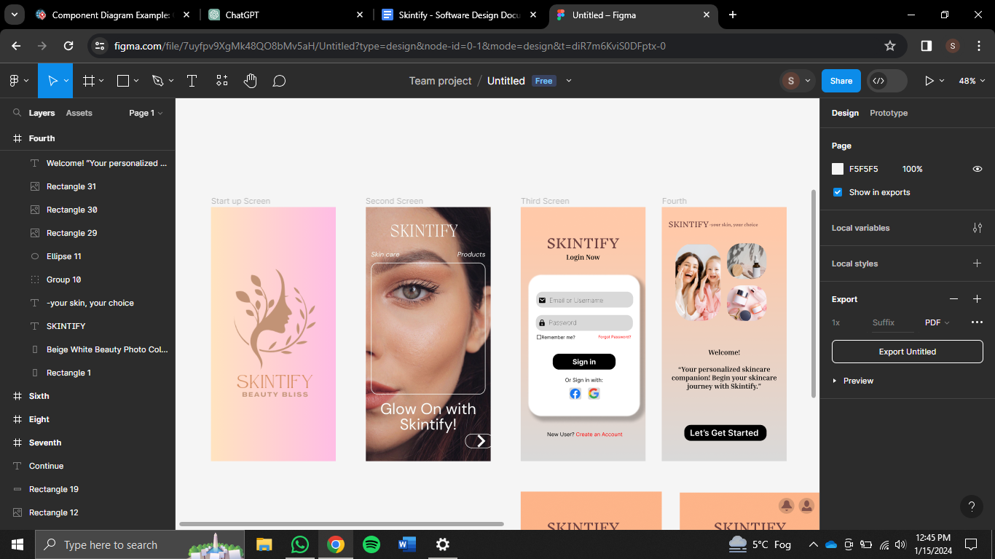

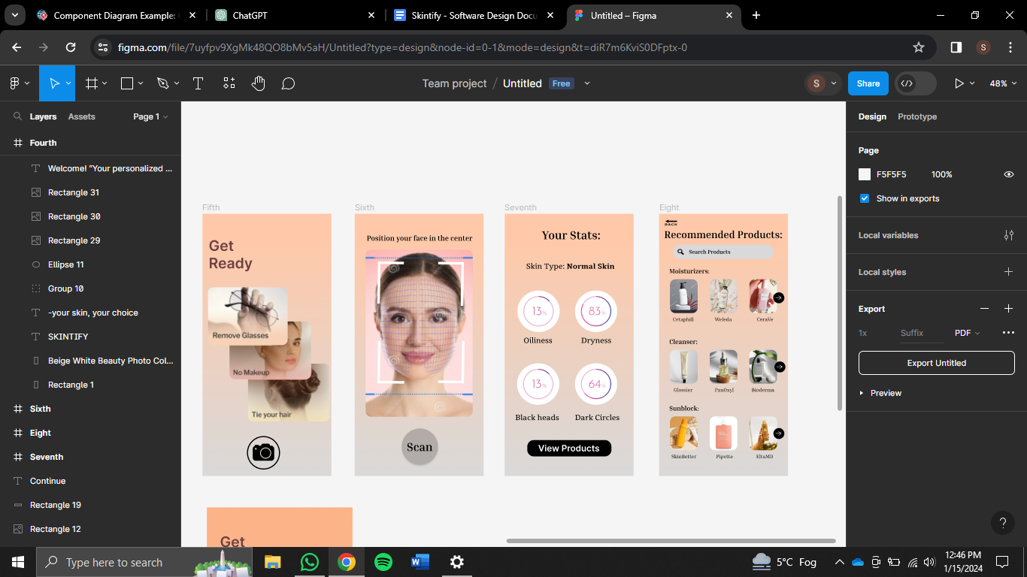

Figure 17: User Interface of Skintify built to ensure a seamless and intuitive user experience for skin analysis and personalized product suggestions.

The user interface for the Skintify app, as shown, includes eight screens, each serving a distinct purpose in the user's experience:
- Start-up Screen:
This is the first screen a user encounters upon launching the Skintify app. It features a warm, welcoming color palette and the Skintify logo with the tagline "Beauty Bliss," setting a positive, beauty-focused tone for the user experience.
- Second Screen:
This screen functions as a promotional slide within the app, highlighting the app's benefits or features with the slogan "Glow On with Skintify!". It serves to introduce the user to the app's features before they proceed to log in or sign up.
- Third Screen - Login Screen:
The login screen provides users with the ability to sign in to their account using their email or username and password. It includes a "Remember me" option for convenience, a link for users who may have forgotten their password, and alternative sign-in options using social media accounts like Facebook and Google. There's also an option for new users to create an account, indicating this screen serves both returning and new users.
- Fourth Screen - Main Menu:
This main menu screen appears after a user has successfully logged in. It offers a simple, clear interface from where the user can start to get their skin analyzed and further on get the personalized product recommendations tailored to their skin analysis based on their specific skin metrics.
- Fifth Screen - Preparation Instructions:
This screen is designed to help users prepare for a skin scan. It provides clear visual instructions on how to get ready for the scan by removing glasses, tying back hair, and ensuring a clean face without makeup. The "Continue" button suggests that once the user has followed these steps, they can proceed to the next stage of the skin analysis process.
- Sixth Screen - Skin Scanning:
Here, users are guided through the skin scanning process. The screen displays an overlay where users are instructed to align their face within the provided guidelines, ensuring an accurate scan. A prominent "Scan" button initiates the skin analysis process.
- Seventh Screen - Skin Analysis Results:
This screen presents the results of the skin analysis, displaying metrics such as skin type, oiliness, dryness, presence of blackheads, and dark circles. The design includes visual representations of these metrics, in the form of percentage rings, providing an at-a-glance overview of the user's skin condition. A "View Products" button suggests that users can proceed to see personalized product recommendations based on these stats.
- Eighth Screen - Product Recommendations:
The final screen showcases personalized skincare product recommendations based on the user's skin analysis results. Products are categorized (e.g., moisturizers, cleansers, sunblock), and each category has a selection of items displayed with images, making it easy for users to identify and choose products. There is also a search bar for users to look for products directly, enhancing the functionality and user autonomy in finding products.

6.3 Screen Objects and Actions:
- Start-up Screen:
Objects: Skintify Logo, Tagline.
Actions: No direct user actions; serves as a visual welcome message.
- Second Screen:
Objects: Informational Text, Background Image.
Actions: Swipe or tap to continue to the next screen.
- Third Screen - Login Screen:
Objects: Input Fields (Email/Username, Password), Sign-in Button, Social Media Sign-in Options, Forgot Password Link, Create Account Option.
Actions: Enter login credentials, tap to sign in, choose social media login, navigate to account recovery or account creation.
- Fourth Screen - Main Menu:
Objects: Menu Options (Scan Skin, Check Stats, Products Recommendation), Icons.
Actions: Tap on menu options to navigate to respective features.
- Fifth Screen - Preparation Instructions:
Objects: Instructional Content (Remove Glasses, No Makeup, Tie Your Hair), Continue Button.
Actions: Read instructions and tap "Continue" to proceed to the scan.
- Sixth Screen - Skin Scanning:
Objects: Face Alignment Overlay, Scan Button.
Actions: Position face within the overlay and tap "Scan" to initiate skin analysis.
- Seventh Screen - Skin Analysis Results:
Objects: Results Metrics (Skin Type, Oiliness, Dryness, Blackheads, Dark Circles), View Products Button.
Actions: Review analysis results and tap "View Products" to see recommended skincare items.
- Eighth Screen - Product Recommendations:
Objects: Search Bar, Product Categories, Individual Product Listings, Navigation Icons.
Actions: Use the search bar to find products, select a product category, choose a product for more information.

7. Logical Design:
Logical design refers to the conceptual and abstract representation of a system without specifying the details of how it will be implemented physically. The logical procedure for Skintify begins with 'Image Capture,' where a user takes a picture of their face. The system then extracts the 'Facial Region of Interest (ROI)' which focuses on the area of the image necessary for analysis. Once the ROI is determined, 'Feature Statistic' processes are applied to the extracted facial region to identify and quantify specific skin features. These features are then fed into a predictive algorithm such as SVM (Support Vector Machine) where it predicts the skin type by classifying it into categories such as 'Dry Skin' or 'Oily Skin'.
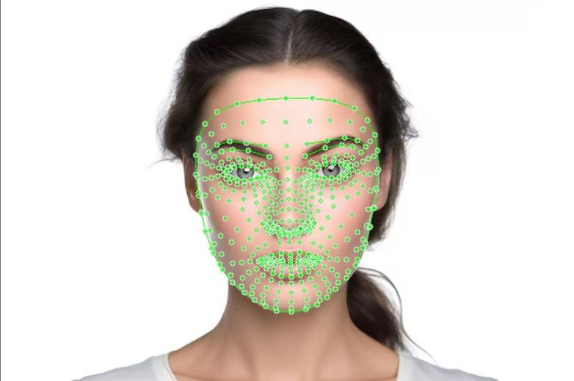

Subsequently, the flowchart depicts another 'Texture Feature Statistics' step, suggesting that a deeper analysis is conducted on the skin's texture, likely looking for specific issues like 'Blackheads' or 'Dark Circles'. Another predictive analysis follows, which uses the texture statistics to make further classifications.
The process concludes with the 'Product Recommendation' phase, where based on the final predictions or rather the skin analysis, suitable skincare products are suggested to the user.
Figure 18: ROI extraction from Skintify
This recommendation is informed by a database that contains information about various skin types and a corresponding product database that includes details on skincare products. These are then tailored to recommend skincare products that correspond to the user’s analyzed skin features by Skintify’s model.

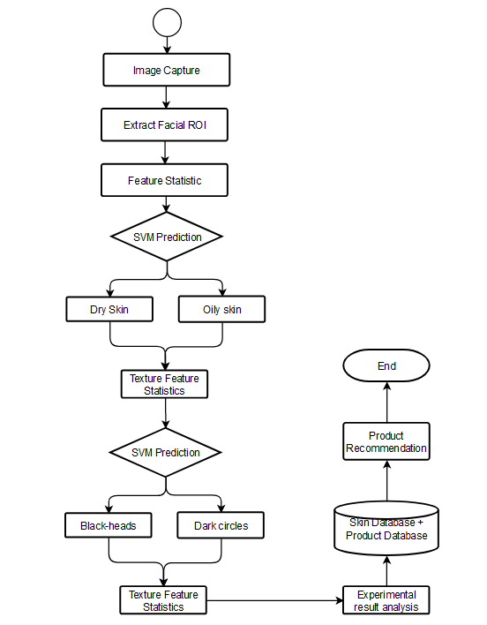

Figure 19: Logical flow of Skintify model creation.

8. Requirement Matrix
A Requirements Traceability Matrix (RTM) is a document, typically in the form of a table, that captures and maps all the requirements of a system to their corresponding test cases. The purpose of an RTM is to ensure that every functional and nonfunctional requirement is accounted for throughout the stages of the project lifecycle, from initial conception through design, development, testing, and final delivery.
Below is the RTM of Skintify detailed out as per the stipulated requirements prior in the Software Requirement Specification (SRS) document as well as those enunciated in the component design in this document:

Requirement ID | Description | Source | Priority | Use Case | Design Element | Test Case(s) | Test Status
REQ-001 | User must be able to create an account | SRS | High | Create Account | User Class | TC-001-CreateAccount | Pending
REQ-002 | User must be able to login | SRS | High | Login | User Class | TC-002-Login | Pending
REQ-003 | User must be able to perform a facial scan | SRS | High | Do a face-scan | FaceScan Class | TC-003-FacialScan | Pending
REQ-004 | The system must analyze facial scans and generate skin stats | SRS | High | See skin-stats | SkinStat Class | TC-004-GenerateSkinStats | Pending
REQ-005 | The system must recommend products based on skin stats | SRS | High | Recommend Products | Recommender Class | TC-005-ProductRecommendation | Pending
REQ-006 | User must be able to edit their profile | SDD | Medium | Edit Profile | User Class | TC-006-EditProfile | Pending
REQ-007 | User must be able to delete their account | SDD | Medium | Delete Account | User Class | TC-007-DeleteAccount | Pending

9. References
- DOBSON, J. E. (2023). Describing Pictures: From Image Understanding to Computer Vision. In The Birth of Computer Vision (pp. 97–132). University of Minnesota Press. http://www.jstor.org/stable/10.5749/j.ctv2z86295.7
- WEST, D. M., & ALLEN, J. R. (2020). WHAT IS AI? In Turning Point: Policymaking in the Era of Artificial Intelligence (pp. 1–26). Brookings Institution Press. http://www.jstor.org/stable/10.7864/j.ctvwh8fcb.4
- Li, Z., Koban, K. C., Schenck, T. L., Giunta, R. E., Li, Q., & Sun, Y. (2022). Artificial Intelligence in Dermatology Image Analysis: Current Developments and Future Trends. Journal of Clinical Medicine, 11(22), 6826. MDPI AG. Retrieved from http://dx.doi.org/10.3390/jcm11226826
- Vatiwutipong, P., Vachmanus, S., Noraset, T., & Tuarob, S. (2023). Artificial Intelligence in Cosmetic Dermatology: A Systematic Literature review. IEEE Access, 11, 71407–71425. https://doi.org/10.1109/access.2023.3295001
- Hosek, S. D., & Straus, S. G. (2013). Privacy of Individual Health Information. In Patient Privacy, Consent, and Identity Management in Health Information Exchange:Issues for the Military Health System (pp. 19–30). RAND Corporation. http://www.jstor.org/stable/10.7249/j.ctt3fgzjz.10
- Model-View-Controller Pattern. (2009). In Apress eBooks (pp. 353–402). https://doi.org/10.1007/978-1-4302-2370-2_20
- Freeman, A. (2014). The Singleton pattern. In Apress eBooks (pp. 113–136). https://doi.org/10.1007/978-1-4842-0394-1_6
- Freeman, A. (2014a). The observer pattern. In Apress eBooks (pp. 447–472). https://doi.org/10.1007/978-1-4842-0394-1_22
- The composite pattern. (2008). In Apress eBooks (pp. 125–140). https://doi.org/10.1007/978-1-4302-0496-1_9
- Li, Q., & Chen, Y. (2009). Data Flow Diagram. In Springer eBooks (pp. 85–97). https://doi.org/10.1007/978-3-540-89556-5_4

10. Appendices

Appendix A: Glossary

A
App: Refers to the Skintify application

API: Stands for Application Programming Interface, a set of protocols and tools for building software applications

Authentication: The process of verifying the identity of a user or device

B
Back-end: The part of the application that is responsible for processing and managing data

Browser: A software application used to access information on the internet

D
Database: A collection of data stored electronically
Deployment: The process of making an application available for use by end-users

E
Encryption: The process of transforming readable data into unreadable code

Error Handling: The process of managing and responding to errors that occur in an application.

F
Front-end: The part of the application that is responsible for the user interface and interaction

H
HTML: Stands for Hypertext Mark-up Language, a standard mark-up language used for creating web pages and other on-line content

HTTP: Hypertext Transfer Protocol, a protocol used for communicating data across a network.

I
IDE: Stands for Integrated Development Environment, a software application that provides comprehensive facilities for software development

IP: Stands for Internet Protocol, a protocol used for communicating data across a network.

L
Login: The process of verifying a user's identity before granting access to a system or service

N
Network: A system of computers and other devices connected together

P
Performance: The measure of how well the system performs in terms of speed, efficiency, and resource utilization

Portability: The ability of the system to be transferred or adapted to different environments or platforms without requiring significant modifications

Privacy: The protection of user data and information from unauthorized access or disclosure

Prototype: A preliminary version of the system that is used to test and refine its design and functionality

Q
Quality Assurance: The process of ensuring that the system meets the specified quality standards and requirements

Query: A question posed to a database

R
Reliability: The ability of the system to perform its functions accurately and consistently over a period of time without failure or error

Requirements: The functional and non-functional features and characteristics that the system must possess to meet the needs and expectations of its users and stakeholders

S
Scalability: The ability of the system to handle increased workloads or users without compromising performance or functionality

Security: The protection of the system from unauthorized access, use, modification, or destruction of data or information

Server: A computer that provides services to other computers

Software: The programs, applications, and scripts that make up the system and enable it to perform its functions

Appendix B: Work Breakdown Structure of Skintify
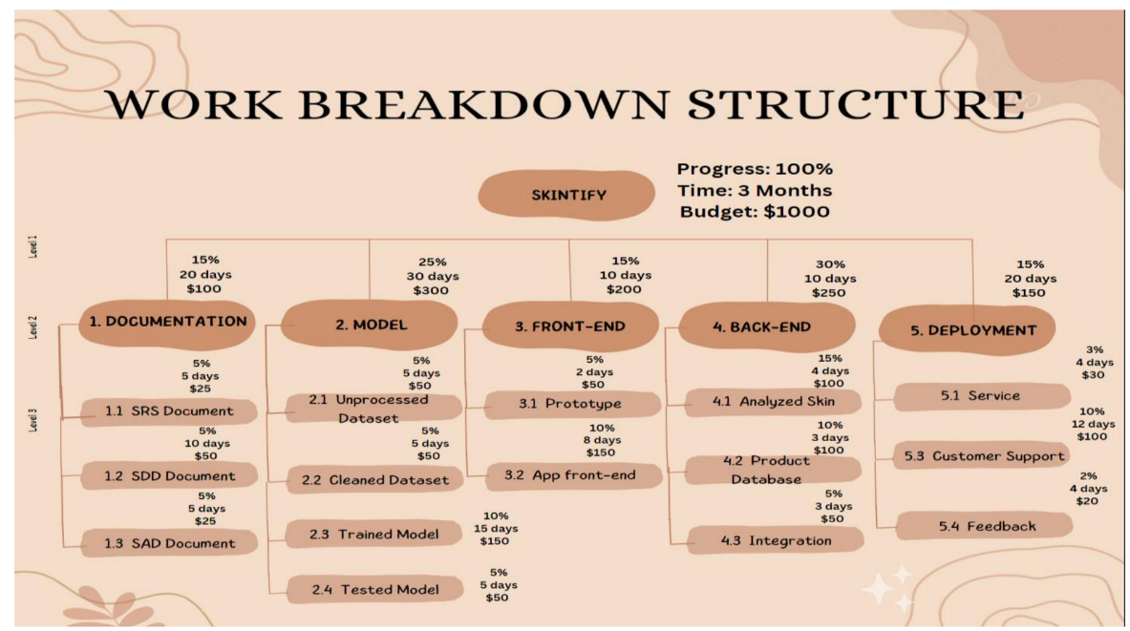
Figure 20: Work Breakdown Structure of Skintify detailing the budget, time and progress breakdown throughout the project deliverables.

Appendix C: Deployment View of the system.
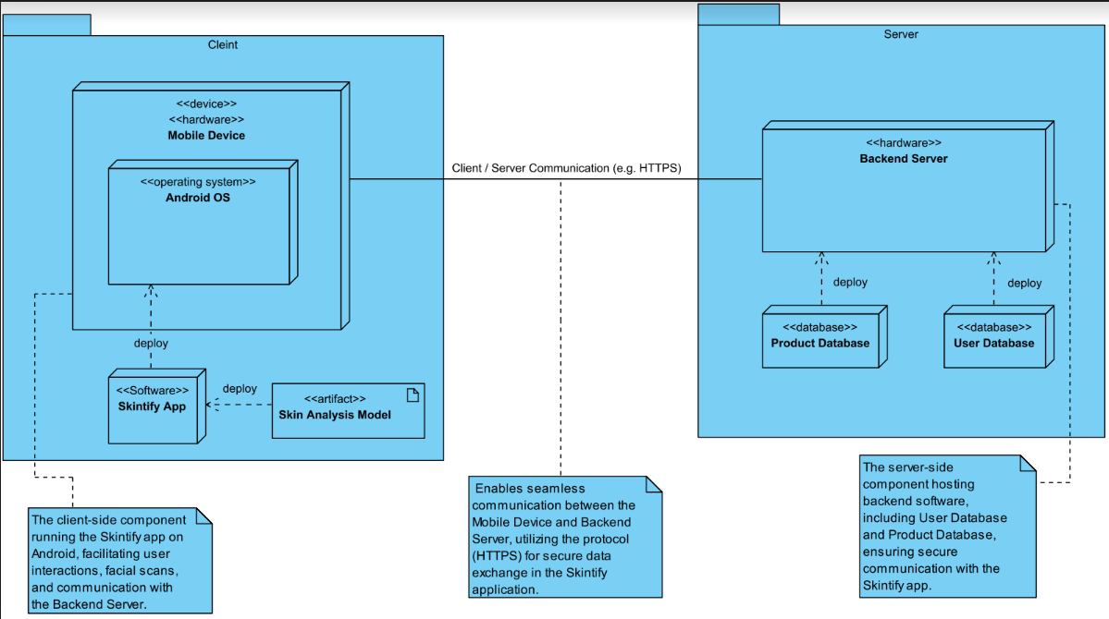
Figure 21: Deployment View of Skintify illustrating the physical deployment strategy

The deployment diagram for the Skintify application illustrates how the software components are distributed across the hardware and how they interact with each other.
On the client side, the deployment is on a mobile device running the Android operating system. Two key software components are deployed here: the Skintify App, which is the front-end application that users interact with, and the Skin Analysis Model, which is the trained model used by the Skintify App for conducting skin analysis.
Communication between the client and the server is facilitated via a secure protocol, such as HTTPS, ensuring that data transmitted between the client and server is encrypted and secure.
The server side shows a Backend Server, which is responsible for the server-side operations of the Skintify application. This server hosts two databases: the Product Database and the User Database. The Product Database stores information about skincare products that can be recommended to users, and the User Database holds user-related information including user credentials, preferences, and skin analysis history.

Appendix D: Skintify Timeline
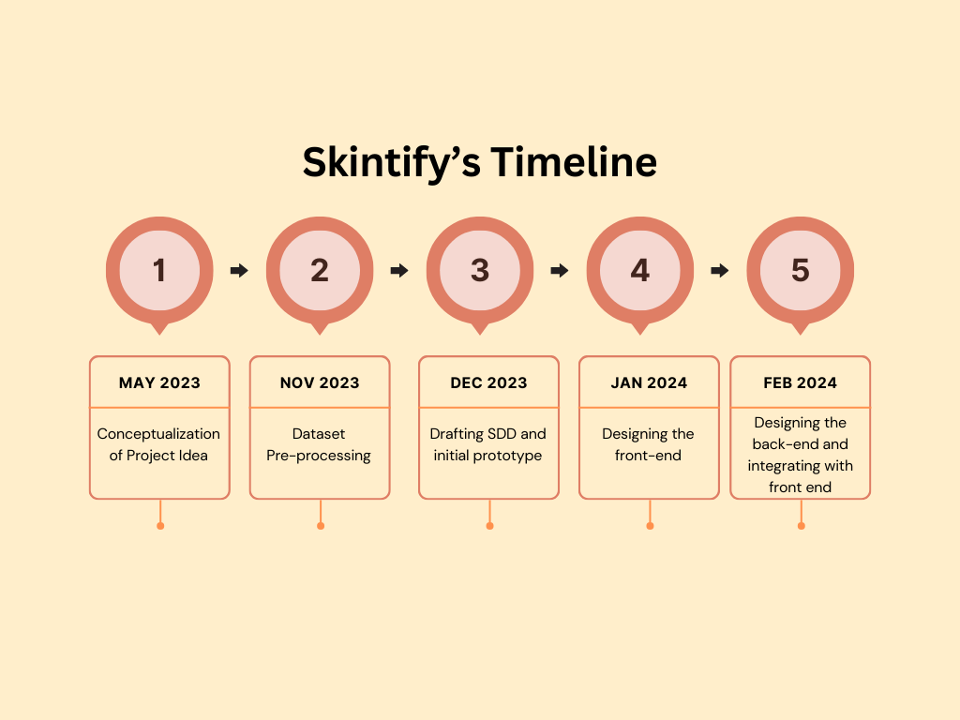

Figure 22: The tentative Skintify application timeline detailing the project milestones.

Appendix E: To Be Determined List
The following is a numbered list of TBD references that require further specification or clarification in the Skintify SDD. These TBD items will be tracked and addressed accordingly to ensure the comprehensive and accurate documentation of the project:
TBD: Specify the synchronization mechanisms utilized in the Skintify app for data coordination.
TBD: Provide detailed information on the encryption methods and protocols employed to secure user data during communication.
TBD: Outline the message formatting requirements for communication functions, including any specific standards for data presentation.
TBD: Identify the precise integration protocols, data items, and messages between the Skintify app and external software components, including the version of third-party software used.
TBD: Document the exact interfaces between the Skintify app and the hardware components, specifying supported device types, data and control interactions, and communication protocols.

The above TBD items will be resolved and detailed as part of the ongoing project documentation efforts.

