IOT - Assignment 3

Amna Alvie
Department of Software Engineering Military College of Signals Islamabad, Pakistan aalvie.bse22mcs@student.nust.edu.pk

Ayela Noor Arshad
Department of Software Engineering Military College of Signals Islamabad, Pakistan
aarshad.bse22mcs@student.nust.edu.pk

Mavia Adil Siddiqui
Department of Software Engineering Military College of Signals Islamabad, Pakistan
msiddiqui.bse22mcs@student.nust.edu.pk

Radia Riaz
Department of Software Engineering Military College of Signals Islamabad, Pakistan rriaz.bse22mcs@student.nust.edu.pk

Sidra Kayenat
Department of Software Engineering Military College of Signals Islamabad, Pakistan
skayenat.bse22mcs@student.nust.edu.pk

Question 1

Write functions of GPIO pins of Raspberry Pi.
Raspberry Pi GPIO Pin Functions
The GPIO (General Purpose Input/Output) pins on a Raspberry Pi allow for versatile interfacing with external components. These pins support digital input and output, making it possible to control LEDs, read button states, or activate relays [1] [2] [3]. Power pins (e.g., Pin 1 for 3.3V, Pin 2 for 5V) supply power to peripherals, while GND pins (e.g., Pin 6, 9, 14) provide grounding. PWM (e.g., Pin 12 for hardware PWM) enables control over devices like LEDs and motors for analog effects. Communication protocols like I2C (Pins 3 for SDA, 5 for SCL), SPI (Pins 19 for MOSI, 21 for MISO, 23 for SCLK), and UART (Pins 8 for TXD, 10 for RXD) allow data transfer with compatible sensors, displays, and modules.
Some GPIO pins have specialized functions; for instance, Pin 27 is generally reserved for I2C communication with an EEPROM. Other pins like Pin 7 (GPIO 4) can output a clock signal. Overall, the Raspberry Pi’s GPIO layout provides a flexible means to interface with both digital and analog devices, suitable for building a range of DIY and IoT projects.
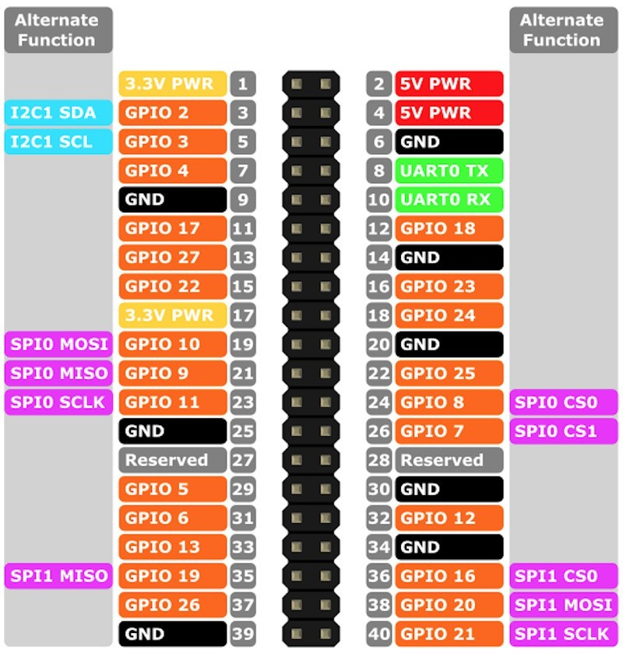
Figure 1. Raspberry Pi GPIO Pinout Diagram
Question 2

Compare Arduino and Raspberry Pi in terms of com- ponents and functions.

Arduino

The Arduino is a microcontroller platform optimized for direct, low-latency hardware control, making it ideal for sim- ple, single-purpose applications like sensor data collection, motor control, and LED management. It was designed to provide a simple and accessible platform for beginners to learn electronics and programming with a limited number of I/O pins. It operates without an OS, running commands sequentially, which is advantageous for real-time responses in embedded applications. With onboard flash memory (typically 32 KB) and RAM (2 KB), it has limited storage and requires programming in C/C++ via the Arduino IDE. Powered through USB Type B, it consumes low power and resumes operation automatically after power interruptions, minimizing the impact on ongoing tasks [4].

Raspberry Pi

The Raspberry Pi, a single-board computer, runs on an ARM-based processor and supports full OSes like Raspberry Pi OS, making it versatile for multitasking and high-level processing tasks. It offers connectivity options (HDMI, Eth- ernet, Wi-Fi) and programming flexibility (Python, C, Java), suitable for networked applications, multimedia, and GUI- based projects. It uses a more powerful system-on-a-chip (SoC) that provides more processing power and memory, and a greater number of I/O pins. Its clock speed (1.5 GHz on Pi 4) and support for larger memory (e.g., 4 GB eMMC, expandable via SD card) enable it to execute commands based on priorities or in parallel, but frequent power interruptions can damage its hardware, often requiring a UPS [4].

Table I
Comparison of Components and Functions of Arduino and
Raspberry Pi

Aspect | Arduino | Raspberry Pi
Components
Core Component | Microcontroller Unit (MCU) | Microprocessor (Broadcom SoC)
Clock Speed | Varies by model; typically around  16 MHz to 480 MHz | Typically 1.5 GHz or higher
Memory | Varies by model; usually has 32  KB Flash Memory, 2 KB SRAM | Up to 8 GB RAM (varies by  model)
GPIO Pins | Typically around 14 to 20 GPIO  pins | Typically 40 GPIO pins
Operating Voltage | 5V | Between 1.8V and 3.3V
Power Source | Powered via USB Type B or  external power supply; low power requirements | Requires micro-USB or USB-C; higher power consumption
Power Management | Not significantly affected by  power interruptions; resumes automatically | Susceptible to damage from power interruptions; may require a UPS
Connectivity | Limited to GPIO and basic serial  communication | Extensive options including USB,  HDMI, Ethernet, and more
Functions
Working Principle | Microcontroller processes inputs  and controls outputs based on programmed instructions | CPU manages operating system  tasks, running various software and interfacing with hardware
Functionality | Executes simple, real-time tasks; excellent for hardware control | Functions as a mini-computer,  running a full OS for complex applications
Development | Generally programmed using Arduino IDE with C/C++ | Supports multiple programming  languages and IDEs (Python, Java, etc.)
Typical Applications | Best for hardware projects,  robotics, sensor integration | Ideal for media centers, web  servers, gaming, and IoT projects

Question 3
How Arduino and Raspberry Pi can be used together. Give an example.
How Arduino and Raspberry Pi Can Be Used Together
Arduino and Raspberry Pi are both powerful platforms, each with unique strengths that make them well-suited to specific tasks. By using them together, we can create a flexible, effi- cient system for various applications. Here are three examples of how Arduino and Raspberry Pi can complement each other in scenarios like :

Sensor Data Collection and Processing:
  - The Arduino is ideal for collecting real-time data from sensors, managing inputs, and handling straightforward tasks that require precise timing.
  - The Raspberry Pi can process, analyze, and store this data, creating a powerful combined system. The Arduino handles the hardware-specific tasks (such as temperature, light, or motion sensing), while the Raspberry Pi processes the collected data and displays it on a user interface, often accessible over the internet.

Robotics and Automation Systems:
  - The Arduino can be the primary controller for mo- tors, sensors, and actuators in a robot or automated system, while the Raspberry Pi acts as the brain, running complex algorithms and handling image processing or decision-making.
  - The Arduino operates at a low level, managing individual components, while the Raspberry Pi can handle more advanced functions, making the system
robust and efficient. One such Project that uses both Arduino and Raspberry PI for Robotics is [5]

Example of a Combined Project: Raspberry Pi and Arduino UNO Working Together as a Basic Meteorological Station
The research paper [6] provides a concrete example of how these platforms can be integrated for weather monitoring.

Project Overview
This project describes a meteorological station that mon- itors environmental data, specifically designed to support renewable energy projects by collecting information about weather conditions (temperature, humidity, solar radiation, wind speed, and direction). The project was carried out at the Instituto Tecnolo´gico de Veracruz in Mexico, where a team of engineers built a combined system using Raspberry Pi Model B and Arduino UNO to create a responsive, internet-enabled meteorological station.

Hardware Components Used
- Raspberry Pi Model B: Acts as the central hub, man- aging data received from the Arduino and hosting a web server.
- Arduino UNO: Collects data from environmental sensors and transmits it to the Raspberry Pi.
- USB Cable (Type A to B): Connects the Arduino to the Raspberry Pi for serial data transmission.
- Various Sensors: Arduino connects to multiple sensors for measuring solar luminescence, humidity, wind speed, and temperature.
System Architecture and Function

Arduino UNO for Sensor Management:
  - The Arduino UNO collects data from multiple sen- sors, configured to measure temperature, humidity, wind, and solar radiation.
  - The collected data is transmitted to the Raspberry Pi over a USB connection. The serial communication speed was initially set to 1 Mbps but was later adjusted to a more reliable 9600 baud rate to reduce data errors.

Raspberry Pi for Data Processing and Web Display:
  - The Raspberry Pi runs the Raspbian OS and is programmed in Python. It receives sensor data from the Arduino, logs it for later analysis, and displays it on a web interface using the Apache web server.
  - Apache, along with PHP for webpage creation and PostgreSQL for database management, enables real-time data viewing on a locally hosted webpage, which refreshes every five minutes. The system’s data is also stored in log files for historical tracking and analysis.

Web Server and Data Accessibility:

  - The Raspberry Pi acts as a web server, using Apache to display the collected sensor data in real- time. A secondary Python script reads the latest data from the log file and updates the HTML code in the web page, making the latest measurements viewable to users who access the page.
  - This setup allows for remote access to the me- teorological data, facilitating easy monitoring of environmental conditions.
How Arduino and Raspberry Pi complement each other

Task Optimization:
  - The project efficiently splits tasks between the two platforms: Arduino handles real-time data collection from sensors, while Raspberry Pi manages data processing, logging, and web hosting. This division of labor ensures each component operates within its optimal capacity without performance compromise.

Flexibility and Expandability:
  - This modular design allows for future scalability. More sensors can be added to the Arduino without affecting the Raspberry Pi. Additionally, if a newer model of either platform is needed, it can be swapped in without significant reconfiguration.

User Accessibility:
  - By hosting a web page on the Raspberry Pi, the system provides easy remote access to the latest en- vironmental data, a feature that would be challenging to implement on Arduino alone. This setup is ideal for real-time environmental monitoring applications where remote data access is critical.

Conclusion
In summary, combining Arduino and Raspberry Pi leverages their strengths to enhance project capabilities across diverse applications. Arduino specializes in real-time data collection and control, while Raspberry Pi provides advanced process- ing and connectivity. Together, they enable flexible, scalable, and efficient systems suitable for automation, robotics, and environmental monitoring, streamlining development and im- proving overall functionality.
References
- Tutorialspoint, “Raspberry pi - gpio connector,” [Accessed: Nov. 2, 2024]. [Online]. Available: https://www.tutorialspoint.com/raspberry pi/ raspberry pi gpio connector.htm
- Raspberry Pi Foundation, “Raspberry pi documentation - gpio and the 40-pin header,” [Accessed: Nov. 2, 2024]. [On- line]. Available: https://www.raspberrypi.com/documentation/computers/ raspberry-pi.html#gpio-and-the-40-pin-header
- Pinout.xyz, “General purpose clock (gpclk) pinout,” https://pinout.xyz/ pinout/gpclk, [Accessed: Nov. 2, 2024].
- G. L. Team, “Arduino vs raspberry pi: What’s the difference?” accessed: 2024-11-01. [Online]. Available: https://www.mygreatlearning.com/blog/ arduino-vs-raspberry-pi/
- Sebastian, “Radu: How to build a robot with arduino and raspberry pi.” [Online]. Available: https://dev.to/admantium/ radu-how-to-build-a-robot-with-arduino-and-raspberry-pi-38m4
- J. Leon, R. Martinez-Gonzalez, A. Miranda, and L. A. Pelaez, “Raspberry pi and arduino uno working together as a basic meteorological station,” International Journal of Computer Science and Information Technology, vol. 9, pp. 97–104, 10 2017.

