IoT-based LPG Gas Leakage Detection and Prevention System

Amna Alvie ¹
Department of Software Engineering Military College of Signals Islamabad, Pakistan aalvie.bse22mcs@student.nust.edu.pk

Ayela Noor Arshad ²
Department of Software Engineering Military College of Signals Islamabad, Pakistan
aarshad.bse22mcs@student.nust.edu.pk

Mavia Adil Siddiqui ³
Department of Software Engineering Military College of Signals Islamabad, Pakistan
msiddiqui.bse22mcs@student.nust.edu.pk

Radia Riaz ⁴
Department of Software Engineering Military College of Signals Islamabad, Pakistan rriaz.bse22mcs@student.nust.edu.pk

Sidra Kayenat ⁵
Department of Software Engineering Military College of Signals Islamabad, Pakistan
skayenat.bse22mcs@student.nust.edu.pk

Abstract—Internet of Things is changing the scenario of safety and automation with real-time communication between devices. This research aims at developing an IoT-based system for Liquefied Petroleum Gas leakage detection and prevention. The system monitors gas leaks continuously, detects tampering, and automates safety responses such as alarm activation, gas supply shutoff, ventilation, and alerts. This system enhances safety in residential, commercial, and industrial environments through the use of components such as MQ-6 Gas Sensor, Bluetooth Module, and Arduino Uno. Future directions include integration with smart home systems and advanced data analytics.
Index Terms—IOT, LPG leakage detection, LPG leak preven- tion, tampering detection.

- SCOPE
The purpose of this study is to develop an IoT-based LPG leakage monitoring and prevention system that will enhance safety in residential, commercial, and industrial settings. It was designed for real-time monitoring, automatic reactions, and alerting capabilities. The integration of advanced sensors and communication modules ensures rapid hazard detection, operational reliability, and increased user awareness. Scalable technology can meet immediate safety concerns as well as long-term operational issues; thus, its applications include smart homes and industrial safety systems.
- INTRODUCTION
Liquefied Petroleum Gas (LPG) is commonly used in Pak- istan for cooking, heating, and industrial purposes because it is efficient and cost-effective. However, due to its high flammability, it is a significant safety hazard in residential settings where gas appliances are not always handled properly. Cases of improper handling, such as undeliberately left-open gas stoves or poorly maintained valves, can result in disastrous consequences including gas explosions. LPG gas leaks pose risks to a large number of communities in Pakistan. Families dependent on LPG for cooking and heating are at increased
risk, especially women and children, who spend much time at home.
Gas accidents have always caused immense damage, thereby emphasizing the importance of a proper gas leak detection and prevention system. The more severe side effects of gas leakage comprise respiratory disorders, nausea, and dizziness. However, with high levels of LPG exposure, there could be a possibility of death. Recently, a bus stand explosion took place in Lahore, where 13 people were injured. This shows the continued dangers of gas leakage in the area(1). Another is the LPG blast in Hyderabad injured at least 50 people(2), and other similar incidents in residential and commercial areas caused loss of life, injuries, and psychological trauma.
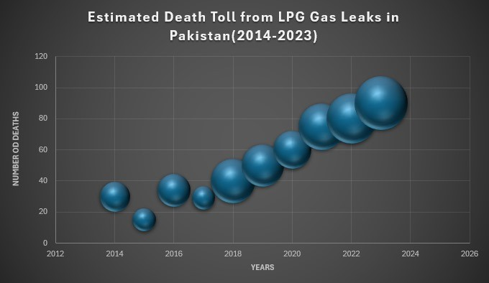

Fig. 1. Estimated Death Toll Due to LPG Leakage in Pakistan

This is the approximate total number of deaths caused by leakage of LPG gas during the period of 2014 to 2023, as collected from diverse online sources, which would include articles, news articles, and public discussions relating to safety. The relative size of the bubble refers to the number of incidents occurring that year. The graph shows the increasing rate of

deaths, starting from 2014 till 2023. Few such incidents are mentioned below. Five people got injured due to a gas leak in the year 2013 as well. In the year 2015, five death tolls were reported due to leakage in Rawalpindi and Islamabad. In 2020 and 2021, two different gas leaks in Karachi resulted in 21 dead and over 100 people affected and injured (3), (4). In 2020 and 2021, two various gas leaks in Karachi caused the deaths of 21 people and damaged over 100 people, where over 100 people have been injured (3), (4). More recently, with a van explosion killing three passengers in 2024 (5) and a cylinder blast in Hyderabad (6), the threat becomes more and more intense. Implementing this approach will greatly improve public health and safety by reducing the occurrence of gas-related incidents. It will also ease the financial burden on families by lowering expenses related to home repairs and medical treatments. Furthermore, enhancing community safety fosters a sense of security and well-being, which in turn supports economic growth and strengthens social bonds. Therefore, through prevention of gas leakage, it also indirectly minimizes the psychological effect on the survivors as the emotional trauma for affected persons and their families can also be alleviated. Hence, an overall gas leakage detection and prevention system could benefit both individuals and a whole community as well as provide a robust foundation in which community members could regain vitality and resilience.
- LITERATURE REVIEW
There have been extensive studies regarding gas leakage detection systems since the critical role they play is in accident prevention and ensuring safety. Different approaches to the issue have been developed, including finding cost-effective systems that are efficient and reliable to alert the user when a gas leak occurs. This section will summarize some of the literature and research papers on leakage detection systems in terms of methodologies, strengths, weaknesses, and compar- isons with the developed system.

TABLE I
Comparison of Gas Detection Systems Over the Years

Study | Leakage Det. | Leakage Cont. | Alarm/LED’s | Bluetooth | Ventilation Sys | Tamper Det. | LCD
Bairagi (7) | ✓ | ✓ | ✓/✓ | ✗ | ✗ | ✗ | ✗
M. Khan (8) | ✓ | ✗ | ✓/✓ | ✗ | ✗ | ✗ | ✗
Okonkwo (9) | ✓ | ✗ | ✓/✓ | ✗ | ✗ | ✗ | ✗
Olusanya (10) | ✓ | ✓ | ✓/✓ | ✗ | ✓ | ✗ | ✗
Raeesa (11) | ✓ | ✓ | ✓/✓ | ✗ | ✓ | ✗ | ✗
Yadav (12) | ✓ | ✓ | - /✗ | ✗ | - ​ | ✗ | ✗
Mishu (13) | - ​ | - ​ | ✓/✓ | ✗ | - ​ | ✗ | ✗
L. Dewi (14) | ✓ | ✓ | ✓/✓ | ✓ | ✓ | ✗ | ✗
Baballe (15) | ✓ | ✗ | ✓/✓ | ✗ | ✓ | ✗ | ✗
Proposed Solution | ✓ | ✓ | ✓/✓ | ✓ | ✓ | ✓ | ✓

In (7), the authors have presented a gas detection system using an MQ-6 sensor, Arduino Uno Micro-controller, GSM and Servo motor to detect LPG leaks, shut off the gas supply
and alert the users personally. The system provides alarms and a manual override for the control of the user.
However, it has significant limitations: there is no tampering or earthquake detection, it is entirely based on alarms and there is no ventilation mechanism to disperse gas. Moreover, the design is not scalable for future IoT integration due to cost-effectiveness.
Our system eliminates these drawbacks by including a vibration sensor for tampering and earthquake detection, hence making the system safer. We use a servo motor to close the gas valve and turn on an exhaust fan for gas diffusion. Moreover, our system sends alerts with the assistance of the integrated bluetooth module. Our design is more reliable and scalable, offering better safety and automation than the authors’ solution.
The study by the authors in (8) introduces an inexpensive, sensor-based leakage detection system of gas through an MQ- 6 gas sensor, Arduino Uno, and LCD display. This alerts the user via a buzzer and visual indicators with the detection of gas leakage. LCD displays instantaneous information about the status of the leakage. The interesting feature of this system is its cost-effectiveness for wide use in developing countries.
One major strength of this system is the simplicity and low cost: the total cost of the system is reported to be just 10 USD. Additionally, the use of an LCD to display leakage status is a user-friendly feature that provides immediate feedback to users. However, the system’s alerting capabilities are limited to local indicators, such as a buzzer and LED, with no re- mote alerting mechanism. Furthermore, there is no emergency shutoff feature, which reduces the system’s effectiveness in preventing gas buildup in unattended scenarios.
In contrast, the system proposed here contains not only an LCD for displaying critical information but also contains a module of bluetooth to send alerts. In addition, our system contains an emergency shut-off mechanism, which drastically increases safety because it will automatically cut off the gas supply when a leak is detected. In addition, our system contains a feature of showing the state of the system on the LCD, ensuring continuous functionality, which is a feature not found in (8).
In (9), the authors present a gas detection system that effectively detects LPG leaks using an MQ-6 sensor, Buzzers/LEDSs and Arduino and integrates alarms and visual indicators for user awareness. The system is capable of sending SMS alerts via GSM SIM 800L to notify users about gas leakage, which is essential for prompt response.
However, the system does not have automatic gas con- trol features; it only uses alarms and notifications without a mechanism to shut off the gas supply. It also lacks a ventilation system to disperse gas, which is essential for safety in environments where leaks may occur. It also lacks a tampering detection mechanism, which would compromise the overall reliability and safety of the system.
Our system overcomes all the limitations because it does not only offer full leakage detection but also provides auto- matic gas valve control by means of a servo motor and an

exhaust fan to provide ventilation. Moreover, the vibration sensor is provided to ensure that tampering is more effectively prevented and safety is improved against interference. We have also included the bluetooth module to send notice in the application, Bluetooth Terminal, if there is a gas leak or an attempt to tamper with the system, increasing the robustness and convenience of our design.
In (10), the authors design an embedded Arduino-based LPG detection system with MQ-2 gas sensor, GSM module, and automatic shutoff mechanism. The system is intended for the detection of gas leakage, SMS alert via the GSM module, and activating the extractor fan to minimize gas concentration in the environment. The system will automatically cut off the supply of gas when its concentration surpasses a threshold limit.
The strength of this system is seen in its complete safety features; it includes the automatic shutdown mechanism and SMS alert mechanism. The addition of an extractor fan reduces the concentration of gas around the environment and is an extra precaution to minimize the impact of a gas leak, but it lacks tampering detection, which may make a big difference in having a complete security system for the gas network. Our system compared to the solution of which was proposed in
(10) comes with several improvements. To start, it incorporates tampering detection because it uses a vibration sensor so that it can detect all sorts of unauthorized interference which might be done with the gas valve. In that regard, our system involves a feature of using the bluetooth module to send alerts upon occurrence of an emergency situation.
In (11), the authors depict an advanced gas detection system with an MQ-2 sensor for effective LPG leak detection. The said system provides visual and audio alarms to the users and can issue SMS alerts for remote alarming via GSM, ensuring a timely alert in case of gas leakage. It also contains the facility of ventilation system dispersing gas and minimizing risk due to gas accumulation. Moreover, it uses a piezo buzzer, 220V Relay and Arduino Uno Microcontroller.
This does not have tampering-detecting mechanisms that might come in handy in case illegal access is done to the gas supply. The system also cannot display its state on the LCD; it is necessary to make sure that the system works uninterruptedly.
Our proposed system takes care of all these weaknesses by incorporating a vibration sensor for tampering detection for overall safety against unauthorized interference. Our design also features a servo motor for controlling the gas valve automatically, an exhaust fan for efficient gas diffusion, and a bluetooth module for alert sending. This makes our system more complete, user-friendly, and safer for gas detection.
In (12), authors have presented a microcontroller-based LPG gas leakage detection system, which uses an MQ-6 gas sensor for detecting the combustible gases. The system is designed such that if a gas leak is detected, it automatically activates a buzzer and LED. It also has a servo motor that automatically closes the gas valve to stop additional leaks and gives the user a ”GAS LEAKAGE” SMS notice. To guarantee real-time
notifications, the system makes use of GSM technology.
This system’s strength is its use of a servo motor to automatically cut off the gas supply in the event of a leak. Moreover, the alert system based on GSM technology allows remote monitoring, thus the users are notified even if they are not present at the site. However, the system has no provisions for detecting tampering with the gas valve that may be a critical weakness in ensuring overall gas system security. Also, the sole use of GSM for communication may prove to be a limitation where network coverage is poor.
Compared to the system proposed in this study, which combines both gas leakage detection and tampering detection through a vibration sensor, the solution in (12) is more limited. Our system offers a more comprehensive safety solution since it addresses the tampering aspect, thereby improving the reliability and security of the gas detection system.
In (13), the authors describe a gas leakage detection system with an MQ-5 sensor for monitoring and preventing LPG gas leaks. It is equipped with visual indicators (LEDs) and audible alerts (buzzer) to alert users about hazardous gas levels. At 300 ppm gas concentration, an exhaust fan is turned on to evacuate the gas. It will also close a gas valve by activating the servo motor. The valve, then, prevents additional leakage from the system. A Liquid Crystal Display module is interfaced through the I2C module that provides actual gas levels in ppm along with status update such as ”Safe” or ”Danger.”
The system, although very effective, does not provide tam- pering detection and monitoring of the system state that is necessary to maintain continuous operation and avoid unau- thorized access to the gas supply.
To improve security, our proposed system contains a vi- bration sensor for detecting tampering. We include a servo motor for automatic control of the gas valve, an exhaust fan for dispersion of gas, and a bluetooth module for sending alerts. In (14), the system consists of two components: the main
system, which includes an Arduino Uno, MQ-6 gas sensor, Bluetooth HC-05, buzzer, LED, LCD, exhaust fan, and syn- chronous motor for gas leak detection, and a supporting system with an Arduino Nano that wirelessly connects to the main system. The detection occurs in two areas: the sensor will be placed inside the gas tube, and another will be placed near the connection hose and stove using the extremely sensitive MQ-6 with a detection range of 300–10,000 ppm.
The simulations use a gas match that makes leakage in the system. This would force the sensor to sense the presence of gas and transfer information to the main system. Upon receiving the information, the system starts alerts, displays data on the LCD, turns on the exhaust fan, and regulates the gas flow. Our proposed system also has another vibration sensor to detect an earthquake or even tampering.
In (15) gas leakage detection system using MQ-5 sensor for automatic identification and control of gas leaks by turning ON an exhaust fan to draw out hazardous gas. Red and green LEDs are there for gas presence indication; it uses Arduino UNO as the main controller. When a leak is found, the system generates

an alarm, turns ON the exhaust fan, and shows updates on an LCD screen that makes it safe in risky environments.
When the system is turned on, it displays a ”Please wait” message while testing for gas. If it does not detect any leakage, it displays ”No Gas Detected.” If there is a leakage, then the alarm sounds, and the exhaust fan is switched on, and the red LED lights up until the area is cleared of gas. This is very essential for households and industries which use LPG and natural gas.
For increased reliability, our suggested improvements will include a bluetooth module, advanced LCD displays that detail the status, and a vibration sensor to indicate tampering or earthquakes to provide a more robust solution for gas detection.
- PROPOSED SOLUTION
This IoT based LPG gas leakage prevention and detection system is designed to resolve the safety issues associated with gas and LPG. Automation of preventive measures like gas valve shutoff and ventilation activation is also done by it, thus helping in providing timely detection of gas leakages, tampered gas lines, and seismic disturbances. The solution im- proves the reliability of operations in residential, commercial, and industrial settings by utilizing IoT components such as MQ-6 gas sensors, a bluetooth module, and an Arduino Uno microcontroller. The system developed is a prototype that can be used to demonstrate its efficiency in detecting gas leaks, automating safety responses, and sending alerts.

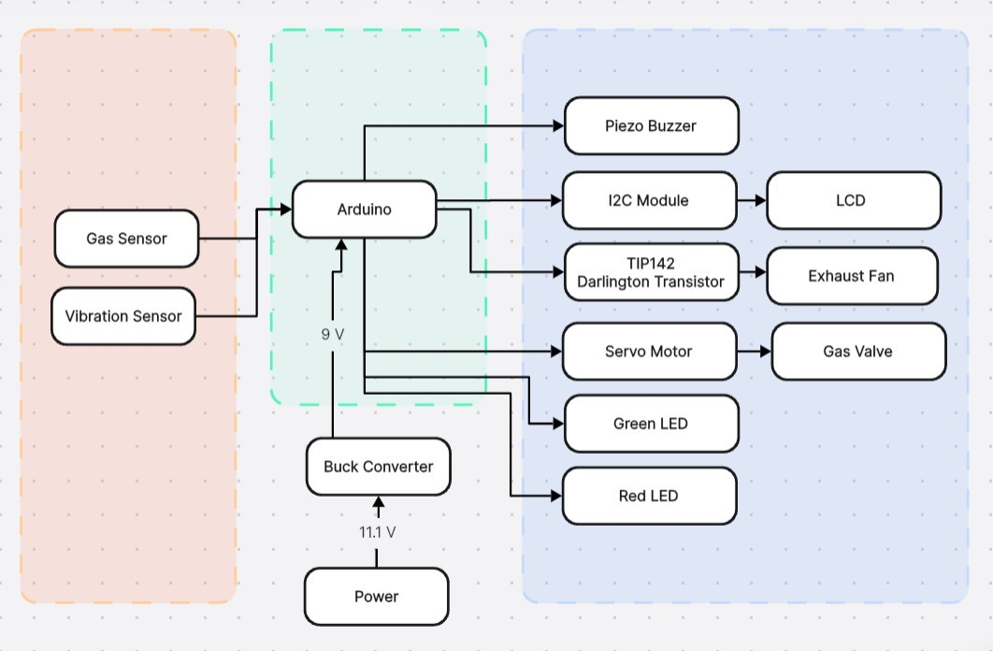

Fig. 2. System Block Diagram

- METHODOLOGY
The proposed system integrates a variety of sensors, ac- tuators, and a communication module to detect and mitigate hazards while providing real-time alerts. The main hardware components are as follows:
- Hardware Components
  - MQ-6 Gas Sensor: Detects LPG presence and alerts the microcontroller when a specific threshold is crossed.
  - Arduino Uno R3: The primary microcontroller that processes inputs from sensors and manages system re- sponses.
  - SW-420 Vibration Sensor: Monitors tampering and seismic activities, triggering immediate safety responses when required.
  - SG90 Micro Servo Motor: Automatically shuts off the gas valve to prevent further leakage.
  - TIP142 NPN Darlington Transistor: Drives the exhaust fan with greater power handling capability compared to MOSFETs.
  - 18650 Lithium Battery Holder (3P): Rechargeable battery setup that powers the system.
  - Buck Converter: Steps down the 11.1V battery pack to 9V for Arduino input and provides 5V output to peripherals.
  - HC-05 Bluetooth Module: Enables wireless communi- cation to send alerts in case of leaks.
  - LCD Display: Displays real-time feedback about leaks, including the percentage of gas detected.
  - Piezo Buzzer: Emits audible alarms to alert individuals nearby.
  - 5V Brushless Exhaust Fan: Reduces gas concentration by ventilating the area during a leak.
  - Green LED: Provides a visual indication that the system is active.
  - Red LED: Lights up to indicate a detected gas leak.
  - Veroboard: Serves as a durable platform for assembling and connecting electronic components.

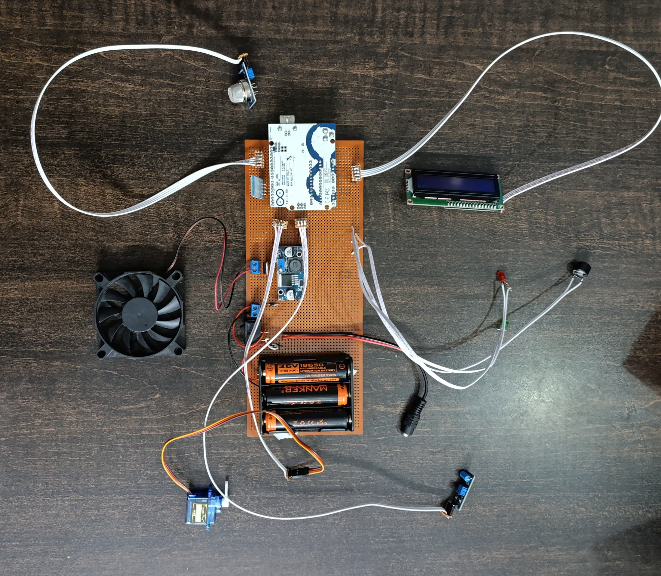

Fig. 3. Prototype Top View

TABLE II
Summarized Hardware Specifications

Component | Type | Power Require- ment | Weight | Size | Cost | Usage | Basic Working Principle
MQ-6 Gas Sen- sor | Sensor | 5V | 20g | 32mm x 20mm | 250 PKR | Detects LPG concentration | Detects gas presence via resistance change
SW-420  Vibration Sensor | Sensor | 3.3V - 5V | 15g | 30mm x 20mm | 200 PKR | Detects vibra- tion/movement | Senses vibrations and sends signal
Arduino Uno R3 | Microcontroller | 7V - 12V | 25g | 68.6mm x 53.4mm | 800 PKR | Executes code  and controls sensors | Processes input and con- trols output
HC-05 Bluetooth Module | Communication Module | 3.3V - 5V | 12g | 36mm x 15mm | 900 PKR | Facilitates wire- less communica- tion | Uses serial communica- tion to connect via Blue- tooth
Exhaust Fan | Actuator | 5V | 15g | 50mm x 50mm x 10mm | 100 PKR | Ventilates area in case of gas leak | Uses TIP142 transistor to control rotor via electro- magnets
Servo Motor | Actuator | 4.8V - 6V | 50g | 40mm x 20mm | 300 PKR | 180-degree rota- tion | Rotates to open/close valve
Buzzer | Actuator | 5V | 10g | 30mm x 20mm | 50 PKR | Produces sound alert | Generates sound via piezoelectric effect
Green/Red LED | Actuator | 2.2V | Negligible | 1.6mm x 0.8mm x 0.8mm | 4 PKR | Visual Indicator | Current passing through semiconductor causes electrons to recombine and release energy
18650 Lithium Battery Holder (3P) | Power Source | 11.1V | 60g | 75mm x 20mm x 20mm | 500 PKR | Powers the entire system | Holds rechargeable batter- ies for power
Buck Converter | Power Module | Converts 11.1V to 9V | 25g | 40mm x 20mm | 300 PKR | Steps down volt- age | Uses DC-DC conversion to regulate output
Veroboard | Circuit Board | - | 50g | 150mm x 100mm | 300 PKR | Connects and as- sembles compo- nents | Provides a durable plat- form for connections

- System Workflow
The system works as follows:
Continuous Monitoring: The MQ-6 Gas Sensor continu- ously monitors LPG concentrations.
Leak Detection: nce a leak is detected, the system performs the following:
  - Activates local alarms through the Piezo Buzzer and LEDs.
  - Rotates the Servo Motor which is a shutoff mechanism.
  - Activates the ventilation system to dissipate leaked gas.
  - Sends alerts through the Bluetooth Module and LCD.
Tampering Detection: The vibration sensor adds a tamper- ing detection layer. If any tampering is detected then it will show the same gas leak reaction but with ”Vibration detect” display on LCD.
vides a signal to the Arduino Uno for processing when the safety threshold is exceeded.
- Auto Safety Protocol: SG90 micro servo motors are used to close the gas valve, activate the ventilation system to release the gas, and set off local alarms using LEDs and a piezo buzzer.
- Bluetooth Warnings: To increase awareness of threats, a Bluetooth module sends alerts to pre-installed apps on Bluetooth-enabled devices.
- Theft Detection: Seismic activity or illegal entry is detected by the SW-420 vibration sensor, which triggers the same security response as a gas leak.
- Smooth Operation: To ensure continuous operation, a 16x2 LCD monitors and displays the system status in real-time.
diagram:
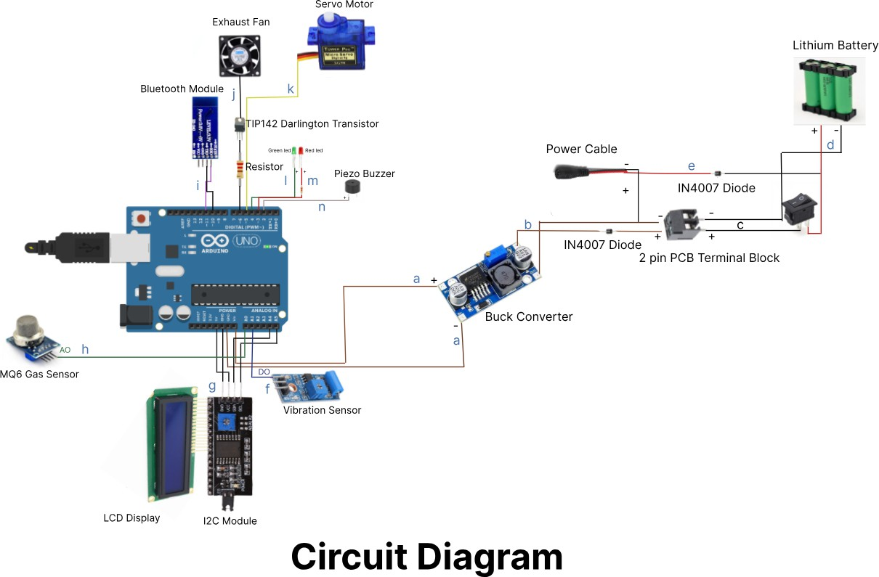

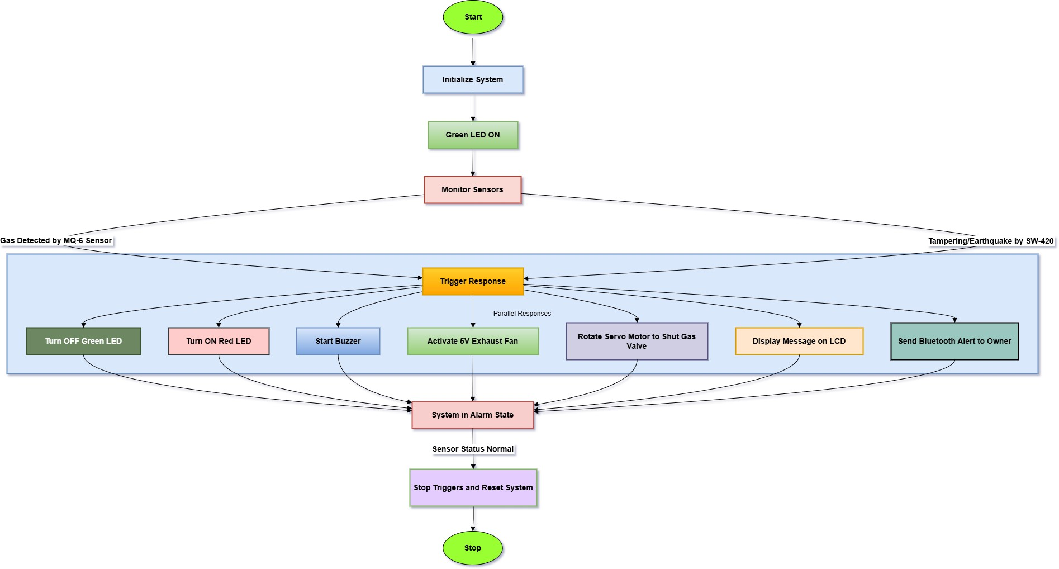

Fig. 4. System Flow Diagram

- SYSTEM DESIGN
The system involves the integration of functionalities into a uniform architecture to guarantee robust automated operation. Working mechanism in detail is given as follows:
- Working Mechanism
  - Gas Concentration Tracking: The MQ-6 gas sensor continuously measures the LPG concentration and pro-
Fig. 5. System Circuit Diagram

Following is the explanation for the connections in the circuit diagram:
  - a: Connections between the buck converter and the Ar- duino Uno, providing stable 9V power to the Arduino.
  - b: Connections between the buck converter and the 2- pin PCB terminal block, which enables regulated power distribution to other components.
  - c: Connections between the 2-pin PCB terminal block and the ON/OFF switch for power control.
  - d: Connections between the switch, lithium battery, and 2-pin PCB terminal block complete the power supply circuit.
  - e: Connects the power cord to the lithium battery’s positive line, enabling recharging or direct power trans- mission.
  - f: Connection between the vibration sensor and the Arduino Uno, which sends signals when vibrations are sensed.
  - g: By connecting the I2C module, Arduino Uno, and LCD display, system statuses such as ”System Ready” or alarms can be shown.

  - h: Connect the MQ-6 gas sensor to the Arduino Uno, which will provide input for gas concentration readings.
  - i: The Bluetooth module-to-Arduino Uno link enables wireless system control and monitoring.
  - j: The exhaust fan is connected to the Arduino Uno via a TIP142 Darlington transistor and a power resistor.
  - k: The servo motor is connected to the Arduino Uno, allowing it to switch off the gas valve during an alert.
  - l: The green LED connected to the Arduino Uno indicates that the system is ready.
  - m: Connect the red LED to the Arduino Uno with the help of a resistor to signal an alert (for example, gas or vibration detection).
  - n: Connection between the piezo buzzer and the Arduino Uno, which produces sound notifications during an event.

- Functionalities
The system offers the following key functionalities:
  - Gas Leak Detection: The system monitors the LPG concentration at all times to detect leaks.
  - Automatic Valve Shutoff: The system automatically turns off the gas valve to prevent any additional leakage.
  - Activation Ventilation: The system disperses gas to decrease concentration in the surroundings.
  - Local Alerts: The system provides audio and visual alerts to people nearby.
  - Tampering and Seismic Detection: The system detects anomalous physical disturbances.
  - App Alerts: If the system detects a hazard, it will send an alert to the app.
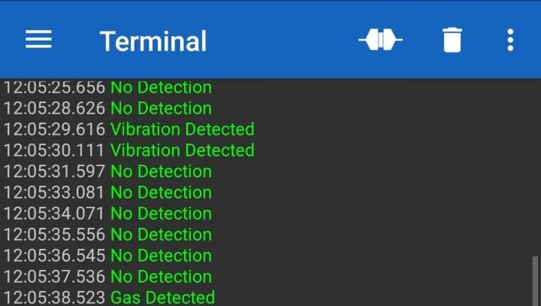

Fig. 6. Leak Alerts in Bluetooth Terminal App

The system allows for real-time monitoring, automates reactions, and provides alerts in the event of a hazard through a unified architecture. The Arduino Uno acts as the central processing unit that commands sensor-actuator interactions, while Bluetooth communication ensures quick notifications to people in hazardous situations. Additionally, the LCDs provide visual warnings for increased awareness.
- RESULTS
Testing has been done on the proposed system in different scenarios. Important findings are as follows:
  - Leak Response Time: The gas valve is closed within 5 seconds of leak detection.
  - Alert Effectiveness: Alerts have been sent within 5 seconds of detection.
  - Ventilation Efficiency: The cooling fan decreased gas concentrations to acceptable levels in under 2 minutes.
  - Tamper Detection: The vibration sensor detected tam- pering incidents with high accuracy, efficiently initiating safety processes.
  - Battery Life: The system’s battery life is determined by the rechargeable battery bank attached to it, and it ranges between 2 and 3 hours.
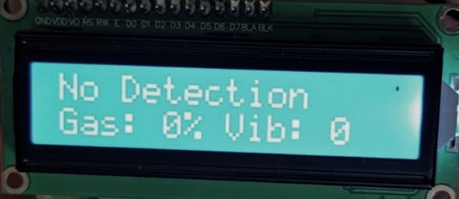

Fig. 7. No Detection in LCD

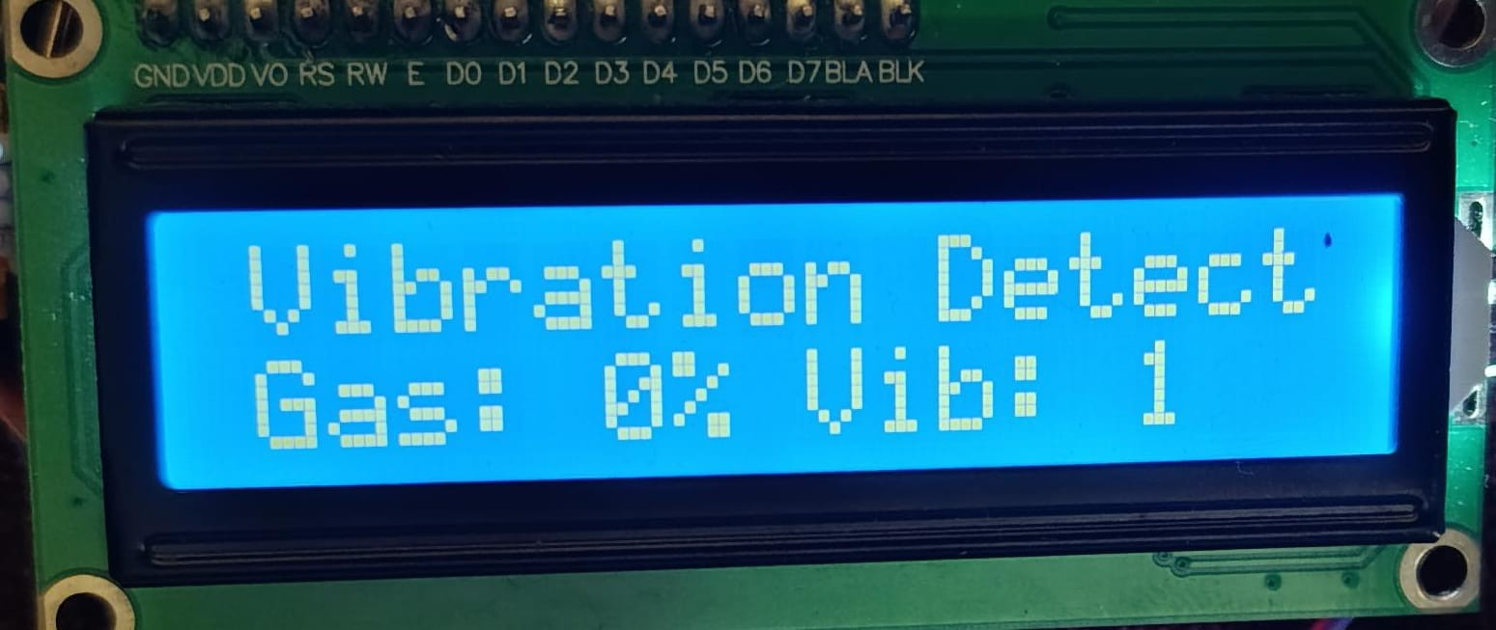

Fig. 8. Vibration Detection in LCD

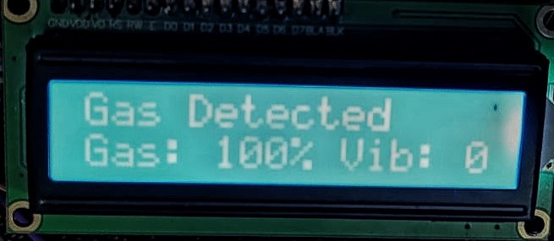

Fig. 9. Gas Detection in LCD

The findings verify the system’s ability to improve safety, reduce hazards, and issue trustworthy alarms.
- CONCLUSION
The proposed solution is an IoT-based LPG gas leakage detection and prevention system. It integrates a multi-layer safety structure through automation of critical responses and monitoring in real time, and thereby increasing the safety aspects of any environment relying on LPG. It makes the solution complete with the tampering detection and alerting features against hazards.
The prototype successfully demonstrates the potential for merging advanced IoT components into one unified safety solution. Its results underscore the potential for scalability and customization to meet diverse safety needs. While certain limitations in the system have been recognized, it still serves as a solid foundation for future improvements. This system can be leveraged to connect with smart home technologies and employ data analytics for proactive safety initiatives. This study adds to the expanding field of IoT-based safety solutions and lays out a plan for establishing strong, automated safety protocols in environments reliant on LPG.
- LIMITATIONS
Though the IoT-based LPG gas leakage detection and pre- vention system shows huge improvements in the area of safety, there are some drawbacks also encountered:
  - Bluetooth Range and Application: The Bluetooth mod- ule has a low range, which may affect its usability to send alerts to far-off distances. In addition to that, the user also has to open the app for the alert of the danger to be received.
  - Power Supply Limitations: The use of a recharge- able type 18650 lithium holder provides portability and continuous operation. However, this requires frequent recharging.
  - Sensor Sensitivity Constraints: The MQ-6 gas sensor and SW-420 vibration sensor are effective, but to maintain accuracy, they need to be re-calibrated over time.
  - Scalability Challenges: Although the current prototype is tailored for single-unit deployment, it poses challenges when scaling to larger environments or multi-site deploy- ments.
  - Environmental Factors: Factors such as extreme humid- ity or temperature fluctuations could affect the sensors’ performance.
- FUTURE WORK
Future enhancements of this system include:
  - Predictive Analytics and Machine Learning: This im- plies that the system applies machine learning algorithms for processing data patterns from gas leakages as well as tampering incidents. Predictive analytics presents the potential to predict and prevent the risks before its occurrence; hence, making the system better placed both in efficiency and safety aspects.
  - Multi-Channel Communication: Adding more commu- nication channels beyond Bluetooth for greater reliability and scalability.
  - Backup Power Supply: Adding advanced power solu- tions such as solar-powered units or larger capacity batter- ies to guarantee uninterrupted operation during extended outages.
  - Enhanced Bluetooth Connectivity: Widening the Blue- tooth range or integrating alternative wireless protocols such as Wi-Fi or Zigbee for more effective connectivity and alerting.
  - Cloud Integration: Storing logs and incident data in cloud platforms for centralized monitoring, analysis, and long-term storage.
  - Enhanced Sensor Suite: Adding temperature and hu- midity sensors to increase the ability of the system to recognize unsafe environmental conditions and, therefore, improve the overall reliability.

References
- T. Nation, “Gas cylinder blast at bus stand injures 13 in lahore,” The Nation, 2024. [Online]. Available: https://www.nation.com.pk/08-May-2024/ gas-cylinder-blast-at-bus-stand-injures-13-in-lahore
- M. H. Khan. (2024, May) At least 50 injured in major blast in hyderabad lpg shop: officials. Accessed: June 10, 2024. [Online]. Available: https:
//www.dawn.com/news/1836659
- A. Agency. (2021, December) Suspected gas explosion kills 16 in karachi, pakistan. Accessed: June 10, 2024. [Online]. Available: https://www.aa.com.tr/en/asia-pacific/ suspected-gas-explosion-kills-16-in-karachi-pakistan/ 2450907
- K. Klasra. (2020, February) Pakistan: five dead, more than 100 hospitalised after toxic gas leak. Accessed: June 10, 2024. [Online]. Available: https:
//www.scmp.com/news/asia/south-asia/article/3051028/ pakistan-five-dead-more-100-hospitalised-after-toxic-gas-leak
- (2024, October) Three passengers burnt alive as lpg cylinder explodes in van. Accessed: June 10, 2024. [Online]. Available: https://dunyanews.tv/en/Pakistan/
844593-three-passengers-burnt-alive-as-lpg-cylinder-explodes-in-va
- S. Report. (2024, May) Hyderabad cylinder blast toll rises to seven; 17 critical in karachi hospital. Accessed: June 10, 2024.
- P. Bairagi, B. Patir, P. Bora, L. Deka, and S. Rajbongshi, “Smartguard: An intelligent lpg leakage detection and control system,” International Journal of Engineering Trends and Technology, vol. 72, pp. 265–272, 09 2024.
- M. Khan, “Sensor-based gas leakage detector system,”
Engineering Proceedings, vol. 2, p. 28, 11 2020.
- P. Okonkwo, A. Obi, and I. Solomon, “Design and construction of cooking gas (lpg) leakage detector,” 01 2021.

- O. Olusanya, O. Mayowa, U. Musa, A. Fawole, and
K. Adebo, “Coden(usa): Jserbr an embedded arduino based lpg detection system with sms alert and automatic gas shut off,” The Journal of Scientific and Engineering Research, vol. 6, pp. 81–87, 04 2019.
- Raeesa, Navashree, R. J. Mascarenhas, S. J. Tauro, and
D. K. R, “Gas detection system using arduino,” INTER- NATIONAL JOURNAL OF ENGINEERING RESEARCH & TECHNOLOGY (IJERT), vol. 09, no. 12, 2021, nC-
CDS – 2021.
- V. Yadav, A. Shukla, S. Bandra, V. Kumar,
U. Ansari, S. Khanna, and U. G. Scholar, “A review on microcontroller based lpg gas leakage detection & controlling system using iot & gsm module,” 2016. [Online]. Available: https://api.semanticscholar.org/CorpusID:209328541
- M. F. H. Mishu, T. Mahzabin Moumita, and M. N. Ibn Sattar, “Detection, alert and exhaustion system for leakage of lpg gas,” 07 2021.
- L. Dewi and Y. Somantri, “Detection and prevention of gas leakage using iot,” IOP Conference Series: Materials Science and Engineering, vol. 384, p. 012064, 2018.
- M. A. Baballe and M. I. Bello, “Gas leakage detection system with alarming system,” Review of Computer Engineering Research, vol. 9, no. 1, pp. 30–43, 2022. [Online]. Available: https://ideas.repec.org/a/pkp/rocere/ v9y2022i1p30-43id2984.html

1Correspondence: amnaalviee@gmail.com
2Correspondence: ayelaarshad4002@gmail.com 3Correspondence: maviaadilsiddiqui@gmail.com 4Correspondence: radia riaz@outlook.com
5Correspondence: sidrakayenatofficial@gmail.com

