National University of Sciences and Technology (NUST) Military College of signals (MCS)

FINAL YEAR PROJECT

Software Design Description
For
SCHOLASTIC SANCTUARY

Muhammad Saad Filza Khan Tareen M. Saad Bin Khalid Memoona Ramzan

Lt. Col Khawir Mehmood 18th December, 2024

Table of Contents
1. Introduction………………………………………………………………………………………………………………….3
1.1 Purpose……………………………………………………………………………………………………………………………..............3
1.2 Scope…………………………………………………………………………………………………………………………………………….3
1.3 Overview……………………………………………………………………………………………………………………………………….4
1.4 ReferenceMaterial..………………………………………………………………………………………………………………………4
1.5 Definitions andAcronyms...…………………………………………………………………………………………………...........4
2. System Overview……………………………………………………………………………………………………………...6
3. SystemArchitecture………………………………………………………………………………………………………7
3.1 ArchitecturalDesign.………………………..……………………………………………………………………………………………7
3.2 DecompositionDescription………………………………………………………………………………………………………….10
3.3 DesignRationale………………………………………………………………………………………………………………………….43
4. DataDesign………………………………………………………………………………………………………………….45
4.1 DataDescription…………………………………………………………………………………………………………………………..45
4.2 DataDictionary………………………………………………………………………………………………………………………….…57
5. ComponentDesign……………………………………………………………………………………………………..59
6. Human InterfaceDesign………………………………………………………………………………………………60
6.1 Overview of UserInterface………..………………………………………………………………………………………………...60
6.2 ScreenImages………………………………………………………………………………………………………………………………61
6.3 Screen Objects andActions………………………………………………………………………………………………………….64
RequirementMatrix…………………………………………………………………………………………………….65

2

1. Introduction
1.1 Purpose
This Software Design Document (SDD) outlines the architecture and system design for Scholastic Sanctuary, a 3D software application aimed at providing interactive experiences. The primary
objective of this document is to detail the technical specifications, system functionalities, and design constraints of the application, ensuring clarity and direction for the development team. Intended audiences are:
Developers: To understand the technical requirements and implementation strategies. Testers/Quality Assurance Team: To identify testing protocols and ensure the software meets specified requirements.
End Users: To provide insights into how the application will function and what features will be available.
Project Supervisor: To oversee project progress and ensure alignment with educational
objectives.

1.2 Scope
The scope of the Scholastic Sanctuary project encompasses the development of an interactive 3D software application designed to facilitate user engagement and collaboration in a vibrant virtual environment. This platform aims to merge educational elements with entertainment, allowing users to create accounts, communicate in real-time, and explore user-generated content. The primary goals include developing a user-friendly interface that encourages exploration, implementing robust security measures to protect user data, and fostering a sustainable ecosystem that promotes ongoing user engagement.

The objectives of this project are to create a dynamic platform where users can discover new ideas and passions while enjoying their interactions. By enabling features such as real-time communication, collaborative spaces, and customizable environments, Scholastic Sanctuary
3

seeks to enhance the learning experience through immersive technology. The benefits of this project include providing a unique space for creativity and collaboration, empowering users to showcase their ideas, and creating an engaging community that supports educational growth through interactive experiences.

1.3 Overview
This document provides a comprehensive Software Requirements Specification (SRS) for Scholastic Sanctuary, detailing its intended functionalities, user interactions, and system architecture. It is organized into several key sections, beginning with an introduction that outlines the purpose and scope of the project. Following this, the document presents a detailed description of the product's features, user classes, and operating environment. The organization
of the SRS includes sections on document conventions, intended audience, and overall product description. Additionally, it covers design and implementation constraints, user interface requirements, and external interface requirements. Each section is designed to ensure clarity and facilitate understanding among all stakeholders involved in the project. The document concludes with assumptions and dependencies that may impact development, providing a holistic view of the software's requirements and guiding principles for successful implementation

1.4 References
UGS Documentation:
https://docs.unity.com/ugs/en-us/manual/overview/manual/unity-gaming-services-home Unity Netcode Documentation: https://docsmultiplayer.unity3d.com/netcode/current/about/ Unity Documentation: https://docs.unity.com/
C# OOP Practices: https://www.w3schools.com/cs/cs_oop.php

1.5 Definitions and Acronyms

4

Term/Acronym | Definition
3D | Refers to three-dimensional graphics, which provide depth perception and a realistic representation of objects in a virtual environment.
UGS | Stands for Unity Gaming Services, a suite of tools and services provided by Unity Technologies to facilitate game development, including user authentication and  real-time interactions.
NPC | Non-Playable Character, a character in the game that is not controlled by a player but by the game's programming, often used to enhance the interactive experience.
Lobby | A pre-game area where players can gather, set up teams, and prepare before entering the main game session.
Relay | A service that allows players to connect without needing to manage IP addresses, facilitating secure multiplayer sessions.
DevOps | A set of practices that combines software development (Dev) and IT operations (Ops) to shorten the development lifecycle and deliver high-quality software continuously.
Vivox | A communication service that provides voice and text chat capabilities for multiplayer games, enabling real-time interaction among players.
Real-time Database | A database that updates in real-time, allowing for immediate data synchronization across all users in an application.
Client-Server Model | A computing model where client devices request resources or services from centralized servers that process these requests and return the appropriate
5

Term/Acronym | Definition
 | responses.
Authentication | The process of verifying the identity of a user or system before granting access to resources.

2. System Overview
The application is designed as an interactive 3D software application. The primary functionality
of the system allows users to create accounts, communicate in real-time, and explore a dynamic environment filled with user-generated content. Users can join or host 3D rooms, interact with
other participants and non-playable characters (NPCs), and showcase their ideas through virtual stalls.
The context of this project is rooted in the increasing demand for immersive learning experiences that leverage technology to enhance creativity and collaboration. By providing a space where users can freely express their ideas and connect with others, Scholastic Sanctuary aims to foster a community of learners and creators. The application is built on Unity Gaming Services (UGS), which facilitates essential features such as user authentication, multiplayer interactions, and real-time data management.
In terms of design, the application prioritizes user experience with an intuitive interface that encourages exploration and interaction. It incorporates robust security measures to protect user data and ensure safe communication within the platform. The overall architecture supports scalability and performance optimization, allowing for smooth operation even in environments with many concurrent users.
This document serves as a foundational guide for understanding the system's requirements, functionalities, and design principles, ensuring that all stakeholders have a clear understanding
of the project's objectives and capabilities.

6

3. System Architecture
3.1 Architectural Design

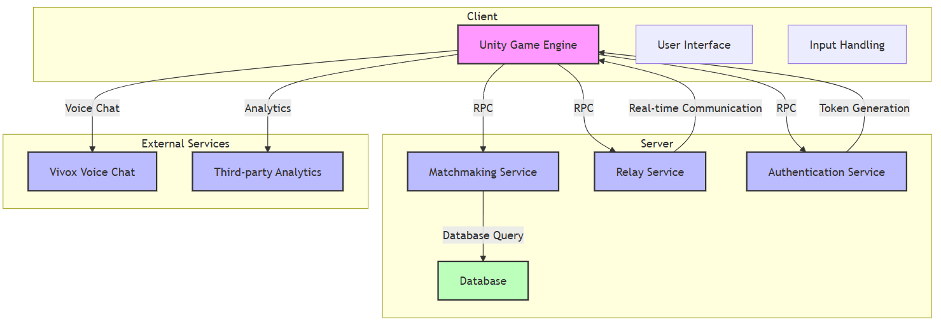

This diagram represents a high-level architecture for scholastic sanctuary. It includes:
Client-side components (Unity Game Engine, UI, Input Handling)
Server-side components (Matchmaking Service, Relay Service, Authentication Service, Database)
External services (Vivox for voice chat, Third-party Analytics)
The arrows indicate the connections and data flow between these components. Components are grouped into logical subgraphs (Client, Server, External Services). Arrows show the direction
of data flow and interactions. The Unity game engine is highlighted as the central client application.

7

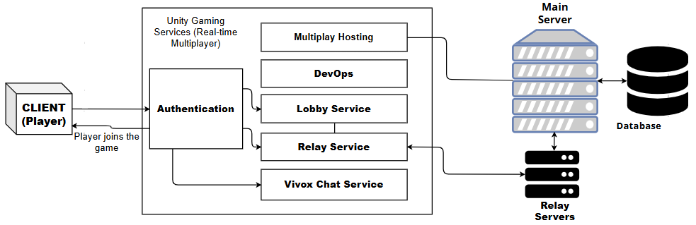

Figure 1The client is authenticated first, then is connected to the main server via relay. Then client can join lobbies and ultimately can join the Application with other players in it.

The main architecture consists of the application, which implements unity gaming services, the client which connects to those services and thus the application, a main server used for server side logic and validations, and a database that will handle some persistent data. Unity Gaming Services facilitate developers to avail services that assist them in development of a multiplayer game or application in unity. Explanation is given below:

Multiplay Hosting: Provides scalable, hybrid cloud-based hosting for multiplayer games, allowing server scaling, low-latency global coverage, and cost-efficient infrastructure management to support real-time multiplayer gameplay.
DevOps: Automates and optimizes game development workflows, ensuring smooth deployment, continuous integration, and monitoring of multiplayer game services to maintain stability, scalability, and uptime. Includes version control capabilities.
Lobby: Manages pre-game sessions where players can join, leave, or modify their team settings before the actual game begins, helping with the setup of multiplayer experiences.
Relay: Enables connectivity without the need for knowing or managing exact IP addresses of dedicated servers, reducing infrastructure costs while maintaining secure and efficient
8

multiplayer sessions. Involves a relay server that handles connections.
Vivox: Provides voice and text chat for multiplayer games, allowing players to communicate in real-time during gameplay.

High-Level Subsystems:
The architectural design of Scholastic Sanctuary is structured around a modular program framework that facilitates the development and maintenance of the application while ensuring scalability and flexibility. The system is divided into several high-level subsystems, each responsible for specific functionalities, which collaborate to achieve the overall goals of the platform. The diagram below illustrates these major subsystems and their interconnections:

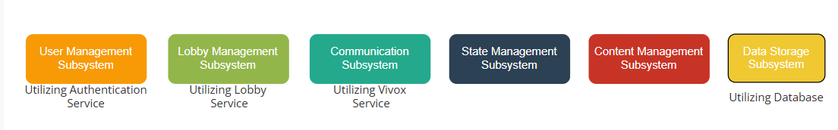

Figure 2.These Subsystems interact with each other in the application.
Description is given below:
1. User Management Subsystem: Handles user account creation, login, and validation using Unity Gaming Services.
2. Lobby Management Subsystem: Responsible for managing pre-joining sessions, this subsystem allows users to create or join 3D rooms/lobbies. It facilitates group setup and ensures that users can browse available rooms using unique join codes.
3. Game State Management Subsystem: This core subsystem maintains the overall state of the game environment, including user interactions, NPC behaviors, and real-time updates. It processes inputs from users and synchronizes these actions across all clients connected to a particular room.
9

4. Communication Subsystem: Facilitates voice and text communication using Vivox.
5. Content Management Subsystem: This subsystem allows users to create and manage their content within the application, such as placing stalls to showcase ideas or broadcasting information about events. It ensures that user-generated content is stored efficiently and displayed correctly in the virtual environment.
6. Data Storage Subsystem: A real-time database is utilized to store user information, and interactions. This subsystem ensures quick access to data while maintaining performance standards even with multiple concurrent users.
The subsystems collaborate through a well-defined interface mechanism that allows them to communicate effectively. For instance, when a user logs in via the User Management Subsystem, it sends authentication details to the Game State Management Subsystem to update the user's status in real time. Similarly, when a player joins a lobby through the Lobby Management Subsystem, this information is relayed to both the Game State Management and Communication Subsystems to ensure all participants are informed about new arrivals.

3.2 Decomposition Description
Data flow of the application is server authoritative, as follows:
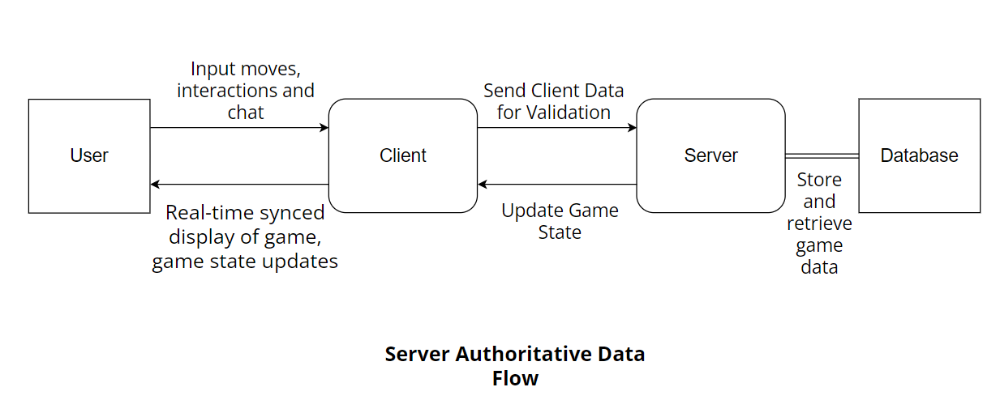

User performs actions such as pressing input keys, speaking for voice chat etc., which is sent by
10

the client to server for validation via RPCs (Remote Procedure Calls). Server then performs relevant business logic, in addition to coordinating with the database to keep the state updated, and sends the updated state back to the client, which is rendered in the form of updated state and synced real-time display of the changes made by the user.

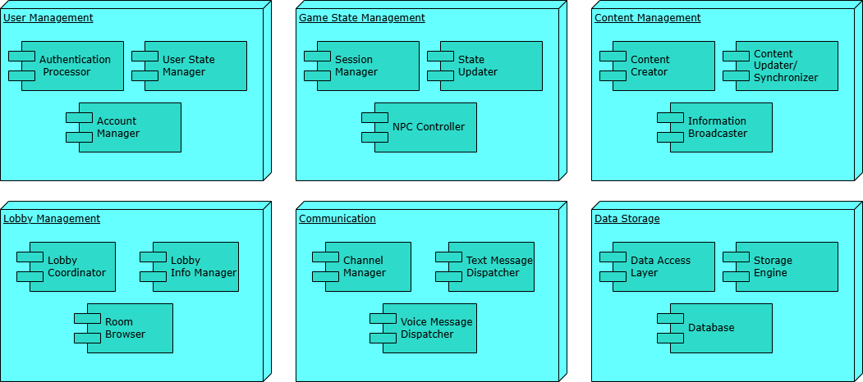

Below is the top-level data flow diagram of the major subsystems:

11

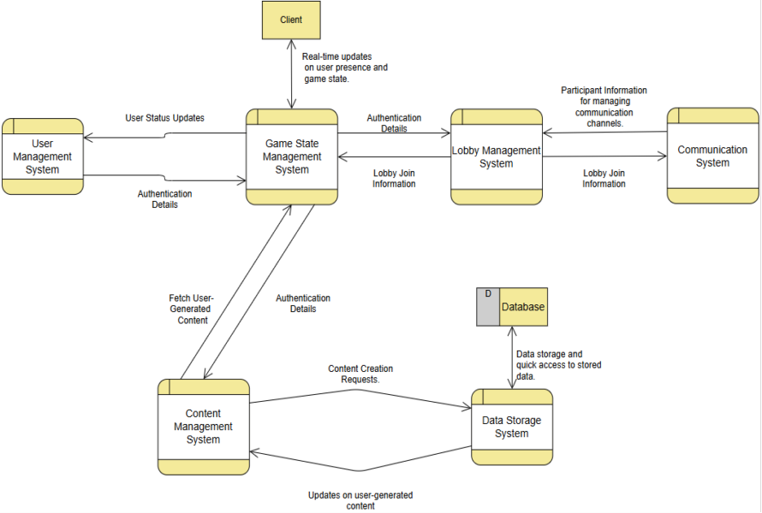

Data Flow:
User Management to Game State Management: Authentication Details
When a user attempts to log in, the User Management Subsystem processes the
authentication request. Upon successful login, it sends Authentication Details to the Game
State Management Subsystem. This data typically includes the user's credentials (e.g.,
username and password hash) and any relevant user identification information (such as user I
and session token). The Game State Management Subsystem uses this information to establis
the user's session and update their status in real time, allowing for immediate access to game
features.

Game State Management to User Management: User Status Updates
Once the Game State Management Subsystem has processed the authentication details, it may
need to communicate back to the User Management Subsystem with User Status Updates. Thi
flow includes information about the user's current state within the game environment (e.g. |  | ,
online/offline status, current lobby participation). Such updates ensure that user account
statuses are synchronized across subsystems, maintaining accurate records of user activity.

12

Lobby Management to Game State Management: Lobby Join Information
When a player chooses to join a lobby or create a new one, the Lobby Management
Subsystem sends Lobby Join Information to the Game State Management Subsystem. This data
encompasses details about the lobby being joined (e.g., lobby ID, player ID) and includes additional
context such as the number of participants or lobby settings. The Game State Management Subsystem
utilizes this information to update its internal state, ensuring that all connected clients are aware of ne
participants and can synchronize their game states accordingly.

Lobby Management to Communication: Lobby Join Information
Simultaneously, when a player joins a lobby, the Lobby Management Subsystem also forwards Lob |  | y
Join Information to the Communication Subsystem. This flow is crucial for establishing communication
channels among participants in the lobby. The Communication Subsystem uses this data to manage
voice and text interactions among players, ensuring that all users can effectively communicate with |  | in
their lobby environment.

Game State Management to All Clients: Real-Time Updates on User Presence and Game Stat
The Game State Management Subsystem plays a pivotal role in maintaining real-time awareness of use
presence and game state across all clients connected to a particular lobby or game session. It sends out
periodic updates containing information about user actions (e.g., joining or leaving) and changes i
game state (e.g., NPC behavior updates). This ensures that all players have an accurate view of the
current game environment, enhancing collaborative gameplay experiences.

Communication to Lobby Management: Participant Information
The Communication Subsystem requires participant information from the Lobby Management
Subsystem to effectively manage communication channels among users. This flow includes details such
as participant IDs and their respective roles within the lobby (e.g., speaker, listener). This information
allows for proper management of voice channels and text chat functionalities, ensuring smoot |  | h
communication during gameplay.

Content Management to Data Storage: Content Creation Requests
When users create or modify content within the application (such as placing stalls or broadcasting even
information), the Content Management Subsystem sends Content Creation Requests to the Data
Storage Subsystem. These requests include details about the content being created or updated, such as
content type, metadata, and user ID associated with the creation action. The Data Storage Subsystem
processes these requests by storing user-generated content efficiently.
Data Storage to Content Management: Updates on User-Generated Content

After processing content creation requests, the Data Storage Subsystem provides updates back to th
Content Management Subsystem regarding user-generated content. This flow may include
confirmations of successful storage or updates on existing content (e.g., modifications made by other
13

users). Such feedback is essential for maintaining an accurate representation of available content within
the virtual environment.
Process Decomposition:
It encapsulates essential functionalities, including user registration, secure login, Lobby creation and management, Interaction with the 3d world, text and voice chat etc. The diagrams visually represent the dynamic relationships between users and the system, offering a comprehensive understanding of the core functionalities within Scholastic Sanctuary.
Use Cases:

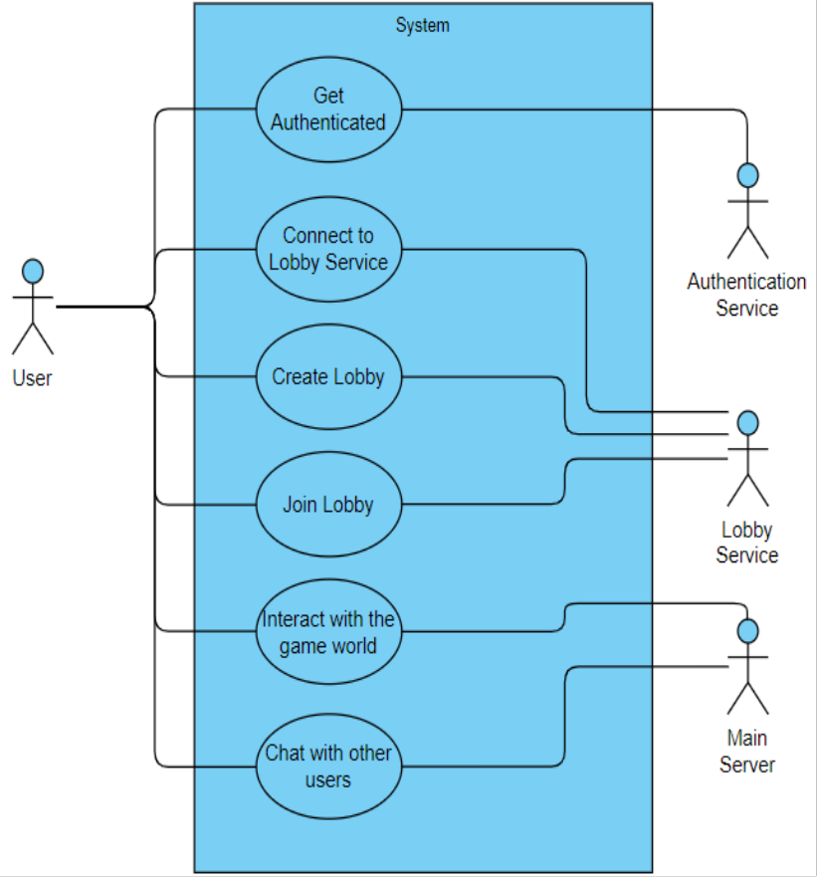

14

UC 01: Authentication:

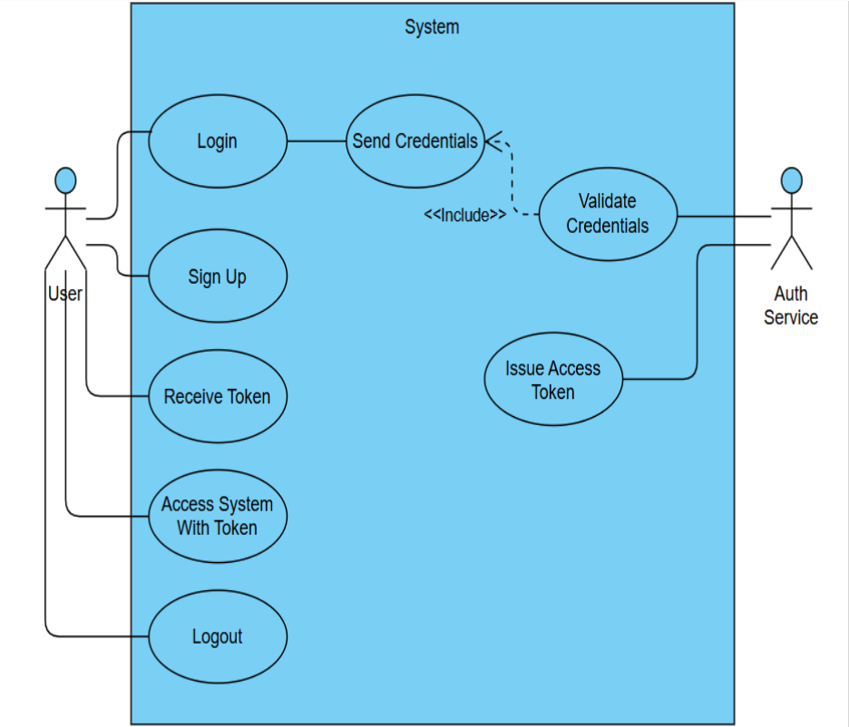

Element | Description
Primary Actor | User
Secondary Actor | Auth Service
Use Cases | Login, Sign Up
Normal Course | Login:  1. User navigates to the login page.
15

2. User enters credentials.
3. System sends credentials to the Auth Service (Send Credentials).
4. Auth Service validates the credentials (Validate Credentials).
5. System grants access to the user. Sign Up:
1. User navigates to the sign-up page. 2. User enters new credentials.
3. System sends credentials to the Auth Service (Send New Credentials).
4. Auth Service validates the credentials (Validate Credentials).
5. Auth Service issues an access token (Issue Access Token).
6. System provides access to the user.
Pre-Condition | Auth Service and system servers must be up and running.  Login:  • User must already have an account.  Sign Up:  • User is not registered in the system.
Post-Condition | Login: User is logged into the system.  Sign Up: User account is created, and an access token is issued.
Alternate Course | - Invalid credentials→Auth Service rejects the login or sign-up request.  - Login: User fails to enter correct credentials→Error is displayed.  - Sign Up: User enters existing credentials→System notifies that the account exists.

16

UC 02: Lobby Creation and Joining:

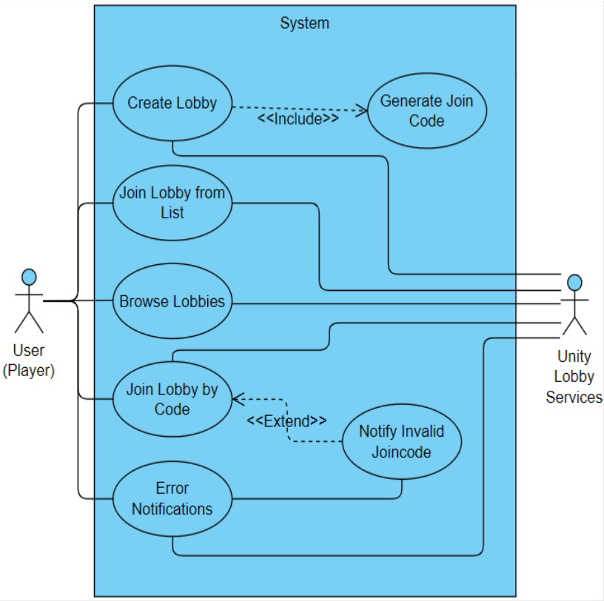

17

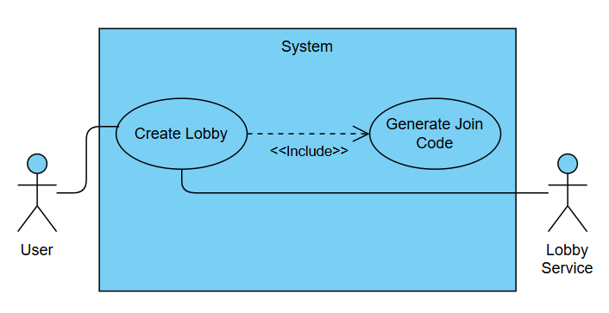

Element | Description
Primary Actor | User
Secondary Actor | Lobby Services
Use Cases | Create Lobby
Normal Course | 1. User initiates the "Create Lobby" action. 2. System generates a join code (Include:  Generate Join Code).  3. Unity Lobby Services stores the lobby details and join code.  4. System confirms the lobby creation and shares the join code with the user.
Pre-Condition | - The user is logged into the system.  - Unity Lobby Services must be available.
Post-Condition | - A new lobby is successfully created, and the join code is provided to the user.
Alternate Course | - Unity Lobby Services is unavailable→System displays an error notification.

18

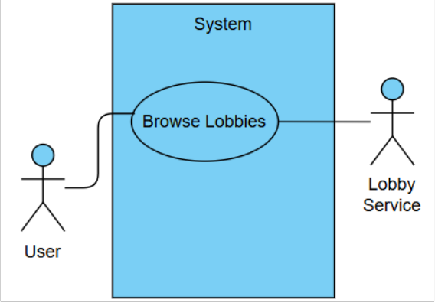

Element | Description
Primary Actor | User
Secondary Actor | Lobby Services
Use Cases | Browse Lobbies
Normal Course | 1. User initiates the "Browse Lobbies" action. 2. System fetches available lobbies from Unity Lobby Services.  3. System displays the list of lobbies to the user.
Pre-Condition | - The user is logged into the system.  - Unity Lobby Services must be available. - Lobbies must exist.
Post-Condition | - The list of available lobbies is displayed to the user.
Alternate Course | - Unity Lobby Services is unavailable→System displays an error notification.  - No lobbies exist→System notifies the user that no lobbies are available.

19

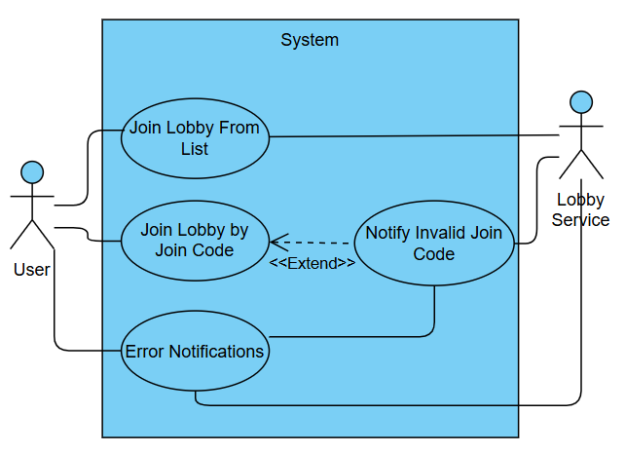

Element | Description
Primary Actor | User
Secondary Actor | Lobby Services
Use Cases | Join Lobby (from List or by Code)
Normal Course | Join Lobby from List:  1. User selects a lobby from the list.  2. System sends a join request to Unity Lobby Services.  3. Unity Lobby Services validates the join request and grants access.  4. System confirms that the user has successfully joined the lobby.  Join Lobby by Code:  1. User provides a join code to join a specific lobby.
20

2. System sends the join code to Unity Lobby Services.
3. Unity Lobby Services validates the join code. 4. System grants access if the join code is valid.
Pre-Condition | - The user is logged into the system.  - Unity Lobby Services must be available. - Valid lobbies exist.
Post-Condition | - User successfully joins a lobby.  - System confirms the action to the user.
Alternate Course | - Invalid join code→Notify Invalid Join Code is triggered.  - Unity Lobby Services is unavailable→System displays an error notification.

UC 03: Text and Voice Chat:

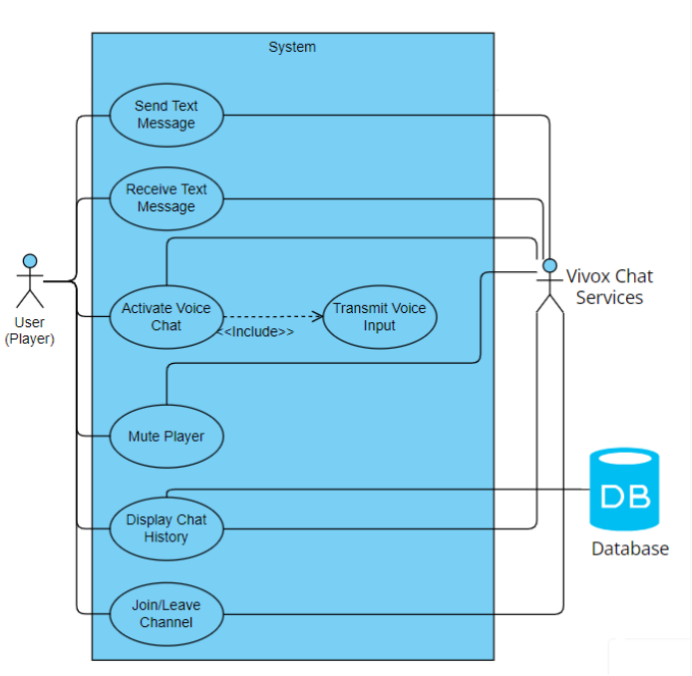

21

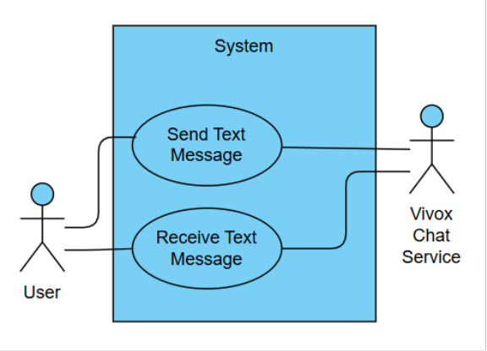

Element | Description
Primary Actor | User
Secondary Actor | Vivox Chat Services
Use Cases | Send Text Message, Receive Text Message
Normal Course | Send Text Message:  1. User sends a text message.  2. System stores the message in the database.  3. System transmits the message to the intended recipient.  Receive Text Message:  1. System receives a new message.  2. System displays the message to the user.
Pre-Condition | - User is connected to the system. - Database services are available.
Post-Condition | - Message is successfully sent or received.
Alternate Course | - Vivox Service is unavailable→System notifies the user of an error.

22

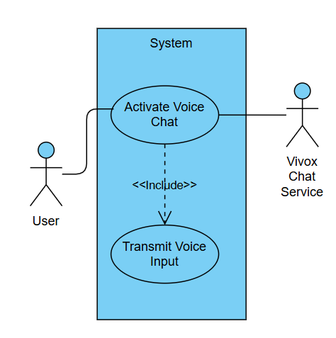

Element | Description
Primary Actor | User
Secondary Actor | Vivox Chat Services
Use Cases | Activate Voice Chat, Transmit Voice Input
Normal Course | Activate Voice Chat:  1. User activates voice chat.  2. System initializes voice chat via Vivox Chat Services.  Transmit Voice Input:  1. User speaks into the microphone.  2. System transmits the voice input to Vivox Chat Services for processing.
Pre-Condition | - User has voice chat enabled.  - Vivox Chat Services are available.
Post-Condition | - Voice chat is successfully activated or voice input is transmitted.
Alternate Course | - Vivox Chat Services are unavailable→System notifies the user.

23

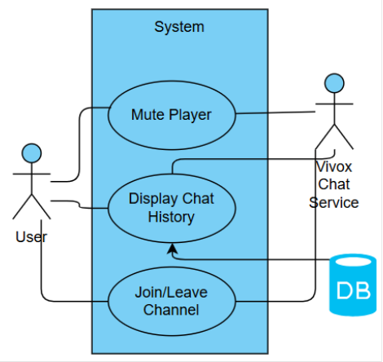

Element | Description
Primary Actor | User
Secondary Actor | Vivox Chat Services
Use Cases | Mute Player, Display Chat History, Join/Leave Channel
Normal Course | Mute Player:  1. User mutes a specific player.  2. System updates mute status for that player.  Display Chat History:  1. User requests chat history.  2. System fetches chat history from the database and displays it.  Join/Leave Channel:  1. User chooses to join or leave a channel.  2. System updates the user's channel status.
Pre-Condition | - User is connected to the system. - Database services are available.
Post-Condition | - Player is muted/unmuted. - Chat history is displayed.  - User successfully joins or leaves a channel.
Alternate Course | - Vivox Chat Services are unavailable→System notifies the user.
24

UC 04: Stall Placement and Viewing:

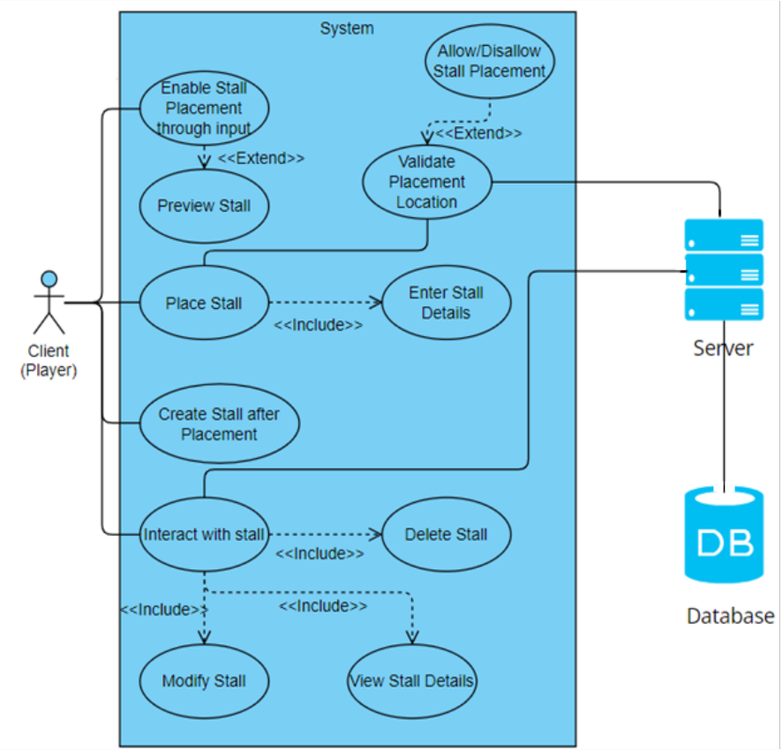

25

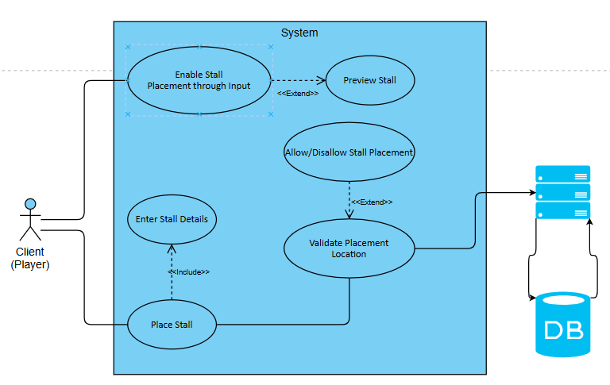

Element | Description
Primary Actor | Client (User/Player)
Secondary Actor | Server, Database
Use Cases | Enable Stall Placement through Input, Place Stall, Enter Stall Details, Validate Placement Location
Normal Course | Enable Stall Placement:  1. User initiates stall placement.  2. System enables the stall placement interface.  Place Stall:  1. User selects a location to place a stall.  2. System validates the placement location.  Enter Stall Details:  1. User inputs stall details.  2. System stores the stall details in the database.
Pre-Condition | - User is connected to the system.  - Server and Database services are available.
Post-Condition | - Stall placement is validated and details are stored.
Alternate Course | - Invalid placement→System notifies user of invalid placement.  - Server unavailable→System displays an error message.
26

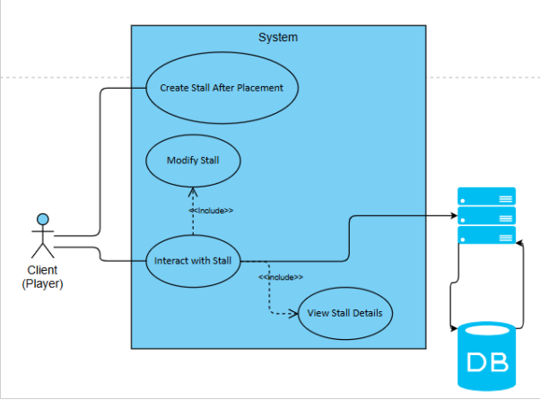

Element | Description
Primary Actor | Client (User/Player)
Secondary Actor | Server, Database
Use Cases | Create Stall after Placement, Interact with Stall, Modify Stall, View Stall Details
Normal Course | Create Stall after Placement:  1. System finalizes stall creation after placement is validated.  Interact with Stall:  1. User interacts with the stall (e.g., open settings  or details).  2. System enables further actions.  Modify Stall:  1. User selects a stall to modify.  2. System allows updates to stall details.  View Stall Details:  1. User requests to view stall details.  2. System retrieves and displays details from the database.
Pre-Condition | - Stall is already placed in the system. - Server and Database are accessible.
Post-Condition | - Stall is modified, created, or viewed successfully.
27

Alternate Course | - Server or database unavailable→System notifies the user of an error.

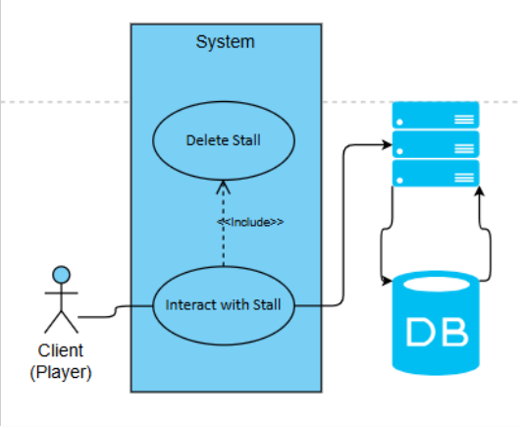

Element | Description
Primary Actor | Client (User/Player)
Secondary Actor | Server, Database
Use Cases | Delete Stall
Normal Course | Delete Stall:  1. User selects a stall to delete.  2. System confirms the deletion request.  3. System removes the stall from the database.
Pre-Condition | - Stall exists in the system.  - Server and Database are accessible.
Post-Condition | - Stall is successfully deleted.
Alternate Course | - Database error→System notifies user of failure to delete the stall.

28

UC 05: NPC Information Broadcasting:

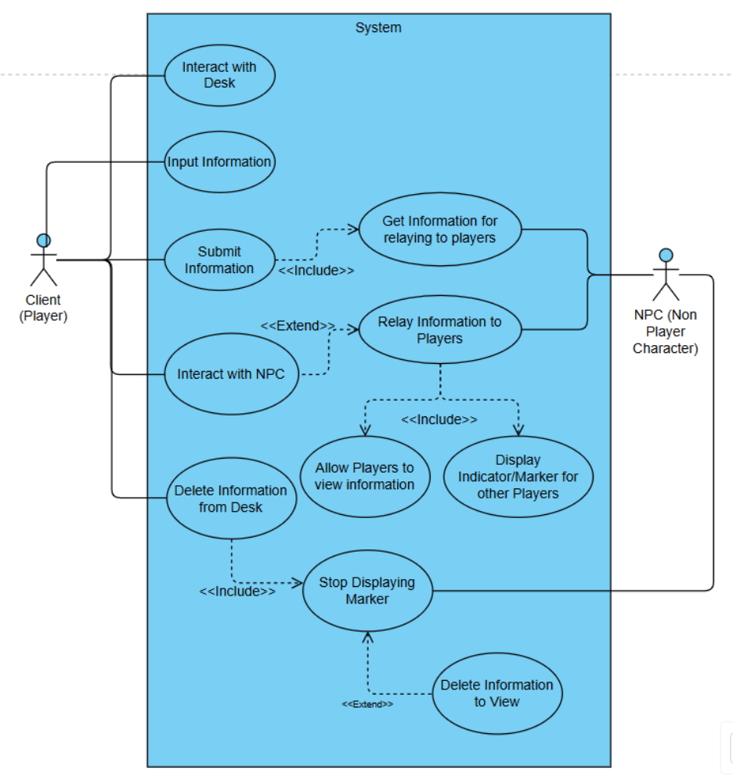

29

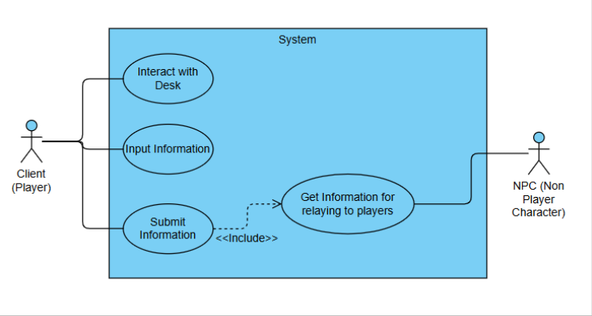

Element | Description
Primary Actor | Client (User/Player)
Secondary Actor | NPC (Non-Player Character)
Use Cases | Interact with Desk, Input Information, Submit Information, Get Information for Relaying to Players
Normal Course | Interact with Desk:  1. User interacts with the desk to begin the process.  Input Information:  1. User inputs information at the desk.  Submit Information:  1. User submits the input information.  2. System includes "Get Information for relaying to players" to process it.  Get Information for Relaying:  1. System fetches the submitted information.  2. Information is relayed to the relevant actors (players or NPC).
Pre-Condition | - The user is interacting with the system.  - NPC and system are available for data relay.
Post-Condition | - Information is submitted and available for relaying.

30

Alternate Course | - NPC unavailable→System notifies the user of relay failure.  - Invalid input→System prompts for correction.

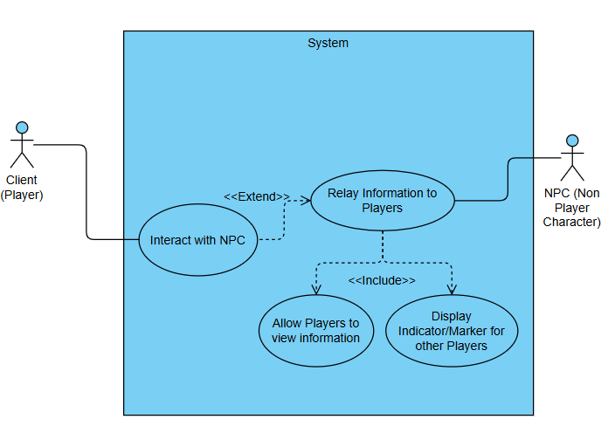

Element | Description
Primary Actor | Client (User/Player)
Secondary Actor | NPC (Non-Player Character)
Use Cases | Interact with NPC, Relay Information to Players, Allow Players to View Information, Display Indicator/Marker for Other Players
Normal Course | Interact with NPC:  1. User interacts with an NPC.  2. System initiates NPC-specific actions.  Relay Information to Players:  1. System relays collected information to relevant players.  2. System includes "Allow Players to view information" and "Display Marker for Other
31

Players."
Allow Players to View Information:
1. System allows the information to be visible to players.
Display Indicator/Marker for Other Players:
1. System displays a marker to indicate where the information is located.
Pre-Condition | - NPC is active and available for interaction. - System is connected and operational.
Post-Condition | - Information is successfully relayed, and markers are displayed.
Alternate Course | - NPC unavailable→System notifies the user.  - Marker display fails→System retries or notifies the user.

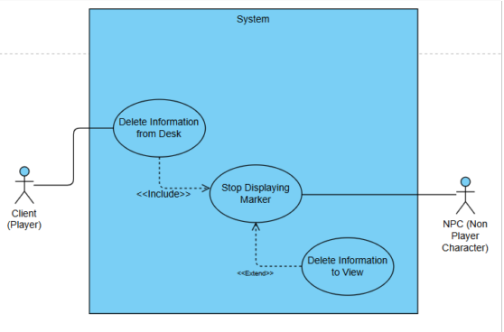
Element | Description
Primary Actor | Client (User/Player)
Secondary Actor | NPC (Non-Player Character)
Use Cases | Delete Information from Desk, Stop Displaying Marker, Delete Information to View
Normal Course | Delete Information from Desk:  1. User deletes information stored at the desk. 2. System includes "Stop Displaying Marker" action.  Stop Displaying Marker:
32

1. System stops displaying the marker/indicator.
Delete Information to View:
1. System extends marker removal by deleting associated information.
Pre-Condition | - Information exists at the desk or for view. - User has the required permissions.
Post-Condition | - Information is deleted, and markers are no longer displayed.
Alternate Course | - Information not found→System notifies the user.  - Marker removal fails→Retry or notify user.
Sequence Diagrams:
These sequence diagrams provide a comprehensive overview of various processes in the application, from authentication to specific gameplay mechanics like stall placement and editing. They illustrate the flow of information between clients, servers, and databases, highlighting key steps and potential points of interaction within scholastic sanctuary.

33

Authentication Sign-In Sequence Diagram:
Unity Sign-In Sequence Diagram
This diagram illustrates the workflow for user authentication in the application: User presses
the sign-in button, A web page for authentication is opened. User enters credentials on the web page: If credentials are valid, a token is provided to the app. The app validates the token with the server. If valid, the user is welcomed and can interact with the game.

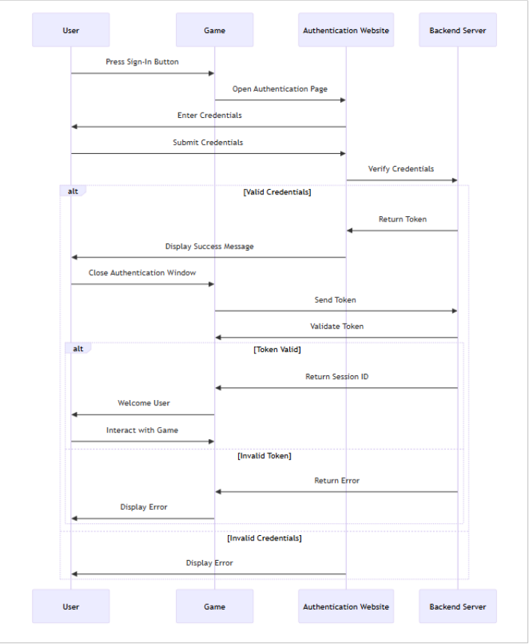

34

Vivox Text and Voice Chat System Sequence Diagram:
This diagram outlines the workflow for text and voice chat using Vivox services: The user initiates chat by pressing a button. The game initializes the Vivox SDK. The user authenticates with the Vivox service. For voice chat: The user speaks, audio is sent to the server, transmitted to others, and played back. For text chat: The user types a message, it's sent to the server, broadcasted to others, and displayed. Users can mute/unmute themselves. When leaving, the user disconnects from the chat.

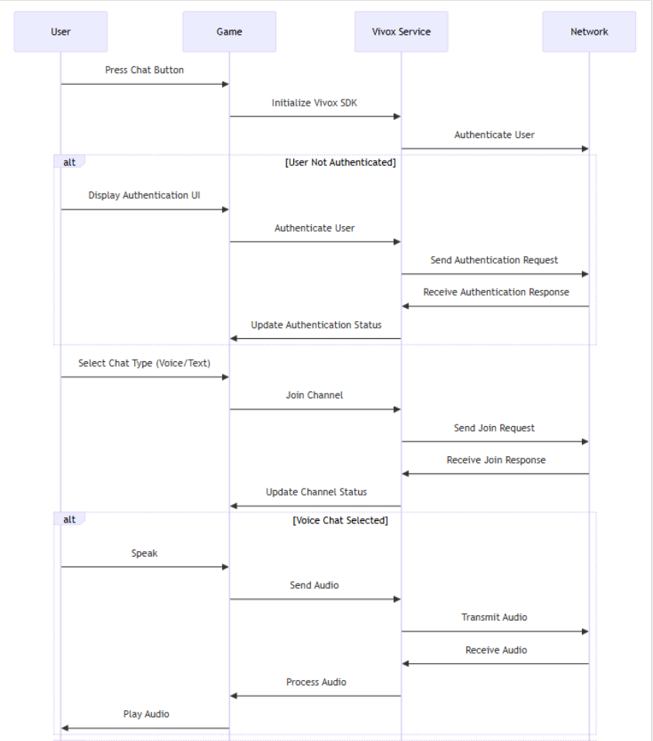

35

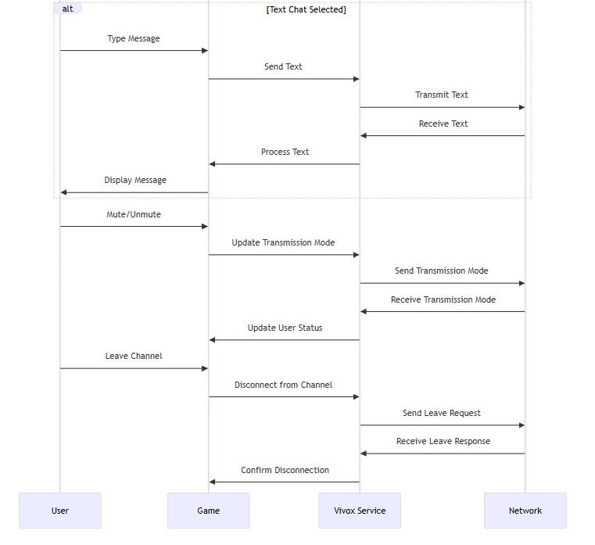

36

For Lobby Creation and Joining:
This diagram shows the process of creating and joining game lobbies: A player presses the host button to create a lobby. The game requests lobby creation from the matchmaker service. The
relay service creates the lobby and returns a unique lobby ID. Other players can join using a lobby code or by browsing the lobby list. When joining, the game sends an RPC to the server to request joining. The server validates the join request and notifies other players if successful.

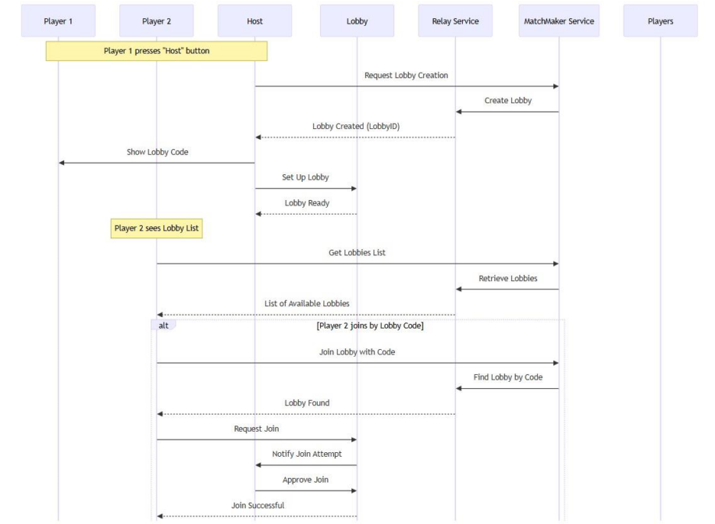

37

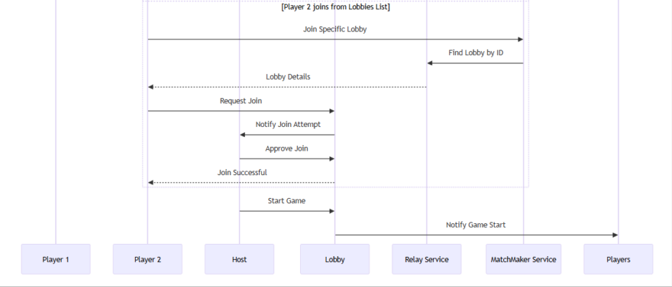

Stall Placement/Viewing:
This diagram illustrates the process of placing a stall in the game: The user presses the stall placement key. An RPC is sent to the server requesting a preview. The server validates the placement location. If valid, a preview is shown to the user. The user confirms the placement by clicking. The server performs final validation. If successful, the user inputs stall details. The edited details are submitted via RPC. The server stores the details in the database. A confirmation RPC is sent back to the client

38

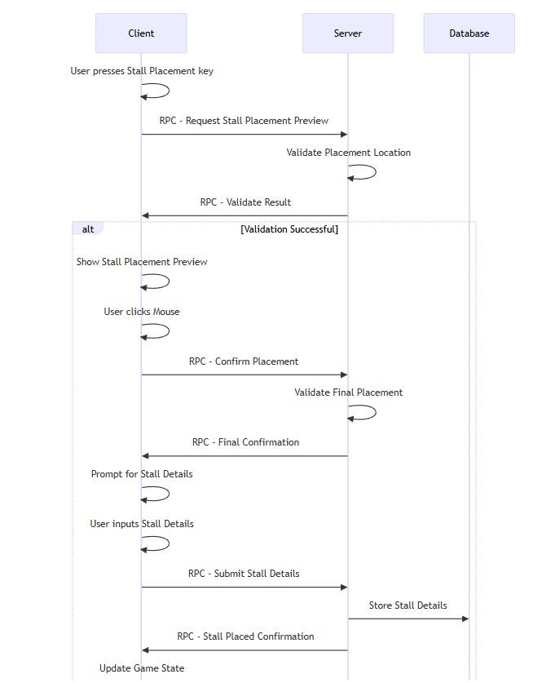

39

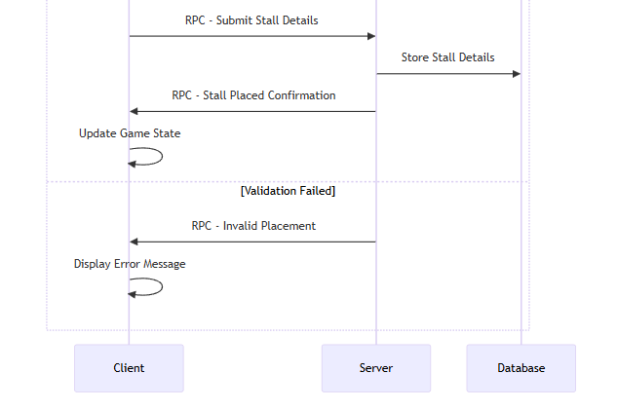

40

Stall Modification:
This diagram shows how users can edit existing stalls or view them: For editing: The owner presses the edit button. An RPC is sent to request edit details. The server fetches and sends stall details to the owner. The owner edits the details and submits them. The edited details are sent via RPC to the server. The server updates the database. A confirmation RPC is sent back to the
owner. For viewing: A non-owner presses the view button. An RPC is sent to request stall details. The server fetches and sends stall details to the viewer. The received details are displayed to the non-owner.

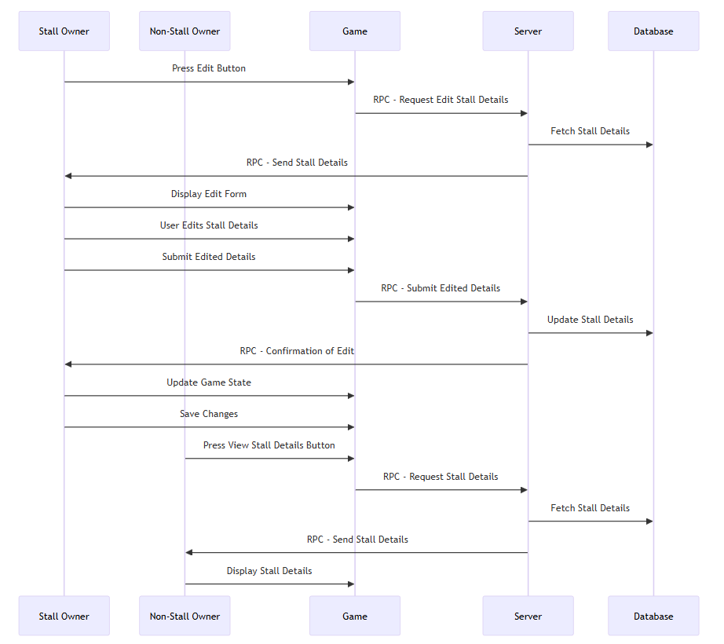

41

NPC Broadcasting: This diagram depicts the detailed interactions between the player, desk, system, and NPCs for the information broadcast feature: It begins with the player interacting with the desk, triggering the system to display an input prompt. The player enters and submits information, which the system validates. If valid, the system saves the information, distributes it to NPCs, and activates markers above NPCs to indicate new information. Players can then interact with the marked NPCs to retrieve the broadcasted information, and the system removes the markers for players who have viewed it. If the input is invalid, the system prompts an error message. The diagram captures the sequential flow, focusing on interactions, validations, and marker management.

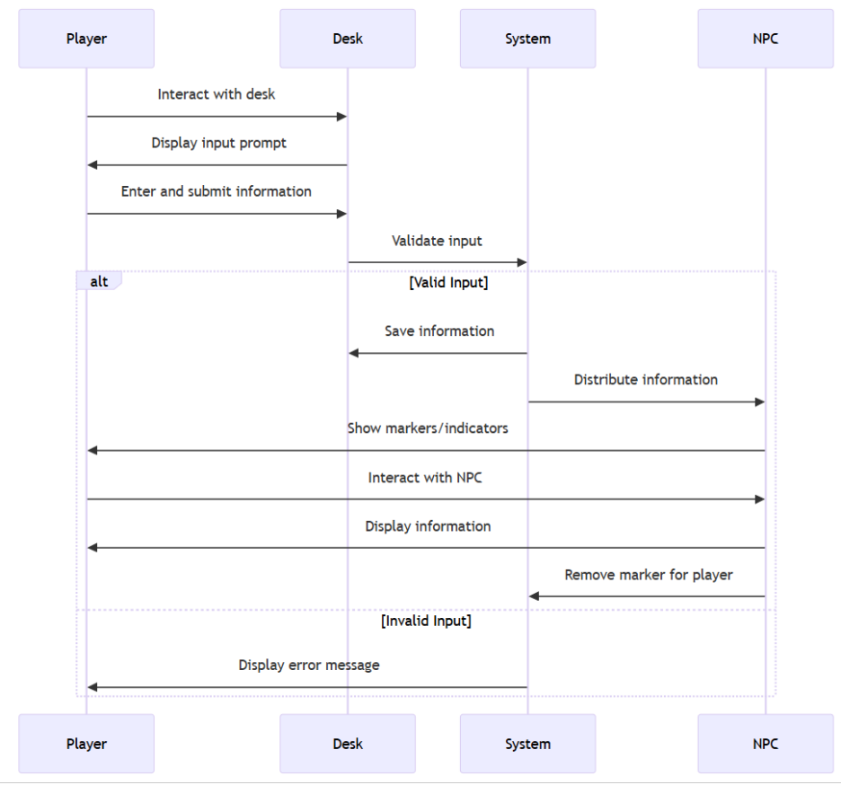

42

3.3 Design Rationale
The design rationale for the Scholastic Sanctuary application outlines the key decisions made during the development process, emphasizing the reasoning behind the chosen architecture, technologies, and functionalities. This section aims to provide clarity on how these decisions align with the project goals and user needs.
Key Design Decisions
1. Architectural Framework:
The application is built using a modular architecture that separates concerns into distinct subsystems (e.g., User Management, Lobby Management, Game State Management). This design promotes maintainability and scalability, allowing for easier updates and feature enhancements as user needs evolve.
2. Technology Choices:
Unity Gaming Services (UGS) was selected for its robust support for multiplayer functionalities, including user authentication and real-time data management. This choice facilitates seamless integration of essential features while ensuring high performance and low latency in multiplayer environments.
3. User-Centric Design:
An intuitive user interface was prioritized to enhance user engagement and exploration within the 3D environment. By focusing on user experience, the design encourages users to interact with the platform more freely, fostering creativity and collaboration.

Trade-offs and Alternatives Considered Alternatives:
43

Various game engines were evaluated during the initial design phase. While alternatives like Unreal Engine were considered for their graphical capabilities, Unity was ultimately chosen due to its extensive community support, documentation, and compatibility with UGS, which aligns well with the project's requirements.
Performance vs. Complexity:
The decision to implement a real-time database was made to ensure quick access to user data while maintaining performance standards. Although this adds complexity to the system architecture, it is essential for supporting multiple concurrent users without performance degradation.
User Experience Considerations
• Features such as real-time communication via Vivox were integrated to enhance interaction among users. This decision was influenced by user feedback indicating a strong preference for collaborative features that mimic real-life interactions.
• The design also includes customizable environments where users can showcase their ideas, reinforcing the platform's goal of fostering creativity.
Security Measures
• Robust security measures are embedded within the application design to protect user data and ensure safe communication. Utilizing UGS for user authentication helps mitigate risks associated with data breaches while providing a secure environment for interactions.
• The architecture includes server-side validation processes to ensure that all actions performed by users are authenticated and authorized, thereby enhancing overall system security.
Scalability and Performance
• The modular design allows for easy scaling of subsystems as user demand increases. For instance, additional lobby management capabilities can be integrated without disrupting existing functionalities.
44

4. Data Design
4.1 Data Description
Data Entities
User Data:
Contains information about user accounts, including:
o Usernames
o Hashed passwords
o Email addresses
o Player IDs
o Local Client IDs
Lobby Data:
Includes details about game lobbies, such as:
o Lobby IDs
o Participant lists
o Settings (e.g., privacy options)
o Current game state
o Join code
Game State Data:
Represents real-time data about the game environment, including:
o Current Scene
o Players’ Position
o Game events
o Stall data
o Animation Data
Content Data:
Refers to user-generated content like:
o Virtual stalls
o Information broadcasts
o Associated metadata (e.g., creation date, creator ID)
45

Activity Diagrams:
Authentication: This diagram outlines the authentication process: Starts with the user initiating login. Includes steps for anonymous auth login. Shows the verification of credentials Illustrates the storage of anonymous credentials. Covers logout functionality. Ends with the user being returned to the login status.

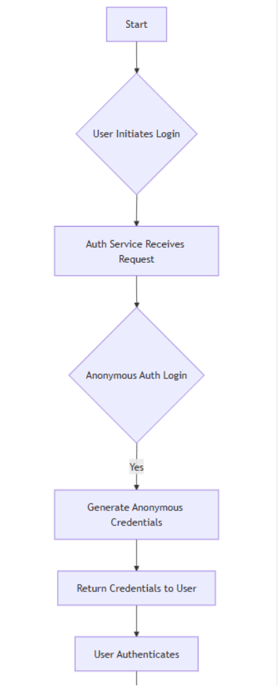

46

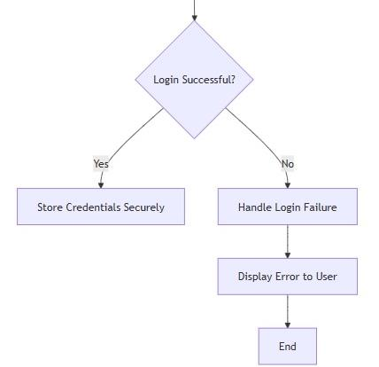

47

Stall Placement: This diagram illustrates the process of placing a stall in the game: Starts with the user pressing the stall placement key. Proceeds through validating the placement location. Shows the preview display if valid. Continues with user confirmation and final validation. Includes steps for entering and submitting stall details. Ends with saving changes and updating the game state. The diagram clearly shows the flow from initial request to final confirmation, highlighting key decision points and user interactions.

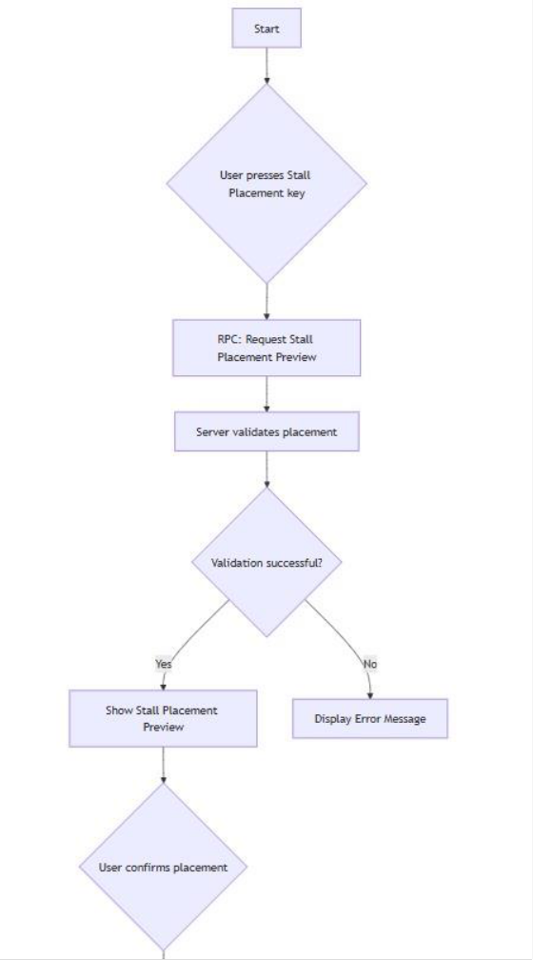

48

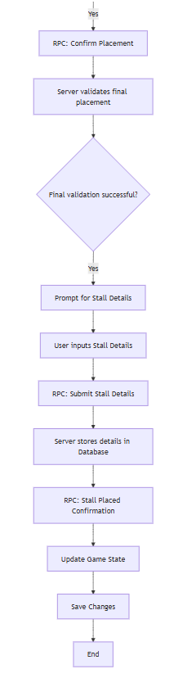

49

Edit/View Stall: This diagram covers both editing (by owners) and viewing (by non-owners):
Begins with either an edit button press or view button press. Shows the process of fetching/storing stall details. Illustrates the difference in flow based on whether the user is the
owner. Includes steps for displaying/editing stall details. Ends with updating the game state and saving changes. The diagram effectively separates the owner and non-owner processes while maintaining a consistent overall structure.

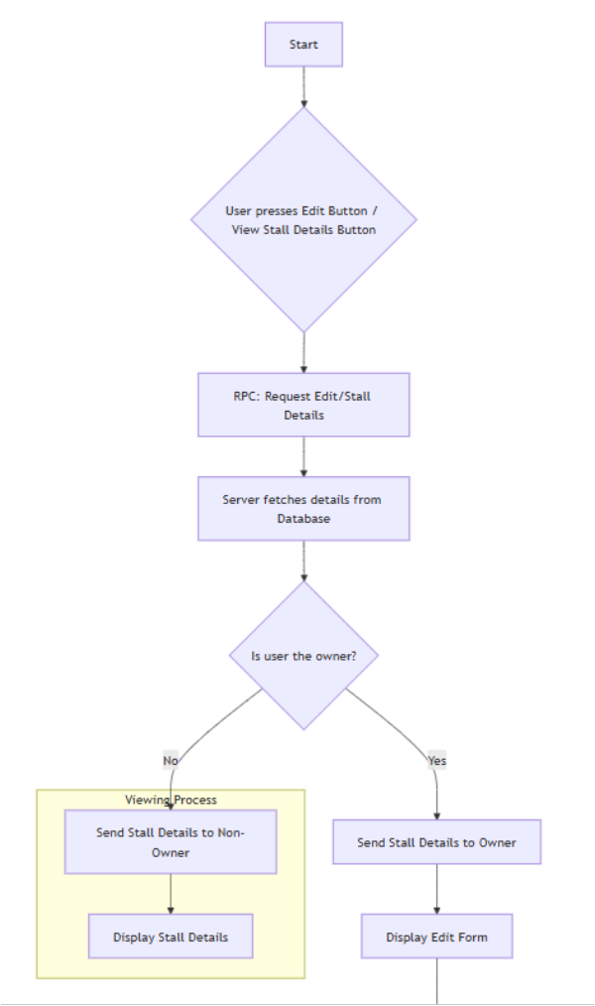

50

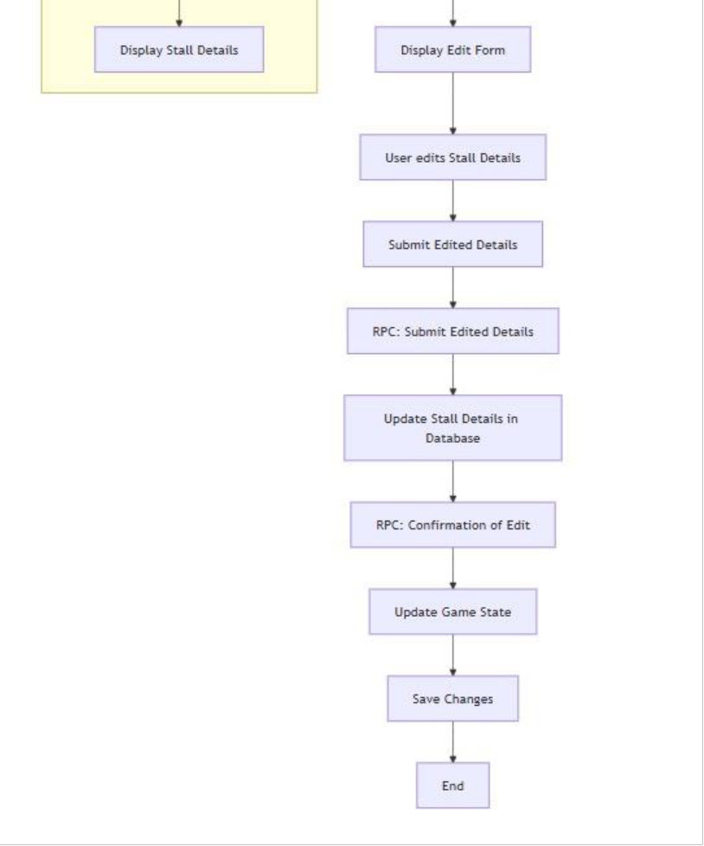

51

Lobby Creation: This diagram illustrates the process of creating a lobby: Begins with the user requesting lobby creation. Shows validation of credentials. Includes steps for generating a lobby
code. Covers creating the lobby in the lobby service. Illustrates setting lobby properties. Ends with notifying other players and updating the lobby list.

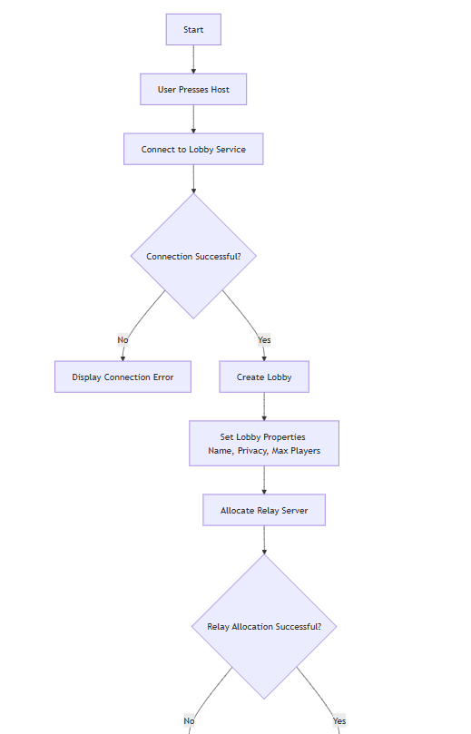

52

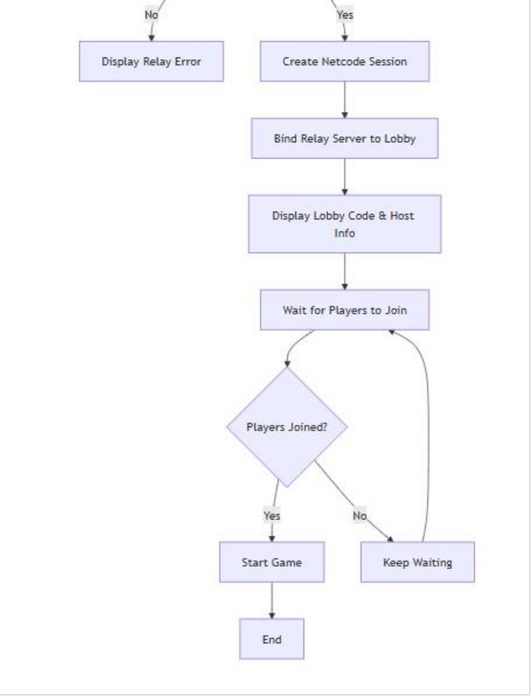

53

Lobby Joining: This comprehensive diagram covers two joining methods: One path for joining via public list or quick join, and Another path for joining using a lobby code. Both paths include credential validation. Shows the process of finding or creating a channel. Illustrates updating player status and notifying others. Ends with joining successfully and updating local state.

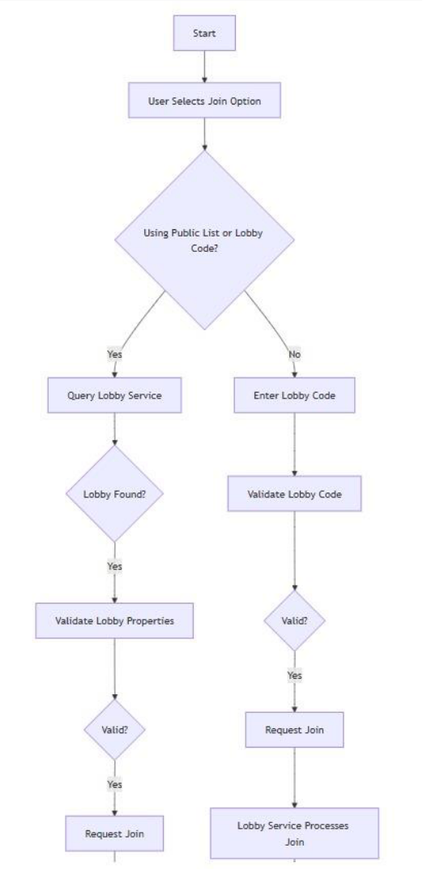

54

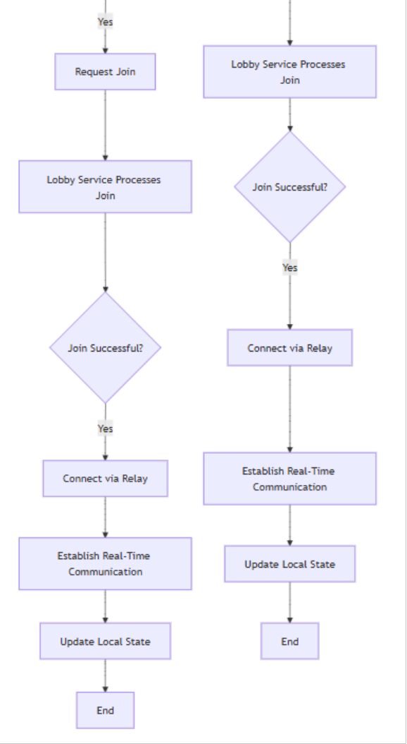

55

NPC Broadcasting: This diagram illustrates the process of broadcasting information in the game: It starts with the player approaching and interacting with a designated desk. The system then displays a prompt for the player to input information, such as events or tasks. After the player submits the information, the system validates the input. If the input is valid, the information is saved and distributed to NPCs, which display markers to indicate new information. Players can then approach marked NPCs and interact to retrieve the information. The system ensures that markers disappear for players who have viewed the information. The diagram highlights key interactions, decision points, and system responses, emphasizing the flow from input to NPC dissemination.

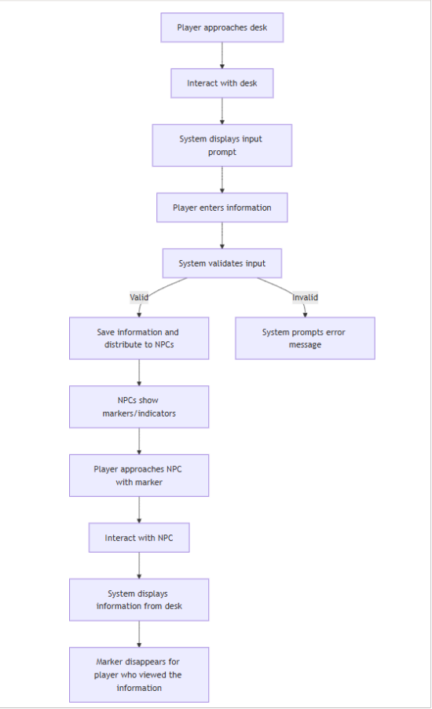

56

Data Relationships
• User and Lobby Relationships:
o A single user can join multiple lobbies.
o Each lobby can include multiple users.
o Only one user can host lobbies.
• Content and User Relationships:
o All Content data is directly linked to the user who created it.
o This connection simplifies content management and updates.
• Game State to All Clients:
o Game state relays data like current player positions, animation data, stall data etc. to all players/clients, keeping everything in sync.
o This connection simplifies content management and updates.

Following is the class diagram for these relationships:

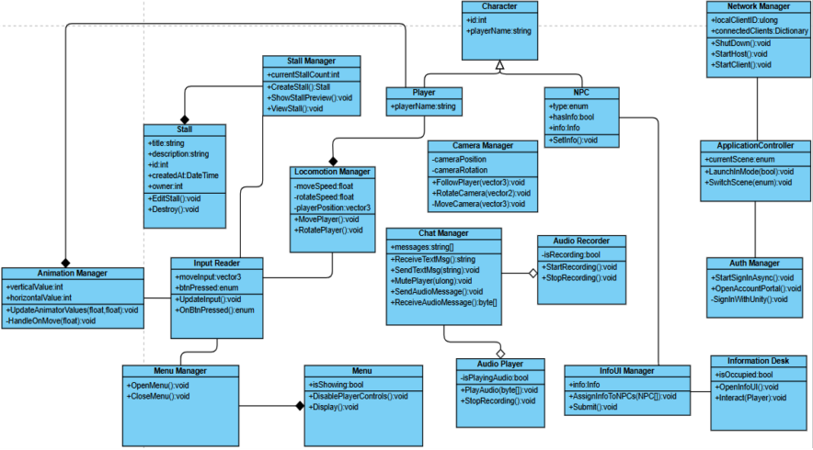

4.2 Data Dictionary

A comprehensive data dictionary will be maintained to define all data elements used in the
application. This includes:
57

Data Element |  | Description |  |  | Data Type |  |  | Constraints
UserID | Unique identifier for each user |  |  | Integer |  |  | Primary Key
Username | User's chosen display name |  |  | String |  |  | Unique, 3-20 characters
PasswordHash | Hashed password for user authentication |  |  | String |  |  | Must meet security standards
LobbyID | Unique identifier for each lobby |  |  | Integer |  |  | Primary Key
ParticipantList | List of users currently in a lobby |  |  | Array of UserIDs |  |  | Must not exceed defined limits
GameState | Current state of the game environment |  |  | JSON |  |  | Dynamic structure
ContentID | Unique identifier for user-generated content |  |  | Integer |  |  | Primary Key
ContentType | Type of content (e.g., stall, event broadcast) |  |  | String |  |  | Enum (stall, broadcast)
Data Storage Strategy

•  • | The application will utilize a real-time database to manage user data and interactions
 | efficiently. This choice ensures quick access to data while maintaining performance
 | standards even with multiple concurrent users.
 | Data will be organized into collections that align with the defined entities, allowing fo |  |  |  | r
 | straightforward querying and manipulation.
58

Data Flow
The flow of data within the application is designed to support real-time interactions:

•  •  • | User actions (e.g., logins, content creation) trigger updates in the respective
 | subsystems.
 | The Game State Management Subsystem communicates changes back to clients to
 | ensure all users have an up-to-date view of the game environment.
 | Regular synchronization between subsystems ensures that all components reflect the
 | latest state of user interactions and content.

5. Component Design

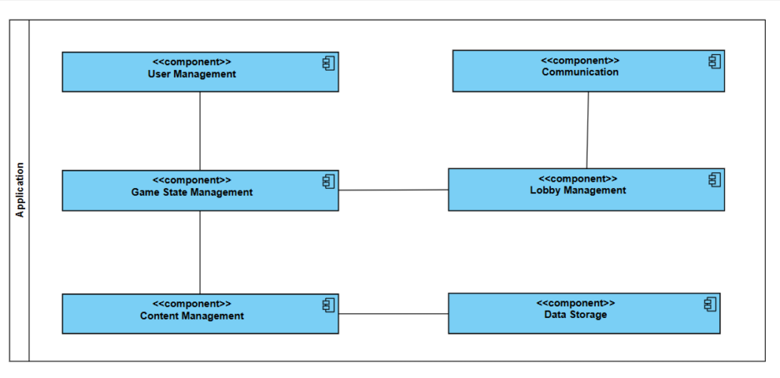

59



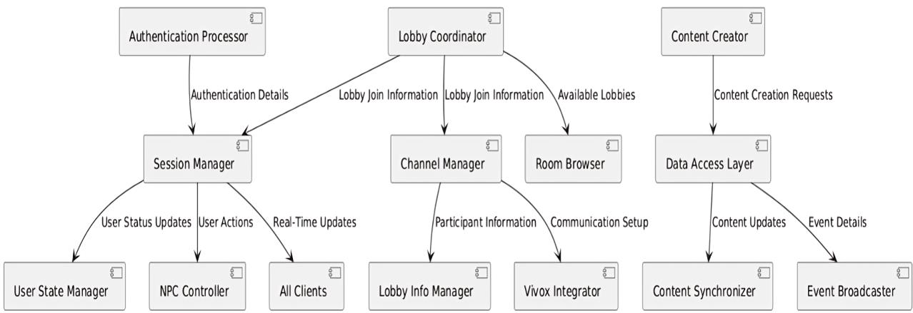

6. Human Interface Design
6.1 Overview of User Interface

The user interface (UI) for Scholastic Sanctuary is designed to facilitate seamless interaction
within a 3D virtual environment. The interface will prioritize clarity and ease of use, enablin

60

users to navigate the platform effectively while engaging with its various features. Key
elements include:

•  • | Main Navigation Menu: A clear and accessible menu that allows users to acce |  | s
 | different sections of the application, such as lobby management, creation, and joining.
 | In-Game HUD (Heads-Up Display): An intuitive HUD that provides real-time informati
 | about game state, and available actions. This includes visual indicators for chat
 | functionality, notifications for events, and quick access buttons for essential features
 | like logout.

6.2 Screen Images

Visual representations of the user interface will be provided to illustrate the layout and design
of critical screens within the application. These images will include:

•  •  • | Login Screen: A simple and secure login interface where users can enter their
 | credentials or create a new account.
 | Lobby Screen: A dynamic screen displaying available lobbies for users to join or create
 | new ones, featuring filters for easy navigation.
 | Game Environment: Screenshots showcasing the interactive 3D world where users can
 | explore, interact with NPCs, and engage with other participants.

61

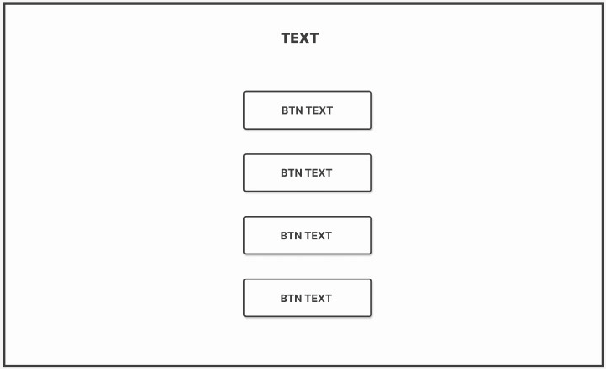

Figure 1. Layout for Menus (Like main menu, login menu etc.) for the Application.

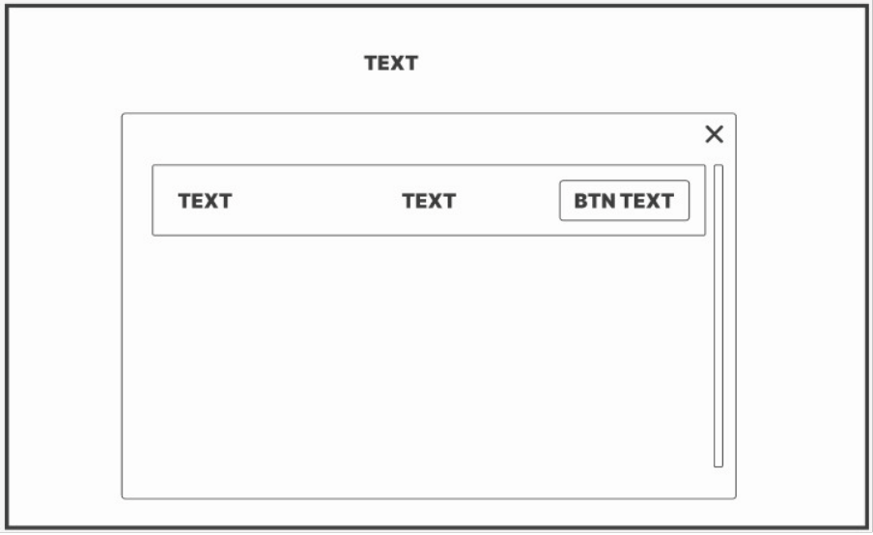

Figure 2. Layout for displaying Lists within the Application (like Lobbies List.)

62

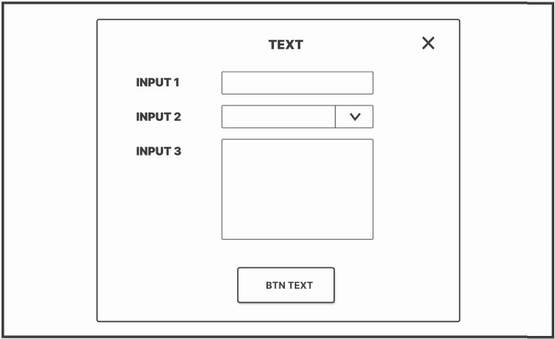

Figure 3. Layout for details or information input (As in entering stall details, details at desk).

63

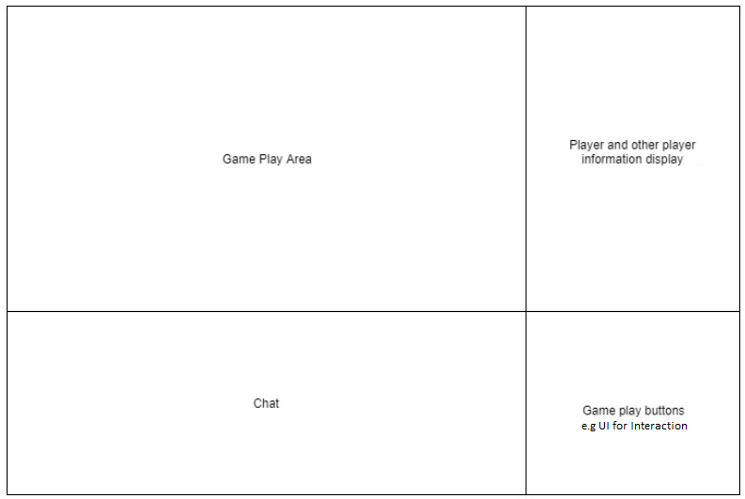

Figure 4. Game HUD (heads-up display) Layout, Player will be able to see this UI once in the application play-state.

6.3 Screen Objects and Actions
The following describes key screen objects and their associated actions within the application:

•  •  •  • | Buttons: Interactive elements that allow users to perform actions such as "Join Lobby,"
 | "Create Content," or "Send Message." Buttons will have clear labels and visual feedbac
 | (e.g., color changes) upon interaction.
 | Text Fields: Input fields for entering usernames, passwords, or messages in chat. These
 | fields will include placeholder text to guide users on expected input.
 | Dropdown Menus: Used for selecting options such as lobby settings or content
 | categories. These menus will be designed for easy access and quick selection.
 | Chat Interface: A dedicated area for real-time communication among users. It will
 | include text input capabilities and options for voice chat integration.

64

Accessibility Considerations

The design will incorporate accessibility features to ensure that all users can interact with the
application effectively. Key considerations include:

•  •  • | Keyboard Navigation: Ensuring that all interactive elements are accessible via keyboard
 | shortcuts to accommodate users with mobility impairments.
 | Screen Reader Support: Implementing attributes to enhance compatibility with screen reade |  |  |  |  | s
 | to read text chats for visually impaired users.
 | Color Contrast: Using high-contrast color schemes to improve readability for users with visual
 | impairments.
7. Requirements Matrix

Requirement  ID | Requirement Description | Priority | Source | Notes
REQ-1 | System must allow  players to input information at the desk. | High | Gameplay | Core feature for interaction
REQ-2 | System should display  markers/indicators above NPCs to indicate info. | High | Gameplay | Key visual indicator  for player interaction
REQ-3 | NPCs should relay  information to players when interacted with. | High | Gameplay | Interaction  mechanism for NPCs
REQ-4 | Marker should disappear  for the player who viewed the information. | High | Gameplay | Enhances user  experience by reducing clutter
REQ-5 | Multiple NPCs can carry  information if necessary. | Medium | Gameplay | Flexibility for  gameplay
65

 |  |  |  | mechanics
REQ-6 | Players should be able to  modify/delete information, updating NPCs. | Medium | Gameplay | Interaction and  content management feature
REQ-7 | Information must be  dispatched within a specified time. | High | Gameplay | Time-sensitive information delivery
REQ-8 | System must allow user  to create a unique account. | High | Authentication | User account creation required
REQ-9 | System should  authenticate user based  on credentials. | High | Authentication | Ensures secure access
REQ-10 | Authentication service  must be live for users to log in. | High | Authentication | Service availability for authentication
REQ-11 | System should include a  forgot password feature. | Medium | Authentication | Password recovery  mechanism
REQ-12 | Authentication must be  completed before accessing the game. | High | Authentication | Ensures secure and authorized access
REQ-13 | System must allow users  to create a lobby/room with a unique join code. | High | Multiplayer | Core multiplayer feature
REQ-14 | Users should be able to  join lobbies using a valid | High | Multiplayer | Lobby access  mechanism
66

 | join code.
REQ-15 | System should enforce player limits in lobbies. | High | Multiplayer | Prevents  overcrowding in lobbies
REQ-16 | Lobbies should sync  changes (joining/leaving users) immediately. | High | Multiplayer | Real-time sync  required for multiplayer experience
REQ-17 | Errors in lobby creation or  joining should be notified. | Medium | Multiplayer | User feedback on  errors
REQ-18 | Real-time text  communication between players in the same  lobby. | High | Communication | Essential for  multiplayer interaction
REQ-19 | System should enable  voice chat for players in the lobby/team. | High | Communication | Critical for team-  based communication
REQ-20 | Players should be able to  mute/block specific players in text/voice chat. | Medium | Communication | Moderation and  control in communication
REQ-21 | Chat should be  moderated for inappropriate behavior/language. | High | Communication | Ensures safe  communication environment
REQ-22 | System must allow  players to place a stall in the game world. | High | Gameplay | Key gameplay interaction
67

REQ-23 | Placement location of stalls must be validated. | High | Gameplay | Prevents  unauthorized stall placement
REQ-24 | Players can enter custom  details for the stall. | Medium | Gameplay | Customization  feature for stalls
REQ-25 | Custom details should  show when the stall is interacted with. | Medium | Gameplay | Enhances user  interaction with the stalls
REQ-26 | Players should be able to  modify or remove the stall. | Medium | Gameplay | Content  modification for user control
REQ-27 | System should limit the  number of stalls a player can place. | High | Gameplay | Prevents  overcrowding and balance issues
REQ-28 | System must enforce a  limit on how many stalls can be placed in a designated area. | High | Gameplay | Balances game  world economy and performance
REQ-29 | System should process  user actions within 2-30 seconds under normal load. | High | Performance | Ensures good user experience
REQ-30 | System should support 20  concurrent users without performance  degradation. | High | Performance | Scalability  requirement for multiplayer functionality
REQ-31 | System must handle 1000 | High | Performance | High traffic handling
68

 | requests per minute  during peak usage. |  |  | for peak periods
REQ-32 | Network latency should  be under 300ms for real- time interactions. | High | Performance | Critical for smooth user interaction
REQ-33 | Implement robust  encryption protocols for user data (DTLS). | High | Security | Protects user data  and ensures secure communications
REQ-34 | Implement content  moderation to prevent harmful content. | High | Security | Ensures safe  environment for all users
REQ-35 | Enforce strong password  policies and multi-factor authentication (MFA). | High | Security | Enhances account security
REQ-36 | Application must adhere  to strict security and privacy standards. | High | Security | Ensures user data  protection and safe interactions
REQ-37 | System must be server-  authoritative for all user actions. | High | Security | Anti-cheating mechanism
REQ-38 | System must achieve a  usability score that reflects ease of use. | Medium | Quality | Enhances overall user experience
REQ-39 | System must have 80%  uptime over a month. | High | Quality | Ensures availability  and reliability
REQ-40 | Code must be modular  for easier updates and | High | Maintainability | Ensures future  updates are easier
69

 | bug fixes. |  |  | to implement
REQ-41 | System must be  thoroughly tested for reliability and performance. | High | Quality | Ensures bug-free  operation before release
REQ-42 | Game should maintain 60 FPS during gameplay. | High | Performance | Critical for smooth  gameplay experience
REQ-43 | Database should support  concurrent access without performance issues. | High | Performance | Supports real-time  game updates and queries

70

