

National University of Sciences and Technology (NUST) Military College of signals (MCS)

FINAL YEAR PROJECT

Software Requirement Specification
For
SCHOLASTIC SANDBOX

Version 1.0

Muhammad Saad Filza Khan Tareen M. Saad Bin Khalid Memoona Ramzan

Lt. Col Khawir Mehmood 24th October, 2024

Table of Contents
Table of Contents .....................................................................................................................................2
Revision History .......................................................................................................................................2
1. Introduction ...............................................................................................................................................3
1.1 Purpose……………………………………………………………………………………………………………………………...3
1.2 Document Conventions.............................................................................................................................................3
1.3 Intended Audience and Reading Suggestions ................................................................................................3
1.4 ProductScope…………………………………………………………………………………………………………………….4
1.5 References………………………………………………………………………………………………………………………….4
2. Overall Description.................................................................................................................................5
2.1 Product Perspective ...................................................................................................................................................5
2.2 Product Functions.......................................................................................................................................................6
2.3 User Classes and Characteristics ..........................................................................................................................7
2.4 Operating Environment ............................................................................................................................................7
2.5 Design and Implementation Constraints..........................................................................................................8
2.6 User Documentation...................................................................................................................................................9
2.7 Assumptions and Dependencies...........................................................................................................................9
3. External Interface Requirements....................................................................................................9
3.1 UserInterfaces……………………………………………………………………………………………………………………9
3.2 Hardware Interfaces ................................................................................................................................................14
3.3 Software Interfaces...................................................................................................................................................14
3.4 Communications Interfaces..................................................................................................................................15
4. System Features ....................................................................................................................................17
4.1 PlayerAuthentication………………………………………………………………………………………………18
4.2 Lobby Creation and Joining ...................................................................................................................................19
4.3 Chat and Communication .......................................................................................................................................21
4.4 Stall Placement and Viewing.................................................................................................................................23
4.5 NPC Information Broadcasting ............................................................................................................................25
5. Other Nonfunctional Requirements............................................................................................27
5.1 Performance Requirements..................................................................................................................................27
5.2 Safety Requirements ................................................................................................................................................28
5.3 Security Requirements............................................................................................................................................28
5.4 Software Quality Attributes..................................................................................................................................29
5.5 BusinessRules……………………………………………………………………………………………………………........30
6. Other Requirements............................................................................................................................30
Appendix A: Glossary..........................................................................................................................31
Revision History

Name | Date | Reason For Changes | Version
Filza, M.Saad | 15th-17th Oct | Added section 1 and 2 | 1
Saad Khalid, Memoona | 18th Oct | Added section 3 and modified 2 | 1
Filza, M. Saad | 19th Oct | Added section 4 and 5 | 1
2

Filza, M. Saad | 22nd Oct | Added Diagrams and Glossary | 1
1. Introduction
1.1 Purpose
The product whose software requirements are specified in this document is Scholastic Sanctuary, a 3D software application designed for interactive experiences. The scope of this Software Requirements Specification (SRS) encompasses the entire system, detailing its features, user interactions, and security measures.

1.2 Document Conventions
This Software Requirements Specification (SRS) adheres to the following standards and typographical conventions:
• Font and Highlighting: The primary font used throughout this document is Arial, with headings in bold to distinguish them from body text. Important terms and concepts are highlighted in italics for emphasis.
• Requirement Prioritization: Each requirement statement is assigned a priority level, which is explicitly stated with the requirement. Higher-level requirements do not automatically inherit priorities from detailed requirements; each requirement must be evaluated and prioritized independently to ensure clarity and focus during development.
• Section Numbering: Sections are numbered sequentially (e.g., 1.1, 1.2) to facilitate easy navigation within the document.
• Terminology Consistency: Key terms used in this SRS are defined in a glossary section, ensuring that all stakeholders have a common understanding of the terminology employed.
1.3 Intended Audience and Reading Suggestions
This document is intended for developers, testers or quality assurance team, end users
3

and project supervisor. It is intended to be read sequentially to understand it thoroughly. The Overall Description and System Features section is to be read by all the above-mentioned audience to properly understand requirements. End users may refer to glossary for explanation of technical terms.

1.4 Product Scope
A 3D platform/software application that can be used by anyone for the purpose of interaction or to experience the 3D vibrant world. It targets a wide range of audiences that can create accounts, communicate in real-time, discover new ideas. This application depends on user-generated content as well. This application merges educational elements with entertainment, offering a vibrant environment where users can present and showcase their ideas in an engaging manner.
The primary objective of Scholastic Sanctuary is to create a dynamic platform that enables users to discover new ideas and passions while having fun. The goals include:
• Developing a user-friendly interface that promotes interaction and exploration.
• Ensuring robust security measures for user data protection.
• Building a sustainable ecosystem that encourages ongoing user engagement.
Security measures such as secure logins, server-client separated concerns etc. will be considered. The overall scope focuses on building a dynamic, collaborative platform that remains engaging and sustainable through user interactions.

1.5 References
Unity Gaming Services Documentation:
• Author: Unity Technologies
• Location: https://docs.unity.com/ugs/en-us/manual/overview/manual/unity- gaming-services-home

Multiplayer Games Best Practices:

4

Author: Unity Technologies
Location: https://unity.com/how-to/multiplayer-game-development-factors

2. Overall Description
2.1 Product Perspective
Scholastic Sanctuary is a new, self-contained product designed as an interactive 3D digital platform. It allows users to engage, collaborate, and showcase their creative ideas in an immersive environment that blends educational elements with entertainment. This product is not a follow-on member of an existing product family nor a replacement for any current systems; rather, it represents a novel approach to interactive learning and social interaction. The concept emerged from the idea of a 3d-platform that facilitates real-time communication and collaboration among users while providing an engaging experience. The software aims to target a wide audience, enabling users to create accounts, communicate in real-time, and explore new ideas through user-generated content.

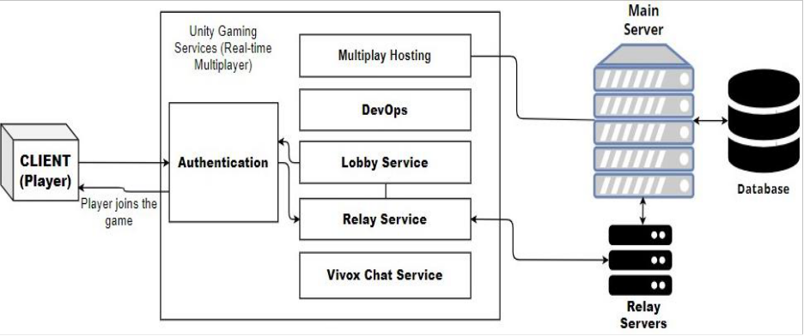

Figure 1. The client is authenticated first, then is connected to the main server via relay. Then client can join lobbies and ultimately can join the platform with other players in it.
Unity Gaming Services facilitate developers to avail services that assist them in development
5

of a multiplayer game or application in unity. Explanation is given below:

Multiplay Hosting: Provides scalable, hybrid cloud-based hosting for multiplayer games, allowing server scaling, low-latency global coverage, and cost-efficient infrastructure management to support real-time multiplayer gameplay.
DevOps: Automates and optimizes game development workflows, ensuring smooth deployment, continuous integration, and monitoring of multiplayer game services to maintain stability, scalability, and uptime. Includes version control capabilities.
Lobby: Manages pre-game sessions where players can join, leave, or modify their team settings before the actual game begins, helping with the setup of multiplayer experiences. Relay: Enables connectivity without the need for knowing or managing exact IP addresses of dedicated servers, reducing infrastructure costs while maintaining secure and efficient multiplayer sessions.
Vivox: Provides voice and text chat for multiplayer games, allowing players to communicate in real-time during gameplay.
2.2 Product Functions
Several functions of the product are described below:
• Users can create account to authenticate with the unity gaming services (UGS)
• Users can act as a host and create a 3D room for other users to join in.
• Other users can use the join code to join the room or can browse for the public rooms.
• They can explore the rooms/lobbies
• They can interact with other users and NPCs in the same room.
• Users can also interact with the world (placing stalls in the world, adding descriptions etc. for the stalls and many more)
• Users can place a stall, showcasing their work and ideas for other users to interact with
• Users can go to the information desk to broadcast any information (Like workshops, events etc.)
6

• Users can interact with NPCs to read any information like upcoming workshops etc.

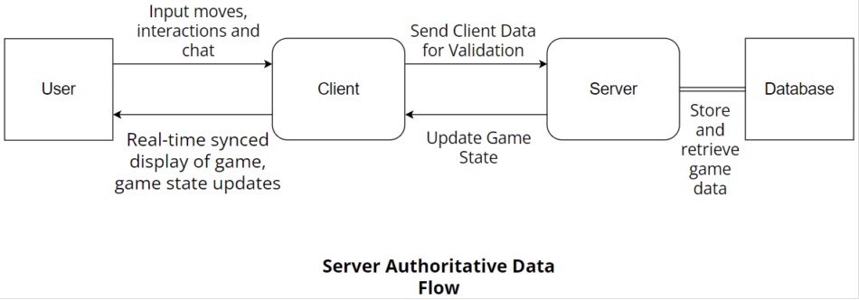

Figure 2. The client sends inputs to the server for validation via RPCs. The server verifies, processes, updates the game state, and syncs actions across all clients, ensuring real-time updates and security.
Interactions like stall placement, Broadcasting information etc. will be first verified and validated by the server, then server updates the state for all clients, so that all clients are in sync with each other.

2.3 User Classes and Characteristics
The most important user classes are host and participant
• Host: Host creates and manages 3D rooms where other users can gather. They can set access rules, deciding whether rooms will be private or public for anyone to join.
• Participants: Participants join 3D rooms created by hosts, either by entering a specific join code for private rooms or browsing through publicly accessible rooms. Once inside, they can engage with other users, interact with NPCs, and explore the virtual environment. Participants can visit stalls where creators showcase their work, ideas, or projects.
2.4 Operating Environment
Scholastic Sanctuary will need to operate seamlessly in this environment, ensuring compatibility with hardware and software systems as defined.
Minimum System Requirements
7

• Operating System: Windows 10 or higher (64-bit).
• Graphics Card: A DirectX 11 compatible GPU is required.
• RAM: At least 4GB of RAM (though 8GB or more is ideal).
• Processor: A recent dual-core processor or better.
• Network: Stable internet connection for online interactions within 3D rooms and content sharing.

2.5 Design and Implementation Constraints
Several constraints will influence the design and development of the project:
• Hardware Limitations: The product must be designed to perform efficiently on systems that meet the minimum hardware specifications, including at least 4GB of RAM and a DirectX 11 compatible GPU. These hardware limitations must be factored into development to ensure the product runs smoothly on a wide range of devices without compromising performance.
• Database Constraints: An appropriate real-time database will be necessary to store and manage critical data like user information and world interactions. This reliance on external databases imposes constraints on data management and retrieval speed, ensuring that database queries do not impede performance.
• Security: User authentication and secure data sharing are essential aspects of the product, particularly for rooms where sensitive information may be exchanged ensuring all interactions and data exchanges are secure, safeguarding user privacy and maintaining the integrity of the virtual environment.
• Performance Requirements: The product needs to deliver high performance, focusing on
optimized 3D rendering and real-time interactions. Even in rooms with many participants, the system must maintain smooth functionality without noticeable lag or interruptions, providing a seamless user experience.
• Platform Restrictions: Since the product is being developed using Unity, the design must adhere to the limitations of Unity's asset management and rendering pipelines. Any features
or graphical assets must be optimized to work within Unity's framework to ensure
8

compatibility and stable performance across different platforms.

2.6 User Documentation
Documentation may or may not be provided, but in-game help system will be available for users as well as first time users.
In-Game Help System:
Description: A help feature integrated into the application, providing users with how the application works and what they will do in it. This may include menus, scroll views, and step- by-step guides accessible via a help button in the main menu or as a welcoming screen. Format: Interactive pop-ups and overlays.

2.7 Assumptions and Dependencies
The project is built on the following assumptions and dependencies
• Internet Connectivity: The project assumes a reliable internet connection for seamless interactions within the 3D environment. Any disruption in internet service could negatively affect real-time interactions, potentially leading to delays, disconnections, or an inability to join or host rooms.
• Service Dependency: The platform relies on Unity Gaming Services (UGS) for essential functions such as user authentication, real-time interactions, and server-side operations. If UGS experiences downtime or any service interruptions, key features like login and multiplayer interactions may be disrupted.
• Platform Dependency: The project is dependent on Unity and associated plug-ins for its development. It assumes that Unity and its tools will continue to be supported and compatible with future operating system updates. Any changes or discontinuation of support could pose challenges to future updates and maintenance.

3. External Interface Requirements
3.1 User Interfaces
9

1. GUI Standards for the Game
• Consistency: We will use a consistent color palette, typography, and UI elements across the game to ensure users feel immersed in the virtual world.
• Clear Hierarchy: Important elements like chat windows, and menus will be prominently displayed while not overwhelming the player’s view of the world.
• Intuitive Layout: We will use familiar patterns like bottom or side-aligned action bars, chat boxes for easy access.
• Minimalism: The GUI will be as minimal as possible during gameplay, only showing what is necessary to keep the screen uncluttered.

2. Product Family Style Guides
• Typography: A specific font family for headers, subtext, and UI labels will be set.
• Color Schemes: We plan to have borders and active states, red for errors, green for positive feedback, and yellow/orange for warnings or status alerts.

3. Screen Layout Constraints
• Fixed Aspect Ratio: The game is set for a screen resolution of 1920x1080, ensuring all assets are designed to fit within this resolution without losing detail.
• Adaptive UI: key UI elements will be positioned close to screen edges while ensuring they do not obstruct player actions.
• Mouse-Driven Interaction: We will use larger clickable areas for interactive elements to suit a mouse-driven UI, considering precision.
• Visibility of Elements: We will ensure that key information (like user names) stays clearly visible and does not overlap with critical gameplay views.

4. Standard Buttons
• Action Buttons: Distinct, easily recognizable buttons for common actions (e.g., Join Button, Submit Button) will be used. Standard shapes such as rectangles with icons and clear labeling will be prefered.
10

• Size: We will ensure that buttons are large enough to click comfortably but not so large that they occupy too much space.

5. Keyboard Shortcuts
• Movement: Useage of standard WASD keys for character movement.
• Action/Interaction: E for interacting with objects, F for special actions.
• Communication: Enter to open chat, Esc for opening menus etc.

6. Error Message Display Standards
• Clear & Specific: Error messages will be clear, specific, and non-technical to inform users of what went wrong. For example, "Connection lost" instead of "Socket Error."
• Placement: Error messages will appear at the top or bottom of the screen, in a noticeable but non-intrusive location, with distinct color coding (e.g., red for errors, yellow/Orange for warnings).
• Auto-dismiss: Minor warnings will auto-dismiss after a few seconds, while critical errors will require user action (e.g., retry or close).

7. Software Components for which User Interface is Needed
• Main Menu: Start game, join multiplayer, exit, options, etc.
• Player HUD: Chat Button, Interaction Buttons etc. will appear when needed.
• Chat System: Text-based chat between players will be allowed with a message window.
• Settings Menu: Quit to main menu etc.
• Game Notifications: Alerts for player actions.

8. Wireframes:

11

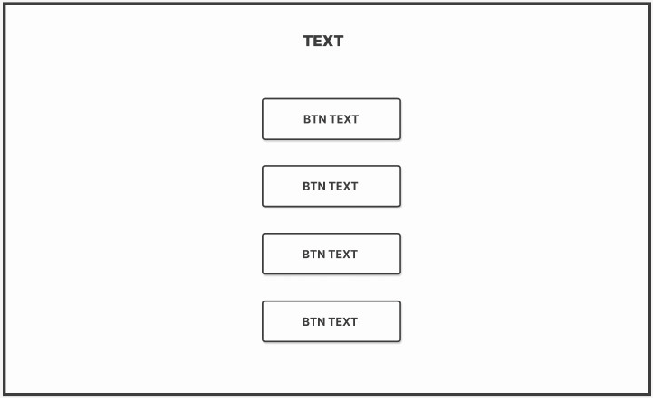

Figure 3. Layout for Menus (Like main menu, login menu etc.) for the Application.

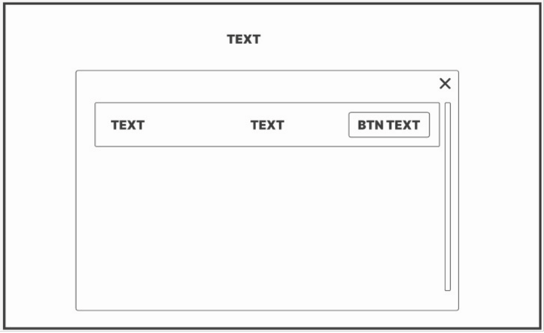

Figure 4. Layout for displaying Lists within the Application (like Lobbies List.)
12

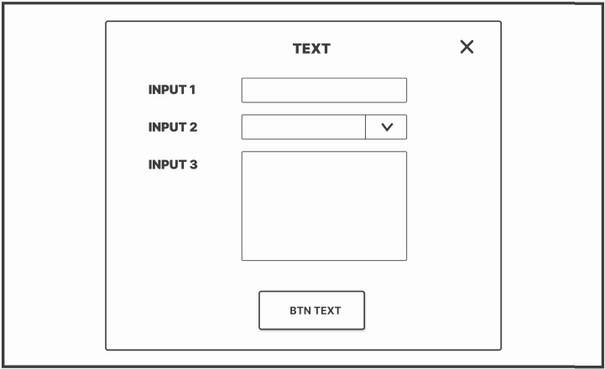

Figure 5. Layout for details or information input (As in entering stall details, details at desk).

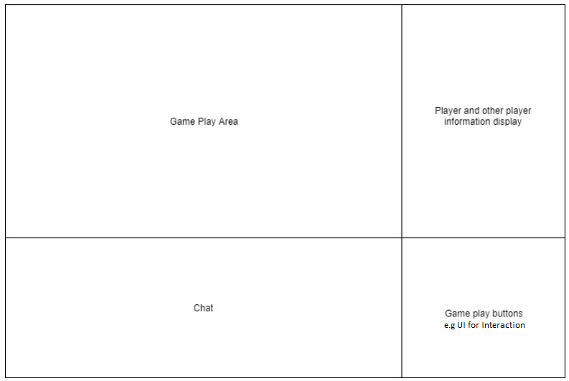

Figure 6. Game HUD (heads-up display) Layout, Player will be able to see this UI once in the application play-state.
13

3.2 Hardware Interfaces
The Scholastic Sanctuary application interfaces with various hardware components to ensure smooth operation and user interaction. Below are the logical and physical characteristics of each interface:
Supported Device Types
• Personal Computers: The primary platform for the application, specifically those running Windows 10 or higher (64-bit).
• Input Devices:
• Mouse: For navigation, selection, and interaction within the application.
• Keyboard: For text input, shortcuts, and command execution.
• Microphone: For voice chat functionality within the lobby.

Nature of Data and Control Interactions
• Input Data: User inputs such as keyboard commands (e.g., movement, chat messages), mouse clicks (e.g., selecting options, interacting with objects), and voice commands (for voice chat).
• Output Data: Visual feedback displayed on the screen (e.g., chat messages, user interactions), audio feedback (e.g., notifications, alerts).
• Control Interactions: The application will process user inputs in real-time, sending commands to the server for validation and updating the game state accordingly. The server will then synchronize these updates across all connected clients.

3.3 Software Interfaces
Software Components
1. Unity Gaming Services (UGS):
• Version: Latest version compatible with Unity.

14

• Functions: Provides user authentication, lobby management, relay services, version control, multiplay hosting and real-time communication.
• Data Items:
• User credentials for authentication.
• Lobby details including join codes and player lists. 2. Database Management System:
• Type: Real-time database (e.g., Firebase or similar).
• Functions: Stores user data, lobby configurations, and interaction histories.
• Data Items:
• User profiles including usernames and passwords (hashed).
• Room details such as settings and participant lists. 3. Communication Libraries:
• Examples: Vivox for voice communication.
• Functions: Facilitates real-time voice and text chat among users in the lobby.
• Data Items:
• Voice data packets for transmission during chat sessions.
• Text messages sent between users.

3.4 Communications Interfaces
The communications functions required by the Scholastic Sanctuary application include various protocols and standards to ensure effective interaction among users:
Communication Requirements 1. Network Protocols:
• UDP: Used for real-time communication in Unity's Netcode for GameObjects, ensuring low-latency delivery of game state updates, even if some data packets are lost.
• WebRTC: Used for peer-to-peer communication, including features like Vivox voice chat, enabling real-time audio without requiring a dedicated server.
• HTTP/HTTPS: Used for services like Unity Authentication and retrieving data
15

from the server via APIs, but not for real-time gameplay updates. RPCs in Netcode for GameObjects use UDP, not HTTP.

2. Message Formatting Standards:
• JSON format will be used for data exchange between the client and server due to its lightweight nature and ease of use in web applications.

3. Communication Security Issues:
• All communications will be secured using HTTPS to encrypt data transmitted
over the network, protecting sensitive information such as user credentials.
• Voice communication will also be encrypted to prevent eavesdropping during chats.

4. Data Transfer Rates & Synchronization Mechanisms:
• The system will aim for a minimum data transfer rate of 1 Mbps for optimal performance during multiplayer interactions.
• Synchronization mechanisms will include periodic state updates from the server to ensure all clients have consistent game states, especially when users join or leave lobbies.

16

4. System Features

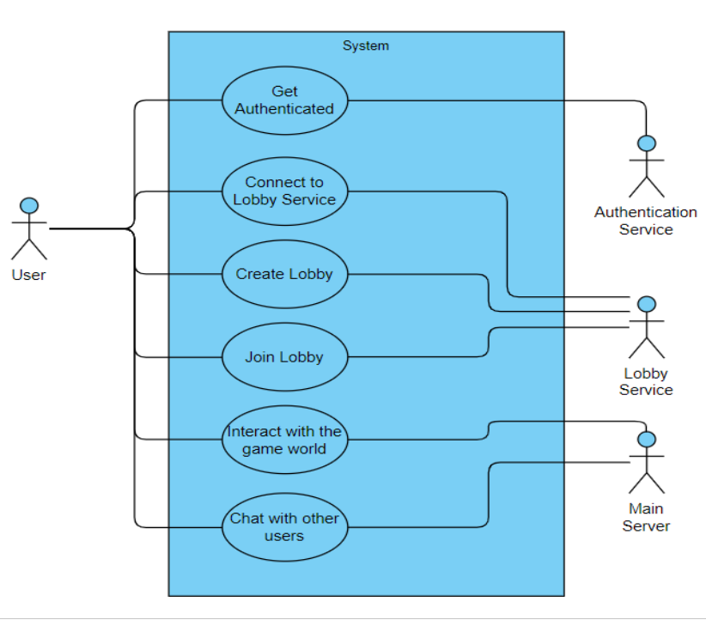

Figure 7. Use Case Diagram for Application Capabilities. Users can get authenticated, connect to lobby service, create/join lobby, interact with game world and chat with users.

17

4.1 Player Authentication

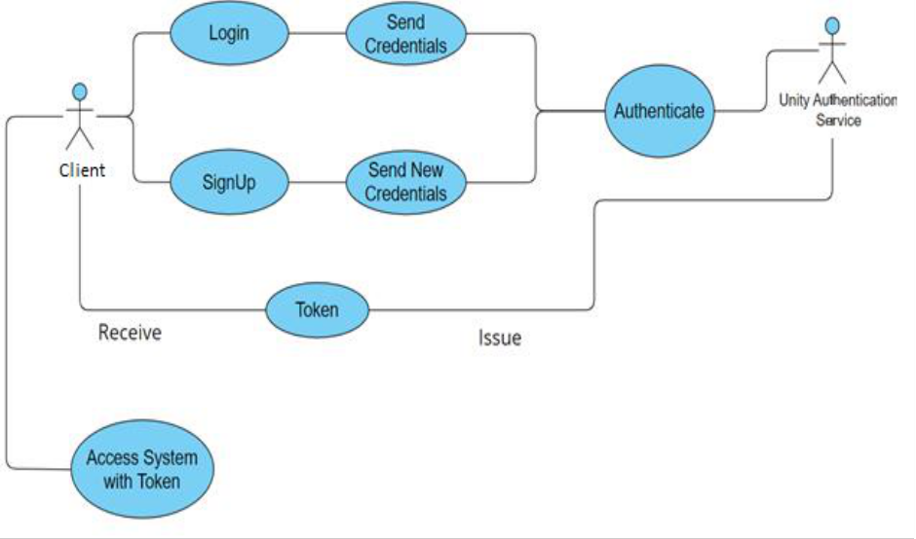

Figure 8. User Logs in or signs up, sends credentials to Unity Authentication Service, which authenticates user and sends a token if authentication is successful. This token is used by client App to Access the Application.
4.1.1 Description and Priority
This feature enables the player to create accounts, login and manage accounts. The users authenticate with the Unity Gaming Services (UGS) to use different unity services like relay etc.
Priority: High
4.1.2 Stimulus/Response Sequences
• User Action: click “SignUp”or “SignIn”
o System Response: Display Sign Up or Sign In form
• User Action: user fills in the form and submit
o System Response: validate input, Authenticate the user and redirect to the main
18

menu.
4.1.3 Functional Requirements
REQ-1: The system should allow user to create an account with unique username and password
REQ-2: The system should authenticate the user based on credentials
REQ-3: Authentication service should be live all the time for users to login REQ-4: The system implements a forgot password feature
REQ-5: Authentication process should be completed before accessing the game

4.2 Lobby Creation and Joining

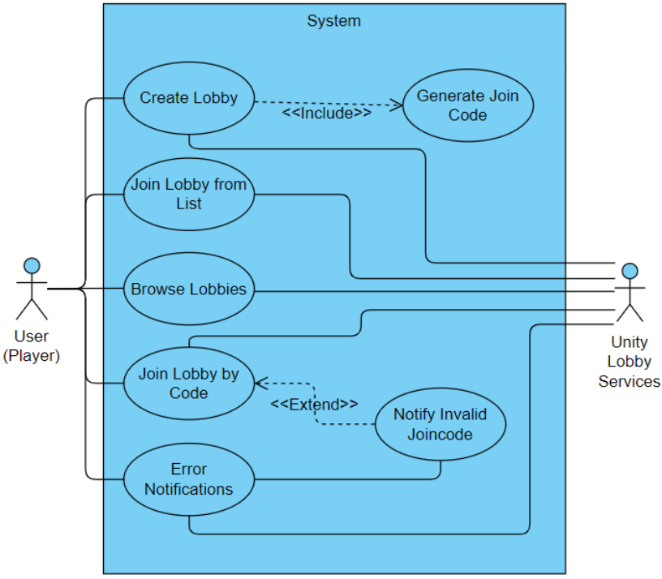

Figure 9. Use case diagram illustrating user interactions and Unity Lobby Services functionalities for lobby creation and joining in a multiplayer game.
19

4.2.1 Description and Priority
This feature allows players to create game lobbies (rooms) and join existing lobbies using a join code or browsing the lobbies list. The users will utilize unity lobby services to create and manage lobbies
Priority: High
4.2.2 Stimulus/Response Sequences
• User Action: click“Host”button.
o System Response: check if user is authenticated, create a lobby using Lobby Services (UGS) and generate a join code, display lobby details to the user (join code, lobby id etc.)
• User Action: click “join lobby” and enter a join code.
o System Response: validate the join code and connect the player to the desired lobby, redirect the user to the game scene.
• User Action: click “find lobbies” button.
o System Response: display the list of lobbies retrieved from unity lobby services, allow the user to browse and join the lobbies.
• User Action: select a lobby from the list and click“join”.
o System Response: validate the selection, connect the user to the desired lobby, redirect the user to the game scene.
4.2.3 Functional Requirements
REQ-1: The system should allow user to create a lobby/room.
REQ-2: The system should generate a unique join code for each lobby created. REQ-3: Users should be able to join lobbies using a valid join code.
REQ-4: The system should allow users to browse and join lobbies from the list.
REQ-5: The system should check for limits like maximum players and prevent more than specified users from joining in.
REQ-6: Lobbies should be synced in, changes like users joining in and leaving should be rendered immediately.
REQ-7: Any errors in lobby creation or joining should be notified to the user.
20

4.3 Chat and Communication

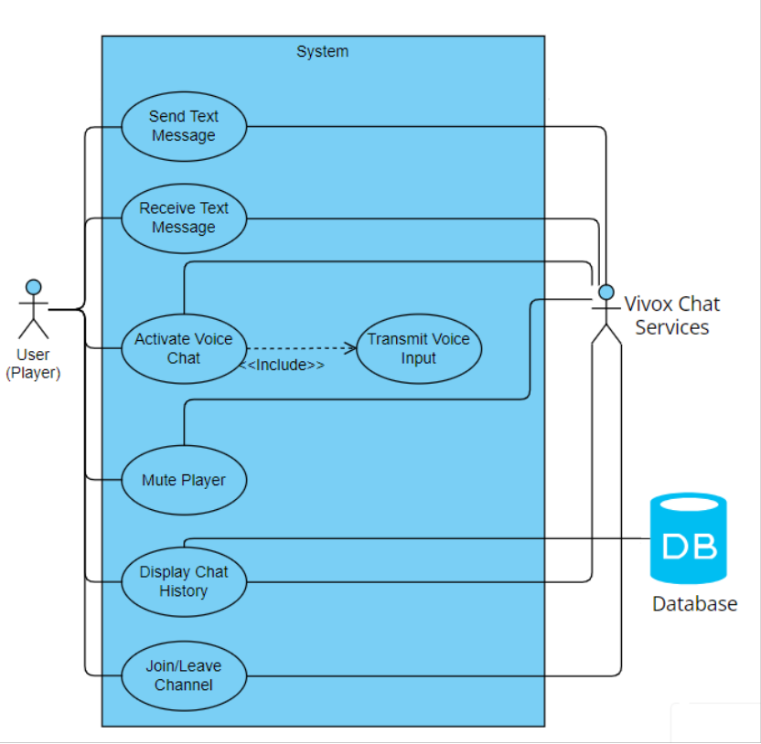

Figure 10. Use case diagram illustrating user interactions and Vivox chat services functionalities for text and voice communication in the multiplayer game lobby.
4.3.1 Description and Priority
This feature allows players to communicate with each other in the lobby through text or voice chat.
Priority: Medium
4.3.2 Stimulus/Response Sequences
21

• User Action: type a message in lobby chat.
o System Response: send the message to all the players in the lobby and display it in the chat window.
• User Action: press a key to activate voice chat.
o System Response: read the voice input and transmit it to the other players in the lobby.
4.3.3 Functional Requirements:
REQ-1: The system should allow real-time text communication between players in the same lobby.
REQ-2: The system should enable voice chat for players in a lobby or team. REQ-3: The system should allow players to mute or block specific players in both text and voice chat.
REQ-4: Chat should be moderated for inappropriate behavior or language.

22

4.4 Stall Placement/Viewing

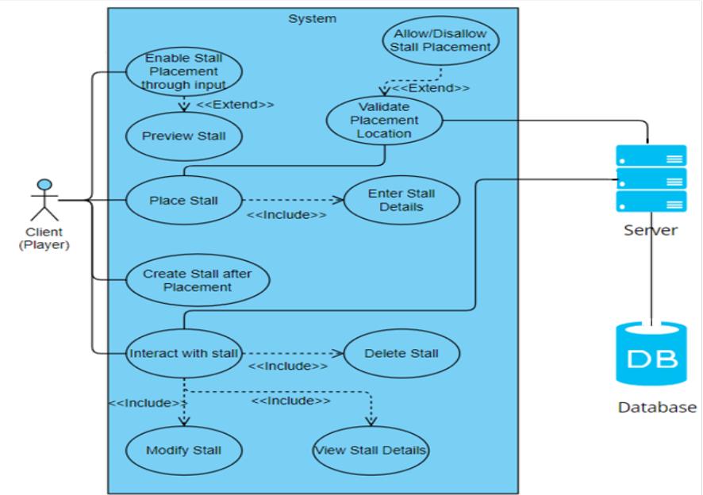

Figure 11. Use case diagram illustrating user interactions and system functionalities for stall placement and viewing in the game world.
4.4.1 Description and Priority
The feature allows players to place stalls in designated area of game world and lets them attach details to the stall (details such as ideas, links, messages etc.).
Priority: medium
4.4.2 Stimulus/Response Sequences
• User Action: Press key on keyboard to enable stall placement
o System Response: Preview dummy stall and let user select position to place it in.
• User Action: Click Mouse Button on designated area to place stall.
o System Response: Prompt the user to enter details for the stall
• User Action: Enter the details and click create stall button
23

o System Response: Validate placement area from server, store details in database and render the stall for all players/clients
• User Action: Interact with placed stalls using interact button
o System Response: Display the details of the stalls 4.4.3 Functional Requirements
REQ-1: The system should allow players to place a stall in the game world for a particular amount of time.
REQ-2: The system should validate the placement location and ensure that the stall can only be placed in the designated area.
REQ-3: The system should allow the player to enter custom details for the stall.
REQ-4: The system should show the custom details when the stall is interacted with.
REQ-5: The player should be able to modify or remove the stall and its associated details. REQ-6: The system should limit the number of stalls a player can place as well as how many stalls can be placed in that designated area to avoid overcrowding.

24

4.5 NPC Information Broadcasting

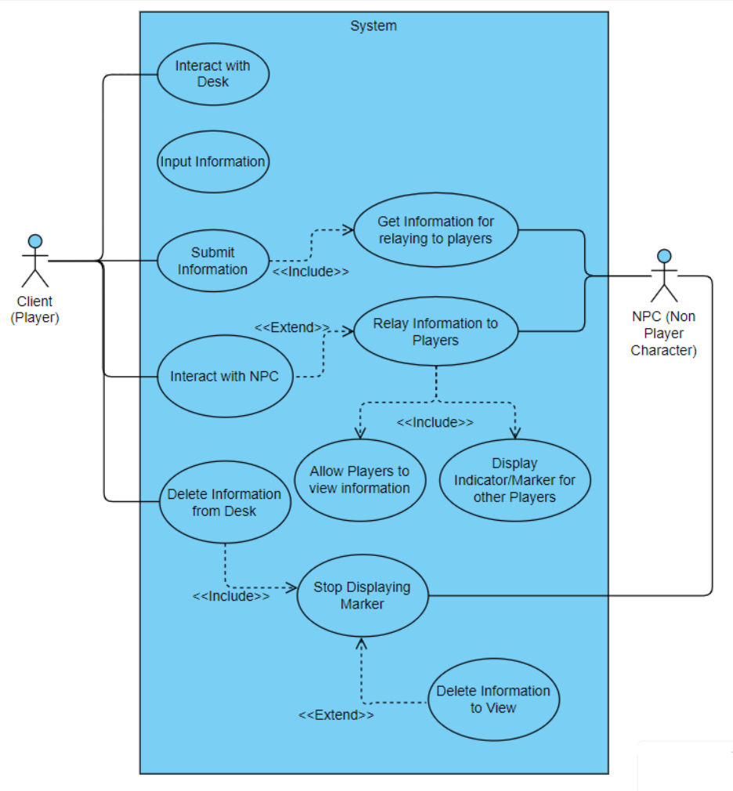

Figure 12. Use case diagram illustrating user interactions and NPC functionalities for information broadcasting in the game world.
4.5.1 Description and Priority
The feature allows players to provide information at a designated desk in-game, which is
25

then distributed to non-Player Characters (NPCs). The NPCs will display markers/indicators indicating they have new information. When the players interact with these NPCs, they will relay the given information to those players.
Priority: low
4.5.2 Stimulus/Response Sequences
• User Action: Approach and interact with the desk
o System Response: Display prompt to input information they wish broadcasted (e.g. An Upcoming event/workshop, message, task etc.).
• User Action: Enter information and submit.
o System Response: Validate the input, save the information and distribute it to NPCs. NPCs start to show indicators indicating that they hold new information.
• User Action: Approach an NPC with a marker and interact.
o System Response: Prompt the user with the given information given at the desk.
4.5.3 Functional Requirements
REQ-1: The system should allow players to input information at the desk.
REQ-2: The system should display the marker/indicator above NPCs to indicate they have information to view.
REQ-3: NPCs should be able to relay the information to players when interacted with.
REQ-4: The system should ensure that the marker disappears for the player who has viewed the information.
REQ-5: The system should allow multiple NPCs to carry information if necessary.
REQ-6: The players should be able to modify/delete the information on the desk, updating NPCs accordingly.
REQ-7: The information should be dispatched within the specific amount of time, within which no other player can dispatch new information.

26

5. Other Nonfunctional Requirements
5.1 Performance Requirements
Below are the specified performance requirements along with their rationale:
• Response Time:
The system should respond to user actions (e.g., login, signup, and access requests) within about 2-30 seconds under normal load conditions. Quick response times enhance user satisfaction and engagement, reducing frustration during interactions.
• Concurrent Users:
The application must support at least 20 concurrent users without degradation in performance. Given the interactive nature of the platform, supporting multiple users simultaneously is essential for real-time collaboration and communication.
• Data Processing Speed:
The system should process user-generated content and updates within 2-3 seconds
on a stable network connection (As sending packets would depend on how fast user can ping the server). Fast processing ensures that users can see changes in real-time, which is crucial for maintaining an engaging environment.
• Token Validation Time:
Token validation must occur within 2-3 seconds to ensure seamless access to features. Quick validation prevents delays in accessing functionalities, enhancing the
overall user experience.
• Load Handling Capacity:
The system should handle up to 1000 requests per minute during peak usage times. Ensuring the system can manage high traffic is vital for maintaining performance during busy periods.
• Network Latency:
The application should maintain a network latency of less than 300 milliseconds for real-time interactions. Low latency is critical for a smooth user experience, especially in a collaborative environment where timing is essential, otherwise it will be jittery.
27

5.2 Safety Requirements
The application must address potential risks associated with its use, ensuring user safety and data protection. Below are the specified safety requirements, safeguards, and relevant policies:
• Data Protection and Privacy:
Implement robust encryption protocols for user data during transmission and storage. Use DTLS for secure data transfer using unity transport layer. Protects users from data breaches and unauthorized access.
• User Safety:
Implement content moderation mechanisms to prevent harmful or inappropriate content from being shared. Use automated filters and manual review processes to monitor user-generated content. Ensures a safe environment for all users, particularly minors.
• Account Security:
Enforce strong password policies and multi-factor authentication (MFA) for user accounts. Require passwords to meet complexity criteria and provide MFA options. Reduces the risk of account compromise.

5.3 Security Requirements
The application must adhere to strict security and privacy standards to protect user data and ensure safe interactions. Below are the specified requirements:
• User Identity Authentication:
Implement multi-factor authentication (MFA) for all user accounts. MFA adds an additional layer of security, reducing the risk of unauthorized access.
• Server Authority:
Application is server-authoritative, meaning all user actions, including stall placement, movement etc. must be first authorized by the server and then granted
28

the permission to perform that action. Protects sensitive user information from interception and unauthorized access. It’s an anti-cheating mechanism.

5.4 Software Quality Attributes
The application must meet several quality characteristics that are important to both users and developers. These characteristics are defined to be specific, quantitative, and verifiable where possible.
• Usability:
The application should achieve a good usability score. High usability ensures that users can easily navigate the platform, enhancing their overall experience.
• Reliability:
The system should maintain an uptime of 80% over a month. High availability is essential for user trust and engagement, especially during peak usage times.
• Performance:
The application should support up to 20 (in free tier, can be scaled up) concurrent users without performance degradation. This ensures that the platform can handle expected traffic during peak times.
• Maintainability:
Code should be modular, allowing for easier updates and bug fixes. High maintainability reduces the time and cost associated with future modifications.
• Adaptability:
The application should allow for feature updates to be deployed within a maximum
of two weeks after approval. Quick adaptability to user feedback or market changes is crucial for maintaining relevance.
• Testability:
Testing should be done during and after development. High testability ensures that the application can be reliably tested for bugs and performance issues before deployment.
• Portability
29

The user should access the game from any computer with an internet connection

5.5 Business Rules
• User Roles and Permissions:
o User: Can create an account, log in, sign up, and access features.
o Authentication Service: Responsible for validating user credentials, issuing tokens, and managing user sessions.
• Access Control:
o Users must authenticate via the Authentication Service to access the system. Only authenticated users can perform actions such as logging in and signing up.
o The system will restrict access to certain features based on user roles.
• Error Handling:
o Users must be informed of any errors during login or signup attempts, with specific messages indicating whether the issue is due to incorrect credentials
or system errors.
o The Authentication Service must log all failed login attempts for security auditing.
• Session Management:
o User sessions will automatically expire after a period of inactivity (e.g., 15 minutes) to enhance security.
o Users will be notified of session expiration and prompted to log in again.
• Data Privacy Compliance:
o Users should have the ability to request deletion of their accounts and associated data.
6. Other Requirements
• The game should maintain a minimum frame rate of 60 frames per second during gameplay
30

on target hardware
• The database should support concurrent access by multiple users to ensure real time updates and queries without performance degradation.
• Visual response to user input should be within 100 milliseconds
• The time between a player making a move and other players updating the game state should be under 5 seconds
• The game should be compatible with different OS (MacOS, Windows etc.)
• The multiplayer system components such as matchmaking, lobbies and relay services should be designed for reuse across different game modes or future titles.
• Art assets (UI components, sound effects) should be organized for potential reuse.

Appendix A: Glossary
1. 3D (Three-Dimensional): Refers to the representation of objects in a three-dimensional space, allowing users to interact in a virtual environment.
2. Account Authentication: The process of verifying the identity of a user attempting to access the system, typically through a username and password.
3. API (Application Programming Interface): A set of rules and protocols for building and interacting with software applications, allowing different software components to communicate.
4. DTLS (Datagram Transport Layer Security): A protocol that provides privacy for datagram protocols, ensuring secure data transfer in real-time applications.
5. MFA (Multi-Factor Authentication): A security mechanism that requires two or more verification methods to gain access to an account, enhancing security.
6. NPC (Non-Player Character): Characters in the game that are not controlled by players but can interact with them, often providing information or tasks.
7. Relay Server: A server that facilitates communication between users in the lobby, managing data packets and ensuring smooth interactions.
8. UGS (Unity Gaming Services): A suite of services provided by Unity Technologies that
31

supports game development, including user authentication and lobby management.
9. User-Generated Content: Any content created and uploaded by users within the application, such as messages, stalls, or interactive elements.
10. Lobby: A virtual space within the application where users can gather, communicate, and participate in activities together.
11. Real-Time Communication: The ability for users to send and receive messages instantly during their interactions within the application.
12. Security Measures: Protocols and practices implemented to protect user data and ensure safe interactions within the application.
13. Token Validation: The process of verifying a user's session token to confirm their identity and permissions before granting access to features.
14. RPC (Remote Procedure Call): A method for invoking functions on remote networked
objects, enabling synchronized actions and state updates in multiplayer games. Used in coding.
15. HUD (Heads-Up Display): The HUD is the graphical interface that presents essential information to users during gameplay, such as health status, inventory items, and chat messages. It is designed to provide immediate feedback while minimizing disruption to the immersive experience of the game environment.

Acronyms
• API: Application Programming Interface
• DTLS: Datagram Transport Layer Security
• MFA: Multi-Factor Authentication
• NPC: Non-Player Character
• SRS: Software Requirements Specification
• UGS: Unity Gaming Services
• RPC: Remote Procedure Call
• HUD: Heads Up Display

32

