Feature: SignIn

*In order to add profile details*

*As a registered member*

*Seller has to login with correct credentials*

*@Home*

Scenario: I want to access Mars website

Given I Launch Chrome Browser

When I enter the Home URL

And Presses Enter key

Then Homepage should be displayed

And Sign in link should appear on the Homepage

And Join Button should appear on the Homepage

*@Home@SignIn@Autoamte*

Scenario: When I enter correct credentials I should be successfully login In

Given I am on the SignIn page

When I enter "*sidra\_riz@yahoo.com*" in username and "*sid6638659*" in password field

And I Click on Login Button

Then I should successfully login

*@Home@SignIn*

Scenario: When I check the Remember Me Checkbox my credentials details should be saved for future

Given I entered the correct credentials

When I check the Remember me? Checkbox

And Click on Sign In button

Then Verify my credentials are showing up on next SignIn

*@Home@SignIn*

Scenario Outline: When I enter Incorrect Credentials an error message should be displayed

Given I enter <emailaddress> and <password> into the application

When I click the Login Button

Then I should be informed that login is unsuccessful by an <error message>

Examples:

| *emailaddress* | *password* | *error message*

| sidra\_riz@yahoo.com | 123456 | Invalid emailaddress or password

| sidra\_riz@yahoo.com | 67\*5#sdd | Invalid emailaddress or password

| adc\_123@gmail.com | sid6638659 | Invalid emailaddress or password

| sidra\_riz@yahoo.com | | password is mandatory |

| | sid6638659 | emailaddress is mandatory

| sidra\_riz@yahoo.com | sid6628659 | Invalid emailaddress or password

| sidra-riz@yahoo.com | sid6638659 | Invalid emailaddress or password

| $%#@#$sidra\_riz@yahoo.com | %#\*#\*\*#sid6638659 | Invalid emailaddress or password

| SIDRA\_RIZ@YAHOO.COM | SID6638659 | Invalid emailaddress or password

*@Home@Join@SignIn*

Scenario: When I am on Join page and want to SignIn instead of creating an account then SignIn page should be available.

Given I am on Join page

And Sign in link is available

When I Click on SignIn link

Then Directs me to the SignIn page

*@Home Join*

Scenario Outline: On filling my details on Joining form my new account should be created

Given I am on Join page

When I complete the form with <firstname> <last name> <emailaddress> <password> and <confirm password> details

And Check the Terms and conditions box

And I Click the Join button

Then <message> should be displayed

And Directed to the Profile page

Examples:

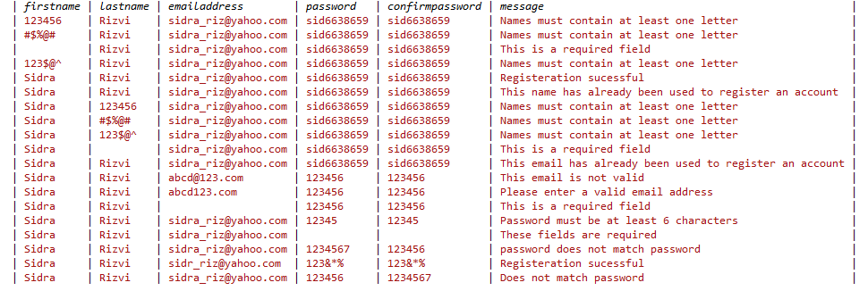

*@Home@ForgotmyPassword*

Scenario: When I forget my password then Forgot Password Link should be available to reset it

Given I Click on Forgot password link

And Email Verification page is loaded

When I enter the valid email address

And Click on Send Verification Email button

Then password reset email should be sent

And "Email has been sent" message should be displayed

And Verify Email is delivered to the correct email address

*@Home@ForgotmyPassword@SignIn*

Scenario: When I am on Forgot password page I should be directed to Sign in page on recalling password.

Given I am on Forgot password link

When I Click Remember your password link?

Then I should be directed to SignIn page

*@Home@Profile@Signout*

Scenario: When I click on Sign out I should be Successfully Sign out from the application

Given I am on Profile Page

And Sign Out page is available

When I Click Sign Out Button

Then I should be Sign out successfully from the application

*@Home@SignIn@CrossbrowerTesting*

Scenario Outline: I should be getting the same view on accessing Mars from different versions of Chrome browser

Given I have installed the correct chrome browser

When I enter Home URL in chrome browser of <version>

And Presses the Enter Key

Then The Login feature should work the same way in all web version

Examples:

| *version* |

| 95.0.4638 |

| 96.0.4664 |

| 97.0.4692 |

| 98 |

*@Home@SignIn@PerformanceTesting*

Scenario: When I enter URl, the Login screen should be loaded within the defined time

Given I have installed correct browser version

When I enter the Home URL and presses Enter

Then Home Page should be loaded within standard time of 5-10 seconds

*@Home@SignIn@CompatabilityTesting*

Scenario: When I Sign in from my Mobile/Desktop/Tablet, application should work properly in different platforms

Given User has installed correct browser version and other prerequisite

When User is Logging in from different platforms

Then Login functionality should work properly the same

Feature: Seller [] AddProfileDetails

*As a Seller I want to add some detail to my Profile*

*And want buyers to view the added details on visiting my Profile*

*@Home@SignIn@Profile*

Scenario: I want to access Language Tab

Given I have registered myself

And I have signed in successfully

And On Profile Page Language Tab is selected by default

When I click on Language Tab

Then Add New Button should be visible

And I should be able to see my previously added Languages on the page

*@Home@Profile@LanguageTab@AddNewLanguage*

Scenario Outline: I want to add new Language to my Profile

Given I am on Language Tab of my Profile Page

And My previously added Skills are listed below and Add Language Textbox, Choose Language Level Dropdown, Add and Cancel Buttons are visible

When I enter <Add Language> in the Textbox and selects any <Language Level> from Dropdown List

And I Click Add Button

Then Verify that the Skill has been added successfully to my Skillset

And <Message box> should be displayed

And Message box should disappear within 3 seconds

And Add New Button should be visible for adding another language

Examples:

*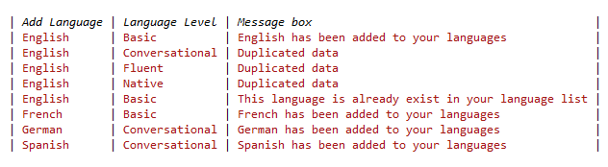*

*@Home@Profile@LanguageTab@CancelLanguage*

Scenario: I want to Cancel the Add Language request

Given I am on Add New Language page

When I click the Cancel Button

Then Redirects Me to Language Tab on Profile page

*@Home@Profile@LanguageTab@EditLanguage*

Scenario Outline: I want to update my Language level

Given I am on the Language tab on my Profile page

And I have Clicked the Edit Icon of the record to be edited

When I Enter the updated <Language> OR <Level>

And I Click the Update Button

Then Profile details should be updated

And <Message box> should be displayed

Examples:

*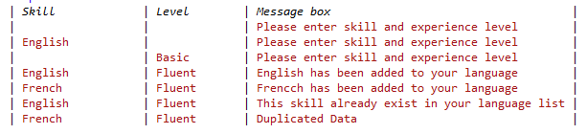*

*@Home@Profile@LanguageTab*

Scenario: The Add New Button should disappear on entering the fourth Language

Given I am on the Add New Button Tab

When I Enter the fourth Language

Then Verify the Add New Button disappear

*@Home@Profile@LanguageTab@DeleteLanguage*

Scenario: I want to delete my previously added Language

Given I am on the Language tab on my Profile page

And I have Clicked the Delete Icon of the record to be deleted

When I Click the Delete Icon

Then Verify the record is deleted

And Message box should be displayed

*@Home@Profile@LanguageTab*

Scenario: I should be able to view all added languages on my Profile page

Given I have entered the correct credentials

When I logged in the application

Then Language Tab should be active by default

And My previously added Language should be displayed

*@Home@SignIn@Profile*

Scenario: I want to access Skills Tab

Given I have registered myself

And I have signed in successfully

And On Profile Page Language Tab is selected by default

When I click on Skills Tab

Then I should be directed to the Skills Dashboard

And Add and Cancel Button should be visible

*@Home@Profile@SkillTab@AddNewSkill*

Scenario Outline: I want to add new Skills to my Profile

Given I am on Skills Tab of my Profile Page

And My previously added Skills are listed below

And Skill Textbox, Choose Skill Level Dropdown, Add and Cancel Buttons are visible

When I enter <Skill> in the Textbox and selects any <Level> from Dropdown List

And I Click Add Button

Then Verify that the Skill has been added successfully to my Skillset

And <Message box> should be displayed

And Message box should disappear within 3 seconds

And Add New Button should be visible for adding another skill

*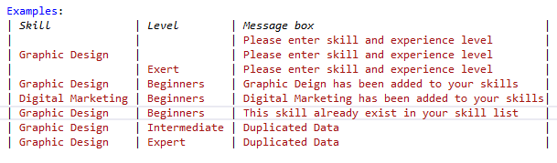*

*@Home@Profile@SkillTab@CancelSkill*

Scenario: I want to Cancel the Add Skill request

Given I am on Add New Skill page

When I click the Cancel Button

Then Redirects Me to Skill Tab on Profile page

*@Home@Profile@SkillTab@EditSkill*

Scenario Outline: I want to update my skills

Given I am on the Skill tab on my Profile page

And I have Clicked the Edit Icon of the record to be edited

When I Enter the updated <Skill> OR <Level>

And Clicks the Update Button

Then Profile details should be updated

And Message box should be displayed saying the skill has been updated

*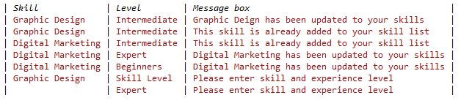*

*@Home@Profile@SkillTab@DeleteSkill*

Scenario: I want to delete my previously added Skill

Given I am on the Skill tab on my Profile page

And I have Clicked the Delete Icon of the record to be deleted

When I Click the Delete Icon

Then Verify the record is deleted

And Message box should be displayed

*@Home@Profile@SkillTab*

Scenario: I should be able to view all added skills on my Profile page

Given I am on my Profile page after successfully Signed In

And Language Description form is available

When I Click on Skills Tab

Then My previously added Skills should be displayed

And Add new Button should be visible

And Edit/Delete Icons should be visible

*@Home@SignIn@Profile*

Scenario: I want to access Education Tab

Given I have registered myself

And I have signed in successfully

And On Profile Page Language Tab is selected by default

When I click on Education Tab

Then Add New Button should be visible

And I should be able to see my previously added Education on the page

*@Home@Profile@EducationTab@AddNew*

Scenario Outline: I want to add new Education to my Profile

Given I am on Education Tab of my Profile Page

And My previously added Educational Background are listed below

When I enter <College/University Name> in the Textbox and selects <Country of University>

And I enter <Title> from Dropdown <degree> in Textbox <Year of Graduation> from Dropdown

And I Click Add Button

Then Verify that the education details have been added successfully to my Skillset

And <Message box> should be displayed

And Message box should disappear within 3 seconds

And Add New Button should be visible for adding another

*@Home@Profile@EducationTab@CancelEducation*

Scenario: I want to Cancel the AddEduaction request

Given I am on Add Education page

When I click the Cancel Button

Then Redirects Me to Education Tab on Profile page

*@Home@Profile@EducationTab@EditEducation*

Scenario Outline: I want to update my Language level

Given I am on the Language tab on my Profile page

And I have Clicked the Edit Icon of the record to be edited

When I Enter the updated <Language> OR <Level>

And I Click the Update Button

Then Profile details should be updated

And <Message box> should be displayed

*@Home@Profile@SkillTab@DeleteEducation*

Scenario: I want to delete my previously added Education details

Given I am on the Education tab on my Profile page

And I have Clicked the Delete Icon of the record to be deleted

When I Click the Delete Icon

Then Verify the record is deleted

And Message box should be displayed

*@Home@Profile@EducationTab*

Scenario: I should be able to view all added education details on my Profile page

Given I am on my Profile page after successfully Signed In

And Language Description form is available

When I Click on Education Tab

Then My previously added Education details should be displayed

And Add new Button should be visible

And Edit/Delete Icons should be visible

*@Home@SignIn@Profile*

Scenario: I want to access certification Tab

Given I have registered myself

And I have signed in successfully

And On Profile Page Language Tab is selected by default

When I click on Certificate Tab

Then Add New Button should be visible

And I should be able to see my previously added Certificate on the page

*@Home@Profile@CertificateTab@AddNewCertificate*

Scenario Outline: I want to add new Certificate to my Profile

Given I am on Certificate Tab of my Profile Page

And My previously added Certificates are listed below

When I enter <Certificate> in the Textbox and selects any <Year> from drop Down List

And I Click Add Button

Then Verify that the Certificate has been added successfully to my Skillset

And <Message box> should be displayed

And Message box should disappear within 3 seconds

And Add New Button should be visible for adding another Certificate

*@Home@Profile@CertificationTab@CancelCertificate*

Scenario: I want to Cancel the Add Certificate request

Given I am on Add New Certificate Tab

When I click the Cancel Button

Then Redirects Me to Certificate Tab on Profile page

*@Home@Profile@CertificationTab@EditCertificate*

Scenario Outline: I want to update my certificate details

Given I am on the Certificate tab on my Profile page

And I have Clicked the Edit Icon of the record to be edited

When I Enter the updated <Certificate><From><Year>

And I Click the Update Button

Then Profile details should be updated

And <Message box> should be displayed

*@Home@Profile@CertficationTab@DeleteCertification*

Scenario: I want to delete my previously added Certifications

Given I am on the Certification tab on my Profile page

And I have Clicked the Delete Icon of the record to be deleted

When I Click the Delete Icon

Then Verify the last record is deleted

And Message box should be displayed

*@Home@Profile@CertificationTab*

Scenario: I should be able to view all added certificates on my Profile page

Given I have entered the correct credentials

When I logged in the application

And I click the Certificate Tab

Then My previously added Certifications should be displayed