**CS5542 Big Data Apps and Analytics**

**LAB ASSIGNMENT #4**

**Name:Sidrah Junaid**

**Class Id:15**

**1.Write a spark program for the following Machine Learning Tasks**

**Answer**

Selected data set contain different images of birds.By classifying the images we can easily identify the different birds.

**Dataset:**

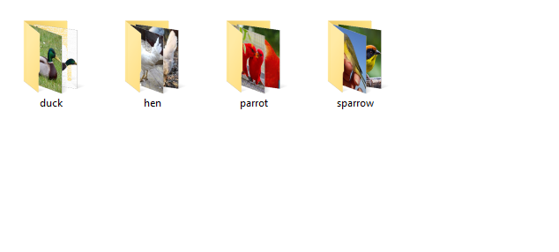

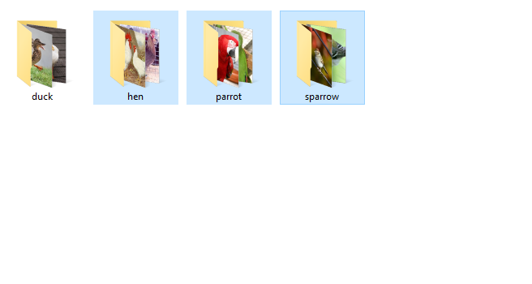

The dataset is split into 70% of Training data and 30% of test data.

The key descriptors generated by Decision Tree Algorithm are:

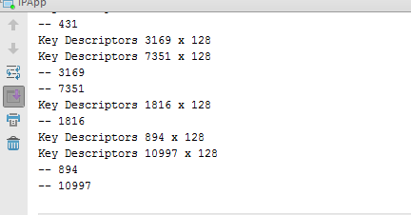

**Histogram :**

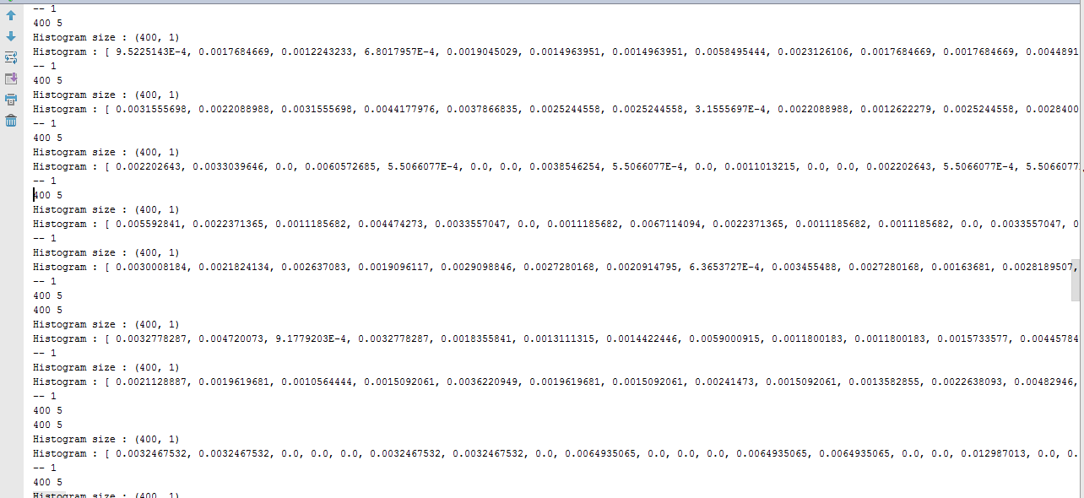

**Confusion Matrix**

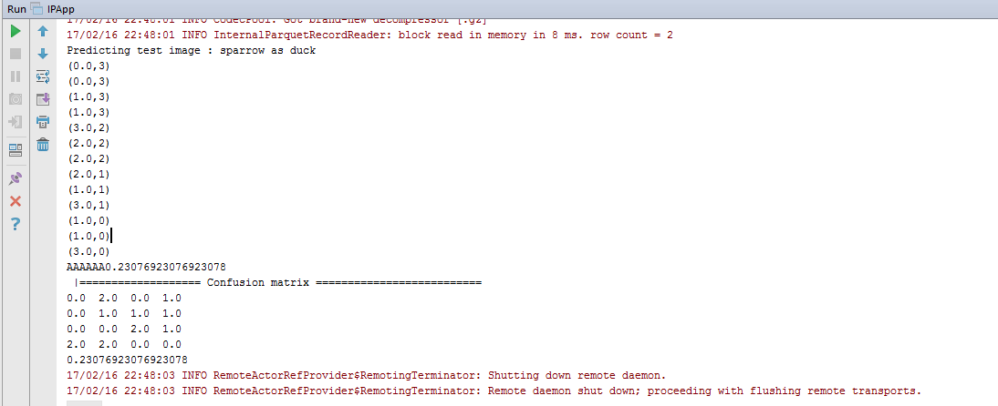

**Accuracy**

23.07%

**Error Rate**

