**SE TOOLS AND PRACTICES**

**Laboratory 3**

**Leander R. Galido**

**BSSE-2**

**Part I.**

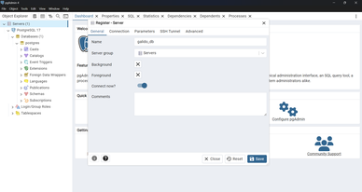**Setting up PostgreSQL.**

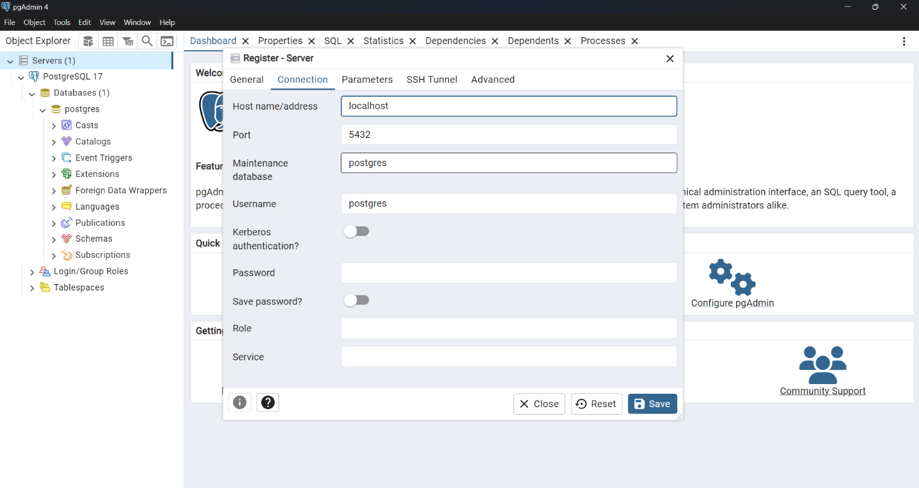

**PART II.**

**I created a table structure here.**

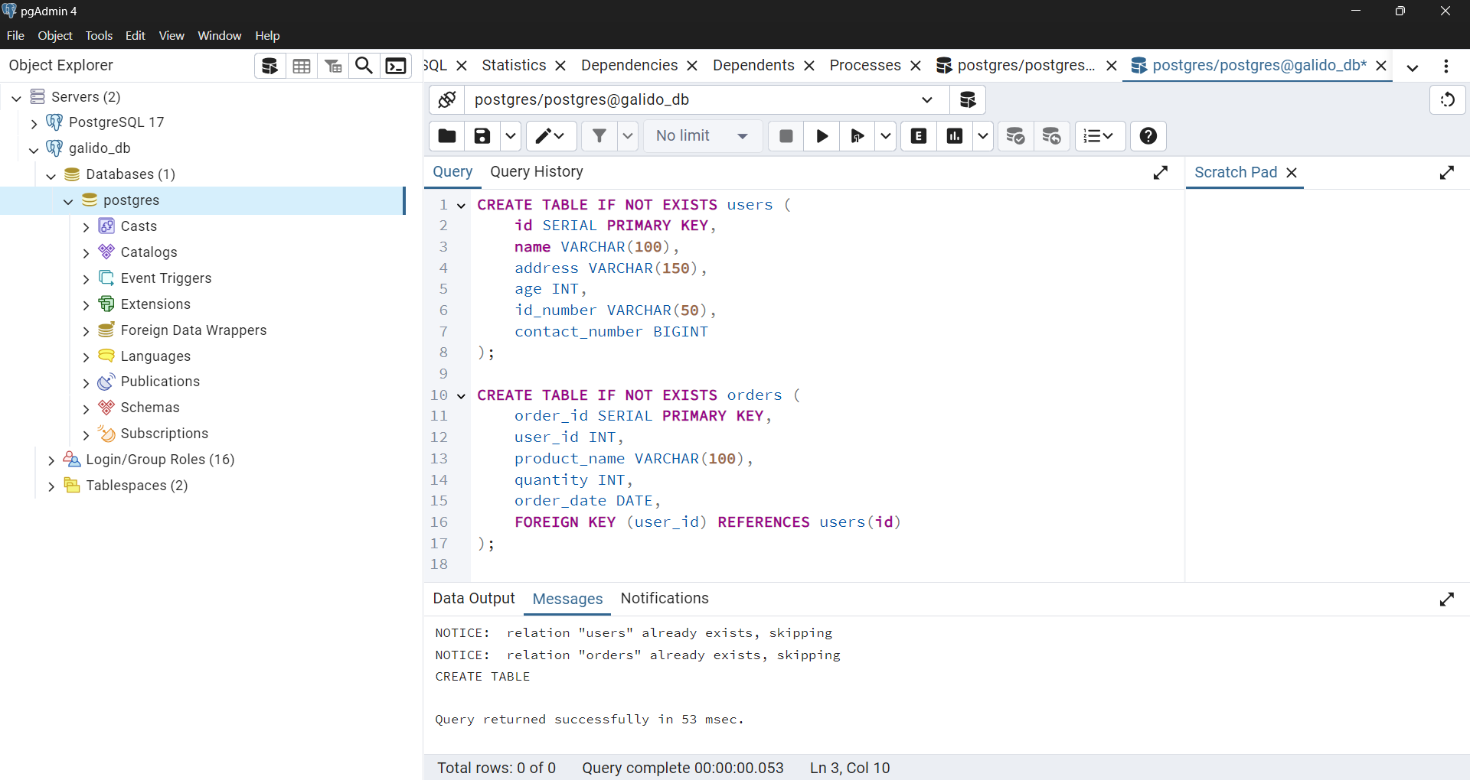

**User table:**

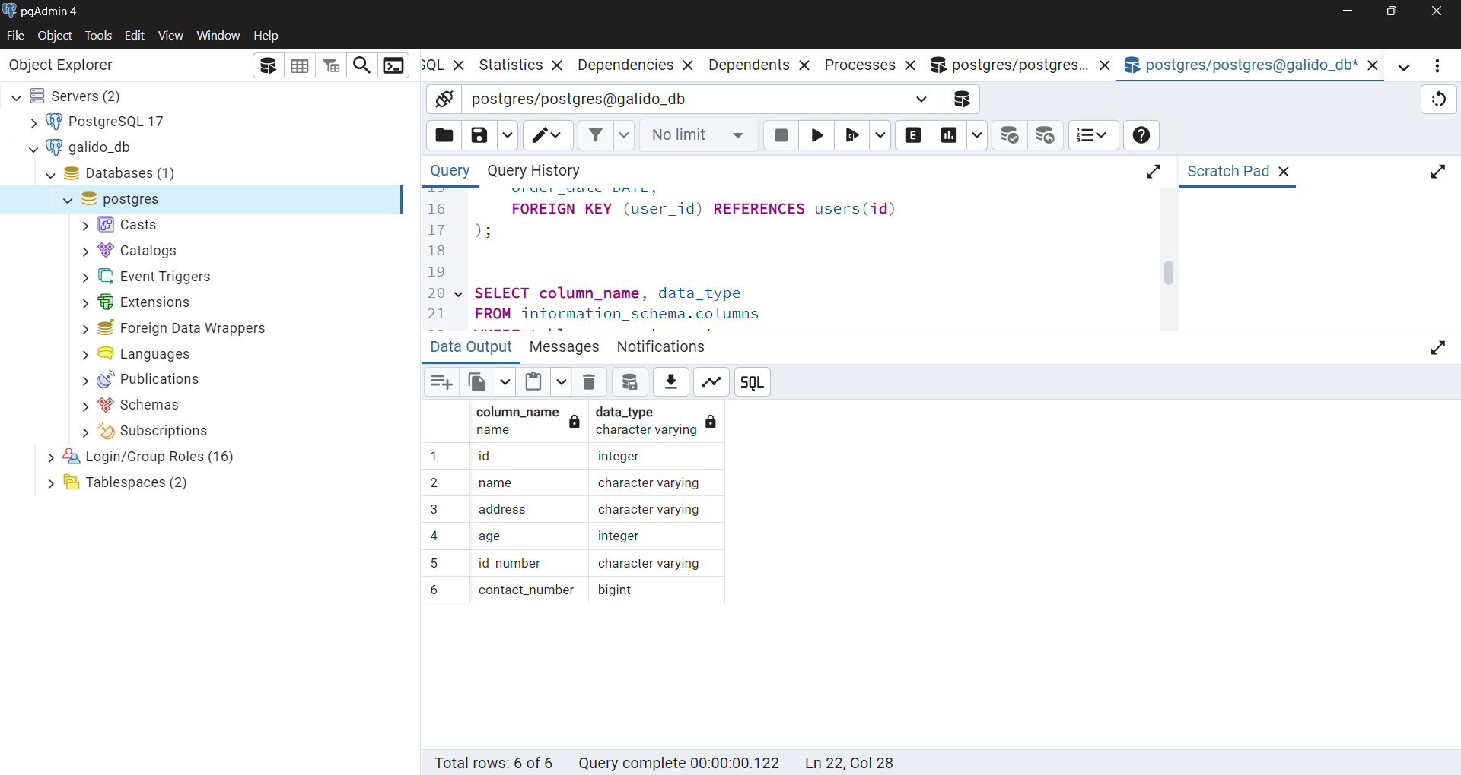

**Order table:**

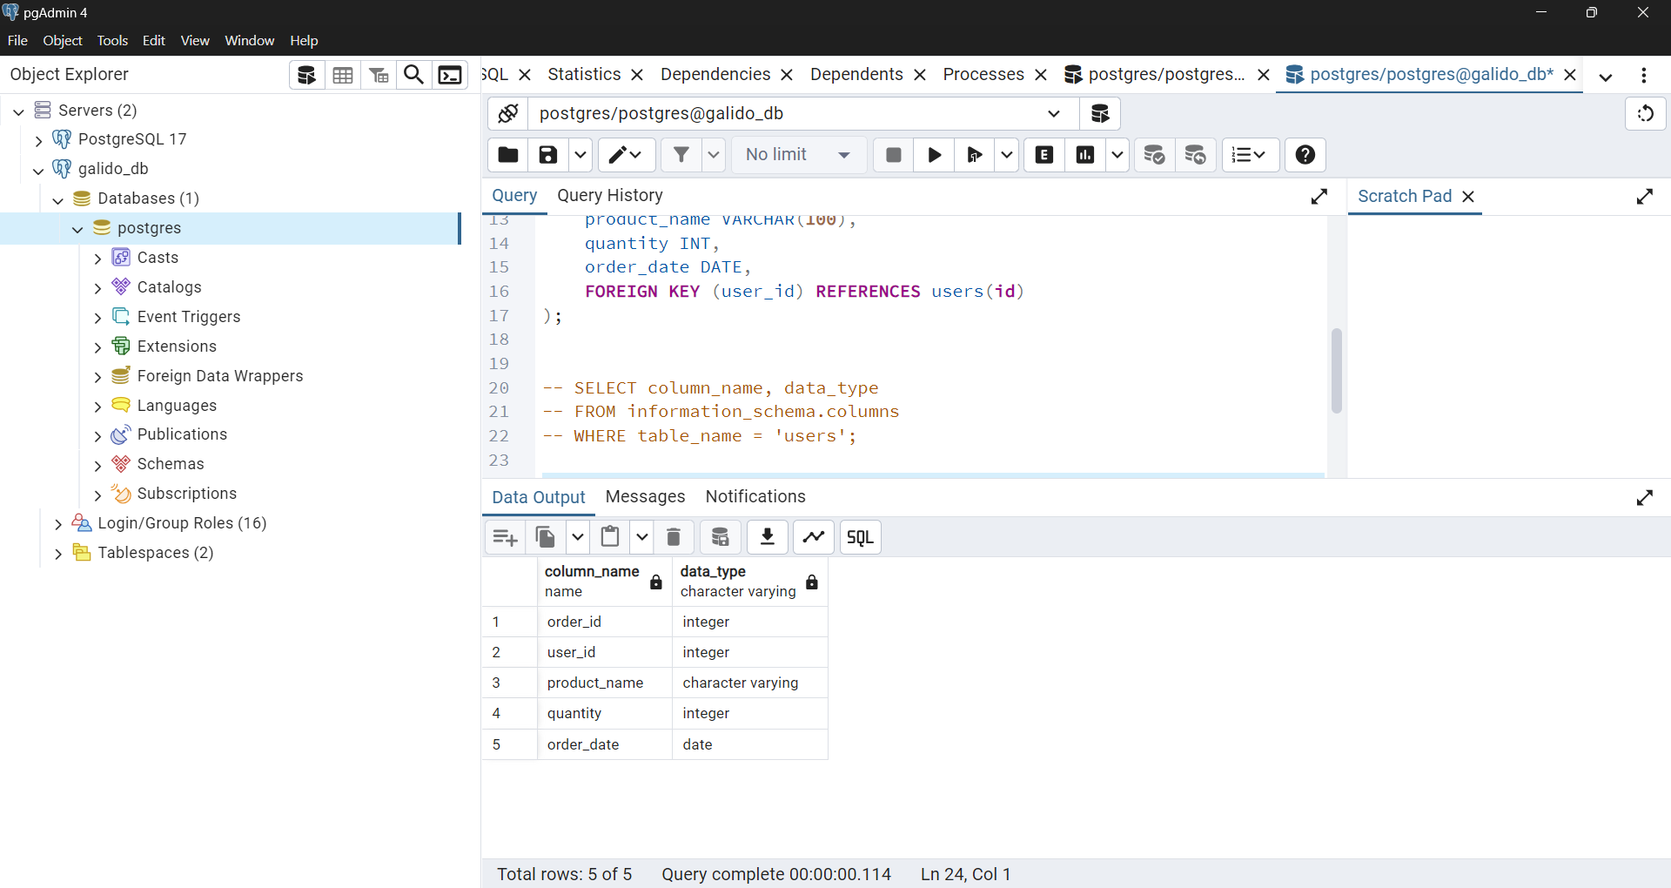

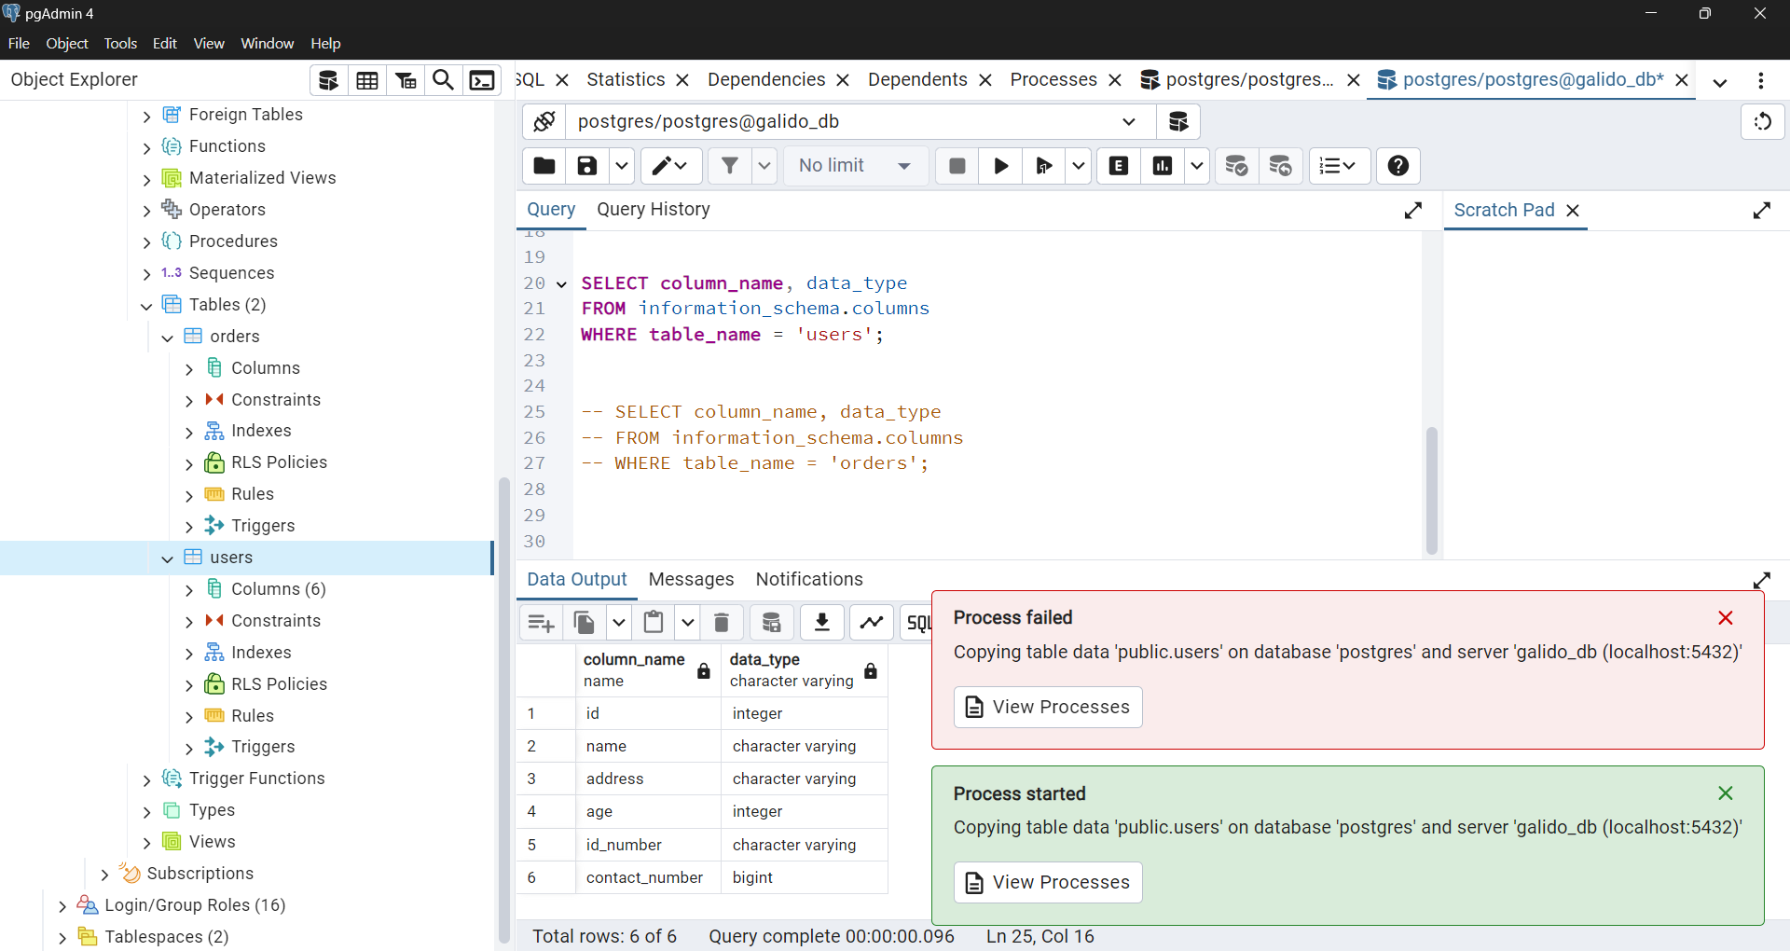**PART III.**

**While uploading the file I encountered some errors.**

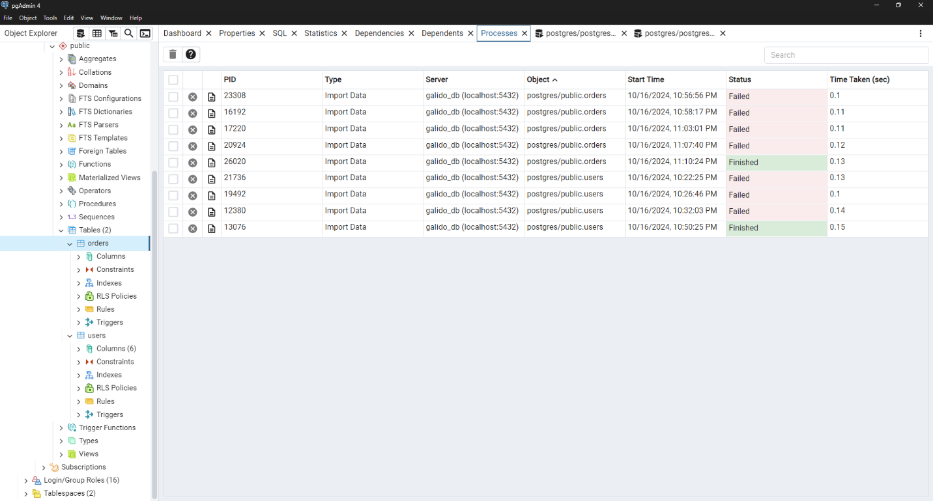

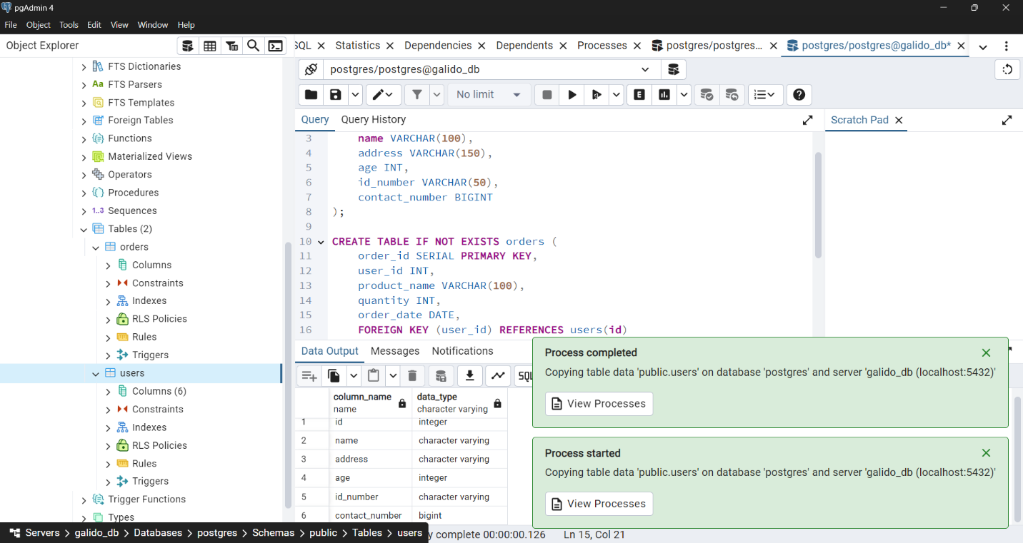I fixed my error by renaming my headers, checking the header option, and double checking my sql code. Here is my data, but I limit it only to ten displays to fit in my screen.

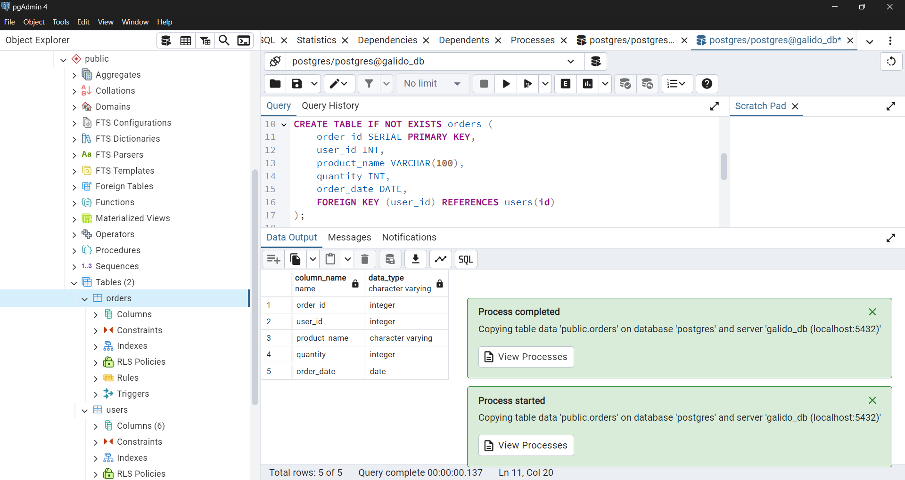

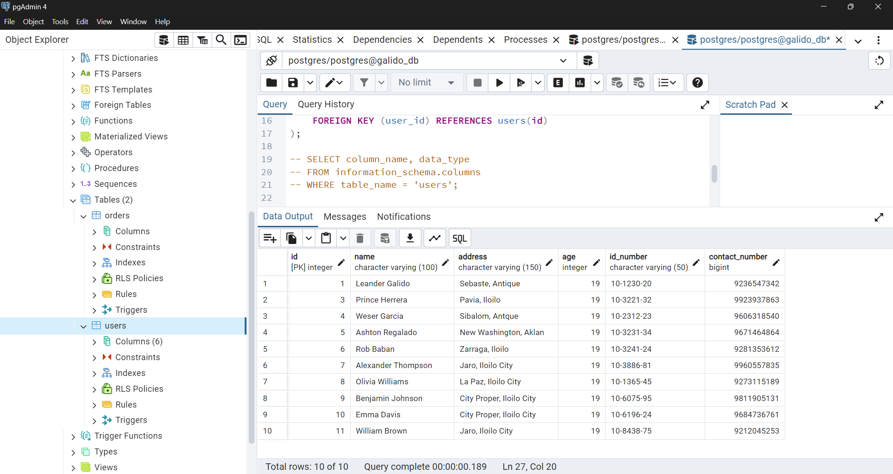

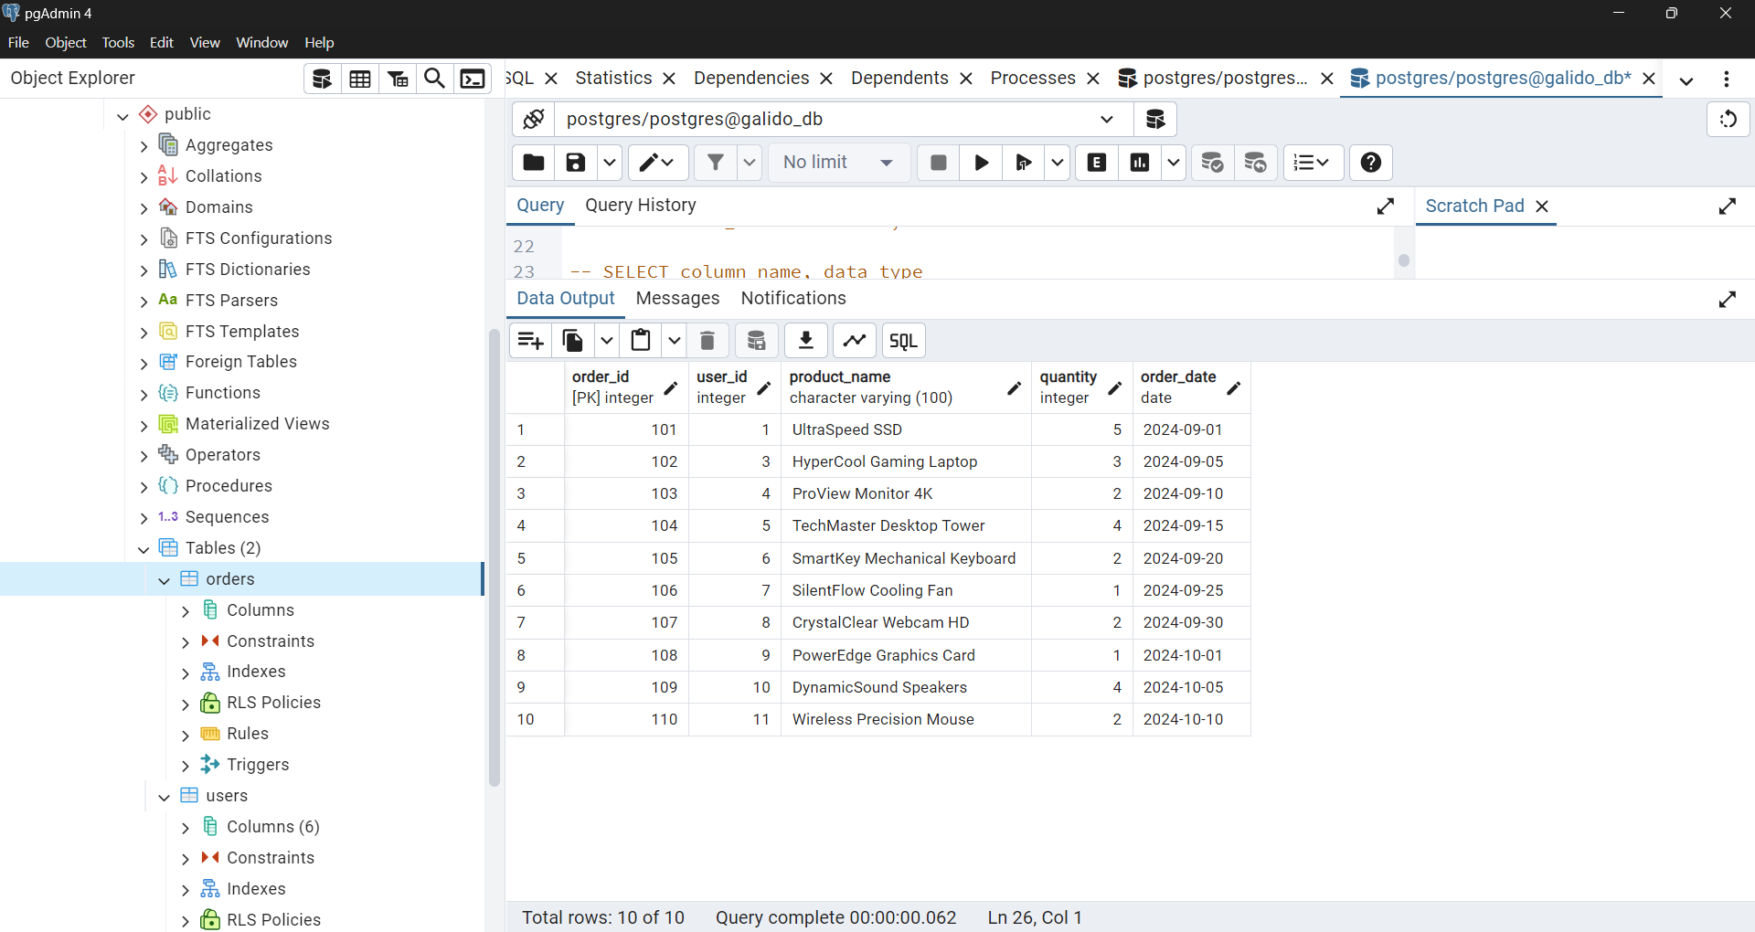

**PART IV.**

**Here I display the data’s from my CSV to my POSTGRESQL.**

**USERS DATA.**

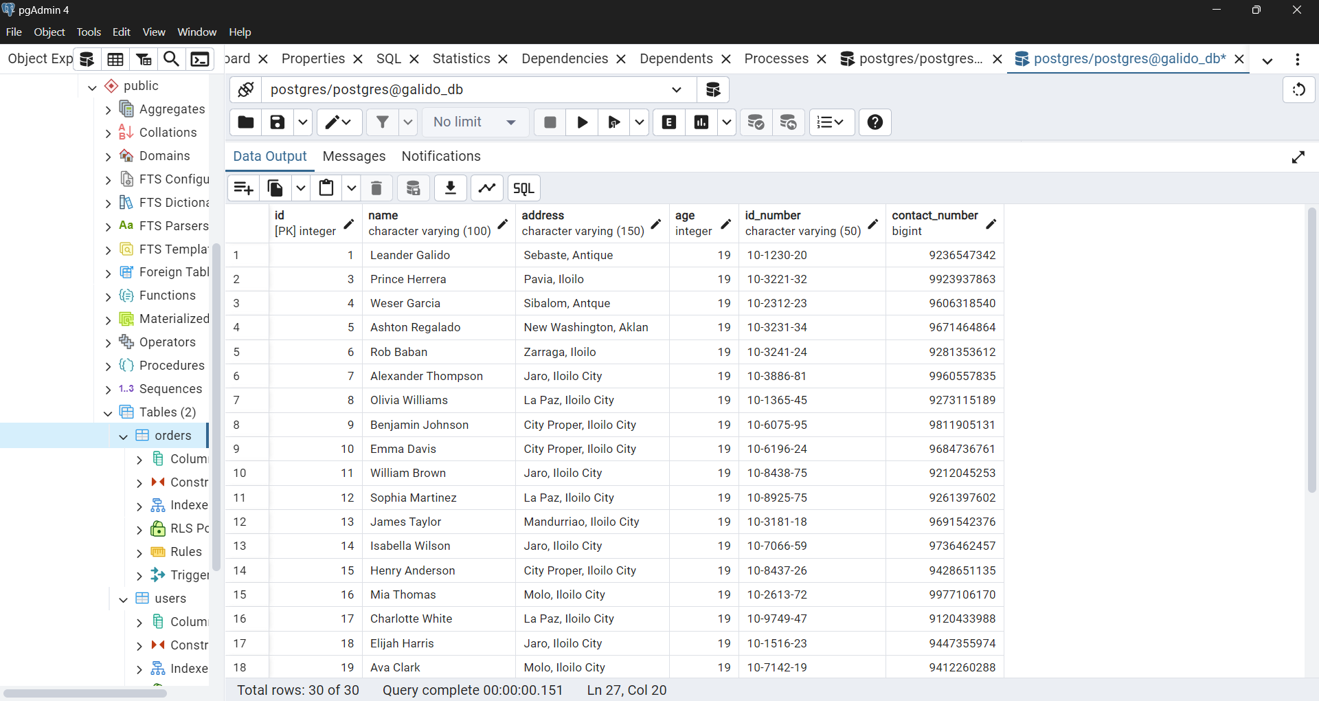

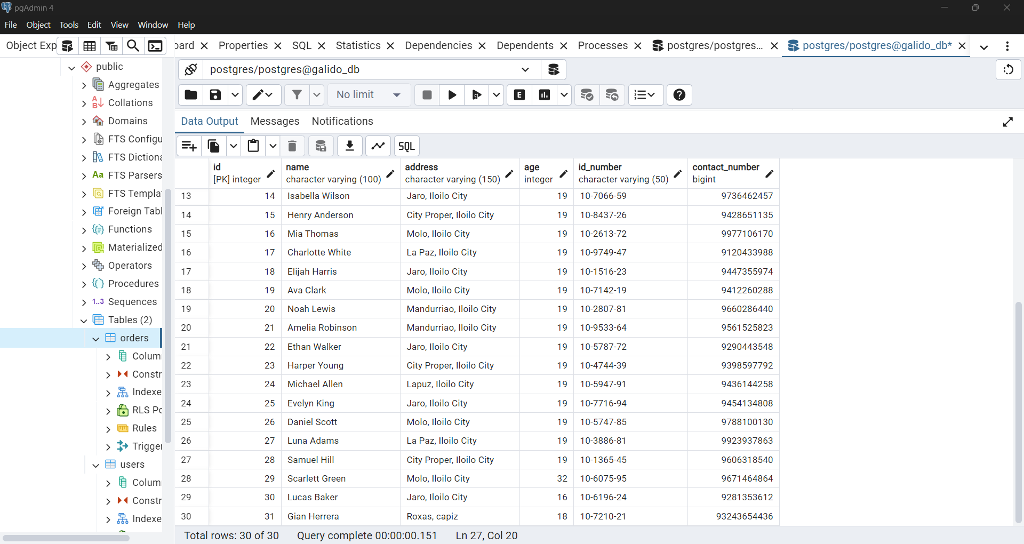

**ORDERS DATA**

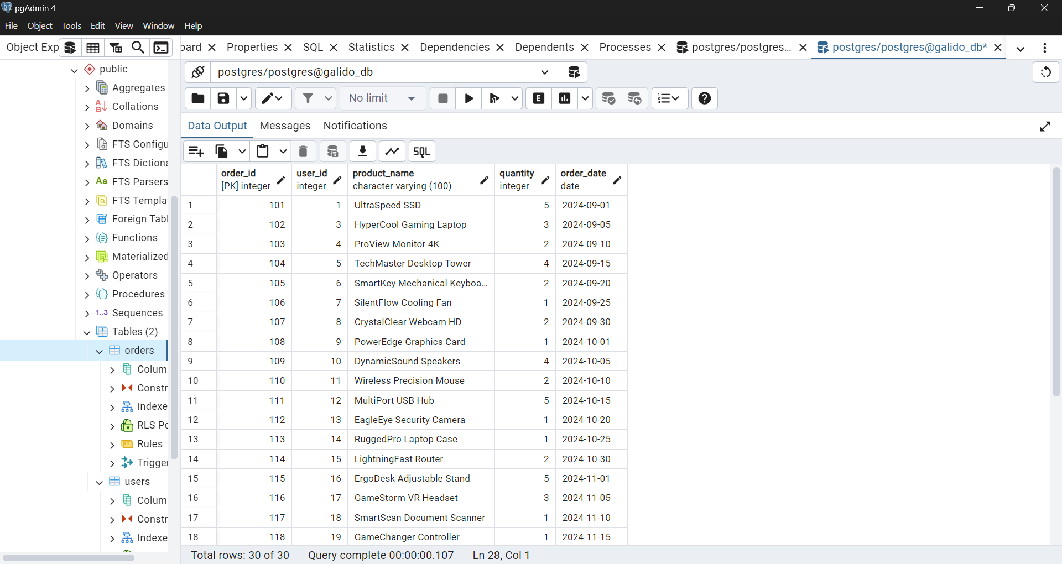

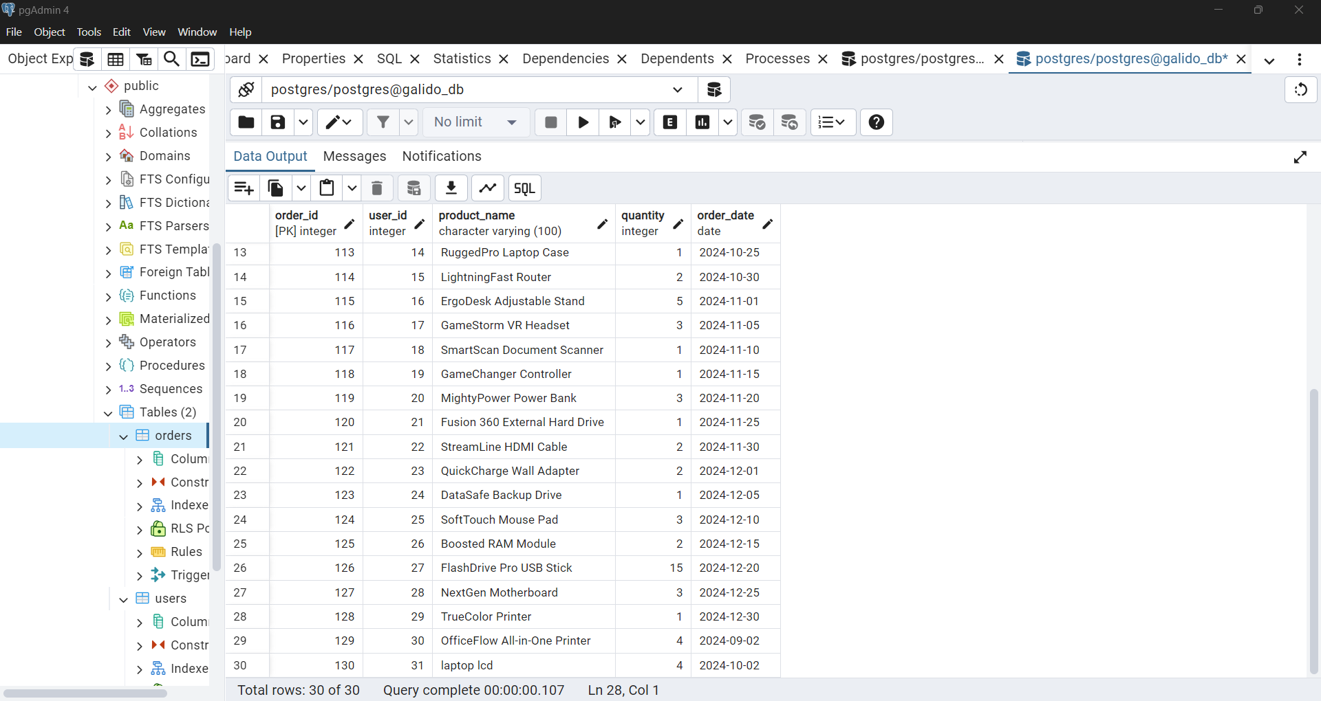

**I compared the data here to see if they match with each other.**

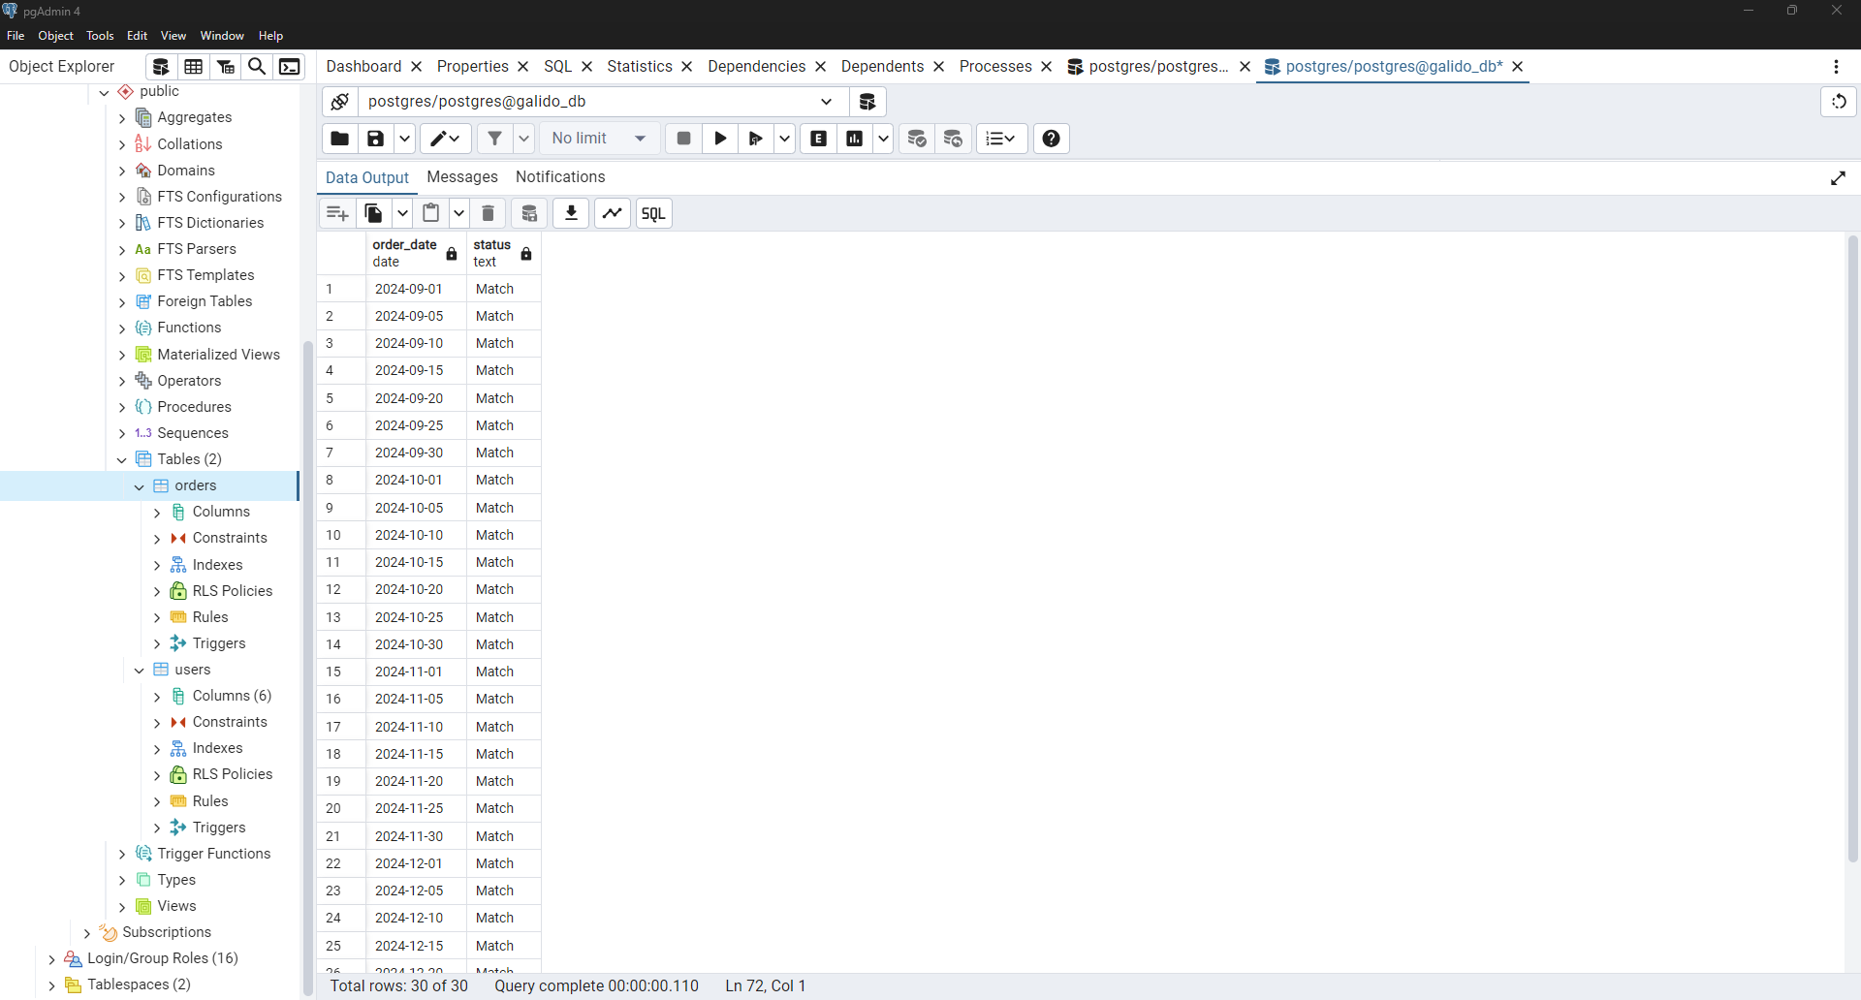

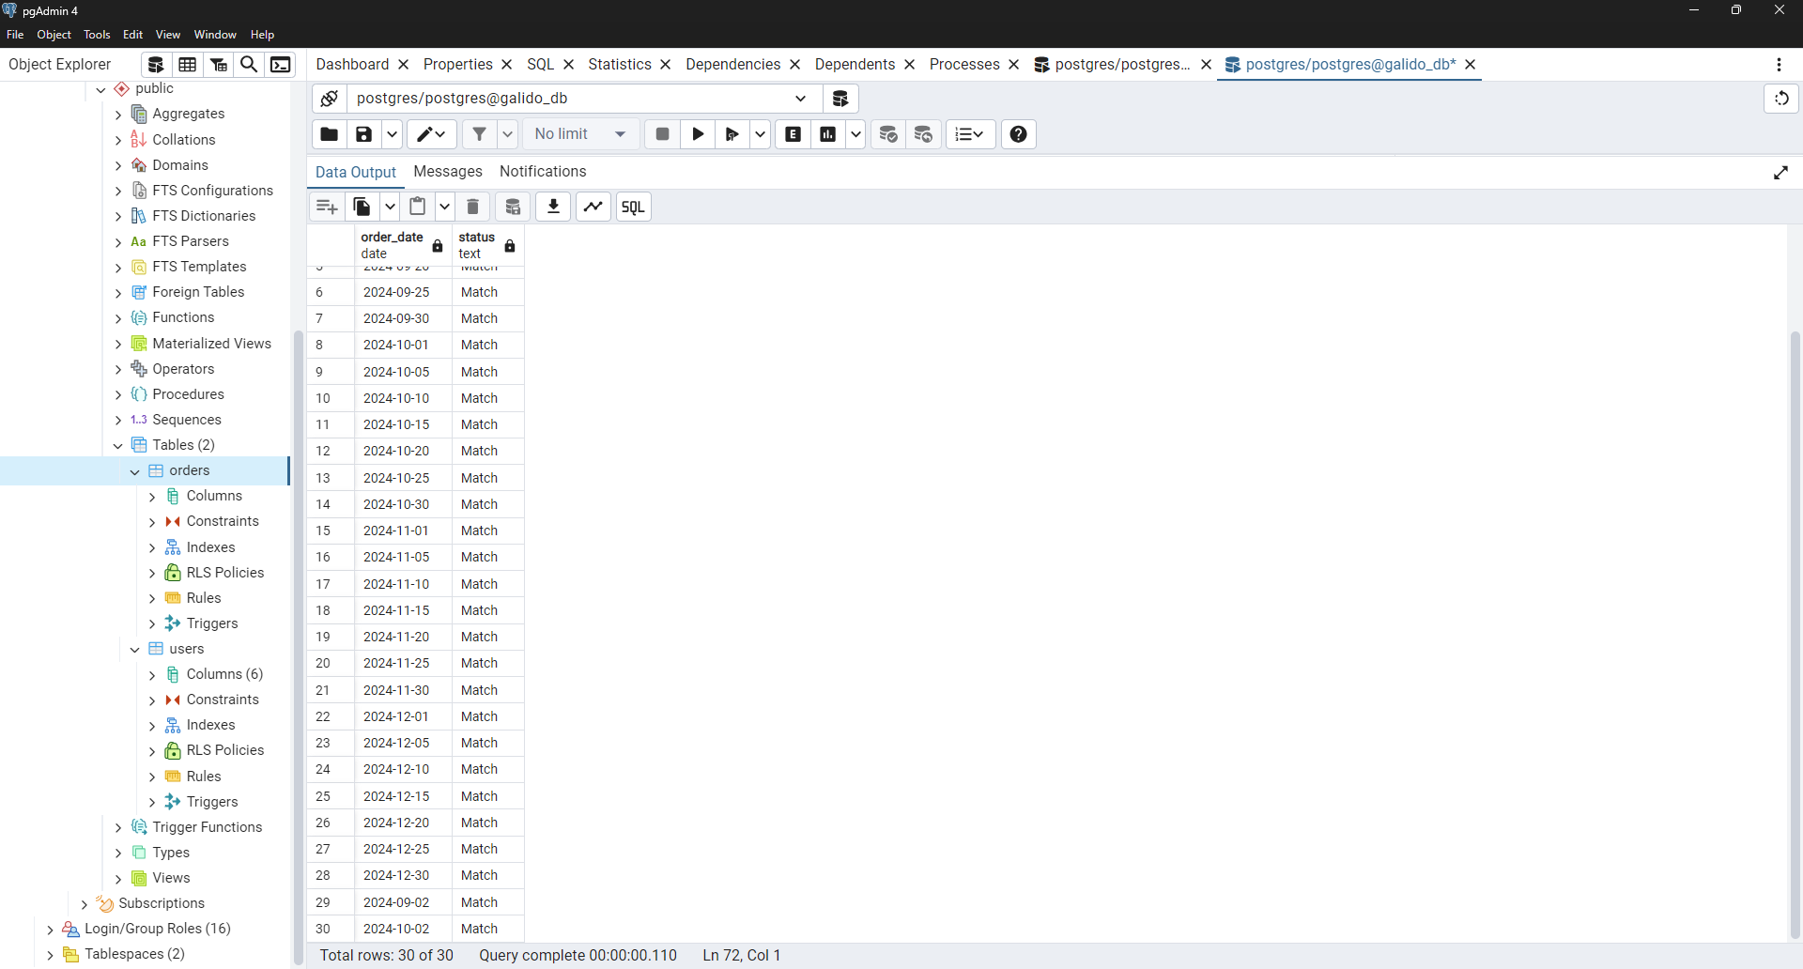

I put some test here, where the user_id has no match in my user’s database and it shows these errors. This states that my database onl;u accepts valid inputs.

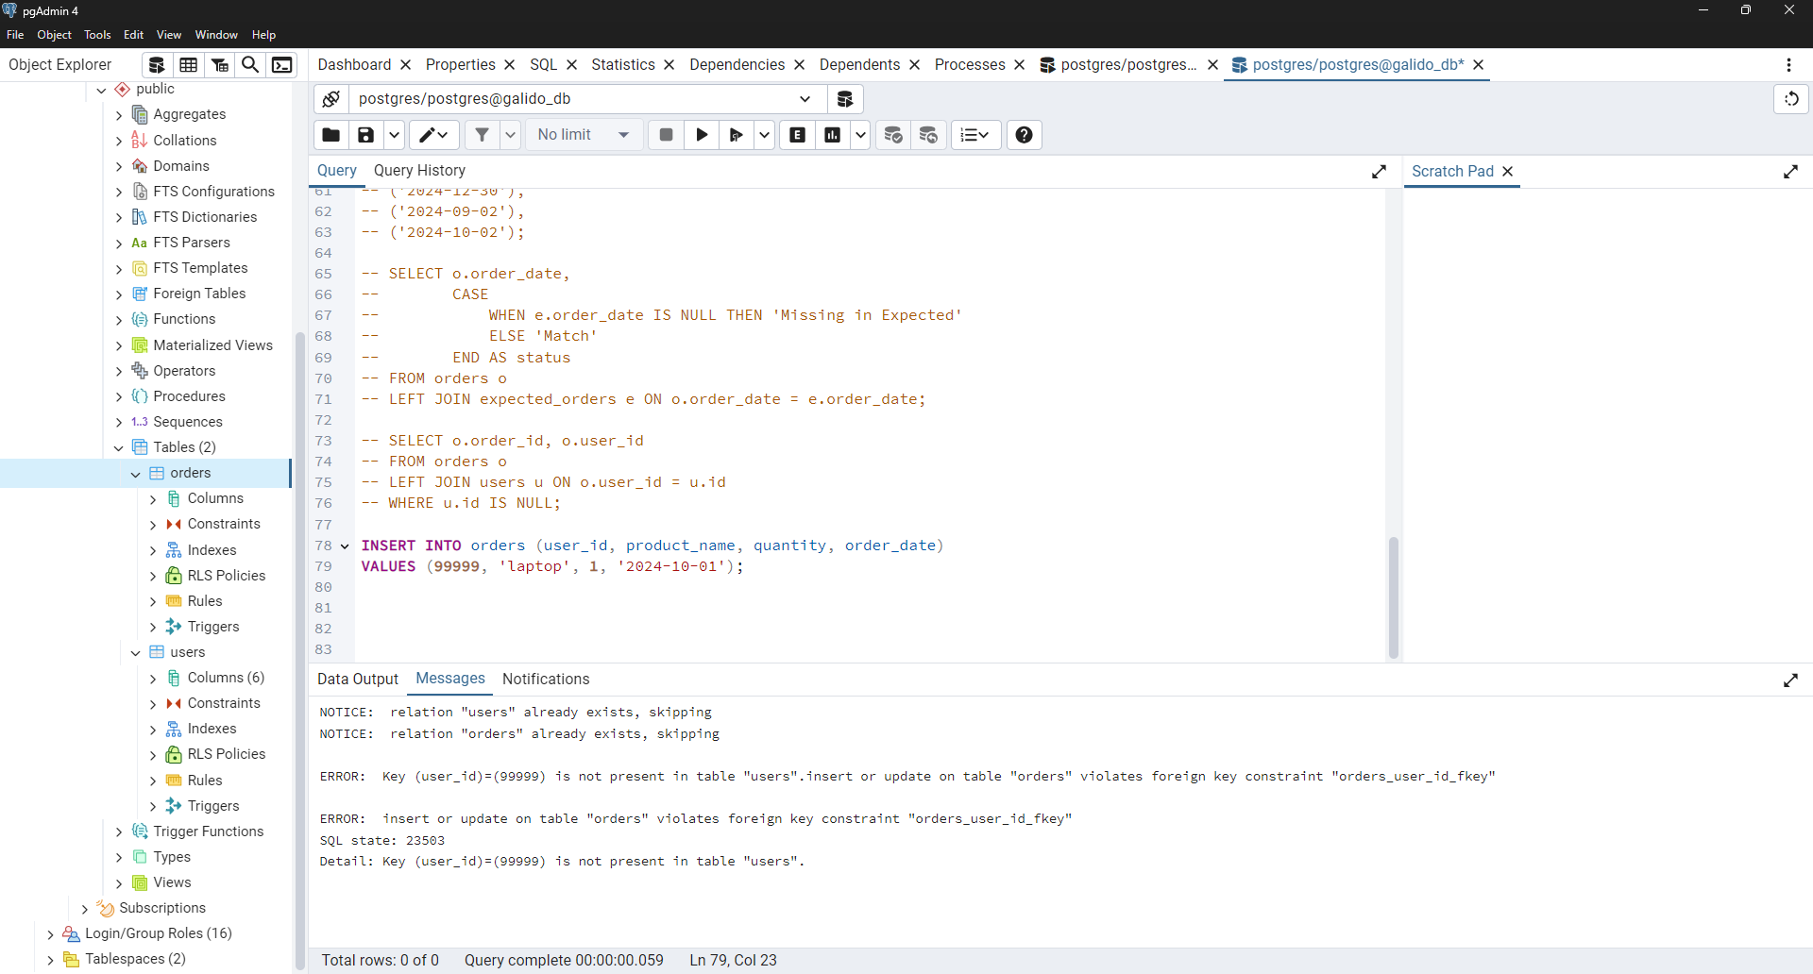

**Reflection:**

**While doing the laboratory activity, I initially found it overwhelming because I have a limited background in databases and no experience with PostgreSQL. However, with the help of YouTube tutorials and online research, I gradually started to understand how it works. As I progressed, I faced several challenges, such as issues with importing my CSV file and syntax errors in my code. Thankfully, with patience and a bit of help from Google, I was able to fix these problems. This experience has been quite challenging, but it has taught me valuable lessons about being more understanding, patient, and observant. I’ve learned to focus on the important aspects of the task at hand. Overall, this activity has helped me grow and develop my skills in a practical way, making me more confident in handling similar tasks in the future.**