RAMDEOBABA UNIVERSITY
Department of CSE (AI & ML)
Machine Learning Lab
Lab No.1
Lab Aim
To study and apply Data Preprocessing techniques on given dataset. Prepare a titanic dataset for training with machine learning algorithm by applying suitable data preprocessing techniques.

Lab Objectives
• Understand data preprocessing.
• Handle missing values.
• Clean and transform the dataset.
• Encode categorical variables.
• Apply feature scaling.
• Prepare the dataset for machine learning.

Dataset / Resources Used
Dataset: Titanic Dataset (train.csv)
Software: Python 3.x, Jupyter Notebook / Google Colab
Libraries: Pandas, NumPy, Scikit-learn, Matplotlib, Seaborn
GitHub URL: __________________

Date of Performance
____ / ____ / 2026

Theory
Data preprocessing is an important step in machine learning that involves cleaning and transforming raw data into a format suitable for analysis and model training. Since real-world datasets often contain missing values, inconsistent data, and categorical variables, preprocessing helps improve data quality and model performance.
In this practical, the Titanic dataset is preprocessed by handling missing values, cleaning and transforming the dataset, encoding categorical variables into numerical values, and applying feature scaling. Missing values are replaced using appropriate statistical methods, unnecessary columns are removed, and categorical features are converted into numerical form using encoding techniques. Numerical attributes are then standardized using feature scaling to ensure all features have a similar range.
After completing these preprocessing steps, the dataset becomes clean, consistent, and ready for training machine learning algorithms, leading to more accurate and reliable predictions.

Procedures and Materials Used
Materials Used
Hardware
- Computer/Laptop
Software
- Python 3.x
- Jupyter Notebook / Google Colab
Libraries
- Pandas
- NumPy
- Scikit-learn
- Matplotlib
- Seaborn
Dataset
- Titanic Dataset

Procedure
- Import the required Python libraries.
- Load the Titanic dataset.
- Display the dataset using head() and tail().
- Check the dataset information and identify missing values.
- Handle missing values using suitable techniques.
- Remove unnecessary columns from the dataset.
- Encode categorical variables into numerical values.
- Apply feature scaling to numerical features.
- Display the final preprocessed dataset.
- Save the cleaned dataset for machine learning.

Outputs Screenshots and Descriptions
Output1: Importing Libraries and Loading the Titanic Dataset
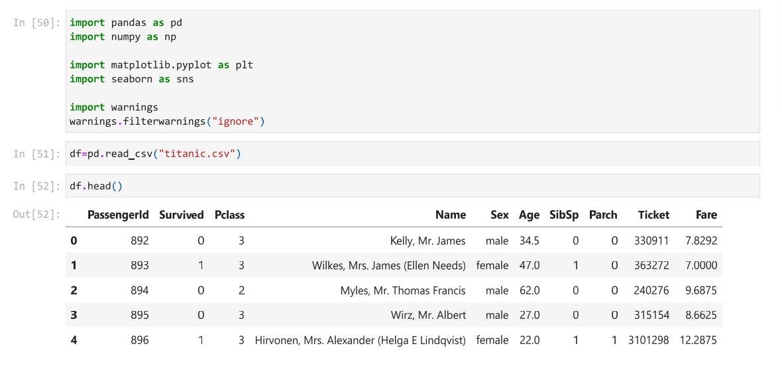
Description:
In this step, the required Python libraries such as Pandas, NumPy, Matplotlib, and Seaborn are imported to perform data preprocessing and visualization. The Titanic dataset is loaded into a DataFrame using the read_csv() function. The head() function is then used to display the first five records of the dataset, providing an overview of the available features and confirming that the dataset has been loaded successfully.

Output2: Displaying the Last Five Records of the Dataset
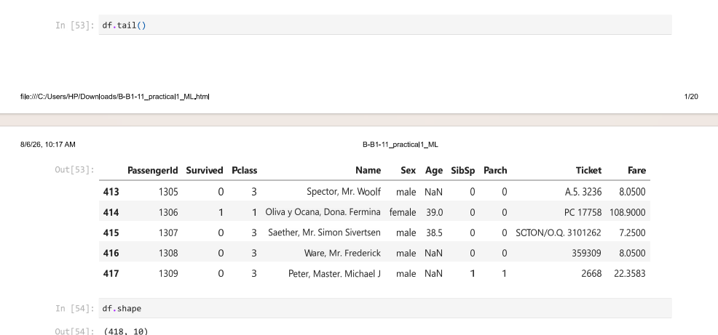
Description:
The tail() function is used to display the last five records of the Titanic dataset, confirming that the dataset has been loaded completely. It also helps identify missing values, such as NaN in the Age column, which indicates the need for preprocessing. The shape attribute is then used to determine the dimensions of the dataset. The output (418, 10) indicates that the dataset contains 418 rows and 10 columns, providing an overview of its size before preprocessing.

Output3: Displaying Dataset Information Using df.info()
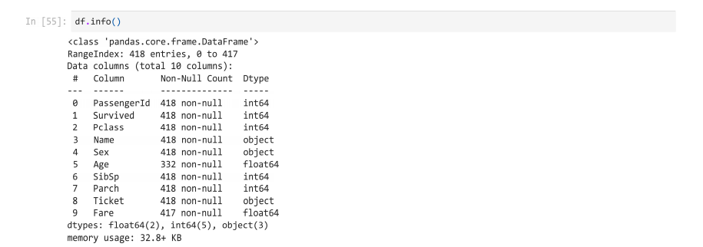
Description:
The info() function is used to display a summary of the Titanic dataset. It provides information such as the total number of rows and columns, column names, data types, non-null values, and memory usage. The output shows that the dataset contains 418 rows and 10 columns, with missing values in the Age and Fare columns. This information helps identify the preprocessing steps required before training a machine learning model.

Output4: Displaying Statistical Summary Using df.describe()
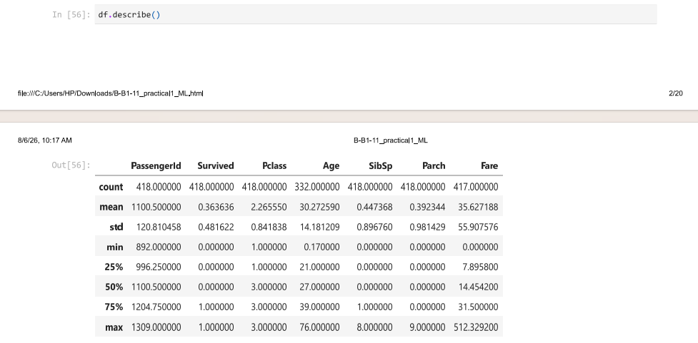
Description:
The describe() function is used to generate the statistical summary of the numerical columns in the Titanic dataset. It displays important measures such as count, mean, standard deviation, minimum value, maximum value, and quartiles (25%, 50%, and 75%). This summary helps in understanding the distribution and range of the numerical features and identifying any unusual values before performing data preprocessing and machine learning.

Output5: Identifying Missing Values Using df.isnull().sum()
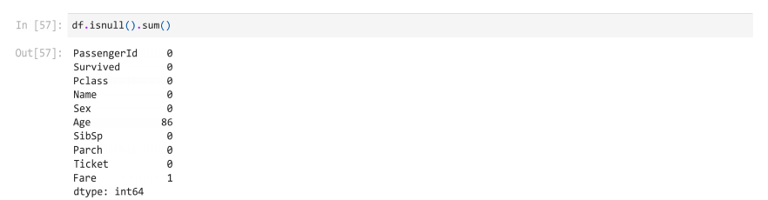
Description:
The isnull().sum() function is used to identify the number of missing (null) values present in each column of the Titanic dataset. The output shows that the Age column contains 86 missing values, while the Fare column contains 1 missing value. All other columns have no missing values. This analysis helps determine which columns require preprocessing before training a machine learning model.

Output6: Displaying Unique Values of the Fare Column
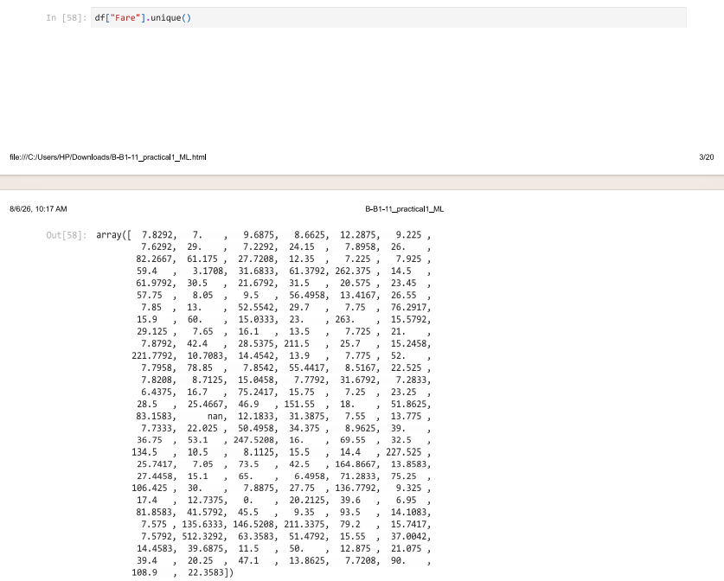Description:
The unique() function is used to display all distinct values present in the Fare column of the Titanic dataset. This helps identify the different ticket fare values paid by passengers and understand the distribution of the feature. The output also reveals the presence of a NaN value, indicating a missing fare entry that must be handled during data preprocessing.

Output7: Displaying the Dataset After Applying Value Replacement
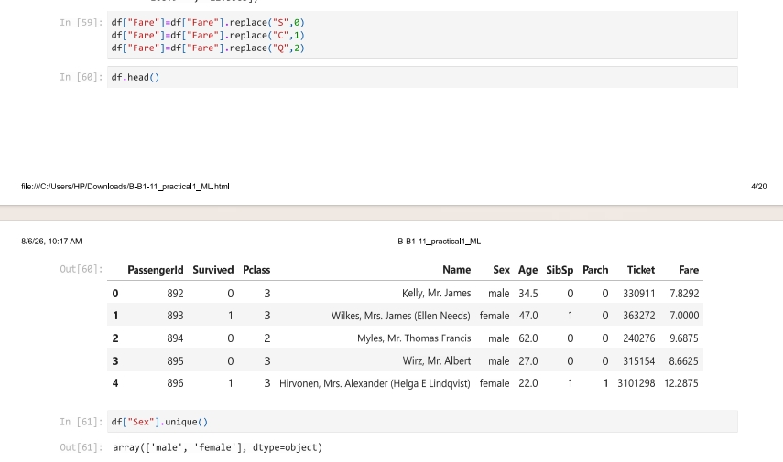

Description:
The replace() function is then applied to transform categorical values into numerical values as part of the data preprocessing process. Finally, the head() function is used to display the first five records and verify that the dataset is ready for further machine learning tasks. The unique() function is used to display the distinct values present in the Sex column of the Titanic dataset. The output shows two unique categories: male and female, which helps identify the categorical values before encoding.

Output 8: Handling Missing Values and Removing Unnecessary Columns
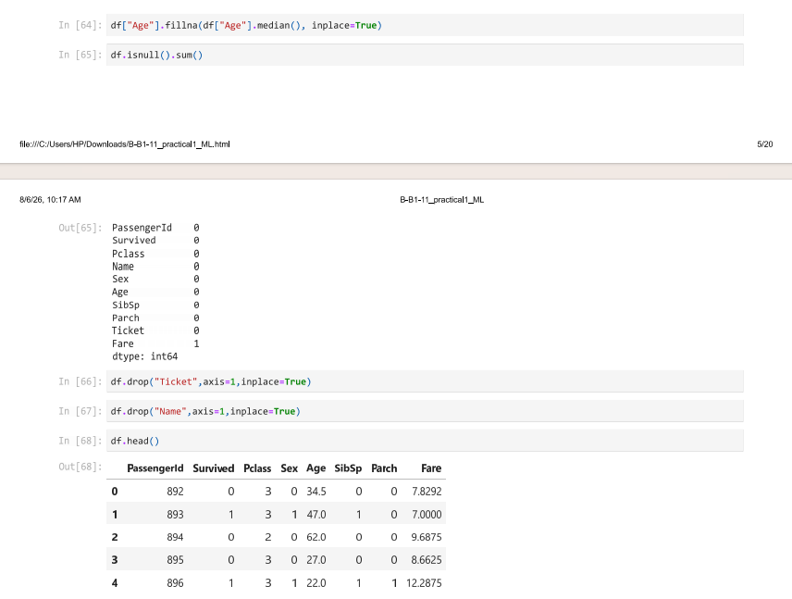
Description:
The missing values in the Age column are replaced with the median value using the fillna() function, ensuring that the dataset no longer contains null values in that column. The isnull().sum() function is then used to verify the remaining missing values. Next, the Ticket and Name columns are removed using the drop() function, as they are not essential for model training. Finally, the head() function displays the updated dataset after preprocessing.

Output 9: Removing Duplicate Records and Visualizing Outliers
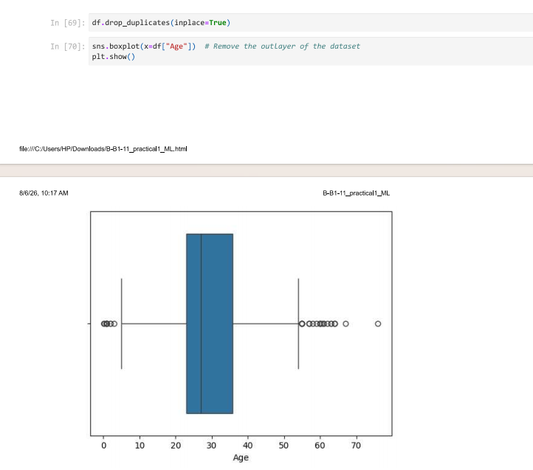
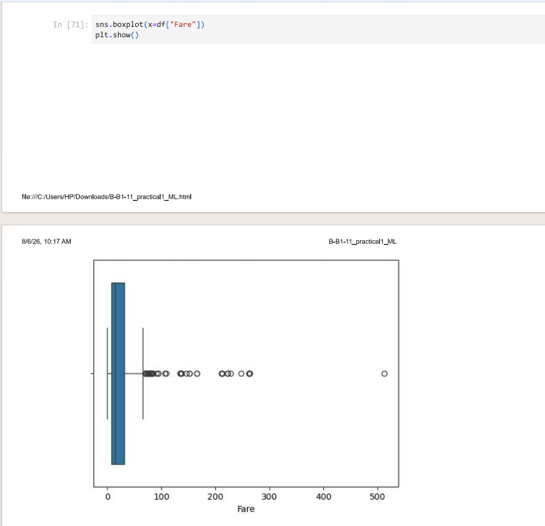

Description:
The drop_duplicates() function is used to remove duplicate records from the dataset, ensuring that each observation is unique. Box plots are then generated for the Age and Fare columns using the Seaborn library to visualize the distribution of data and identify potential outliers. The plots display the median, quartiles, and values that lie outside the normal range. This analysis helps detect extreme values and supports decisions regarding outlier treatment before training the machine learning model.

Output 10: Visualizing Data Distribution Using Histograms
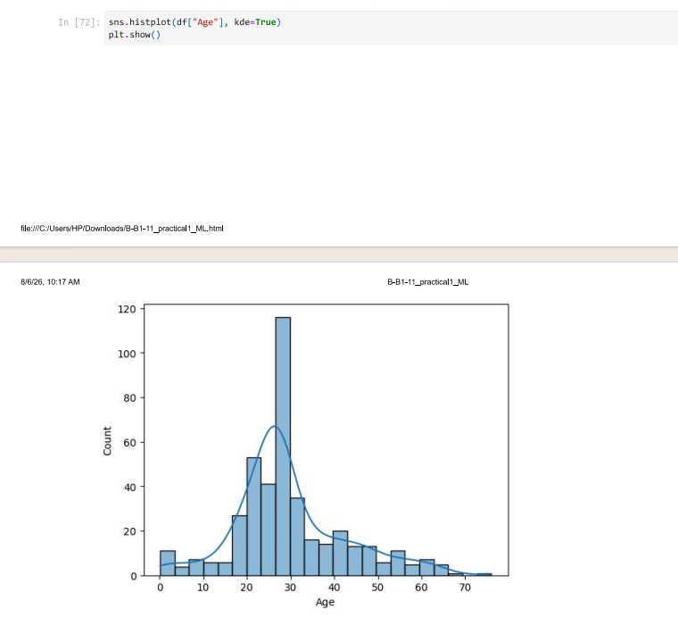

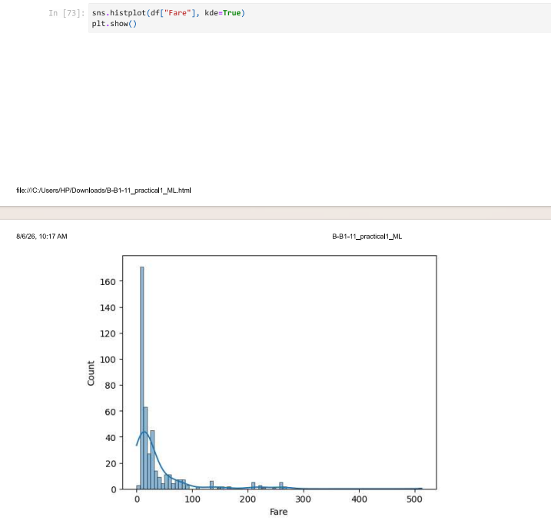

Description:
Histograms with Kernel Density Estimation (KDE) are plotted for the Age and Fare columns to analyze their data distribution. The histogram of the Age column shows that most passengers are between 20 and 35 years of age, with fewer passengers at the lower and higher age ranges. The histogram of the Fare column indicates that most passengers paid lower fares, while a few passengers paid significantly higher fares, resulting in a positively skewed distribution. These visualizations help understand the spread of the data and identify any irregularities before applying machine learning algorithms.

Output 11: Visualizing Survival Distribution Using a Count Plot
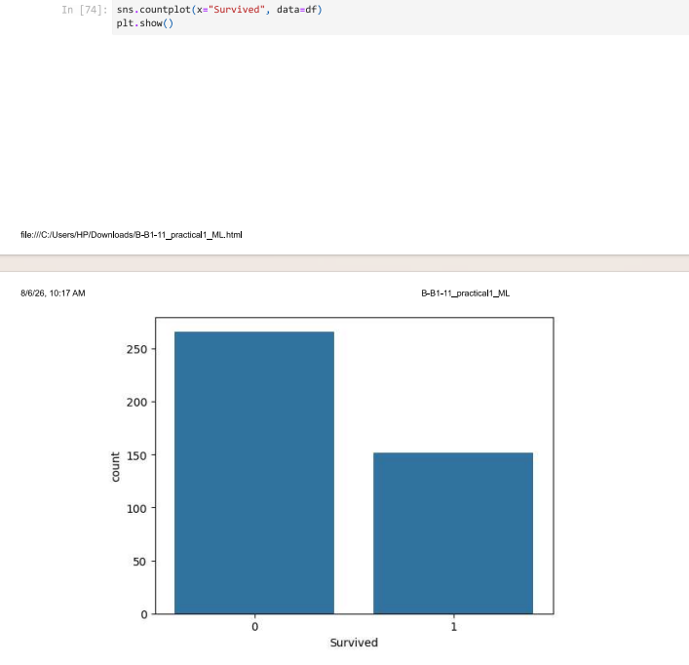
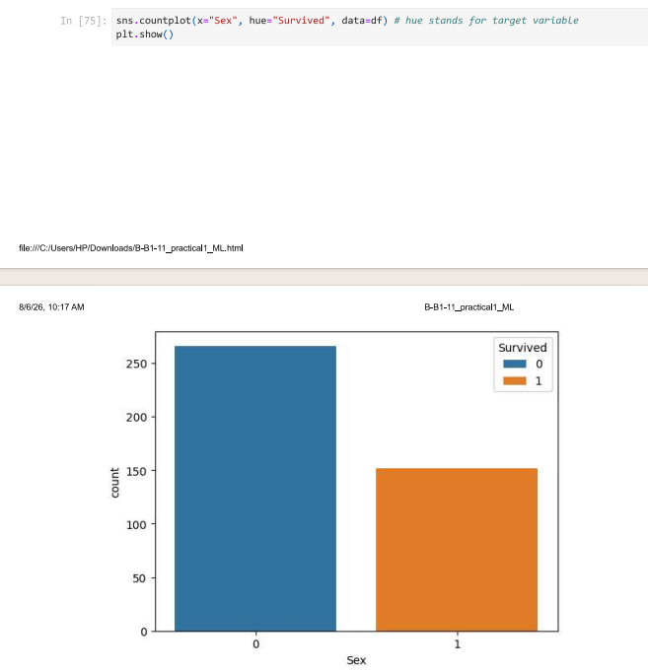

Description:
The countplot() function from the Seaborn library is used to visualize the distribution of passengers based on the Survived column. The plot displays the number of passengers who did not survive (0) and those who survived (1). It provides a clear comparison of the target variable and helps understand the class distribution in the dataset. This visualization is useful for identifying class imbalance before applying machine learning algorithms.

Output 12: Visualizing the Relationship Between Age and Fare Using a Scatter Plot
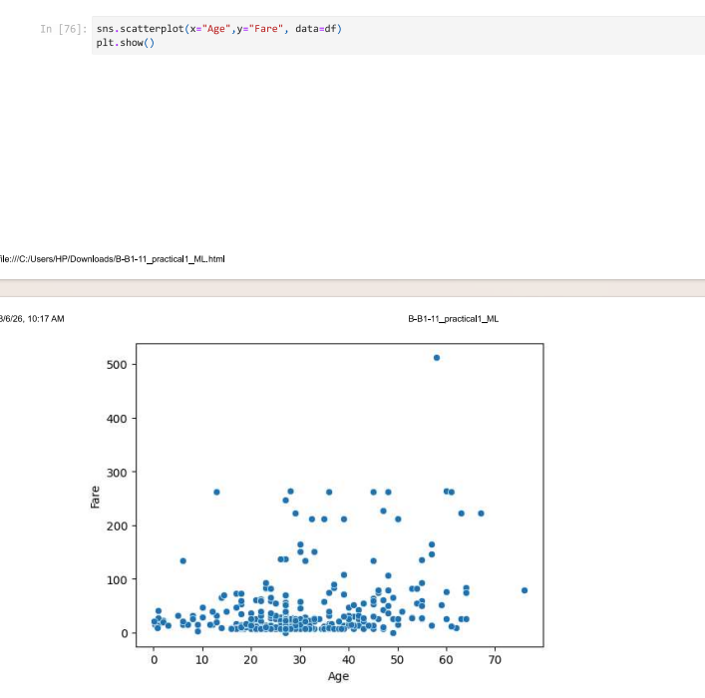
Description:
The scatterplot() function from the Seaborn library is used to visualize the relationship between the Age and Fare columns in the Titanic dataset. Each point in the plot represents an individual passenger, where the x-axis indicates the passenger's age and the y-axis represents the ticket fare. The plot helps identify patterns, trends, and outliers in the data. It also shows that most passengers paid lower fares, while only a few paid significantly higher fares, regardless of age.

Output 13: Visualizing Correlation Between Numerical Features Using a Heatmap
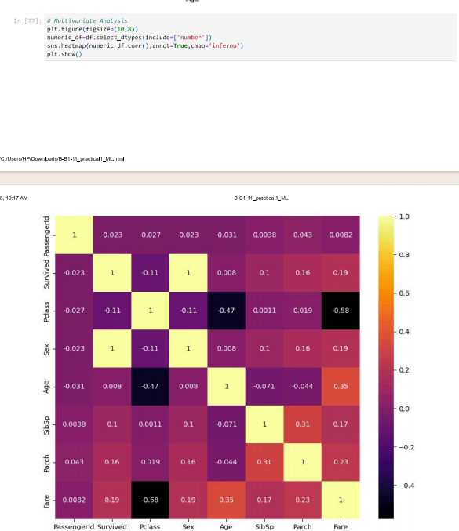
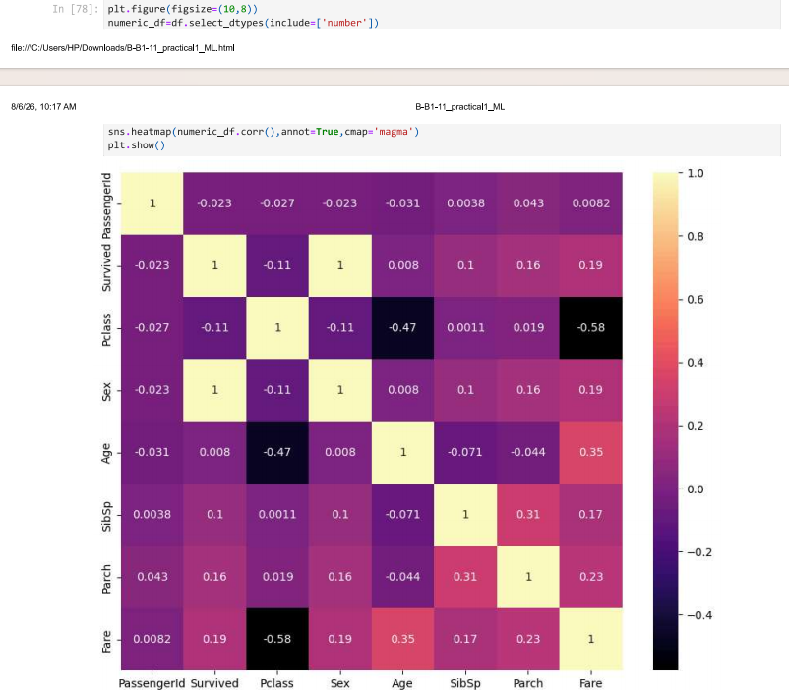
Description:
The heatmap() function from the Seaborn library is used to visualize the correlation matrix of numerical features in the Titanic dataset. Two heatmaps are created using the inferno and magma color maps. The annotated values show the correlation between each pair of features, making it easy to identify positive, negative, and weak relationships. These heatmaps help in understanding feature relationships for data analysis and machine learning

Output 14: Visualizing Categorical Features Using Count Plots
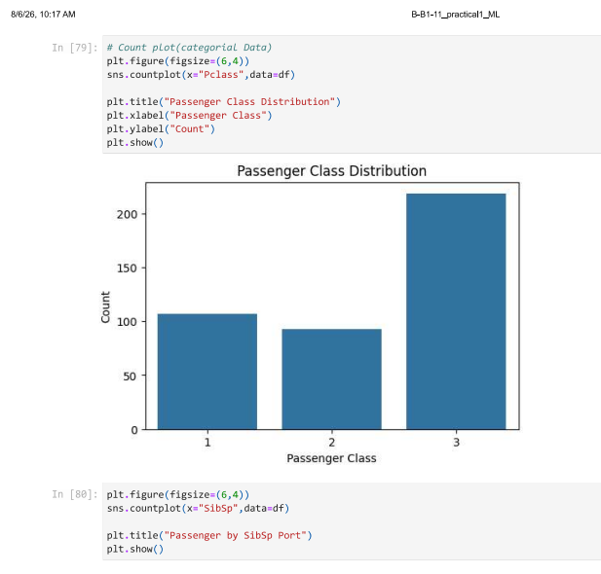
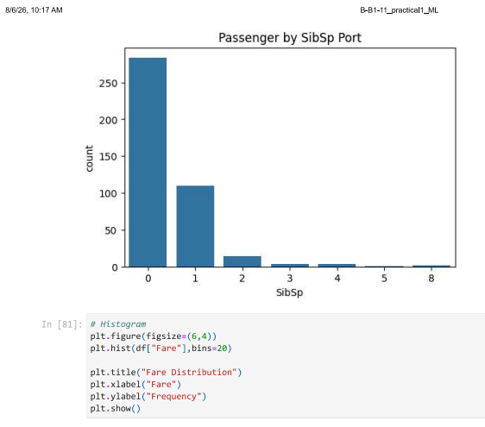
Description:
The countplot() function from the Seaborn library is used to visualize the distribution of categorical features in the Titanic dataset. Count plots are created for Passenger Class (Pclass) and SibSp to show the number of passengers in each category. These plots help understand the distribution of passenger classes and family sizes in the dataset.

Output 15: Visualizing Categorical and Numerical Feature Distributions
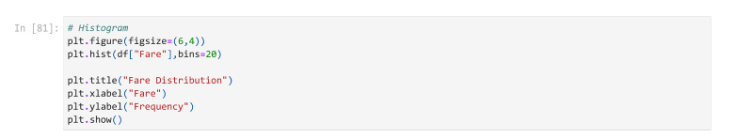
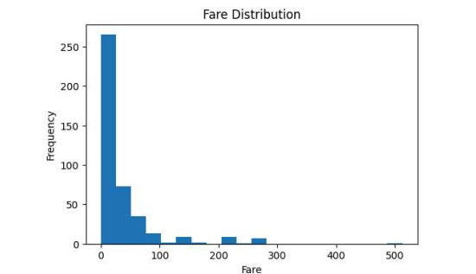
Description:
The countplot() and hist() functions are used to visualize the distribution of important features in the Titanic dataset. Count plots display the distributions of Passenger Class (Pclass) and SibSp, while the histogram shows the distribution of Fare values. These visualizations help understand passenger class, family size, and ticket fare patterns in the dataset.

Output 16: Feature Scaling Using StandardScaler
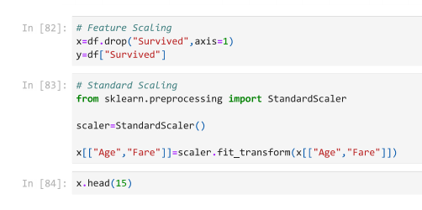

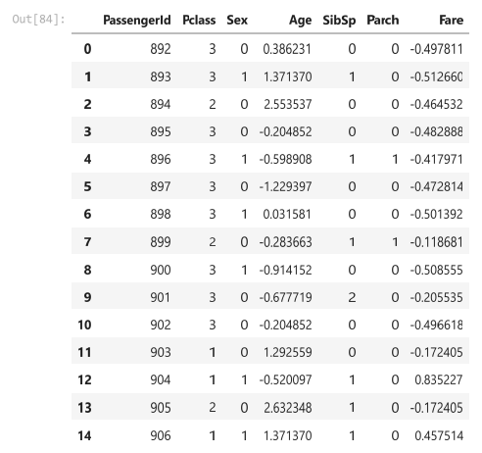
Description:
The StandardScaler from the Scikit-learn library is used to standardize the numerical features Age and Fare. It transforms the values so that they have a mean of 0 and a standard deviation of 1. Feature scaling ensures that numerical features are on the same scale, improving the performance of many machine learning algorithms. The head() function displays the first 15 rows of the scaled dataset.

Output 17: Splitting the Dataset into Training and Testing Sets
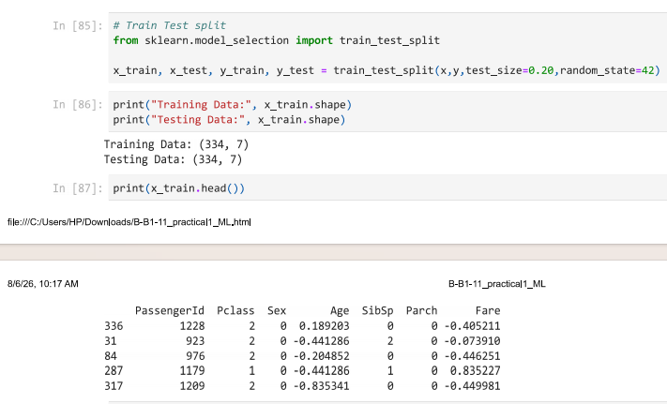
B, 11, Siddhi Deshpande, B1
Description:
The train_test_split() function from the Scikit-learn library is used to divide the dataset into training and testing sets. Here, 80% of the data is used for training and 20% for testing, with random_state=42 ensuring consistent results. The shapes of the training and testing datasets are displayed, followed by the first few rows of the training dataset using the head() function.

Viva Questions with Answers
Q1. What is data preprocessing?
Answer: Data preprocessing is the process of cleaning and transforming raw data into a suitable format for machine learning.
Q2. Why are missing values handled?
Answer: Missing values can affect the accuracy of machine learning models. They are handled to improve data quality and model performance.
Q3. What is label encoding?
Answer: Label encoding converts categorical data into numerical values so that machine learning algorithms can process them.
Q4. Why is feature scaling important?
Answer: Feature scaling standardizes numerical features to a similar range, improving the performance of many machine learning algorithms.
Q5. Why is data preprocessing necessary before training a model?
Answer: Data preprocessing improves data quality, removes inconsistencies, and prepares the dataset for accurate and efficient machine learning model training.

