Ramdeobaba University, Nagpur
Department of CSE (AIML)
Lab No.: 8

Lab Aim
To implement Support Vector Machine (SVM) algorithm for classification

Lab Objective

- To understand the basic concept of the Support Vector Machine algorithm.
- To load and preprocess a classification dataset.
- To train an SVM classifier using the training data.
- To predict the class labels for the testing data.
- To evaluate the model using accuracy, confusion matrix, precision, recall, and F1-score.

Dataset / Resources Used:
Dataset: “Wholesale customers data.csv”
Software: Python 3.x, Jupyter Notebook
Libraries: Pandas, NumPy, Matplotlib, Seaborn, and Scikit-learn

Date of Performance:
24/09/2026

Theory
Support Vector Machine (SVM) is a supervised machine learning algorithm used for classification and regression. It classifies data by finding the best decision boundary, called a hyperplane, that separates different classes.
SVM tries to find the maximum margin between the classes. The data points closest to the hyperplane are called support vectors. These points help determine the position of the decision boundary.
SVM uses different kernel functions, such as linear, polynomial, and Radial Basis Function (RBF), to classify data. Feature scaling is often applied before training to improve the model's performance.
In this experiment, the Wholesale Customers dataset is used to study customer purchasing patterns. Since SVM is a classification algorithm, suitable customer class labels must be available or created before training the model.
Objective: To implement the SVM classification algorithm using Python and evaluate its performance using accuracy, a confusion matrix, precision, recall, and F1-score.

GitHub Repository
The source code (notebook) and dataset for this lab are available in the GitHub repository given below.
GitHub Repository URL:
https://github.com/Sids08/Machine-Learning-/blob/main/_Perceptron%20Learning%20Algorithm.ipynb

Procedures and Materials Used

Materials Used

Computer or laptop.

Python 3.x programming language.

Jupyter Notebook or Google Colab environment.

“Wholesale customers data.csv”

Libraries: Pandas, NumPy, Matplotlib, Seaborn, and Scikit-learn.
GitHub account to upload the source code.
Procedure
- Import the required libraries, such as Pandas, NumPy, Matplotlib, and Scikit-learn.
- Load the Wholesale customers data.csv dataset using Pandas.
- Display the first few rows and check the dataset's columns, data types, and missing values.
- Select the input features based on customers' purchasing data.
- Create suitable customer class labels because the original dataset may not contain a classification target.
- Split the dataset into training and testing sets using train_test_split().
- Apply StandardScaler to standardize the input features.
- Create an SVM classifier using SVC() and train it with the training data.
- Predict the customer classes using the testing data.
- Evaluate the model using accuracy, confusion matrix, precision, recall, and F1-score.
- Display the results and save screenshots of the outputs for the lab report.

Output Screenshots and Descriptions
Output 1: Machine Failure Count
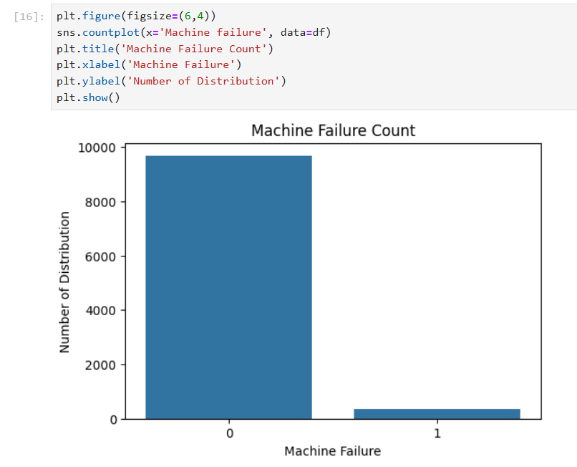
Description: The count plot shows the distribution of machine failures in the dataset. The X-axis represents machine failure categories (0 = No Failure, 1 = Failure), and the Y-axis represents the number of observations. The graph indicates that most machines did not experience failure, while only a small number experienced failure. This shows that the dataset is highly imbalanced, with significantly fewer failure cases than non-failure cases.

Output 2: Distribution of Numerical Features
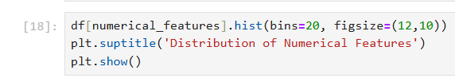
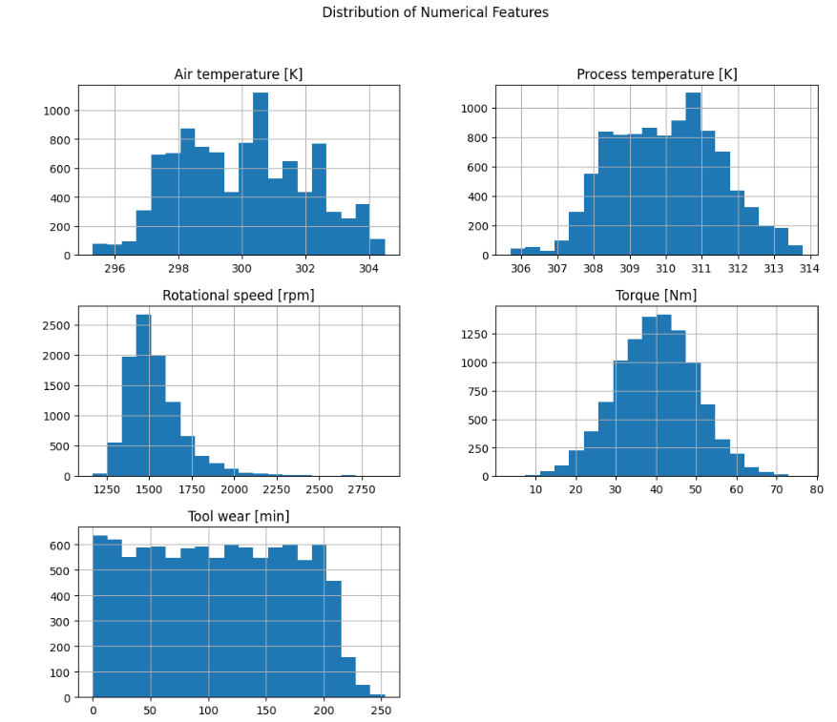

Description The histograms display the distribution of all numerical features in the dataset using 20 bins for each feature. They help identify the spread of values, frequency patterns, skewness, and possible outliers. Some features may show a normal distribution, while others may be positively or negatively skewed. This visualization helps understand the data before applying preprocessing techniques and building a machine learning model.

Output 3: Boxplots of Numerical Features
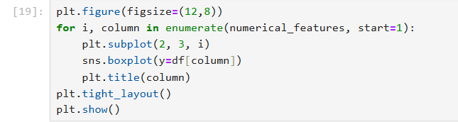
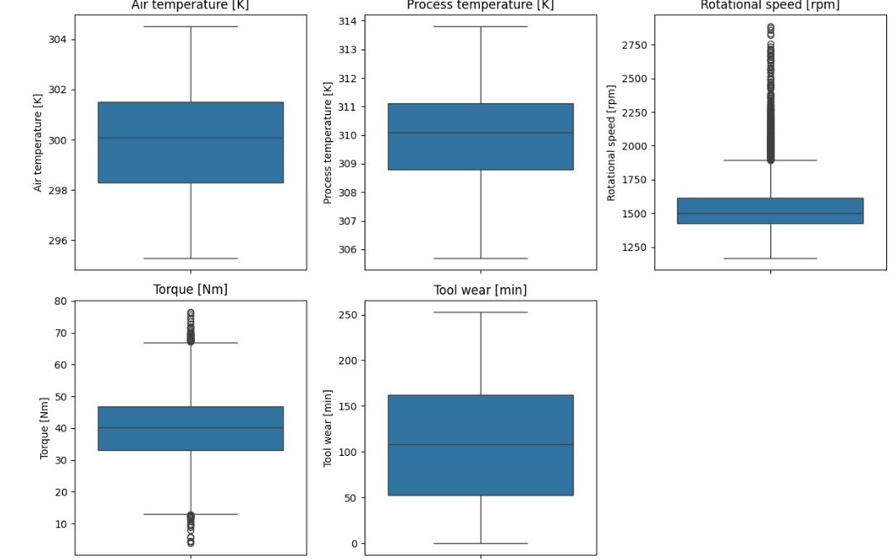
Description: The boxplots represent the distribution of numerical features in the dataset. They show the median, interquartile range (IQR), spread of values, and potential outliers for each feature. Outliers appear as individual points beyond the whiskers. This visualization helps identify unusual values and understand the variability of each numerical feature before applying data preprocessing techniques.

Output 4: Correlation Heatmap
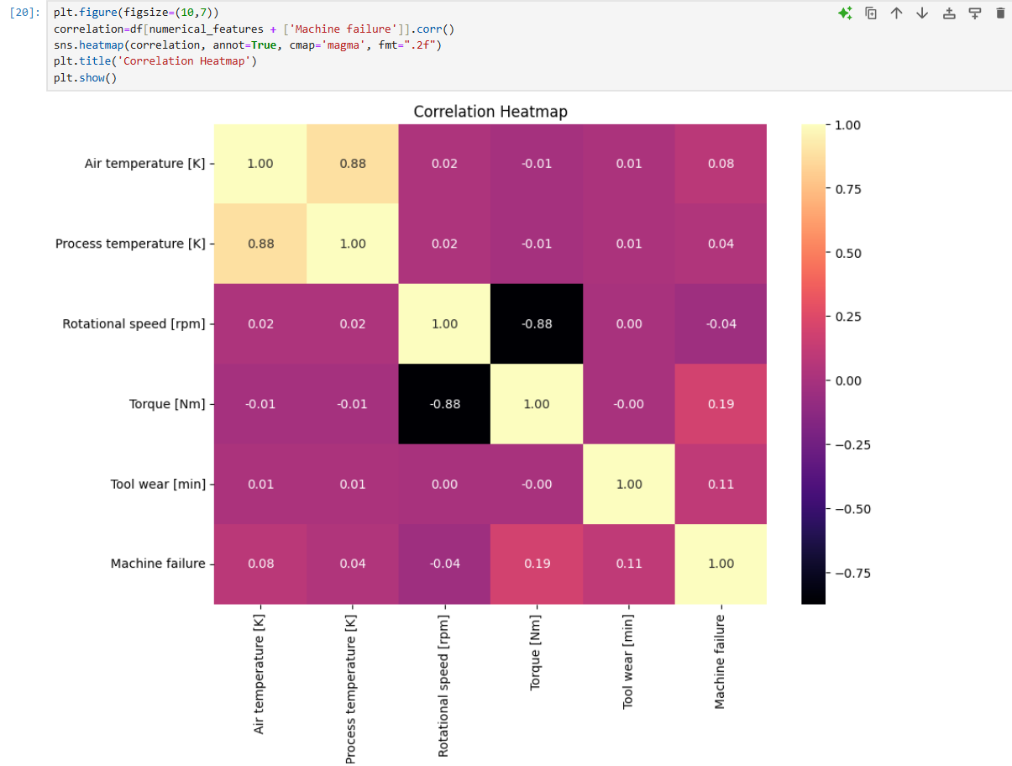
Description: The correlation heatmap shows the relationships between numerical features and machine failure. Air temperature and process temperature have a strong positive correlation of 0.88, while rotational speed and torque have a strong negative correlation of -0.88. Machine failure has a weak positive correlation with torque (0.19), tool wear (0.11), and air temperature (0.08). This visualization helps identify relationships between features and understand which variables may be associated with machine failure.

Output 5: Feature Selection and Train-Test Split
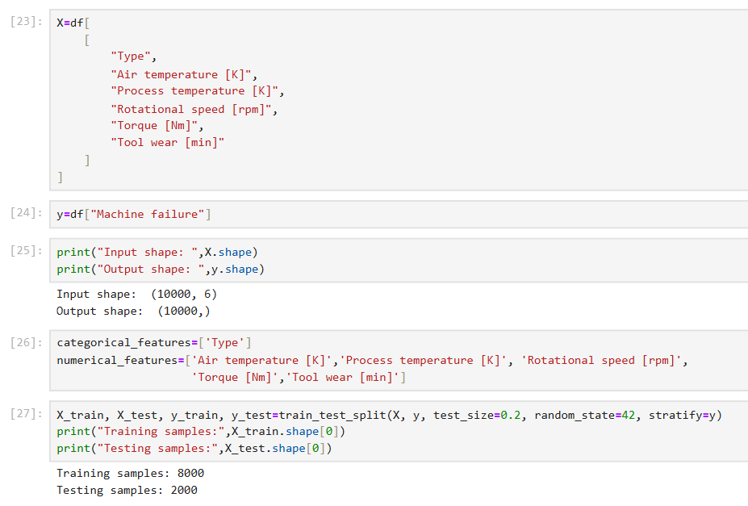
Description: The input features (\(X\)) consist of six columns, including machine type, air temperature, process temperature, rotational speed, torque, and tool wear. The target variable (\(y\)) is the Machine failure column. The input shape is (10,000, 6), and the output shape is (10,000,). The dataset is divided into 80% training data (8,000 samples) and 20% testing data (2,000 samples) using train_test_split(). The stratify=y parameter maintains the proportion of failure and non-failure cases in both sets, while random_state=42 ensures reproducible results.

Output 6: Linear SVM Model Training
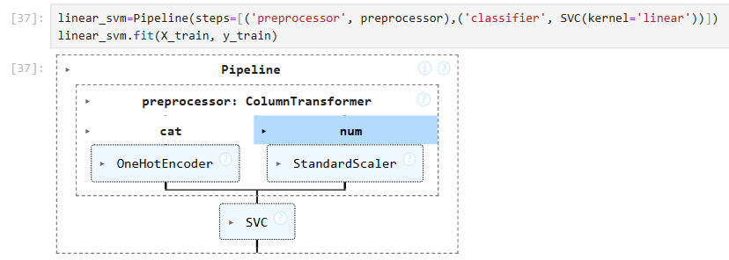
Description: A Linear Support Vector Machine (SVM) model is created using Pipeline() with a ColumnTransformer for preprocessing and SVC(kernel='linear') as the classifier. The categorical features are converted into numerical form using OneHotEncoder(), while numerical features are scaled using StandardScaler(). The fit(X_train, y_train) function trains the model on the training dataset. The pipeline combines preprocessing and classification into a single workflow, helping the model learn patterns and classify the data.

Output 7: Linear SVM Model Evaluation
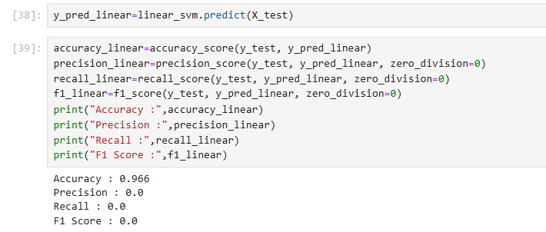
Description: The trained Linear SVM model is used to predict the target values for the test dataset using predict(X_test). The model performance is evaluated using accuracy, precision, recall, and F1-score. The model achieves an accuracy of 96.6%, while precision, recall, and F1-score are 0.0. This indicates that the model predicts the majority class correctly but fails to identify the positive class (machine failure). Therefore, despite its high accuracy, the model's performance in detecting machine failures is poor.

Output 8: Classification Report of Linear SVM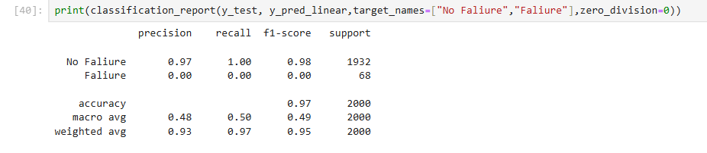
Description: The classification report evaluates the performance of the Linear SVM model for the two classes: No Failure and Failure. The model achieves 96.6% accuracy on 2,000 test samples. For the No Failure class, precision is 0.97, recall is 1.00, and F1-score is 0.98. However, for the Failure class, all three metrics are 0.00, indicating that the model fails to identify any machine failures. The test dataset contains 1,932 No Failure cases and 68 Failure cases. This happens because the dataset is imbalanced, with many more non-failure cases than failure cases. Therefore, accuracy alone is not sufficient to evaluate the model, and techniques such as class weighting or oversampling can be used to improve failure detection.

Output 9: Confusion Matrix – Linear SVM
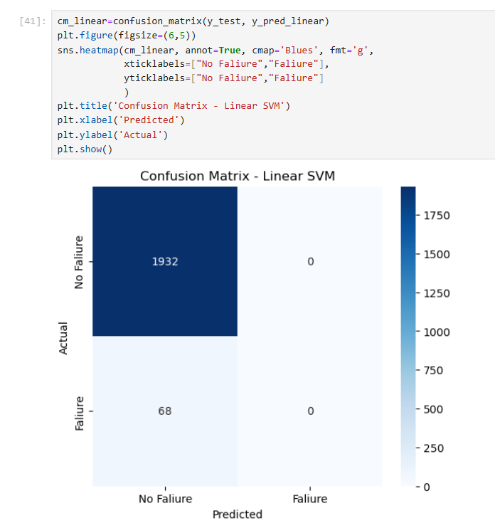
Description: The confusion matrix shows the classification performance of the Linear SVM model on the test dataset. Out of 2,000 samples, the model correctly predicts 1,932 No Failure cases and incorrectly classifies all 68 Failure cases as No Failure. It predicts zero cases as Failure. Therefore, the model performs well in identifying machines without failure but fails to detect actual machine failures. This indicates that the model needs improvement in detecting the minority class, and techniques such as class weighting or oversampling can be applied to improve its performance.

Output 10: Confusion Matrix – RBF SVM
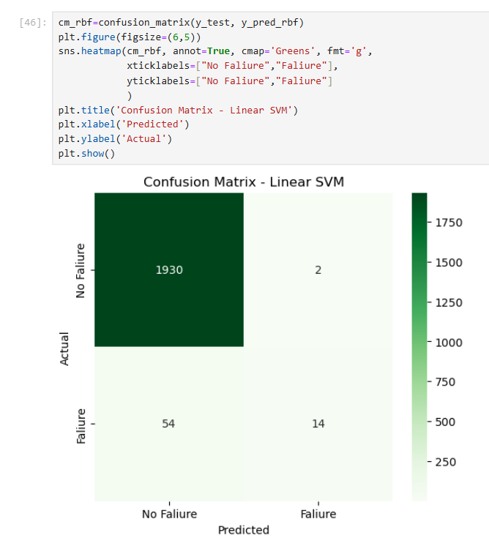
Description: The confusion matrix shows the classification performance of the RBF (Radial Basis Function) SVM model on the test dataset. Out of 2,000 samples, the model correctly classifies 1,930 No Failure cases and 14 Failure cases. It incorrectly classifies 2 No Failure cases as Failure and 54 Failure cases as No Failure. The model identifies some machine failures, unlike the Linear SVM model, which fails to detect any failures. However, it still misses 54 actual failures, so further improvement is needed to detect machine failures more accurately.

Output 11: Performance Comparison of Linear and RBF SVM
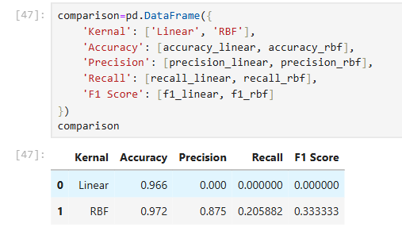
Description: The performance of Linear SVM and RBF SVM models is compared using accuracy, precision, recall, and F1-score. The Linear SVM achieves an accuracy of 96.6%, but its precision, recall, and F1-score are 0.0, indicating that it fails to detect machine failures. The RBF SVM achieves a higher accuracy of 97.2%, precision of 0.875, recall of 0.206, and F1-score of 0.333. Therefore, the RBF SVM performs better than the Linear SVM because it identifies some machine failures. However, its recall is still low, meaning that it misses many actual failures. Hence, further model improvement is required for reliable machine failure detection.

Output 12: Graphical Comparison of SVM Kernels
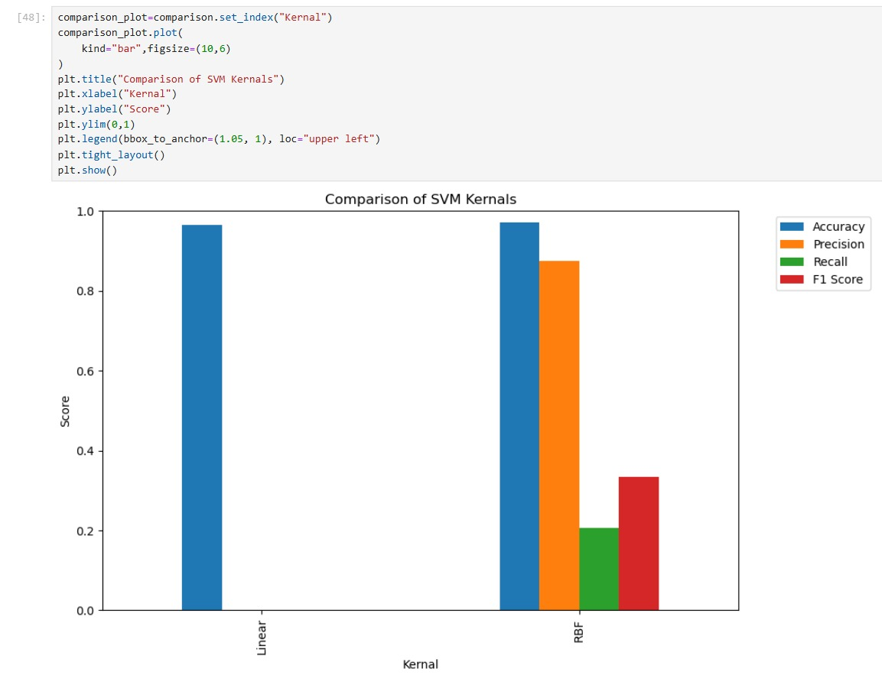
Description: The bar graph compares the performance of Linear SVM and RBF SVM using accuracy, precision, recall, and F1-score. The Linear SVM achieves an accuracy of 96.6%, but its precision, recall, and F1-score are 0.0. The RBF SVM achieves an accuracy of 97.2%, precision of 0.875, recall of 0.206, and F1-score of 0.333. The graph shows that RBF SVM performs better than Linear SVM because it can identify some machine failures. However, its recall remains low, indicating that many actual failures are still missed. Therefore, RBF SVM is better than Linear SVM for this dataset, but further improvement is needed.

Output 13: Hyperparameter Tuning of SVM using GridSearchCV
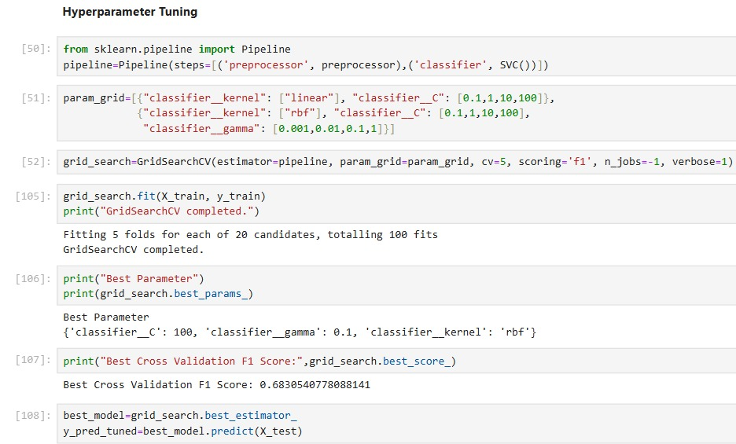
Description: Hyperparameter tuning is performed using GridSearchCV to find the best parameters for the SVM model. The pipeline combines preprocessing with the SVM classifier, and 5-fold cross-validation is used to evaluate different parameter combinations based on the F1-score. The tuning process evaluates 20 candidates, resulting in 100 model fits. The best parameters obtained are kernel='rbf', C=100, and gamma=0.1, with a best cross-validation F1-score of approximately 0.6831. Finally, the best model is selected using best_estimator_ and used to predict the target values of the test dataset.

Output 14: Performance Evaluation of Tuned SVM Model

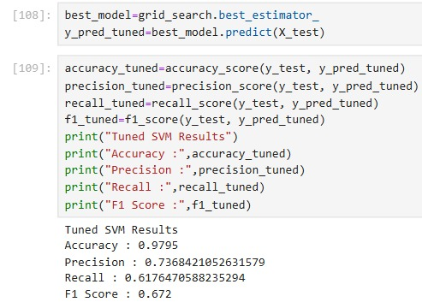

Description: The best SVM model obtained through hyperparameter tuning using GridSearchCV is used to predict the target values of the test dataset. The model achieves an accuracy of 97.95%, precision of 0.7368, recall of 0.6176, and F1-score of 0.672. These results show that the tuned SVM model performs better in detecting machine failures than the initial Linear and RBF SVM models. The improved recall indicates that the model identifies more actual machine failures, while the F1-score shows a better balance between precision and recall. Therefore, hyperparameter tuning improves the overall performance of the SVM model.

Output 15: Final Performance Comparison of SVM Models

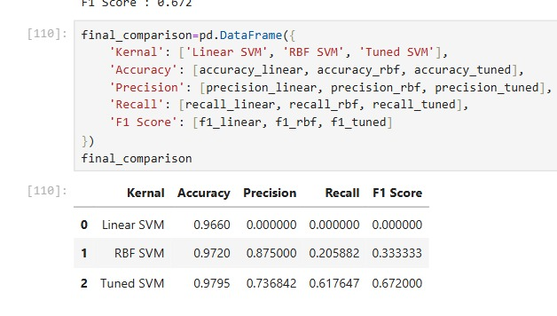

Description: The final comparison evaluates the performance of Linear SVM, RBF SVM, and Tuned SVM using accuracy, precision, recall, and F1-score. Linear SVM achieves an accuracy of 96.60% but fails to detect machine failures. RBF SVM achieves an accuracy of 97.20%, precision of 0.875, recall of 0.2059, and F1-score of 0.3333. The Tuned SVM achieves the best accuracy of 97.95%, with precision of 0.7368, recall of 0.6176, and F1-score of 0.6720. Therefore, the Tuned SVM provides the best overall performance, detecting more actual machine failures while maintaining a good balance between precision and recall.

Output 16: Graphical Performance Comparison of SVM Models
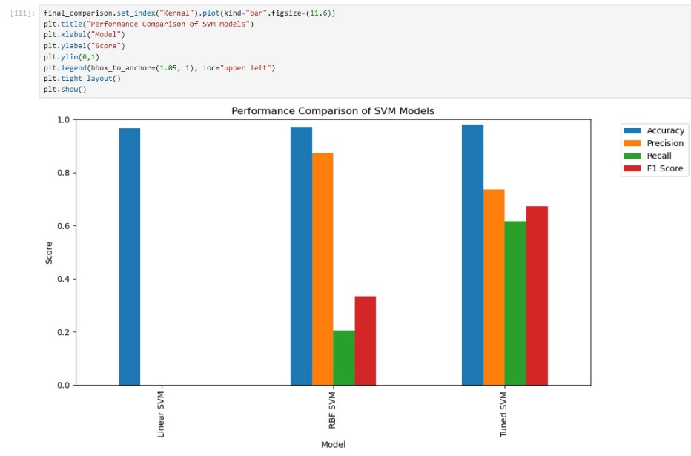

Description: The bar graph compares the performance of Linear SVM, RBF SVM, and Tuned SVM using accuracy, precision, recall, and F1-score. Linear SVM achieves 96.60% accuracy but fails to detect machine failures. RBF SVM achieves 97.20% accuracy and identifies some failures. The Tuned SVM achieves the highest accuracy of 97.95%, along with a precision of 73.68%, recall of 61.76%, and F1-score of 67.20%. The graph shows that hyperparameter tuning improves the model's ability to detect machine failures. Therefore, the Tuned SVM is the best-performing model among the three for this dataset, although further improvement in failure detection may still be needed.

Viva Questions with Solutions

- What is SVM?
SVM (Support Vector Machine) is a supervised machine learning algorithm used for classification and regression. It finds the best boundary to separate different classes.

- What is a hyperplane in SVM?
A hyperplane is a decision boundary that separates data points belonging to different classes.

- What are support vectors?
Support vectors are the data points closest to the hyperplane. They help determine the position of the decision boundary.

- What is the kernel in SVM?
A kernel helps SVM separate data that cannot be separated using a straight line. Common kernels are Linear, Polynomial, RBF, and Sigmoid.

- . How do you evaluate an SVM classification model?
We evaluate the model using accuracy, precision, recall, F1-score, and a confusion matrix.

