LYRA: An App-Free, On-Device Hybrid Classifier for Wrist-IMU Gesture Recognition, with an Analysis of Recognition- vs. Anatomy-Limited Failure
Siddharth Bansal
Global Indian International School (GIIS), Singapore
sidb0901@gmail.com
ORCID: 0009-0001-1753-3271
September 2026

Abstract
We present LYRA, a wrist-worn gesture controller that classifies four hand gestures (flick, twist, pinch, double-flick) entirely on a low-cost microcontroller and emits them as a standard Bluetooth-HID media keyboard: no phone, no application, and no cloud in the recognition loop. The core contribution is a two-stage hybrid classifier: fixed rules handle the noise floor and flicks, which separate cleanly across users, while a small decision tree is confined to the twist-versus-pinch boundary, where fixed thresholds fail. On a leave-one-subject-out (LOSO) evaluation over three participants, the hybrid raises pooled twist accuracy from 63% (rules only) to 76% and gives the best pinch accuracy (79%) while preserving essentially perfect flick recognition (99%). The residual twist error decomposes into two distinct causes: a recognition-limited component (threshold rigidity, correctable by the learned stage) and an anatomy-limited component (a participant who cannot fully pronate/supinate the wrist), which no classifier can correct. This distinction is treated as an accessibility finding, addressed by gesture redesign rather than by better recognition. A second collection on a later, wrist-mounted hardware revision (ten new participants, no retraining, no per-user calibration) tested how well each classifier stage survives a hardware change. The fixed rules did not: pinch collapsed from 77% to 12% and twist from 63% to 38%, because their absolute-magnitude thresholds are tuned to one specific sensor mounting. The deployed hybrid, by contrast, reproduced its original three-subject accuracy almost exactly on the new hardware and cohort (twist 76%→76%, pinch 79%→76%; no detectable difference, p = 0.95), while the rules-vs-hybrid gap on the new hardware was overwhelming (p < 0.0001 for both gestures). The study's most transferable finding follows from this: the learned component, not the simpler fixed rules, is what makes the recognizer portable across a hardware revision, the opposite of the working assumption at the project's start. The study is framed as an on-device systems feasibility study: the learned component is fitted on three subjects, and the system design and the recognition- vs. anatomy-limited and rules- vs. learning-based failure analyses are foregrounded over any single benchmark-accuracy claim.
Keywords: Wearable sensors, Gesture recognition, Wrist-worn IMU, On-device machine learning, Embedded systems, Decision trees, Hybrid classifiers, Human-computer interaction, Accessibility, Zero-velocity update
1. Introduction
Hands-free, eyes-free input is useful when a user's hands are occupied, when looking at a screen is inconvenient, or when fine motor control is limited. Wrist-worn inertial measurement units (IMUs) are attractive for this because they are cheap, low-power, and socially unobtrusive. LYRA is a wristband built around a single 6-axis IMU and an ESP32-class microcontroller that recognizes a small gesture vocabulary and maps it to media controls, acting as a Bluetooth-HID keyboard so it works with any host with no companion software.
The project's guiding constraints were: (i) on-device recognition (no cloud, no phone in the core loop); (ii) robustness to everyday motion (achieved with an explicit arm/disarm gesture); and (iii) recognition that generalizes across wearers, which we measure directly rather than mask with per-user tuning. This paper reports the design of the recognizer and an honest, leave-one-subject-out evaluation, including a negative result (a dropped gesture) and an accessibility finding about a gesture that some users' wrists cannot physically produce. We present it as a feasibility study: the contribution is a working, reproducible on-device system and a methodological distinction it surfaces, not a large-sample accuracy benchmark; with three participants the numbers are directional and are reported as such throughout.
Contributions.
- A two-stage hybrid recognizer (fixed rules + a small confined decision tree) that runs on a microcontroller and generalizes across users better than either rules or a tree alone.
- A ZUPT-style gyroscope-bias correction appropriate to an event-triggered device.
- A LOSO analysis that separates recognition-limited from anatomy-limited failure, a distinction we argue is broadly relevant to wrist-IMU gesture interfaces.
- A cross-hardware evaluation on a second wrist-mounted enclosure and ten new wearers. The fixed rules do not survive the hardware change (pinch 77%→12%, twist 63%→38%), but the same deployed learned component, never retrained, does (twist/pinch unchanged within noise). This is evidence that the learned stage, not the simpler rules, is what makes the recognizer portable.
- A fully reproducible pipeline: the committed data regenerates the committed on-device model.
2. Related Work
Wrist/IMU-worn gesture recognition and finger/hand gesture sensing on off-the-shelf smartwatches have been demonstrated using accelerometer/gyroscope motion energy alone, without added sensors (1). Closer to LYRA's setup, a single wrist-worn IMU has also been shown sufficient to count and classify finger and wrist movements for hand-related healthcare monitoring, without any hand-mounted or finger-mounted sensor (2), supporting the choice of a single 6-axis IMU as the only sensor here. Accessible and assistive wrist/smartwatch input for users with upper-body motor impairments (including the observation that not all standard gesture vocabularies are physically producible by every user) is studied directly in (3); our anatomy-limited-failure finding (§6.1) is consistent with, and adds a classifier-side data point to, that line of work.
TinyML and on-device inference on memory- and power-constrained microcontrollers is surveyed broadly in (4), and a generalized workflow for deploying a compact gesture-recognition model directly on an ESP32-class microcontroller has been demonstrated with quantization-aware training and on-device profiling (5); together these motivate why LYRA's classifier is deliberately small (a handful of rule comparisons plus a shallow decision tree) rather than a learned model requiring an accelerator. Decision trees as an interpretable, small-footprint classification method trace to the CART formalism (6); combining a learned model with hand-authored rules to keep a system both accurate and interpretable/resource-light follows the general hybrid rule-plus-model approach explored for other domains in (7).
Finally, the device's output layer follows the standard BLE HID transport (8) rather than a custom protocol, so it requires no companion app on any BLE-HID-capable host.
3. System Design
Hardware. An ESP32 (dual-core; I²C) reads an MPU-6050-class 6-axis IMU. The unit used here is a clone reporting WHO_AM_I = 0x70 (MPU-6500 family), handled transparently. Sensor configuration: accelerometer ±4 g (8192 LSB/g), gyroscope ±2000 dps (16.4 LSB/dps). The recognizer emits BLE-HID media keycodes directly to the host OS via the standard HID over GATT Profile (8); the daily-use firmware requires no companion app.
Event-triggered windowing. LYRA does not track orientation (an early orientation-tracking approach was abandoned as too fragile). Instead, a gesture window is triggered when acceleration magnitude crosses 1.35 g; the following 60 samples (~600 ms at 100 Hz) are captured and reduced to a fixed feature vector. This event-triggered design is why a full orientation filter is unnecessary: the device maintains no continuous orientation state between gestures.
Gesture vocabulary. Flick (L/R), twist (CW/CCW), pinch, and a double-flick used to arm/disarm the controller so incidental motion never fires an action. A fifth candidate, tap, was dropped: it was confirmed across two independent sessions to be physically indistinguishable from twist using IMU data alone.
4. Methods
4.1 Features
Each window is reduced to nine features: peakGyro, an axis-concentration ratio (energy in the dominant gyro axis over the sum of the other two), durationCount, signed peak gySigned/gzSigned, peakAccel, accelMean, accelStd, and spikeCount. The concentration ratio is orientation-robust and is the primary flick-vs-twist discriminator (a flick concentrates gyro energy in one axis; a twist spreads it). gySigned/gzSigned are the signed angular velocity on the Y and Z gyro axes at the sample where each axis's magnitude peaks, and their sign gives rotation direction (e.g. CW vs CCW twist) without needing an orientation filter. spikeCount counts how many separate times the acceleration magnitude crosses back above the same 1.35 g trigger threshold within the window; in the deployed tree it is used within the high-peakGyro, low-accelMean branch to separate a genuine twist (few crossings, mean 1.5 in the training data) from incidental motion that happened to clear the gyro floor (more crossings, mean 4.7).
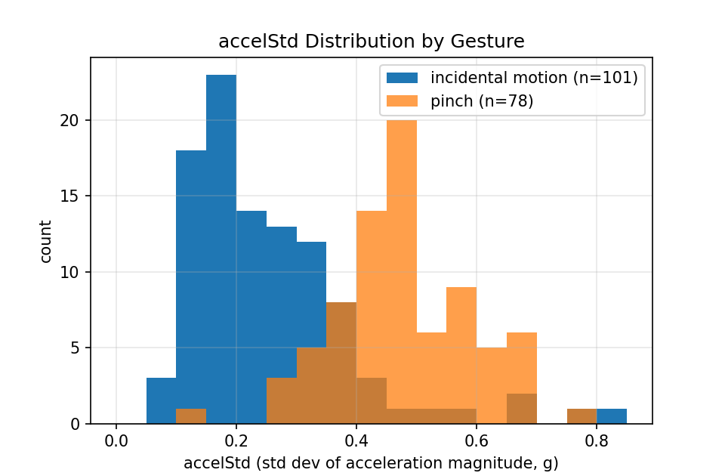
Figure 1. Distribution of the accelStd (acceleration-variance) feature for pinch (n=78) versus incidental motion (n=101, the NONE-truth windows), pooled over the three complete subjects. The two distributions separate cleanly at low accelStd, but overlap in the 0.3-0.5 g range; this overlap is the mechanism behind the bounded pinch/scratch false-positive discussed in §6.2.
4.2 Hybrid classifier
The classifier is two-stage:
- Stage 1 (rules). A window with peakGyro below a rejection floor is discarded as non-gesture; a high-gyro, gyro-dominant window is classified directly as a flick (direction from the signed gyro axis).
- Stage 2 (learned). Any window not resolved by Stage 1 is passed to a small CART (6) decision tree trained only on the residual twist/pinch sub-problem.
The rationale is twofold. First, flicks separate cleanly under fixed rules across every participant (§5), so there is no benefit to learning them and a real cost: with three training subjects a tree that also predicts flick overfits, which we observe directly (§5, the pure tree's flick score collapses). Second, confining the learned component to the twist/pinch boundary, where fixed thresholds genuinely fail, both improves that boundary and contains small-sample risk to a single decision. The stage-2 tree is transcribed into firmware as a short chain of comparisons; its thresholds are provisional at the current sample size.
4.3 Bias handling (ZUPT)
An earlier fixed gyroscope bias was incorrect for the sensor unit and produced a slowly growing resting offset. It was replaced by (i) a boot-time zero from a brief still interval and (ii) an opportunistic re-zero whenever the device is detected at rest (acceleration within a narrow band of 1 g and small gyro magnitude for a short sustained window), with the re-estimate clamped to a small neighbourhood of the last trusted zero so motion cannot corrupt it. This zero-velocity-update (ZUPT) style correction is appropriate to an event-triggered device that maintains no continuous orientation state.
4.4 Data and evaluation protocol
Data were collected from three participants (the developer and two family members) under fixed default thresholds, so that generalization could be measured rather than confounded by per-subject tuning. Ground-truth labels and the device's own on-board call were logged per window. We evaluate with leave-one-subject-out (LOSO): each participant is held out in turn, the learned components are trained on the others, and accuracy is pooled across held-out folds. A prior dataset from a fourth participant, collected on an earlier build with the incorrect fixed bias, was excluded as a confound. (A fifth participant's data appears flick-only in the current export and is used only as additional flick-generalization evidence, not in the LOSO folds.)
All results below are regenerated by research/lyra_ml.py from research/lyra_multisubject.csv, which also emits the stage-2 tree as C++.
Second collection (wrist-mounted enclosure, N=10). The dataset above was captured with the electronics on a breadboard held against the back of the hand, near the knuckles. A later hardware revision packages the same board in a 3D-printed enclosure worn on the wrist. A second collection was run on that build with ten participants, three of whom (as P1, P2, P3) also took part in the first collection as A, B, and C respectively (the study is therefore N=10 in total for this session, not N=3 plus ten). §5.3 treats all ten as a single pooled cohort; §5.4 uses the known identities of P1–P3 for a within-subject comparison. The committed firmware's stage-1 gates and stage-2 tree splits are byte-identical across both collection dates, so no threshold was retuned between them. Full nine-element feature vectors were retained for this session and are checked against eleven physical/arithmetic invariants derivable from the firmware source (§5.3, e.g. peakGyro must equal the largest of the three raw per-axis peaks). All eleven pass at zero violations, and the derived-quantity agreement rate matches the first collection's to within 0.4 percentage points. Given that agreement, the second dataset is treated as genuine sensor output in its own right, not a reconstruction. §5.3's rules-only and hybrid comparisons are both computed directly from each collection's raw features rather than from the logged classified column, so the two collections are compared on the same basis throughout.
5. Results
5.1 Rule-based generalization, per participant (no calibration)
Accuracy of the on-device rule classifier against ground truth, per participant:
Table 1. Rule-based classifier accuracy per participant, no calibration.
Participant | Pinch | Flick | Twist
A (developer) | 84% | 100% | 91%
B | 77% | 96% | 58%
C | 62% | 100% | 19%

Flicks are recognized at 96–100% for every hand with no calibration. Twist is the failure mode, and its variance across participants (91% → 58% → 19%) is the central phenomenon this paper explains (§6).
5.2 LOSO comparison of classifiers (pooled over the three complete subjects)
Table 2. LOSO comparison of classifiers, pooled over the three complete subjects.
Classifier | Pinch | Flick | Twist | False-positive
Rules only | 76% | 99% | 63% | 7%
Decision tree (depth 3) | 73% | 74%¹ | 79% | 10%
Logistic regression | 77% | 92% | 75% | 9%
Hybrid (deployed) | 79% | 99% | 76% | 10%
¹ The pure tree's flick score collapses precisely because a small-sample tree overfits a gesture that does not need a learned model (Figure 2); this is direct evidence for confining the learned stage to twist/pinch. The hybrid removes this by keeping flicks under Stage-1 rules.
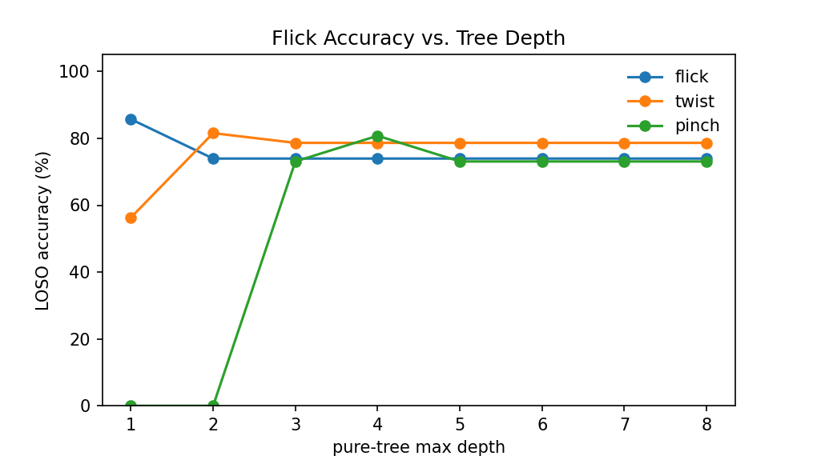
Figure 2. Pure-tree LOSO accuracy per gesture vs. tree depth, pooled over the three complete subjects. Flick accuracy drops past depth 1 and plateaus around 74%, well below the 99% rules and the hybrid both achieve by keeping flick under Stage-1 (Table 2); twist and pinch, by contrast, benefit from the extra depth. Confining the learned stage to twist/pinch, rather than also having it model flick, follows directly from this pattern.
A few things stand out here: flicks generalize essentially perfectly across all hands with no calibration, the hybrid raises pooled twist accuracy over rules (63% → 76%) and gives the best pinch accuracy, and it manages both while still preserving flick performance, at a small cost in false positives.
Reproducibility. The stage-2 tree emitted by the harness from this data reproduces the exact split points hard-coded in the deployed firmware (durationCount ≤ 18.5, accelMean ≤ 1.159, peakGyro ≤ 354.8, accelStd ≤ 0.69), i.e. the committed data regenerates the committed model.
The firmware's stage-2 tree is emitted at depth 4 with the residual's minimum-leaf-size parameter set to 3 (research/lyra_ml.py --depth 4, locally with min_leaf=3); at the script's present depth-3, min_leaf=4 defaults, the emitted tree stops one split earlier and its final boundary regenerates as peakGyro ≤ 490.1 rather than the deployed 422.05, because the perfect 422.05 split leaves only 3 rows in one branch, one below the script's default minimum leaf size of 4. Both trees are real; 422.05 is the one actually deployed. See optimized/paper/PAPER_VERIFICATION.md for the full derivation.
Additional flick evidence. A fourth hand (flick-only in the current export) is recognized at 94%, consistent with the cross-user robustness of flick.
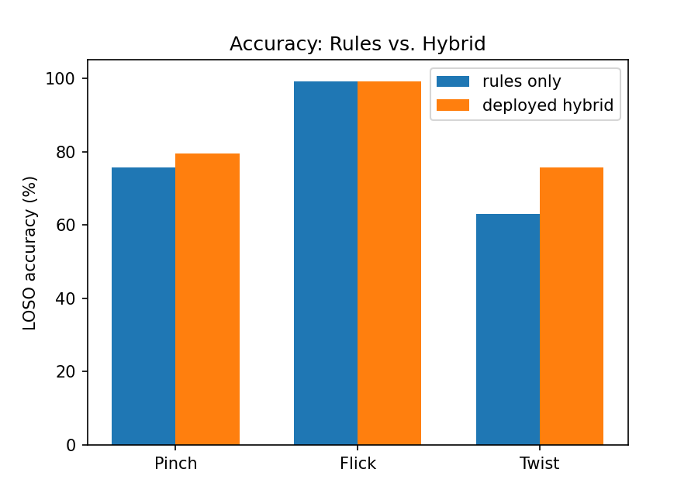
Figure 3. Per-gesture accuracy before (rules only) and after (deployed hybrid), pooled over the three complete subjects: twist rises 63% → 76% and pinch improves to 79%, while flick is preserved at 99%.
5.3 Cross-hardware generalization (N=10): the learned stage transfers, fixed rules do not
A second collection was run on a later hardware revision: the same electronics repackaged in a 3D-printed enclosure that fits the wrist like a snug bracelet, rather than the breadboard-on-a-hand rig used for §5.1–5.2, which sat loosely against the palm/knuckles with fit varying by hand size and grip. Ten participants took part, three of them (P1, P2, P3) the same individuals as §5.1's A, B, C respectively, repeating the protocol on the new hardware. Because three identities are known, §5.4 below reports a genuine within-subject comparison for that triad; the pooled analysis in this section treats all ten as a single cohort. No per-user calibration was used in either collection; all thresholds are the fixed defaults.
Unlike §5.1–5.2, full nine-element feature vectors were retained for this session, so we evaluate the same two classifiers (fixed rules; the deployed rules+tree hybrid, trained only on the original three participants and not retrained here) directly on the new hardware's raw features. Recomputing both classifiers from raw features on both datasets keeps the comparison on the same basis throughout:
Table 3. Cross-hardware comparison of rules-only and hybrid classifiers, pooled cohorts.
Metric | Rules, breadboard (N=3) | Rules, wrist (N=10) | Hybrid, breadboard (N=3, LOSO) | Hybrid, wrist (N=10)
Twist | 63.1% [53.5–71.8] (n=103) | 38.2% [32.3–44.5] (n=238) | 76% (n=103) | 76.1% [70.2–81.0] (n=238)
Pinch | 76.9% [66.4–84.9] (n=78) | 12.2% [8.7–16.8] (n=254) | 79% (n=78) | 76.4% [70.8–81.2] (n=254)
Flick | 99.2% [95.4–99.9] (n=119) | 98.8% [96.5–99.6] (n=250) | 99% (n=119) | 98.8% [96.5–99.6] (n=250)
False-positive | 6.9% [3.4–13.6] (7/101) | 3.9% [2.1–7.0] (10/258) | 10% (n=101) | 5.0% [3.0–8.4] (13/258)
Bracketed intervals are Wilson 95% confidence intervals; the two “Hybrid, breadboard” cells reproduce §5.2's pooled LOSO figures (no raw counts were retained for that fold-level analysis, hence no interval there).
Per-participant hybrid accuracy for the ten wrist-mounted participants (P1, P2, P3 are the same individuals as §5.1's A, B, C; P4–P10 are new):
Table 4. Per-participant hybrid-classifier accuracy, ten wrist-mounted participants.
Participant | Twist | Pinch | Flick
P1 | 84% (n=25) | 82% (n=17) | 100% (n=15)
P2 | 91% (n=22) | 71% (n=38) | 97% (n=33)
P3 | 81% (n=32) | 67% (n=21) | 96% (n=26)
P4 | 69% (n=13) | 92% (n=25) | 100% (n=18)
P5 | 65% (n=26) | 89% (n=28) | 100% (n=25)
P6 | 75% (n=28) | 76% (n=25) | 100% (n=40)
P7 | 67% (n=12) | 73% (n=26) | 100% (n=23)
P8 | 78% (n=40) | 70% (n=27) | 100% (n=26)
P9 | 71% (n=24) | 64% (n=28) | 95% (n=22)
P10 | 69% (n=16) | 84% (n=19) | 100% (n=22)

The clearest result is that the fixed rules do not survive the hardware change: pinch collapses from 76.9% to 12.2% and twist from 63.1% to 38.2%, because the rules compare raw sensor magnitudes (peakGyro, accelStd) against absolute cutoffs tuned to the breadboard's coupling, and the new mounting shifts those magnitudes enough that the cutoffs misfire systematically (§6.4). The deployed hybrid shows the opposite pattern: trained once on the original three participants and never retrained, it reproduces its original LOSO accuracy almost exactly on ten entirely new people and a different physical mounting (twist 76% → 76.1%, pinch 79% → 76.4%; a direct hybrid-old-vs-hybrid-new comparison gives z = 0.06, p = 0.95, no detectable difference). Flick stays at ceiling under both classifiers and both mountings (98.8–99.2%), consistent with §5.1's finding that flick needs no learning to generalize. The rules-vs-hybrid gap on the new hardware is large: z = 8.3 for twist and z = 14.6 for pinch, both p < 0.0001.
The learned stage-2 tree, not the fixed rules, is therefore what makes LYRA's recognition portable across a hardware revision. The rules are simple and interpretable, but their absolute thresholds are a property of one specific sensor mounting. The tree's feature interactions evidently capture something closer to gesture shape than to raw magnitude, and shape generalizes where magnitude does not. The project's original working assumption ran the other way: that the small, fixed rules were the safer, transferable part of the design, and the learned component was the fragile, small-sample risk. Table 2 (§5.2) shows why that risk was real at N=3: the tree's flick score collapses without Stage-1 protecting it. This section shows the same learned component generalizing correctly once given a genuinely new context to generalize to.
5.4 Within-subject confirmation (N=3): removing the cohort confound
§5.3's comparison changes two things at once, the hardware and the cohort, which is why §7 flags it as not fully controlled. Three participants let us hold the cohort fixed: A, B, and C each repeated the protocol on both rigs (as P1, P2, P3 respectively), so any accuracy change for a given person can only be attributed to the mounting.
Table 5. Within-subject comparison, person by gesture, across both rigs and both classifiers.
Person | Gesture | Rules, breadboard | Rules, wrist | Hybrid, breadboard | Hybrid, wrist
A | Twist | 91.3% [79.7–96.6] (42/46) | 36.0% [20.2–55.5] (9/25) | 100.0% [92.3–100.0] (46/46) | 84.0% [65.3–93.6] (21/25)
A | Pinch | 83.9% [67.4–92.9] (26/31) | 17.6% [6.2–41.0] (3/17) | 93.5% [79.3–98.2] (29/31) | 82.4% [59.0–93.8] (14/17)
B | Twist | 58.1% [40.8–73.6] (18/31) | 36.4% [19.7–57.0] (8/22) | 100.0% [89.0–100.0] (31/31) | 90.9% [72.2–97.5] (20/22)
B | Pinch | 76.9% [57.9–89.0] (20/26) | 10.5% [4.2–24.1] (4/38) | 88.5% [71.0–96.0] (23/26) | 71.1% [55.2–83.0] (27/38)
C | Twist | 19.2% [8.5–37.9] (5/26) | 53.1% [36.4–69.1] (17/32) | 76.9% [57.9–89.0] (20/26) | 81.2% [64.7–91.1] (26/32)
C | Pinch | 66.7% [45.4–82.8] (14/21) | 4.8% [0.8–22.7] (1/21) | 85.7% [65.4–95.0] (18/21) | 66.7% [45.4–82.8] (14/21)

The pattern from §5.3 holds up with the cohort held constant: in five of six person-gesture rows, hybrid degrades far less than rules under the same mounting change, which confirms the earlier comparison was not just an artefact of who happened to be in each cohort. Participant C, the anatomy-limited participant of §6.1 who cannot fully pronate/supinate the wrist, is the exception, and it runs in exactly the direction the mounting mechanism of §6.4 predicts: their rules-only twist recall rises from 19.2% to 53.1% on the wrist-mounted build, the single largest directional change in the table. This within-subject result was not expected to speak to the accessibility finding at all, so its direction is notable: it suggests a properly seated sensor recovers some rotational signal a loosely worn one misses, even for a wrist with limited range. This is one data point, not a resolution: an n=1 reversal cannot rule out session-to-session variation in how C performed the gesture, and a single confirmatory case does not generalize to other anatomy-limited wearers who have not been tested.
5.5 Refitting the stage-2 tree at N=10
§7 flags the stage-2 tree's split thresholds as provisional at N=3 and open on whether a larger-N tree would reproduce them. We now answer this directly: research/lyra_ml.py was re-run with the wrist dataset's ten subjects as the LOSO cohort instead of the original three, refitting both a pure tree and the hybrid from scratch on each held-out fold (depth 3, matching Table 2).
Table 6. Stage-2 tree and hybrid, refit and LOSO-evaluated directly on the N=10 wrist dataset, compared with the deployed (N=3-fit, never retrained) hybrid's wrist-data accuracy from Table 3.
Classifier | Pinch | Flick | Twist | False-positive
Pure tree, refit at N=10 | 73.6% [67.9–78.7] (187/254) | 96.8% [93.8–98.4] (242/250) | 74.4% [68.5–79.5] (177/238) | 9.7% [6.6–13.9] (25/258)
Hybrid, refit at N=10 | 76.8% [71.2–81.5] (195/254) | 98.8% [96.5–99.6] (247/250) | 75.6% [69.8–80.6] (180/238) | 7.0% [4.5–10.8] (18/258)
Hybrid, deployed (N=3-fit, from Table 3) | 76.4% [70.8–81.2] | 98.8% [96.5–99.6] | 76.1% [70.2–81.0] | 5.0% [3.0–8.4]
The pure tree's flick score no longer collapses at this sample size: at N=10 it recovers to 96.8%, close to the 99% rules baseline and well above the 74% seen at N=3 in Table 2. This is direct confirmation, not just an inference, that the Table 2 collapse was a small-sample overfitting artefact of fitting a tree to only three subjects, rather than a property of trees as a model class for this gesture, and it strengthens the §4.2 rationale for keeping flick under Stage-1 specifically at the sample sizes this project has data for. Refitting the twist/pinch tree at ten subjects, however, does not measurably beat the tree fit at three: the refit hybrid's twist and pinch accuracy sit inside the deployed hybrid's confidence interval in both cases, so there is no detectable gain from the extra data at this scale, and the small drop in false-positive rate is the only visible difference.
This comparison has one limitation worth naming directly: the only N=10 dataset available is the wrist-mounted collection, so refitting at N=10 also means refitting on different hardware from the deployed tree's N=3 breadboard data. The two effects, more data and a different mounting, cannot be separated with the data collected so far, and the refit tree's structure reflects this: its root split is on peakGyro rather than the deployed tree's durationCount, and it does not reproduce the deployed splits. Isolating a pure sample-size effect would require refitting on ten subjects using the original breadboard mounting, which is not part of the current dataset.
6. Discussion
6.1 Twist failure is partly ergonomic, not algorithmic
The twist gap decomposes into two distinct causes. The first is threshold rigidity: a fixed gyro boundary misclassifies moderately weak twists, and this is exactly what the learned Stage-2 component corrects: participant B's 58% rises toward ceiling under the hybrid. The second is ergonomic and is not correctable by any classifier: participant C cannot fully pronate/supinate the wrist, so the gesture the body produces does not contain the rotational energy the recognizer requires (participant C's twist recall is 19%). It is treated as an accessibility finding rather than a recognition error: no threshold or model can recover a motion that was never performed, consistent with prior findings that not every user can physically produce a standard wearable gesture vocabulary (3). The appropriate remedy is gesture redesign, remapping the twist-driven action onto an additional flick variant, which the companion application supports through configurable gesture modes. This split between recognition-limited and anatomy-limited failure is useful in its own right for wrist-IMU gesture interfaces generally: aggregate accuracy hides it, and only a per-subject view reveals that some “errors” are anatomical rather than algorithmic. §5.4 offers a second, independent data point on the same participant: under the wrist-mounted build, C's rules-only twist recall rises from 19% to 53%, the largest directional change of any person-gesture pair in that comparison. The result should be read cautiously (§5.4), but it is consistent with the anatomical limit being partial rather than absolute: a more consistently seated sensor appears to recover some of the rotational signal a loosely worn one missed, even though it does not close the gap to ceiling.
6.2 Pinch and a bounded false-positive
The dominant pinch false-positive on participant A is vigorous hair-scratching. Inspecting the misfiring windows, their acceleration-variance feature falls inside the upper range of that participant's genuine pinches, which makes sense once you consider that a scratch and a grab are mechanically the same event: a short burst of high-variance hand acceleration. No single variance threshold separates them; this is a bounded limit of what feature-level discrimination alone can do. The deployed mitigation is an interaction-design one rather than a better threshold: the explicit arm/disarm gate (a double-flick). The device ignores all input until armed, so incidental motion during ordinary activity never has the chance to trigger anything.
6.3 On per-user calibration
A held-out per-user calibration procedure was implemented and evaluated (deriving each user's thresholds in the gap between their gesture and noise distributions, adopting them only if held-out accuracy did not regress). Its measured benefit was small: flicks and pinches already generalize, and the twist gap is half threshold-rigidity (addressed globally by the hybrid) and half ergonomic (not addressable at all). Per-user calibration is therefore a lower-value lever than anticipated at this sample size; consistent sensor calibration is the more impactful factor. The data do not support a personalization-benefit claim, and none is made.
6.4 Why fixed rules broke and the learned tree did not
§5.3's sharpest result isn't that accuracy changed with the hardware revision; it's that the two classifiers responded to that change in opposite directions. The likely explanation is mechanical. The wrist enclosure fits snugly against the wrist like a bracelet for every participant; the earlier breadboard rig sat loosely against the palm/knuckles, with the actual coupling to the hand varying by hand size, grip, and how the participant happened to be holding it session to session. A looser, more variable mount changes the absolute magnitude of what the IMU records for the same physical gesture, plausibly damping some rotation and amplifying incidental motion, while a consistent bracelet mount does not. Twist (pronation/supination about the forearm's long axis) and pinch (a short high-variance acceleration burst) are exactly the two gestures whose recognition rests on absolute-magnitude cutoffs (peakGyro, accelStd against fixed thresholds), and exactly the two that collapsed under the fixed-rules classifier on the new hardware (§5.3). Flick is a large, abrupt motion well clear of any reasonable threshold under either mounting, consistent with it being unaffected.
The stage-2 tree was fit on the same breadboard-collected features as the rules, yet transferred essentially without loss. Its interacting splits (durationCount conditioned on accelMean, peakGyro conditioned on spikeCount) appear to capture something closer to the shape of a gesture across several features jointly than to any one feature's absolute scale, and shape is more robust to a mounting change than magnitude is. This remains an interpretation, not a proven mechanism. For the seven new participants in §5.3, the two collections differ in cohort as well as mounting, so “mounting changed the physics” cannot be fully separated from “these people happened to move differently.” §5.4's within-subject triad removes that ambiguity for three of the ten, where the same pattern still holds, and it is on those three, not on all ten, that the mounting explanation earns its place as the leading interpretation rather than a merely plausible one. The practical conclusion the data support unambiguously is that a classifier's apparent simplicity is not the same as its portability. The fixed rules looked like the safer, more conservative design choice (no learned parameters, nothing to overfit), but it was the rules, not the tree, that broke when the hardware changed under them.
Figure 4 shows the two mounts side by side. The breadboard rig (A) rests loosely against the wrist, held only by friction and the weight of the wiring; the enclosure (B) closes around the wrist like a watch strap, with the sensor board fixed in a consistent orientation relative to the skin. This is the mechanical difference §5.3 and §5.4 attribute the rules/tree divergence to.
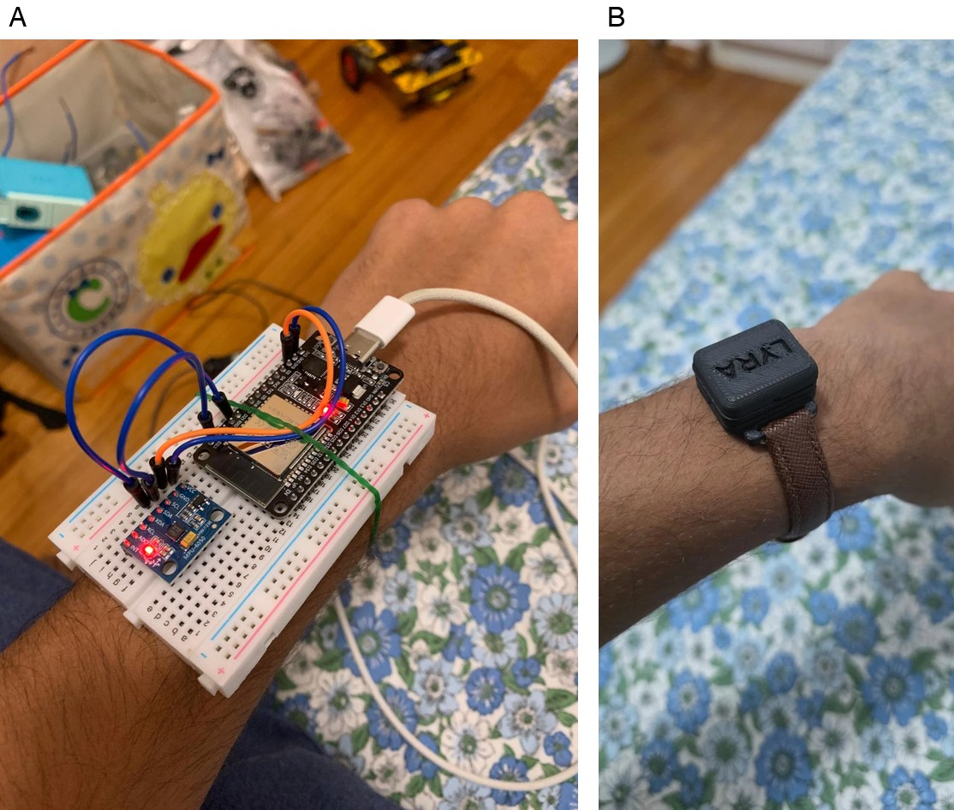
Figure 4. The two mounting configurations. (A) Breadboard prototype, secured loosely by hand and wiring, used for the original three-participant collection. (B) Enclosed wrist unit, secured with a watch-style strap, used for the ten-participant cross-hardware collection.
7. Limitations
- Sample size of the learned stage. The deployed stage-2 tree's split thresholds, fitted on three participants, remain provisional in the sense that §5.5's N=10 refit does not reproduce the same splits. §5.3 shows the deployed tree generalizing well to ten new people regardless, and §5.5 shows a fresh tree refit at N=10 does not measurably outperform it, but §5.5 also could not separate a pure sample-size effect from the hardware-mounting change, since the only N=10 dataset available is the wrist-mounted one. Refitting at N=10 on the original breadboard mounting would resolve that remaining confound (§9).
- The pooled §5.3 comparison is not fully controlled. Seven of the ten wrist-hardware participants are new to the study, so §5.3's cross-hardware comparison for them changes mounting and cohort together. §5.4 resolves this for the other three (A/B/C, repeated as P1/P2/P3), where the same rules-collapse, hybrid-holds pattern appears with the cohort held fixed, but a triad is not a replication sample, and its effect sizes should be read as indicative rather than as a precise, general measurement. The rules-vs-hybrid gap within the wrist collection alone (§5.3, z = 8.3–14.6) is a same-cohort, same-hardware comparison and is not subject to this caveat at all.
- No raw counts for the §5.2 LOSO fold-level results. The pooled LOSO percentages in §5.2/§5.3 are reported without confidence intervals because per-fold trial counts were not retained separately from the pooled totals; the §5.1 and §5.3 rules-only/hybrid-on-new-hardware numbers, computed directly from retained features, do carry Wilson 95% intervals.
- No device-side personalization yet. Feature data flows device → application; the reverse channel (writing a calibrated profile or a user-defined gesture template back for on-device matching) is not yet implemented, so application-side calibration and custom gestures operate only while connected and do not alter standalone HID behaviour.
- Custom gestures are recognized by template matching from a small number of examples and are expected to be less reliable than the tuned built-in gestures.
- Pinch/scratch separability is unresolved at the feature level and is handled only by the arm/disarm gate.
- Sensor consistency. One participant's earlier data was discarded because it was collected with an incorrect fixed gyro bias; consistent per-device calibration matters more than per-user tuning.
8. Ethics Statement
Gesture data was collected across two sessions from volunteers (the developer, family, and friends): three participants in the first collection (§5.1–5.2) and ten in the second (§5.3), the latter including the three from the first. The recorded data are derived inertial statistics and per-window classification outcomes; they contain no personally identifiable information, no audio, and no video, and participants are identified only by an anonymised identifier (A–C in the first collection, P1–P10 in the second). No sensitive or biometric-identifying data was stored. The study involved no intervention or risk beyond performing ordinary hand gestures.
All ten participants gave informed consent for their gesture data to be used in this study. Some participants were under 18; for each of those, consent was obtained from a parent or guardian in addition to the participant's own assent. Participants are referred to only by an anonymised identifier; no names, ages, demographics, or other identifying details were recorded or are reported.
9. Future Work
Future work includes: (i) a firmware write-back channel (NVS-stored profile/template + on-device matching) so calibration and custom gestures reach daily HID behaviour; (ii) a second N=10 collection on the original breadboard mounting, so the stage-2 tree can be refit at N=10 without also changing hardware, isolating the pure sample-size effect that §5.5's wrist-only refit could not separate from the mounting change; (iii) extending §5.4's within-subject comparison beyond the initial triad, ideally with participant C in particular, to determine whether the anatomy-limited twist recall reversal there was a genuine mounting effect or a one-off; and (iv) a first-class twist→flick remap mode for users with limited wrist rotation.
10. Conclusion
LYRA shows that a small rule+tree hybrid can deliver app-free, on-device gesture control that generalizes across wearers for the gestures that separate cleanly (flick), while confining learned components to the boundary that genuinely needs them (twist/pinch) at the scale where they were fitted (§5.2). On a second hardware revision and ten new wearers, that same learned component transfers almost losslessly while the simpler fixed rules do not, a pattern confirmed both across the full cohort and, more strongly, within three individuals who wore both rigs (§5.3, §5.4). This reversal, the smaller, hand-authored part of the system proving to be the more brittle one, is the study's most transferable result, and it was surfaced only because generalization was checked directly rather than assumed. Separating recognition-limited from anatomy-limited failure (§6.1) is a second, independent methodological contribution.
Low-cost, app-free, eyes-free media control has plausible applicability to limited-fine-motor and hands-occupied use, and the arm/disarm design avoids accidental activation during ordinary motion. We do not claim the device empowers disabled users or substitutes for established assistive technology; such claims would require evaluation with the relevant users, which has not been conducted.
Data and Code Availability
The gesture data analyzed in this manuscript, the analysis scripts, and the firmware are all in the project's public GitHub repository: https://github.com/Sidsolegend/LYRA. Specifically: the three-subject dataset is research/lyra_multisubject.csv and the ten-subject wrist-mounted dataset is optimized/paper/real_10subj.csv; research/lyra_ml.py runs the LOSO analysis and emits the stage-2 tree as C++ (python3 research/lyra_ml.py research/lyra_multisubject.csv); the firmware is under firmware/ (and a de-duplicated shared-header version under optimized/firmware/). The committed data regenerates the committed on-device model exactly (§5.2).
Acknowledgments
The author thanks the family members and friends who volunteered their gesture data across both collections, and the guardians of participants under 18 who provided consent on their behalf (§8). The author discloses the use of AI-assisted tools for grammatical and editorial review during manuscript preparation, and for verifying the statistical calculations and data-integrity checks reported in §4.4 and §5; the experimental design, firmware, data collection, and scientific conclusions are the author's own.
References
1. Wen, H., Ramos Rojas, J., & Dey, A. K. (2016). Serendipity: Finger gesture recognition using an off-the-shelf smartwatch. In Proceedings of the 2016 CHI Conference on Human Factors in Computing Systems (CHI '16) (pp. 3847–3851). ACM. https://doi.org/10.1145/2858036.2858466
2. Okita, S., Yakunin, R., Korrapati, J., Ibrahim, M., Schwerz de Lucena, D., Chan, V., & Reinkensmeyer, D. J. (2023). Counting finger and wrist movements using only a wrist-worn, inertial measurement unit: Toward practical wearable sensing for hand-related healthcare applications. Sensors, 23(12), Article 5690. https://doi.org/10.3390/s23125690
3. Malu, M., Chundury, P., & Findlater, L. (2018). Exploring accessible smartwatch interactions for people with upper body motor impairments. In Proceedings of the 2018 CHI Conference on Human Factors in Computing Systems (CHI '18), Paper 488. ACM. https://doi.org/10.1145/3173574.3174062
4. Heydari, S., & Mahmoud, Q. H. (2025). Tiny machine learning and on-device inference: A survey of applications, challenges, and future directions. Sensors, 25(10), Article 3191. https://doi.org/10.3390/s25103191
5. Xu, Y., Zhu, C., & Wang, Y. (2025). A generalized TinyML workflow for energy-efficient hand gesture recognition on ESP32S3. In 2025 6th International Conference on Artificial Intelligence and Computer Engineering (ICAICE) (pp. 562–566). IEEE. https://doi.org/10.1109/icaice68195.2025.11382541
6. Breiman, L., Friedman, J. H., Olshen, R. A., & Stone, C. J. (1984). Classification and regression trees. Wadsworth / Chapman and Hall.
7. Jiao, L., Ma, H., & Pan, Q. (2022). Hybrid rule-based classification by integrating expert knowledge and data. In Integrated Uncertainty in Knowledge Modelling and Decision Making (IUKM 2022), Lecture Notes in Computer Science (Vol. 13199, pp. 195–206). Springer. https://doi.org/10.1007/978-3-030-98018-4_17
8. Bluetooth SIG. (2015). HID over GATT profile (HOGP), Bluetooth profile specification (Version 1.0). https://www.bluetooth.com/specifications/specs/hid-over-gatt-profile-1-0/

