Project-I

Number of resources: 5000(73% in India)

Employee strength: 690

Strength in India: 60%

Strength in Australia: 5%

Asia Pacific Centres: 7%

Customer distribution

Customers in US: 32%

Customers in Middle east: 27%

Customers in Europe: 20%

Revenue share Margin share

BFSI: 46% BFSI:42%

Healthcare: 21% Retail:39%

Others: 33% US: 48% Europe: 44%

India: 9% Asia-pacific: 14%

Major revenue producer: Digital marketing products (90%)

Root problem: The company is struggling to keep up with the year-on-year growth of other companies hence the root problem.

***Issue tree***

Offer more affordable options in IT solutions and products

Improve the products offered

Grow no. of customers

Improve marketing

Acquire SMEs

Revenue

Provide better maintenance by giving frequent updates and patches

Increase customer lifetime value

Increase cross-sell

YOY growth

Increase production

Share technology and joint R&D

Reduce fixed costs

Provide cheaper maintenance

Cost

Acquire niche-specialised companies to mitigate price war

Reduce variable costs

Add new resources from acquisitions to launch cheaper products

Growth of BFSI sector in India in previous years is shown in the following graphs. The banking sector has shown an average overall growth of 8% per year. Financial services sector has shown a CAGR of 9.72% over last 7 years, while the life insurance premium has shown growth. This growth in BFSI sector will clearly ask for more organisations to provide services which proves to be a fruitful business for this company in India.

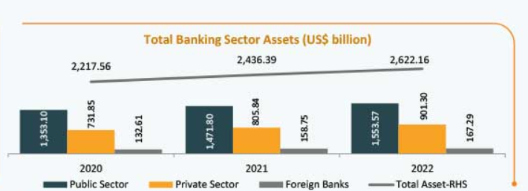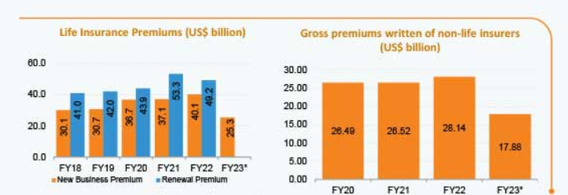

[Source: [*www.ibef.org*](http://www.ibef.org)]

In US, post COVID, healthcare services and technology(HST) particularly in data and technology will show a positive growth from 2021 to 2026 which is shown in the graph shown below. The predictions suggest strongly to invest in HST sector in US which will prove to be profitable and increase YOY growth of this company.

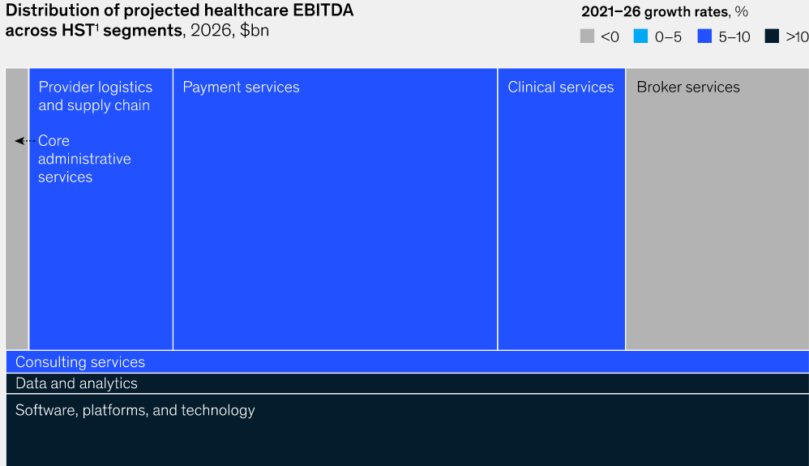

Source: McKinsey and Company

Like US, the healthcare sector will be oriented towards more data-driven sector as predictive analytics, genome sequencing, big data analysis will be the major driving forces. The graph below shows a predictive CAGR of 19.4% from 2022 to 2028 in the healthcare sector of Europe. Healthcare sector would require more companies to provide their IT services so that any future outbreak can be prevented or dealt with, much efficiently. More lives would be saved by predicting the disease or ailment an individual may get afflicted with using one’s history of health data.

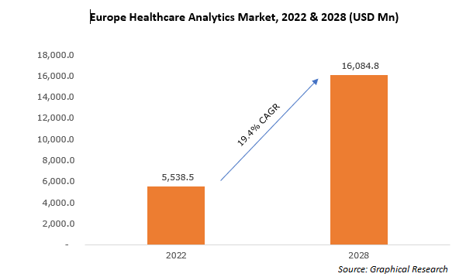

***Important points to cosider:-***

* The company should acquire SMEs which specialise in niche technologies to gain customers with very specific needs.
* Providing frequent updates and patches for software products will increase customer retention and provide safer online environment for the customer companies.
* Data Analytics would be required if the company wants to grow in India amidst fierce competition, which will be easier by acquiring SMEs as their customers have specific needs which is not being provided with by rival companies.
* In US and European markets, the digital network is much denser and huge which should be taken advantage of to provide better healthcare services.
* Acquiring healthcare startups in USA and Europe, which were started during COVID and after will help in the offline retail and delivery business, consequently improving offline market presence of the company.